UNITED STATES

SECURITIES AND EXCHANGE COMMISSION

Washington, D.C. 20549

FORM 8-K

CURRENT REPORT

PURSUANT TO SECTION 13 OR 15(d)

OF THE SECURITIES EXCHANGE ACT OF 1934

Date of report (Date of earliest event reported): November 5, 2026

Expensify, Inc.

 | (Exact Name of Registrant as Specified in its Charter)
Delaware | 001-41043 | 27-0239450
(State or Other Jurisdiction | (Commission | (IRS Employer
of Incorporation) | File Number) | Identification No.)
 | 88 Kearny St, Ste 1600
 | San Francisco, California 94108
 | (Address of Principal Executive Offices) (Zip Code)
 | (971) 365-3939
 | (Registrant’s telephone number, including area code)
 | Not applicable
 | (Former Name or Former Address, if Changed Since Last Report)

Check the appropriate box below if the Form 8-K filing is intended to simultaneously satisfy the filing obligation of the registrant under any of the following provisions:

- Written communications pursuant to Rule 425 under the Securities Act (17 CFR 230.425).

- Soliciting material pursuant to Rule 14a-12 under the Exchange Act (17 CFR 240.14a-12).

- Pre-commencement communications pursuant to Rule 14d-2(b) under the Exchange Act (17 CFR 240.14d-2(b)).

- Pre-commencement communications pursuant to Rule 13e-4(c) under the Exchange Act (17 CFR 240.13e-4(c)).

Securities registered pursuant to Section 12(b) of the Act:

 |  | Trading |  | Name of each exchange
Title of each class |  | Symbols |  | on which registered
Class A Common Stock, par value $0.0001 per share |  | EXFY |  | The Nasdaq Stock Market LLC

Indicate by check mark whether the registrant is an emerging growth company as defined in Rule 405 of the Securities Act of 1933 (§230.405 of this chapter) or Rule 12b-2 of the Securities Exchange Act of 1934 (§240.12b-2 of this chapter).

Emerging growth company ☐

If an emerging growth company, indicate by check mark if the registrant has elected not to use the extended transition period for complying with any new or revised financial accounting standards provided pursuant to Section 13(a) of the Exchange Act. ☐

Item 2.02 Results of Operations and Financial Condition.

On November 5, 2026, the Expensify, Inc. (“Expensify” or “the Company”) issued a press release announcing its financial results for the year and quarter ended September 30, 2026. A copy of this press release is furnished as Exhibit 99.1 to this current report on Form 8-K and is incorporated herein by reference.

Item 7.01 Regulation FD Disclosure.

On November 5, 2026, the Company posted an investor presentation to its website at https://ir.expensify.com (the “Investor Presentation”). A copy of the Investor Presentation is attached as Exhibit 99.2 to this current report on Form 8-K and is incorporated herein by reference. The Company expects to use the Investor Presentation, in whole or in part, and possibly with modifications, in connection with presentations to investors, analysts and others.

The information contained in the Investor Presentation is summary information that is intended to be considered in the context of the Company’s Securities and Exchange Commission (“SEC”) filings and other public announcements that the Company may make, by press release or otherwise, from time to time. The Investor Presentation speaks only as of the date of this current report on Form 8-K. The Company undertakes no duty or obligation to publicly update or revise the information included in the Investor Presentation, although it may do so from time to time. Any such updating may be made through the filing of other reports or documents with the SEC, through press releases or other public disclosure. In addition, the exhibit furnished herewith contains statements intended as “forward-looking statements” that are subject to the cautionary statements about forward-looking statements set forth in such exhibit. By furnishing the information contained in the Investor Presentation, the Company makes no admission as to the materiality of any information in the Investor Presentation that is required to be disclosed solely by reason of Regulation FD.

The information contained in Item 2.02 and this Item 7.01, including Exhibit 99.1 and 99.2, is being furnished and shall not be deemed “filed” for the purposed of Section 18 of the Securities and Exchange Act of 1934, as amended (the “Exchange Act”), or otherwise subject to the liabilities of that section, nor shall it be deemed incorporated by reference in any filing made by Expensify under the Securities Act of 1933, as amended, or the Exchange Act, except as expressly set forth by specific reference in such a filing.

Item 9.01 Financial Statements and Exhibits.

- Exhibits.

Exhibit No. Description

99.1 Press Release issued by Expensify, Inc., dated November 5, 2026.

99.2 Investor Presentation, dated November 5, 2026.

104 Cover Page Interactive Data File (embedded within the Inline XBRL document).

SIGNATURE

Pursuant to the requirements of the Securities Exchange Act of 1934, the registrant has duly caused this report to be signed on its behalf by the undersigned hereunto duly authorized.

Expensify, Inc.

By: /s/ Ryan Schaffer

Name: Ryan Schaffer

Title: Chief Financial Officer

Date: November 5, 2026

Exhibit 99.1

EXPENSIFY ANNOUNCES Q3 2026 RESULTS

Revenue from New Expensify increased 30% from Q2, and is up 212% y/y.

SAN FRANCISCO, CAL.--(BUSINESS WIRE)--November 5, 2026-- Expensify, Inc. (Nasdaq: EXFY), the easiest way to manage expenses, corporate cards, and travel, today released a letter to shareholders from Founder and CEO David Barrett alongside results for its quarter ended September 30, 2026.

A Message From Our Founder

Another strong quarter, both in financial results, as well as product functionality shipped:

- Cash flow remains strong. Q3 produced $4.0 million in Operating Cash Flow, up 510% from last year, and $3.3 million in Free Cash Flow, up 170% from last year. Some of this was used to repurchase 722,121 shares of Class A common stock, returning approximately $1.3 million to shareholders. Based on this continued strength we've increased FY 2026 FCF guidance by $1.5 million to $13.5 million - $15.5 million.

- New Expensify continues to grow and improve. Revenue from New Expensify increased 30% from Q2, and is up 212% y/y. This growth comes in part from major feature launches, such as dozens of new GL and HR integrations, as well as quality-of-life crowd pleasers like enhanced admin roles and bulk workspace management. But much of it comes from paying particular attention to micro-optimizations along the conversion pipeline, which has increased cohort conversion by 67% y/y.

- Expensify Card continues to expand. We now issue in the UK and 12 EU countries for GBP and EUR bank accounts, with enhanced PIN/biometric controls, one-time/date-bound virtual cards, and more real-time spend controls by currency, max amount, and merchant.

- Expensify Travel economics continue to improve. Our new consolidated travel billing feature enables customers to in effect finance their travel bookings to receive a single monthly debit from their bank account, resulting in substantially more revenue to Expensify from each travel booking.

- Explosive adoption of AI features. New MCP connections doubled last month, and are still accelerating. This is strong everywhere, but especially in Claude, in part due Expensify to being selected for the Claude for Small Business bundle. Our custom agent beta has been adopted by thousands of customers, and is able to handle over 96%¹ of real world requests received — out of an infinite range of potential requests.

As we outlined last quarter, Expensify Classic is a stable cash-flow engine whose customer base naturally declines over time, while New Expensify is our growth engine. That growth engine is taking on a massive, largely untapped market. As we enter the final stretch of 2026, I'm extremely proud of what we accomplished, and cannot wait to reveal what we've got in store for 2027.

-david

Founder and CEO of Expensify

- Represents the portion of individual requests that were completed as requested or rejected with clear, actionable steps for the user to complete the request themselves, based on a random sampling of all requests made between October 26, 2026 and November 1, 2026

Exhibit 99.1

Financial

Third Quarter 2026 Highlights

- Revenue, net was $33.0 million, a decrease of 6% as compared to the same period last year.

- Generated $4.0 million of cash from operating activities.

- Free cash flow was $3.3 million.

- Net loss was $3.3 million, compared to $2.3 million for the same period last year.

- Non-GAAP net income was $3.1 million.

- Adjusted EBITDA was $6.1 million.

- Interchange revenue derived from the Expensify Card grew to $5.8 million, an increase of 8% as compared to the same period last year.

- See Financial Outlook section for free cash flow guidance for fiscal year ending December 31, 2026.

Business

Third Quarter 2026 Highlights

- Paid members - Paid members were 630,000, a decrease of 2% as compared to the same period last year.

- Referral agreement with Visa - Entered into a referral agreement with Visa, under which Visa can refer eligible clients and corporate card programs to Expensify for expense management.

- Expensify Travel accelerates - Trips booked through Expensify Travel grew 40% year over year and 13% from Q2, with Q3 2026 the highest quarter on record, and launched consolidated travel billing so companies can pay for all business travel on a single invoice.

- Expensify Card expands to Europe - Launched the Expensify Card across 13 European markets, including the UK.

- Expanded integrations - Launched native integrations with AI-native ERPs Rillet and DualEntry, a Claude for Small Business connector, and new Workday, HiBob, BambooHR and Certinia integrations.

- Capital return to shareholders - The Company repurchased 722,121 shares of its Class A common stock, totaling approximately $1.3 million.

Exhibit 99.1

Financial Outlook

Expensify's outlook statements are based on current estimates, expectations and assumptions and are not a guarantee of future performance. The following statements are forward-looking and actual results could differ materially depending on market conditions and the factors set forth under “Forward-Looking Statements” below. There can be no assurance that the Company will achieve the results expressed by this guidance.

Free Cash Flow

Expensify estimates free cash flow of $13.5 million - $15.5 million for the fiscal year ending December 31, 2026.

The Company does not provide a reconciliation for free cash flow estimates on a forward-looking basis because it is unable, without making unreasonable efforts, to provide a meaningful or reasonably accurate calculation or estimation of net cash provided by operating activities and certain reconciling items on a forward-looking basis, which could be significant to the Company's results.

Stock Based Compensation

An estimate of expected stock-based compensation for the next four fiscal quarters is as follows, which is driven primarily by the pre-IPO grant of RSUs issued to all employees (which vest quarterly over eight years with approximately three years remaining).

Est. stock-based compensation (millions)

 |  | Q4 2026 |  |  |  |  |  | Q1 2027 |  |  |  |  |  | Q2 2027 |  |  |  |  |  | Q3 2027
 |  | Low |  |  | High |  |  | Low |  |  | High |  |  | Low |  |  | High |  |  | Low |  |  | High
Cost of revenue, net | $ | 2.1 | $ |  | 2.8 | $ |  | 2.1 | $ |  | 2.8 | $ |  | 2.0 | $ |  | 2.7 | $ |  | 1.9 | $ |  | 2.6
Research and development |  | 1.7 |  |  | 2.3 |  |  | 1.6 |  |  | 2.2 |  |  | 1.6 |  |  | 2.2 |  |  | 1.6 |  |  | 2.2
General and administrative |  | 1.1 |  |  | 1.4 |  |  | 1.0 |  |  | 1.3 |  |  | 1.0 |  |  | 1.3 |  |  | 1.0 |  |  | 1.3
Sales and marketing |  | 0.9 |  |  | 1.3 |  |  | 0.9 |  |  | 1.3 |  |  | 0.9 |  |  | 1.3 |  |  | 0.9 |  |  | 1.3
Total | $ | 5.8 | $ |  | 7.8 | $ |  | 5.6 | $ |  | 7.6 | $ |  | 5.5 | $ |  | 7.5 | $ |  | 5.4 | $ |  | 7.4

Availability of Information on Expensify’s Website

Investors and others should note that Expensify routinely announces material information to investors and the marketplace using SEC filings, press releases, public conference calls, webcasts and the Expensify Investor Relations website at https://ir.expensify.com. While not all of the information that the Company posts to its Investor Relations website is of a material nature, some information could be deemed to be material. Accordingly, the Company encourages investors, the media and others interested in Expensify to review the information that it shares on its Investor Relations website.

Conference Call

Expensify will host a video call to discuss the financial results and business highlights at 2:00 p.m. Pacific Time today. An investor presentation and the video call information is available on Expensify’s Investor Relations website at https://ir.expensify.com. A replay of the call will be available on the site for three months.

Exhibit 99.1

Non-GAAP Financial Measures

In addition to financial measures prepared in accordance with U.S. generally accepted accounting principles (“GAAP”), we provide certain non-GAAP financial measures, including adjusted EBITDA, non-GAAP net (loss) income, and free cash flow.

We believe our non-GAAP financial measures are useful in evaluating our business, measuring our performance, identifying trends affecting our business, formulating business plans and making strategic decisions. Accordingly, we believe that these non-GAAP financial measures provide useful information to investors and others in understanding and evaluating our results of operations in the same manner as our management team. These non-GAAP financial measures are presented for supplemental informational purposes only, should not be considered a substitute for financial information presented in accordance with GAAP, and may be different from similarly titled metrics or measures presented by other companies. Non-GAAP financial measures have limitations as analytical tools and should not be considered in isolation or as substitutes for financial information presented under GAAP. There are a number of limitations related to the use of non-GAAP financial measures versus comparable financial measures determined under GAAP. For example, other companies in our industry may calculate these non-GAAP financial measures differently or may use other measures to evaluate their performance. All of these limitations could reduce the usefulness of these non-GAAP financial measures as analytical tools. Investors are encouraged to review the related GAAP financial measures and the reconciliations of these non-GAAP financial measures to their most directly comparable GAAP financial measures and to not rely on any single financial measure to evaluate our business. A reconciliation of each non-GAAP financial measure to the most directly comparable financial measure stated in accordance with GAAP is at the end of this press release.

Adjusted EBITDA. We define adjusted EBITDA as net loss excluding provision for income taxes, other income, net, depreciation and amortization, and stock-based compensation expense.

Non-GAAP net income. We define non-GAAP net income as net loss excluding stock-based compensation expense.

Free cash flow. We define free cash flow as net cash provided by (used in) operating activities excluding changes in settlement assets, net and settlement liabilities, reduced by the purchases of property and equipment and other assets and software development costs.

The tables at the end of the Condensed Consolidated Financial Statements provide reconciliations to the most directly comparable GAAP financial measure to each of these non-GAAP financial measures.

Forward-Looking Statements

Forward-looking statements in this press release, or made during the earnings call, which are not historical facts, are forward-looking statements within the meaning of the Private Securities Litigation Reform Act of 1995. These statements include statements regarding our strategy, future financial condition, future operations, future cash flow, projected costs, prospects, plans, objectives of management and expected market growth, product developments and their potential impact and our stock-based compensation estimates and involve known and unknown risks that are difficult to predict. As a result, our actual results, performance or achievements may differ materially from those expressed or implied by these forward-looking statements. In some cases, you can identify forward-looking statements because they contain words such as “may,” “will,” “shall,” “should,” “expects,” “plans,” “anticipates,” “could,” “intends,” “target,” “projects,” “contemplates,” “believes,” “estimates,” “predicts,” “potential,” “goal,” “ambition,” “objective,” “seeks,” “outlook,” or “continue” or the negative of these words or other similar terms or expressions that concern our expectations, strategy, plans, or intentions. Such forward-looking statements are necessarily based upon estimates and assumptions that, while considered reasonable by us and our management, are inherently uncertain. Factors that may cause actual results to differ materially from current expectations include, but are not limited to: the impact on inflation on us and our members; our borrowing costs, which have and may continue to increase as a result of increases in interest rates; our expectations regarding our financial performance and future operating performance; our ability to attract and retain members, expand usage of our platform, sell subscriptions to our platform and convert individuals and organizations into paying customers; the timing and success of new features, integrations, capabilities and enhancements by us, or by competitors to their products, or any other changes in the competitive landscape of our market; the amount and timing of operating expenses that we

Exhibit 99.1

may incur to maintain and expand our business and operations to remain competitive; the sufficiency of our cash, cash equivalents and investments to meet our liquidity needs; our ability to make required payments under and to comply with the various requirements of our current and future indebtedness; our cash flows, the prevailing stock prices, general economic and market conditions and other considerations that could affect the specific timing, price and size of repurchases under our stock repurchase program or our ability to fund any stock repurchases; geopolitical tensions, including the war in Ukraine and the conflict in the Middle East; our ability to effectively manage our exposure to fluctuations in foreign currency exchange rates; the size of our addressable markets, market share and market trends; anticipated trends, developments and challenges in our industry, business and the highly competitive markets in which we operate; any adverse impact on our business operations as a result of using artificial intelligence or other machine learning technologies in our services; our reliance on third parties, including our issuing bank, payment processor and card network, for the Expensify Card program, and our ability to continue to grow adoption of the Expensify Card; our expectations regarding our income tax liabilities and the adequacy of our reserves; our ability to effectively manage our growth and expand our infrastructure and maintain our corporate culture; our ability to identify, recruit and retain skilled personnel, including key members of senior management; the safety, affordability and convenience of our platform and our offerings; our ability to successfully defend litigation brought against us; our ability to successfully identify, manage and integrate any existing and potential acquisitions of businesses, talent, technologies or intellectual property; general economic conditions in either domestic or international markets, including geopolitical uncertainty and instability, and their effects on software spending; our ability to protect against security incidents, technical difficulties, or interruptions to our platform; our ability to maintain, protect and enhance our intellectual property; our ability to meet the Nasdaq continued listing requirements for minimum bid price or other Nasdaq listing requirements and the potential delisting of our common stock; the impact of tariffs and global trade disruptions on us, our customers and our vendors, including the impact on inflation, supply chains and consumer sentiment; and other risks discussed in our filings with the SEC. All forward-looking statements attributable to us or persons acting on our behalf are expressly qualified in their entirety by the cautionary statements set forth above. We caution you not to place undue reliance on any forward-looking statements, which are made only as of the date of this press release. We do not undertake or assume any obligation to update publicly any of these forward-looking statements to reflect actual results, new information or future events, changes in assumptions or changes in other factors affecting forward-looking statements, except to the extent required by applicable law. If we update one or more forward-looking statements, no inference should be drawn that we will make additional updates with respect to those or other forward-looking statements.

About Expensify

Expensify is the easiest way to do your expenses, travel, and corporate cards. Built for businesses of all sizes and trusted by 15 million members worldwide, Expensify is a top-rated app across G2, TrustRadius, Capterra, and more. Learn more at use.expensify.com.

Investor Relations Contact

Nick Tooker

investors@expensify.com

Press Contact

James Dean

press@expensify.com

Expensify, Inc.

Condensed Consolidated Balance Sheets

(unaudited, in thousands, except share and per share data)

As of September 30,

2026

As of December 31,

2025

Assets
Cash and cash equivalents | $ | 63,747 | $ |  | 63,080
Accounts receivable, net |  | 11,245 |  |  | 12,617
Settlement assets, net |  | 57,356 |  |  | 45,378
Prepaid expenses |  | 5,263 |  |  | 5,588
Other current assets |  | 21,758 |  |  | 26,344
Total current assets |  | 159,369 |  |  | 153,007
Capitalized software, net |  | 10,998 |  |  | 13,596
Property and equipment, net |  | 12,553 |  |  | 13,016
Lease right-of-use assets |  | 5,325 |  |  | 4,730
Deferred tax assets, net |  | 467 |  |  | 494
Other assets |  | 1,601 |  |  | 1,146
Total assets | $ | 190,313 | $ |  | 185,989
Liabilities and stockholders' equity
Accounts payable | $ | 928 | $ |  | 289
Accrued expenses and other liabilities |  | 7,380 |  |  | 17,893
Lease liabilities, current |  | 936 |  |  | 678
Settlement liabilities |  | 36,144 |  |  | 27,545
Total current liabilities |  | 45,388 |  |  | 46,405
Lease liabilities, non-current |  | 5,352 |  |  | 5,061
Other liabilities |  | 2,112 |  |  | 1,778
Total liabilities |  | 52,852 |  |  | 53,244
Commitments and contingencies
Stockholders' equity:
Preferred stock, par value $0.0001; 10,000,000 shares authorized; no shares issued and outstanding as of September 30, 2026
and December 31, 2025 |  | — |  |  | —
Common stock, par value $0.0001;
Class A common stock; 1,000,000,000 shares authorized; 80,041,088 and 80,767,385 shares issued and outstanding as of
September 30, 2026 and December 31, 2025, respectively;
LT10 common stock; 21,871,197 shares authorized; 4,209,827 shares issued and outstanding as of September 30, 2026 and
December 31, 2025;
LT50 common stock; 24,741,868 and 24,967,114 shares authorized as of September 30, 2026 and December 31, 2025,
respectively; 8,129,514 and 8,083,690 shares issued and outstanding as of September 30, 2026 and December 31, 2025,
respectively |  | 9 |  |  | 9
Additional paid-in capital |  | 319,192 |  |  | 304,953
Accumulated deficit |  | (181,740) |  |  | (172,217)
Total stockholders' equity |  | 137,461 |  |  | 132,745
Total liabilities and stockholders' equity | $ | 190,313 |  | $ | 185,989

Expensify, Inc.

Condensed Consolidated Statements of Operations

(unaudited, in thousands, except share and per share data)

 |  | Three Months Ended September 30, |  |  |  |  |  | Nine Months Ended September 30,
 |  | 2026 |  |  | 2025 |  |  | 2026 |  |  | 2025
Revenue, net | $ | 33,021 | $ |  | 35,065 | $ |  | 100,856 | $ |  | 106,903
Cost of revenue, net⁽¹⁾ |  | 18,089 |  |  | 17,667 |  |  | 53,424 |  |  | 52,686
Gross margin |  | 14,932 |  |  | 17,398 |  |  | 47,432 |  |  | 54,217
Operating expenses:
Research and development⁽¹⁾ |  | 4,952 |  |  | 4,905 |  |  | 15,199 |  |  | 15,421
General and administrative⁽¹⁾ |  | 8,302 |  |  | 9,814 |  |  | 27,011 |  |  | 30,054
Sales and marketing⁽¹⁾ |  | 4,354 |  |  | 4,936 |  |  | 12,791 |  |  | 22,824
Total operating expenses |  | 17,608 |  |  | 19,655 |  |  | 55,001 |  |  | 68,299
Loss from operations |  | (2,676) |  |  | (2,257) |  |  | (7,569) |  |  | (14,082)
Other income, net |  | 367 |  |  | 96 |  |  | 740 |  |  | 1,309
Loss before income taxes |  | (2,309) |  |  | (2,161) |  |  | (6,829) |  |  | (12,773)
Provision for income taxes |  | (1,026) |  |  | (154) |  |  | (2,694) |  |  | (1,499)
Net loss | $ | (3,335) | $ |  | (2,315) | $ |  | (9,523) | $ |  | (14,272)
Net loss per share:
Basic and diluted | $ | (0.04) | $ |  | (0.03) | $ |  | (0.10) | $ |  | (0.15)
Weighted average shares of common stock used to compute net loss per share:
Basic and diluted |  | 91,529,433 |  |  | 92,559,381 |  |  | 93,555,317 |  |  | 92,114,672

- Includes stock-based compensation expense as follows:

 | Three Months Ended September 30, |  |  |  |  |  |  | Nine Months Ended September 30,
 | 2026 |  | 2025 |  |  |  |  | 2026 |  |  | 2025
Cost of revenue, net | $ | 2,370 | $ |  | 2,630 | $ |  | 7,101 | $ |  | 8,439
Research and development |  | 1,880 |  |  | 1,881 |  |  | 5,800 |  |  | 6,301
General and administrative |  | 1,166 |  |  | 1,147 |  |  | 3,593 |  |  | 3,897
Sales and marketing |  | 1,032 |  |  | 1,005 |  |  | 3,142 |  |  | 2,943
Total stock-based compensation expense | $ | 6,448 | $ |  | 6,663 | $ |  | 19,636 | $ |  | 21,580

Expensify, Inc.

Condensed Consolidated Statements of Cash Flows

(unaudited, in thousands)

 | Nine Months Ended September 30,
 | 2026 |  | 2025
Cash flows from operating activities:
Net loss | $ | (9,523) | $ |  | (14,272)
Adjustments to reconcile net loss to net cash provided by operating activities:
Depreciation and amortization |  | 6,943 |  |  | 6,179
Reduction of operating lease right-of-use assets |  | 446 |  |  | 427
Loss on impairment, receivables and sale or disposal of equipment |  | 907 |  |  | 448
Stock-based compensation expense |  | 19,636 |  |  | 21,580
Amortization of debt issuance costs |  | 112 |  |  | 79
Deferred income taxes |  | 73 |  |  | 2
Changes in assets and liabilities:
Accounts receivable, net |  | 629 |  |  | 50
Settlement assets, net |  | (4,479) |  |  | (5,658)
Prepaid expenses |  | 325 |  |  | 7,915
Other current assets |  | 6,207 |  |  | (2,564)
Other assets |  | (267) |  |  | 6
Accounts payable |  | 640 |  |  | 451
Accrued expenses and other liabilities |  | (10,463) |  |  | (350)
Operating lease liabilities |  | (483) |  |  | (435)
Settlement liabilities |  | 1,575 |  |  | 1,318
Other liabilities |  | 288 |  |  | (116)
Net cash provided by operating activities |  | 12,566 |  |  | 15,060
Cash flows from investing activities:
Purchase of property and equipment and other assets |  | (227) |  |  | (17)
Software development costs |  | (3,030) |  |  | (2,740)
Net cash used in investing activities |  | (3,257) |  |  | (2,757)
Cash flows from financing activities:
Change in customer funds, net |  | 5,654 |  |  | 2,827
Principal payments of finance leases |  | (100) |  |  | (104)
Payments for debt issuance costs |  | (114) |  |  | (88)
Proceeds from common stock purchased under the Matching Plan |  | 4,210 |  |  | 4,351
Proceeds from issuance of common stock upon exercise of stock options |  | 66 |  |  | 315
Payments for employee taxes withheld from stock-based awards |  | (133) |  |  | —
Repurchase and retirement of common stock |  | (10,477) |  |  | (6,057)
Net cash (used in) provided by financing activities |  | (894) |  |  | 1,244
Net increase in cash and cash equivalents and restricted cash | $ | 8,415 | $ |  | 13,547
Cash and cash equivalents and restricted cash at beginning of period |  | 104,624 |  |  | 90,834
Cash and cash equivalents and restricted cash at end of period | $ | 113,039 | $ |  | 104,381
Noncash investing and financing items:
Stock-based compensation capitalized as software development costs | $ | 935 | $ |  | 1,359
Repurchases and retirement of common stock in accounts payable and accrued expenses | $ | 13 | $ |  | —
Purchases of property and equipment and other assets and capitalized software in accounts payable and accrued expenses | $ | 62 | $ |  | 78
Fair value of common stock issued to settle liability-classified restricted stock units | $ | 1,031 | $ |  | 792
Right-of-use assets acquired with operating lease liabilities | $ | 1,123 | $ |  | —
Reconciliation of cash and cash equivalents and restricted cash to the Condensed Consolidated Balance Sheets:
Cash and cash equivalents | $ | 63,747 | $ |  | 61,453
Restricted cash included in other current assets |  | 20,163 |  |  | 17,875
Restricted cash included in settlement assets, net |  | 29,129 |  |  | 25,053
Total cash and cash equivalents and restricted cash | $ | 113,039 |  | $ | 104,381

Expensify, Inc.

Reconciliation of GAAP to Non-GAAP Financial Measures

(unaudited, in thousands, except percentages)

Adjusted EBITDA and Adjusted EBITDA Margin

 | Three Months Ended September 30, |  |  |  |  |  |  | Nine Months Ended September 30,
 | 2026 |  |  | 2025 |  |  |  | 2026 |  |  | 2025
Net loss | $ | (3,335) | $ |  | (2,315) | $ |  | (9,523) | $ |  | (14,272)
Net loss margin |  | (10)% |  |  | (7)% |  |  | (9)% |  |  | (13)%
Add:
Provision for income taxes |  | 1,026 |  |  | 154 |  |  | 2,694 |  |  | 1,499
Other income, net |  | (367) |  |  | (96) |  |  | (740) |  |  | (1,309)
Depreciation and amortization |  | 2,304 |  |  | 2,097 |  |  | 6,821 |  |  | 6,059
Stock-based compensation expense |  | 6,448 |  |  | 6,663 |  |  | 19,636 |  |  | 21,580
Adjusted EBITDA | $ | 6,076 | $ |  | 6,503 | $ |  | 18,888 | $ |  | 13,557
Adjusted EBITDA margin |  | 18 % |  |  | 19 % |  |  | 19 % |  |  | 13 %

Non-GAAP Net Income and Non-GAAP Net Income Margin

 | Three Months Ended September 30, |  |  |  |  |  |  | Nine Months Ended September 30,
 | 2026 |  | 2025 |  |  |  |  | 2026 |  |  | 2025
Net loss | $ | (3,335) | $ |  | (2,315) | $ |  | (9,523) | $ |  | (14,272)
Net loss margin |  | (10)% |  |  | (7)% |  |  | (9)% |  |  | (13)%
Add:
Stock-based compensation expense |  | 6,448 |  |  | 6,663 |  |  | 19,636 |  |  | 21,580
Non-GAAP net income | $ | 3,113 | $ |  | 4,348 | $ |  | 10,113 | $ |  | 7,308
Non-GAAP net income margin |  | 9 % |  |  | 12 % |  |  | 10 % |  |  | 7 %

Free Cash Flow and Free Cash Flow Margin

 | Three Months Ended September 30, |  |  |  |  |  |  | Nine Months Ended September 30,
 | 2026 |  |  | 2025 |  |  |  | 2026 |  |  | 2025
Net cash provided by (used in) operating activities | $ | 4,015 | $ |  | (980) | $ |  | 12,566 | $ |  | 15,060
Operating cash flow margin |  | 12 % |  |  | (3)% |  |  | 12 % |  |  | 14 %
Changes in settlement assets and liabilities:
Settlement assets, net |  | 1,158 |  |  | (336) |  |  | 4,479 |  |  | 5,658
Settlement liabilities |  | (1,097) |  |  | 3,629 |  |  | (1,575) |  |  | (1,318)
Less:
Purchase of property and equipment and other assets |  | (227) |  |  | — |  |  | (227) |  |  | (17)
Software development costs |  | (539) |  |  | (1,085) |  |  | (3,030) |  |  | (2,740)
Free cash flow | $ | 3,310 | $ |  | 1,228 | $ |  | 12,213 | $ |  | 16,643
Free cash flow margin |  | 10 % |  |  | 4 % |  |  | 12 % |  |  | 16 %

Exhibit 99.2

Expensify, Inc.

Investor Presentation
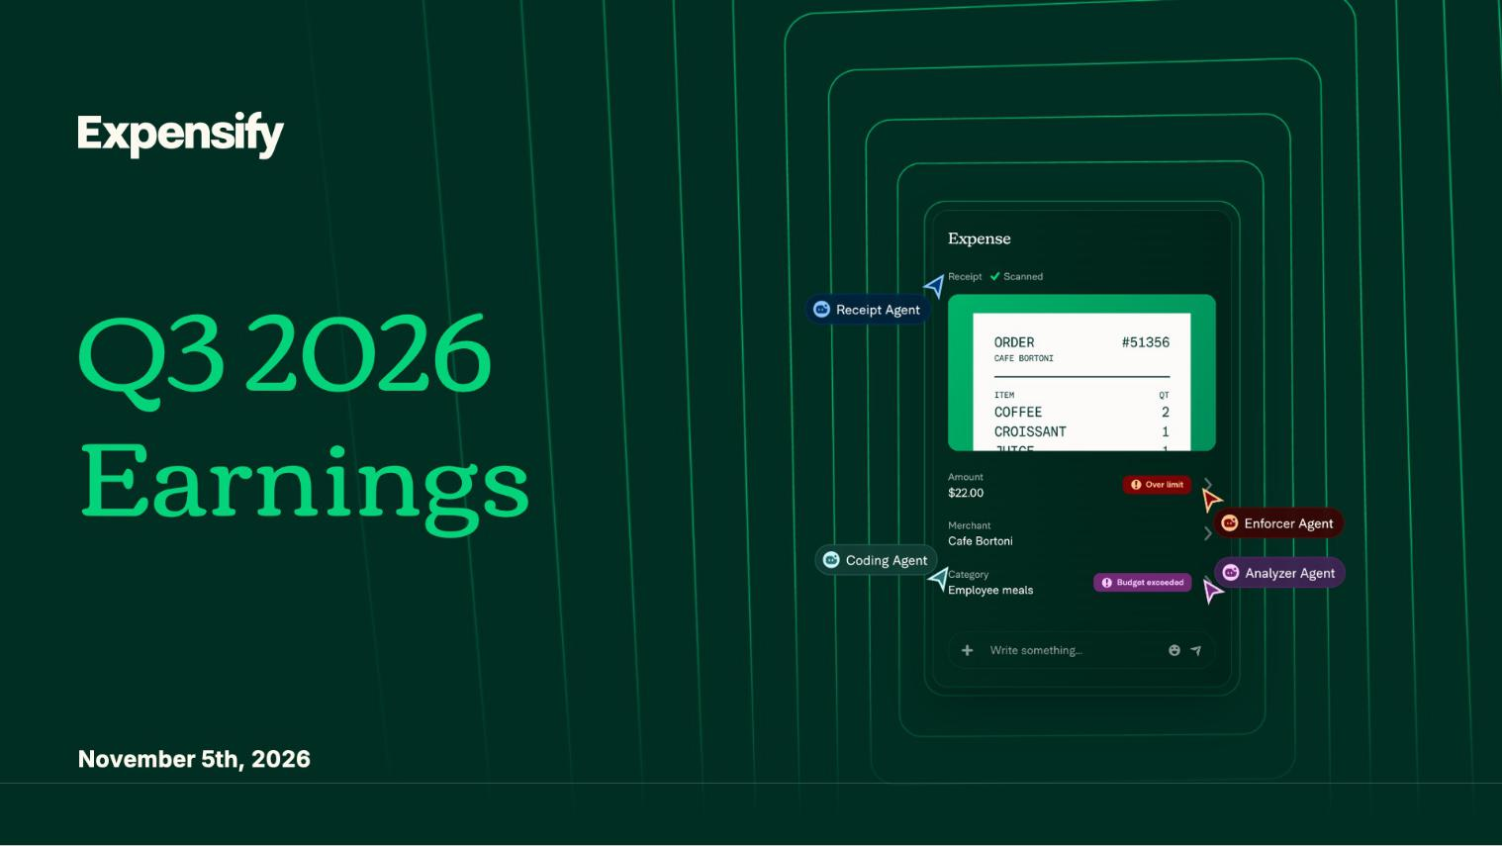

1

Exhibit 99.2

Expensify, Inc.

Investor Presentation


2

Exhibit 99.2

Expensify, Inc.

Investor Presentation


3

Exhibit 99.2

Expensify, Inc.

Investor Presentation
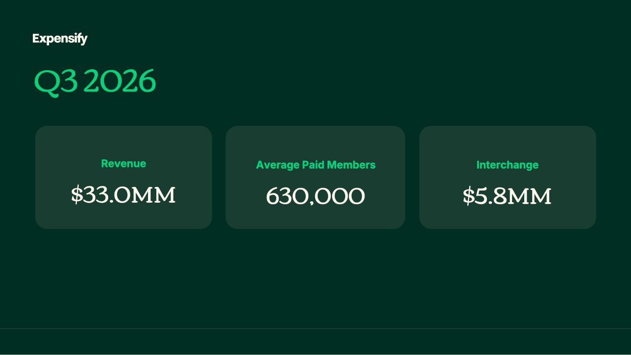

4

Exhibit 99.2

Expensify, Inc.

Investor Presentation
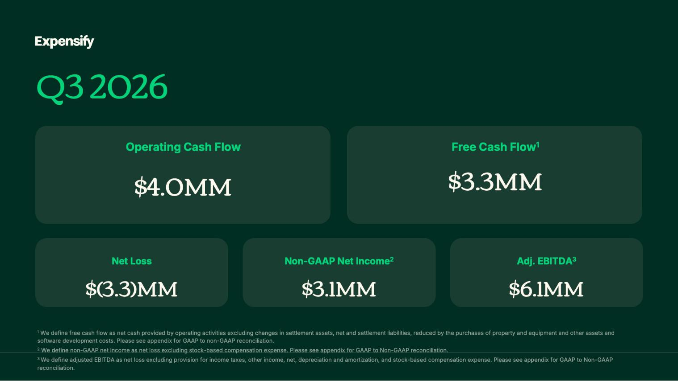

5

Exhibit 99.2

Expensify, Inc.

Investor Presentation
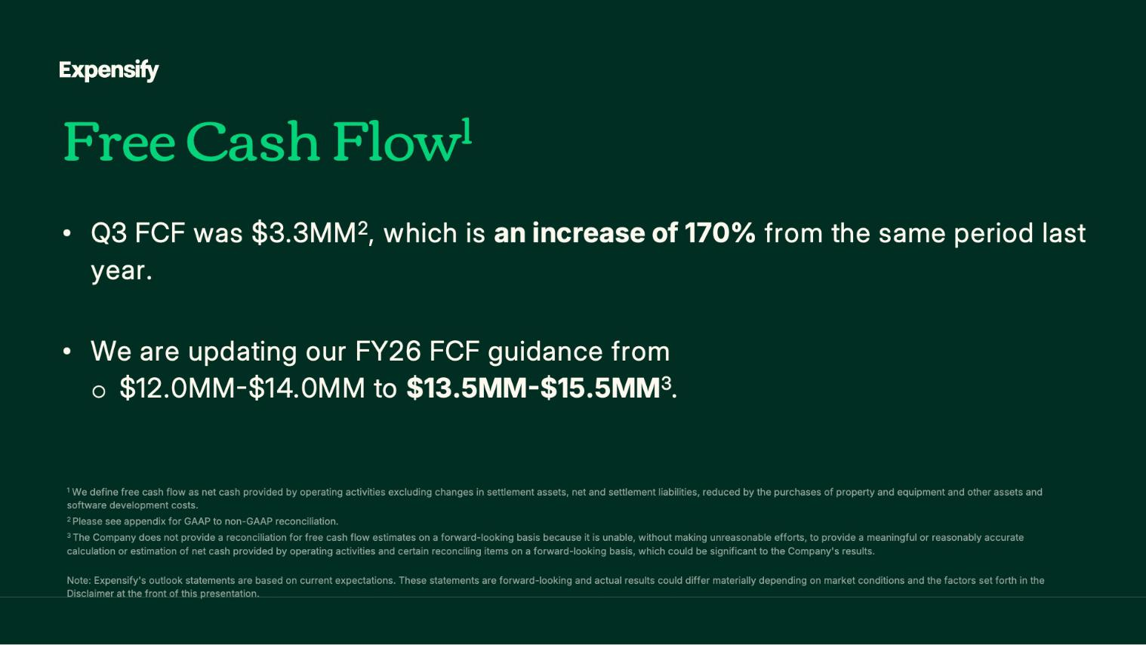

6

Exhibit 99.2

Expensify, Inc.

Investor Presentation
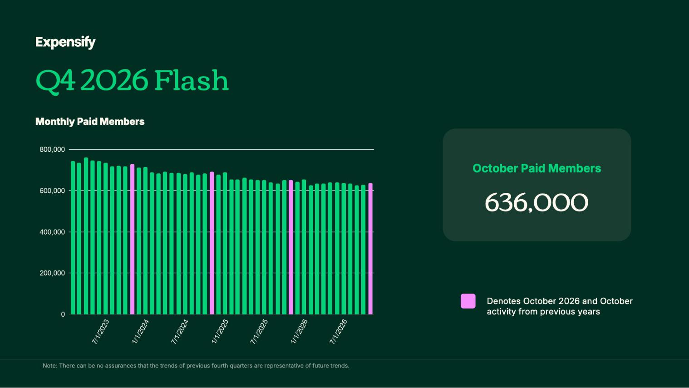

7

Exhibit 99.2

Expensify, Inc.

Investor Presentation


8

Exhibit 99.2

Expensify, Inc.

Investor Presentation
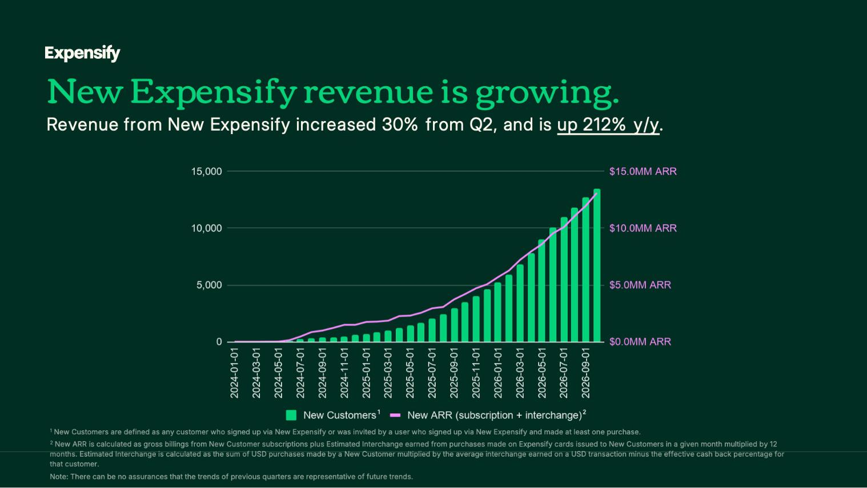

9

Exhibit 99.2

Expensify, Inc.

Investor Presentation
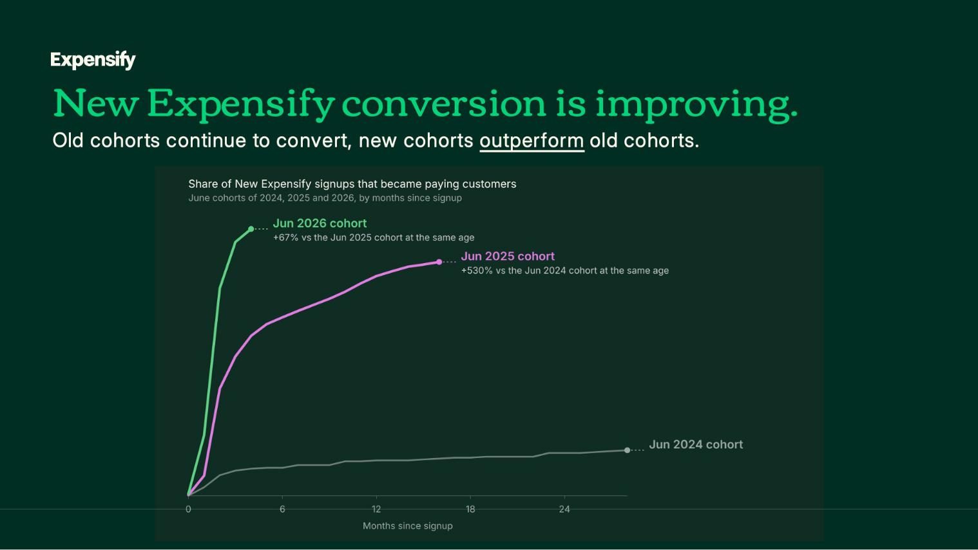

10

Exhibit 99.2

Expensify, Inc.

Investor Presentation
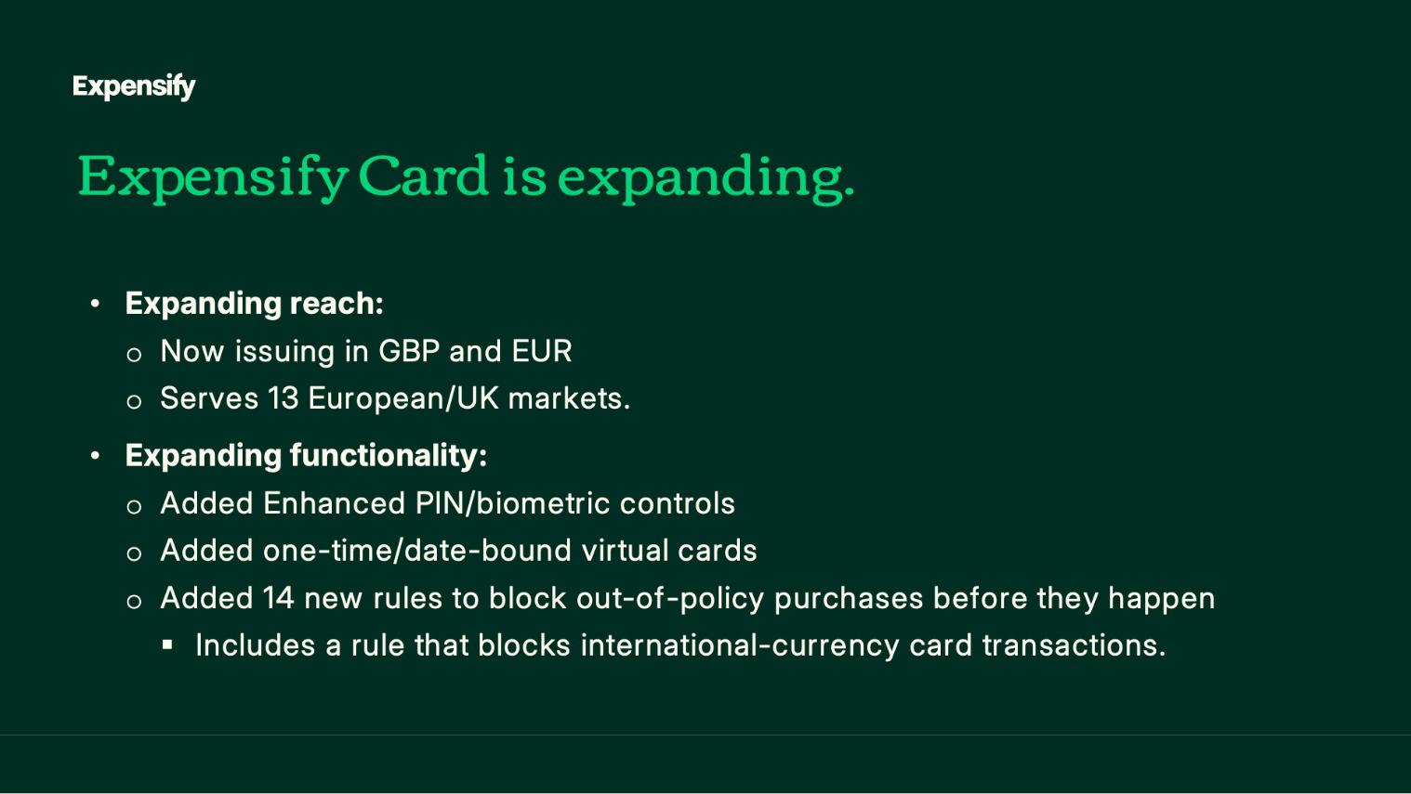

11

Exhibit 99.2

Expensify, Inc.

Investor Presentation
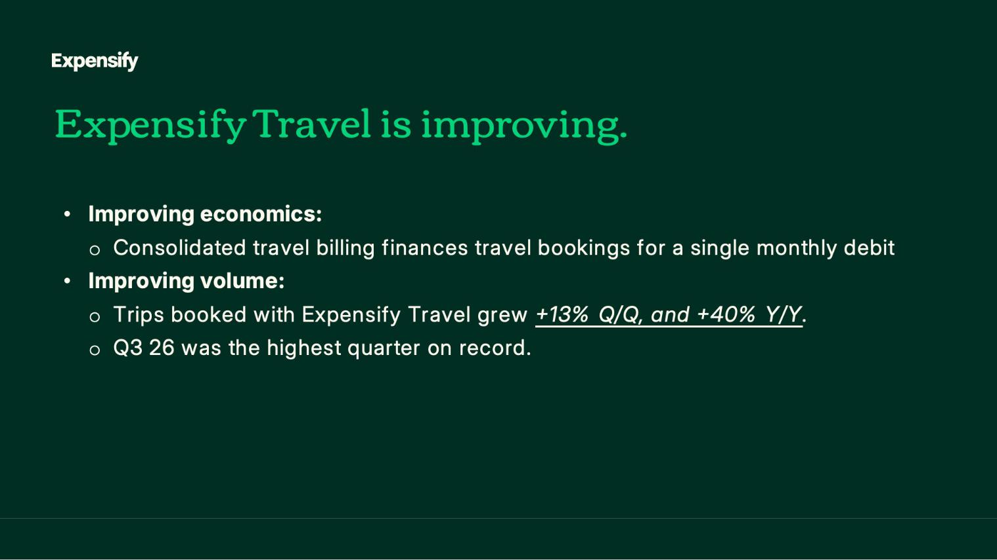

12

Exhibit 99.2

Expensify, Inc.

Investor Presentation
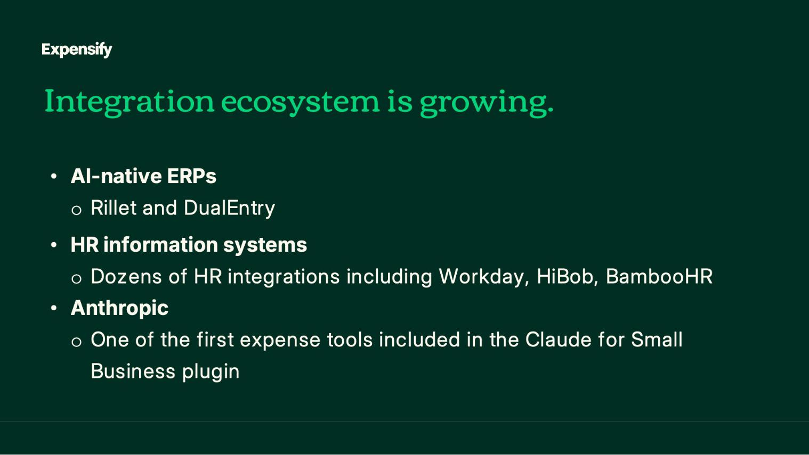

13

Exhibit 99.2

Expensify, Inc.

Investor Presentation


14

Exhibit 99.2

Expensify, Inc.

Investor Presentation
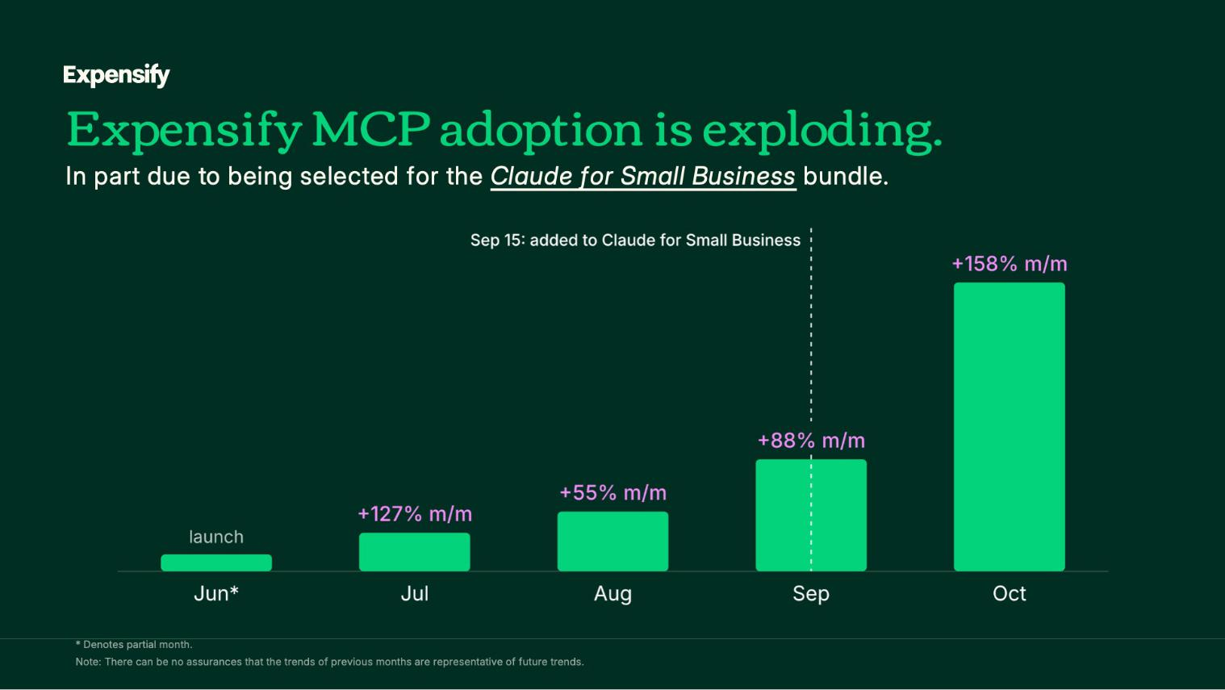

15

Exhibit 99.2

Expensify, Inc.

Investor Presentation
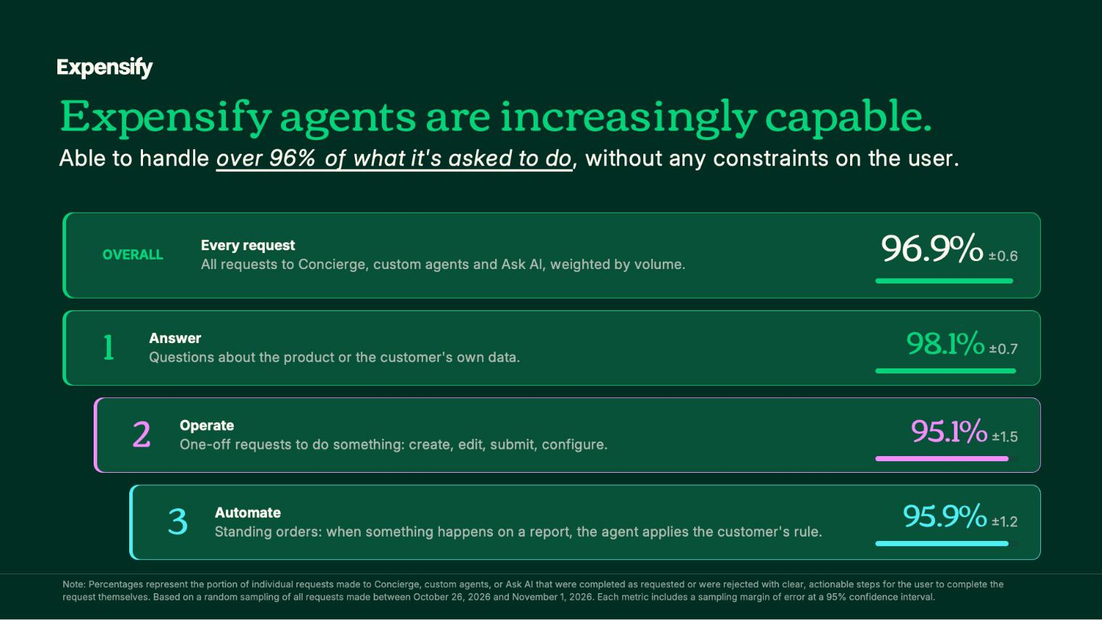

16

Exhibit 99.2

Expensify, Inc.

Investor Presentation
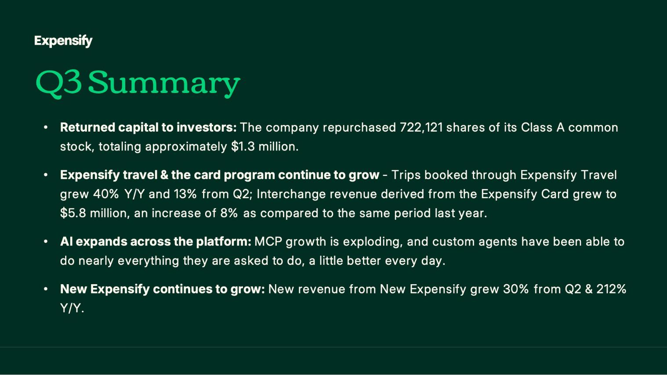

17

Exhibit 99.2

Expensify, Inc.

Investor Presentation


18

Exhibit 99.2

Expensify, Inc.

Investor Presentation


19

Exhibit 99.2

Expensify, Inc.

Investor Presentation


20

Exhibit 99.2

Expensify, Inc.

Investor Presentation
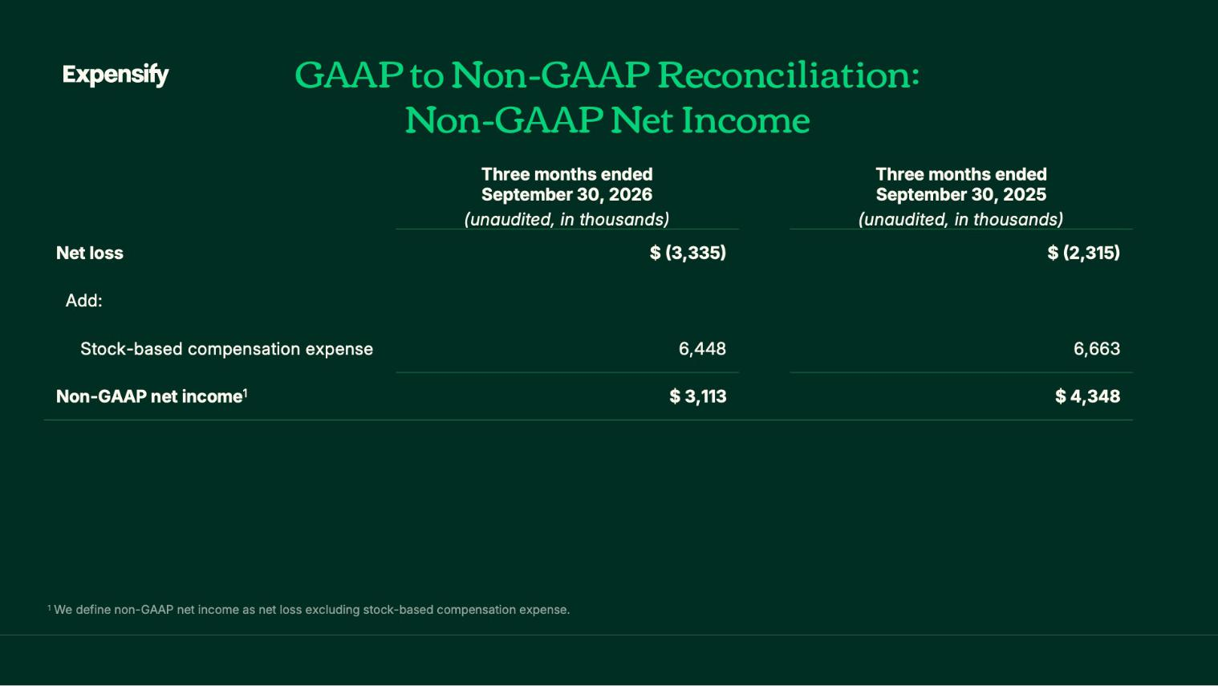

21

Exhibit 99.2

Expensify, Inc.

Investor Presentation
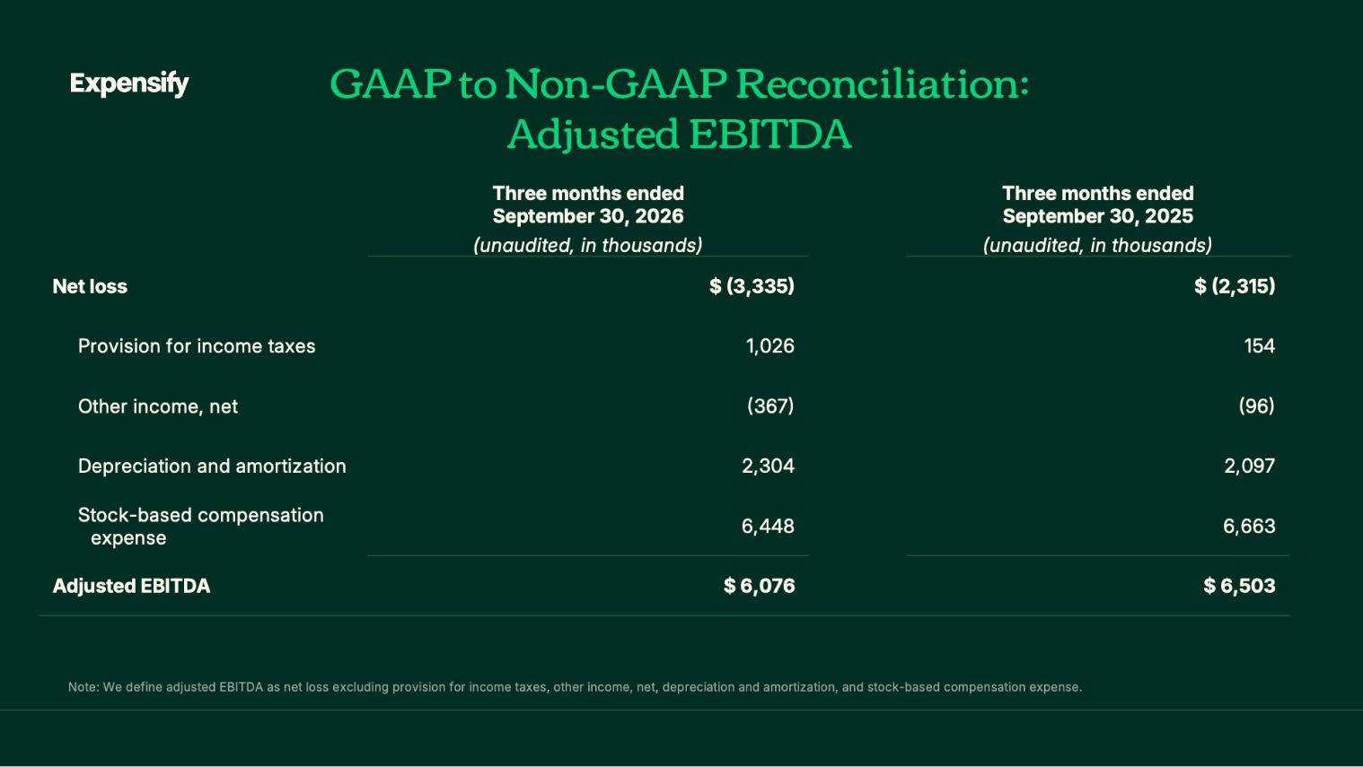

22

Exhibit 99.2

Expensify, Inc.

Investor Presentation
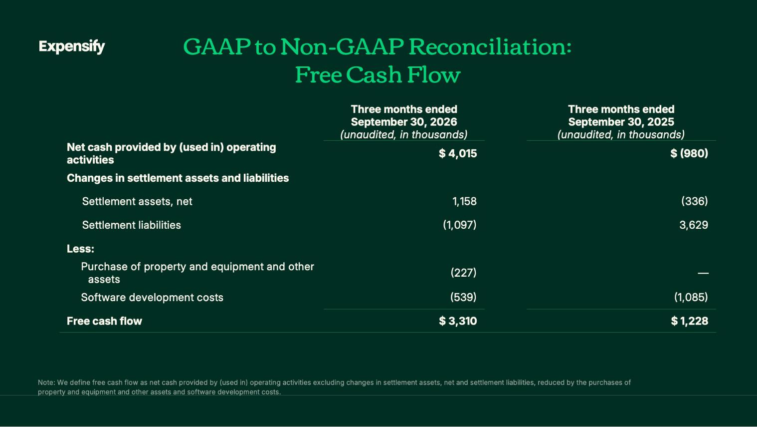

23

Exhibit 99.2

Expensify, Inc.

Investor Presentation
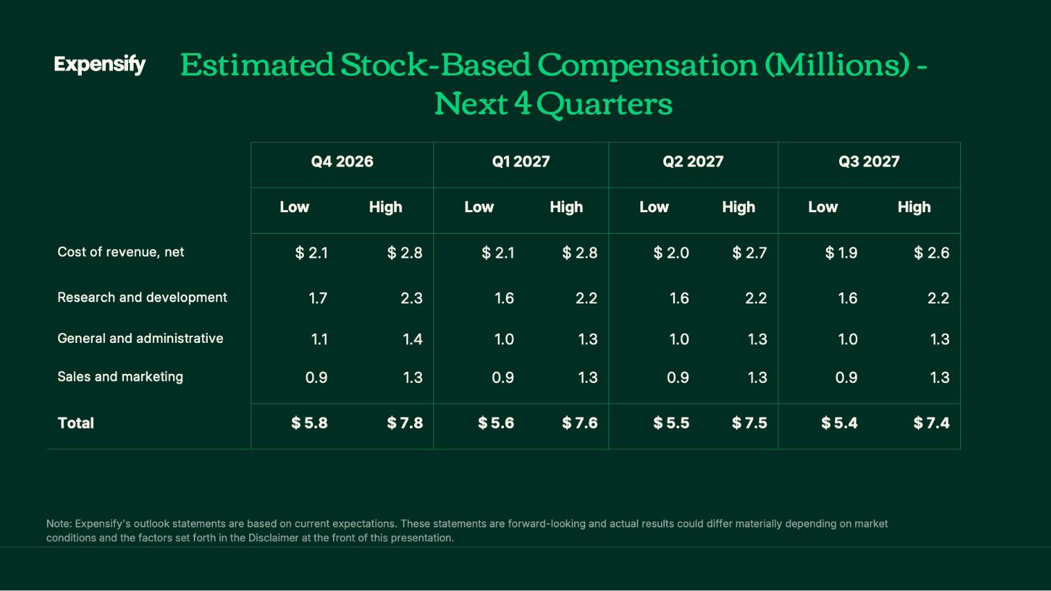

24

Exhibit 99.2

Expensify, Inc.

Investor Presentation

25

