UNITED STATES
SECURITIES AND EXCHANGE COMMISSION
Washington, D.C. 20549
FORM 8-K
CURRENT REPORT
PURSUANT TO SECTION 13 OR 15(d)
OF THE SECURITIES EXCHANGE ACT OF 1934
Date of report (Date of earliest event reported): May 9, 2023
Expensify, Inc.
(Exact Name of Registrant as Specified in its Charter)
Delaware |  |  |  |  |  | 001-41043 |  |  |  |  |  | 27-0239450
(State or Other Jurisdiction  of Incorporation) |  |  |  |  |  | (Commission  File Number) |  |  |  |  |  | (IRS Employer  Identification No.)
401 SW 5th Ave
Portland, Oregon 97204
(Address of Principal Executive Offices) (Zip Code)
(971) 365-3939
(Registrant’s telephone number, including area code)
Not applicable
(Former Name or Former Address, if Changed Since Last Report)
Check the appropriate box below if the Form 8-K filing is intended to simultaneously satisfy the filing obligation of the registrant under any of the following provisions:
☐ |  |  |  |  |  | Written communications pursuant to Rule 425 under the Securities Act (17 CFR 230.425).
☐ |  |  |  |  |  | Soliciting material pursuant to Rule 14a-12 under the Exchange Act (17 CFR 240.14a-12).
☐ |  |  |  |  |  | Pre-commencement communications pursuant to Rule 14d-2(b) under the Exchange Act (17 CFR 240.14d-2(b)).
☐ |  |  |  |  |  | Pre-commencement communications pursuant to Rule 13e-4(c) under the Exchange Act (17 CFR 240.13e-4(c)).
Securities registered pursuant to Section 12(b) of the Act:
Title of each class |  |  |  |  |  | Trading  Symbol(s) |  |  |  |  |  | Name of each exchange  on which registered
Class A Common Stock, par value $0.0001 per share |  |  |  |  |  | EXFY |  |  |  |  |  | The Nasdaq Stock Market LLC
Indicate by check mark whether the registrant is an emerging growth company as defined in Rule 405 of the Securities Act of 1933 (§230.405 of this chapter) or Rule 12b-2 of the Securities Exchange Act of 1934 (§240.12b-2 of this chapter).
Emerging growth company ☐
If an emerging growth company, indicate by check mark if the registrant has elected not to use the extended transition period for complying with any new or revised financial accounting standards provided pursuant to Section 13(a) of the Exchange Act. ☐

Item 2.02 Results of Operations and Financial Condition.
On May 9, 2023, Expensify, Inc. (“Expensify” or the “Company”) issued a press release announcing its financial results for the quarter ended March 31, 2023. A copy of this press release is furnished as Exhibit 99.1 to this current report on Form 8-K and is incorporated herein by reference.

Item 7.01 Regulation FD Disclosure.
On May 9, 2023, the Company posted an investor presentation to its website at https://ir.expensify.com (the “Investor Presentation”). A copy of the Investor Presentation is furnished as Exhibit 99.2 to this current report on Form 8-K and is incorporated herein by reference. The Company expects to use the Investor Presentation, in whole or in part, and possibly with modifications, in connection with presentations to investors, analysts and others.
The information contained in the Investor Presentation is summary information that is intended to be considered in the context of the Company’s Securities and Exchange Commission (“SEC”) filings and other public announcements that the Company may make, by press release or otherwise, from time to time. The Investor Presentation speaks only as of the date of this current report on Form 8-K. The Company undertakes no duty or obligation to publicly update or revise the information included in the Investor Presentation, although it may do so from time to time. Any such updating may be made through the filing of other reports or documents with the SEC, through press releases or other public disclosure. In addition, the exhibit furnished herewith contains statements intended as “forward-looking statements” that are subject to the cautionary statements about forward-looking statements set forth in such exhibit. By furnishing the information contained in the Investor Presentation, the Company makes no admission as to the materiality of any information in the Investor Presentation that is required to be disclosed solely by reason of Regulation FD.

The information contained in Item 2.02 and this Item 7.01, including Exhibits 99.1 and 99.2, is being furnished and shall not be deemed “filed” for purposes of Section 18 of the Securities and Exchange Act of 1934, as amended (the “Exchange Act”), or otherwise subject to the liabilities of that section, nor shall it be deemed incorporated by reference in any filing made by Expensify under the Securities Act of 1933, as amended, or the Exchange Act, except as expressly set forth by specific reference in such a filing.

Item 9.01 Financial Statements and Exhibits.
(d) Exhibits.
Exhibit No. |  |  |  |  |  | Description
99.1 |  |  |  |  |  | Press Release issued by Expensify, Inc., dated May 9, 2023.
99.2 |  |  |  |  |  | Investor Presentation, dated May 9, 2023.
104 |  |  |  |  |  | Cover Page Interactive Data File (embedded within the Inline XBRL document).

SIGNATURE
Pursuant to the requirements of the Securities Exchange Act of 1934, the registrant has duly caused this report to be signed on its behalf by the undersigned hereunto duly authorized.
Expensify, Inc.
By: |  |  |  |  |  | /s/ Ryan Schaffer
Name: |  |  |  |  |  | Ryan Schaffer
Title: |  |  |  |  |  | Chief Financial Officer
Date: May 9, 2023

Exhibit 99.1

EXPENSIFY ANNOUNCES Q1 2023 RESULTS
The company had operating cash flows of $7.6 million and demonstrated strong free cash flow in Q1 of $10.2 million. The Expensify Card grew 85% compared to the same period last year, and the company continues share buybacks.
PORTLAND, Ore.--(BUSINESS WIRE)--May 9, 2023-- Expensify, Inc. (Nasdaq: EXFY), a payments superapp that helps individuals and businesses around the world simplify the way they manage money across expenses, corporate cards and bills, today released a letter to shareholders from Founder and CEO David Barrett alongside results for its quarter ended March 31, 2023.
A Message From Our Founder
When I started Expensify at the bottom of the 2008 recession, it was amongst the crashing of giants, towering redwoods buckling under the weight of their rotten unit economics. Today feels similar, in three ways.
•The first is the headlines are the same, where dotcom darlings nervously present their ability to lose money at increasing scale as a kind of perverse success. A decade of free money via zero interest rates – followed by staggering stimulus checks – has filled war chests to the brim (at the ironic cost to the same banks that served as war profiteers in the leadup). But losing money on every customer while attempting to make it up with scale wasn't a viable strategy then, and we're skeptical it is now. A longer runway doesn't help if your plane fundamentally can't fly.
•The second, more important similarity, is that our strategy then and now is the same. We believe addressable market size and unit economics are the only defensible long-term differentiation. It's true we've added SDRs and outbound calling to our toolbox (and the results aren't super noticeable yet, but are trending in promising ways). And these can help us navigate these really difficult near-term market conditions (as well as hold our own against competition increasingly willing to lose on every customer and hope nobody notices). But these tactical adjustments don't alter the high level strategy: viral growth is the only path to a billion user ambition.
•Which brings me to the third, and most important of all similarity between 2008 and now. There has never – truly never – been more excitement within the walls of Expensify for what we've been quietly building throughout this nuclear winter, and are finally beginning to roll out this year. It feels like the early days of having a bold, disruptive vision, but with the resources and scale to execute faster and more decisively than we could have ever dreamed then.
Don't get me wrong, this quarter sucked. Yes customers were up, which is great. But the average activity per customer was down, which is not great. Additionally, yes card adoption is up, which is great. But our double-whammy of interchange not being revenue – and cashback being contra-revenue – means card growth contra-intuitively harms revenue… which is not great.
Thankfully, it kind of doesn't matter. We have over $100MM in the bank, have strong cash flow, are buying back shares, and plan to pay off debt. We're shipping code faster than ever, with more engineers than ever, on a more amazing product than ever. When the economy comes back, all those new customers (and the old) will get active, and all will be well. More than well. Amazing. Because we have just started migrating users over to our eponymously named "New Expensify" (new.expensify.com), which is shaping up so much better than even we imagined.
I know, it's hard to believe: a single app flexible enough to do everything from expense management to payroll, simple enough for your kid's summer block party but powerful enough for your multinational public CFO? Built by an open source community of a thousand developers, atop a hyper scalable blockchain database, using a single codebase that works across all platforms, including desktop and mobile, without needing to install anything, and without needing permission from your IT or accounting department? It's easy to be skeptical.
Exhibit 99.1

But we believe those skeptics are going to be kicking themselves. Google was the 25th search engine after all. That means 24 before it missed the Google-scale vision – right when everyone thought the market was over, they demonstrated that it had only barely begun. That's how we see expense management: only a rounding error of global businesses do their expenses on us or any of our competition, after all. If a billion people can chat about photos, we think a billion people can chat about money – especially since they already do, just pointlessly fragmented across a hundred niche platforms.
Expensify can never be the first expense management player. The industry was largely defined and unchanged since before we arrived. But that's fine. We don't need to be the first. We are trying to be the last. And I've never been more excited for our prospects. Stay tuned!
-david
Founder and CEO of Expensify
First Quarter 2023 Highlights

Financial:
•Revenue was $40.1 million, a decrease of 1% compared to the same period last year.
•Generated $7.6 million cash provided by operating activities and $10.2 million of free cash flow.
•Net loss was $5.9 million, compared to $7.4 million for the same period last year.
•Non-GAAP net income was $4.1 million.
•Adjusted EBITDA was $8.7 million.
•Interchange derived from the Expensify Card grew to $2.3 million, an increase of 85% compared to the same period last year.
•Uses of Q1 Free Cash Flow:
◦Continued Buybacks - $0.7 million spent via net share settlement in Q1. Plan for a further $3.0 million of near-term share repurchases in the open market starting May 10th, 2023.
◦Reducing Debt - Plan to deploy $8.0 million to reduce the company’s debt.
Business
•Paid members - Paid members grew to 747,000, an increase of 6% from the same period last year.
•Hosted ExpensiConX to strengthen workforce - Many of the world’s top react native engineers and teams came together to discuss React Native and the future of the Expensify roadmap.
◦Expensify also hosted its partner sales and support teams to further train and increase the efficiency of their roles.
•Continued to scale contributor program - With a 322% increase in the number of jobs completed by contributors in April 2023 compared to April 2022
•Increased Sales Development Representative ("SDR") count to 100+ SDRs - With multiple vendors in a built to scale fashion.
•Improved free trials - Increasing monthly free trials by 79% y/y when looking at March 2023 compared to March 2022. This was done through product led growth and increasing SDR efficiency.
•Scaling outsourced setup specialists - On average, annual seats closed by outsourced sales teams has doubled every month starting January 2023 compared to the previous month.
Exhibit 99.1

•Strengthened partner channels - Over 100+ invitees confirmed to ExpensiCon 3 from some of the world's best accounting firms.
Financial Outlook
Expensify's outlook statements are based on current estimates, expectations and assumptions and are not a guarantee of future performance. The following statements are forward-looking and actual results could differ materially depending on market conditions and the factors set forth under “Forward-Looking Statements” below. There can be no assurance that the Company will achieve the results expressed by this guidance.

We reaffirm our long term guidance provided in connection with our fourth quarter 2022 results of 25-35% revenue growth over a multi-year period, which assumes an eventual return to normalcy of the world economy.

Expensify is also providing an estimate on what stock based compensation is expected to look like for the next four fiscal quarters. Driven primarily by the pre-IPO grant of RSUs issued to all employees (which quarterly vest over 8 years with approximately 7 years remaining), stock based compensation is estimated as seen below:

Est. stock-based compensation (millions)
 |  |  | Q2 2023 |  |  |  |  |  |  |  |  |  |  |  | Q3 2023 |  |  |  |  |  |  |  |  |  |  |  | Q4 2023 |  |  |  |  |  |  |  |  |  |  |  | Q1 2024
 |  |  | Low |  |  |  |  |  | High |  |  |  |  |  | Low |  |  |  |  |  | High |  |  |  |  |  | Low |  |  |  |  |  | High |  |  |  |  |  | Low |  |  |  |  |  | High
Cost of revenue, net |  |  | $ | 2.9 |  |  |  |  | $ | 3.6 |  |  |  |  | 2.9 |  |  |  |  |  | $ | 3.5 |  |  |  |  | $ | 2.8 |  |  |  |  | $ | 3.4 |  |  |  |  | $ | 2.7 |  |  |  |  | $ | 3.3
Research and development |  |  | 2.5 |  |  |  |  |  | 3.1 |  |  |  |  |  | 2.5 |  |  |  |  |  | 3.0 |  |  |  |  |  | 2.4 |  |  |  |  |  | 3.0 |  |  |  |  |  | 2.3 |  |  |  |  |  | 2.9
General and administrative |  |  | 2.2 |  |  |  |  |  | 2.6 |  |  |  |  |  | 2.1 |  |  |  |  |  | 2.6 |  |  |  |  |  | 2.1 |  |  |  |  |  | 2.6 |  |  |  |  |  | 2.0 |  |  |  |  |  | 2.5
Sales and marketing |  |  | 1.7 |  |  |  |  |  | 2.0 |  |  |  |  |  | 1.6 |  |  |  |  |  | 2.0 |  |  |  |  |  | 1.6 |  |  |  |  |  | 1.9 |  |  |  |  |  | 1.6 |  |  |  |  |  | 1.9
Total |  |  | $ | 9.3 |  |  |  |  | $ | 11.3 |  |  |  |  | $ | 9.1 |  |  |  |  | $ | 11.1 |  |  |  |  | $ | 8.9 |  |  |  |  | $ | 10.9 |  |  |  |  | $ | 8.6 |  |  |  |  | $ | 10.6

Availability of Information on Expensify’s Website
Investors and others should note that Expensify routinely announces material information to investors and the marketplace using SEC filings, press releases, public conference calls, webcasts and the Expensify Investor Relations website at https://ir.expensify.com. While not all of the information that the Company posts to its Investor Relations website is of a material nature, some information could be deemed to be material. Accordingly, the Company encourages investors, the media and others interested in Expensify to review the information that it shares on its Investor Relations website.

Conference Call
Expensify will host a video call to discuss the financial results and business highlights at 2:00 p.m. Pacific Time today. An investor presentation and the video call information is available on Expensify’s Investor Relations website at https://ir.expensify.com. A replay of the call will be available on the site for three months.

Non-GAAP Financial Measures
In addition to financial measures prepared in accordance with U.S. generally accepted accounting principles (“GAAP”), we provide certain non-GAAP financial measures, including adjusted EBITDA, adjusted EBITDA margin, non-GAAP net income, and free cash flow.

We believe our non-GAAP financial measures are useful in evaluating our business, measuring our performance, identifying trends affecting our business, formulating business plans and making strategic decisions. Accordingly, we believe that these non-GAAP financial measures provide useful information to investors and others in understanding and evaluating our results of operations in the same manner as our management team. These non-GAAP financial measures are presented for supplemental informational purposes only, should not be considered a
Exhibit 99.1

substitute for financial information presented in accordance with GAAP, and may be different from similarly titled metrics or measures presented by other companies. Non-GAAP financial measures have limitations as analytical tools and should not be considered in isolation or as substitutes for financial information presented under GAAP. There are a number of limitations related to the use of non-GAAP financial measures versus comparable financial measures determined under GAAP. For example, other companies in our industry may calculate these non-GAAP financial measures differently or may use other measures to evaluate their performance. All of these limitations could reduce the usefulness of these non-GAAP financial measures as analytical tools. Investors are encouraged to review the related GAAP financial measures and the reconciliations of these non-GAAP financial measures to their most directly comparable GAAP financial measures and to not rely on any single financial measure to evaluate our business. A reconciliation of each non-GAAP financial measure to the most directly comparable financial measure stated in accordance with GAAP is at the end of this press release.

Adjusted EBITDA. We define adjusted EBITDA as net income from operations excluding provision for income taxes, interest and other expenses, net, depreciation and amortization and stock based compensation.

Non-GAAP net income. We define non-GAAP net income as net income from operations in accordance with US GAAP excluding stock-based compensation. Through the fourth quarter of 2021, non-GAAP net income also excluded bonus costs related to our IPO, which we consider to be the discretionary cash bonuses paid to our employees during 2021. These IPO-related bonus costs impacted the second, third and fourth fiscal quarters of 2021 but did not impact any subsequent quarters.

Free cash flow. We define Free cash flow as net cash (used in) provided by operating activities excluding changes in settlement assets and settlement liabilities, which represent funds held for customers and customer funds in transit, respectively, reduced by the purchases of property and equipment and software development costs.

The tables at the end of the Condensed Consolidated Financial Statements provide reconciliations to the most directly comparable GAAP financial measure to each of these non-GAAP financial measures.

Forward-Looking Statements
Forward-looking statements in this press release, or made during the earnings call, which are not historical facts, are forward-looking statements within the meaning of the Private Securities Litigation Reform Act of 1955. These statements include statements regarding our strategy, future financial condition, future operations, projected costs, prospects, plans, objectives of management and expected market growth, product developments and their potential impact, our ability to meet our long-term guidance, the amount and timing of any share repurchases, our stock-based compensation estimates and the timing of when we expect the economy to return to normalcy and involve known and unknown risks that are difficult to predict. As a result, our actual results, performance or achievements may differ materially from those expressed or implied by these forward-looking statements. In some cases, you can identify forward-looking statements because they contain words such as “may,” “will,” “shall,” “should,” “expects,” “plans,” “anticipates,” “could,” “intends,” “target,” “projects,” “contemplates,” “believes,” “estimates,” “predicts,” “potential,” “goal,” "ambition," “objective,” “seeks,” "outlook," or “continue” or the negative of these words or other similar terms or expressions that concern our expectations, strategy, plans, or intentions. Such forward-looking statements are necessarily based upon estimates and assumptions that, while considered reasonable by us and our management, are inherently uncertain. Factors that may cause actual results to differ materially from current expectations include, but are not limited to: the impact on inflation on us and our members; our borrowing costs have and may continue to increase as a result of increases in interest rates; our expectations regarding our financial performance and future operating performance; our ability to attract and retain members, expand usage of our platform, sell subscriptions to our platform and convert individuals and organizations into paying customers; the timing and success of new features, integrations, capabilities and enhancements by us, or by competitors to their products, or any other changes in the competitive landscape of our market; the amount and timing of operating expenses and capital expenditures that we may incur to maintain and expand our business and operations to remain competitive; the sufficiency of our cash, cash equivalents and investments to meet our liquidity needs; our ability to make required payments under and to comply with the various requirements of our current and future indebtedness; our cash flows, the prevailing stock prices, general economic and market conditions and other considerations that could affect the specific timing, price and size of repurchases under our stock repurchase program or our ability to
Exhibit 99.1

fund any stock repurchases; the war in Ukraine and escalating geopolitical tensions as a result of Russia's invasion of Ukraine; our ability to effectively manage our exposure to fluctuations in foreign currency exchange rates; the increased expenses associated with being a public company; the size of our addressable markets, market share and market trends; anticipated trends, developments and challenges in our industry, business and the highly competitive markets in which we operate; our expectations regarding our income tax liabilities and the adequacy of our reserves; our ability to effectively manage our growth and expand our infrastructure and maintain our corporate culture; our ability to identify, recruit and retain skilled personnel, including key members of senior management; the safety, affordability and convenience of our platform and our offerings; our ability to successfully defend litigation brought against us; our ability to successfully identify, manage and integrate any existing and potential acquisitions of businesses, talent, technologies or intellectual property; general economic conditions in either domestic or international markets; our protections against security breaches, technical difficulties, or interruptions to our platform; our ability to maintain, protect and enhance our intellectual property; and other risks discussed in our filings with the SEC. All forward-looking statements attributable to us or persons acting on our behalf are expressly qualified in their entirety by the cautionary statements set forth above. We caution you not to place undue reliance on any forward-looking statements, which are made only as of the date of this press release. We do not undertake or assume any obligation to update publicly any of these forward-looking statements to reflect actual results, new information or future events, changes in assumptions or changes in other factors affecting forward-looking statements, except to the extent required by applicable law. If we update one or more forward-looking statements, no inference should be drawn that we will make additional updates with respect to those or other forward-looking statements.

About Expensify
Expensify is a payments superapp that helps individuals and businesses around the world simplify the way they manage money. More than 12 million people use Expensify's free features, which include corporate cards, expense tracking, next-day reimbursement, invoicing, bill pay, and travel booking in one app. All free. Whether you own a small business, manage a team, or close the books for your clients, Expensify makes it easy so you have more time to focus on what really matters.

Investor Relations Contact
Nick Tooker
investors@expensify.com
Press Contact
James Dean
press@expensify.com

Expensify, Inc.
Condensed Consolidated Balance Sheets
(unaudited, in thousands, except share and per share data)
 |  |  | As of March 31, |  |  |  |  |  | As of December 31,
 |  |  | 2023 |  |  |  |  |  | 2022
Assets
Cash and cash equivalents |  |  | $ | 111,232 |  |  |  |  | $ | 103,787
Accounts receivable, net |  |  | 15,705 |  |  |  |  |  | 16,448
Settlement assets, net |  |  | 38,490 |  |  |  |  |  | 35,838
Prepaid expenses |  |  | 7,411 |  |  |  |  |  | 8,825
Other current assets |  |  | 21,282 |  |  |  |  |  | 22,217
Total current assets |  |  | 194,120 |  |  |  |  |  | 187,115
Capitalized software, net |  |  | 7,581 |  |  |  |  |  | 6,881
Property and equipment, net |  |  | 14,021 |  |  |  |  |  | 14,492
Lease right-of-use assets |  |  | 512 |  |  |  |  |  | 745
Deferred tax assets, net |  |  | 374 |  |  |  |  |  | 344
Other assets |  |  | 658 |  |  |  |  |  | 664
Total assets |  |  | $ | 217,266 |  |  |  |  | $ | 210,241
Liabilities and stockholders' equity
Accounts payable |  |  | $ | 2,003 |  |  |  |  | $ | 1,059
Accrued expenses and other liabilities |  |  | 10,770 |  |  |  |  |  | 9,070
Borrowings under line of credit |  |  | 15,000 |  |  |  |  |  | 15,000
Current portion of long-term debt, net of original issue discount and debt issuance costs |  |  | 550 |  |  |  |  |  | 551
Lease liabilities, current |  |  | 443 |  |  |  |  |  | 800
Settlement liabilities |  |  | 33,144 |  |  |  |  |  | 33,882
Total current liabilities |  |  | 61,910 |  |  |  |  |  | 60,362
Lease liabilities, non-current |  |  | 95 |  |  |  |  |  | —
Other liabilities |  |  | 1,268 |  |  |  |  |  | 1,204
Long-term debt, net of original issue discount and debt issuance costs |  |  | 51,297 |  |  |  |  |  | 51,434
Total liabilities |  |  | 114,570 |  |  |  |  |  | 113,000
Commitments and contingencies
Stockholders' equity:
Preferred stock, par value $0.0001; 10,000,000 shares of preferred stock authorized as of March 31, 2023 and December 31, 2022; no shares of preferred stock issued and outstanding as of March 31, 2023 and December 31, 2022 |  |  | — |  |  |  |  |  | —
Common stock, par value $0.0001; 1,000,000,000 shares of Class A common stock authorized as of March 31, 2023 and December 31, 2022; 68,496,251 and 68,238,245 shares of Class A common stock issued and outstanding as of March 31, 2023 and December 31, 2022, respectively; 24,996,826 and 24,997,561 shares of LT10 common stock authorized as of March 31, 2023 and December 31, 2022, respectively; 7,335,456 and 7,336,191 shares of LT10 common stock issued and outstanding as of March 31, 2023 and December 31, 2022, respectively; 24,999,020 shares of LT50 common stock authorized as of March 31, 2023 and December 31, 2022; 6,974,821 and 6,854,931 shares of LT50 common stock issued and outstanding as of March 31, 2023 and December 31, 2022, respectively |  |  | 7 |  |  |  |  |  | 7
Additional paid-in capital |  |  | 206,207 |  |  |  |  |  | 194,807
Accumulated deficit |  |  | (103,518) |  |  |  |  |  | (97,573)
Total stockholders' equity |  |  | 102,696 |  |  |  |  |  | 97,241
Total liabilities and stockholders' equity |  |  | $ | 217,266 |  |  |  |  | $ | 210,241

Expensify, Inc.
Condensed Consolidated Statements of Operations
(unaudited, in thousands, except share and per share data)
 |  |  | Three months ended March 31,
 |  |  | 2023 |  |  |  |  |  | 2022
Revenue |  |  | $ | 40,101 |  |  |  |  | $ | 40,370
Cost of revenue, net (1) |  |  | 15,775 |  |  |  |  |  | 14,133
Gross margin |  |  | 24,326 |  |  |  |  |  | 26,237
Operating expenses:
Research and development (1) |  |  | 5,418 |  |  |  |  |  | 3,701
General and administrative (1) |  |  | 12,429 |  |  |  |  |  | 14,006
Sales and marketing (1) |  |  | 9,183 |  |  |  |  |  | 13,372
Total operating expenses |  |  | 27,030 |  |  |  |  |  | 31,079
Loss from operations |  |  | (2,704) |  |  |  |  |  | (4,842)
Interest and other expenses, net |  |  | (1,416) |  |  |  |  |  | (902)
Loss before income taxes |  |  | (4,120) |  |  |  |  |  | (5,744)
Provision for income taxes |  |  | (1,825) |  |  |  |  |  | (1,632)
Net loss |  |  | $ | (5,945) |  |  |  |  | $ | (7,376)
Net loss per share:
Basic and diluted |  |  | $ | (0.07) |  |  |  |  | $ | (0.09)
Weighted average shares of common stock used to compute net loss per share:
Basic and diluted |  |  | 81,768,429 |  |  |  |  |  | 80,147,208
(1)Includes stock-based compensation expense as follows:

 |  |  | Three months ended March 31,
 |  |  | 2023 |  |  |  |  |  | 2022
Cost of revenue, net |  |  | $ | 3,306 |  |  |  |  | $ | 4,908
Research and development |  |  | 2,206 |  |  |  |  |  | 2,708
General and administrative |  |  | 2,644 |  |  |  |  |  | 4,975
Sales and marketing |  |  | 1,848 |  |  |  |  |  | 2,076
Total stock-based compensation expense |  |  | $ | 10,004 |  |  |  |  | $ | 14,667

Expensify, Inc.
Condensed Consolidated Statements of Cash Flows
(unaudited, in thousands)
 |  |  | Three Months Ended March 31,
 |  |  | 2023 |  |  |  |  |  | 2022
Cash flows from operating activities:
Net loss |  |  | $ | (5,945) |  |  |  |  | $ | (7,376)
Adjustments to reconcile net loss to net cash provided by operating activities:
Depreciation and amortization |  |  | 1,413 |  |  |  |  |  | 1,167
Reduction of operating lease right-of-use assets |  |  | 181 |  |  |  |  |  | 185
Loss on impairment, receivables and sale or disposal of equipment |  |  | 146 |  |  |  |  |  | 231
Stock-based compensation expense |  |  | 10,004 |  |  |  |  |  | 14,667
Amortization of original issue discount and debt issuance costs |  |  | 11 |  |  |  |  |  | 10
Deferred tax assets |  |  | (30) |  |  |  |  |  | —
Changes in assets and liabilities:
Accounts receivable, net |  |  | 707 |  |  |  |  |  | (482)
Settlement assets, net |  |  | (2,683) |  |  |  |  |  | (5,689)
Prepaid expenses |  |  | 1,414 |  |  |  |  |  | 377
Related party loan receivable |  |  | 406 |  |  |  |  |  | (224)
Other current assets |  |  | — |  |  |  |  |  | 14
Other assets |  |  | 8 |  |  |  |  |  | 80
Accounts payable |  |  | 944 |  |  |  |  |  | (2,316)
Accrued expenses and other liabilities |  |  | 1,947 |  |  |  |  |  | (2,635)
Operating lease liabilities |  |  | (206) |  |  |  |  |  | (6)
Settlement liabilities |  |  | (738) |  |  |  |  |  | 12,433
Other liabilities |  |  | 63 |  |  |  |  |  | 787
Net cash provided by operating activities |  |  | 7,642 |  |  |  |  |  | 11,223
Cash flows from investing activities:
Purchases of property and equipment |  |  | (28) |  |  |  |  |  | (179)
Software development costs |  |  | (870) |  |  |  |  |  | (494)
Net cash used in investing activities |  |  | (898) |  |  |  |  |  | (673)
Cash flows from financing activities:
Principal payments of finance leases |  |  | (201) |  |  |  |  |  | (197)
Principal payments of term loan |  |  | (150) |  |  |  |  |  | (146)
Vesting of early exercised stock options |  |  | — |  |  |  |  |  | 295
Issuance of restricted stock units |  |  | — |  |  |  |  |  | 18
Repurchases of early exercised stock options |  |  | (7) |  |  |  |  |  | (4)
Proceeds from common stock purchased under Matching Plan |  |  | 1,099 |  |  |  |  |  | —
Proceeds from issuance of common stock on exercise of stock options |  |  | 66 |  |  |  |  |  | 252
Payments for employee taxes withheld from stock-based awards |  |  | (666) |  |  |  |  |  | —
Net cash provided by financing activities |  |  | 141 |  |  |  |  |  | 218
Net increase in cash and cash equivalents and restricted cash |  |  | 6,885 |  |  |  |  |  | 10,768
Cash and cash equivalents and restricted cash, beginning of period |  |  | 147,710 |  |  |  |  |  | 125,315
Cash and cash equivalents and restricted cash, end of period |  |  | $ | 154,595 |  |  |  |  | $ | 136,083
Supplemental disclosure of cash flow information:
Cash paid for interest |  |  | $ | 1,409 |  |  |  |  | $ | 267
Cash paid for income taxes |  |  | $ | 351 |  |  |  |  | $ | 284
Noncash investing and financing items:
Stock-based compensation capitalized as software development costs |  |  | $ | 657 |  |  |  |  | $ | 287
Right-of-use assets acquired through operating leases |  |  | $ | 145 |  |  |  |  | $ | —
Reconciliation of cash and cash equivalents and restricted cash to the Condensed Consolidated Balance Sheets
Cash and cash equivalents |  |  | $ | 111,232 |  |  |  |  | $ | 101,101
Restricted cash included in other current assets |  |  | 19,013 |  |  |  |  |  | 9,973
Restricted cash included in other assets |  |  | — |  |  |  |  |  | 46
Restricted cash included in settlement assets, net |  |  | 24,350 |  |  |  |  |  | 24,963
Total cash, cash equivalents and restricted cash |  |  | $ | 154,595 |  |  |  |  | $ | 136,083

Expensify, Inc.
Reconciliation of GAAP to Non-GAAP Financial Measures
(unaudited, in thousands, except percentages)
Adjusted EBITDA and Adjusted EBITDA Margin
 |  |  | Three Months Ended March 31,
 |  |  | 2023 |  |  |  |  |  | 2022
Net loss |  |  | $ | (5,945) |  |  |  |  | $ | (7,376)
Add:
Provision for income taxes |  |  | 1,825 |  |  |  |  |  | 1,632
Interest and other expenses, net |  |  | 1,416 |  |  |  |  |  | 902
Depreciation and amortization |  |  | 1,413 |  |  |  |  |  | 1,167
Stock-based compensation |  |  | 10,004 |  |  |  |  |  | 14,667
Adjusted EBITDA |  |  | $ | 8,713 |  |  |  |  | $ | 10,992

Non-GAAP Net Income and Non-GAAP Net Income Margin
 |  |  | Three Months Ended March 31,
 |  |  | 2023 |  |  |  |  |  | 2022
Net loss |  |  | $ | (5,945) |  |  |  |  | $ | (7,376)
Add:
Stock-based compensation |  |  | 10,004 |  |  |  |  |  | 14,667
Non-GAAP net income |  |  | $ | 4,059 |  |  |  |  | $ | 7,291

Adjusted Operating Cash Flow and Free Cash Flow
 |  |  | Three Months Ended March 31,
 |  |  | 2023 |  |  |  |  |  | 2022
Net cash provided by operating activities |  |  | $ | 7,642 |  |  |  |  | $ | 11,223
(Increase) decrease in changes in assets and liabilities:
Settlement assets |  |  | (2,683) |  |  |  |  |  | (5,689)
Settlement liabilities |  |  | (738) |  |  |  |  |  | 12,433
Adjusted operating cash flow |  |  | $ | 11,063 |  |  |  |  | $ | 4,479
Less:
Purchases of property and equipment |  |  | (28) |  |  |  |  |  | (179)
Software development costs |  |  | (870) |  |  |  |  |  | (494)
Free cash flow |  |  | $ | 10,165 |  |  |  |  | $ | 3,806

Exhibit 99.2

Expensify, Inc.
Investor Presentation

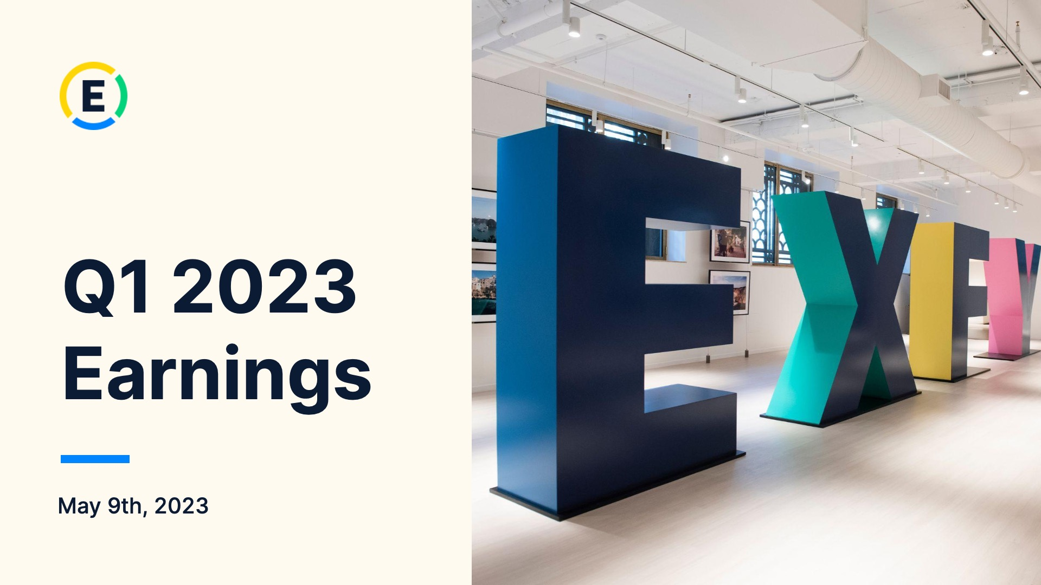

Exhibit 99.2
1
Expensify, Inc.
Investor Presentation

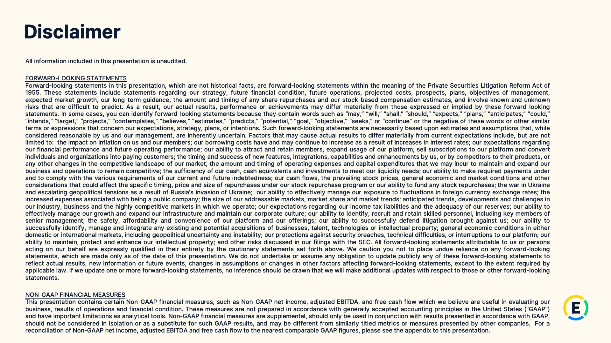

Exhibit 99.2
2
Expensify, Inc.
Investor Presentation



Exhibit 99.2
3
Expensify, Inc.
Investor Presentation

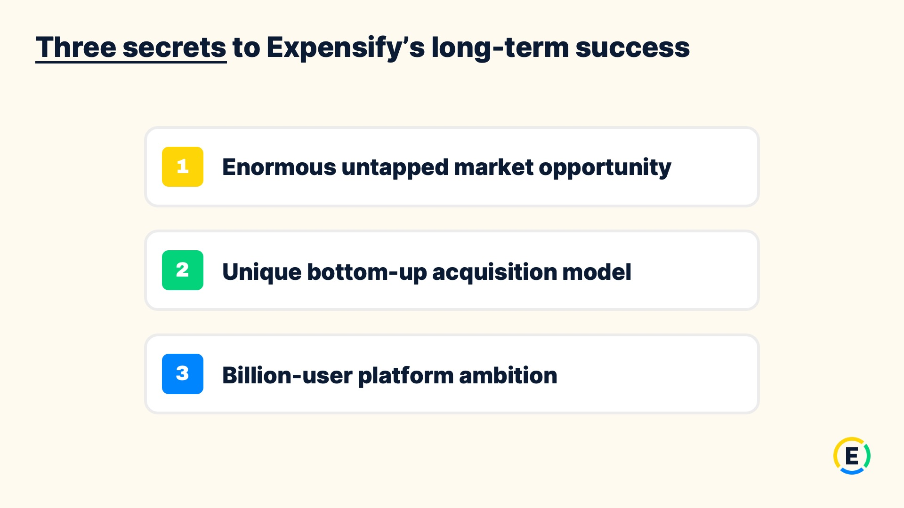

Exhibit 99.2
4
Expensify, Inc.
Investor Presentation

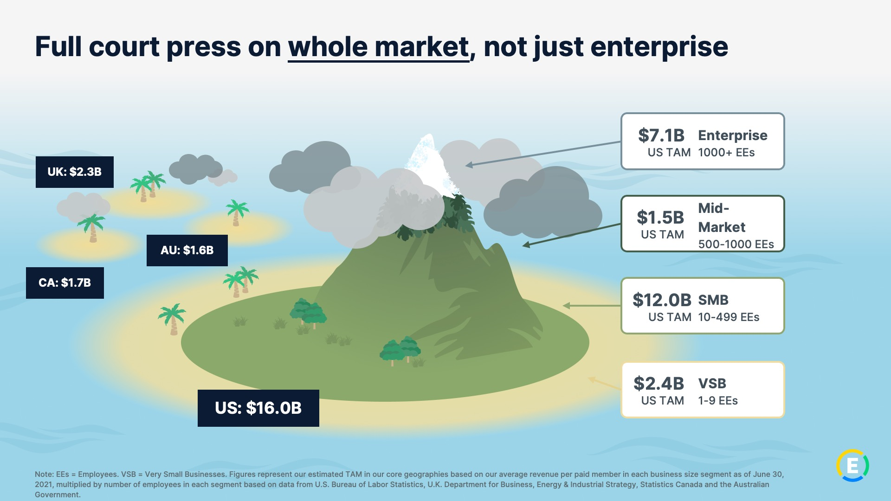

Exhibit 99.2
5
Expensify, Inc.
Investor Presentation

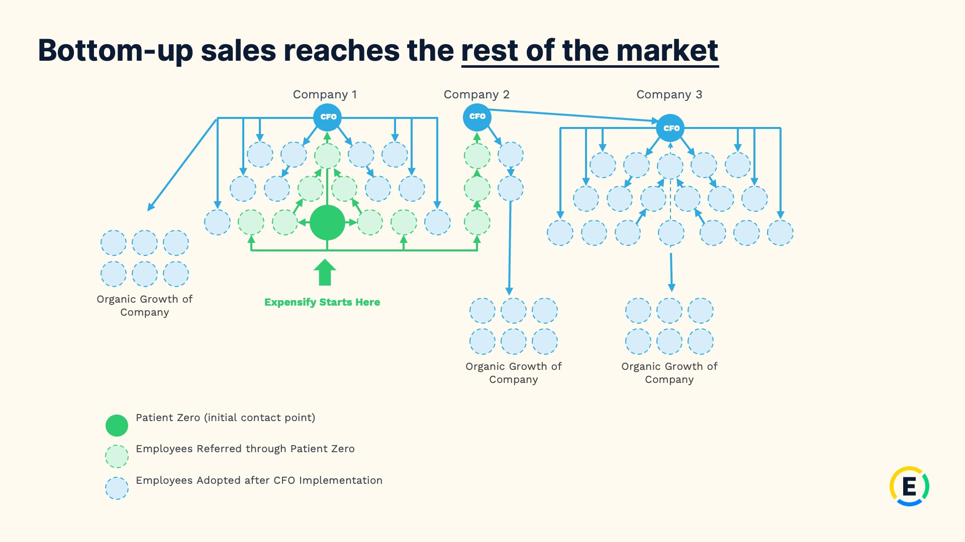

Exhibit 99.2
6
Expensify, Inc.
Investor Presentation

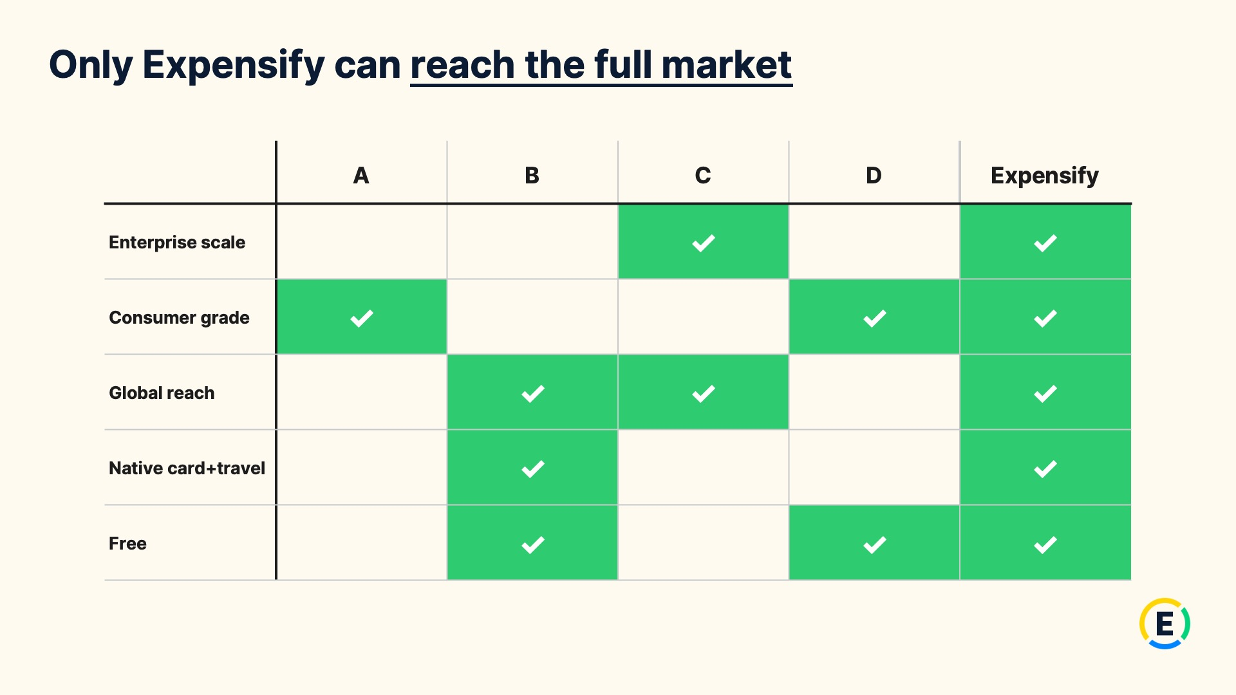

Exhibit 99.2
7
Expensify, Inc.
Investor Presentation

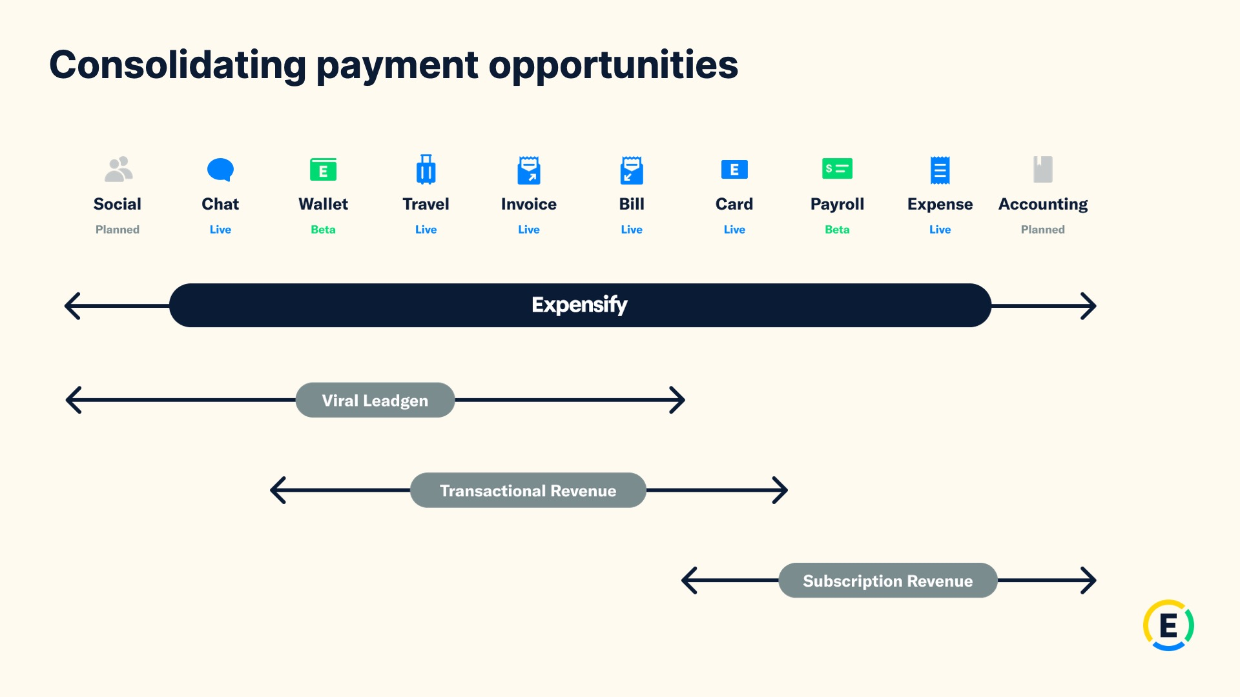

Exhibit 99.2
8
Expensify, Inc.
Investor Presentation



Exhibit 99.2
9
Expensify, Inc.
Investor Presentation

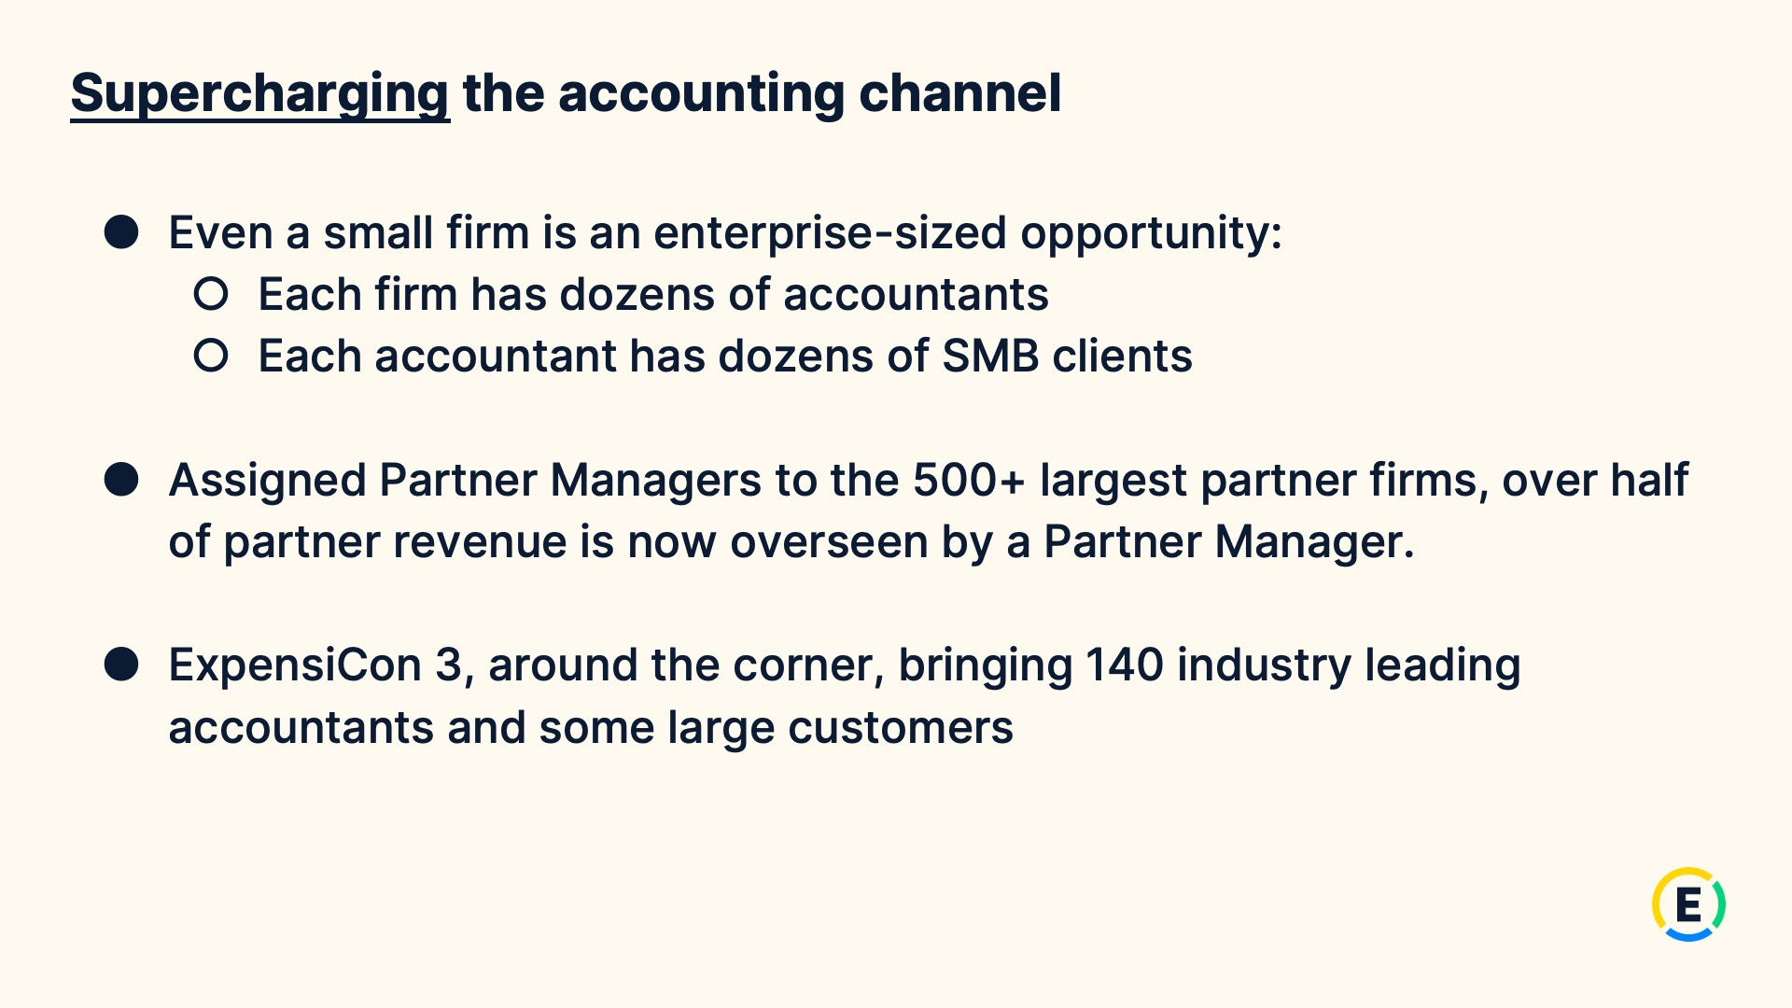

Exhibit 99.2
10
Expensify, Inc.
Investor Presentation

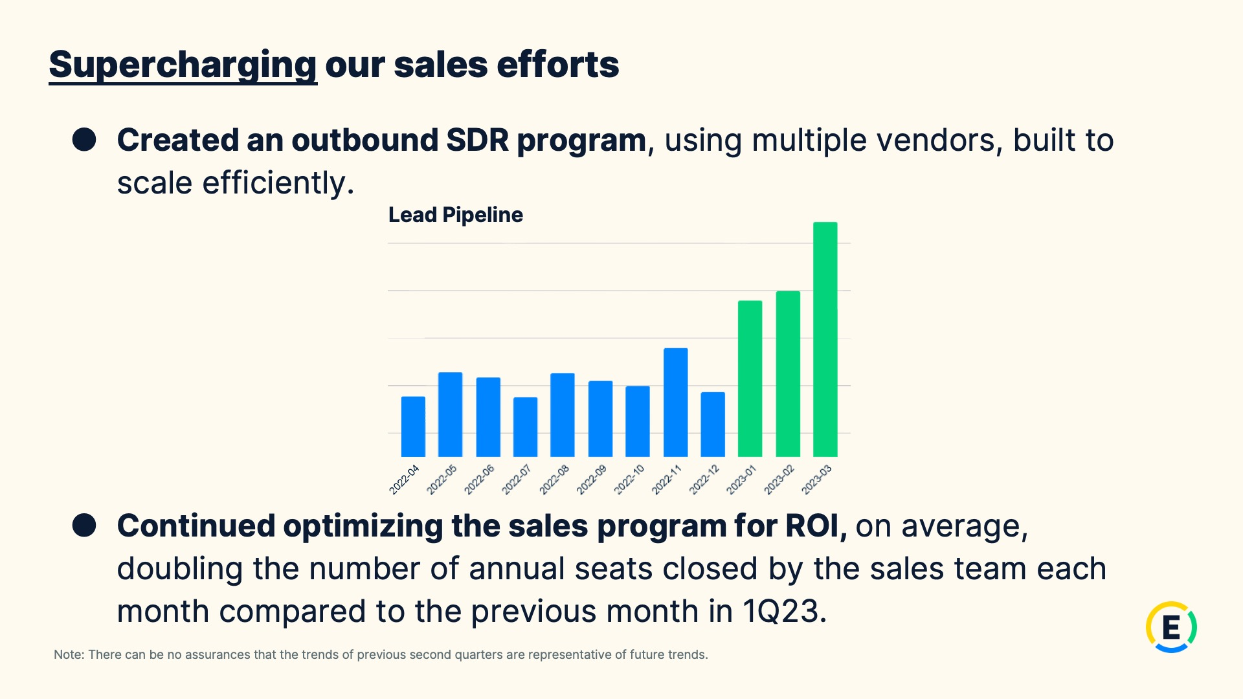

Exhibit 99.2
11
Expensify, Inc.
Investor Presentation

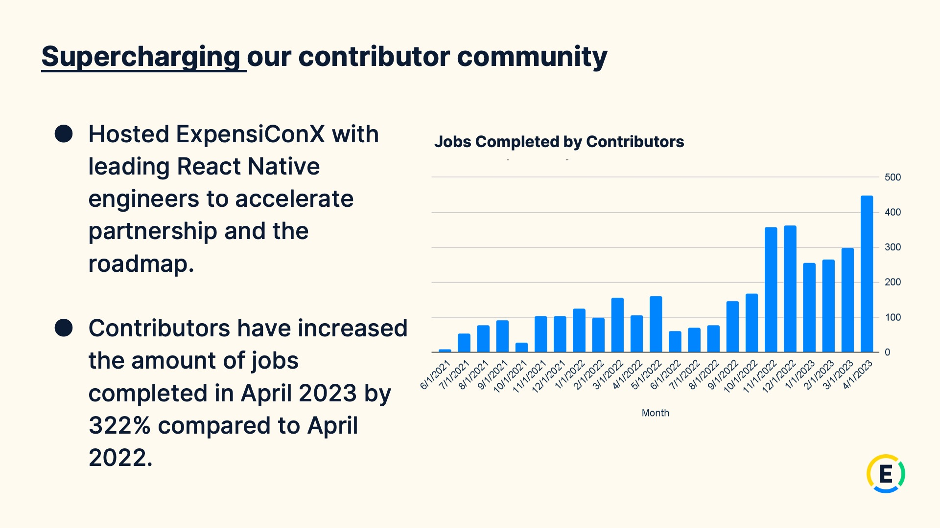
Exhibit 99.2
12
Expensify, Inc.
Investor Presentation


Exhibit 99.2
13
Expensify, Inc.
Investor Presentation

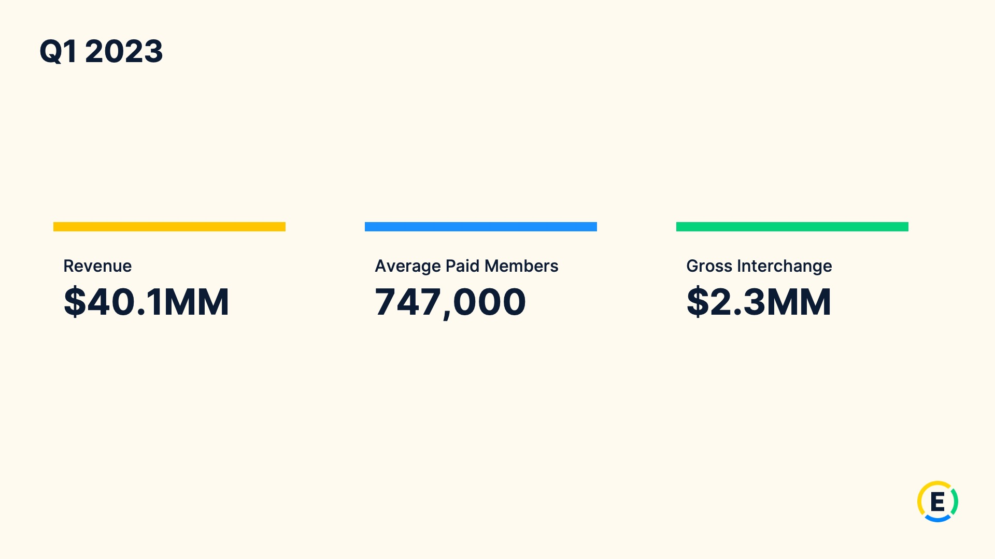
Exhibit 99.2
14
Expensify, Inc.
Investor Presentation

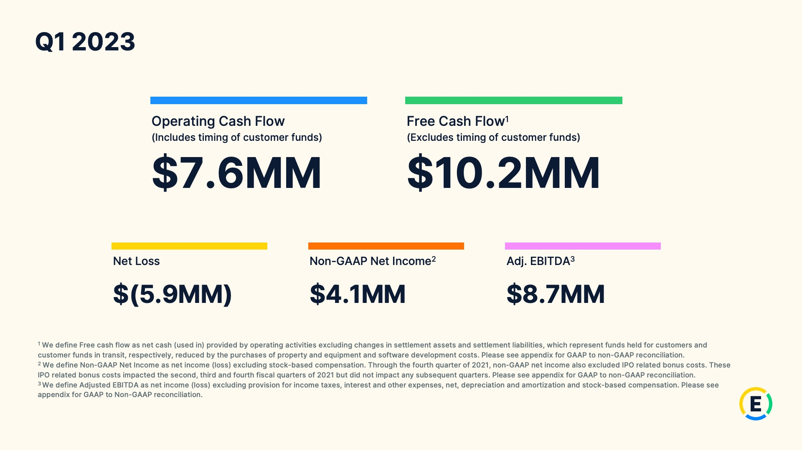
Exhibit 99.2
15
Expensify, Inc.
Investor Presentation

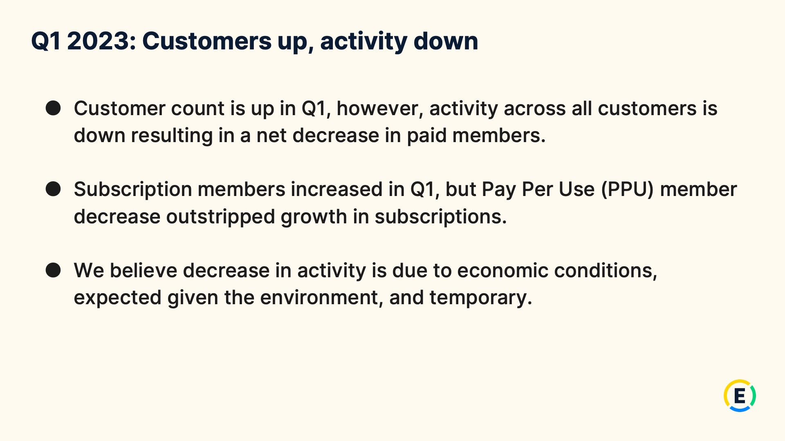
Exhibit 99.2
16
Expensify, Inc.
Investor Presentation

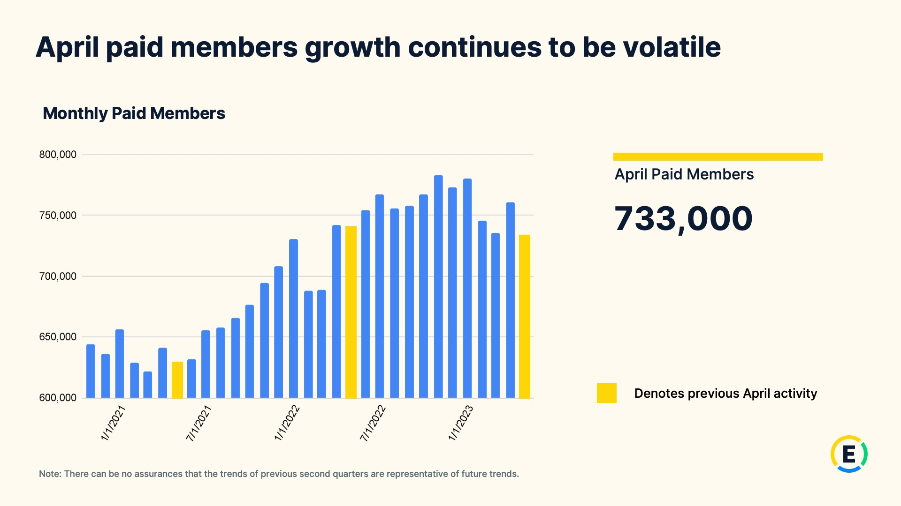
Exhibit 99.2
17
Expensify, Inc.
Investor Presentation

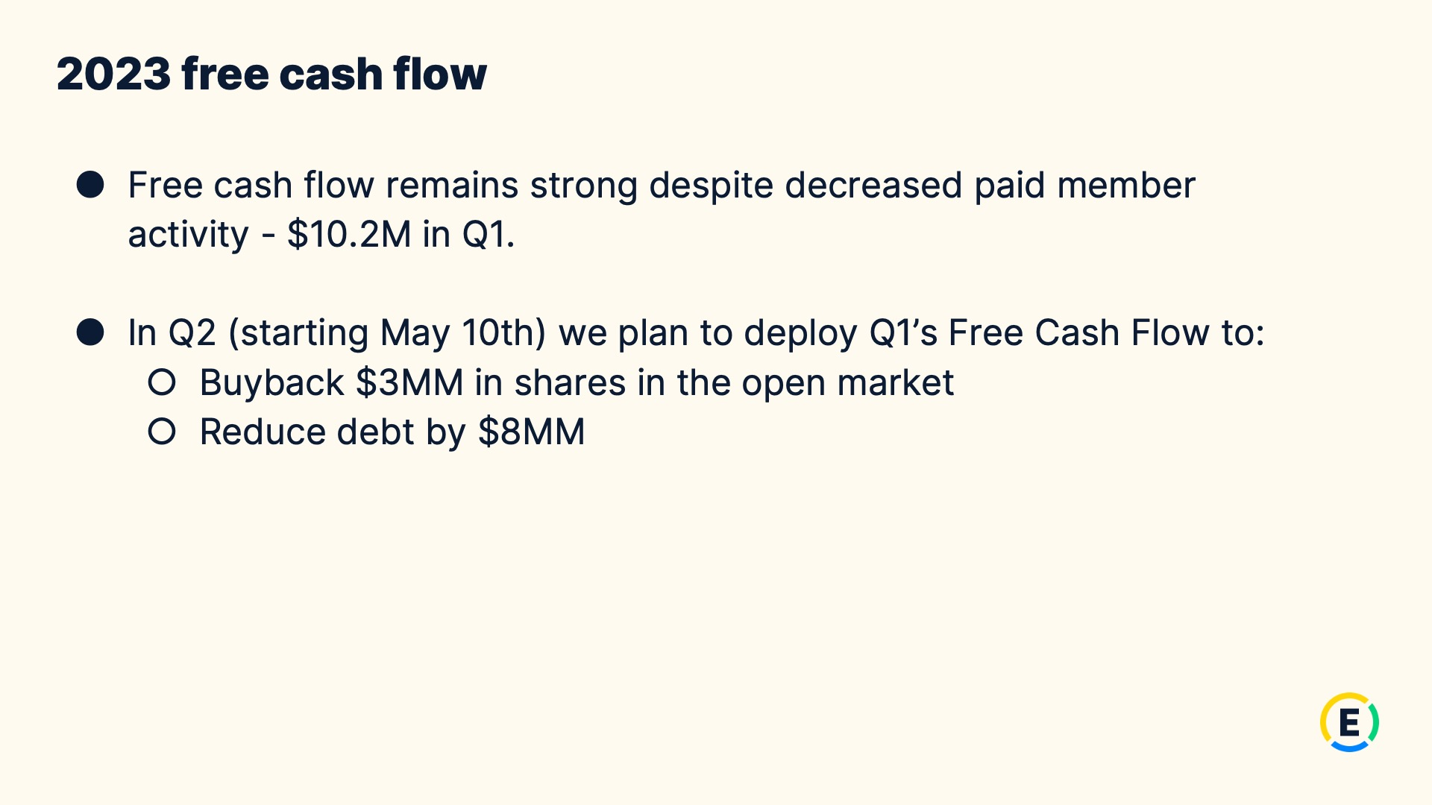
Exhibit 99.2
18
Expensify, Inc.
Investor Presentation

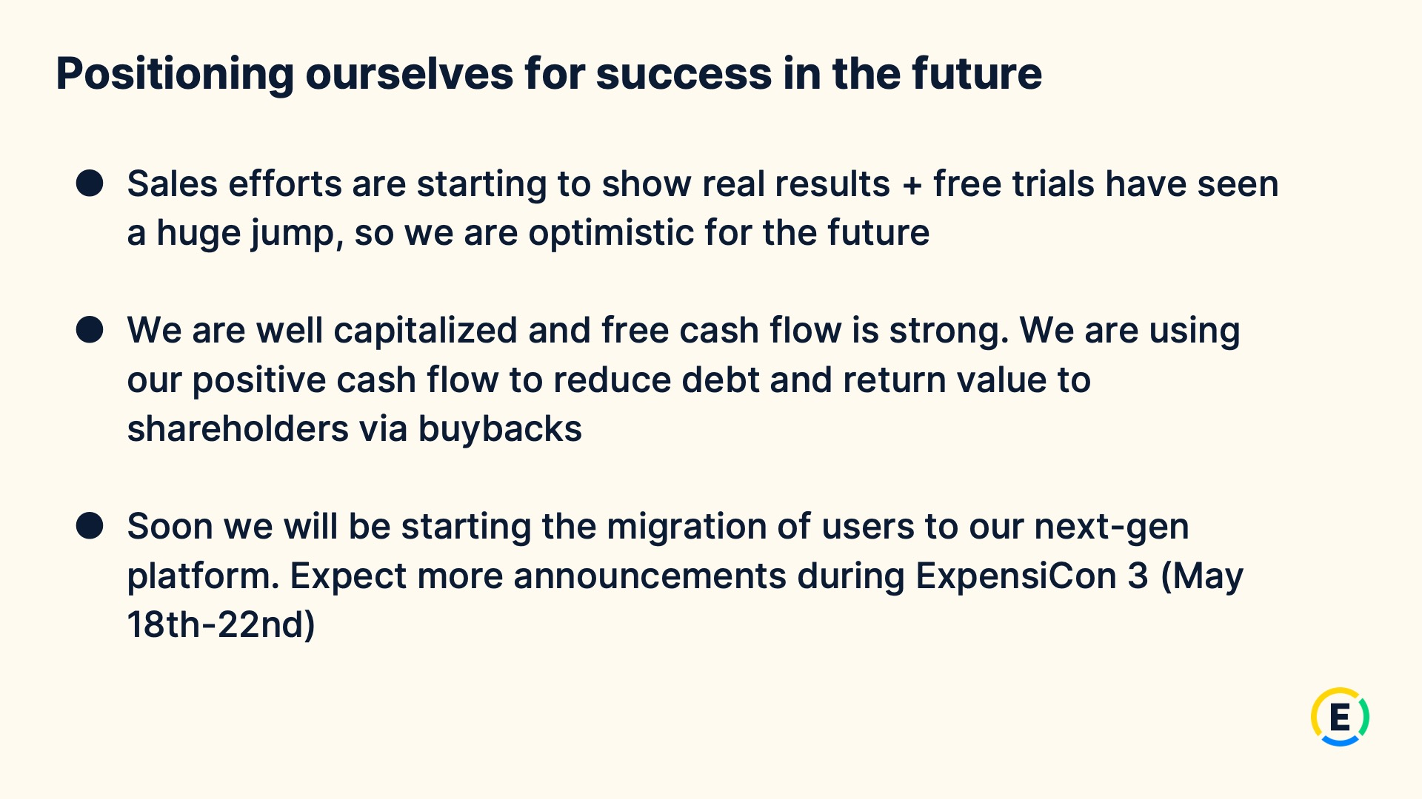
Exhibit 99.2
19
Expensify, Inc.
Investor Presentation

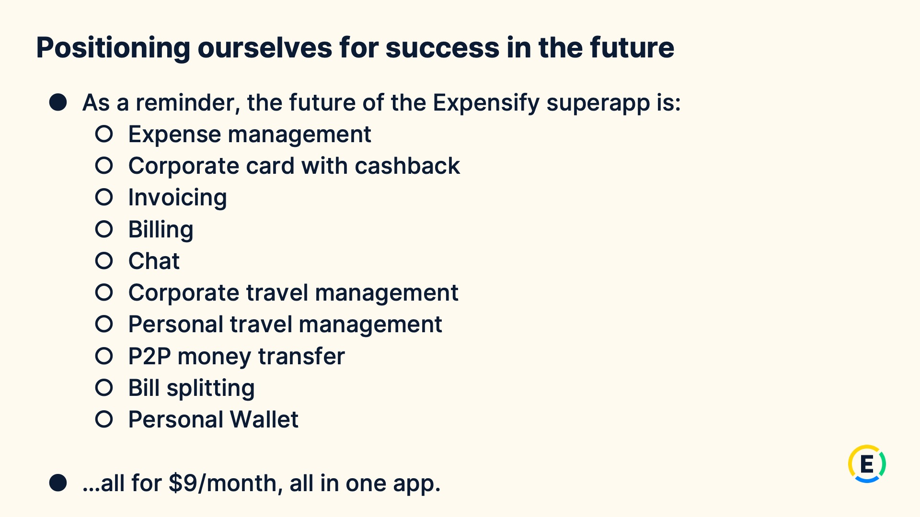
Exhibit 99.2
20
Expensify, Inc.
Investor Presentation


Exhibit 99.2
21
Expensify, Inc.
Investor Presentation


Exhibit 99.2
22
Expensify, Inc.
Investor Presentation


Exhibit 99.2
23
Expensify, Inc.
Investor Presentation

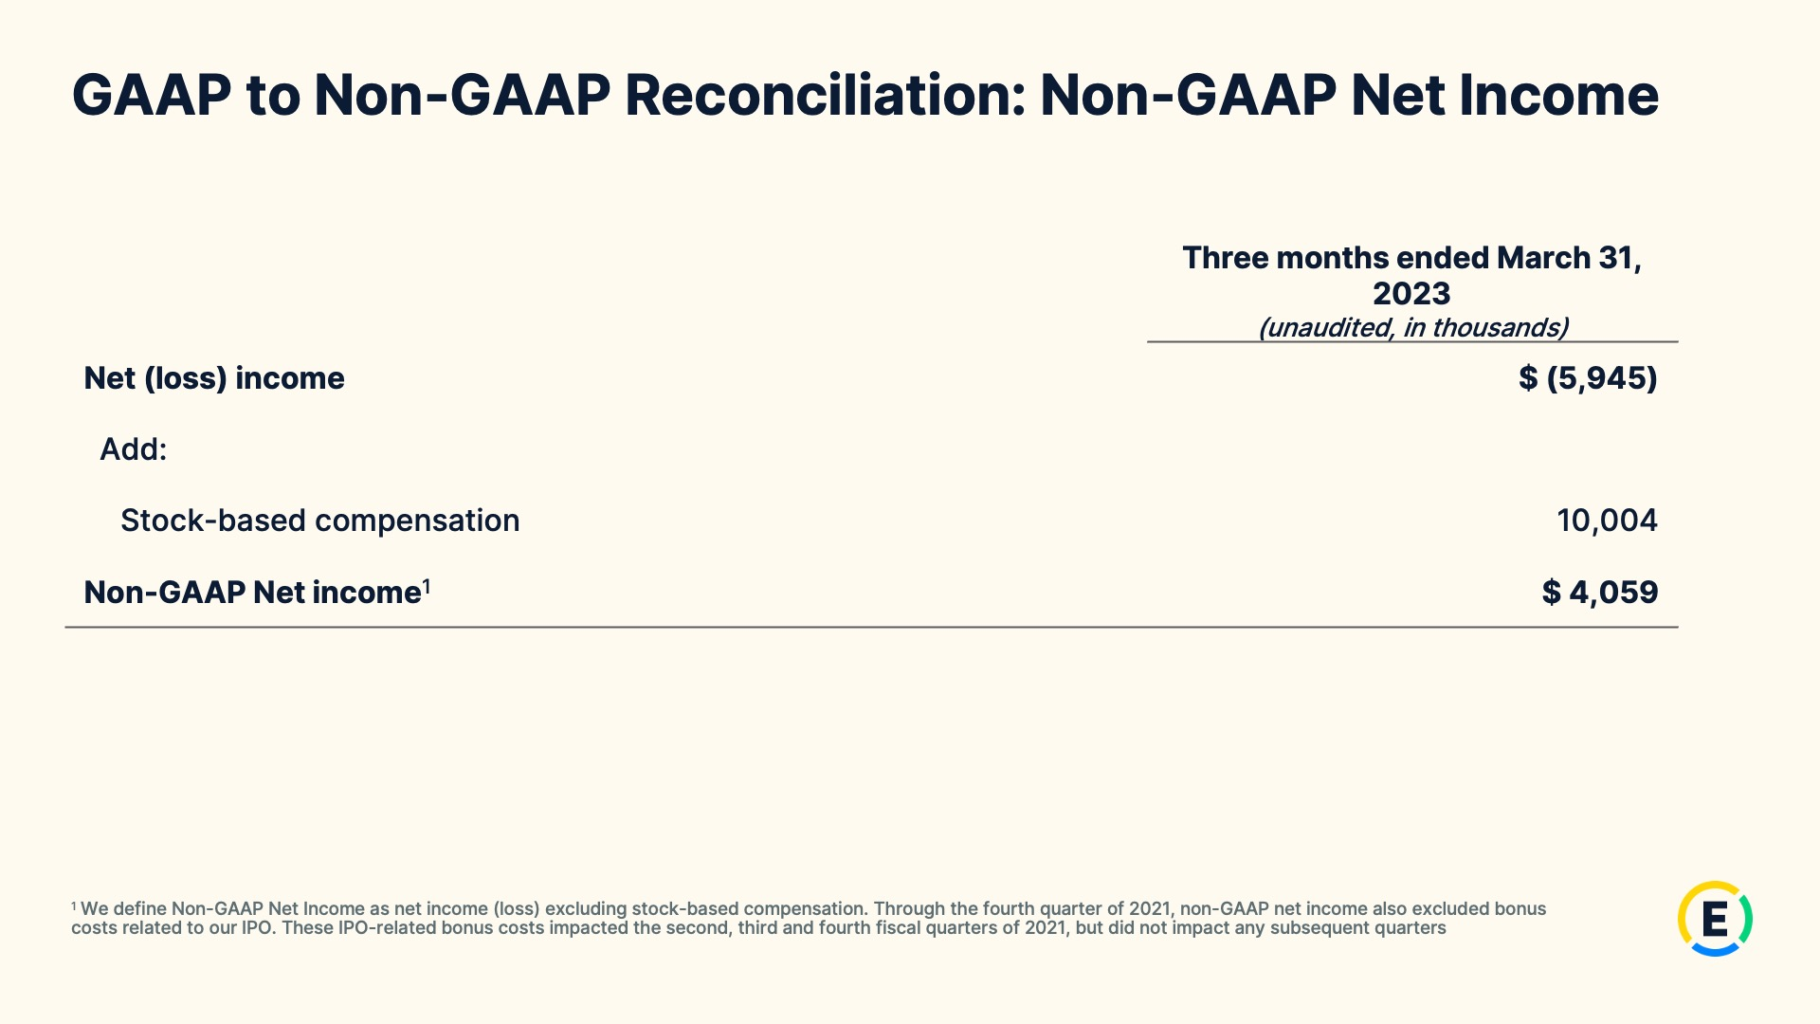
Exhibit 99.2
24
Expensify, Inc.
Investor Presentation

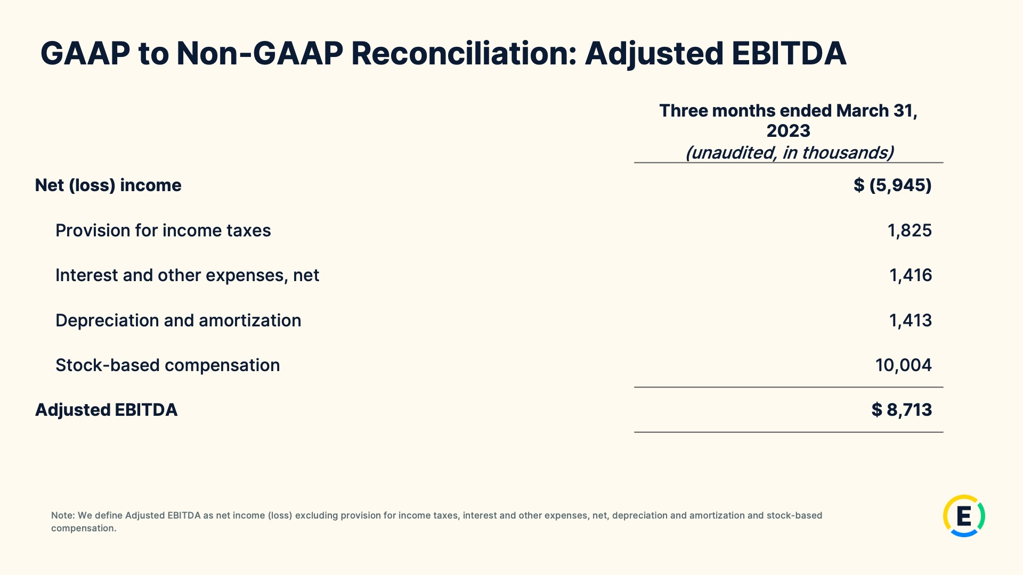
Exhibit 99.2
25
Expensify, Inc.
Investor Presentation

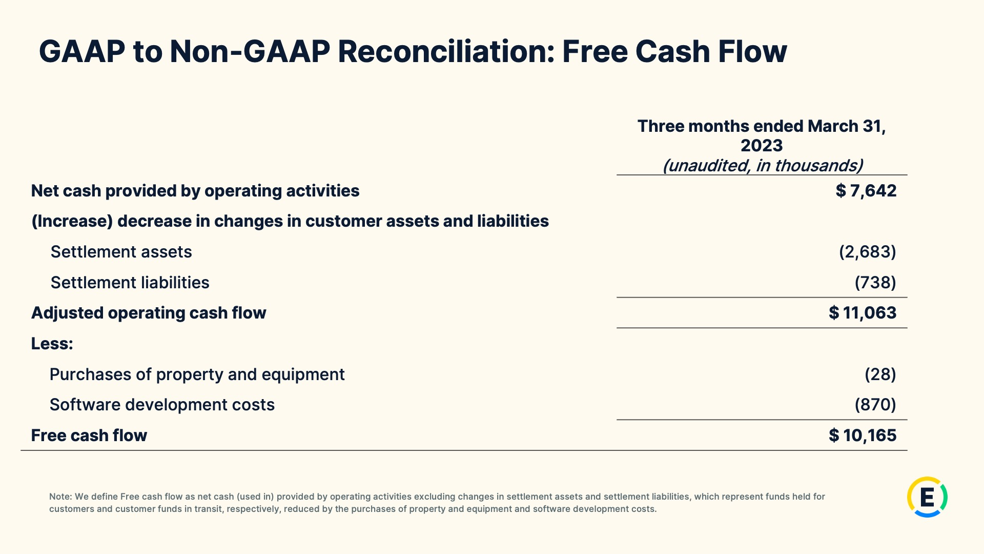
Exhibit 99.2
26
Expensify, Inc.
Investor Presentation

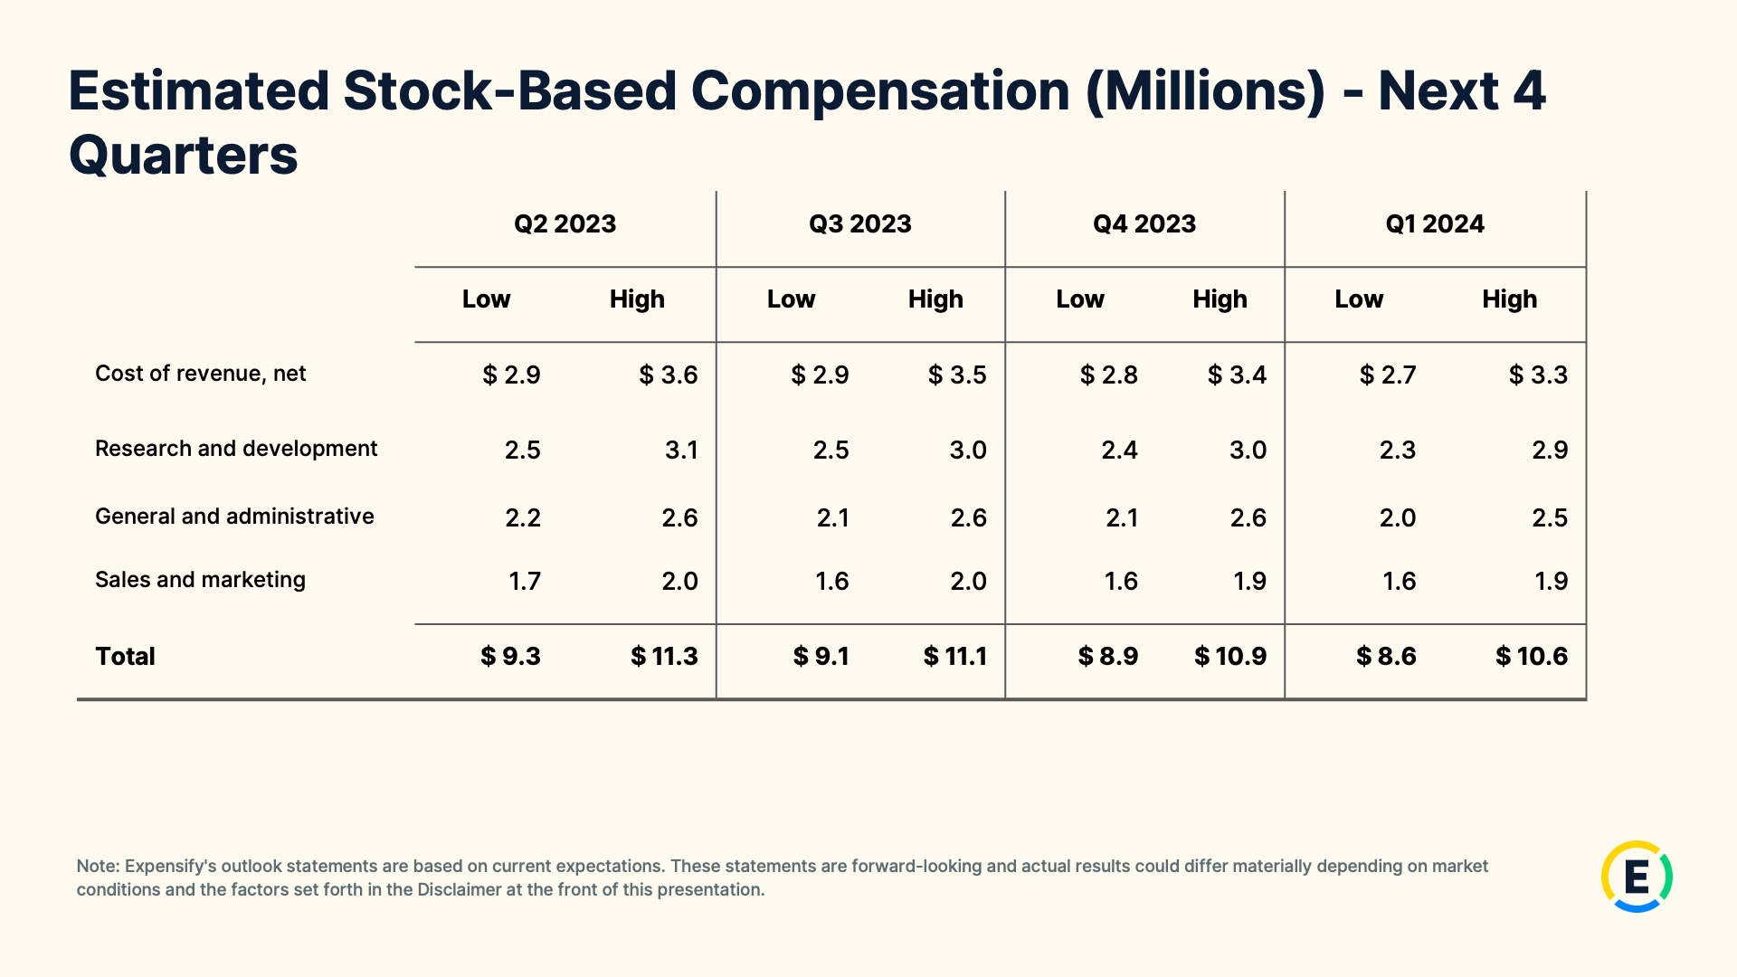
Exhibit 99.2
27
Expensify, Inc.
Investor Presentation

28

