UNITED STATES
SECURITIES AND EXCHANGE COMMISSION
Washington, D.C. 20549
FORM 8-K
CURRENT REPORT
PURSUANT TO SECTION 13 OR 15(d)
OF THE SECURITIES EXCHANGE ACT OF 1934
Date of report (Date of earliest event reported): August 6, 2026
Expensify, Inc.
(Exact Name of Registrant as Specified in its Charter)
Delaware |  |  |  |  |  | 001-41043 |  |  |  |  |  | 27-0239450
(State or Other Jurisdiction  of Incorporation) |  |  |  |  |  | (Commission  File Number) |  |  |  |  |  | (IRS Employer  Identification No.)
88 Kearny St, Ste 1600
San Francisco, California 94108
(Address of Principal Executive Offices) (Zip Code)
(971) 365-3939
(Registrant’s telephone number, including area code)
Not applicable
(Former Name or Former Address, if Changed Since Last Report)
Check the appropriate box below if the Form 8-K filing is intended to simultaneously satisfy the filing obligation of the registrant under any of the following provisions:
☐ |  |  |  |  |  | Written communications pursuant to Rule 425 under the Securities Act (17 CFR 230.425).
☐ |  |  |  |  |  | Soliciting material pursuant to Rule 14a-12 under the Exchange Act (17 CFR 240.14a-12).
☐ |  |  |  |  |  | Pre-commencement communications pursuant to Rule 14d-2(b) under the Exchange Act (17 CFR 240.14d-2(b)).
☐ |  |  |  |  |  | Pre-commencement communications pursuant to Rule 13e-4(c) under the Exchange Act (17 CFR 240.13e-4(c)).
Securities registered pursuant to Section 12(b) of the Act:
Title of each class |  |  |  |  |  | Trading  Symbols |  |  |  |  |  | Name of each exchange  on which registered
Class A Common Stock, par value $0.0001 per share |  |  |  |  |  | EXFY |  |  |  |  |  | The Nasdaq Stock Market LLC
Indicate by check mark whether the registrant is an emerging growth company as defined in Rule 405 of the Securities Act of 1933 (§230.405 of this chapter) or Rule 12b-2 of the Securities Exchange Act of 1934 (§240.12b-2 of this chapter).
Emerging growth company ☐
If an emerging growth company, indicate by check mark if the registrant has elected not to use the extended transition period for complying with any new or revised financial accounting standards provided pursuant to Section 13(a) of the Exchange Act. ☐

Item 2.02 Results of Operations and Financial Condition.
On August 6, 2026, the Expensify, Inc. (“Expensify” or “the Company”) issued a press release announcing its financial results for the year and quarter ended June 30, 2026. A copy of this press release is furnished as Exhibit 99.1 to this current report on Form 8-K and is incorporated herein by reference.

Item 7.01 Regulation FD Disclosure.
On August 6, 2026, the Company posted an investor presentation to its website at https://ir.expensify.com (the “Investor Presentation”). A copy of the Investor Presentation is attached as Exhibit 99.2 to this current report on Form 8-K and is incorporated herein by reference. The Company expects to use the Investor Presentation, in whole or in part, and possibly with modifications, in connection with presentations to investors, analysts and others.
The information contained in the Investor Presentation is summary information that is intended to be considered in the context of the Company’s Securities and Exchange Commission (“SEC”) filings and other public announcements that the Company may make, by press release or otherwise, from time to time. The Investor Presentation speaks only as of the date of this current report on Form 8-K. The Company undertakes no duty or obligation to publicly update or revise the information included in the Investor Presentation, although it may do so from time to time. Any such updating may be made through the filing of other reports or documents with the SEC, through press releases or other public disclosure. In addition, the exhibit furnished herewith contains statements intended as “forward-looking statements” that are subject to the cautionary statements about forward-looking statements set forth in such exhibit. By furnishing the information contained in the Investor Presentation, the Company makes no admission as to the materiality of any information in the Investor Presentation that is required to be disclosed solely by reason of Regulation FD.
The information contained in Item 2.02 and this Item 7.01, including Exhibit 99.1 and 99.2, is being furnished and shall not be deemed “filed” for the purposed of Section 18 of the Securities and Exchange Act of 1934, as amended (the “Exchange Act”), or otherwise subject to the liabilities of that section, nor shall it be deemed incorporated by reference in any filing made by Expensify under the Securities Act of 1933, as amended, or the Exchange Act, except as expressly set forth by specific reference in such a filing.

Item 9.01 Financial Statements and Exhibits.
(d) Exhibits.
Exhibit No. |  |  |  |  |  | Description
99.1 |  |  |  |  |  | Press Release issued by Expensify, Inc., dated August 6, 2026.
99.2 |  |  |  |  |  | Investor Presentation, dated August 6, 2026.
104 |  |  |  |  |  | Cover Page Interactive Data File (embedded within the Inline XBRL document).

SIGNATURE
Pursuant to the requirements of the Securities Exchange Act of 1934, the registrant has duly caused this report to be signed on its behalf by the undersigned hereunto duly authorized.
Expensify, Inc.
By: |  |  |  |  |  | /s/ Ryan Schaffer
Name: |  |  |  |  |  | Ryan Schaffer
Title: |  |  |  |  |  | Chief Financial Officer
Date: August 6, 2026

Exhibit 99.1

EXPENSIFY ANNOUNCES Q2 2026 RESULTS
Interchange revenue derived from the Expensify Card grew to $5.9 million, an increase of 12% as compared to the same period last year.
SAN FRANCISCO, CAL.--(BUSINESS WIRE)--August 6, 2026-- Expensify, Inc. (Nasdaq: EXFY), the easiest way to manage expenses, corporate cards, and travel, today released a letter to shareholders from Founder and CEO David Barrett alongside results for its quarter ended June 30, 2026.

A Message From Our Founder
This is the most exciting quarter in years, as we are finally able to pull back the curtain on New Expensify's growth. To set the stage, recall that Expensify is not just one product, but two:
•Expensify Classic is what established us in the market, and – I think is fair to say – established the standard by which everyone else in the industry is currently being measured: credit card import into a mobile app that scans, categorizes, and reconciles receipts, powered by a robust workflow engine that automatically submits, approves, reimburses, and exports to third party systems. Even though we were the first, everyone else in the industry has largely copied this design. This defined the first twelve or so years of Expensify's life, up to IPO.
•New Expensify is a complete redesign (and major rewrite) based on the sobering realization that no matter how good we made Expensify Classic, it would never appeal to more than a tiny fraction of the global market. Of the 300 million businesses in the world – all of which manage expenses (because you get expenses long before you get revenue) – less than 1% (and closer to 0.1%) has ever paid us or any of our competition. To break out of this tiny corner of a vast market, we needed to radically rethink our product.
These are essentially two different businesses intertwined into one: they share the same servers, the same data, and a lot of the same code. They are both built and maintained by the same team, and to a very large degree, are used by the same customers: most can switch back and forth freely between them, and many do. However, users behave very, very differently on each – and each provides a completely different benefit to our business.
Expensify Classic is a reliable, profitable workhorse: with minimal investment, it has generated steady for us from a stable but slowly shrinking customer base. Expensify Classic is a "fixed" pool of customers: you can't sign up for Expensify Classic today, so it's a pool that will naturally drain. Every business has some nonzero amount of churn, and that churn will gradually reduce our Classic customer base over time.
This has allowed us to pour our efforts into building and growing New Expensify, which is growing very quickly. We'll talk about this more on the earnings call, but revenue from net new customers – meaning, customers who have signed up on New Expensify and have never seen or used Classic – has grown by over 250% year-over-year, to over $10 million ARR across over 10,000 new customers. This is exclusive of Classic customers who have switched to New (which at this point, is most of them).
In my opinion, the conclusion to draw from this is that Expensify isn't a sleepy, low-growth company. Rather, it is the combination of:
•A large, robust, traditional Expensify Classic product that requires minimal maintenance but generates stable cashflow, most of which is being invested into building…
•A small, innovative, and quickly growing New Expensify product that aims to capture a market 10-100x larger than our traditional product ever could.
We feel either of these alone should be reasonably valued higher than the current business is being today – and the sum of the two should be valued even higher still.
Exhibit 99.1

Based on that conviction, we attempted to repurchase $25 million of Class A common stock using a modified Dutch auction tender offer, and successfully repurchased 6.1 million shares of Class A common stock at $1.20 per share. (The tender was substantially undersubscribed despite the premium offered on the share price.) We then purchased approximately 712,000 additional shares, for $1.2 million, bringing the total Q2 repurchase to 6.8 million shares of Class A common stock, representing a ~7% reduction in shares outstanding.
We still have a long road ahead of us, and our path back to sustained growth depends on how effectively we:
•Retain and expand our Classic customers by migrating the last of them onto New Expensify, where they can benefit from a dramatically improved experience for both traditional and modern agentic workflows, and…
•Continue accelerating new customer acquisition by scaling both lead generation and high-velocity self-service sales in this large, untapped market.
This isn't a new story. It's the same story we told at IPO, and on every earnings call since. This isn't a new market: it's the same market that's been there all along.
All that's new is (I feel) we have increasingly solid evidence the plan is going to work – and though I never doubted it, it's extremely exciting to see it play out in practice.
-david
Founder and CEO of Expensify

Exhibit 99.1

Financial
Second Quarter 2026 Highlights
•Revenue, net was $33.9 million, a decrease of 5% as compared to the same period last year.
•Generated $8.4 million of cash from operating activities.
•Free cash flow was $6.4 million.
•Net loss was $3.9 million, compared to $8.8 million for the same period last year.
•Non-GAAP net income was $3.4 million.
•Adjusted EBITDA was $6.6 million.
•Interchange revenue derived from the Expensify Card grew to $5.9 million, an increase of 12% as compared to the same period last year.
•See Financial Outlook section for Free Cash Flow guidance for fiscal year ending December 31, 2026.
Business
Second Quarter 2026 Highlights
•Paid members - Paid members were 640,000, a decrease of 2% as compared to the same period last year.
•AI expands across the platform - Customers can now set up Expensify, automate expenses, and analyze spend using natural language via email, text, or in-app, with AI-powered workflow agents entering beta.
•Expanded commercial ecosystem - Launched the Expensify MCP, connecting Expensify to AI assistants like ChatGPT, Claude, and Cursor for natural-language access to expense data.
•Product velocity remained strong - Shipped 30+ product improvements in Q2 across cards, mileage tracking, policy controls, bulk editing, and AI-powered spend controls, and was named Expense Management Platform of the Year in the TravelTech Breakthrough Awards.
•Capital return to shareholders - Repurchased approximately 6.1 million shares of Class A common stock at $1.20 per share through a modified Dutch auction tender offer, as well as approximately 0.7 million additional shares repurchased at an average price of $1.63 per share. Total repurchases of approximately 6.8 million shares of Class A common stock represent an approximately 7% reduction in shares outstanding.

Exhibit 99.1

Financial Outlook
Expensify's outlook statements are based on current estimates, expectations and assumptions and are not a guarantee of future performance. The following statements are forward-looking and actual results could differ materially depending on market conditions and the factors set forth under “Forward-Looking Statements” below. There can be no assurance that the Company will achieve the results expressed by this guidance.
Free Cash Flow
Expensify estimates free cash flow of $12.0 million - $14.0 million for the fiscal year ending December 31, 2026.
The Company does not provide a reconciliation for free cash flow estimates on a forward-looking basis because it is unable, without making unreasonable efforts, to provide a meaningful or reasonably accurate calculation or estimation of net cash provided by operating activities and certain reconciling items on a forward-looking basis, which could be significant to the Company's results.
Stock Based Compensation
An estimate of expected stock-based compensation for the next four fiscal quarters is as follows, which is driven primarily by the pre-IPO grant of RSUs issued to all employees (which vest quarterly over eight years with approximately three years remaining).
Est. stock-based compensation (millions)
 |  |  | Q3 2026 |  |  |  |  |  |  |  |  |  |  |  | Q4 2026 |  |  |  |  |  |  |  |  |  |  |  | Q1 2027 |  |  |  |  |  |  |  |  |  |  |  | Q2 2027
 |  |  | Low |  |  |  |  |  | High |  |  |  |  |  | Low |  |  |  |  |  | High |  |  |  |  |  | Low |  |  |  |  |  | High |  |  |  |  |  | Low |  |  |  |  |  | High
Cost of revenue, net |  |  | $ | 1.9 |  |  |  |  | $ | 2.5 |  |  |  |  | $ | 1.7 |  |  |  |  | $ | 2.3 |  |  |  |  | $ | 1.7 |  |  |  |  | $ | 2.3 |  |  |  |  | $ | 1.7 |  |  |  |  | $ | 2.3
Research and development |  |  | 1.5 |  |  |  |  |  | 2.1 |  |  |  |  |  | 1.5 |  |  |  |  |  | 2.1 |  |  |  |  |  | 1.4 |  |  |  |  |  | 2.0 |  |  |  |  |  | 1.4 |  |  |  |  |  | 2.0
General and administrative |  |  | 1.0 |  |  |  |  |  | 1.4 |  |  |  |  |  | 1.0 |  |  |  |  |  | 1.4 |  |  |  |  |  | 1.0 |  |  |  |  |  | 1.4 |  |  |  |  |  | 0.9 |  |  |  |  |  | 1.3
Sales and marketing |  |  | 1.0 |  |  |  |  |  | 1.4 |  |  |  |  |  | 1.0 |  |  |  |  |  | 1.4 |  |  |  |  |  | 0.9 |  |  |  |  |  | 1.3 |  |  |  |  |  | 0.9 |  |  |  |  |  | 1.3
Total |  |  | $ | 5.4 |  |  |  |  | $ | 7.4 |  |  |  |  | $ | 5.2 |  |  |  |  | $ | 7.2 |  |  |  |  | $ | 5.0 |  |  |  |  | $ | 7.0 |  |  |  |  | $ | 4.9 |  |  |  |  | $ | 6.9
Availability of Information on Expensify’s Website
Investors and others should note that Expensify routinely announces material information to investors and the marketplace using SEC filings, press releases, public conference calls, webcasts and the Expensify Investor Relations website at https://ir.expensify.com. While not all of the information that the Company posts to its Investor Relations website is of a material nature, some information could be deemed to be material. Accordingly, the Company encourages investors, the media and others interested in Expensify to review the information that it shares on its Investor Relations website.
Conference Call
Expensify will host a video call to discuss the financial results and business highlights at 2:00 p.m. Pacific Time today. An investor presentation and the video call information is available on Expensify’s Investor Relations website at https://ir.expensify.com. A replay of the call will be available on the site for three months.
Exhibit 99.1

Non-GAAP Financial Measures
In addition to financial measures prepared in accordance with U.S. generally accepted accounting principles (“GAAP”), we provide certain non-GAAP financial measures, including adjusted EBITDA, non-GAAP net (loss) income, and free cash flow.
We believe our non-GAAP financial measures are useful in evaluating our business, measuring our performance, identifying trends affecting our business, formulating business plans and making strategic decisions. Accordingly, we believe that these non-GAAP financial measures provide useful information to investors and others in understanding and evaluating our results of operations in the same manner as our management team. These non-GAAP financial measures are presented for supplemental informational purposes only, should not be considered a substitute for financial information presented in accordance with GAAP, and may be different from similarly titled metrics or measures presented by other companies. Non-GAAP financial measures have limitations as analytical tools and should not be considered in isolation or as substitutes for financial information presented under GAAP. There are a number of limitations related to the use of non-GAAP financial measures versus comparable financial measures determined under GAAP. For example, other companies in our industry may calculate these non-GAAP financial measures differently or may use other measures to evaluate their performance. All of these limitations could reduce the usefulness of these non-GAAP financial measures as analytical tools. Investors are encouraged to review the related GAAP financial measures and the reconciliations of these non-GAAP financial measures to their most directly comparable GAAP financial measures and to not rely on any single financial measure to evaluate our business. A reconciliation of each non-GAAP financial measure to the most directly comparable financial measure stated in accordance with GAAP is at the end of this press release.
Adjusted EBITDA. We define adjusted EBITDA as net loss excluding provision for (benefit from) income taxes, other income, net, depreciation and amortization, and stock-based compensation expense.
Non-GAAP net income (loss). We define non-GAAP net income (loss) as net loss excluding stock-based compensation expense.
Free cash flow. We define free cash flow as net cash provided by operating activities excluding changes in settlement assets, net and settlement liabilities, reduced by the purchases of property and equipment and software development costs.
The tables at the end of the Condensed Consolidated Financial Statements provide reconciliations to the most directly comparable GAAP financial measure to each of these non-GAAP financial measures.
Forward-Looking Statements
Forward-looking statements in this press release, or made during the earnings call, which are not historical facts, are forward-looking statements within the meaning of the Private Securities Litigation Reform Act of 1995. These statements include statements regarding our strategy, future financial condition, future operations, future cash flow, projected costs, prospects, plans, objectives of management and expected market growth, product developments and their potential impact and our stock-based compensation estimates and involve known and unknown risks that are difficult to predict. As a result, our actual results, performance or achievements may differ materially from those expressed or implied by these forward-looking statements. In some cases, you can identify forward-looking statements because they contain words such as “may,” “will,” “shall,” “should,” “expects,” “plans,” “anticipates,” “could,” “intends,” “target,” “projects,” “contemplates,” “believes,” “estimates,” “predicts,” “potential,” “goal,” “ambition,” “objective,” “seeks,” “outlook,” or “continue” or the negative of these words or other similar terms or expressions that concern our expectations, strategy, plans, or intentions. Such forward-looking statements are necessarily based upon estimates and assumptions that, while considered reasonable by us and our management, are inherently uncertain. Factors that may cause actual results to differ materially from current expectations include, but are not limited to: the impact on inflation on us and our members; our borrowing costs, which have and may continue to increase as a result of increases in interest rates; our expectations regarding our financial performance and future operating performance; our ability to attract and retain members, expand usage of our platform, sell subscriptions to our platform and convert individuals and organizations into paying customers; the timing and success of new features, integrations, capabilities and enhancements by us, or by competitors to their products, or
Exhibit 99.1

any other changes in the competitive landscape of our market; the amount and timing of operating expenses that we may incur to maintain and expand our business and operations to remain competitive; the sufficiency of our cash, cash equivalents and investments to meet our liquidity needs; our ability to meet the Nasdaq continued listing requirements for minimum bid price or other Nasdaq listing requirements and the potential delisting of our common stock; our ability to make required payments under and to comply with the various requirements of our current and future indebtedness; our cash flows, the prevailing stock prices, general economic and market conditions and other considerations that could affect the specific timing, price and size of repurchases under our stock repurchase program or our ability to fund any stock repurchases; geopolitical tensions, including the war in Ukraine and the conflict in the Middle East; our ability to effectively manage our exposure to fluctuations in foreign currency exchange rates; the size of our addressable markets, market share and market trends; anticipated trends, developments and challenges in our industry, business and the highly competitive markets in which we operate; any adverse impact on our business operations as a result of using artificial intelligence or other machine learning technologies in our services; our expectations regarding our income tax liabilities and the adequacy of our reserves; our ability to effectively manage our growth and expand our infrastructure and maintain our corporate culture; our ability to identify, recruit and retain skilled personnel, including key members of senior management; the safety, affordability and convenience of our platform and our offerings; our ability to successfully defend litigation brought against us; our ability to successfully identify, manage and integrate any existing and potential acquisitions of businesses, talent, technologies or intellectual property; general economic conditions in either domestic or international markets, including geopolitical uncertainty and instability, and their effects on software spending; our ability to protect against security incidents, technical difficulties, or interruptions to our platform; our ability to maintain, protect and enhance our intellectual property; the impact of tariffs and global trade disruptions on us, our customers and our vendors, including the impact on inflation, supply chains and consumer sentiment; and other risks discussed in our filings with the SEC. All forward-looking statements attributable to us or persons acting on our behalf are expressly qualified in their entirety by the cautionary statements set forth above. We caution you not to place undue reliance on any forward-looking statements, which are made only as of the date of this press release. We do not undertake or assume any obligation to update publicly any of these forward-looking statements to reflect actual results, new information or future events, changes in assumptions or changes in other factors affecting forward-looking statements, except to the extent required by applicable law. If we update one or more forward-looking statements, no inference should be drawn that we will make additional updates with respect to those or other forward-looking statements.
About Expensify
Expensify is the easiest way to do your expenses, travel, and corporate cards. Built for businesses of all sizes and trusted by 15 million members worldwide, Expensify is a top-rated app across G2, TrustRadius, Capterra, and more. Learn more at use.expensify.com.
Investor Relations Contact
Nick Tooker
investors@expensify.com
Press Contact
James Dean
press@expensify.com

Expensify, Inc.
Condensed Consolidated Balance Sheets
(unaudited, in thousands, except share and per share data)
 |  |  | As of June 30, |  |  |  |  |  | As of December 31,
 |  |  | 2026 |  |  |  |  |  | 2025
Assets
Cash and cash equivalents |  |  | $ | 65,760 |  |  |  |  | $ | 63,080
Accounts receivable, net |  |  | 11,168 |  |  |  |  |  | 12,617
Settlement assets, net |  |  | 51,484 |  |  |  |  |  | 45,378
Prepaid expenses |  |  | 4,399 |  |  |  |  |  | 5,588
Other current assets |  |  | 21,380 |  |  |  |  |  | 26,344
Total current assets |  |  | 154,191 |  |  |  |  |  | 153,007
Capitalized software, net |  |  | 12,401 |  |  |  |  |  | 13,596
Property and equipment, net |  |  | 12,707 |  |  |  |  |  | 13,016
Lease right-of-use assets |  |  | 4,390 |  |  |  |  |  | 4,730
Deferred tax assets, net |  |  | 474 |  |  |  |  |  | 494
Other assets |  |  | 1,243 |  |  |  |  |  | 1,146
Total assets |  |  | $ | 185,406 |  |  |  |  | $ | 185,989
Liabilities and stockholders' equity
Accounts payable |  |  | $ | 1,131 |  |  |  |  | $ | 289
Accrued expenses and other liabilities |  |  | 8,064 |  |  |  |  |  | 17,893
Lease liabilities, current |  |  | 626 |  |  |  |  |  | 678
Settlement liabilities |  |  | 34,275 |  |  |  |  |  | 27,545
Total current liabilities |  |  | 44,096 |  |  |  |  |  | 46,405
Lease liabilities, non-current |  |  | 4,752 |  |  |  |  |  | 5,061
Other liabilities |  |  | 1,996 |  |  |  |  |  | 1,778
Total liabilities |  |  | 50,844 |  |  |  |  |  | 53,244
Commitments and contingencies
Stockholders' equity:
Preferred stock, par value $0.0001; 10,000,000 shares authorized; no shares issued and outstanding as of June 30, 2026 and December 31, 2025 |  |  | — |  |  |  |  |  | —
Common stock, par value $0.0001;  Class A common stock; 1,000,000,000 shares authorized; 79,647,207 and 80,767,385 shares issued and outstanding as of June 30, 2026 and December 31, 2025, respectively;  LT10 common stock; 21,871,197 shares authorized; 4,209,827 shares issued and outstanding as of June 30, 2026 and December 31, 2025;  LT50 common stock; 24,893,067 and 24,967,114 shares authorized as of June 30, 2026 and December 31, 2025, respectively; 8,040,033 and 8,083,690 shares issued and outstanding as of June 30, 2026 and December 31, 2025, respectively |  |  | 9 |  |  |  |  |  | 9
Additional paid-in capital |  |  | 312,958 |  |  |  |  |  | 304,953
Accumulated deficit |  |  | (178,405) |  |  |  |  |  | (172,217)
Total stockholders' equity |  |  | 134,562 |  |  |  |  |  | 132,745
Total liabilities and stockholders' equity |  |  | $ | 185,406 |  |  |  |  | $ | 185,989

Expensify, Inc.
Condensed Consolidated Statements of Operations
(unaudited, in thousands, except share and per share data)
 |  |  | Three Months Ended June 30, |  |  |  |  |  |  |  |  |  |  |  | Six Months Ended June 30,
 |  |  | 2026 |  |  |  |  |  | 2025 |  |  |  |  |  | 2026 |  |  |  |  |  | 2025
Revenue, net |  |  | $ | 33,866 |  |  |  |  | $ | 35,764 |  |  |  |  | $ | 67,835 |  |  |  |  | $ | 71,838
Cost of revenue, net(1) |  |  | 17,536 |  |  |  |  |  | 17,187 |  |  |  |  |  | 35,333 |  |  |  |  |  | 35,019
Gross margin |  |  | 16,330 |  |  |  |  |  | 18,577 |  |  |  |  |  | 32,502 |  |  |  |  |  | 36,819
Operating expenses:
Research and development(1) |  |  | 4,983 |  |  |  |  |  | 5,158 |  |  |  |  |  | 10,248 |  |  |  |  |  | 10,516
General and administrative(1) |  |  | 9,591 |  |  |  |  |  | 9,411 |  |  |  |  |  | 18,709 |  |  |  |  |  | 20,240
Sales and marketing(1) |  |  | 4,677 |  |  |  |  |  | 14,346 |  |  |  |  |  | 8,438 |  |  |  |  |  | 17,888
Total operating expenses |  |  | 19,251 |  |  |  |  |  | 28,915 |  |  |  |  |  | 37,395 |  |  |  |  |  | 48,644
Loss from operations |  |  | (2,921) |  |  |  |  |  | (10,338) |  |  |  |  |  | (4,893) |  |  |  |  |  | (11,825)
Other income, net |  |  | 202 |  |  |  |  |  | 889 |  |  |  |  |  | 373 |  |  |  |  |  | 1,213
Loss before income taxes |  |  | (2,719) |  |  |  |  |  | (9,449) |  |  |  |  |  | (4,520) |  |  |  |  |  | (10,612)
(Provision for) benefit from income taxes |  |  | (1,132) |  |  |  |  |  | 661 |  |  |  |  |  | (1,668) |  |  |  |  |  | (1,345)
Net loss |  |  | $ | (3,851) |  |  |  |  | $ | (8,788) |  |  |  |  | $ | (6,188) |  |  |  |  | $ | (11,957)
Net loss per share:
Basic and diluted |  |  | $ | (0.04) |  |  |  |  | $ | (0.10) |  |  |  |  | $ | (0.07) |  |  |  |  | $ | (0.13)
Weighted average shares of common stock used to compute net loss per share:
Basic and diluted |  |  | 95,441,380 |  |  |  |  |  | 92,271,924 |  |  |  |  |  | 94,585,048 |  |  |  |  |  | 91,888,633

(1)Includes stock-based compensation expense as follows:
 |  |  | Three Months Ended June 30, |  |  |  |  |  |  |  |  |  |  |  | Six Months Ended June 30,
 |  |  | 2026 |  |  |  |  |  | 2025 |  |  |  |  |  | 2026 |  |  |  |  |  | 2025
Cost of revenue, net |  |  | $ | 2,420 |  |  |  |  | $ | 2,770 |  |  |  |  | $ | 4,731 |  |  |  |  | $ | 5,809
Research and development |  |  | 2,058 |  |  |  |  |  | 2,018 |  |  |  |  |  | 3,920 |  |  |  |  |  | 4,421
General and administrative |  |  | 1,391 |  |  |  |  |  | 1,178 |  |  |  |  |  | 2,427 |  |  |  |  |  | 2,749
Sales and marketing |  |  | 1,342 |  |  |  |  |  | 961 |  |  |  |  |  | 2,110 |  |  |  |  |  | 1,938
Total stock-based compensation expense |  |  | $ | 7,211 |  |  |  |  | $ | 6,927 |  |  |  |  | $ | 13,188 |  |  |  |  | $ | 14,917

Expensify, Inc.
Condensed Consolidated Statements of Cash Flows
(unaudited, in thousands)
 |  |  |  |  | Six Months Ended June 30,
 |  |  |  |  |  |  | 2026 |  |  |  |  |  | 2025
Cash flows from operating activities:
Net loss |  |  |  |  |  |  | $ | (6,188) |  |  |  |  | $ | (11,957)
Adjustments to reconcile net loss to net cash provided by operating activities:
Depreciation and amortization |  |  |  |  |  |  | 4,598 |  |  |  |  |  | 4,041
Reduction of operating lease right-of-use assets |  |  |  |  |  |  | 272 |  |  |  |  |  | 279
Loss on impairment, receivables and sale or disposal of equipment |  |  |  |  |  |  | 720 |  |  |  |  |  | 334
Stock-based compensation expense |  |  |  |  |  |  | 13,188 |  |  |  |  |  | 14,917
Amortization of debt issuance costs |  |  |  |  |  |  | 83 |  |  |  |  |  | 57
Deferred income taxes |  |  |  |  |  |  | 51 |  |  |  |  |  | (4)
Changes in assets and liabilities:
Accounts receivable, net |  |  |  |  |  |  | 819 |  |  |  |  |  | 212
Settlement assets, net |  |  |  |  |  |  | (3,321) |  |  |  |  |  | (5,994)
Prepaid expenses |  |  |  |  |  |  | 1,189 |  |  |  |  |  | 9,565
Other current assets |  |  |  |  |  |  | 6,525 |  |  |  |  |  | (2,186)
Other assets |  |  |  |  |  |  | (97) |  |  |  |  |  | (19)
Accounts payable |  |  |  |  |  |  | 329 |  |  |  |  |  | 1,336
Accrued expenses and other liabilities |  |  |  |  |  |  | (9,995) |  |  |  |  |  | 962
Operating lease liabilities |  |  |  |  |  |  | (287) |  |  |  |  |  | (281)
Settlement liabilities |  |  |  |  |  |  | 478 |  |  |  |  |  | 4,947
Other liabilities |  |  |  |  |  |  | 187 |  |  |  |  |  | (169)
Net cash provided by operating activities |  |  |  |  |  |  | 8,551 |  |  |  |  |  | 16,040
Cash flows from investing activities:
Purchase of property and equipment |  |  |  |  |  |  | — |  |  |  |  |  | (17)
Software development costs |  |  |  |  |  |  | (2,491) |  |  |  |  |  | (1,655)
Net cash used in investing activities |  |  |  |  |  |  | (2,491) |  |  |  |  |  | (1,672)
Cash flows from financing activities:
Change in customer funds, net |  |  |  |  |  |  | 4,251 |  |  |  |  |  | (2,319)
Principal payments of finance leases |  |  |  |  |  |  | (74) |  |  |  |  |  | (68)
Payments for debt issuance costs |  |  |  |  |  |  | (114) |  |  |  |  |  | (88)
Proceeds from common stock purchased under the Matching Plan |  |  |  |  |  |  | 3,283 |  |  |  |  |  | 2,610
Proceeds from issuance of common stock upon exercise of stock options |  |  |  |  |  |  | 39 |  |  |  |  |  | 117
Repurchase and retirement of common stock |  |  |  |  |  |  | (8,451) |  |  |  |  |  | (3,026)
Net cash used in financing activities |  |  |  |  |  |  | (1,066) |  |  |  |  |  | (2,774)
Net increase in cash and cash equivalents and restricted cash |  |  |  |  |  |  | $ | 4,994 |  |  |  |  | $ | 11,594
Cash and cash equivalents and restricted cash at beginning of period |  |  |  |  |  |  | 104,624 |  |  |  |  |  | 90,834
Cash and cash equivalents and restricted cash at end of period |  |  |  |  |  |  | $ | 109,618 |  |  |  |  | $ | 102,428
Noncash investing and financing items:
Stock-based compensation capitalized as software development costs |  |  |  |  |  |  | $ | 710 |  |  |  |  | $ | 775
Repurchases and retirement of common stock in accounts payable and accrued expenses |  |  |  |  |  |  | $ | 774 |  |  |  |  | $ | —
Purchases of property and equipment and capitalized software in accounts payable and accrued expenses |  |  |  |  |  |  | $ | 26 |  |  |  |  | $ | 31
Fair value of common stock issued to settle liability-classified restricted stock units |  |  |  |  |  |  | $ | 718 |  |  |  |  | $ | 343
Reconciliation of cash and cash equivalents and restricted cash to the Condensed Consolidated Balance Sheets:
Cash and cash equivalents |  |  |  |  |  |  | $ | 65,760 |  |  |  |  | $ | 60,519
Restricted cash included in other current assets |  |  |  |  |  |  | 20,074 |  |  |  |  |  | 21,132
Restricted cash included in settlement assets, net |  |  |  |  |  |  | 23,784 |  |  |  |  |  | 20,777
Total cash and cash equivalents and restricted cash |  |  |  |  |  |  | $ | 109,618 |  |  |  |  | $ | 102,428

Expensify, Inc.
Reconciliation of GAAP to Non-GAAP Financial Measures
(unaudited, in thousands, except percentages)
Adjusted EBITDA and Adjusted EBITDA Margin
 |  |  | Three Months Ended June 30, |  |  |  |  |  |  |  |  |  |  |  | Six Months Ended June 30,
 |  |  | 2026 |  |  |  |  |  | 2025 |  |  |  |  |  | 2026 |  |  |  |  |  | 2025
Net loss |  |  | $ | (3,851) |  |  |  |  | $ | (8,788) |  |  |  |  | $ | (6,188) |  |  |  |  | $ | (11,957)
Net loss margin |  |  | (11) |  | % |  |  |  | (25) |  | % |  |  |  | (9) |  | % |  |  |  | (17) |  | %
Add:
Provision for (benefit from) income taxes |  |  | 1,132 |  |  |  |  |  | (661) |  |  |  |  |  | 1,668 |  |  |  |  |  | 1,345
Other income, net |  |  | (202) |  |  |  |  |  | (889) |  |  |  |  |  | (373) |  |  |  |  |  | (1,213)
Depreciation and amortization |  |  | 2,301 |  |  |  |  |  | 2,018 |  |  |  |  |  | 4,517 |  |  |  |  |  | 3,961
Stock-based compensation expense |  |  | 7,211 |  |  |  |  |  | 6,927 |  |  |  |  |  | 13,188 |  |  |  |  |  | 14,917
Adjusted EBITDA |  |  | $ | 6,591 |  |  |  |  | $ | (1,393) |  |  |  |  | $ | 12,812 |  |  |  |  | $ | 7,053
Adjusted EBITDA margin |  |  | 19 |  | % |  |  |  | (4) |  | % |  |  |  | 19 |  | % |  |  |  | 10 |  | %
Non-GAAP Net Income (Loss) and Non-GAAP Net Income (Loss) Margin
 |  |  | Three Months Ended June 30, |  |  |  |  |  |  |  |  |  |  |  | Six Months Ended June 30,
 |  |  | 2026 |  |  |  |  |  | 2025 |  |  |  |  |  | 2026 |  |  |  |  |  | 2025
Net loss |  |  | $ | (3,851) |  |  |  |  | $ | (8,788) |  |  |  |  | $ | (6,188) |  |  |  |  | $ | (11,957)
Net loss margin |  |  | (11) |  | % |  |  |  | (25) |  | % |  |  |  | (9) |  | % |  |  |  | (17) |  | %
Add:
Stock-based compensation expense |  |  | 7,211 |  |  |  |  |  | 6,927 |  |  |  |  |  | 13,188 |  |  |  |  |  | 14,917
Non-GAAP net income (loss) |  |  | $ | 3,360 |  |  |  |  | $ | (1,861) |  |  |  |  | $ | 7,000 |  |  |  |  | $ | 2,960
Non-GAAP net income (loss) margin |  |  | 10 |  | % |  |  |  | (5) |  | % |  |  |  | 10 |  | % |  |  |  | 4 |  | %
Free Cash Flow and Free Cash Flow Margin
 |  |  | Three Months Ended June 30, |  |  |  |  |  |  |  |  |  |  |  | Six Months Ended June 30, |  |  |  |  |  |  |  |  |  |  |  | Three Months Ended March 31,
 |  |  | 2026 |  |  |  |  |  | 2025 |  |  |  |  |  | 2026 |  |  |  |  |  | 2025 |  |  |  |  |  | 2026
Net cash provided by operating activities |  |  | $ | 8,433 |  |  |  |  | $ | 8,184 |  |  |  |  | $ | 8,551 |  |  |  |  | $ | 16,040 |  |  |  |  | $ | 118
Operating cash flow margin |  |  | 25 |  | % |  |  |  | 23 |  | % |  |  |  | 13 |  | % |  |  |  | 22 |  | % |  |  |  | — |  | %
Changes in settlement assets and liabilities:
Settlement assets, net |  |  | (1,160) |  |  |  |  |  | 439 |  |  |  |  |  | 3,321 |  |  |  |  |  | 5,994 |  |  |  |  |  | 4,481
Settlement liabilities |  |  | 252 |  |  |  |  |  | (1,138) |  |  |  |  |  | (478) |  |  |  |  |  | (4,947) |  |  |  |  |  | (730)
Less:
Purchase of property and equipment |  |  | — |  |  |  |  |  | (17) |  |  |  |  |  | — |  |  |  |  |  | (17) |  |  |  |  |  | —
Software development costs |  |  | (1,079) |  |  |  |  |  | (1,157) |  |  |  |  |  | (2,491) |  |  |  |  |  | (1,655) |  |  |  |  |  | (1,412)
Free cash flow |  |  | $ | 6,446 |  |  |  |  | $ | 6,311 |  |  |  |  | $ | 8,903 |  |  |  |  | $ | 15,415 |  |  |  |  | $ | 2,457
Free cash flow margin |  |  | 19 |  | % |  |  |  | 18 |  | % |  |  |  | 13 |  | % |  |  |  | 21 |  | % |  |  |  | 7 |  | %

Exhibit 99.2

Expensify, Inc.
Investor Presentation

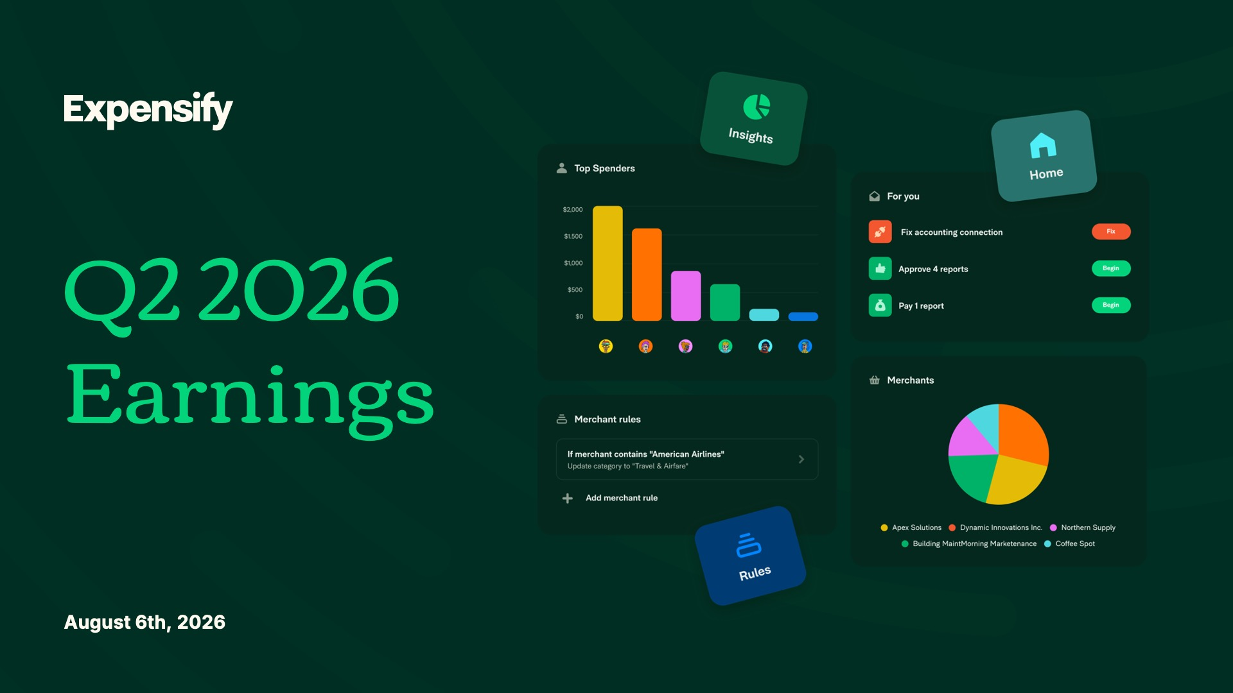

Exhibit 99.2
1
Expensify, Inc.
Investor Presentation



Exhibit 99.2
2
Expensify, Inc.
Investor Presentation



Exhibit 99.2
3
Expensify, Inc.
Investor Presentation

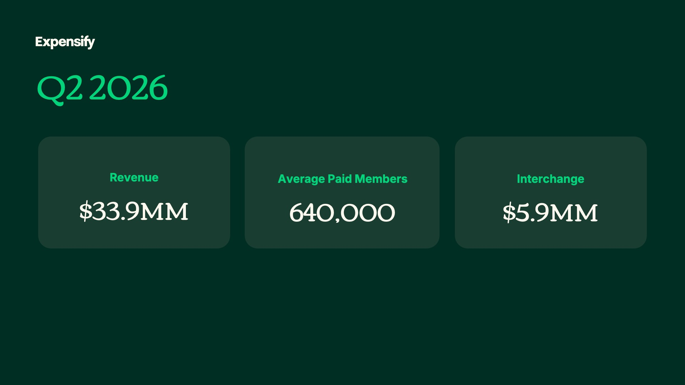

Exhibit 99.2
4
Expensify, Inc.
Investor Presentation

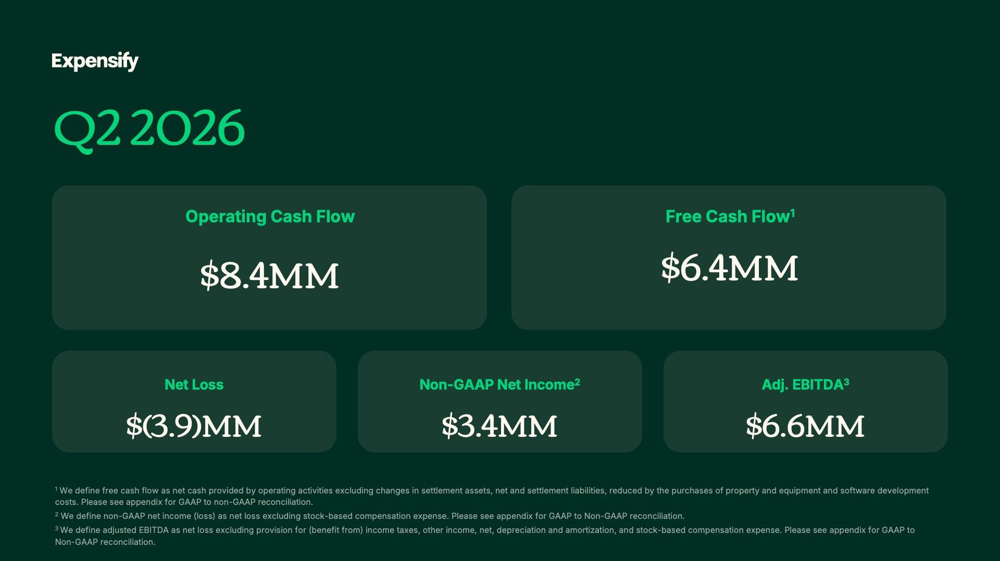

Exhibit 99.2
5
Expensify, Inc.
Investor Presentation

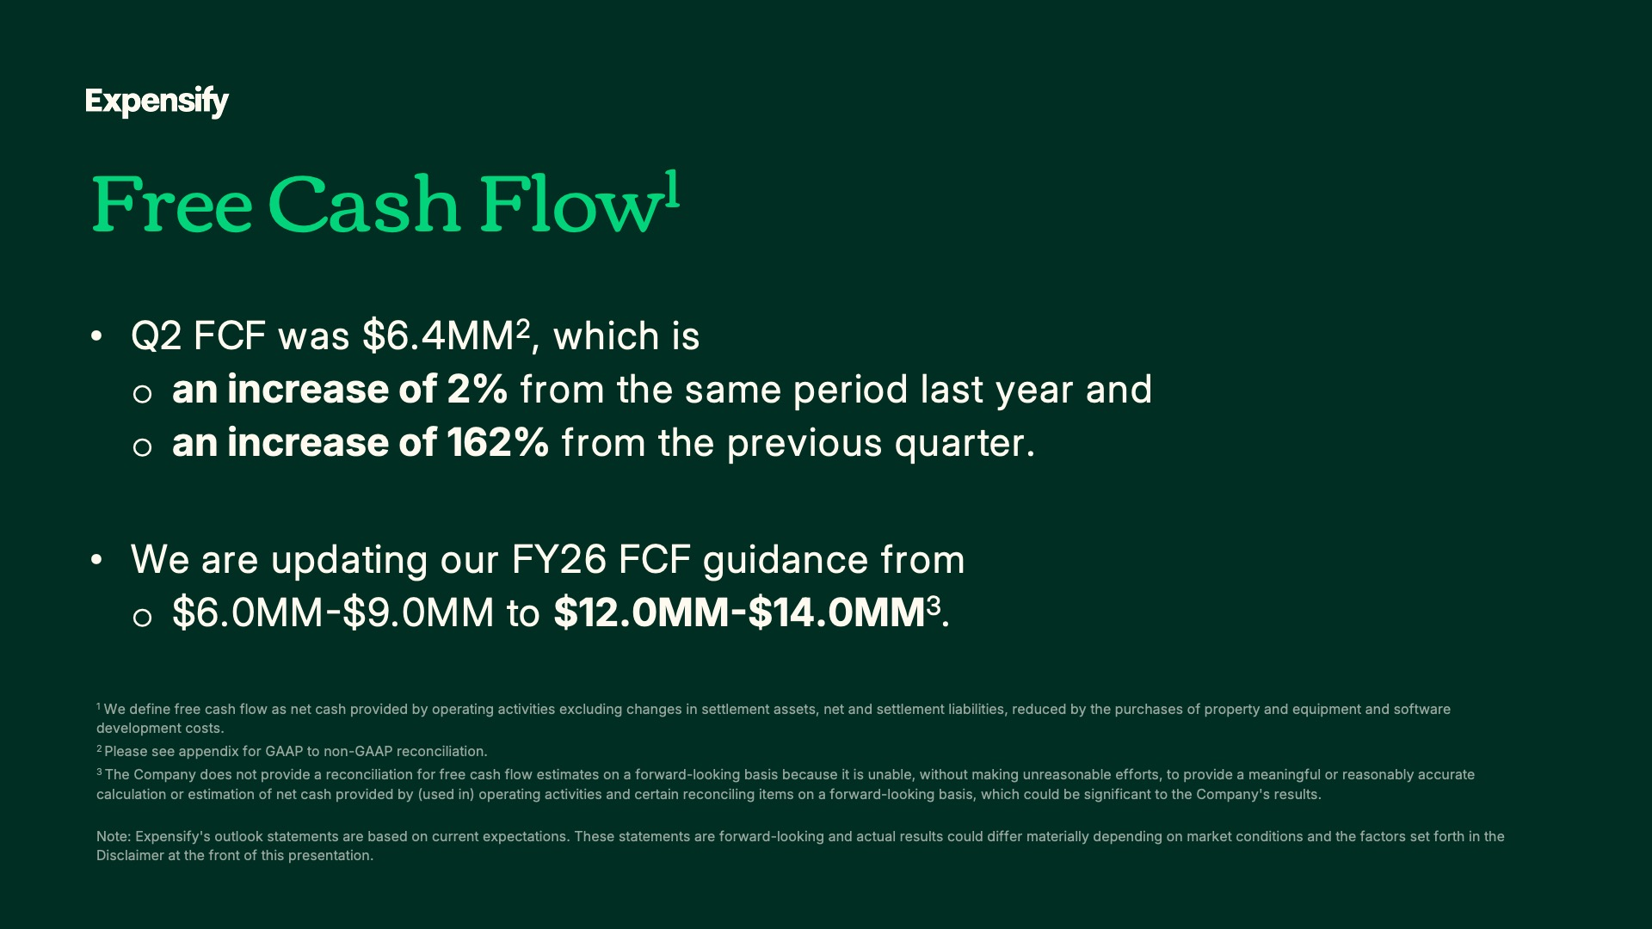

Exhibit 99.2
6
Expensify, Inc.
Investor Presentation

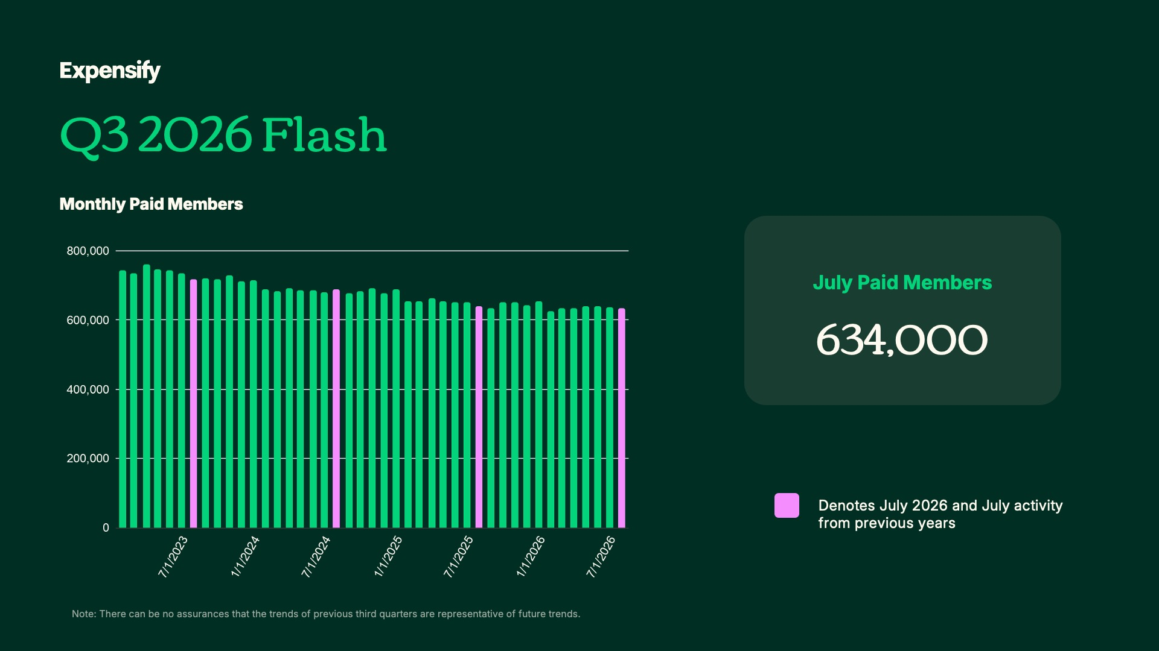

Exhibit 99.2
7
Expensify, Inc.
Investor Presentation

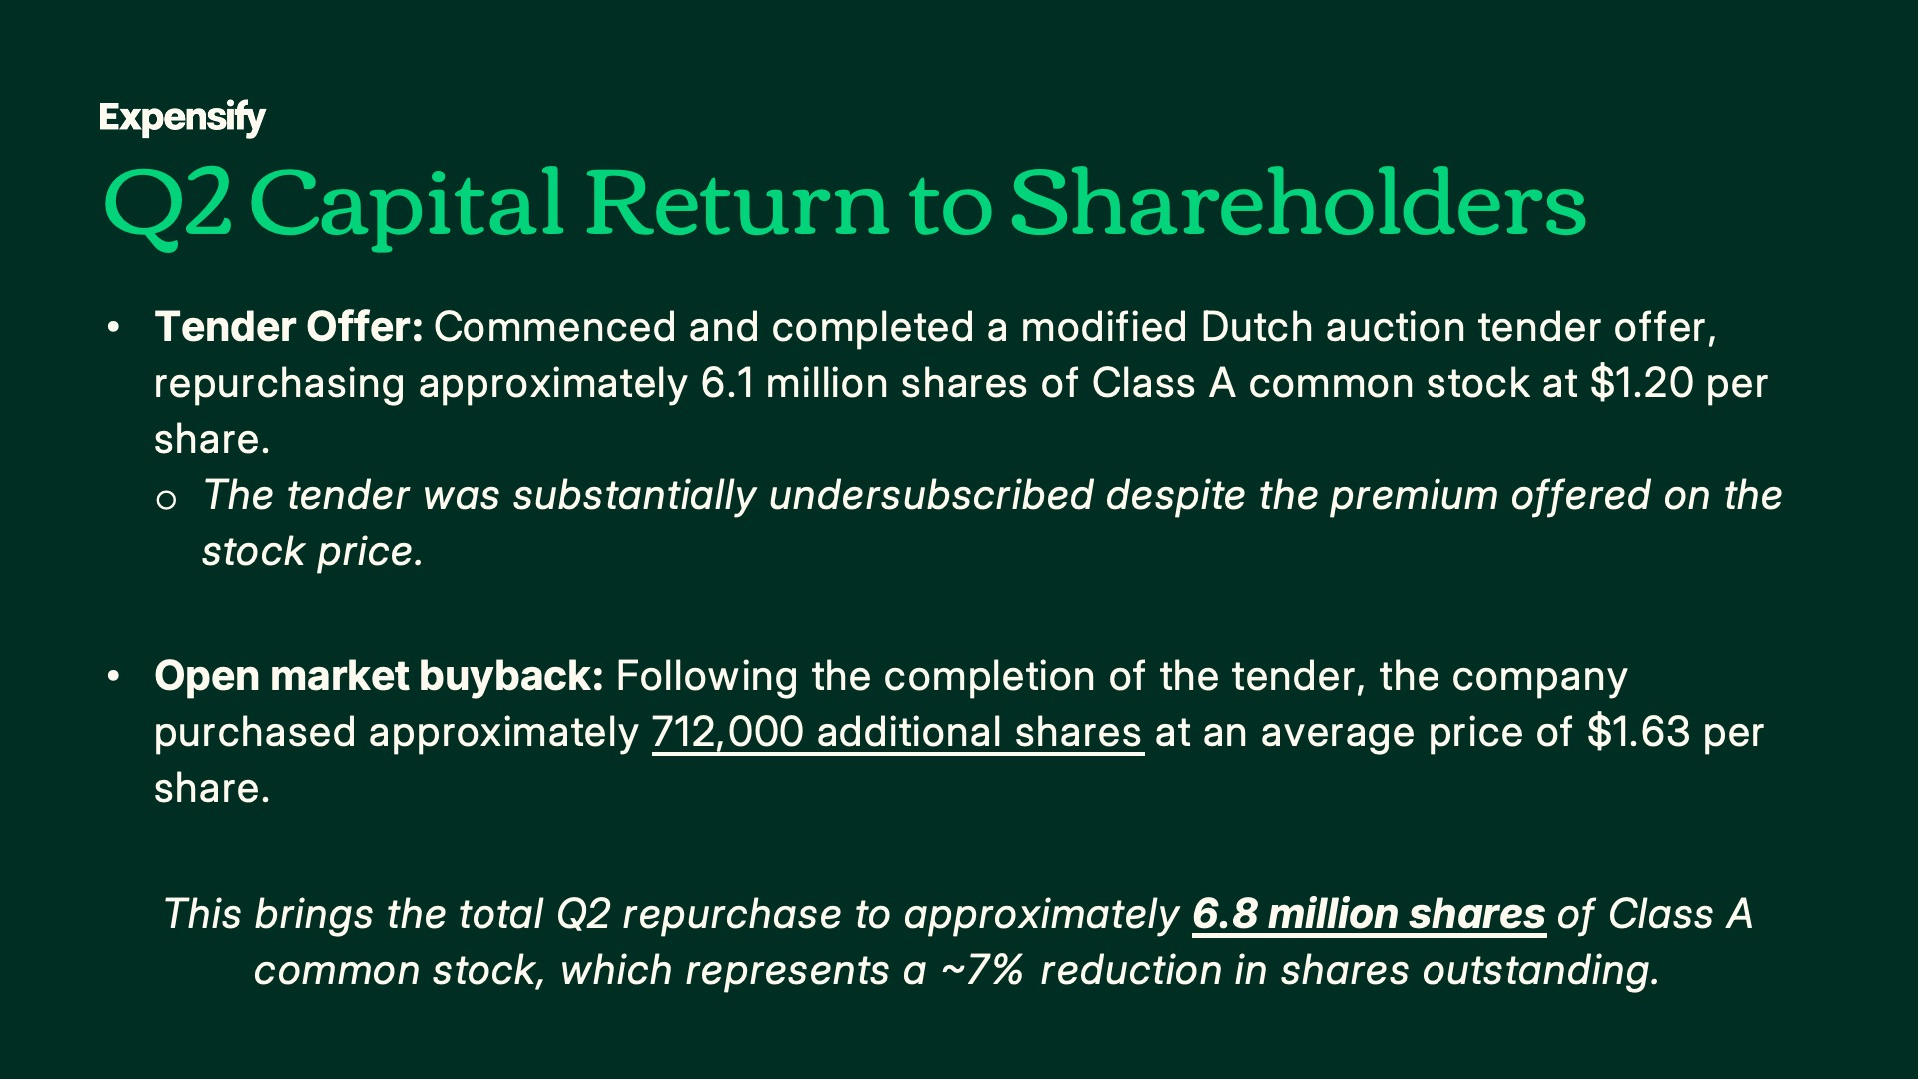

Exhibit 99.2
8
Expensify, Inc.
Investor Presentation



Exhibit 99.2
9
Expensify, Inc.
Investor Presentation


Exhibit 99.2
10
Expensify, Inc.
Investor Presentation

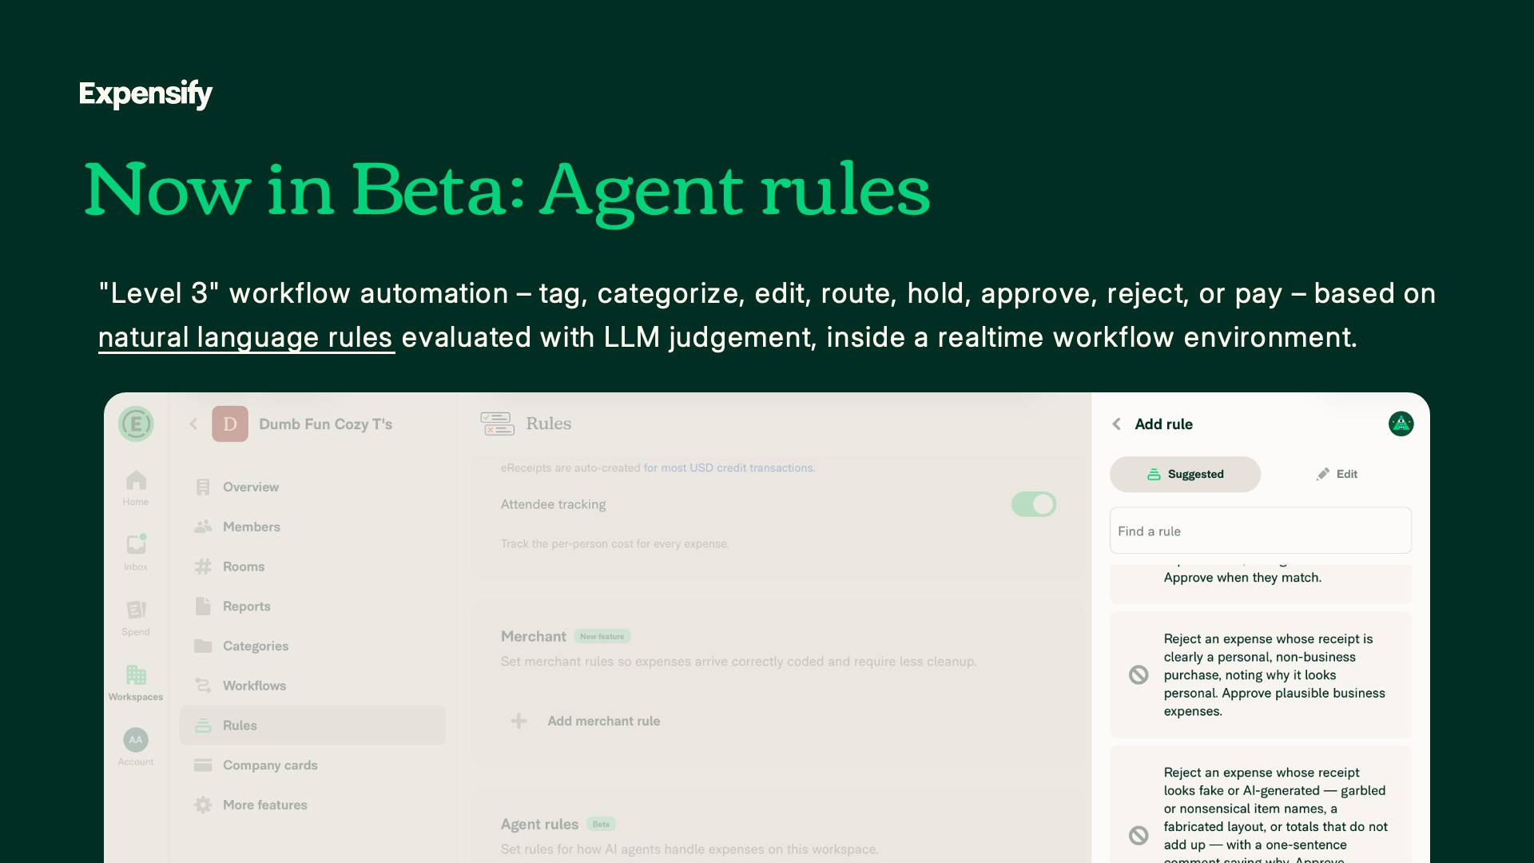
Exhibit 99.2
11
Expensify, Inc.
Investor Presentation

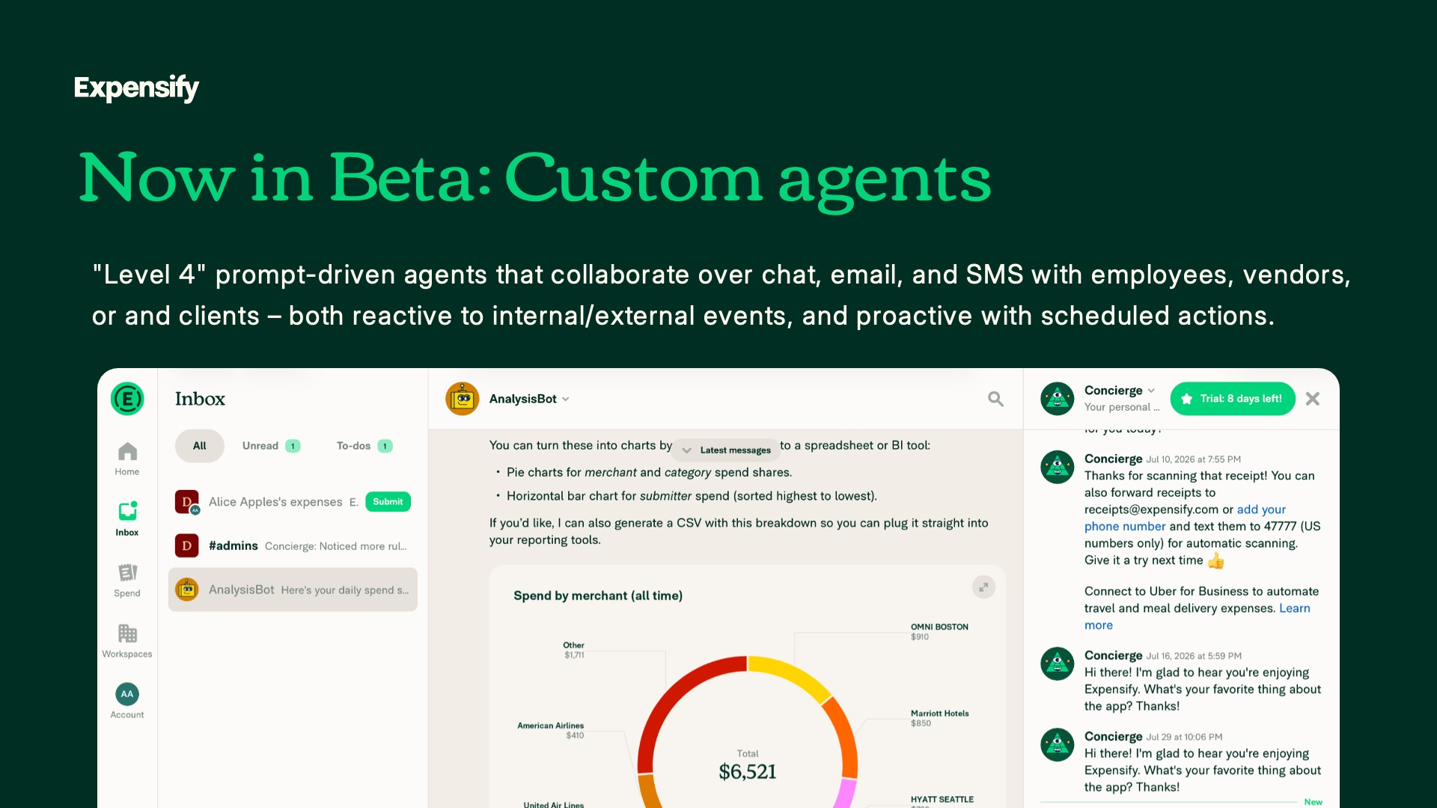
Exhibit 99.2
12
Expensify, Inc.
Investor Presentation

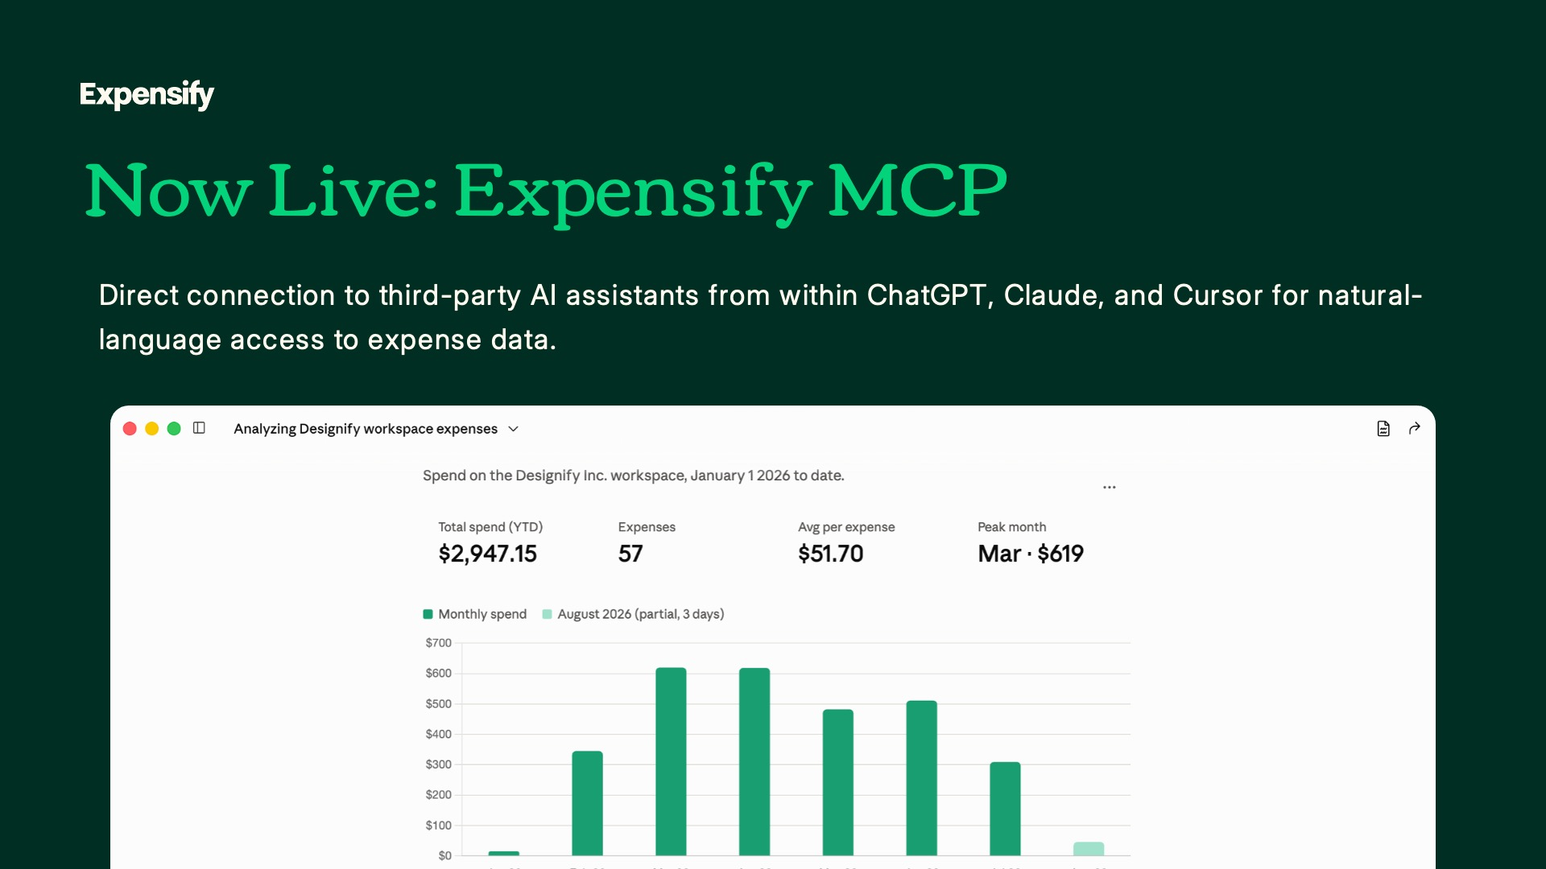
Exhibit 99.2
13
Expensify, Inc.
Investor Presentation

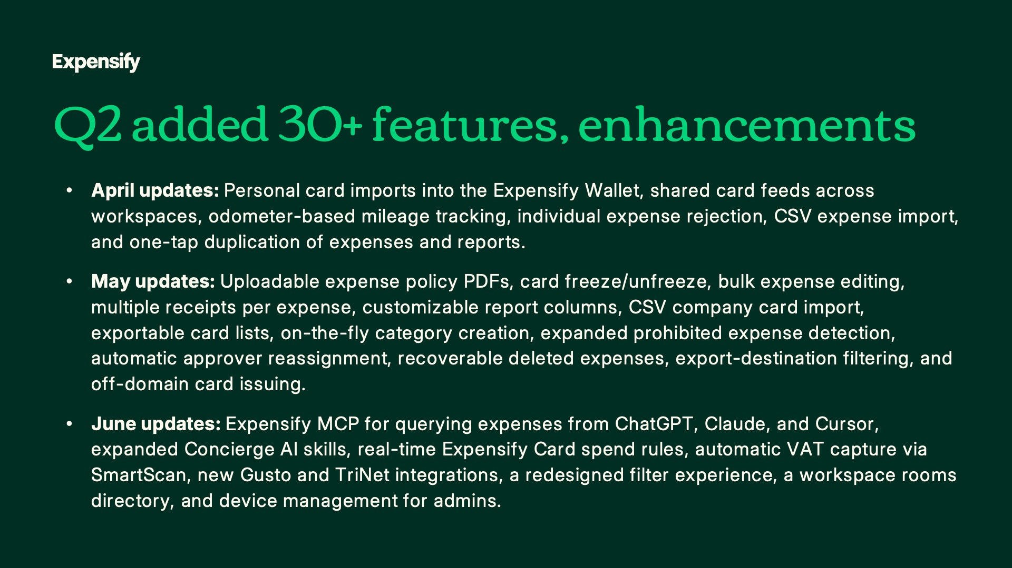
Exhibit 99.2
14
Expensify, Inc.
Investor Presentation


Exhibit 99.2
15
Expensify, Inc.
Investor Presentation


Exhibit 99.2
16
Expensify, Inc.
Investor Presentation

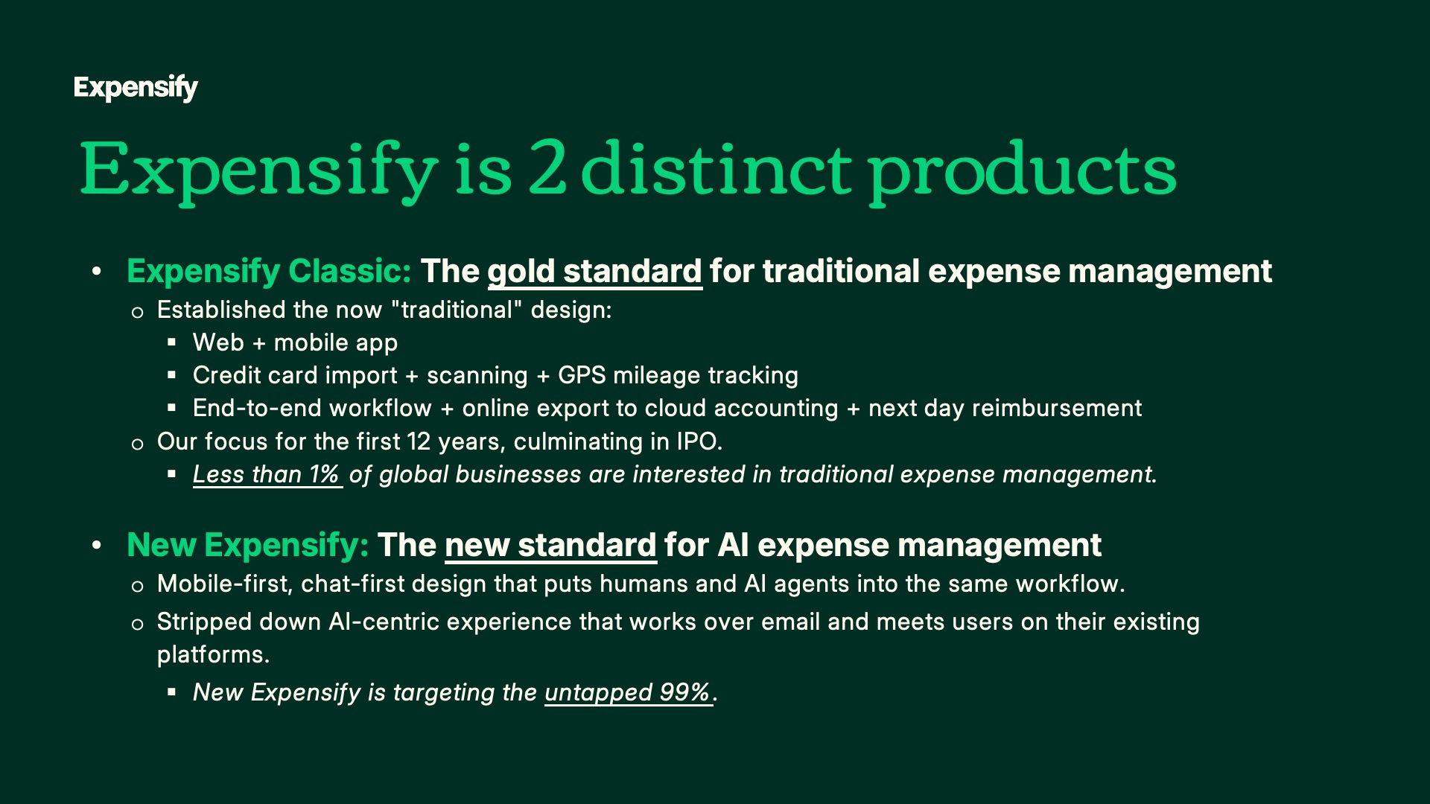
Exhibit 99.2
17
Expensify, Inc.
Investor Presentation

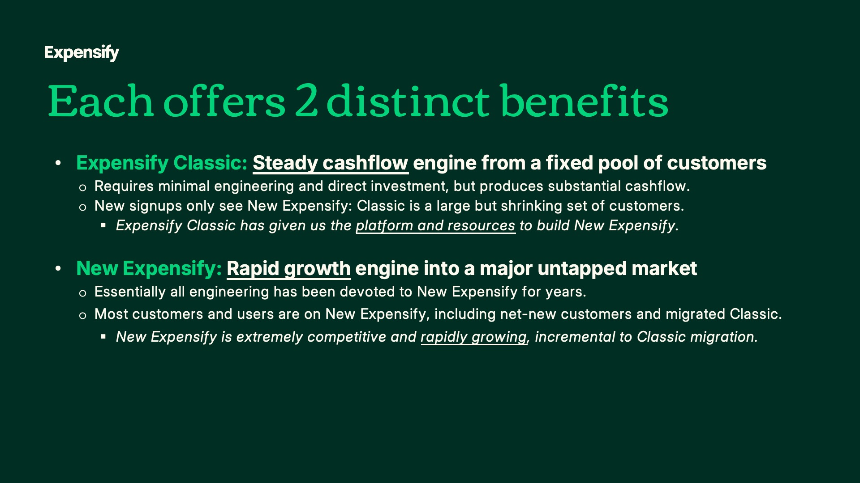
Exhibit 99.2
18
Expensify, Inc.
Investor Presentation

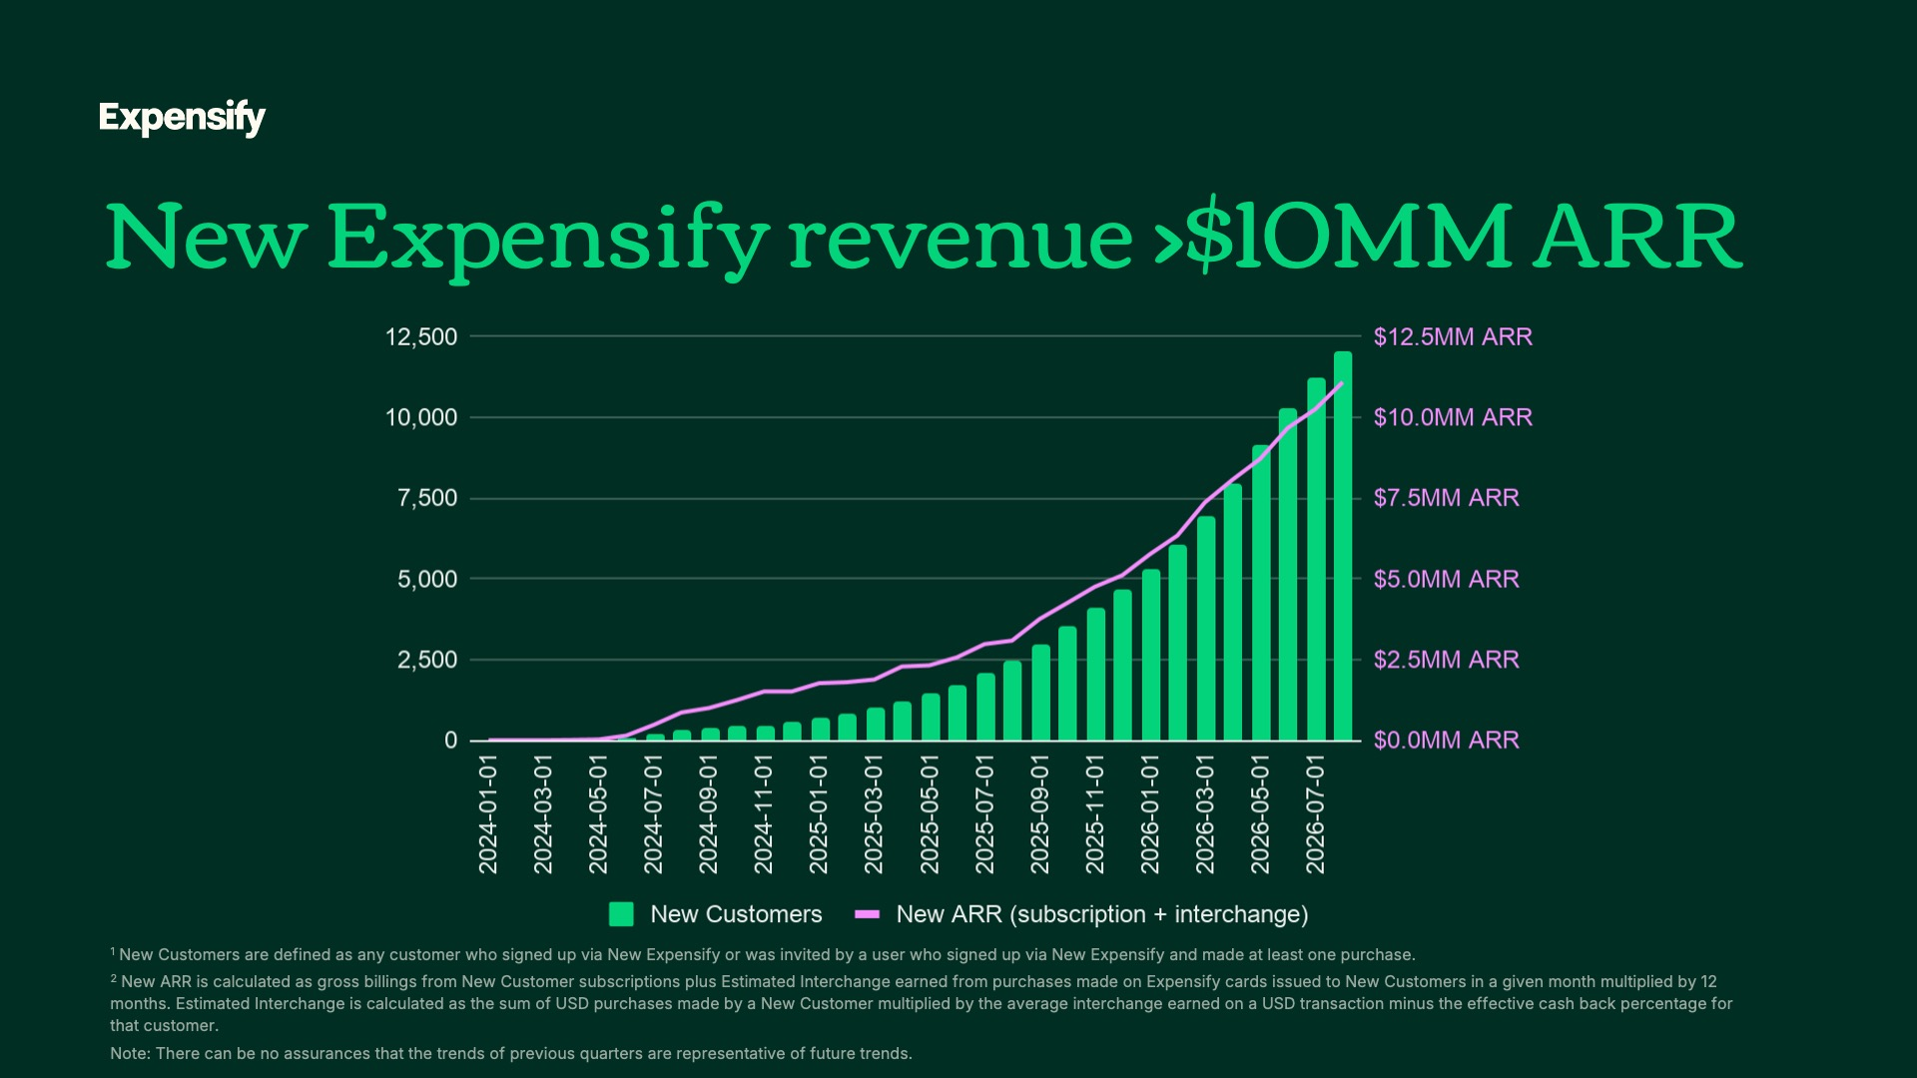
Exhibit 99.2
19
Expensify, Inc.
Investor Presentation

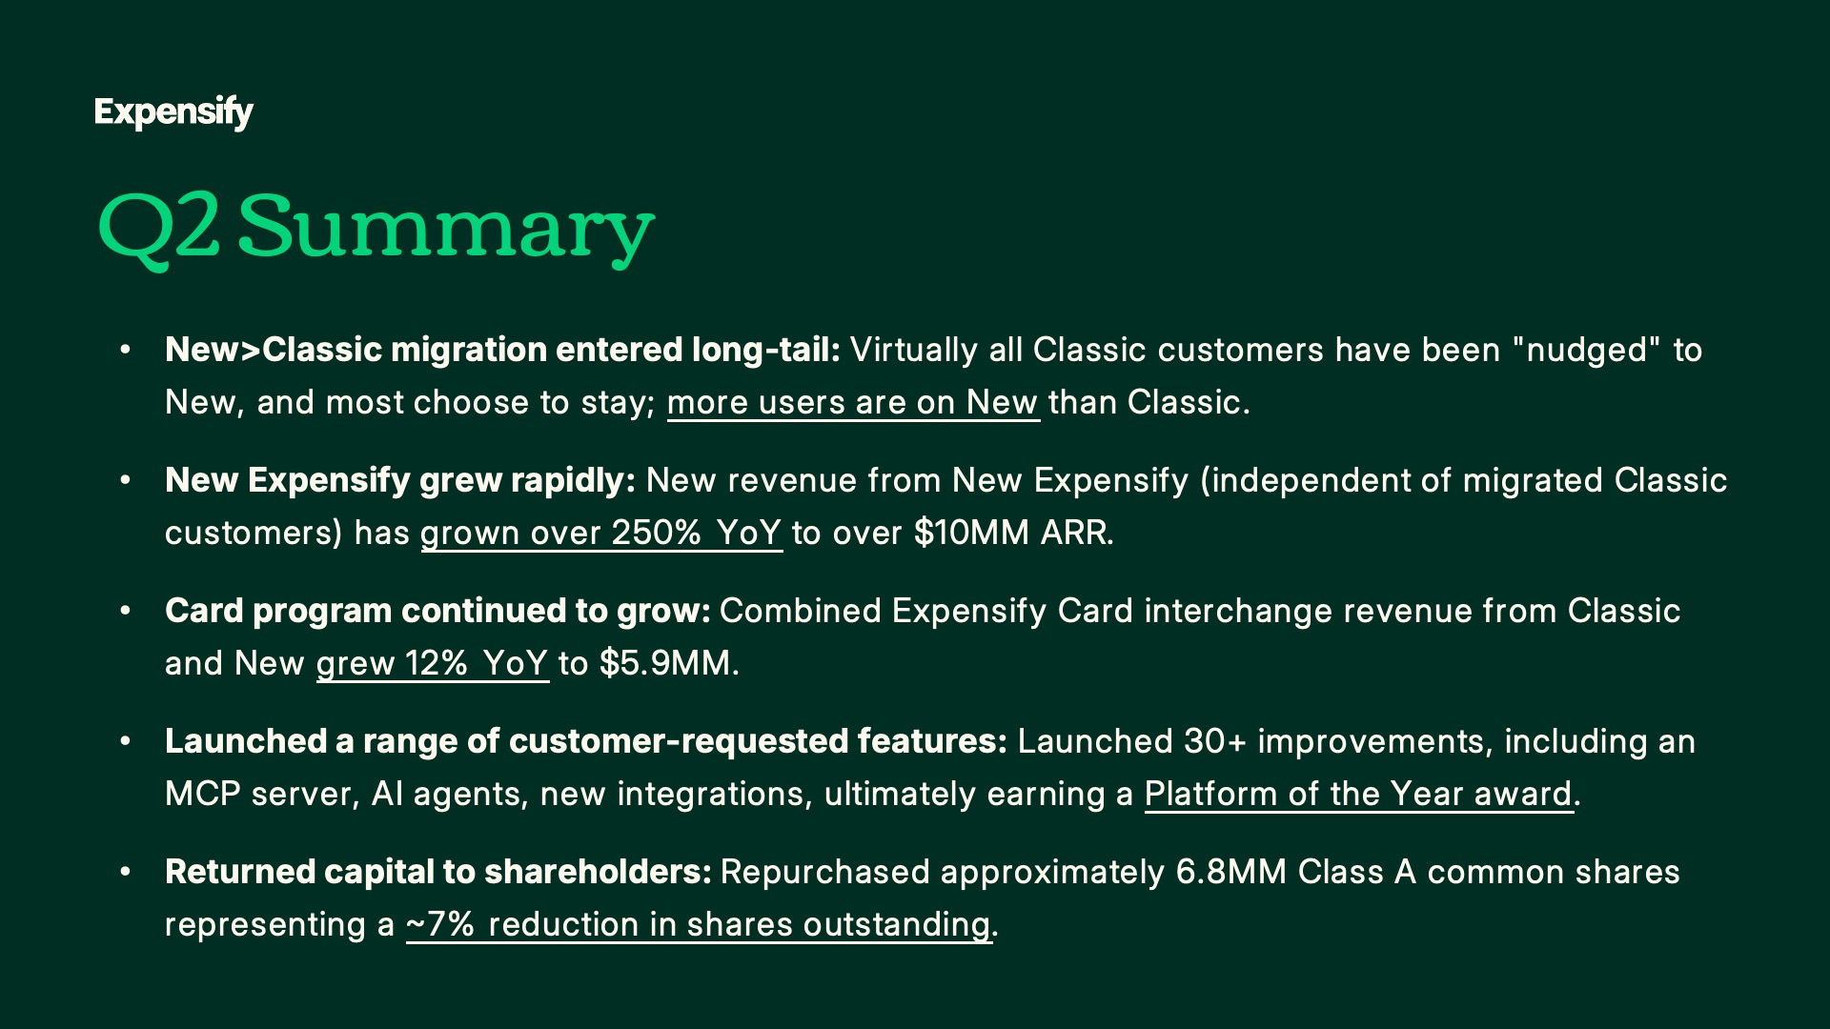

Exhibit 99.2
20
Expensify, Inc.
Investor Presentation



Exhibit 99.2
21
Expensify, Inc.
Investor Presentation



Exhibit 99.2
22
Expensify, Inc.
Investor Presentation



Exhibit 99.2
23
Expensify, Inc.
Investor Presentation

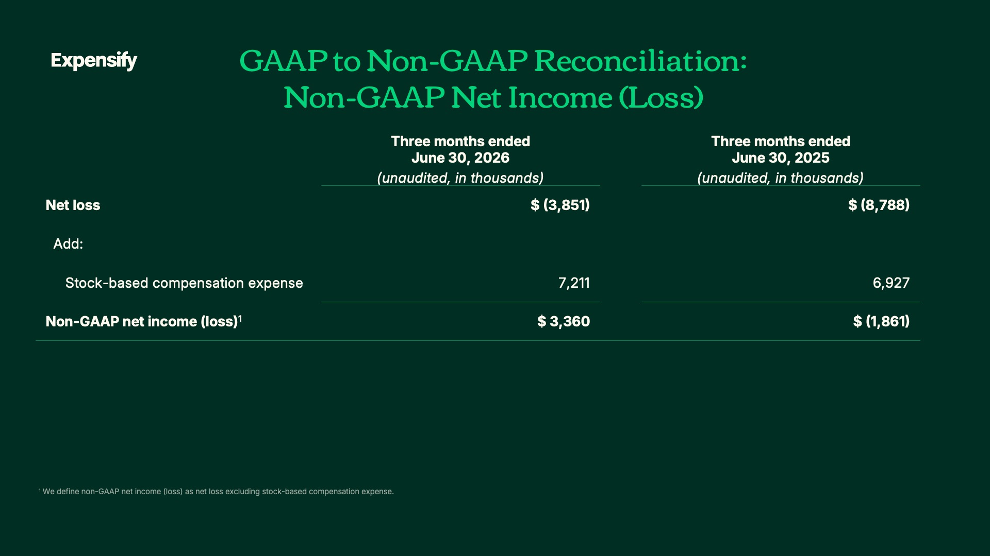

Exhibit 99.2
24
Expensify, Inc.
Investor Presentation

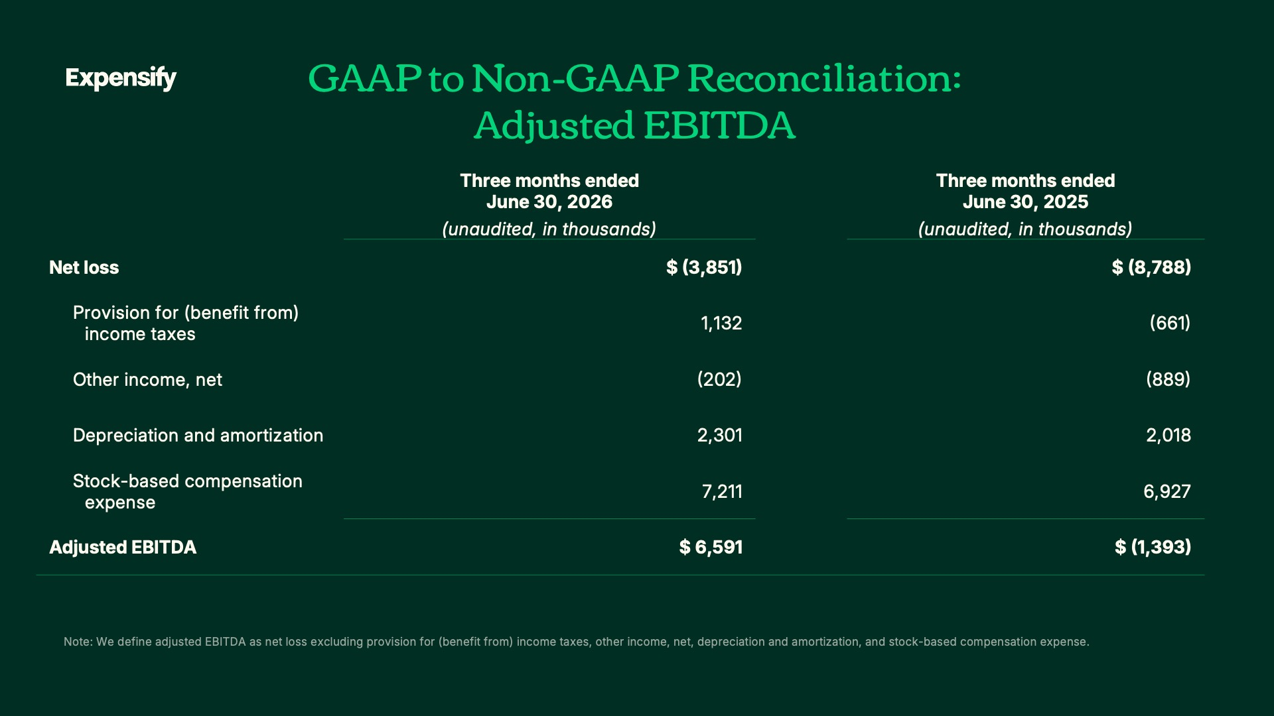

Exhibit 99.2
25
Expensify, Inc.
Investor Presentation

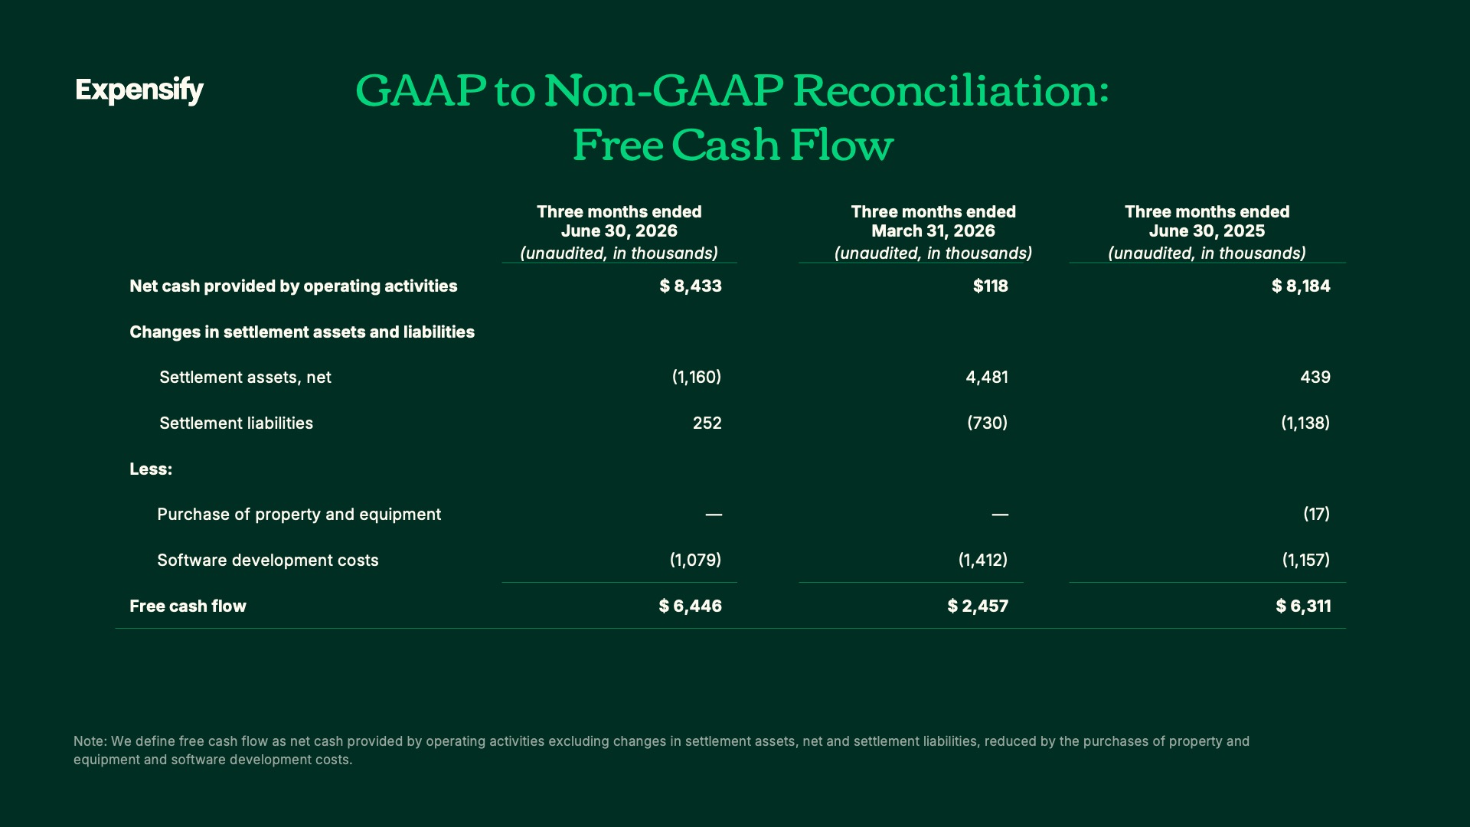

Exhibit 99.2
26
Expensify, Inc.
Investor Presentation

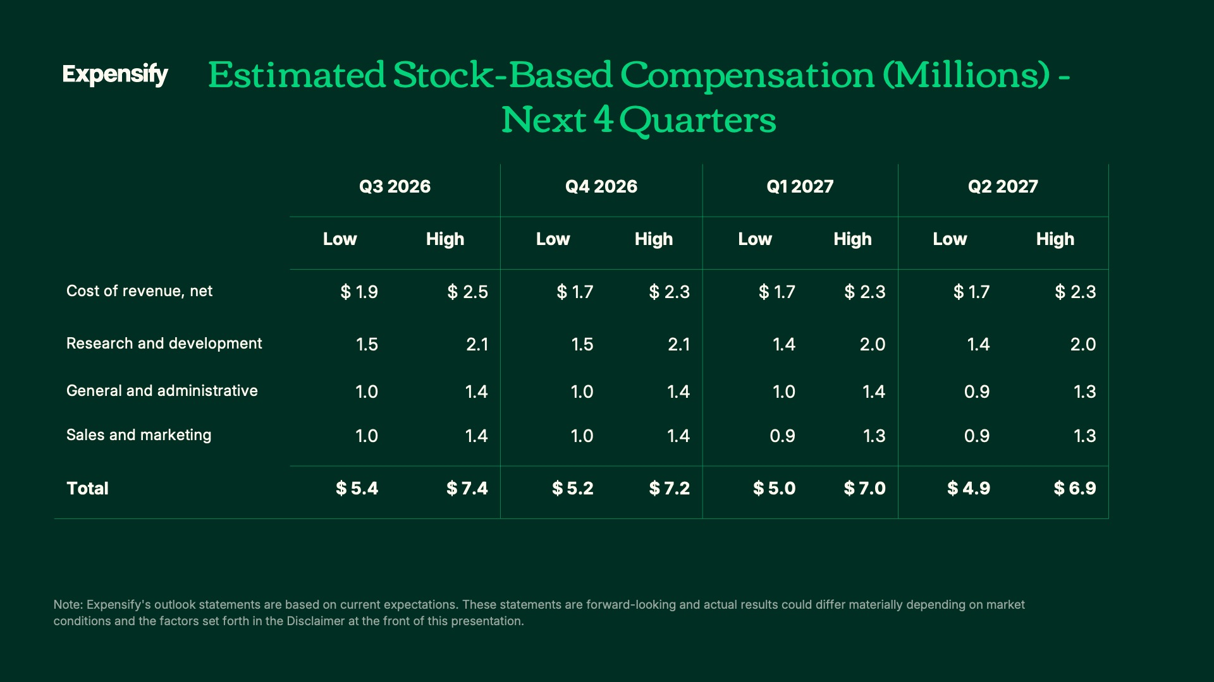

Exhibit 99.2
27
Expensify, Inc.
Investor Presentation

28

