UNITED STATES

SECURITIES AND EXCHANGE COMMISSION

Washington, D.C. 20549

FORM 8-K

CURRENT REPORT

PURSUANT TO SECTION 13 OR 15(d)

OF THE SECURITIES EXCHANGE ACT OF 1934

Date of report (Date of earliest event reported): August 8, 2024

Expensify, Inc.

 | (Exact Name of Registrant as Specified in its Charter)
Delaware | 001-41043 | 27-0239450
(State or Other Jurisdiction | (Commission | (IRS Employer
of Incorporation) | File Number) | Identification No.)
 | 401 SW 5th Ave
 | Portland, Oregon 97204
 | (Address of Principal Executive Offices) (Zip Code)
 | (971) 365-3939
 | (Registrant’s telephone number, including area code)
 | Not applicable
 | (Former Name or Former Address, if Changed Since Last Report)

Check the appropriate box below if the Form 8-K filing is intended to simultaneously satisfy the filing obligation of the registrant under any of the following provisions:

- Written communications pursuant to Rule 425 under the Securities Act (17 CFR 230.425).

- Soliciting material pursuant to Rule 14a-12 under the Exchange Act (17 CFR 240.14a-12).

- Pre-commencement communications pursuant to Rule 14d-2(b) under the Exchange Act (17 CFR 240.14d-2(b)).

- Pre-commencement communications pursuant to Rule 13e-4(c) under the Exchange Act (17 CFR 240.13e-4(c)).

Securities registered pursuant to Section 12(b) of the Act:

 |  | Trading |  | Name of each exchange
Title of each class |  | Symbol(s) |  | on which registered
Class A Common Stock, par value $0.0001 per share |  | EXFY |  | The Nasdaq Stock Market LLC

Indicate by check mark whether the registrant is an emerging growth company as defined in Rule 405 of the Securities Act of 1933 (§230.405 of this chapter) or Rule 12b-2 of the Securities Exchange Act of 1934 (§240.12b-2 of this chapter).

Emerging growth company ☐

If an emerging growth company, indicate by check mark if the registrant has elected not to use the extended transition period for complying with any new or revised financial accounting standards provided pursuant to Section 13(a) of the Exchange Act. ☐

Item 2.02 Results of Operations and Financial Condition.

On August 8, 2024, Expensify, Inc. (“Expensify” or the “Company”) issued a press release announcing its financial results for the quarter ended June 30, 2024. A copy of this press release is furnished as Exhibit 99.1 to this current report on Form 8-K and is incorporated herein by reference.

Item 7.01 Regulation FD Disclosure.

On August 8, 2024, the Company posted an investor presentation to its website at https://ir.expensify.com (the “Investor Presentation”). A copy of the Investor Presentation is furnished as Exhibit 99.2 to this current report on Form 8-K and is incorporated herein by reference. The Company expects to use the Investor Presentation, in whole or in part, and possibly with modifications, in connection with presentations to investors, analysts and others.
The information contained in the Investor Presentation is summary information that is intended to be considered in the context of the Company’s Securities and Exchange Commission (“SEC”) filings and other public announcements that the Company may make, by press release or otherwise, from time to time. The Investor Presentation speaks only as of the date of this current report on Form 8-K. The Company undertakes no duty or obligation to publicly update or revise the information included in the Investor Presentation, although it may do so from time to time. Any such updating may be made through the filing of other reports or documents with the SEC, through press releases or other public disclosure. In addition, the exhibit furnished herewith contains statements intended as “forward-looking statements” that are subject to the cautionary statements about forward-looking statements set forth in such exhibit. By furnishing the information contained in the Investor Presentation, the Company makes no admission as to the materiality of any information in the Investor Presentation that is required to be disclosed solely by reason of Regulation FD.

The information contained in Item 2.02 and this Item 7.01, including Exhibits 99.1 and 99.2, is being furnished and shall not be deemed “filed” for purposes of Section 18 of the Securities and Exchange Act of 1934, as amended (the “Exchange Act”), or otherwise subject to the liabilities of that section, nor shall it be deemed incorporated by reference in any filing made by Expensify under the Securities Act of 1933, as amended, or the Exchange Act, except as expressly set forth by specific reference in such a filing.

Item 9.01 Financial Statements and Exhibits.

- Exhibits.

Exhibit No. Description

99.1 Press Release issued by Expensify, Inc., dated August 8, 2024.

99.2 Investor Presentation, dated August 8, 2024.

104 Cover Page Interactive Data File (embedded within the Inline XBRL document).

SIGNATURE

Pursuant to the requirements of the Securities Exchange Act of 1934, the registrant has duly caused this report to be signed on its behalf by the undersigned hereunto duly authorized.

Expensify, Inc.

By: /s/ Ryan Schaffer

Name: Ryan Schaffer

Title: Chief Financial Officer

Date: August 8, 2024

Exhibit 99.1

EXPENSIFY ANNOUNCES Q2 2024 RESULTS

Interchange derived from the Expensify Card grew to $4.0 million, an increase of 48% as compared to the same period last year.

PORTLAND, Ore.--(BUSINESS WIRE)--August 8, 2024-- Expensify, Inc. (Nasdaq: EXFY), a payments superapp that helps individuals and businesses around the world simplify the way they manage money across expenses, corporate cards and bills, today released a letter to shareholders from Founder and CEO David Barrett alongside results for its quarter ended June 30, 2024.

A Message From Our Founder

I'm extremely pleased with how well Q2 has extended Q1's achievements and improved upon them further:

- Our core business has been stabilize, with increasing cash flow. Revenue and paid users are within 1% of last quarter – with quarterly interchange, operating cash flow, and free cash flow up 14%, 168% and 10% (48%, 2,247% and 399% y/y), respectively.

- The new Expensify Card program is live. Most active Expensify Card customers have already adopted the new program, and 34% of spend has already migrated to the new cards we've mailed out – which earns us 20% more interchange, and contributes directly to revenue. We are well on the way to our target of 100% adoption by EOY.

- New Expensify is live. We have returned to the conference circuit after a multi-year absence, with all messaging and demos focused exclusively on New Expensify. Development is no longer solely core development and now includes pipeline optimizations, and New Expensify is expected to add new revenue in Q3. We continue to make brisk progress on the combined business/consumer superapp experience in anticipation of our extremely visible product placement within Apple TV's biggest budget movie ever, scheduled to be in theaters June 2025.

- Hybrid app is live. This is an incredibly difficult and important technical milestone that allows us to upgrade existing apps deployed on millions of devices worldwide in order to switch interchangeably between New Expensify and Expensify Classic. This is a critical tool for seamlessly migrating existing customers on a selective basis to the new experience, while allowing existing customers with classic functionality that has not yet been updated to remain on their existing experience. The hybrid app is being rolled out globally.

- Expensify Travel is live. We have launched our travel product to new and existing customers, and is expected to generate an entirely new revenue stream of travel bookings in Q3.

This quarter did a fantastic job laying a clear foundation for future growth, and the excitement inside our (virtual) halls is palpable. Hit me up at our booth at Xerocon or SuiteWorld to see the New Expensify pitch in person!

-david

Founder and CEO of Expensify

Exhibit 99.1

Second Quarter 2024 Highlights

Financial:

- Revenue was $33.3 million, a decrease of 14% compared to the same period last year.

- Generated $9.3 million cash from operating activities.

- Free cash flow was $5.7 million.

- Net loss was $2.8 million, compared to $11.3 million for the same period last year.

- Non-GAAP net income was $5.6 million.

- Adjusted EBITDA was $10.2 million.

- Interchange derived from the Expensify Card grew to $4.0 million, an increase of 48% compared to the same period last year.

- See Financial Outlook section for Free Cash Flow guidance for fiscal year ending December 31, 2024.

Business:

- Paid members - Paid members were 684,000, a decrease of 8% from the same period last year.

- New Expensify Card program - The majority of active Expensify Card customers began transitioning to the new program, with 34% of spend migrated by end of Q2.

- New Expensify - The company began supporting businesses on New Expensify that is expected to generate revenue beginning in Q3 2024.

- New Integrations - Expensify launched integrations with QuickBooks Online and Xero on New Expensify, a major milestone to support customers on the new platform.

- Sales and marketing - The company announced a partnership with Apple for lead product placement in Apple's largest feature film investment ever, F1, set to release in June 2025.

- Corporate travel - The company returned to the travel conference circuit to demo Expensify Travel — its corporate travel management platform built for the midsized and small-cap enterprise market — at GBTA, the world's foremost corporate travel event.

Exhibit 99.1

Financial Outlook

Expensify's outlook statements are based on current estimates, expectations and assumptions and are not a guarantee of future performance. The following statements are forward-looking and actual results could differ materially depending on market conditions and the factors set forth under “Forward-Looking Statements” below. There can be no assurance that the Company will achieve the results expressed by this guidance.

Free Cash Flow

Expensify estimates Free Cash Flow of $15.0 million to $16.0 million for the fiscal year ending December 31, 2024.

The Company does not provide a reconciliation for free cash flow estimates on a forward-looking basis because it is unable, without making unreasonable efforts, to provide a meaningful or reasonably accurate calculation or estimation of net cash provided by operating activities and certain reconciling items on a forward-looking basis, which could be significant to the Company's results.

Stock Based Compensation

An estimate of expected stock-based compensation for the next four fiscal quarters is as follows, which is driven primarily by the pre-IPO grant of RSUs issued to all employees (which vest quarterly over eight years with approximately five years remaining).

Est. stock-based compensation (millions)

 |  | Q3 2024 |  |  |  |  |  | Q4 2024 |  |  |  |  |  | Q1 2025 |  |  |  |  |  | Q2 2025
 | Low |  |  |  | High |  |  | Low |  |  | High |  |  | Low |  |  | High |  |  | Low |  |  | High
Cost of revenue, net | $ | 2.4 |  | $ | 3.1 |  | $ | 2.3 |  | $ | 3.0 |  | $ | 2.2 |  | $ | 2.9 |  | $ | 1.9 |  | $ | 2.6
Research and development |  | 3.2 |  |  | 4.0 |  |  | 3.1 |  |  | 3.9 |  |  | 2.9 |  |  | 3.7 |  |  | 2.5 |  |  | 3.3
General and administrative |  | 1.2 |  |  | 1.5 |  |  | 1.2 |  |  | 1.5 |  |  | 1.1 |  |  | 1.4 |  |  | 1.0 |  |  | 1.3
Sales and marketing |  | 0.5 |  |  | 0.7 |  |  | 0.5 |  |  | 0.7 |  |  | 0.4 |  |  | 0.6 |  |  | 0.4 |  |  | 0.6
Total | $ | 7.3 |  | $ | 9.3 |  | $ | 7.1 |  | $ | 9.1 |  | $ | 6.6 |  | $ | 8.6 |  | $ | 5.8 |  | $ | 7.8

Availability of Information on Expensify’s Website

Investors and others should note that Expensify routinely announces material information to investors and the marketplace using SEC filings, press releases, public conference calls, webcasts and the Expensify Investor Relations website at https://ir.expensify.com. While not all of the information that the Company posts to its Investor Relations website is of a material nature, some information could be deemed to be material. Accordingly, the Company encourages investors, the media and others interested in Expensify to review the information that it shares on its Investor Relations website.

Conference Call

Expensify will host a video call to discuss the financial results and business highlights at 2:00 p.m. Pacific Time today. An investor presentation and the video call information is available on Expensify’s Investor Relations website at https://ir.expensify.com. A replay of the call will be available on the site for three months.

Non-GAAP Financial Measures

In addition to financial measures prepared in accordance with U.S. generally accepted accounting principles (“GAAP”), we provide certain non-GAAP financial measures, including adjusted EBITDA, non-GAAP net loss, and free cash flow.

We believe our non-GAAP financial measures are useful in evaluating our business, measuring our performance, identifying trends affecting our business, formulating business plans and making strategic decisions. Accordingly,

Exhibit 99.1

we believe that these non-GAAP financial measures provide useful information to investors and others in understanding and evaluating our results of operations in the same manner as our management team. These non-GAAP financial measures are presented for supplemental informational purposes only, should not be considered a substitute for financial information presented in accordance with GAAP, and may be different from similarly titled metrics or measures presented by other companies. Non-GAAP financial measures have limitations as analytical tools and should not be considered in isolation or as substitutes for financial information presented under GAAP. There are a number of limitations related to the use of non-GAAP financial measures versus comparable financial measures determined under GAAP. For example, other companies in our industry may calculate these non-GAAP financial measures differently or may use other measures to evaluate their performance. All of these limitations could reduce the usefulness of these non-GAAP financial measures as analytical tools. Investors are encouraged to review the related GAAP financial measures and the reconciliations of these non-GAAP financial measures to their most directly comparable GAAP financial measures and to not rely on any single financial measure to evaluate our business. A reconciliation of each non-GAAP financial measure to the most directly comparable financial measure stated in accordance with GAAP is at the end of this press release.

Adjusted EBITDA. We define adjusted EBITDA as net loss from operations excluding provision for income taxes, interest and other expenses, net, depreciation and amortization, and stock-based compensation.

Non-GAAP net income. We define non-GAAP net income as net loss from operations excluding stock-based compensation.

Free cash flow. We define Free cash flow as net cash provided by operating activities excluding changes in settlement assets and settlement liabilities, which represent funds held for customers and customer funds in transit, respectively, reduced by the purchases of property and equipment and software development costs.

The tables at the end of the Condensed Consolidated Financial Statements provide reconciliations to the most directly comparable GAAP financial measure to each of these non-GAAP financial measures.

Forward-Looking Statements

Forward-looking statements in this press release, or made during the earnings call, which are not historical facts, are forward-looking statements within the meaning of the Private Securities Litigation Reform Act of 1955. These statements include statements regarding our strategy, future financial condition, future operations, future cash flow, projected costs, prospects, plans, objectives of management and expected market growth, product developments and their potential impact and our stock-based compensation estimates and involve known and unknown risks that are difficult to predict. As a result, our actual results, performance or achievements may differ materially from those expressed or implied by these forward-looking statements. In some cases, you can identify forward-looking statements because they contain words such as “may,” “will,” “shall,” “should,” “expects,” “plans,” “anticipates,” “could,” “intends,” “target,” “projects,” “contemplates,” “believes,” “estimates,” “predicts,” “potential,” “goal,” “ambition,” “objective,” “seeks,” “outlook,” or “continue” or the negative of these words or other similar terms or expressions that concern our expectations, strategy, plans, or intentions. Such forward-looking statements are necessarily based upon estimates and assumptions that, while considered reasonable by us and our management, are inherently uncertain. Factors that may cause actual results to differ materially from current expectations include, but are not limited to: the impact on inflation on us and our members; our borrowing costs have and may continue to increase as a result of increases in interest rates; our expectations regarding our financial performance and future operating performance; our ability to attract and retain members, expand usage of our platform, sell subscriptions to our platform and convert individuals and organizations into paying customers; the timing and success of new features, integrations, capabilities and enhancements by us, or by competitors to their products, or any other changes in the competitive landscape of our market; the amount and timing of operating expenses and capital expenditures that we may incur to maintain and expand our business and operations to remain competitive; the sufficiency of our cash, cash equivalents and investments to meet our liquidity needs; our ability to make required payments under and to comply with the various requirements of our current and future indebtedness; our cash flows, the prevailing stock prices, general economic and market conditions and other considerations that could affect the specific timing, price and size of repurchases under our stock repurchase program or our ability to fund any stock repurchases;

Exhibit 99.1

geopolitical tensions, including the war in Ukraine and the escalating conflict in Israel, Gaza and surrounding areas; our ability to effectively manage our exposure to fluctuations in foreign currency exchange rates; the expenses associated with being a public company; the size of our addressable markets, market share and market trends; anticipated trends, developments and challenges in our industry, business and the highly competitive markets in which we operate; our expectations regarding our income tax liabilities and the adequacy of our reserves; our ability to effectively manage our growth and expand our infrastructure and maintain our corporate culture; our ability to identify, recruit and retain skilled personnel, including key members of senior management; the safety, affordability and convenience of our platform and our offerings; our ability to successfully defend litigation brought against us; our ability to successfully identify, manage and integrate any existing and potential acquisitions of businesses, talent, technologies or intellectual property; general economic conditions in either domestic or international markets, and geopolitical uncertainty and instability, including as a result of the 2024 United States presidential election; our protections against security breaches, technical difficulties, or interruptions to our platform; our ability to maintain, protect and enhance our intellectual property; and other risks discussed in our filings with the SEC. All forward-looking statements attributable to us or persons acting on our behalf are expressly qualified in their entirety by the cautionary statements set forth above. We caution you not to place undue reliance on any forward-looking statements, which are made only as of the date of this press release. We do not undertake or assume any obligation to update publicly any of these forward-looking statements to reflect actual results, new information or future events, changes in assumptions or changes in other factors affecting forward-looking statements, except to the extent required by applicable law. If we update one or more forward-looking statements, no inference should be drawn that we will make additional updates with respect to those or other forward-looking statements.

About Expensify

Expensify is a payments superapp that helps individuals and businesses around the world simplify the way they manage money. More than 12 million people use Expensify's free features, which include corporate cards, expense tracking, next-day reimbursement, invoicing, bill pay, and travel booking in one app. All free. Whether you own a small business, manage a team, or close the books for your clients, Expensify makes it easy so you have more time to focus on what really matters.

Investor Relations Contact

Nick Tooker

investors@expensify.com

Press Contact

James Dean

press@expensify.com

Expensify, Inc.

Condensed Consolidated Balance Sheets

(unaudited, in thousands, except share data)

 |  | As of June 30, |  |  | As of December 31,
 |  | 2024 |  |  | 2023
Assets
Cash and cash equivalents | $ | 53,234 |  | $ | 47,510
Accounts receivable, net |  | 13,420 |  |  | 13,834
Settlement assets, net |  | 48,301 |  |  | 39,261
Prepaid expenses |  | 8,768 |  |  | 5,649
Other current assets |  | 32,044 |  |  | 30,978
Total current assets |  | 155,767 |  |  | 137,232
Capitalized software, net |  | 16,006 |  |  | 12,494
Property and equipment, net |  | 13,905 |  |  | 14,372
Lease right-of-use assets |  | 5,783 |  |  | 6,435
Deferred tax assets, net |  | 487 |  |  | 457
Other assets |  | 924 |  |  | 5,794
Total assets | $ | 192,872 |  | $ | 176,784
Liabilities and stockholders' equity
Accounts payable | $ | 1,022 |  | $ | 1,425
Accrued expenses and other liabilities |  | 7,853 |  |  | 9,390
Borrowings under line of credit |  | 15,000 |  |  | 15,000
Current portion of long-term debt, net of original issue discount and debt issuance costs |  | 7,592 |  |  | 7,655
Lease liabilities, current |  | 461 |  |  | 432
Settlement liabilities |  | 38,877 |  |  | 33,990
Total current liabilities |  | 70,805 |  |  | 67,892
Lease liabilities, non-current |  | 6,118 |  |  | 6,467
Other liabilities |  | 1,949 |  |  | 1,681
Total liabilities |  | 78,872 |  |  | 76,040
Commitments and contingencies
Stockholders' equity:
Preferred stock, par value $0.0001; 10,000,000 shares of preferred stock authorized as of June 30, 2024 and December 31, 2023; no shares of preferred stock
issued and outstanding as of June 30, 2024 and December 31, 2023 |  | — |  |  | —
Common stock, par value $0.0001; 1,000,000,000 shares of Class A common stock authorized as of June 30, 2024 and December 31, 2023; 74,773,581 and
70,569,815 shares of Class A common stock issued and outstanding as of June 30, 2024 and December 31, 2023, respectively; 24,994,705 and 24,994,989
shares of LT10 common stock authorized as of June 30, 2024 and December 31, 2023, respectively; 5,923,033 and 7,333,619 shares of LT10 common
stock issued and outstanding as of June 30, 2024 and December 31, 2023, respectively; 24,969,634 and 24,998,941 shares of LT50 common stock
authorized as of June 30, 2024 and December 31, 2023, respectively; 7,498,076 and 7,321,894 shares of LT50 common stock issued and outstanding as of
June 30, 2024 and December 31, 2023, respectively |  | 9 |  |  | 8
Additional paid-in capital |  | 261,309 |  |  | 241,509
Accumulated deficit |  | (147,318) |  |  | (140,773)
Total stockholders' equity |  | 114,000 |  |  | 100,744
Total liabilities and stockholders' equity | $ | 192,872 |  | $ | 176,784

Expensify, Inc.

Condensed Consolidated Statements of Operations

(unaudited, in thousands, except share and per share data)

 |  | Three Months Ended June 30, |  |  |  |  |  | Six Months Ended June 30,
 |  | 2024 |  |  | 2023 |  |  | 2024 |  |  | 2023
Revenue | $ | 33,288 |  | $ | 38,884 |  | $ | 66,823 |  | $ | 78,985
Cost of revenue, net ⁽¹⁾ |  | 14,363 |  |  | 16,925 |  |  | 28,947 |  |  | 32,700
Gross margin |  | 18,925 |  |  | 21,959 |  |  | 37,876 |  |  | 46,285
Operating expenses:
Research and development ⁽¹⁾ |  | 6,389 |  |  | 5,094 |  |  | 12,318 |  |  | 10,512
General and administrative ⁽¹⁾ |  | 9,245 |  |  | 11,712 |  |  | 20,676 |  |  | 24,141
Sales and marketing ⁽¹⁾ |  | 3,072 |  |  | 14,714 |  |  | 6,456 |  |  | 23,897
Total operating expenses |  | 18,706 |  |  | 31,520 |  |  | 39,450 |  |  | 58,550
Income (loss) from operations |  | 219 |  |  | (9,561) |  |  | (1,574) |  |  | (12,265)
Interest and other expenses, net |  | (260) |  |  | (1,367) |  |  | (1,214) |  |  | (2,783)
Loss before income taxes |  | (41) |  |  | (10,928) |  |  | (2,788) |  |  | (15,048)
Provision for income taxes |  | (2,723) |  |  | (376) |  |  | (3,757) |  |  | (2,201)
Net loss | $ | (2,764) |  | $ | (11,304) |  | $ | (6,545) |  | $ | (17,249)
Net loss per share:
Basic and diluted | $ | (0.03) |  | $ | (0.14) |  | $ | (0.08) |  | $ | (0.21)
Weighted average shares of common stock used to compute net
loss per share:
Basic and diluted |  | 86,593,955 |  |  | 82,011,477 |  |  | 85,867,683 |  |  | 81,890,624

- Includes stock-based compensation expense as follows:

Three Months Ended June 30,

2024 2023

Six months ended June 30,

2024 2023

Cost of revenue, net | $ | 2,886 |  | $ | 3,600 |  | $ | 5,818 |  | $ | 6,906
Research and development |  | 3,144 |  |  | 2,455 |  |  | 5,894 |  |  | 4,661
General and administrative |  | 1,703 |  |  | 2,376 |  |  | 3,405 |  |  | 5,020
Sales and marketing |  | 648 |  |  | 1,910 |  |  | 788 |  |  | 3,758
Total stock-based compensation expense | $ | 8,381 |  | $ | 10,341 |  | $ | 15,905 |  | $ | 20,345

Expensify, Inc.

Condensed Consolidated Statements of Cash Flows

(unaudited, in thousands)

 |  | Six Months Ended June 30,
 | 2024 |  |  |  | 2023
Cash flows from operating activities:
Net loss | $ | (6,545) |  | $ | (17,249)
Adjustments to reconcile net loss to net cash provided by operating activities:
Depreciation and amortization |  | 3,053 |  |  | 2,789
Reduction of operating lease right-of-use assets |  | 273 |  |  | 334
Loss on impairment, receivables and sale or disposal of equipment |  | 537 |  |  | 402
Stock-based compensation expense |  | 15,905 |  |  | 20,345
Amortization of original issue discount and debt issuance costs |  | 28 |  |  | 49
Deferred tax assets |  | (30) |  |  | (65)
Changes in assets and liabilities:
Accounts receivable, net |  | 175 |  |  | 1,358
Settlement assets, net |  | (7,876) |  |  | (5,244)
Prepaid expenses |  | 1,831 |  |  | 3,775
Other current assets |  | 1,838 |  |  | (952)
Other assets |  | (80) |  |  | (88)
Accounts payable |  | (425) |  |  | 632
Accrued expenses and other liabilities |  | (1,105) |  |  | 2,670
Operating lease liabilities |  | 54 |  |  | (294)
Settlement liabilities |  | 4,887 |  |  | (1,382)
Other liabilities |  | 268 |  |  | 128
Net cash provided by operating activities |  | 12,788 |  |  | 7,208
Cash flows from investing activities:
Purchases of property and equipment |  | — |  |  | (479)
Software development costs |  | (4,867) |  |  | (2,043)
Net cash used in investing activities |  | (4,867) |  |  | (2,522)
Cash flows from financing activities:
Principal payments of finance leases |  | (63) |  |  | (404)
Principal payments of outstanding debt |  | (75) |  |  | (8,300)
Payments for debt issuance costs |  | (71) |  |  | —
Repurchases of early exercised stock options |  | (32) |  |  | (13)
Proceeds from common stock purchased under Matching Plan |  | 2,004 |  |  | 2,076
Proceeds from issuance of common stock on exercise of stock options |  | 53 |  |  | 125
Payments for employee taxes withheld from stock-based awards |  | — |  |  | (1,524)
Repurchase and retirement of common stock |  | — |  |  | (3,000)
Net cash provided by (used in) financing activities |  | 1,816 |  |  | (11,040)
Net increase (decrease) in cash and cash equivalents and restricted cash |  | 9,737 |  |  | (6,354)
Cash and cash equivalents and restricted cash, beginning of period |  | 96,658 |  |  | 147,710
Cash and cash equivalents and restricted cash, end of period | $ | 106,395 |  | $ | 141,356
Supplemental disclosure of cash flow information:
Cash paid for interest | $ | 903 |  | $ | 2,912
Cash paid for income taxes | $ | 2,439 |  | $ | 2,251
Noncash investing and financing items:
Stock-based compensation capitalized as software development costs | $ | 1,561 |  | $ | 1,399
Purchases of property and equipment and capitalized software in accounts payable and accrued expenses | $ | 290 |  | $ | 373
Right-of-use assets acquired through operating leases | $ | — |  | $ | 6,402
Reconciliation of cash and cash equivalents and restricted cash to the Condensed Consolidated Balance Sheets
Cash and cash equivalents | $ | 53,234 |  | $ | 97,795
Restricted cash included in other current assets |  | 30,591 |  |  | 20,986
Restricted cash included in settlement assets, net |  | 22,570 |  |  | 22,575
Total cash, cash equivalents and restricted cash | $ | 106,395 |  | $ | 141,356

Expensify, Inc.

Reconciliation of GAAP to Non-GAAP Financial Measures

(unaudited, in thousands, except percentages)

Adjusted EBITDA and Adjusted EBITDA Margin

 |  |  |  |  | Three Months Ended June 30,
 |  |  |  | 2024 |  |  |  |  | 2023
Net loss |  |  |  | $ |  | (2,764) |  |  | $ |  | (11,304)
Net loss margin |  |  |  |  |  | (8)% |  |  |  |  | (29)%
Add:
Provision for income taxes |  |  |  |  |  | 2,723 |  |  |  |  | 376
Interest and other expenses, net |  |  |  |  |  | 260 |  |  |  |  | 1,367
Depreciation and amortization |  |  |  |  |  | 1,590 |  |  |  |  | 1,376
Stock-based compensation |  |  |  |  |  | 8,381 |  |  |  |  | 10,341
Adjusted EBITDA |  |  |  | $ |  | 10,190 |  |  | $ |  | 2,156
Adjusted EBITDA margin |  |  |  |  |  | 31 % |  |  |  |  | 6 %
Non-GAAP Net Income and Non-GAAP Net Income Margin
 |  |  |  |  | Three Months Ended June 30,
 |  |  |  | 2024 |  |  |  |  | 2023
Net loss |  |  |  | $ |  | (2,764) |  |  | $ |  | (11,304)
Net loss margin |  |  |  |  |  | (8)% |  |  |  |  | (29)%
Add:
Stock-based compensation |  |  |  |  |  | 8,381 |  |  |  |  | 10,341
Non-GAAP net income (loss) |  |  |  | $ |  | 5,617 |  |  | $ |  | (963)
Non-GAAP net income (loss) margin |  |  |  |  |  | 17 % |  |  |  |  | (2)%
Adjusted Operating Cash Flow and Free Cash Flow
 |  |  |  |  |  |  |  |  |  | Three Months Ended March
 | Three Months Ended June 30, |  |  |  |  |  |  |  | 31,
 | 2024 |  |  | 2023 |  |  |  |  | 2024
Net cash provided by (used in) operating activities | $ | 9,317 |  | $ |  | (434) |  |  | $ |  | 3,471
Operating cash flow margin |  | 28 % |  |  |  | (1)% |  |  |  |  | 10 %
(Increase) decrease in changes in assets and liabilities:
Settlement assets |  | 1,756 |  |  |  | 2,561 |  |  |  |  | 6,120
Settlement liabilities |  | (3,317) |  |  |  | 644 |  |  |  |  | (1,570)
Adjusted operating cash flow |  | 7,756 |  |  |  | 2,771 |  |  |  |  | 8,021
Less:
Purchases of property and equipment |  | — |  |  |  | (451) |  |  |  |  | —
Software development costs |  | (2,038) |  |  |  | (1,173) |  |  |  |  | (2,829)
Free cash flow | $ | 5,718 |  |  | $ | 1,147 |  |  |  | $ | 5,192
Free cash flow margin |  | 17 % |  |  |  | 3 % |  |  |  |  | 15 %

Exhibit 99.2

Expensify, Inc.

Investor Presentation


1

Exhibit 99.2

Expensify, Inc.

Investor Presentation


2

Exhibit 99.2

Expensify, Inc.

Investor Presentation


3

Exhibit 99.2

Expensify, Inc.

Investor Presentation
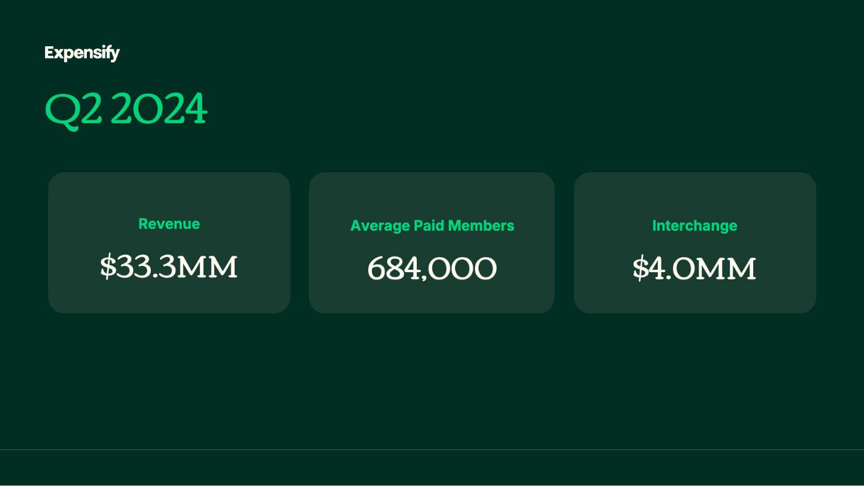

4

Exhibit 99.2

Expensify, Inc.

Investor Presentation
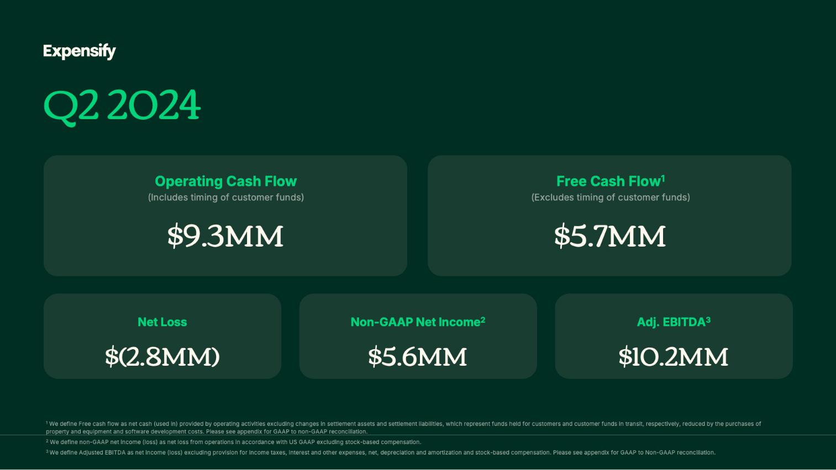

5

Exhibit 99.2

Expensify, Inc.

Investor Presentation
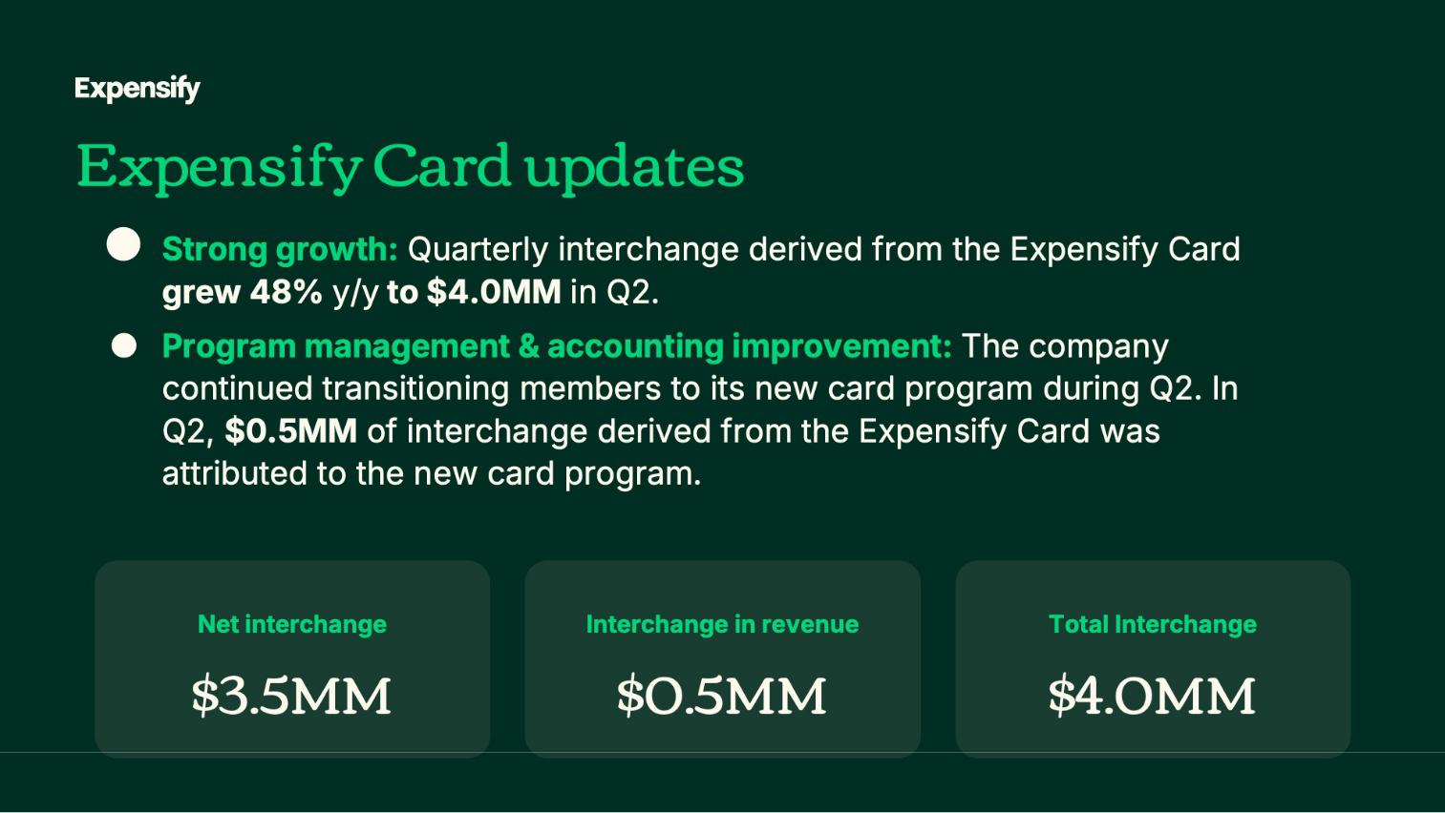

6

Exhibit 99.2

Expensify, Inc.

Investor Presentation
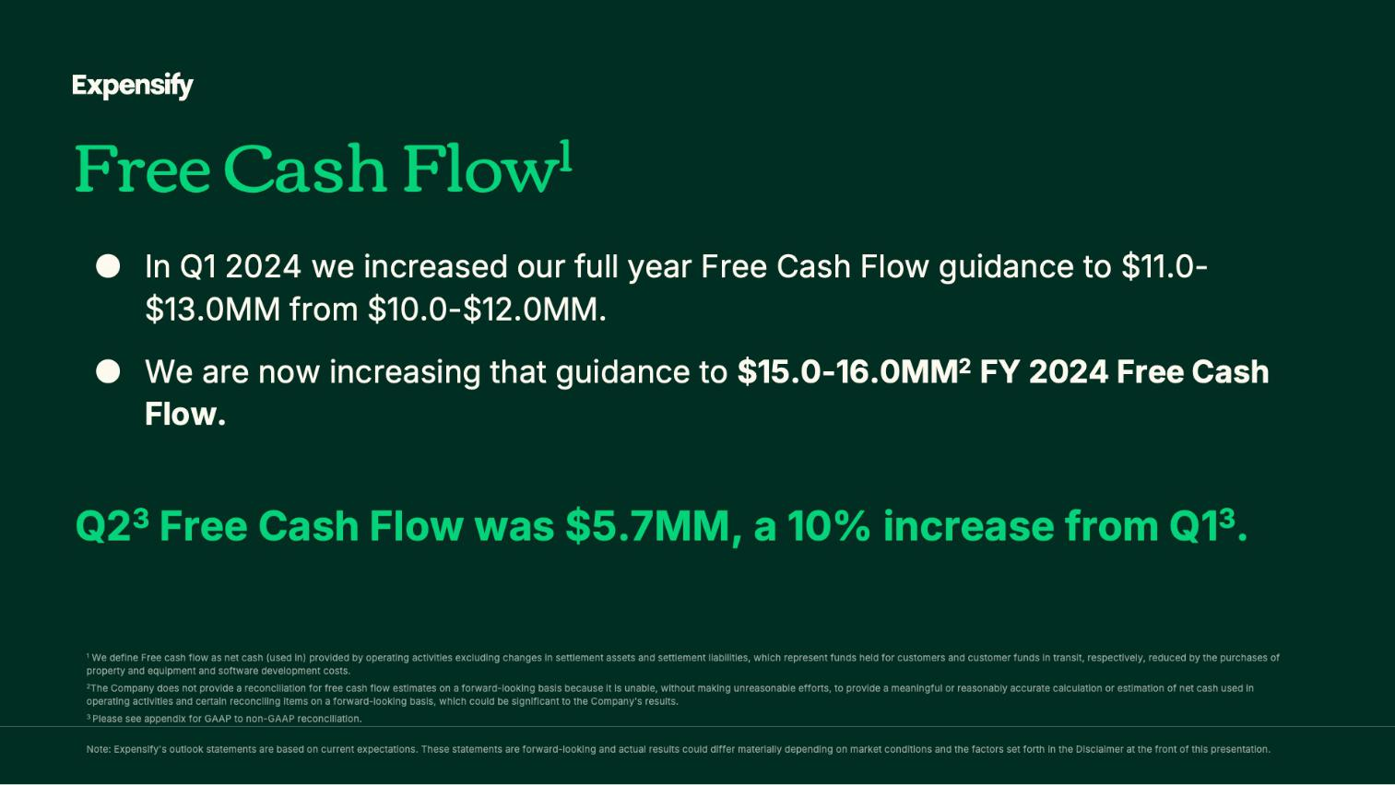

7

Exhibit 99.2

Expensify, Inc.

Investor Presentation
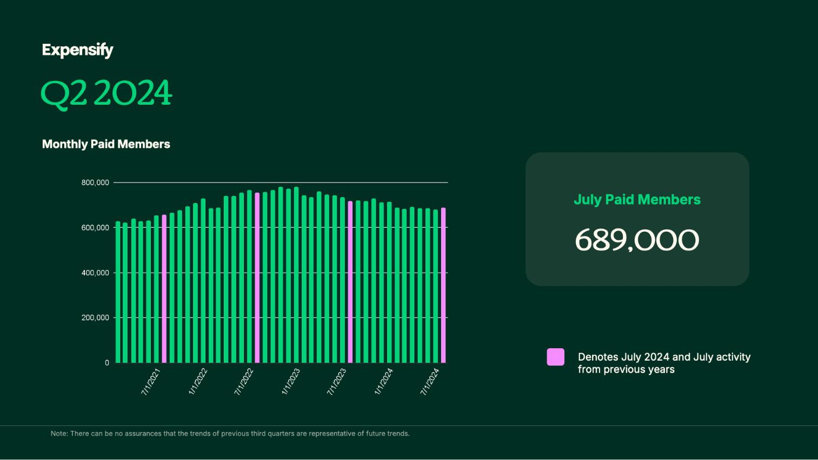

8

Exhibit 99.2

Expensify, Inc.

Investor Presentation
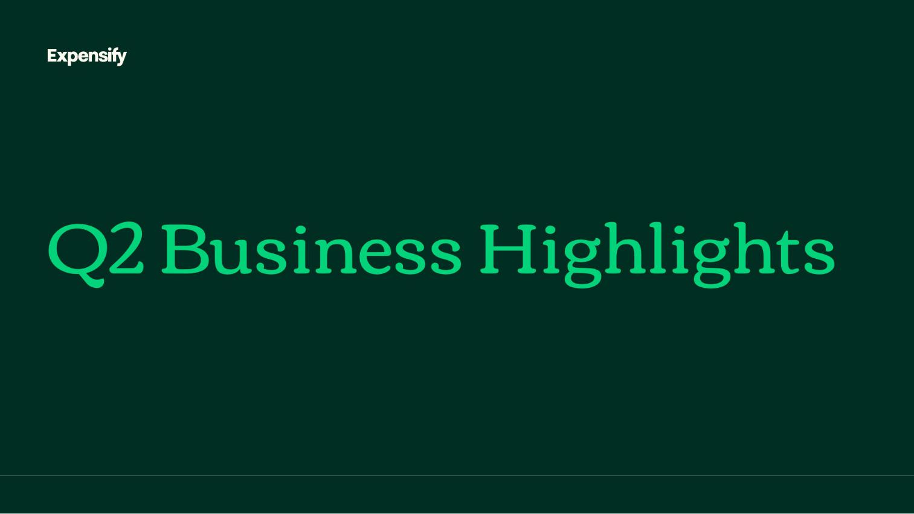

9

Exhibit 99.2

Expensify, Inc.

Investor Presentation
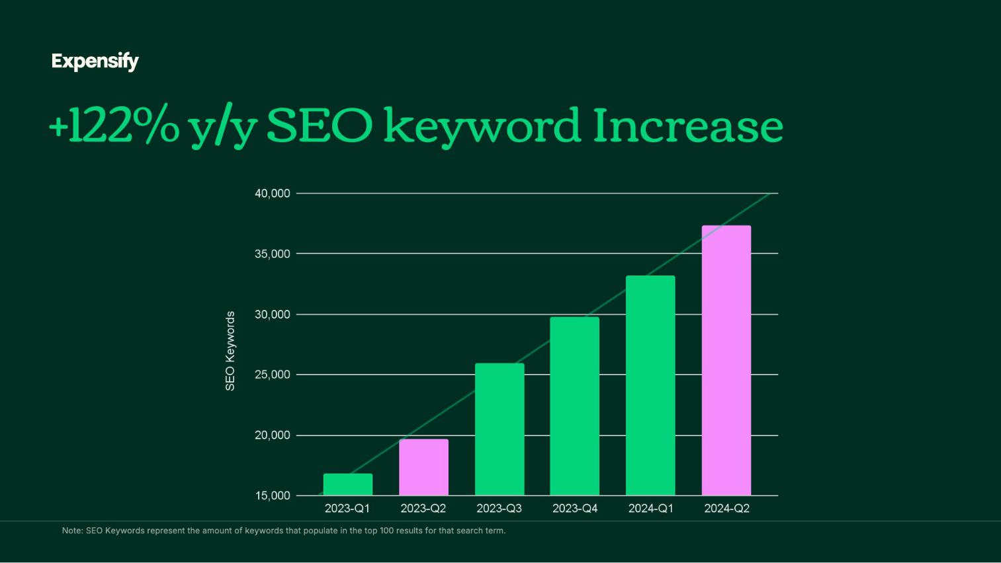

10

Exhibit 99.2

Expensify, Inc.

Investor Presentation
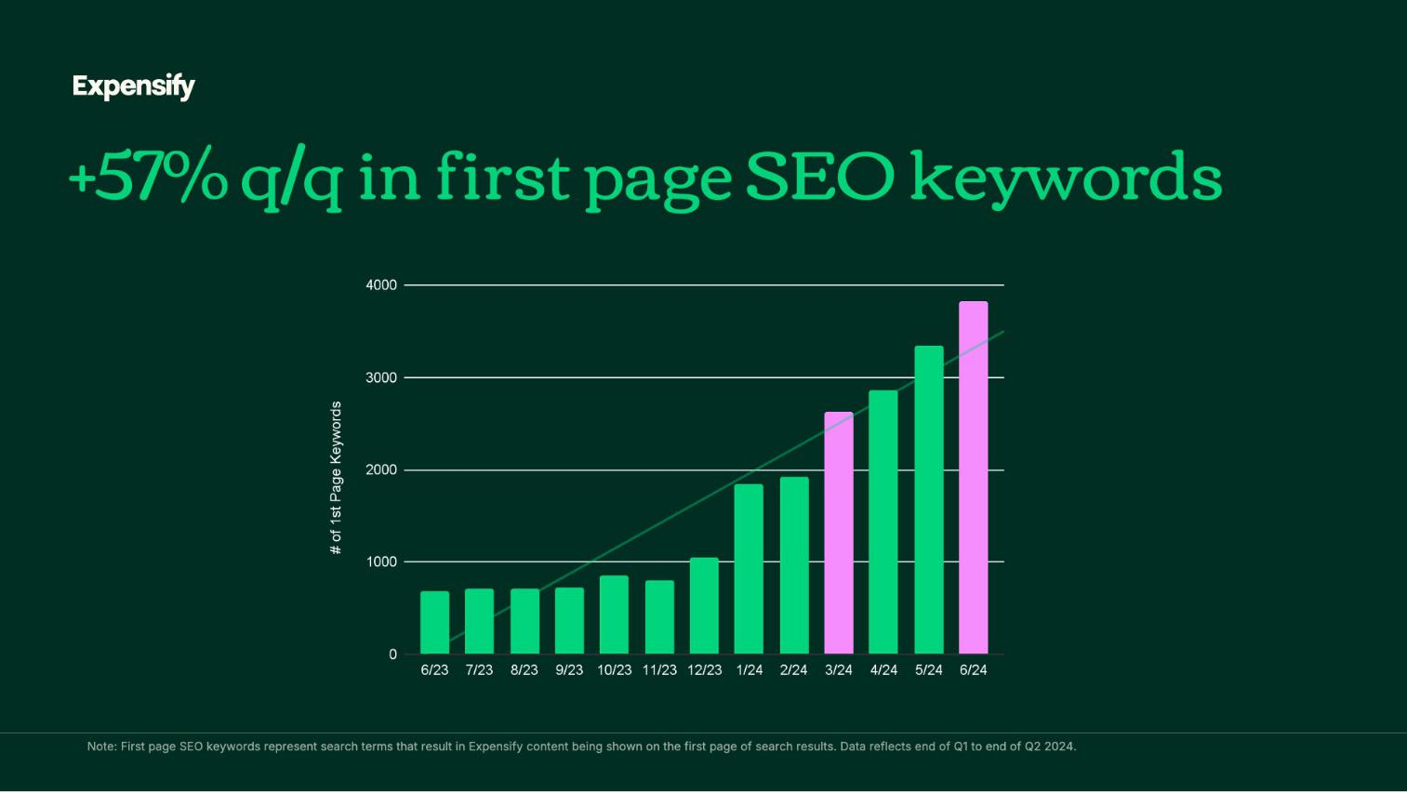

11

Exhibit 99.2

Expensify, Inc.

Investor Presentation
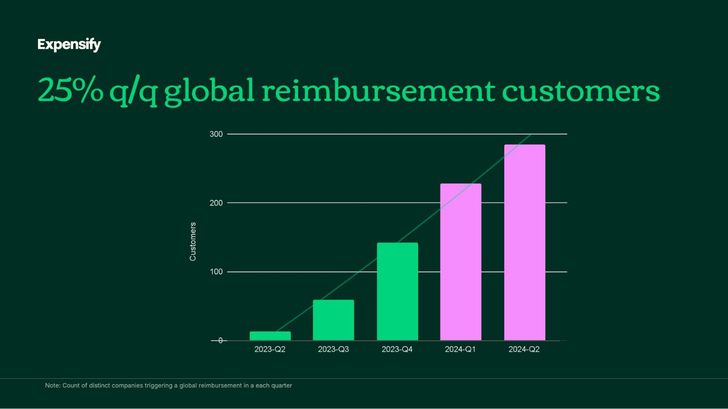

12

Exhibit 99.2

Expensify, Inc.

Investor Presentation


13

Exhibit 99.2

Expensify, Inc.

Investor Presentation


14

Exhibit 99.2

Expensify, Inc.

Investor Presentation
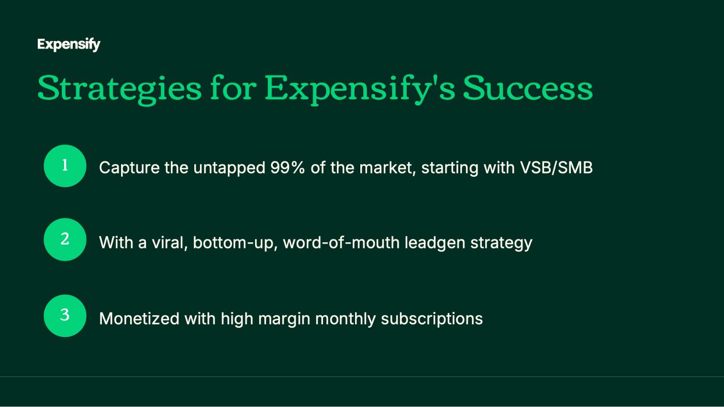

15

Exhibit 99.2

Expensify, Inc.

Investor Presentation
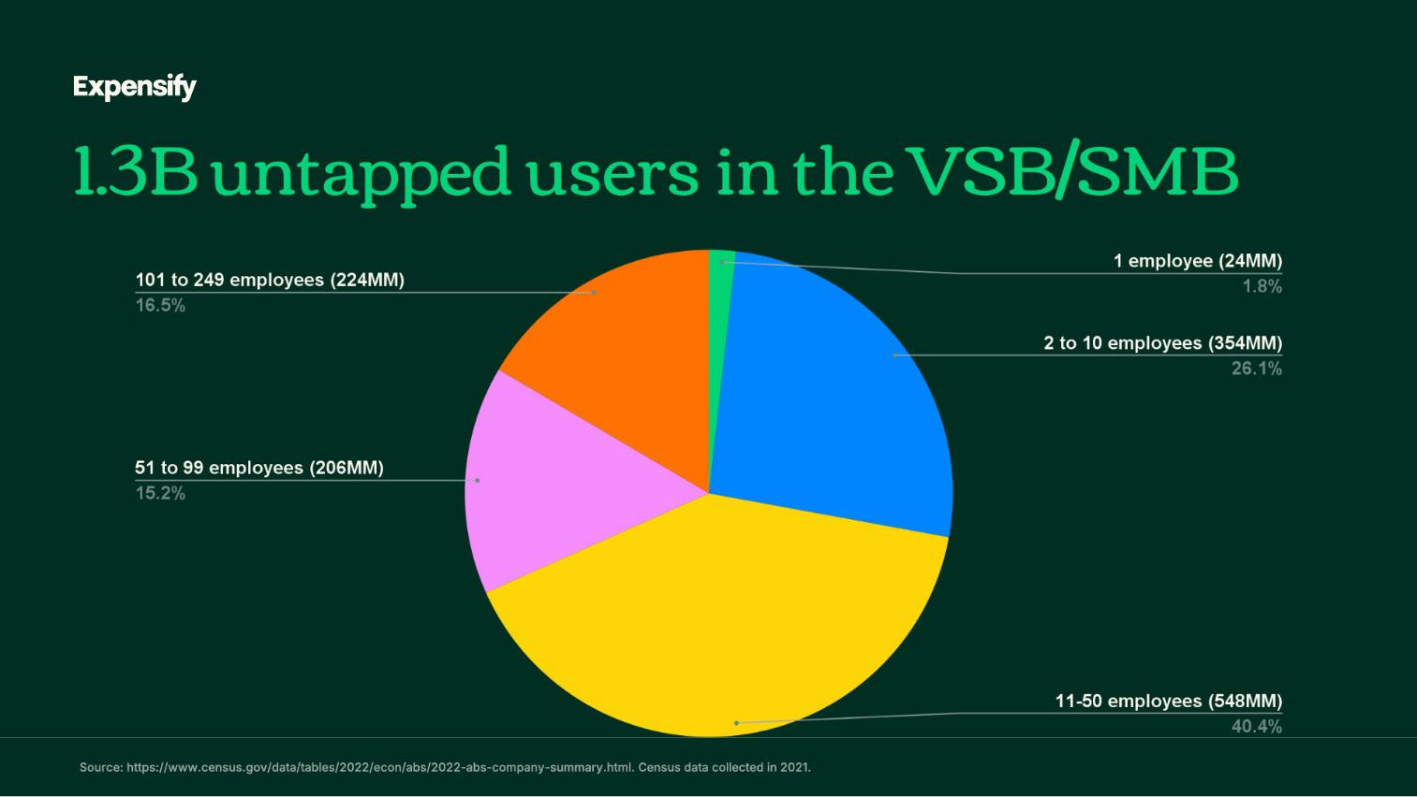

16

Exhibit 99.2

Expensify, Inc.

Investor Presentation

17

Exhibit 99.2

Expensify, Inc.

Investor Presentation
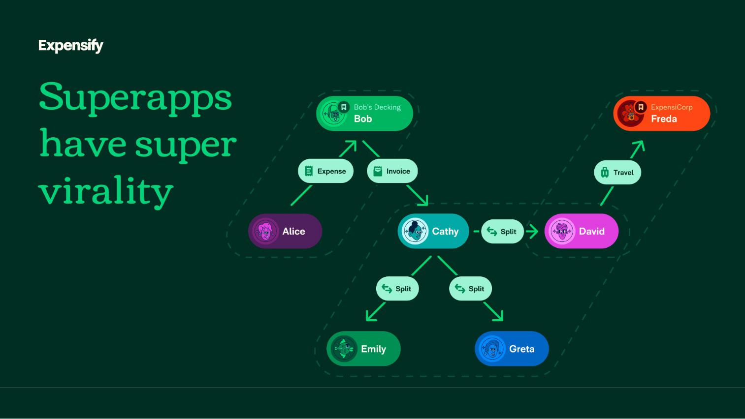

18

Exhibit 99.2

Expensify, Inc.

Investor Presentation
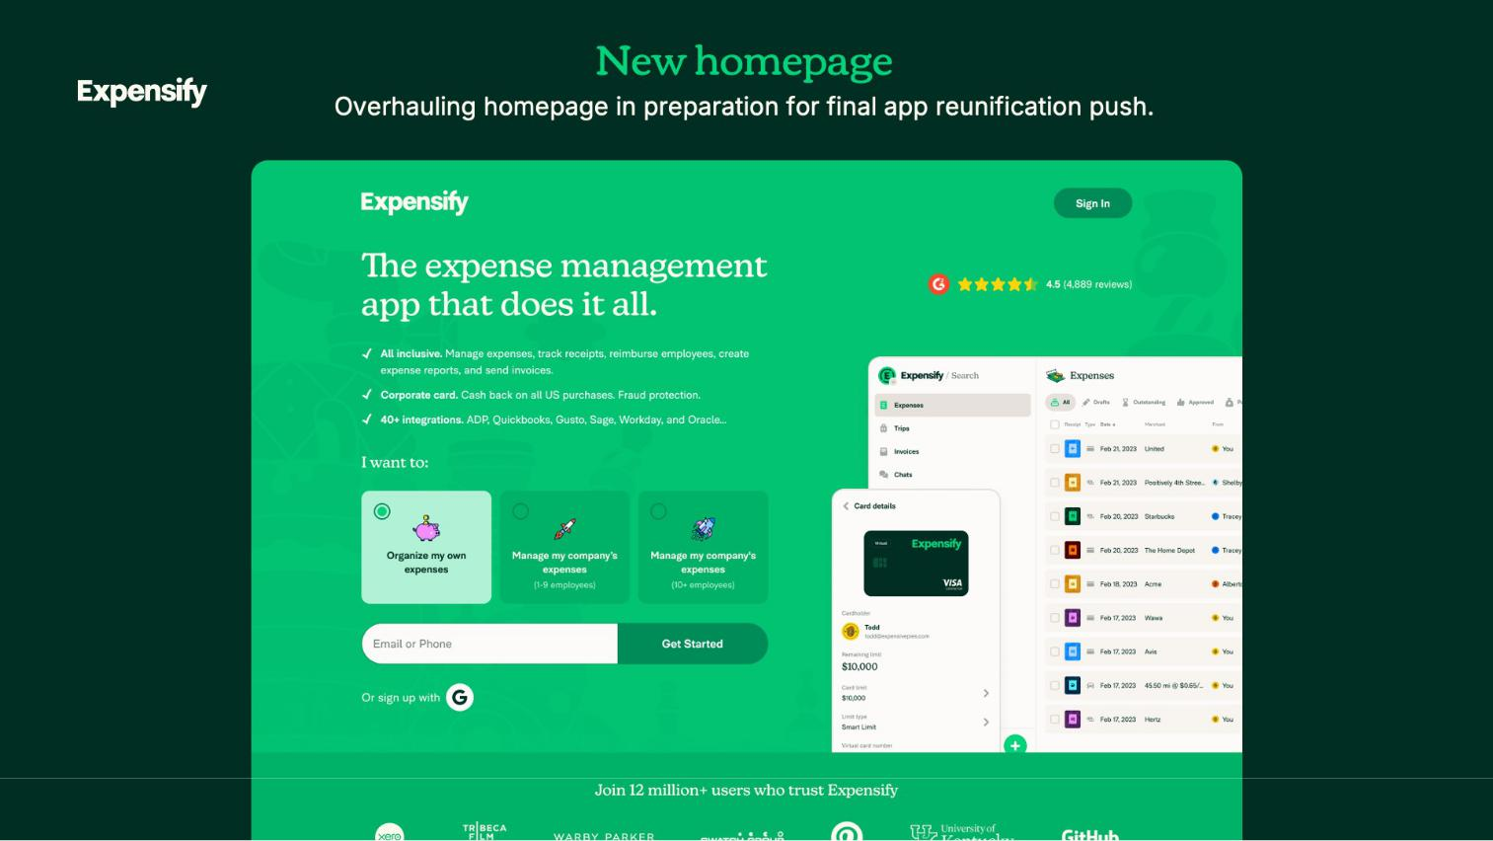

19

Exhibit 99.2

Expensify, Inc.

Investor Presentation


20

Exhibit 99.2

Expensify, Inc.

Investor Presentation


21

Exhibit 99.2

Expensify, Inc.

Investor Presentation
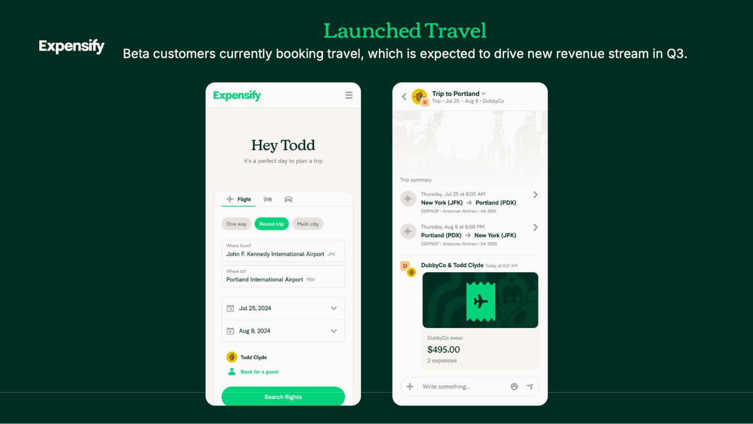

22

Exhibit 99.2

Expensify, Inc.

Investor Presentation
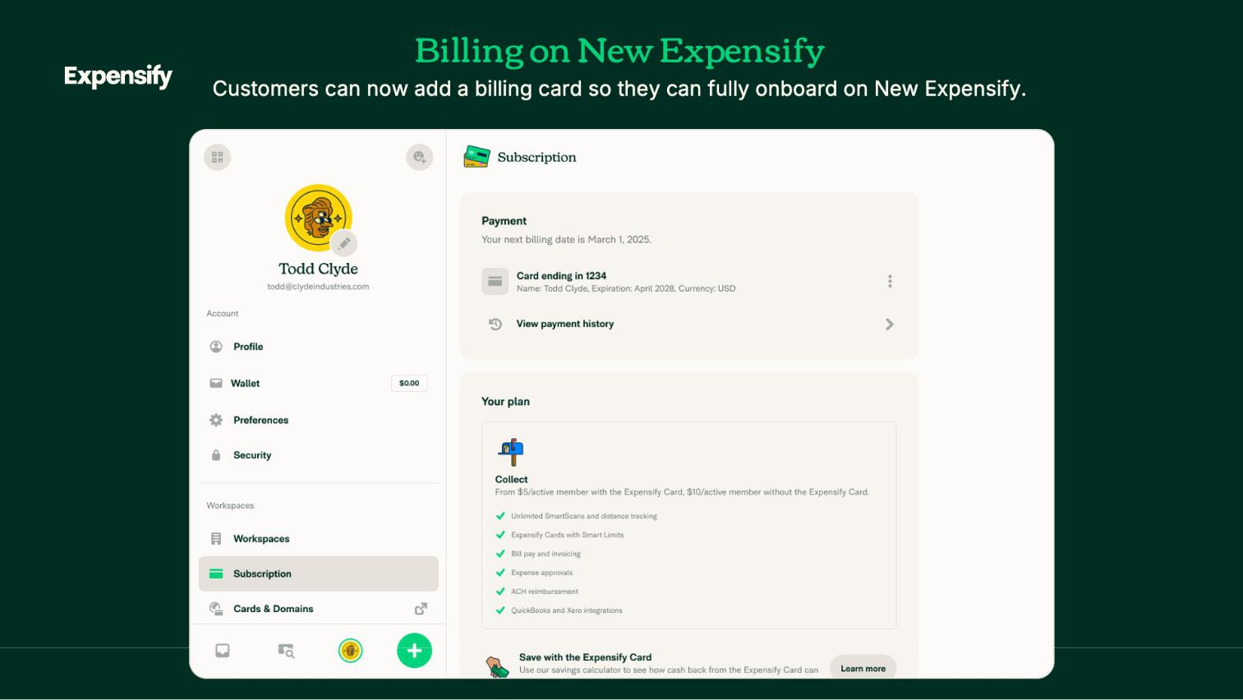

23

Exhibit 99.2

Expensify, Inc.

Investor Presentation
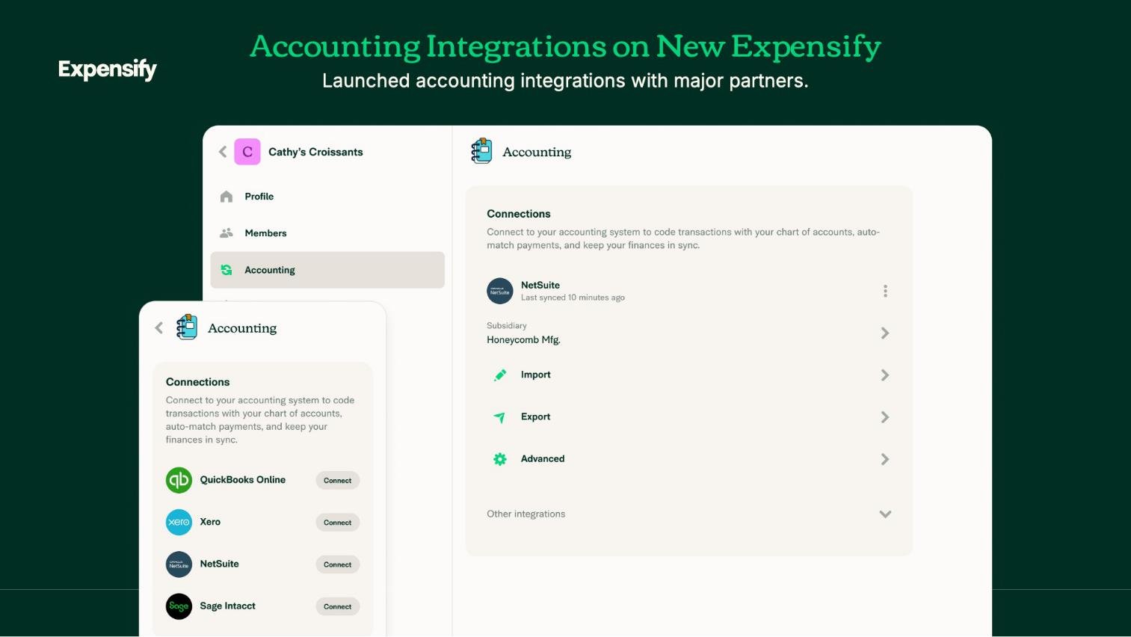

24

Exhibit 99.2

Expensify, Inc.

Investor Presentation


25

Exhibit 99.2

Expensify, Inc.

Investor Presentation
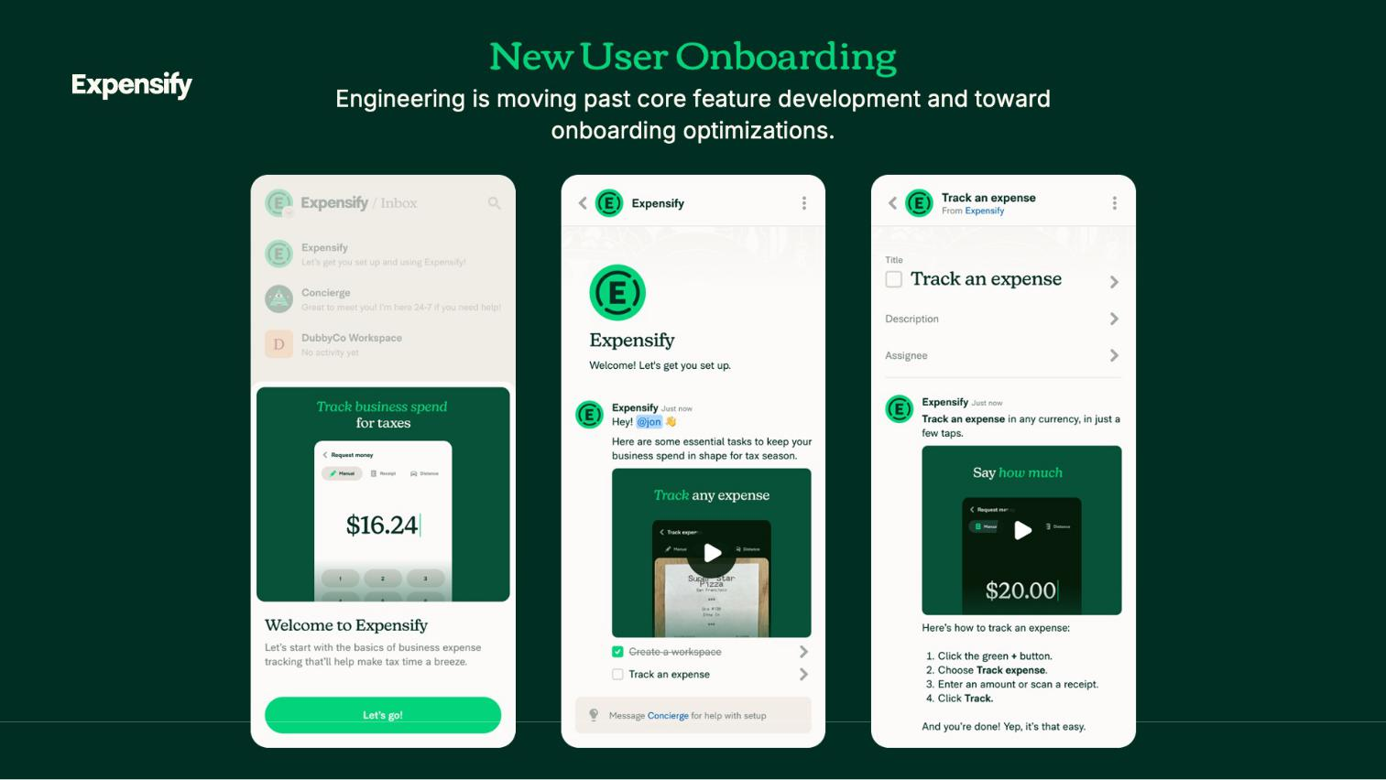

26

Exhibit 99.2

Expensify, Inc.

Investor Presentation
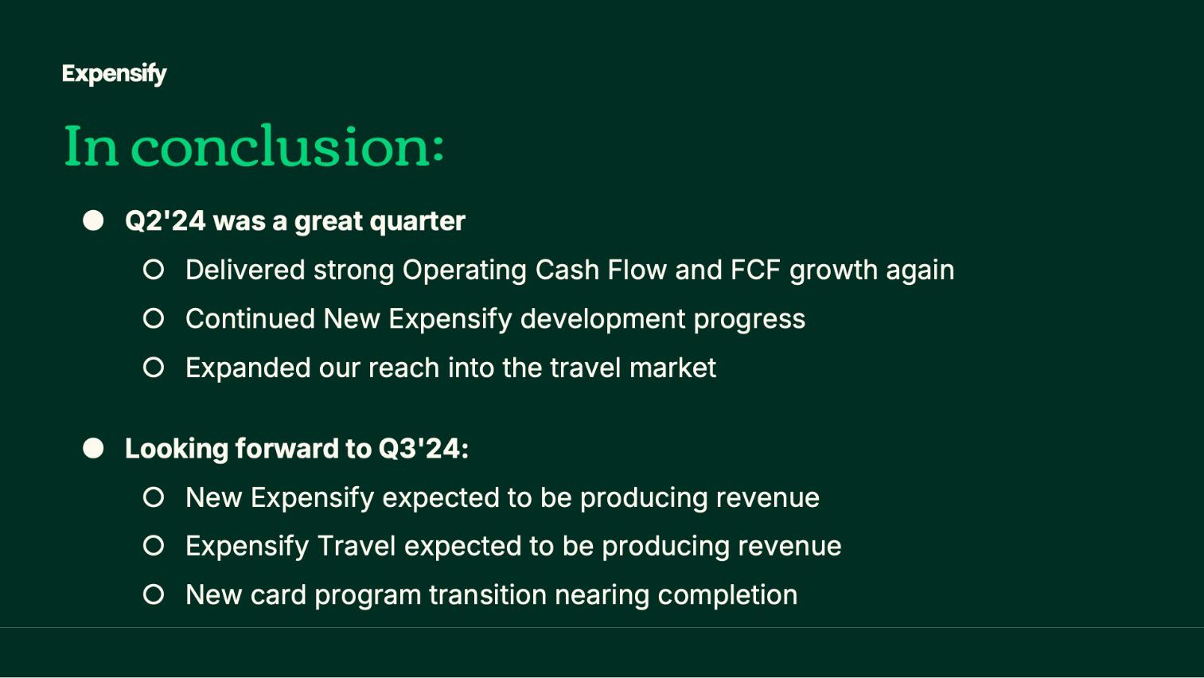

27

Exhibit 99.2

Expensify, Inc.

Investor Presentation


28

Exhibit 99.2

Expensify, Inc.

Investor Presentation


29

Exhibit 99.2

Expensify, Inc.

Investor Presentation


30

Exhibit 99.2

Expensify, Inc.

Investor Presentation


31

Exhibit 99.2

Expensify, Inc.

Investor Presentation
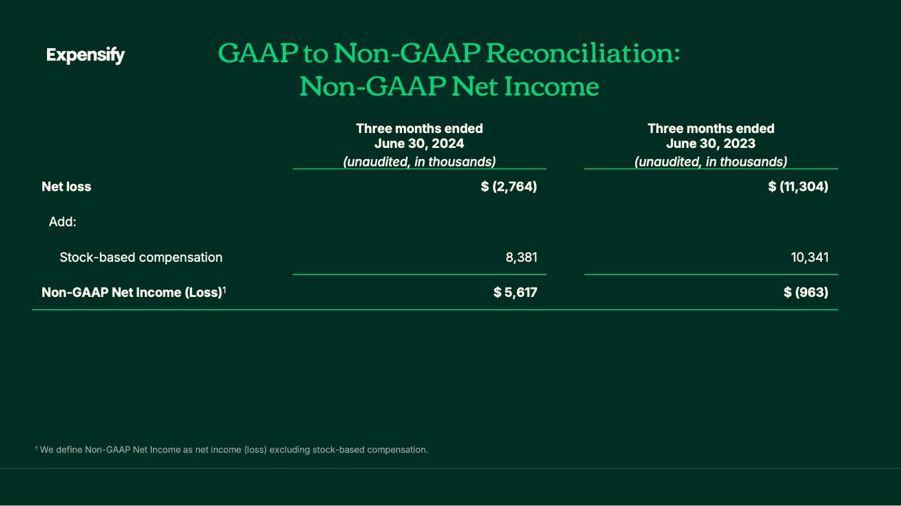

32

Exhibit 99.2

Expensify, Inc.

Investor Presentation
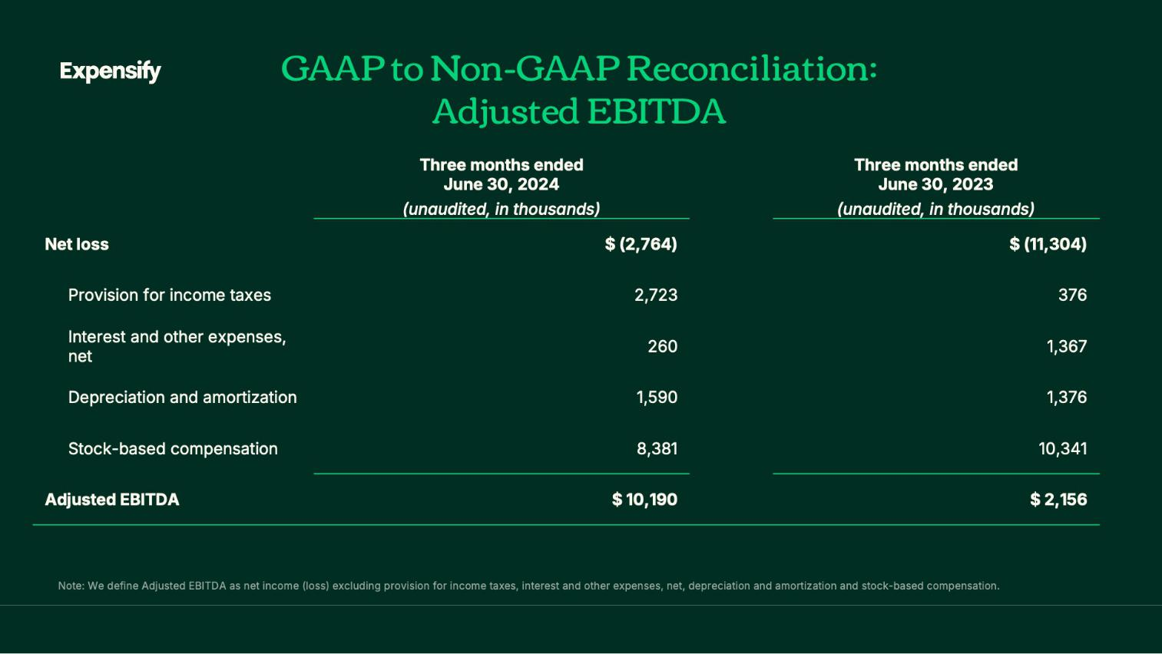

33

Exhibit 99.2

Expensify, Inc.

Investor Presentation
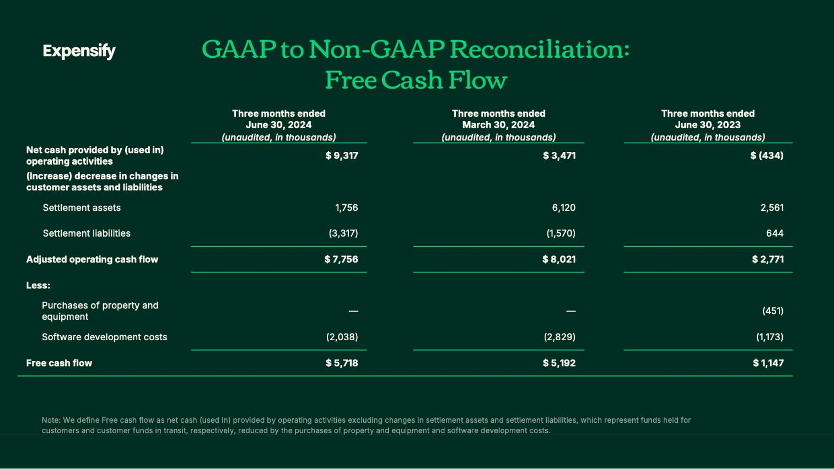

34

Exhibit 99.2

Expensify, Inc.

Investor Presentation
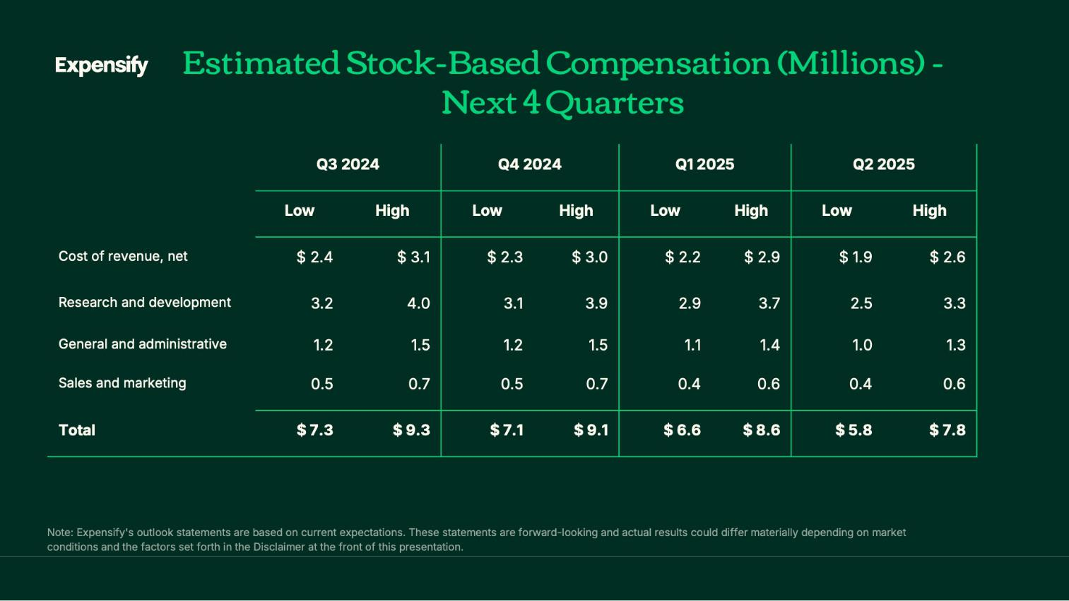

35

Exhibit 99.2

Expensify, Inc.

Investor Presentation

36

