UNITED STATES

SECURITIES AND EXCHANGE COMMISSION

Washington, D.C. 20549

FORM 8-K

CURRENT REPORT

PURSUANT TO SECTION 13 OR 15(d)

OF THE SECURITIES EXCHANGE ACT OF 1934

Date of report (Date of earliest event reported): November 10, 2022

Expensify, Inc.

 | (Exact Name of Registrant as Specified in its Charter)
Delaware | 001-41043 | 27-0239450
(State or Other Jurisdiction | (Commission | (IRS Employer
of Incorporation) | File Number) | Identification No.)
 | 401 SW 5th Ave
 | Portland, Oregon 97204
 | (Address of Principal Executive Offices) (Zip Code)
 | (971) 365-3939
 | (Registrant’s telephone number, including area code)
 | Not applicable
 | (Former Name or Former Address, if Changed Since Last Report)

Check the appropriate box below if the Form 8-K filing is intended to simultaneously satisfy the filing obligation of the registrant under any of the following provisions:

- Written communications pursuant to Rule 425 under the Securities Act (17 CFR 230.425).

- Soliciting material pursuant to Rule 14a-12 under the Exchange Act (17 CFR 240.14a-12).

- Pre-commencement communications pursuant to Rule 14d-2(b) under the Exchange Act (17 CFR 240.14d-2(b)).

- Pre-commencement communications pursuant to Rule 13e-4(c) under the Exchange Act (17 CFR 240.13e-4(c)).

Securities registered pursuant to Section 12(b) of the Act:

 |  | Trading |  | Name of each exchange
Title of each class |  | Symbol(s) |  | on which registered
Class A Common Stock, par value $0.0001 per share |  | EXFY |  | The Nasdaq Stock Market LLC

Indicate by check mark whether the registrant is an emerging growth company as defined in Rule 405 of the Securities Act of 1933 (§230.405 of this chapter) or Rule 12b-2 of the Securities Exchange Act of 1934 (§240.12b-2 of this chapter).

Emerging growth company ☒

If an emerging growth company, indicate by check mark if the registrant has elected not to use the extended transition period for complying with any new or revised financial accounting standards provided pursuant to Section 13(a) of the Exchange Act. ☐

Item 2.02 Results of Operations and Financial Condition.

On November 10, 2022, Expensify, Inc. (“Expensify” or the “Company”) issued a press release announcing its financial results for the quarter ended September 30, 2022. A copy of this press release is furnished as Exhibit 99.1 to this current report on Form 8-K and is incorporated herein by reference.

Item 7.01 Regulation FD Disclosure.

On November 10, 2022, the Company posted an investor presentation to its website at https://ir.expensify.com (the “Investor Presentation”). A copy of the Investor Presentation is furnished as Exhibit 99.2 to this current report on Form 8-K and is incorporated herein by reference. The Company expects to use the Investor Presentation, in whole or in part, and possibly with modifications, in connection with presentations to investors, analysts and others.

The information contained in the Investor Presentation is summary information that is intended to be considered in the context of the Company’s Securities and Exchange Commission (“SEC”) filings and other public announcements that the Company may make, by press release or otherwise, from time to time. The Investor Presentation speaks only as of the date of this current report on Form 8-K. The Company undertakes no duty or obligation to publicly update or revise the information included in the Investor Presentation, although it may do so from time to time. Any such updating may be made through the filing of other reports or documents with the SEC, through press releases or other public disclosure. In addition, the exhibit furnished herewith contains statements intended as “forward-looking statements” that are subject to the cautionary statements about forward-looking statements set forth in such exhibit. By furnishing the information contained in the Investor Presentation, the Company makes no admission as to the materiality of any information in the Investor Presentation that is required to be disclosed solely by reason of Regulation FD.

The information contained in Item 2.02 and this Item 7.01, including Exhibits 99.1 and 99.2, is being furnished and shall not be deemed “filed” for purposes of Section 18 of the Securities and Exchange Act of 1934, as amended (the “Exchange Act”), or otherwise subject to the liabilities of that section, nor shall it be deemed incorporated by reference in any filing made by Expensify under the Securities Act of 1933, as amended, or the Exchange Act, except as expressly set forth by specific reference in such a filing.

Item 9.01 Financial Statements and Exhibits.

- Exhibits.

Exhibit No. Description

99.1 Press Release issued by Expensify, Inc., dated November 10, 2022.

99.2 Investor Presentation, dated November, 10, 2022.

104 Cover Page Interactive Data File (embedded within the Inline XBRL document).

SIGNATURE

Pursuant to the requirements of the Securities Exchange Act of 1934, the registrant has duly caused this report to be signed on its behalf by the undersigned hereunto duly authorized.

Expensify, Inc.

By: /s/ Ryan Schaffer

Name: Ryan Schaffer

Title: Chief Financial Officer

Date: November 10, 2022

Exhibit 99.1

EXPENSIFY ANNOUNCES Q3 2022 RESULTS

Business fundamentals remain strong. Company announces plan for additional $6 million in near-term share repurchases, for an expected total of $10 million for FY22 including

net settling equity awards.

PORTLAND, Ore.--(BUSINESS WIRE)--November 10, 2022-- Expensify, Inc. (Nasdaq: EXFY), a payments superapp that helps individuals and businesses around the world simplify the way they manage money across expenses, corporate cards and bills, today announced results for its quarter ended September 30th, 2022.

"The business is doing great and we’re methodically executing our long-term strategy but the economy sucks, especially for SMBs. We have seen tons of interest in the new payroll launch, and we're super excited about what we've got cooking up in the lab," said David Barrett, founder and CEO. "We stand behind our multi-year revenue guidance, with the caveat that hitting this requires the world to return to normalcy – which we think it will soon, but your guess is as good as ours, The waters are a lot choppier than anybody would like, but we believe all of the contributing factors to this volatility are temporary, so we aren't letting them distract us. I contribute 100% of my salary to the ESPP and the company is actively buying back company stock, so we couldn't be more bullish on the future."

"Despite economic headwinds, we continue to show that Expensify is a strong business able to generate positive cash flow in challenging economic environments,". said Ryan Schaffer, Expensify's CFO. "This quarter we saw modest user growth, with revenue slightly down due to a simplification of subscription management for our accounting partners to streamline client management. We repurchased $4 million in shares in Q3 via net settling equity incentive awards that vested and intend to continue taking advantage of the volatility in the market by repurchasing an additional $6 million starting at market open tomorrow morning."

Third Quarter 2022 Highlights

Financial:

- Revenue was $42.5 million, an increase of 13% compared to the same period last year.

- Net cash used by operating activities was $(0.9) million.

  - The timing of customer settlement funds was the primary driver in decreasing operating cash flow this quarter. Removing customer funds and considering only funds generated by the business gives a Free cash flow of $4.7 million.

- Net loss was $8.2 million, compared to $6.3 million for the same period last year. Q3 22's loss was primarily driven by stock-based compensation expenses of $13.4 million.

  - Non-GAAP net income was $5.1 million.

  - Stock-based compensation is expected to decrease going forward. See stock based compensation schedule below for further details.

- Adjusted EBITDA was $9.0 million, with an Adjusted EBITDA margin of 21%.

- Interchange derived from the Expensify Card grew to $1.9 million, an increase of 115% compared to the same period last year.

Business

- Paid members - Paid members grew to 761,000, an increase of 14% from the same period last year.

- Buyback - The company previously announced it had obtained authorization to repurchase $50M in shares. In Q3, $4M was spent on net share settlement of RSUs, and the company announced its plans to begin repurchasing a further $6M at market open on November 11, 2022.

Exhibit 99.1

- Payroll - Began on-boarding beta customers to Expensify Payroll, with a significant waitlist of interested customers.

- New Pricing for Accountants - In addition to the Expensify CPA Card and preferred pricing, accounting firms that join the Expensify Approved! Accountants program now receive flexible subscription management and a dedicated account manager for them and their clients.

- New Account Managers - Top 41% of customers (by revenue) now have a dedicated account manager. The remaining 59% are being evaluated for account managers in the near future.

- Free Plan - More than 15,000 businesses are now using the Expensify Free Plan, which offers corporate cards, expense management, invoicing, and bill payment at no cost.

Financial Outlook

Expensify's outlook statements are based on current estimates, expectations and assumptions and are not a guarantee of future performance. The following statements are forward-looking and actual results could differ materially depending on market conditions and the factors set forth under “Forward-Looking Statements” below. There can be no assurance that the Company will achieve the results expressed by this guidance.

We reaffirm our long term guidance provided in connection with our fourth quarter 2021 results of 25-35% revenue growth over a multi-year period, which assumes an eventual return to normalcy of the world economy.

Expensify is also providing an estimate on what stock based compensation is expected to look like for the next four fiscal quarters. Driven primarily by the pre-IPO grant of

RSUs issued to all employees (which quarterly vest over 8 years with approximately 7 years remaining), stock based compensation is estimated as seen below:

Est. stock-based compensation (millions)

 |  | Q4 2022 |  |  |  |  |  | Q1 2023 |  |  |  |  |  | Q2 2023 |  |  |  |  | Q3 2023
 |  | Low |  |  | High |  | Low |  |  |  | High |  | Low |  |  |  | High | Low |  |  |  | High
Cost of revenue, net | $ | 3.6 |  | $ | 4.3 |  |  | 3.4 |  | $ | 4.1 |  | $ | 3.3 |  | $ | 4.0 | $ | 3.3 |  | $ | 3.9
Research and development |  | 1.5 |  |  | 1.8 |  |  | 1.4 |  |  | 1.7 |  |  | 1.4 |  |  | 1.7 |  | 1.3 |  |  | 1.6
General and administrative |  | 3.6 |  |  | 4.3 |  |  | 3.4 |  |  | 4.1 |  |  | 3.3 |  |  | 4.0 |  | 3.2 |  |  | 3.9
Sales and marketing |  | 1.7 |  |  | 2.0 |  |  | 1.6 |  |  | 1.9 |  |  | 1.5 |  |  | 1.8 |  | 1.5 |  |  | 1.8
Total | $ | 10.4 |  | $ | 12.4 |  | $ | 9.8 |  | $ | 11.8 |  | $ | 9.5 |  | $ | 11.5 | $ | 9.3 |  | $ | 11.2

Availability of Information on Expensify’s Website

Investors and others should note that Expensify routinely announces material information to investors and the marketplace using SEC filings, press releases, public conference calls, webcasts and the Expensify Investor Relations website at https://ir.expensify.com. While not all of the information that the Company posts to its Investor Relations website is of a material nature, some information could be deemed to be material. Accordingly, the Company encourages investors, the media and others interested in Expensify to review the information that it shares on its Investor Relations website.

Conference Call

Expensify will host a video call to discuss the financial results and business highlights at 2:00 p.m. Pacific Time today. An investor presentation and the video call information is available on Expensify’s Investor Relations website at https://ir.expensify.com. A replay of the call will be available on the site for three months.

Non-GAAP Financial Measures

Exhibit 99.1

In addition to financial measures prepared in accordance with U.S. generally accepted accounting principles (“GAAP”), we provide certain non-GAAP financial measures, including adjusted EBITDA, adjusted EBITDA margin, non-GAAP net income, and free cash flow.

We believe our non-GAAP financial measures are useful in evaluating our business, measuring our performance, identifying trends affecting our business, formulating business plans and making strategic decisions. Accordingly, we believe that these non-GAAP financial measures provide useful information to investors and others in understanding and evaluating our results of operations in the same manner as our management team. These non-GAAP financial measures are presented for supplemental informational purposes only, should not be considered a substitute for financial information presented in accordance with GAAP, and may be different from similarly titled metrics or measures presented by other companies. Non-GAAP financial measures have limitations as analytical tools and should not be considered in isolation or as substitutes for financial information presented under GAAP. There are a number of limitations related to the use of non-GAAP financial measures versus comparable financial measures determined under GAAP. For example, other companies in our industry may calculate these non-GAAP financial measures differently or may use other measures to evaluate their performance. All of these limitations could reduce the usefulness of these non-GAAP financial measures as analytical tools. Investors are encouraged to review the related GAAP financial measures and the reconciliations of these non-GAAP financial measures to their most directly comparable GAAP financial measures and to not rely on any single financial measure to evaluate our business. A reconciliation of each non-GAAP financial measure to the most directly comparable financial measure stated in accordance with GAAP is at the end of this press release.

Adjusted EBITDA. We define adjusted EBITDA as net income from operations excluding provision for income taxes, interest and other expenses, net, depreciation and amortization and stock based compensation.

Adjusted EBITDA margin. We define adjusted EBITDA margin as adjusted EBITDA divided by total revenue for the same period.

Non-GAAP net income. We define non-GAAP net income as net income from operations in accordance with US GAAP excluding stock-based compensation and IPO-related bonus costs. Prior to the fourth quarter of 2021, this metric only excluded IPO-related bonus costs and did not exclude expenses related to stock-based compensation. However, management now believes that further excluding stock-based compensation from non-GAAP net income is useful to better understand the financial performance of our business and to facilitate a better comparison of our results to those of peer companies over multiple periods given that this item may vary between companies for reasons unrelated to overall operating performance. IPO-related bonus costs impacted the second, third and fourth fiscal quarters of 2021 but did not impact the first or second quarters of 2022 and are not expected to impact future periods.

Non-GAAP net income margin. We define non-GAAP net income as non-GAAP net income divided by total revenue for the same period.

Free cash flow. We define Free cash flow as net cash (used in) provided by operating activities excluding changes in settlement assets and settlement liabilities, which represent funds held for customers and customer funds in transit, respectively, reduced by the purchases of property and equipment and software development costs.

The tables at the end of the Condensed Consolidated Financial Statements provide reconciliations to the most directly comparable GAAP financial measure to each of these non-GAAP financial measures.

Forward-Looking Statements

Forward-looking statements in this press release, or made during the earnings call, which are not historical facts, are forward-looking statements within the meaning of the Private Securities Litigation Reform Act of 1955. These statements include statements regarding our strategy, future financial condition, future operations, projected costs,

Exhibit 99.1

prospects, plans, objectives of management and expected market growth, our ability to meet our long-term guidance, the amount and timing of any share repurchases, our stock-based compensation estimates and the timing of when we expect the economy to return to normalcy and involve known and unknown risks that are difficult to predict. As a result, our actual results, performance or achievements may differ materially from those expressed or implied by these forward-looking statements. In some cases, you can identify forward-looking statements because they contain words such as “may,” “will,” “shall,” “should,” “expects,” “plans,” “anticipates,” “could,” “intends,” “target,” “projects,” “contemplates,” “believes,” “estimates,” “predicts,” “potential,” “goal,” “objective,” “seeks,” "outlook," or “continue” or the negative of these words or other similar terms or expressions that concern our expectations, strategy, plans, or intentions. Such forward-looking statements are necessarily based upon estimates and assumptions that, while considered reasonable by us and our management, are inherently uncertain. Factors that may cause actual results to differ materially from current expectations include, but are not limited to: the impact on inflation on us and our members; our borrowing costs have and may continue to increase as a result of increases in interest rates; our expectations regarding our financial performance and future operating performance; our ability to attract and retain members, expand usage of our platform, sell subscriptions to our platform and convert individuals and organizations into paying customers; the timing and success of new features, integrations, capabilities and enhancements by us, or by competitors to their products, or any other changes in the competitive landscape of our market; the amount and timing of operating expenses and capital expenditures that we may incur to maintain and expand our business and operations to remain competitive; the sufficiency of our cash, cash equivalents and investments to meet our liquidity needs; our ability to make required payments under and to comply with the various requirements of our current and future indebtedness; our cash flows, the prevailing stock prices, general economic and market conditions and other considerations that could affect the specific timing, price and size of repurchases under our stock repurchase program or our ability to fund any stock repurchases; the war in Ukraine and escalating geopolitical tensions as a result of Russia's invasion of Ukraine; our ability to effectively manage our exposure to fluctuations in foreign currency exchange rates; the increased expenses associated with being a public company; the size of our addressable markets, market share and market trends; anticipated trends, developments and challenges in our industry, business and the highly competitive markets in which we operate; our expectations regarding our income tax liabilities and the adequacy of our reserves; our ability to effectively manage our growth and expand our infrastructure and maintain our corporate culture; our ability to identify, recruit and retain skilled personnel, including key members of senior management; the safety, affordability and convenience of our platform and our offerings; our ability to successfully defend litigation brought against us; our ability to successfully identify, manage and integrate any existing and potential acquisitions of businesses, talent, technologies or intellectual property; general economic conditions in either domestic or international markets; our protections against security breaches, technical difficulties, or interruptions to our platform; our ability to maintain, protect and enhance our intellectual property; and other risks discussed in our filings with the SEC. All forward-looking statements attributable to us or persons acting on our behalf are expressly qualified in their entirety by the cautionary statements set forth above. We caution you not to place undue reliance on any forward-looking statements, which are made only as of the date of this press release. We do not undertake or assume any obligation to update publicly any of these forward-looking statements to reflect actual results, new information or future events, changes in assumptions or changes in other factors affecting forward-looking statements, except to the extent required by applicable law. If we update one or more forward-looking statements, no inference should be drawn that we will make additional updates with respect to those or other forward-looking statements.

About Expensify

Expensify is a payments superapp that helps individuals and businesses around the world simplify the way they manage money. More than 12 million people use Expensify's free features, which include corporate cards, expense tracking, next-day reimbursement, invoicing, bill pay, and travel booking in one app. All free. Whether you own a small business, manage a team, or close the books for your clients, Expensify makes it easy so you have more time to focus on what really matters.

Investor Relations Contact

Nick Tooker

investors@expensify.com

Press Contact

Exhibit 99.1

James Dean

press@expensify.com

Expensify, Inc.

Condensed Consolidated Balance Sheets

(unaudited, in thousands, except share and per share data)

As of September 30,

2022

As of December 31,

2021

Assets
Cash and cash equivalents | $ | 106,212 |  | $ | 98,398
Accounts receivable, net |  | 16,274 |  |  | 15,713
Settlement assets |  | 39,359 |  |  | 21,880
Prepaid expenses |  | 5,698 |  |  | 7,436
Related party loan receivable |  | — |  |  | 14
Other current assets |  | 21,247 |  |  | 14,201
Total current assets |  | 188,790 |  |  | 157,642
Capitalized software, net |  | 6,142 |  |  | 6,359
Property and equipment, net |  | 14,872 |  |  | 15,930
Lease right-of-use assets |  | 1,109 |  |  | 2,202
Deferred tax assets, net |  | 200 |  |  | 370
Other assets |  | 580 |  |  | 710
Total assets | $ | 211,693 |  | $ | 183,213
Liabilities and stockholders' equity
Accounts payable | $ | 2,177 |  | $ | 3,752
Accrued expenses and other liabilities |  | 7,862 |  |  | 11,046
Borrowings under line of credit |  | 15,000 |  |  | 15,000
Current portion of long-term debt, net of original issuance discount and debt issuance costs |  | 549 |  |  | 549
Lease liabilities, current |  | 1,190 |  |  | 1,549
Settlement liabilities |  | 36,383 |  |  | 21,680
Total current liabilities |  | 63,161 |  |  | 53,576
Lease liabilities, non-current |  | — |  |  | 802
Other liabilities |  | 1,145 |  |  | 153
Long-term debt, net of original issuance discount and debt issuance costs |  | 51,572 |  |  | 52,067
Total liabilities |  | 115,878 |  |  | 106,598
Commitments and contingencies (Note 4)
Stockholders' equity:
Common stock, par value $0.0001; 1,000,000,000 shares of Class A common stock authorized as of September 30, 2022 and December 31, 2021; 68,575,385
and 67,844,060 shares of Class A common stock issued and outstanding as of September 30, 2022 and December 31, 2021, respectively; 24,997,561 and
25,000,000 shares of LT10 common stock authorized as of September 30, 2022 and December 31, 2021, respectively; 7,336,191 and 7,332,640 shares of
LT10 common stock issued and outstanding as of September 30, 2022 and December 31, 2021, respectively; 24,999,170 and 25,000,000 shares of LT50
common stock authorized as of September 30, 2022 and December 31, 2021, respectively; 6,732,693 and 6,224,160 shares of LT50 common stock issued and
outstanding as of September 30, 2022 and December 31, 2021, respectively; preferred stock, par value $0.0001; 10,000,000 shares of preferred stock
authorized as of September 30, 2022 and December 31, 2021; no shares of preferred stock issued and outstanding as of September 30, 2022 and
December 31, 2021 |  | 7 |  |  | 6
Additional paid-in capital |  | 185,326 |  |  | 142,515
Accumulated deficit |  | (89,518) |  |  | (65,906)
Total stockholders' equity |  | 95,815 |  |  | 76,615
Total liabilities and stockholders' equity | $ | 211,693 |  | $ | 183,213

Expensify, Inc.

Condensed Consolidated Statements of Operations

(unaudited, in thousands, except share and per share data)

 |  | Three months ended September 30, |  |  |  |  |  | Nine months ended September 30,
 |  | 2022 |  |  | 2021 |  |  | 2022 |  |  | 2021
 |  |  |  |  | (in thousands, except per share data)
Revenue | $ | 42,493 |  | $ | 37,447 |  | $ | 126,026 |  | $ | 102,471
Cost of revenue, net⁽¹⁾ |  | 16,554 |  |  | 18,197 |  |  | 46,564 |  |  | 33,768
Gross margin |  | 25,939 |  |  | 19,250 |  |  | 79,462 |  |  | 68,703
Operating expenses:
Research and development⁽¹⁾ |  | 3,416 |  |  | 2,167 |  |  | 10,701 |  |  | 8,138
General and administrative⁽¹⁾ |  | 15,898 |  |  | 18,333 |  |  | 45,335 |  |  | 35,827
Sales and marketing⁽¹⁾ |  | 12,342 |  |  | 7,608 |  |  | 37,958 |  |  | 14,555
Total operating expenses |  | 31,656 |  |  | 28,108 |  |  | 93,994 |  |  | 58,520
(Loss) income from operations |  | (5,717) |  |  | (8,858) |  |  | (14,532) |  |  | 10,183
Interest and other expenses, net |  | (2,369) |  |  | (1,054) |  |  | (5,226) |  |  | (2,560)
(Loss) income before income taxes |  | (8,086) |  |  | (9,912) |  |  | (19,758) |  |  | 7,623
Provision for income taxes |  | (156) |  |  | 3,567 |  |  | (3,854) |  |  | 706
Net (loss) income | $ | (8,242) |  | $ | (6,345) |  | $ | (23,612) |  | $ | 8,329
Less: income allocated to participating securities |  | — |  |  | — |  |  | — |  |  | (5,625)
Net (loss) income attributable to Class A, LT10 and LT50 | $ | (8,242) |  | $ | (6,345) |  | $ | (23,612) |  | $ | 2,704
common stockholders | $ | (8,242) |  | $ | (6,345) |  | $ | (23,612) |  | $ | 2,704
Net (loss) income per share attributable to Class A, LT10 and
LT50 common stockholders:
Basic | $ | (0.10) |  | $ | (0.18) |  | $ | (0.29) |  | $ | 0.09
Diluted | $ | (0.10) |  | $ | (0.18) |  | $ | (0.29) |  | $ | 0.07
Weighted-average shares of common stock used to compute net
(loss) income per share attributable to Class A, LT10 and
LT50 common stockholders:
Basic |  | 80,941,664 |  |  | 34,490,860 |  |  | 80,523,557 |  |  | 31,301,387
Diluted |  | 80,941,664 |  |  | 34,490,860 |  |  | 80,523,557 |  |  | 41,452,880

- Includes stock-based compensation expense as follows:

 | Three months ended September 30, |  |  |  |  |  |  | Nine months ended September 30,
 | 2022 |  |  | 2021 |  |  |  | 2022 |  |  | 2021
Cost of revenue, net | $ | 4,667 |  | $ | 245 |  | $ | 14,278 |  | $ | 670
Research and development |  | 1,931 |  |  | 154 |  |  | 6,230 |  |  | 482
General and administrative |  | 4,624 |  |  | 410 |  |  | 15,063 |  |  | 1,118
Sales and marketing |  | 2,142 |  |  | 88 |  |  | 6,222 |  |  | 225
Total stock-based compensation expense | $ | 13,364 |  | $ | 897 |  | $ | 41,793 |  | $ | 2,495

Expensify, Inc.

Condensed Consolidated Statements of Cash Flows

(unaudited, in thousands)

 |  | Nine months ended September 30,
 | 2022 |  |  |  | 2021
Cash flows from operating activities:
Net (loss) income | $ | (23,612) |  | $ | 8,329
Adjustments to reconcile net (loss) income to net cash provided by operating activities:
Depreciation and amortization |  | 4,072 |  |  | 3,732
Reduction of operating lease right-of-use assets |  | 531 |  |  | 552
Loss on impairment, receivables and sale or disposal of equipment |  | 722 |  |  | 283
Stock-based compensation |  | 41,793 |  |  | 2,495
Amortization of original issuance discount and debt issuance costs |  | 22 |  |  | 23
Deferred tax assets |  | 170 |  |  | —
Changes in assets and liabilities:
Accounts receivable, net |  | (1,016) |  |  | (3,865)
Settlement assets |  | (10,096) |  |  | (3,344)
Prepaid expenses |  | 1,738 |  |  | (2,886)
Related party loan receivable |  | 14 |  |  | (224)
Other current assets |  | 558 |  |  | 1,212
Other assets |  | 11 |  |  | 120
Accounts payable |  | (1,575) |  |  | (330)
Accrued expenses and other liabilities |  | (2,195) |  |  | 18,870
Operating lease liabilities |  | (601) |  |  | (614)
Settlement liabilities |  | 14,703 |  |  | 10,699
Other liabilities |  | 990 |  |  | (472)
Net cash provided by operating activities |  | 26,229 |  |  | 34,580
Cash flows from investing activities:
Purchases of property and equipment |  | (467) |  |  | (2,602)
Software development costs |  | (906) |  |  | (4,397)
Net cash used by investing activities |  | (1,373) |  |  | (6,999)
Cash flows from financing activities:
Principal payments of finance leases |  | (593) |  |  | (579)
Principal payments of term loan |  | (445) |  |  | (25,157)
Proceeds from term loan |  | — |  |  | 45,000
Repurchases of early exercised stock options |  | (25) |  |  | —
Proceeds from common stock purchased under Matching Plan |  | 2,433 |  |  | —
Payments of deferred offering costs |  | — |  |  | (4,796)
Vesting of restricted common stock |  | — |  |  | 234
Proceeds from issuance of common stock on exercise of stock options |  | 700 |  |  | 2,862
Payments for employee taxes withheld from stock-based awards |  | (4,172) |  |  | —
Net cash (used) provided by financing activities |  | (2,102) |  |  | 17,564
Net increase in cash and cash equivalents and restricted cash |  | 22,754 |  |  | 45,145
Cash and cash equivalents and restricted cash, beginning of period |  | 125,315 |  |  | 46,878
Cash and cash equivalents and restricted cash, end of period | $ | 148,069 |  | $ | 92,023
Supplemental disclosure of cash flow information:
Cash paid for interest | $ | 2,721 |  | $ | 2,182
Cash paid for income taxes | $ | 879 |  | $ | 6,910
Noncash investing and financing items:
Accrued deferred offering costs | $ | — |  | $ | 795
Reconciliation of cash, cash equivalents and restricted cash to the condensed consolidated balance sheets
Cash and cash equivalents | $ | 106,212 |  | $ | 68,058
Restricted cash included in other current assets |  | 16,255 |  |  | 5,989
Restricted cash included in other assets |  | — |  |  | 47
Restricted cash included in settlement assets |  | 25,602 |  |  | 17,929
Total cash, cash equivalents and restricted cash | $ | 148,069 |  | $ | 92,023

Expensify, Inc.
Reconciliation of GAAP to Non-GAAP Financial Measures
(unaudited, in thousands, except percentages)
Adjusted EBITDA and Adjusted EBITDA Margin
 |  |  | Three months ended September 30,
 |  |  | 2022
Net (loss) income | $ |  | (8,242)
Net (loss) income margin |  |  | (19)%
Add:
Provision for income taxes |  |  | 156
Interest and other expenses, net |  |  | 2,369
Depreciation and amortization |  |  | 1,323
Stock-based compensation |  |  | 13,364
Adjusted EBITDA | $ |  | 8,970
Adjusted EBITDA margin |  |  | 21 %
Non-GAAP Net Income and Non-GAAP Net Income Margin
 |  |  | Three months ended September 30,
 |  |  | 2022
Net (loss) income | $ |  | (8,242)
Net (loss) income margin |  |  | (19)%
Add:
Stock-based compensation |  |  | 13,364
IPO-related bonus expense |  |  | —
Non-GAAP net income | $ |  | 5,122
Non-GAAP net income margin |  |  | 12 %
Adjusted Operating Cash Flow and Free Cash Flow
 |  |  | Three months ended September 30,
 |  |  | 2022
 |  |  | (in thousands)
Net cash (used in) provided by operating activities | $ |  | (929)
(Increase) decrease in changes in assets and liabilities:
Settlement assets |  |  | (1,097)
Settlement liabilities |  |  | (5,207)
Adjusted operating cash flow | $ |  | 5,375
Less:
Purchases of property and equipment |  |  | (200)
Software development costs |  |  | (438)
Free cash flow | $ |  | 4,737

Exhibit 99.2

Expensify, Inc.

Investor Presentation
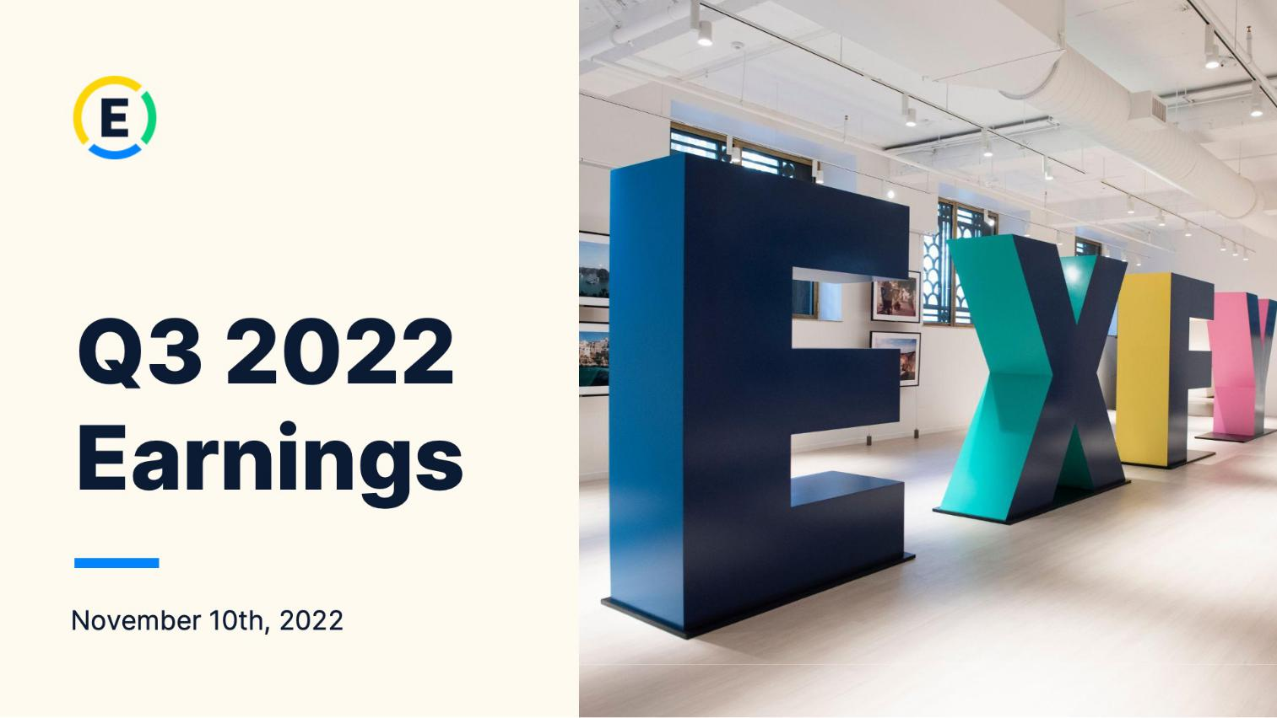

1

Exhibit 99.2

Expensify, Inc.

Investor Presentation

2

Exhibit 99.2

Expensify, Inc.

Investor Presentation


3

Exhibit 99.2

Expensify, Inc.

Investor Presentation
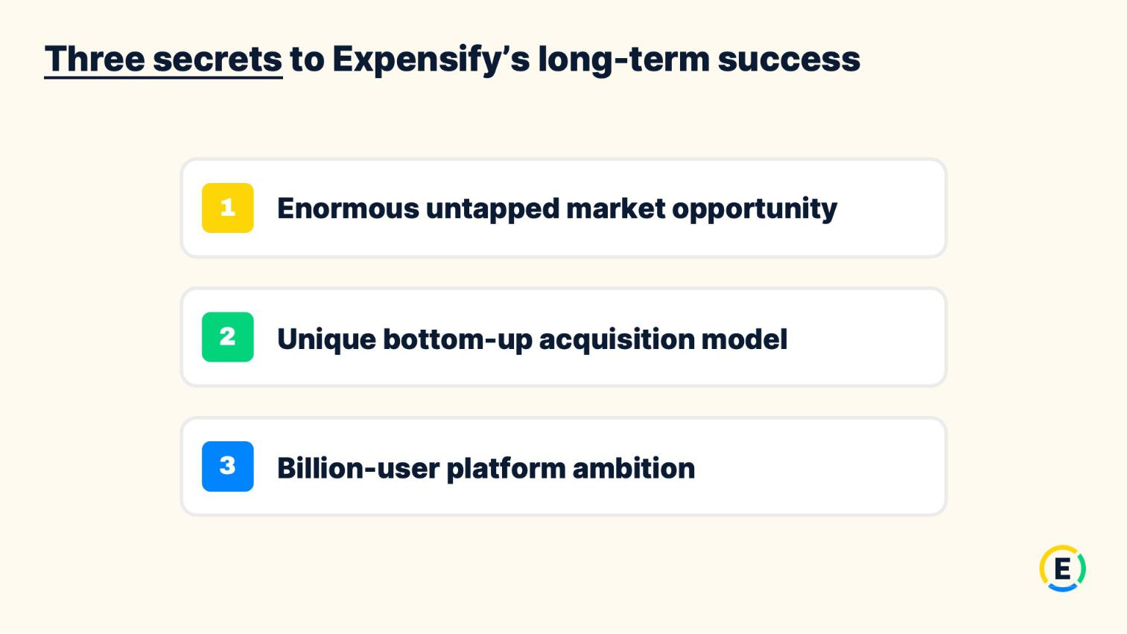

4

Exhibit 99.2

Expensify, Inc.

Investor Presentation
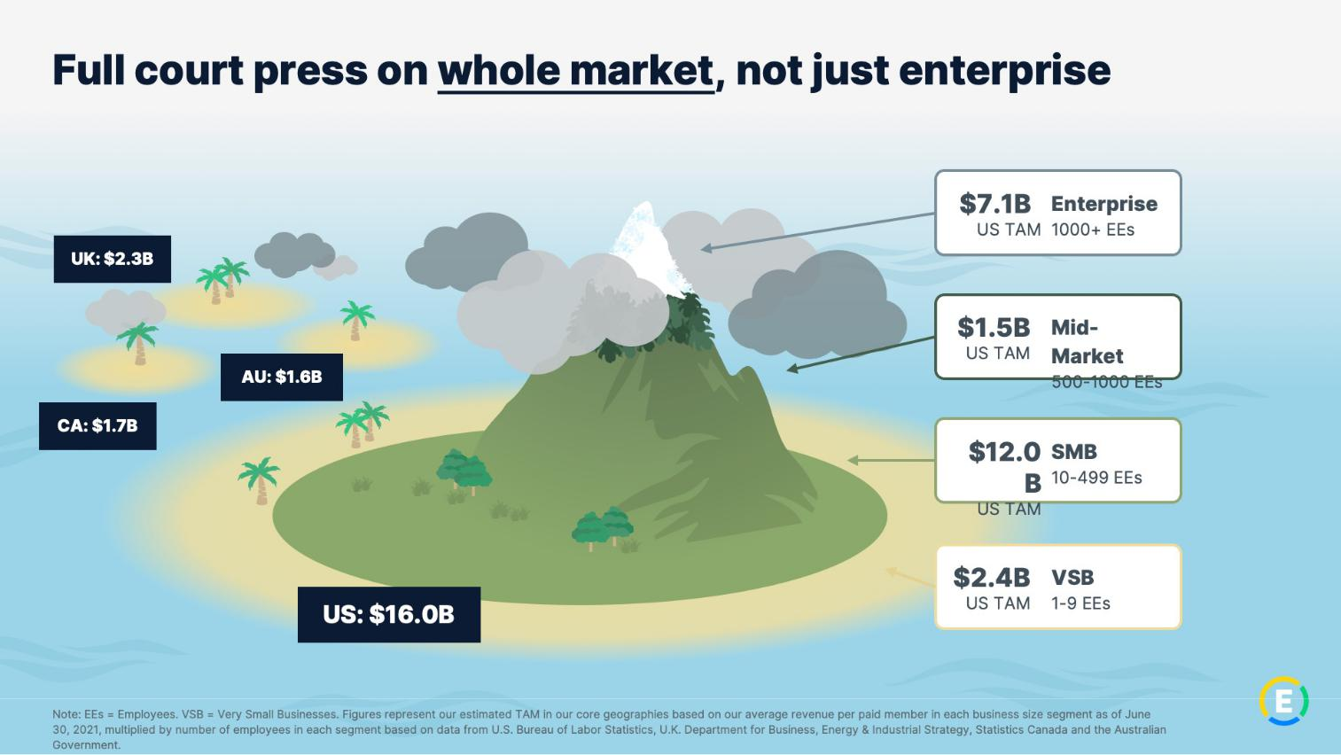

5

Exhibit 99.2

Expensify, Inc.

Investor Presentation
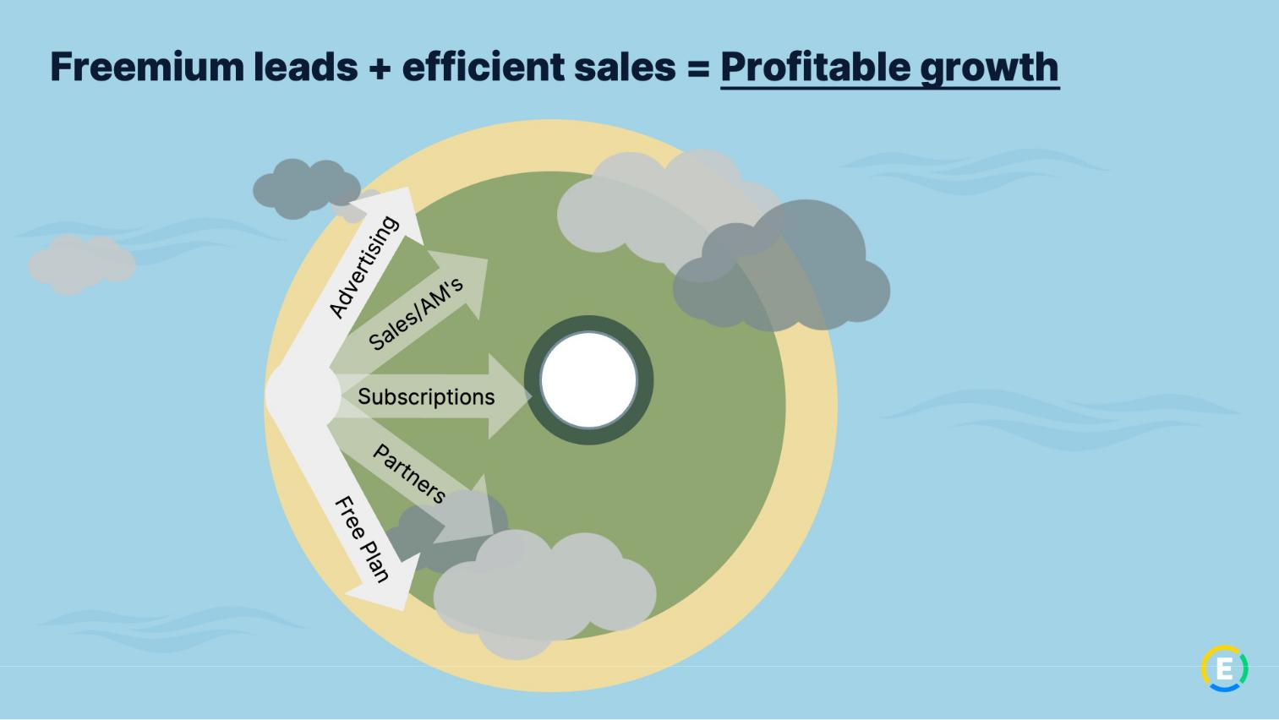

6

Exhibit 99.2

Expensify, Inc.

Investor Presentation
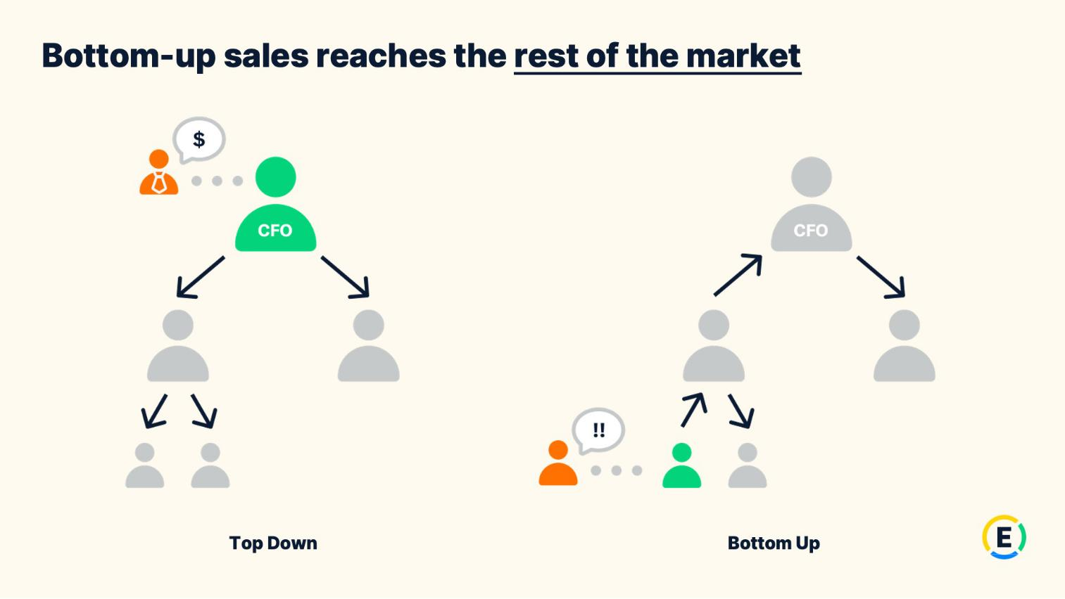

7

Exhibit 99.2

Expensify, Inc.

Investor Presentation
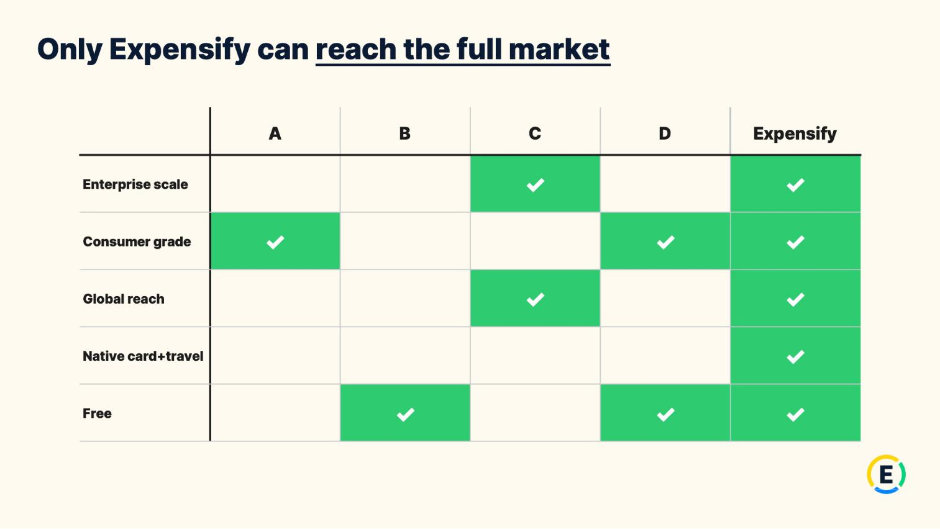

8

Exhibit 99.2

Expensify, Inc.

Investor Presentation
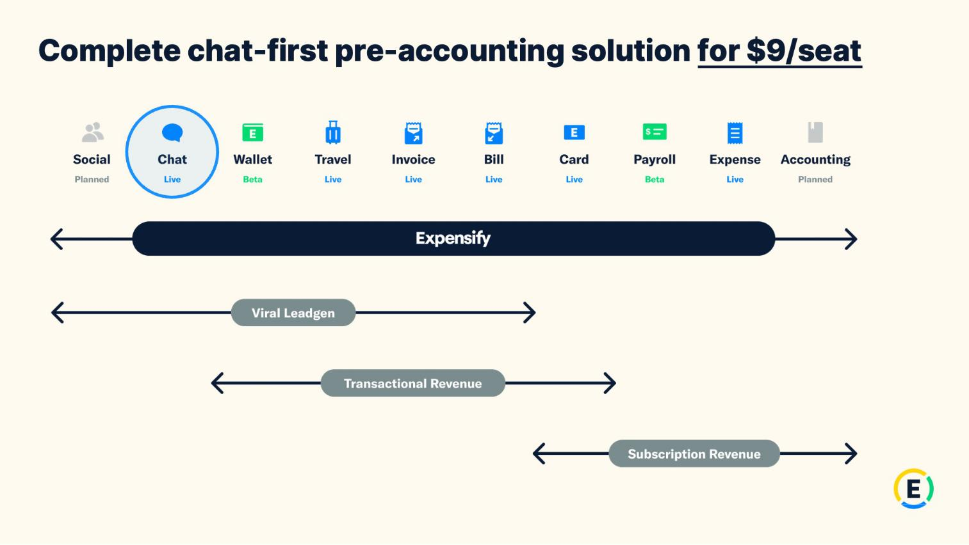

9

Exhibit 99.2

Expensify, Inc.

Investor Presentation


10

Exhibit 99.2

Expensify, Inc.

Investor Presentation
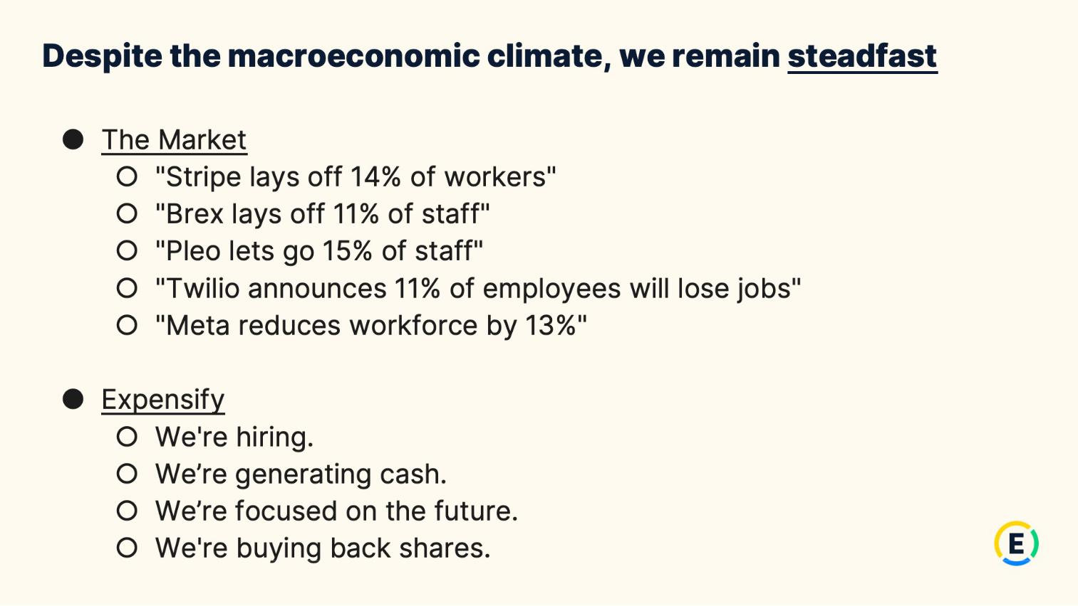

11

Exhibit 99.2

Expensify, Inc.

Investor Presentation
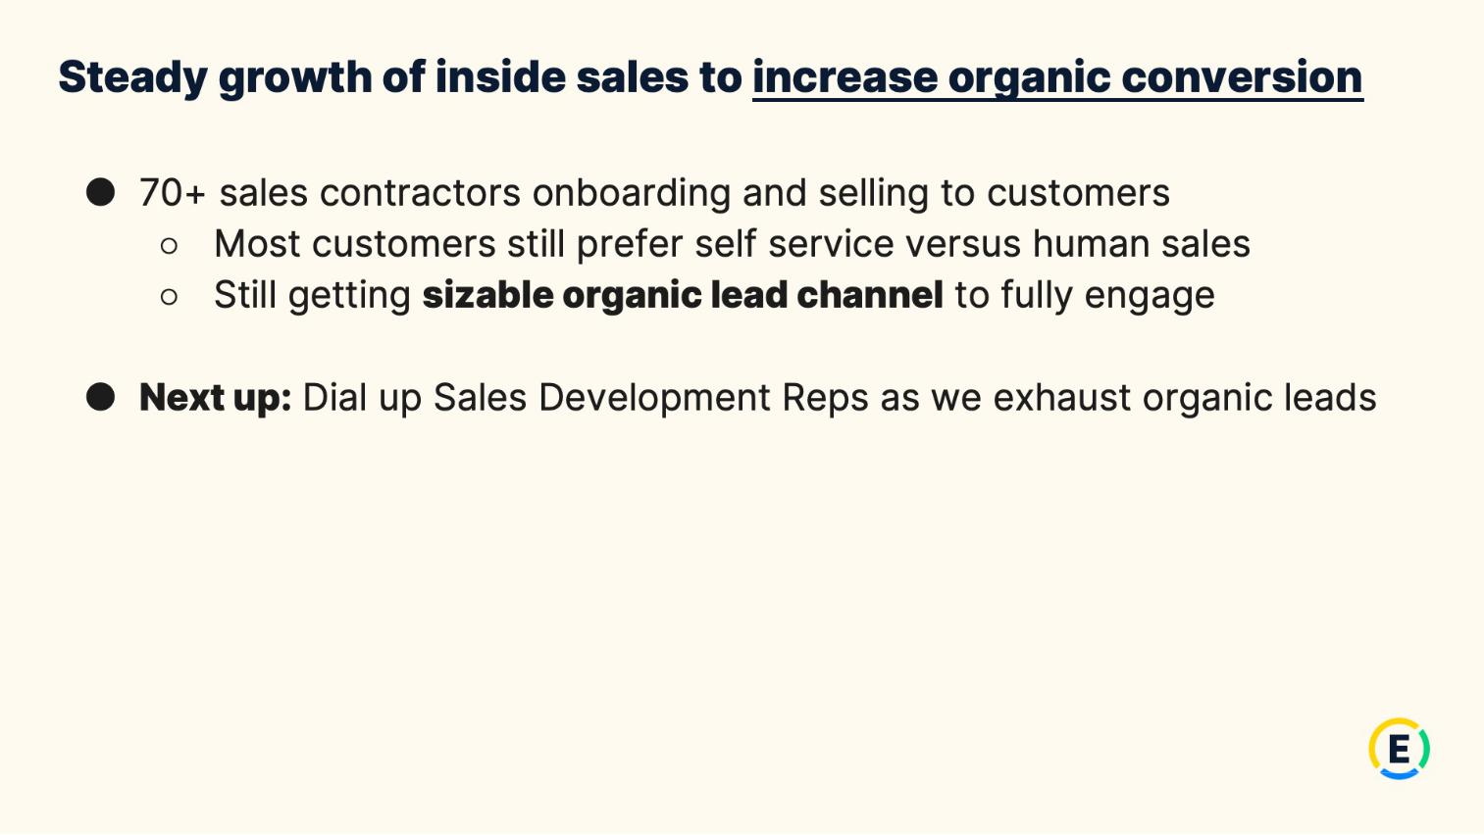

12

Exhibit 99.2

Expensify, Inc.

Investor Presentation
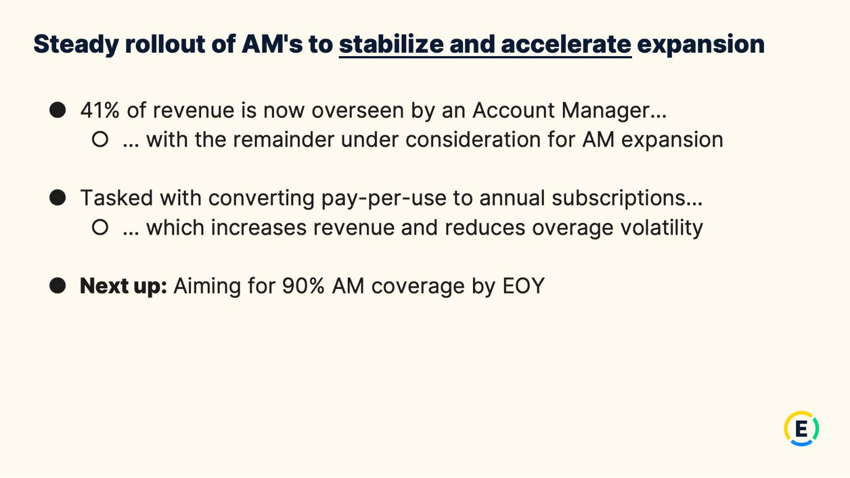

13

Exhibit 99.2

Expensify, Inc.

Investor Presentation
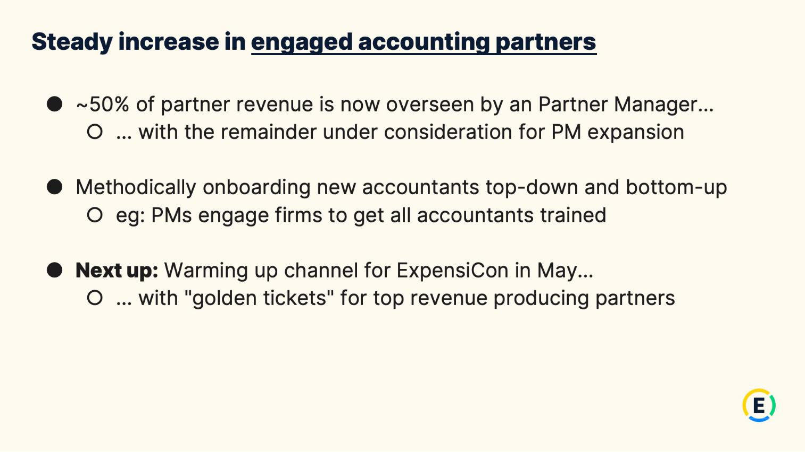

14

Exhibit 99.2

Expensify, Inc.

Investor Presentation
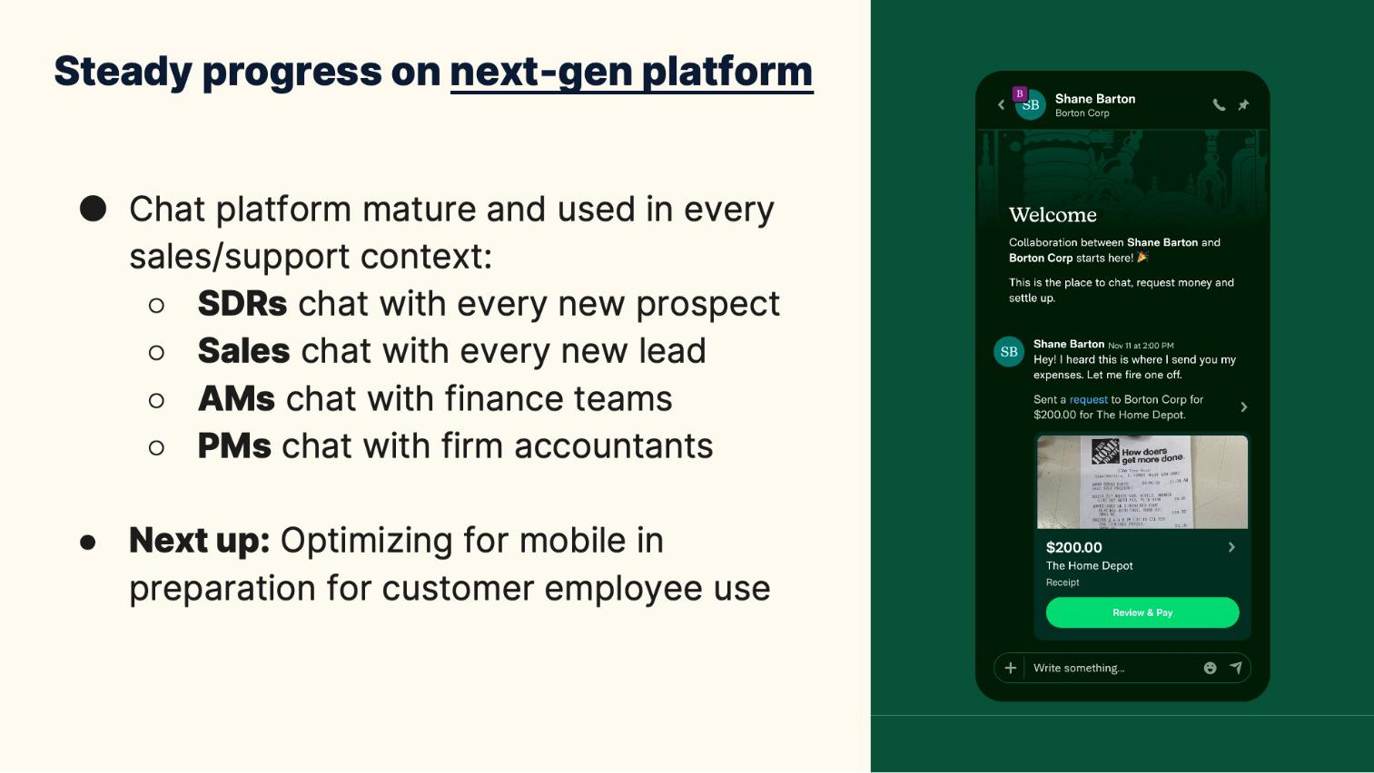

15

Exhibit 99.2

Expensify, Inc.

Investor Presentation
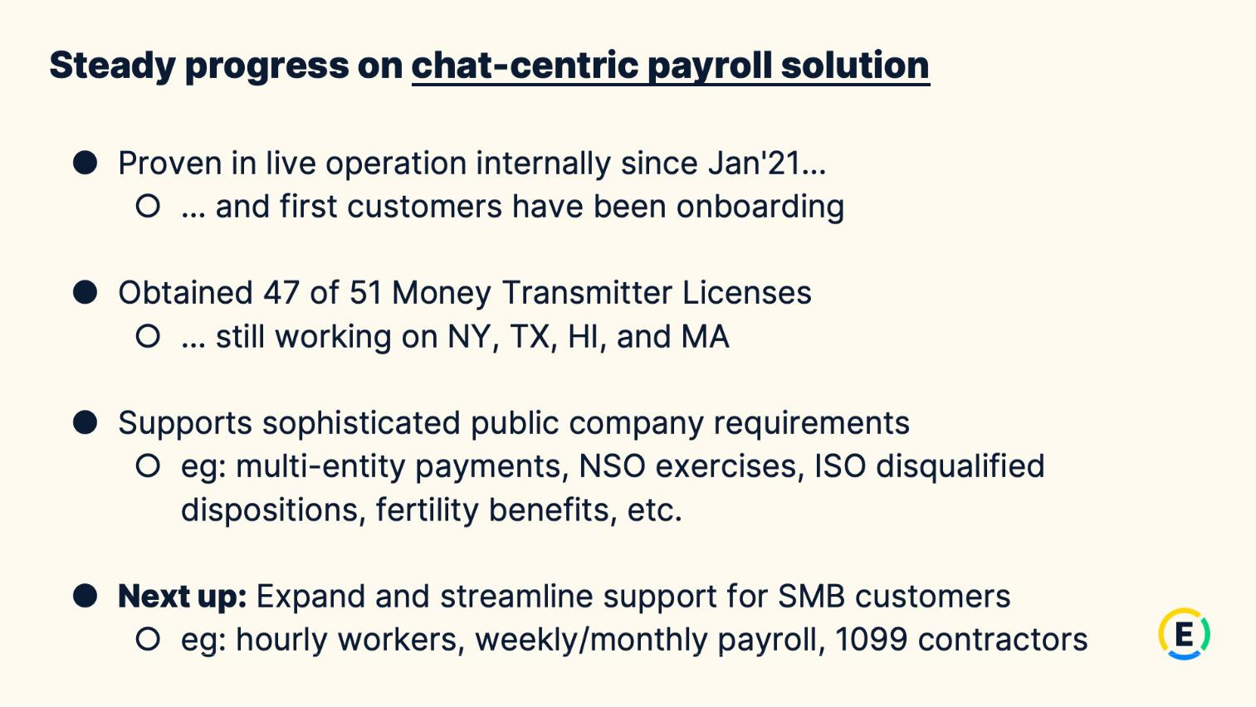

16

Exhibit 99.2

Expensify, Inc.

Investor Presentation
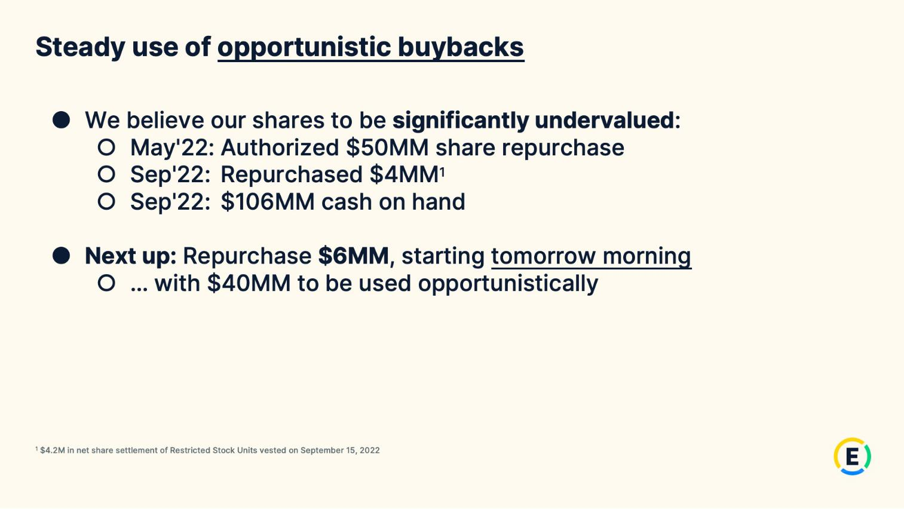

17

Exhibit 99.2

Expensify, Inc.

Investor Presentation


18

Exhibit 99.2

Expensify, Inc.

Investor Presentation
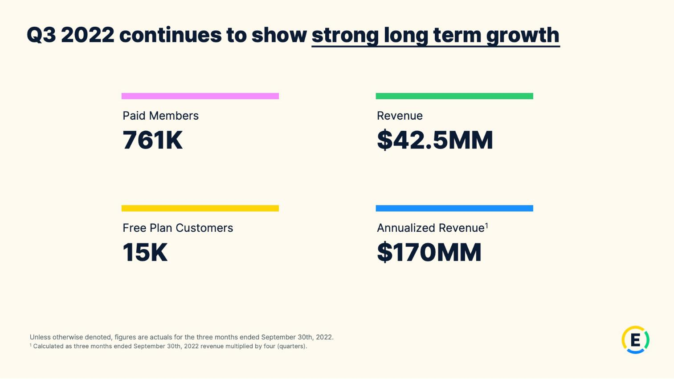

19

Exhibit 99.2

Expensify, Inc.

Investor Presentation
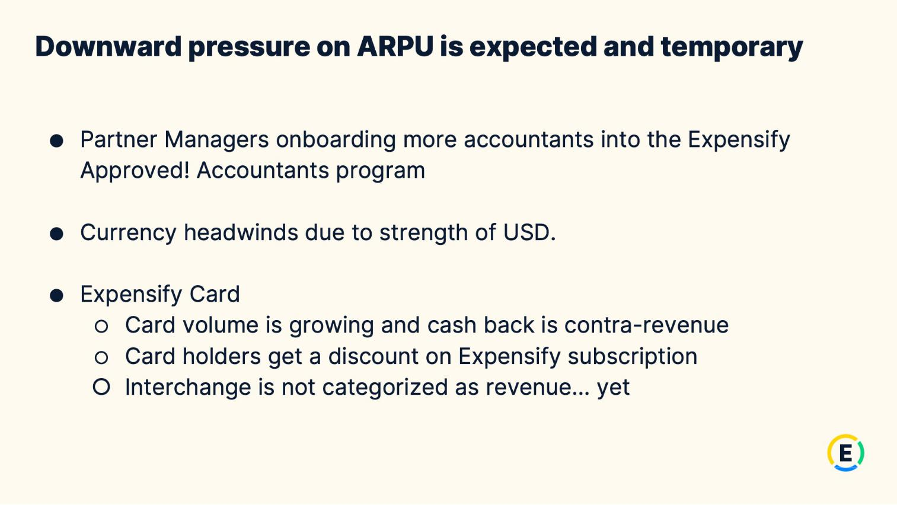

20

Exhibit 99.2

Expensify, Inc.

Investor Presentation
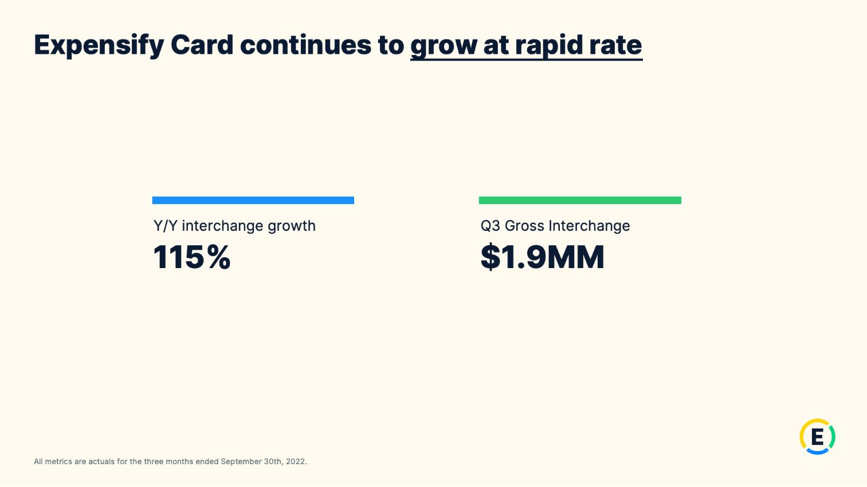

21

Exhibit 99.2

Expensify, Inc.

Investor Presentation
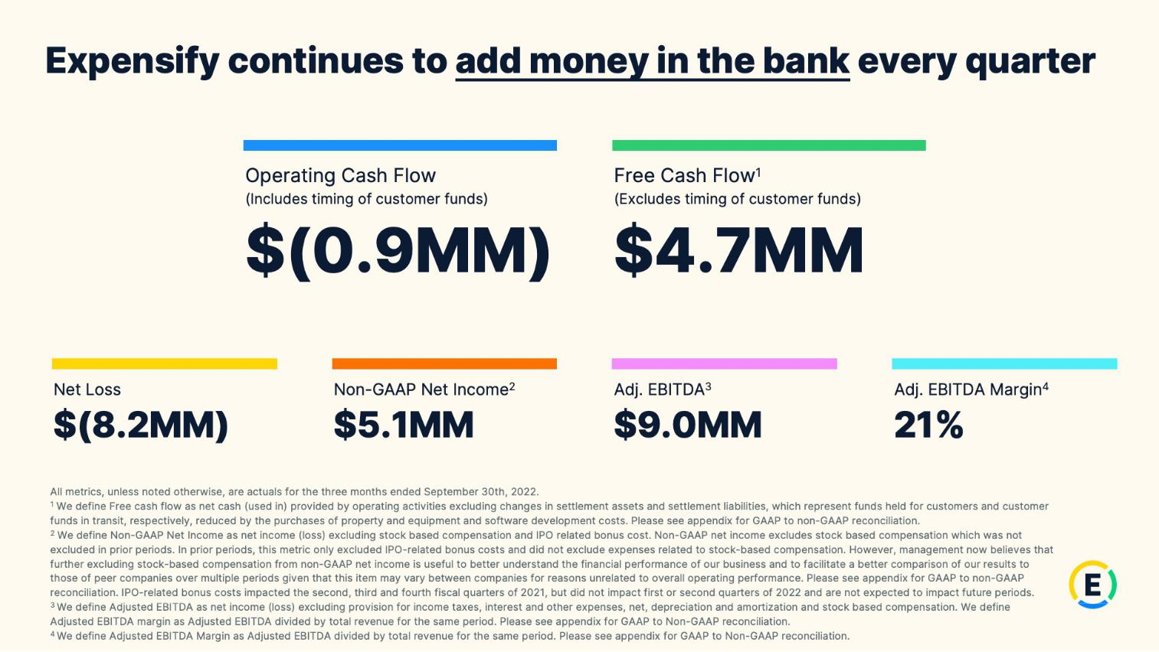

22

Exhibit 99.2

Expensify, Inc.

Investor Presentation
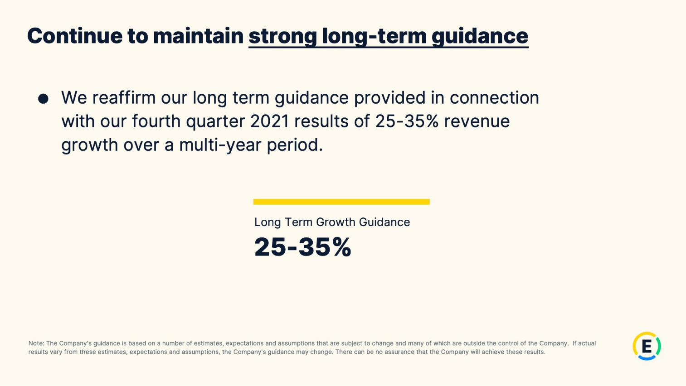

23

Exhibit 99.2

Expensify, Inc.

Investor Presentation
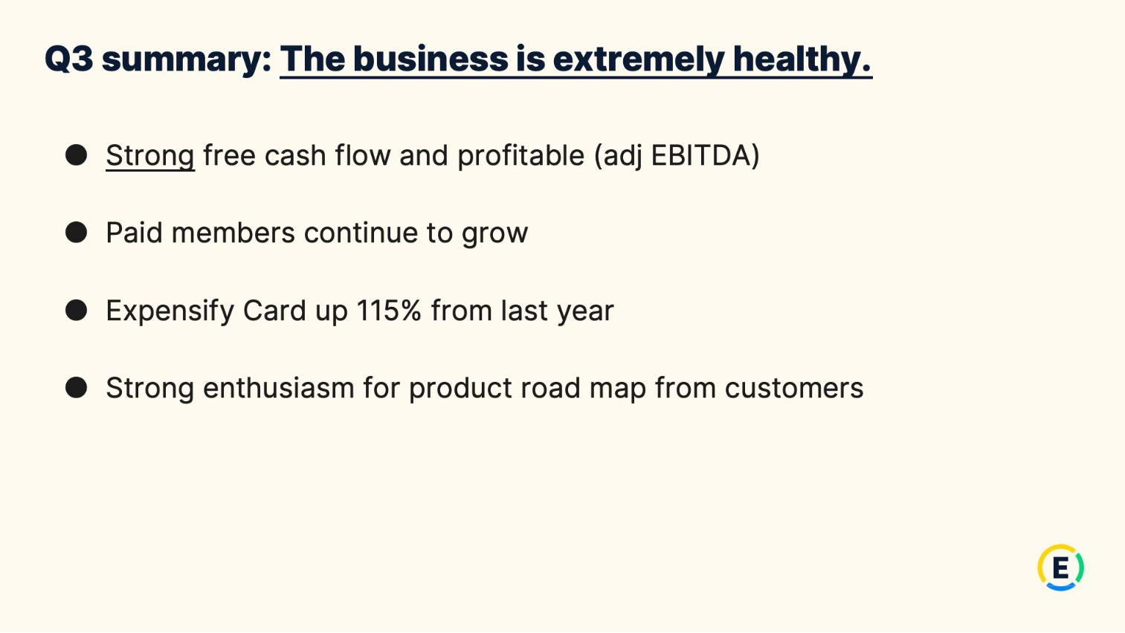

24

Exhibit 99.2

Expensify, Inc.

Investor Presentation
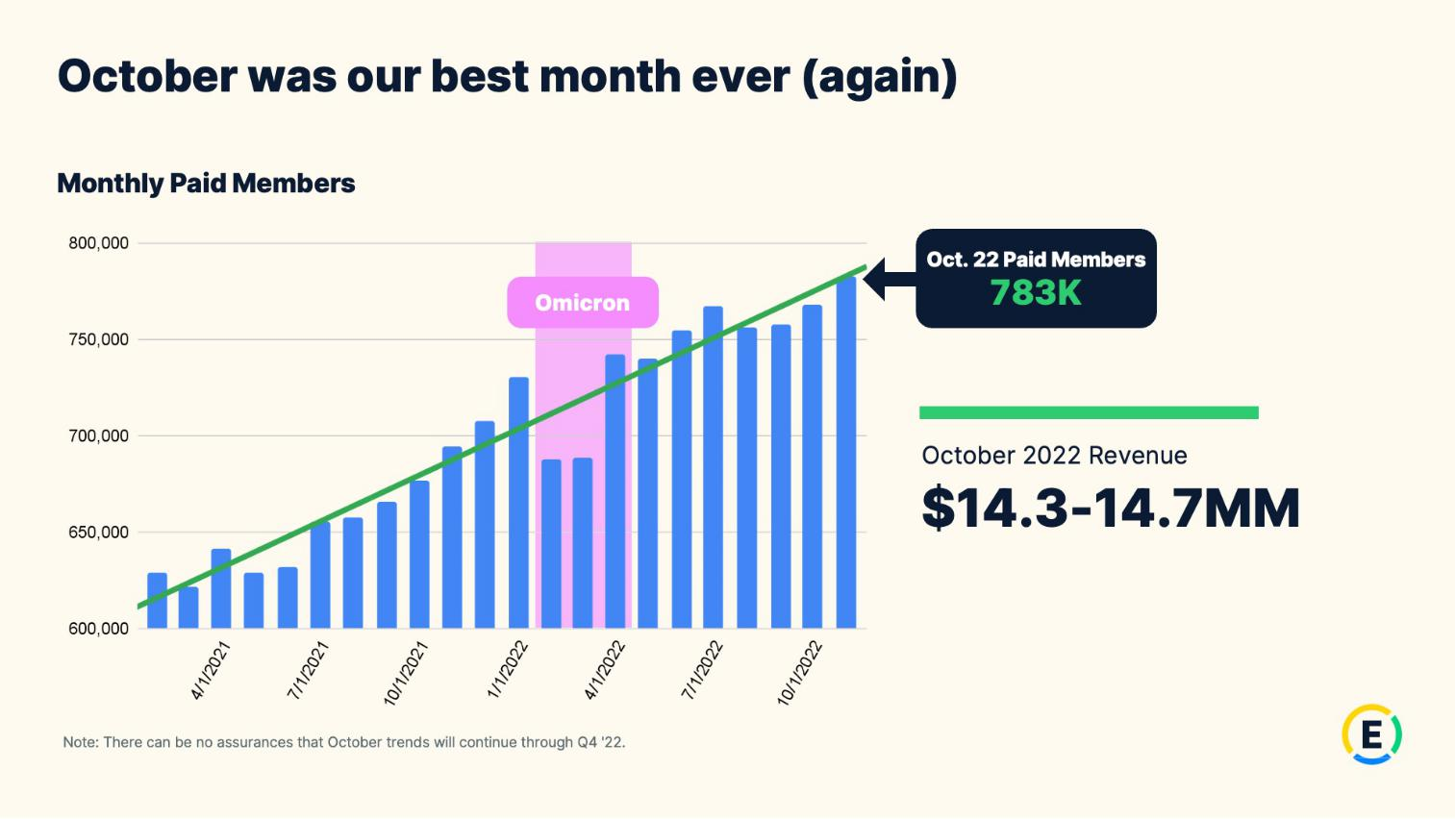

25

Exhibit 99.2

Expensify, Inc.

Investor Presentation


26

Exhibit 99.2

Expensify, Inc.

Investor Presentation


27

Exhibit 99.2

Expensify, Inc.

Investor Presentation


28

Exhibit 99.2

Expensify, Inc.

Investor Presentation
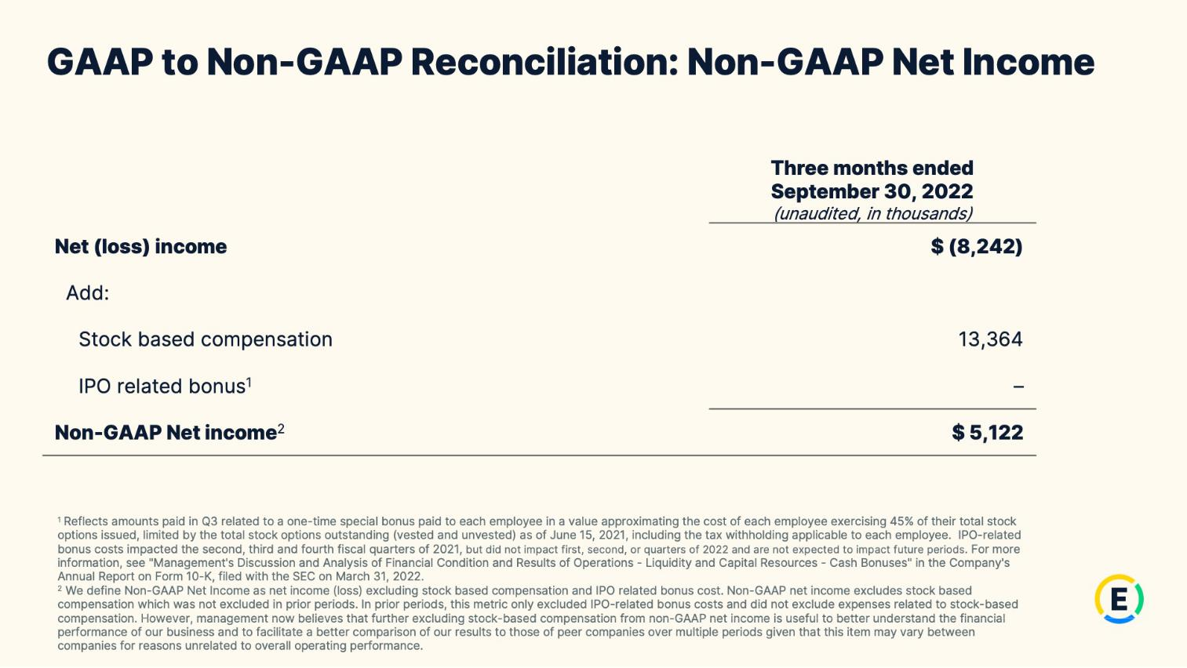

29

Exhibit 99.2

Expensify, Inc.

Investor Presentation
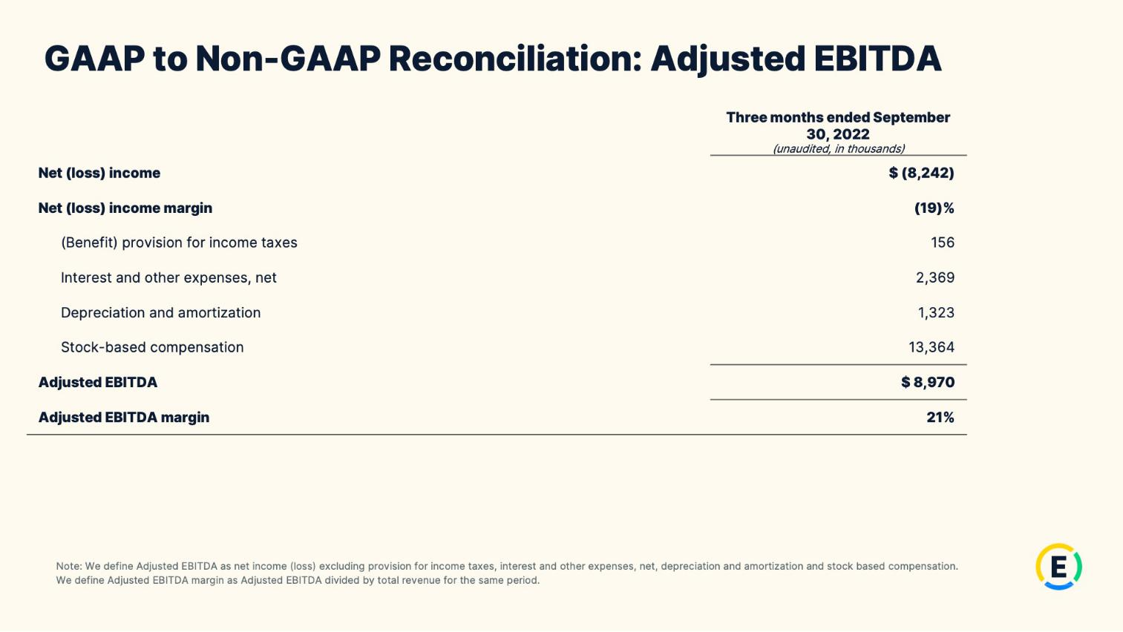

30

Exhibit 99.2

Expensify, Inc.

Investor Presentation
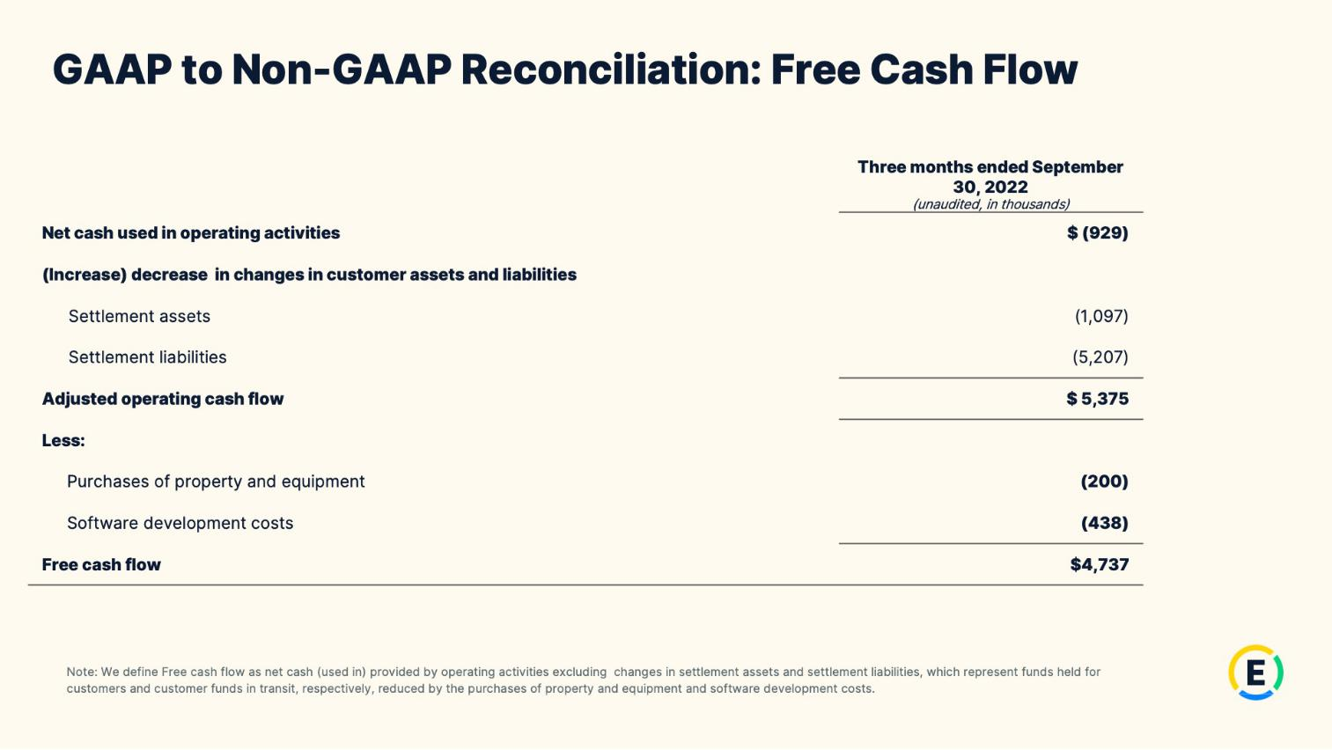

31

Exhibit 99.2

Expensify, Inc.

Investor Presentation

32

Exhibit 99.2

Expensify, Inc.

Investor Presentation

33

