UNITED STATES
SECURITIES AND EXCHANGE COMMISSION
Washington, D.C. 20549
FORM 8-K
CURRENT REPORT
PURSUANT TO SECTION 13 OR 15(d)
OF THE SECURITIES EXCHANGE ACT OF 1934
Date of report (Date of earliest event reported): February 27, 2025
Expensify, Inc.
(Exact Name of Registrant as Specified in its Charter)
Delaware |  |  |  |  |  | 001-41043 |  |  |  |  |  | 27-0239450
(State or Other Jurisdiction  of Incorporation) |  |  |  |  |  | (Commission  File Number) |  |  |  |  |  | (IRS Employer  Identification No.)
401 SW 5th Ave
Portland, Oregon 97204
(Address of Principal Executive Offices) (Zip Code)
(971) 365-3939
(Registrant’s telephone number, including area code)
Not applicable
(Former Name or Former Address, if Changed Since Last Report)
Check the appropriate box below if the Form 8-K filing is intended to simultaneously satisfy the filing obligation of the registrant under any of the following provisions:
☐ |  |  |  |  |  | Written communications pursuant to Rule 425 under the Securities Act (17 CFR 230.425).
☐ |  |  |  |  |  | Soliciting material pursuant to Rule 14a-12 under the Exchange Act (17 CFR 240.14a-12).
☐ |  |  |  |  |  | Pre-commencement communications pursuant to Rule 14d-2(b) under the Exchange Act (17 CFR 240.14d-2(b)).
☐ |  |  |  |  |  | Pre-commencement communications pursuant to Rule 13e-4(c) under the Exchange Act (17 CFR 240.13e-4(c)).
Securities registered pursuant to Section 12(b) of the Act:
Title of each class |  |  |  |  |  | Trading  Symbols |  |  |  |  |  | Name of each exchange  on which registered
Class A Common Stock, par value $0.0001 per share |  |  |  |  |  | EXFY |  |  |  |  |  | The Nasdaq Stock Market LLC
Indicate by check mark whether the registrant is an emerging growth company as defined in Rule 405 of the Securities Act of 1933 (§230.405 of this chapter) or Rule 12b-2 of the Securities Exchange Act of 1934 (§240.12b-2 of this chapter).
Emerging growth company ☐
If an emerging growth company, indicate by check mark if the registrant has elected not to use the extended transition period for complying with any new or revised financial accounting standards provided pursuant to Section 13(a) of the Exchange Act. ☐

Item 2.02 Results of Operations and Financial Condition.
On February 27, 2025, the Expensify, Inc. (“Expensify” or “the Company”) issued a press release announcing its financial results for the year and quarter ended December 31, 2024. A copy of this press release is furnished as Exhibit 99.1 to this current report on Form 8-K and is incorporated herein by reference.

Item 7.01 Regulation FD Disclosure.
On February 27, 2025, the Company posted an investor presentation to its website at https://ir.expensify.com (the “Investor Presentation”). A copy of the Investor Presentation is attached as Exhibit 99.2 to this current report on Form 8-K and is incorporated herein by reference. The Company expects to use the Investor Presentation, in whole or in part, and possibly with modifications, in connection with presentations to investors, analysts and others.
The information contained in the Investor Presentation is summary information that is intended to be considered in the context of the Company’s Securities and Exchange Commission (“SEC”) filings and other public announcements that the Company may make, by press release or otherwise, from time to time. The Investor Presentation speaks only as of the date of this current report on Form 8-K. The Company undertakes no duty or obligation to publicly update or revise the information included in the Investor Presentation, although it may do so from time to time. Any such updating may be made through the filing of other reports or documents with the SEC, through press releases or other public disclosure. In addition, the exhibit furnished herewith contains statements intended as “forward-looking statements” that are subject to the cautionary statements about forward-looking statements set forth in such exhibit. By furnishing the information contained in the Investor Presentation, the Company makes no admission as to the materiality of any information in the Investor Presentation that is required to be disclosed solely by reason of Regulation FD.
The information contained in Item 2.02 and this Item 7.01, including Exhibit 99.1 and 99.2, is being furnished and shall not be deemed “filed” for the purposed of Section 18 of the Securities and Exchange Act of 1934, as amended (the “Exchange Act”), or otherwise subject to the liabilities of that section, nor shall it be deemed incorporated by reference in any filing made by Expensify under the Securities Act of 1933, as amended, or the Exchange Act, except as expressly set forth by specific reference in such a filing.

Item 8.01 Other Events.
On February 27, 2025, the Company issued a press release announcing that its board of directors approved a new share repurchase program with authorization to purchase up to $50 million of shares of its Class A common stock. The program replaces the Company’s share repurchase program that was approved in 2022, which was set to expire in March 2025. The Company may repurchase shares from time to time through open market purchases, in privately negotiated transactions or by other means, including through the use of trading plans intended to qualify under Rule 10b5-1 under the Exchange Act, in accordance with applicable securities laws and other restrictions. The actual timing and total amount of future repurchases are subject to business, economic and market conditions, corporate and regulatory requirements, prevailing stock prices, restrictions under the terms of our loan agreements and other considerations. The share repurchase program does not obligate the Company to acquire any particular amount of Class A common stock, and the program may be suspended or terminated at any time by the Company at any time at its discretion without prior notice. A copy of the press release is attached hereto as Exhibit 99.3 and is incorporated by reference herein.

Item 9.01 Financial Statements and Exhibits.
(d) Exhibits.
Exhibit No. |  |  |  |  |  | Description
99.1 |  |  |  |  |  | Press Release issued by Expensify, Inc., dated February 27, 2025.
99.2 |  |  |  |  |  | Investor Presentation, dated February 27, 2025.
99.3 |  |  |  |  |  | Press Release issued by Expensify, Inc., dated February 27, 2025.
104 |  |  |  |  |  | Cover Page Interactive Data File (embedded within the Inline XBRL document).

SIGNATURE
Pursuant to the requirements of the Securities Exchange Act of 1934, the registrant has duly caused this report to be signed on its behalf by the undersigned hereunto duly authorized.
Expensify, Inc.
By: |  |  |  |  |  | /s/ Ryan Schaffer
Name: |  |  |  |  |  | Ryan Schaffer
Title: |  |  |  |  |  | Chief Financial Officer
Date: February 27, 2025

Exhibit 99.1

EXPENSIFY ANNOUNCES Q4 AND FULL YEAR FISCAL 2024 RESULTS
The company generated $23.9 million in Operating Cash Flow and $23.9 million in free cash flow in fiscal year 2024, Q4 revenue increased 5% from Q3 2024.

PORTLAND, Ore.--(BUSINESS WIRE)--February 27, 2025-- Expensify, Inc. (Nasdaq: EXFY), a payments superapp that helps individuals and businesses around the world simplify the way they manage money across expenses, corporate cards and bills, today released a letter to shareholders from Founder and CEO David Barrett alongside results for its quarter and year ended December 31, 2024.

A Message From Our Founder
Quite simply, another great quarter, capping off an exciting year. The numbers speak for themselves:
•Q4 Revenue is up 5% q/q, FY24 Net loss is down 76% y/y and FY24 Adjusted EBIDTA is up 199% y/y – to a whopping $39.4 million.
•We generated $23.9 million in Operating Cash Flow and $23.9 million in free cash flow – beating the high end of our 2024 forecast by 19% even after raising it multiple times throughout the year.
•Expensify Card spend is up 44% y/y, and interchange is up 54% y/y – essentially all of which is revenue now that we've effectively completed our migration to the new card program (which treats interchange as revenue, not as a contra expense, and earns more interchange per swipe).
•And my personal favorite, we paid off $22.7 million in debt – making us debt free.
These results weren't easy, and are the early results of our integration of "deep AI" – not surface level, gimmicky features, but AI applied to complex systems that have previously required large teams of human agents. For example:
•We have virtually eliminated human intervention in the SmartScan process, and now leverage a highly tuned and backtested AI model that results in faster, more accurate scans, across more languages and complex formats than ever – at 25% the cost.
•We made a major upgrade to our hybrid-AI Concierge system, where AI takes a first pass at every new conversation, resulting in ~80% fewer "escalations" to our human team in February '25. Not only has this increased the speed and accuracy of "basic" customer requests, it has freed up substantially more time for our human team to proactively engage with customers via account management calls.
•We are evaluating the transcripts of every customer call based on documented best practices, providing real-time feedback to our sales team and support staff (as well as detailed performance indicators to their managers). This has resulted in a 97% increase in "perfect calls" (as measured by our team covering every point correctly before hanging up) in January '25 alone.
But that's certainly not all, and is really just a preview of much more impactful projects underway:
•We are planning to add "Concierge everywhere", transforming NewDot's chat-first design into an AI-first experience. If you have a question or want to make a change on basically anything, just ask Concierge in the chat attached to that thing – be that changing a workspace setting, asking about a particular employee's spending patterns, performing a flux analysis across multiple accounting periods, or just fixing an expense violation in natural text. Yes, Expensify Chat can be used like Slack to collaborate with co-workers. But it's better to think of it like ChatGPT: New Expensify is a tool for "chatting" with Concierge and your colleagues, right in the context of what you're analyzing.
•We are working on integrating artificial engineers into our development team. Early work on this was recently published by OpenAI, which has selected the "paid open source" contributor program behind the
Exhibit 99.1

official Expensify app as the basis of its SWE-Lancer coding benchmark. This benchmark evaluates how many of Expensify's real-world, paid freelance projects can be successfully implemented using best-of-breed LLMs. We are betting our unique corporate structure will enable us to seamlessly integrate GenAI engineering on a meaningful scale, just like we've already done with our global network of human freelance engineers.
Granted, it's tough to talk about AI because it is so cliche and noisy, with everyone clamoring to outdo each other with ever more grandiose claims. It's hard to say anything without earning eye rolls in return. But make no mistake:
Expensify is gunning for AI supremacy in fintech. And I think we are better positioned than any competitor to achieve it.
That might sound like wishful thinking, which is why our midwestern sensibilities make us shy to talk about it. But that's the plan, and we feel very, very proud of the progress made down that path in the last year – and super excited about the years to come. Thank you for coming along with us on this journey. It's been quite a ride!
-david
Founder and CEO of Expensify
Financial
Fourth Quarter 2024 Highlights
•Revenue was $37.0 million, an increase of 5% compared to the same period last year.
•Generated $7.4 million of cash from operating activities.
•Free cash flow was $6.3 million.
•Net loss was $1.3 million, compared to $7.2 million for the same period last year.
•Non-GAAP net income was $8.7 million.
•Adjusted EBITDA was $12.4 million.
•Interchange derived from the Expensify Card grew to $5.1 million, an increase of 62% compared to the same period last year.
•See Financial Outlook section for Free Cash Flow guidance for fiscal year ending December 31, 2025.
Full Year Fiscal 2024 Highlights
•Revenue was $139.2 million, a decrease of 8% compared to the prior year.
•Generated $23.9 million of cash from operating activities.
•Free cash flow was $23.9 million.
•Net loss was $10.1 million, compared to $41.5 million for the prior year.
•Non-GAAP net income was $23.5 million.
•Adjusted EBITDA was $39.4 million.
•Interchange derived from the Expensify Card grew to $17.2 million, an increase of 54% compared to the prior year.
Exhibit 99.1

Business
Fourth Quarter 2024 Highlights
•Paid members - Paid members were 687,000, a decrease of 4% from the same period last year, however a slight increase compared to Q3 2024's paid members of 684,000.
•Expanded AI Support - expanded enterprise client relationship with OpenAI to provide 80% of tier 1 support through AI driven responses.
•Expensify Travel - The company launched its travel product, adding fee-based and transactional revenue opportunities to the business.
2024 Highlights
•Debt reduction - The company reduced its debt by $22.7 million in 2024.
•Share purchases - The company’s employees purchased $4.1 million worth of Class A common stock via the company’s Stock Purchase and Matching Plan in 2024.
•Expensify Card migration - The company completed its migration to its new card program with substantially all Expensify Card spend now under the new program.
Financial Outlook
Expensify's outlook statements are based on current estimates, expectations and assumptions and are not a guarantee of future performance. The following statements are forward-looking and actual results could differ materially depending on market conditions and the factors set forth under “Forward-Looking Statements” below. There can be no assurance that the Company will achieve the results expressed by this guidance.
Free Cash Flow
Expensify estimates Free Cash Flow of $16.0 million - $20.0 million for the fiscal year ending December 31, 2025.
The Company does not provide a reconciliation for free cash flow estimates on a forward-looking basis because it is unable, without making unreasonable efforts, to provide a meaningful or reasonably accurate calculation or estimation of net cash provided by operating activities and certain reconciling items on a forward-looking basis, which could be significant to the Company's results.
Stock Based Compensation
An estimate of expected stock-based compensation for the next four fiscal quarters is as follows, which is driven primarily by the pre-IPO grant of RSUs issued to all employees (which vest quarterly over eight years with approximately four years remaining).
Est. stock-based compensation (millions)
 |  |  | Q1 2025 |  |  |  |  |  |  |  |  |  |  |  | Q2 2025 |  |  |  |  |  |  |  |  |  |  |  | Q3 2025 |  |  |  |  |  |  |  |  |  |  |  | Q4 2025
 |  |  | Low |  |  |  |  |  | High |  |  |  |  |  | Low |  |  |  |  |  | High |  |  |  |  |  | Low |  |  |  |  |  | High |  |  |  |  |  | Low |  |  |  |  |  | High
Cost of revenue, net |  |  | $ | 2.7 |  |  |  |  | $ | 3.4 |  |  |  |  | $ | 2.4 |  |  |  |  | $ | 3.1 |  |  |  |  | $ | 2.4 |  |  |  |  | $ | 3.1 |  |  |  |  | $ | 2.3 |  |  |  |  | $ | 3.0
Research and development |  |  | 2.4 |  |  |  |  |  | 3.1 |  |  |  |  |  | 2.2 |  |  |  |  |  | 2.9 |  |  |  |  |  | 2.2 |  |  |  |  |  | 2.9 |  |  |  |  |  | 2.1 |  |  |  |  |  | 2.8
General and administrative |  |  | 1.3 |  |  |  |  |  | 1.7 |  |  |  |  |  | 1.2 |  |  |  |  |  | 1.6 |  |  |  |  |  | 1.1 |  |  |  |  |  | 1.5 |  |  |  |  |  | 1.1 |  |  |  |  |  | 1.5
Sales and marketing |  |  | 0.5 |  |  |  |  |  | 0.7 |  |  |  |  |  | 0.5 |  |  |  |  |  | 0.7 |  |  |  |  |  | 0.5 |  |  |  |  |  | 0.7 |  |  |  |  |  | 0.5 |  |  |  |  |  | 0.7
Total |  |  | $ | 6.9 |  |  |  |  | $ | 8.9 |  |  |  |  | $ | 6.3 |  |  |  |  | $ | 8.3 |  |  |  |  | $ | 6.2 |  |  |  |  | $ | 8.2 |  |  |  |  | $ | 6.0 |  |  |  |  | $ | 8.0
Exhibit 99.1

Availability of Information on Expensify’s Website
Investors and others should note that Expensify routinely announces material information to investors and the marketplace using SEC filings, press releases, public conference calls, webcasts and the Expensify Investor Relations website at https://ir.expensify.com. While not all of the information that the Company posts to its Investor Relations website is of a material nature, some information could be deemed to be material. Accordingly, the Company encourages investors, the media and others interested in Expensify to review the information that it shares on its Investor Relations website.
Conference Call
Expensify will host a video call to discuss the financial results and business highlights at 2:00 p.m. Pacific Time today. An investor presentation and the video call information is available on Expensify’s Investor Relations website at https://ir.expensify.com. A replay of the call will be available on the site for three months.
Non-GAAP Financial Measures
In addition to financial measures prepared in accordance with U.S. generally accepted accounting principles (“GAAP”), we provide certain non-GAAP financial measures, including adjusted EBITDA, non-GAAP net income, and free cash flow.
We believe our non-GAAP financial measures are useful in evaluating our business, measuring our performance, identifying trends affecting our business, formulating business plans and making strategic decisions. Accordingly, we believe that these non-GAAP financial measures provide useful information to investors and others in understanding and evaluating our results of operations in the same manner as our management team. These non-GAAP financial measures are presented for supplemental informational purposes only, should not be considered a substitute for financial information presented in accordance with GAAP, and may be different from similarly titled metrics or measures presented by other companies. Non-GAAP financial measures have limitations as analytical tools and should not be considered in isolation or as substitutes for financial information presented under GAAP. There are a number of limitations related to the use of non-GAAP financial measures versus comparable financial measures determined under GAAP. For example, other companies in our industry may calculate these non-GAAP financial measures differently or may use other measures to evaluate their performance. All of these limitations could reduce the usefulness of these non-GAAP financial measures as analytical tools. Investors are encouraged to review the related GAAP financial measures and the reconciliations of these non-GAAP financial measures to their most directly comparable GAAP financial measures and to not rely on any single financial measure to evaluate our business. A reconciliation of each non-GAAP financial measure to the most directly comparable financial measure stated in accordance with GAAP is at the end of this press release.
Adjusted EBITDA. We define adjusted EBITDA as net loss from operations excluding provision for income taxes, interest and other expenses, net, depreciation and amortization and stock-based compensation.
Non-GAAP net income. We define Non-GAAP net income as net loss from operations excluding stock-based compensation.
Free cash flow. We define Free cash flow as net cash provided by operating activities excluding changes in settlement assets and settlement liabilities, which represent funds held for customers and customer funds in transit, respectively, reduced by the purchases of property and equipment and software development costs.
The tables at the end of the Consolidated Financial Statements provide reconciliations to the most directly comparable GAAP financial measure to each of these non-GAAP financial measures.
Forward-Looking Statements
Forward-looking statements in this press release, or made during the earnings call, which are not historical facts, are forward-looking statements within the meaning of the Private Securities Litigation Reform Act of 1955. These statements include statements regarding our strategy, future financial condition, future operations, future cash flow,
Exhibit 99.1

projected costs, prospects, plans, objectives of management and expected market growth, product developments and their potential impact and our stock-based compensation estimates and involve known and unknown risks that are difficult to predict. As a result, our actual results, performance or achievements may differ materially from those expressed or implied by these forward-looking statements. In some cases, you can identify forward-looking statements because they contain words such as “may,” “will,” “shall,” “should,” “expects,” “plans,” “anticipates,” “could,” “intends,” “target,” “projects,” “contemplates,” “believes,” “estimates,” “predicts,” “potential,” “goal,” “ambition,” “objective,” “seeks,” “outlook,” or “continue” or the negative of these words or other similar terms or expressions that concern our expectations, strategy, plans, or intentions. Such forward-looking statements are necessarily based upon estimates and assumptions that, while considered reasonable by us and our management, are inherently uncertain. Factors that may cause actual results to differ materially from current expectations include, but are not limited to: the impact on inflation on us and our members; our borrowing costs have and may continue to increase as a result of increases in interest rates; our expectations regarding our financial performance and future operating performance; our ability to attract and retain members, expand usage of our platform, sell subscriptions to our platform and convert individuals and organizations into paying customers; the timing and success of new features, integrations, capabilities and enhancements by us, or by competitors to their products, or any other changes in the competitive landscape of our market; the amount and timing of operating expenses and capital expenditures that we may incur to maintain and expand our business and operations to remain competitive; the sufficiency of our cash, cash equivalents and investments to meet our liquidity needs; our ability to make required payments under and to comply with the various requirements of our current and future indebtedness; our cash flows, the prevailing stock prices, general economic and market conditions and other considerations that could affect the specific timing, price and size of repurchases under our stock repurchase program or our ability to fund any stock repurchases; geopolitical tensions, including the war in Ukraine and the conflict in Israel, Gaza and surrounding areas; our ability to effectively manage our exposure to fluctuations in foreign currency exchange rates; the expenses associated with being a public company; the size of our addressable markets, market share and market trends; anticipated trends, developments and challenges in our industry, business and the highly competitive markets in which we operate; any adverse impact on our business operations as a result of using artificial intelligence or other machine learning technologies in our services; our expectations regarding our income tax liabilities and the adequacy of our reserves; our ability to effectively manage our growth and expand our infrastructure and maintain our corporate culture; our ability to identify, recruit and retain skilled personnel, including key members of senior management; the safety, affordability and convenience of our platform and our offerings; our ability to successfully defend litigation brought against us; our ability to successfully identify, manage and integrate any existing and potential acquisitions of businesses, talent, technologies or intellectual property; general economic conditions in either domestic or international markets, and geopolitical uncertainty and instability, and their effects on software spending; our protections against security breaches, technical difficulties, or interruptions to our platform; our ability to maintain, protect and enhance our intellectual property; and other risks discussed in our filings with the SEC. All forward-looking statements attributable to us or persons acting on our behalf are expressly qualified in their entirety by the cautionary statements set forth above. We caution you not to place undue reliance on any forward-looking statements, which are made only as of the date of this press release. We do not undertake or assume any obligation to update publicly any of these forward-looking statements to reflect actual results, new information or future events, changes in assumptions or changes in other factors affecting forward-looking statements, except to the extent required by applicable law. If we update one or more forward-looking statements, no inference should be drawn that we will make additional updates with respect to those or other forward-looking statements.
About Expensify
Expensify helps 15 million people worldwide track expenses, book travel, reimburse employees, manage corporate cards, send invoices, and pay bills—all in one place. Whether you're self-employed, running a small business, managing a team, or overseeing global finances, let Expensify handle your travel and expense, at the speed of chat.
Investor Relations Contact
Nick Tooker
investors@expensify.com
Press Contact
James Dean
press@expensify.com

Expensify, Inc.
Consolidated Balance Sheets
(unaudited, in thousands, except share and per share data)
 |  |  | As of December 31,
 |  |  | 2024 |  |  |  |  |  | 2023
Assets
Cash and cash equivalents |  |  | $ | 48,772 |  |  |  |  | $ | 47,510
Accounts receivable, net |  |  | 12,701 |  |  |  |  |  | 13,834
Settlement assets, net |  |  | 42,406 |  |  |  |  |  | 39,261
Prepaid expenses |  |  | 12,089 |  |  |  |  |  | 5,649
Other current assets |  |  | 20,908 |  |  |  |  |  | 30,978
Total current assets |  |  | 136,876 |  |  |  |  |  | 137,232
Capitalized software, net |  |  | 16,232 |  |  |  |  |  | 12,494
Property and equipment, net |  |  | 13,621 |  |  |  |  |  | 14,372
Lease right-of-use assets |  |  | 5,441 |  |  |  |  |  | 6,435
Deferred tax assets, net |  |  | 499 |  |  |  |  |  | 457
Other assets |  |  | 1,011 |  |  |  |  |  | 5,794
Total assets |  |  | $ | 173,680 |  |  |  |  | $ | 176,784
Liabilities and stockholders' equity
Accounts payable |  |  | $ | 196 |  |  |  |  | $ | 1,425
Accrued expenses and other liabilities |  |  | 8,240 |  |  |  |  |  | 9,390
Borrowings under line of credit |  |  | — |  |  |  |  |  | 15,000
Current portion of long-term debt, net of original issue discount and debt issuance costs |  |  | — |  |  |  |  |  | 7,655
Lease liabilities, current |  |  | 729 |  |  |  |  |  | 432
Settlement liabilities |  |  | 28,845 |  |  |  |  |  | 33,990
Total current liabilities |  |  | 38,010 |  |  |  |  |  | 67,892
Lease liabilities, non-current |  |  | 5,738 |  |  |  |  |  | 6,467
Other liabilities |  |  | 1,689 |  |  |  |  |  | 1,681
Total liabilities |  |  | 45,437 |  |  |  |  |  | 76,040
Commitments and contingencies (Note 12)
Stockholders' equity:
Preferred stock, par value $0.0001; 10,000,000 shares of preferred stock authorized as of December 31, 2024 and 2023, respectively; no shares of preferred stock issued and outstanding as of December 31, 2024 and 2023 |  |  | — |  |  |  |  |  | —
Common stock, par value $0.0001; 1,000,000,000 shares of Class A common stock authorized as of December 31, 2024 and 2023; 79,471,414 and 70,569,815 shares of Class A common stock issued and outstanding as of December 31, 2024 and 2023, respectively; 21,871,197 and 24,994,989 shares of LT10 common stock authorized as of December 31, 2024 and 2023, respectively; 4,209,827 and 7,333,619 shares of LT10 common stock issued and outstanding as of December 31, 2024 and 2023, respectively; 24,967,114 and 24,998,941 shares of LT50 common stock authorized as of December 31, 2024 and 2023, respectively; 7,695,524 and 7,321,894 shares of LT50 common stock issued and outstanding as of December 31, 2024 and 2023, respectively |  |  | 9 |  |  |  |  |  | 8
Additional paid-in capital |  |  | 279,062 |  |  |  |  |  | 241,509
Accumulated deficit |  |  | (150,828) |  |  |  |  |  | (140,773)
Total stockholders' equity |  |  | 128,243 |  |  |  |  |  | 100,744
Total liabilities and stockholders' equity |  |  | $ | 173,680 |  |  |  |  | $ | 176,784

Expensify, Inc.
Consolidated Statements of Operations
(unaudited, in thousands, except share and per share data)
 |  |  | Three Months Ended December 31, |  |  |  |  |  |  |  |  |  |  |  | Year ended December 31,
 |  |  | 2024 |  |  |  |  |  | 2023 |  |  |  |  |  | 2024 |  |  |  |  |  | 2023
Revenue |  |  | $ | 37,004 |  |  |  |  | $ | 35,208 |  |  |  |  | $ | 139,236 |  |  |  |  | $ | 150,687
Cost of revenue, net(1) |  |  | 18,148 |  |  |  |  |  | 16,508 |  |  |  |  |  | 64,239 |  |  |  |  |  | 66,888
Gross margin |  |  | 18,856 |  |  |  |  |  | 18,700 |  |  |  |  |  | 74,997 |  |  |  |  |  | 83,799
Operating expenses:
Research and development(1) |  |  | 6,702 |  |  |  |  |  | 6,249 |  |  |  |  |  | 24,638 |  |  |  |  |  | 23,368
General and administrative(1) |  |  | 8,622 |  |  |  |  |  | 10,842 |  |  |  |  |  | 38,382 |  |  |  |  |  | 49,228
Sales and marketing(1) |  |  | 3,067 |  |  |  |  |  | 7,595 |  |  |  |  |  | 12,797 |  |  |  |  |  | 44,352
Total operating expenses |  |  | 18,391 |  |  |  |  |  | 24,686 |  |  |  |  |  | 75,817 |  |  |  |  |  | 116,948
Income (loss) from operations |  |  | 465 |  |  |  |  |  | (5,986) |  |  |  |  |  | (820) |  |  |  |  |  | (33,149)
Interest and other expenses, net |  |  | (539) |  |  |  |  |  | (169) |  |  |  |  |  | (1,572) |  |  |  |  |  | (5,327)
Loss before income taxes |  |  | (74) |  |  |  |  |  | (6,155) |  |  |  |  |  | (2,392) |  |  |  |  |  | (38,476)
Provision for income taxes |  |  | (1,238) |  |  |  |  |  | (1,049) |  |  |  |  |  | (7,663) |  |  |  |  |  | (2,980)
Net loss |  |  | $ | (1,312) |  |  |  |  | $ | (7,204) |  |  |  |  | $ | (10,055) |  |  |  |  | $ | (41,456)
Net loss per share:
Basic and diluted |  |  | $ | (0.01) |  |  |  |  | $ | (0.09) |  |  |  |  | $ | (0.12) |  |  |  |  | $ | (0.50)
Weighted average shares of common stock used to compute net loss per share:
Basic and diluted |  |  | 89,577,172 |  |  |  |  |  | 83,703,085 |  |  |  |  |  | 87,380,708 |  |  |  |  |  | 82,493,226

(1)Includes stock-based compensation expense as follows:
 |  |  | Three Months Ended December 31, |  |  |  |  |  |  |  |  |  |  |  | Year ended December 31,
 |  |  | 2024 |  |  |  |  |  | 2023 |  |  |  |  |  | 2024 |  |  |  |  |  | 2023
Cost of revenue, net |  |  | $ | 3,845 |  |  |  |  | $ | 3,650 |  |  |  |  | $ | 12,506 |  |  |  |  | $ | 13,868
Research and development |  |  | 3,476 |  |  |  |  |  | 3,308 |  |  |  |  |  | 11,900 |  |  |  |  |  | 10,870
General and administrative |  |  | 1,850 |  |  |  |  |  | 2,290 |  |  |  |  |  | 6,815 |  |  |  |  |  | 9,842
Sales and marketing |  |  | 831 |  |  |  |  |  | 1,352 |  |  |  |  |  | 2,316 |  |  |  |  |  | 6,632
Total stock-based compensation expense |  |  | $ | 10,002 |  |  |  |  | $ | 10,600 |  |  |  |  | $ | 33,537 |  |  |  |  | $ | 41,212

Expensify, Inc.
Consolidated Statements of Cash Flows
(unaudited, in thousands)
 |  |  | Year Ended December 31,
 |  |  | 2024 |  |  |  |  |  | 2023
Cash flows from operating activities:
Net loss |  |  | $ | (10,055) |  |  |  |  | $ | (41,456)
Adjustments to reconcile net loss to cash provided by operating activities:
Depreciation and amortization |  |  | 6,814 |  |  |  |  |  | 5,164
Reduction of operating lease right-of-use assets |  |  | 547 |  |  |  |  |  | 614
Loss on impairment, receivables and sale or disposal of equipment |  |  | 727 |  |  |  |  |  | 923
Stock-based compensation |  |  | 33,537 |  |  |  |  |  | 41,212
Amortization of original issue discount and debt issuance costs |  |  | 54 |  |  |  |  |  | 257
Deferred tax assets |  |  | (42) |  |  |  |  |  | (113)
Changes in assets and liabilities:
Accounts receivable, net |  |  | 704 |  |  |  |  |  | 2,219
Settlement assets, net |  |  | (2,469) |  |  |  |  |  | (6,398)
Prepaid expenses |  |  | (1,490) |  |  |  |  |  | 3,176
Other current assets |  |  | 2,341 |  |  |  |  |  | (561)
Other assets |  |  | (167) |  |  |  |  |  | (5,130)
Accounts payable |  |  | (1,091) |  |  |  |  |  | 228
Accrued expenses and other liabilities |  |  | (404) |  |  |  |  |  | 906
Operating lease liabilities |  |  | 8 |  |  |  |  |  | (200)
Settlement liabilities |  |  | (5,145) |  |  |  |  |  | 108
Other liabilities |  |  | 8 |  |  |  |  |  | 610
Net cash provided by operating activities |  |  | 23,877 |  |  |  |  |  | 1,559
Cash flows from investing activities:
Purchase of property and equipment |  |  | — |  |  |  |  |  | (1,384)
Software development costs |  |  | (7,628) |  |  |  |  |  | (5,910)
Net cash used in investing activities |  |  | (7,628) |  |  |  |  |  | (7,294)
Cash flows from financing activities:
Principal payments of finance leases |  |  | (129) |  |  |  |  |  | (513)
Principal payments of term loan |  |  | (22,671) |  |  |  |  |  | (44,587)
Repurchases of early exercises of common stock |  |  | (35) |  |  |  |  |  | (17)
Proceeds from common stock purchased under Matching Plan |  |  | 4,091 |  |  |  |  |  | 4,255
Proceeds from issuance of common stock on exercise of stock options |  |  | 431 |  |  |  |  |  | 311
Payments for debt issuance costs |  |  | (71) |  |  |  |  |  | —
Payments for employee taxes withheld from stock-based awards |  |  | (2,179) |  |  |  |  |  | (1,766)
Repurchase and retirement of common stock |  |  | (1,510) |  |  |  |  |  | (3,000)
Net cash used in financing activities |  |  | (22,073) |  |  |  |  |  | (45,317)
Net decrease in cash and cash equivalents and restricted cash |  |  | (5,824) |  |  |  |  |  | (51,052)
Cash and cash equivalents and restricted cash, beginning of period |  |  | 96,658 |  |  |  |  |  | 147,710
Cash and cash equivalents and restricted cash, end of period |  |  | $ | 90,834 |  |  |  |  | $ | 96,658
Supplemental disclosure of cash flow information:
Cash paid for interest |  |  | $ | 1,362 |  |  |  |  | $ | 5,936
Cash paid for income taxes |  |  | $ | 5,072 |  |  |  |  | $ | 3,785
Noncash investing and financing items:
Stock-based compensation capitalized as software development costs |  |  | $ | 2,688 |  |  |  |  | $ | 3,126
Purchases of property and equipment and capitalized software in accounts payable and accrued expenses |  |  | $ | 37 |  |  |  |  | $ | 390
Right-of-use assets acquired through operating leases |  |  | $ | — |  |  |  |  | $ | 6,402
Right-of-use assets acquired through finance leases |  |  | $ | — |  |  |  |  | $ | 409
Cashless exercise of stock options |  |  | 335 |  |  |  |  |  | —
Reconciliation of cash and cash equivalents and restricted cash to the Consolidated Balance Sheets:
Cash and cash equivalents |  |  | $ | 48,772 |  |  |  |  | $ | 47,510
Restricted cash included in other current assets |  |  | 19,980 |  |  |  |  |  | 27,742
Restricted cash included in settlement assets, net |  |  | 22,082 |  |  |  |  |  | 21,406
Total cash and cash equivalents and restricted cash |  |  | $ | 90,834 |  |  |  |  | $ | 96,658

Expensify, Inc.
Reconciliation of GAAP to Non-GAAP Financial Measures
(unaudited, in thousands, except percentages)
Adjusted EBITDA and Adjusted EBITDA Margin
 |  |  | Three Months Ended December 31, |  |  |  |  |  |  |  |  |  |  |  | Year ended December 31,
 |  |  | 2024 |  |  |  |  |  | 2023 |  |  |  |  |  | 2024 |  |  |  |  |  | 2023
Net loss |  |  | $ | (1,312) |  |  |  |  | $ | (7,204) |  |  |  |  | $ | (10,055) |  |  |  |  | $ | (41,456)
Net loss margin |  |  | (4) |  | % |  |  |  | (20) |  | % |  |  |  | (7) |  | % |  |  |  | (28) |  | %
Add:
Provision for income taxes |  |  | 1,238 |  |  |  |  |  | 1,049 |  |  |  |  |  | 7,663 |  |  |  |  |  | 2,980
Interest and other expenses, net |  |  | 539 |  |  |  |  |  | 169 |  |  |  |  |  | 1,572 |  |  |  |  |  | 5,327
Depreciation and amortization |  |  | 1,923 |  |  |  |  |  | 1,240 |  |  |  |  |  | 6,655 |  |  |  |  |  | 5,111
Stock-based compensation expense |  |  | 10,002 |  |  |  |  |  | 10,600 |  |  |  |  |  | 33,537 |  |  |  |  |  | 41,212
Adjusted EBITDA |  |  | $ | 12,390 |  |  |  |  | $ | 5,854 |  |  |  |  | $ | 39,372 |  |  |  |  | $ | 13,174
Adjusted EBITDA margin |  |  | 33 |  | % |  |  |  | 17 |  | % |  |  |  | 28 |  | % |  |  |  | 9 |  | %

Non-GAAP Net Income and Non-GAAP Net Income Margin
 |  |  | Three Months Ended December 31, |  |  |  |  |  |  |  |  |  |  |  | Year ended December 31,
 |  |  | 2024 |  |  |  |  |  | 2023 |  |  |  |  |  | 2024 |  |  |  |  |  | 2023
Net loss |  |  | $ | (1,312) |  |  |  |  | $ | (7,204) |  |  |  |  | $ | (10,055) |  |  |  |  | $ | (41,456)
Net loss margin |  |  | (4) |  | % |  |  |  | (20) |  | % |  |  |  | (7) |  | % |  |  |  | (28) |  | %
Add:
Stock-based compensation expense |  |  | 10,002 |  |  |  |  |  | 10,600 |  |  |  |  |  | 33,537 |  |  |  |  |  | 41,212
Non-GAAP net income (loss) |  |  | $ | 8,690 |  |  |  |  | $ | 3,396 |  |  |  |  | $ | 23,482 |  |  |  |  | $ | (244)
Non-GAAP net income (loss) margin |  |  | 23 |  | % |  |  |  | 10 |  | % |  |  |  | 17 |  | % |  |  |  | — |  | %

Adjusted Operating Cash Flow and Free Cash Flow
 |  |  | Three Months Ended December 31, |  |  |  |  |  |  |  |  |  |  |  | Year ended December 31,
 |  |  | 2024 |  |  |  |  |  | 2023 |  |  |  |  |  | 2024 |  |  |  |  |  | 2023
Net cash provided by (used in) operating activities |  |  | $ | 7,402 |  |  |  |  | $ | (543) |  |  |  |  | $ | 23,877 |  |  |  |  | $ | 1,559
Operating cash flow margin |  |  | 20 |  | % |  |  |  | (2) |  | % |  |  |  | 17 |  | % |  |  |  | 1 |  | %
(Increase) decrease in changes in assets and liabilities:
Settlement assets |  |  | (10,733) |  |  |  |  |  | (2,983) |  |  |  |  |  | 2,469 |  |  |  |  |  | 6,398
Settlement liabilities |  |  | 10,534 |  |  |  |  |  | 2,343 |  |  |  |  |  | 5,145 |  |  |  |  |  | (108)
Adjusted operating cash flow |  |  | 7,203 |  |  |  |  |  | (1,183) |  |  |  |  |  | 31,491 |  |  |  |  |  | 7,849
Less:
Purchases of property and equipment |  |  | — |  |  |  |  |  | (281) |  |  |  |  |  | — |  |  |  |  |  | (1,384)
Software development costs |  |  | (929) |  |  |  |  |  | (2,180) |  |  |  |  |  | (7,628) |  |  |  |  |  | (5,910)
Free cash flow |  |  | $ | 6,274 |  |  |  |  | $ | (3,644) |  |  |  |  | $ | 23,863 |  |  |  |  | $ | 555
Free cash flow margin |  |  | 17 |  | % |  |  |  | (10) |  | % |  |  |  | 17 |  | % |  |  |  | — |  | %

Exhibit 99.2

Expensify, Inc.
Investor Presentation

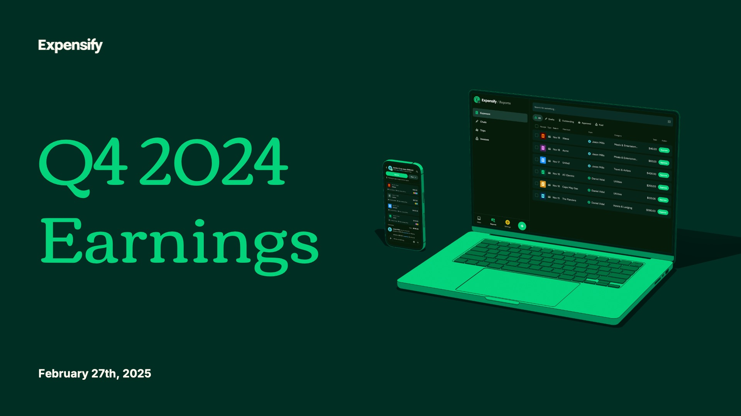

Exhibit 99.2
1
Expensify, Inc.
Investor Presentation



Exhibit 99.2
2
Expensify, Inc.
Investor Presentation



Exhibit 99.2
3
Expensify, Inc.
Investor Presentation

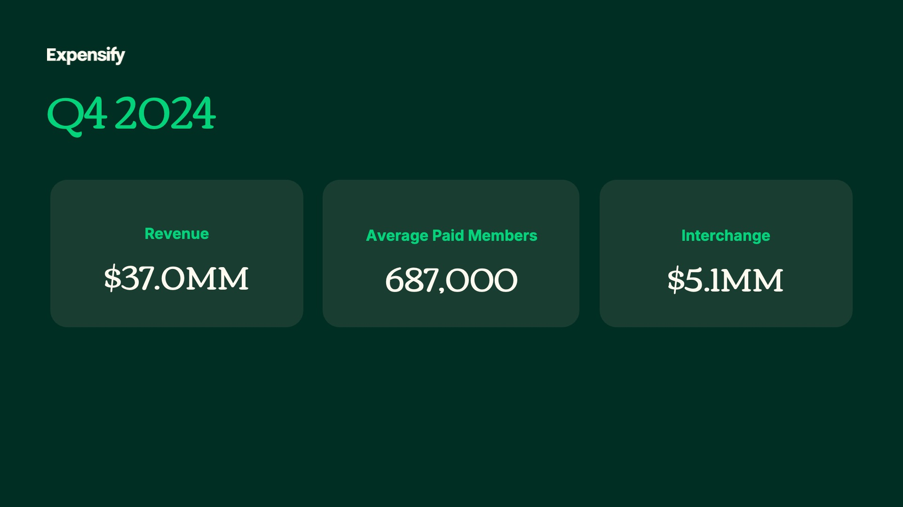

Exhibit 99.2
4
Expensify, Inc.
Investor Presentation

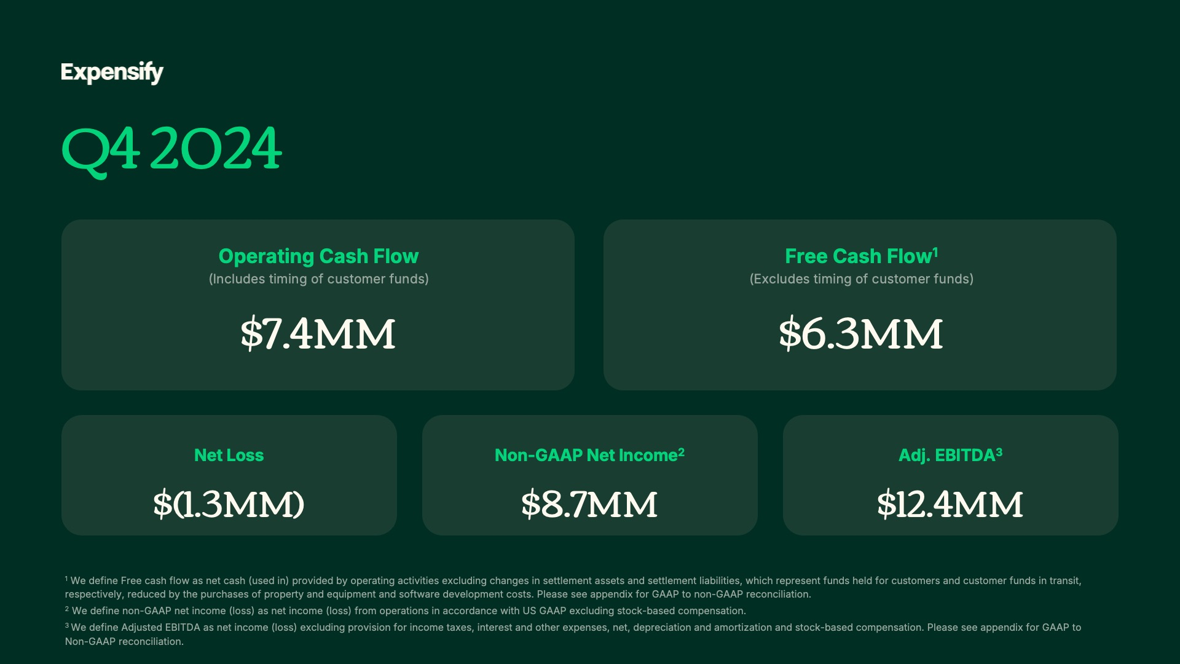

Exhibit 99.2
5
Expensify, Inc.
Investor Presentation

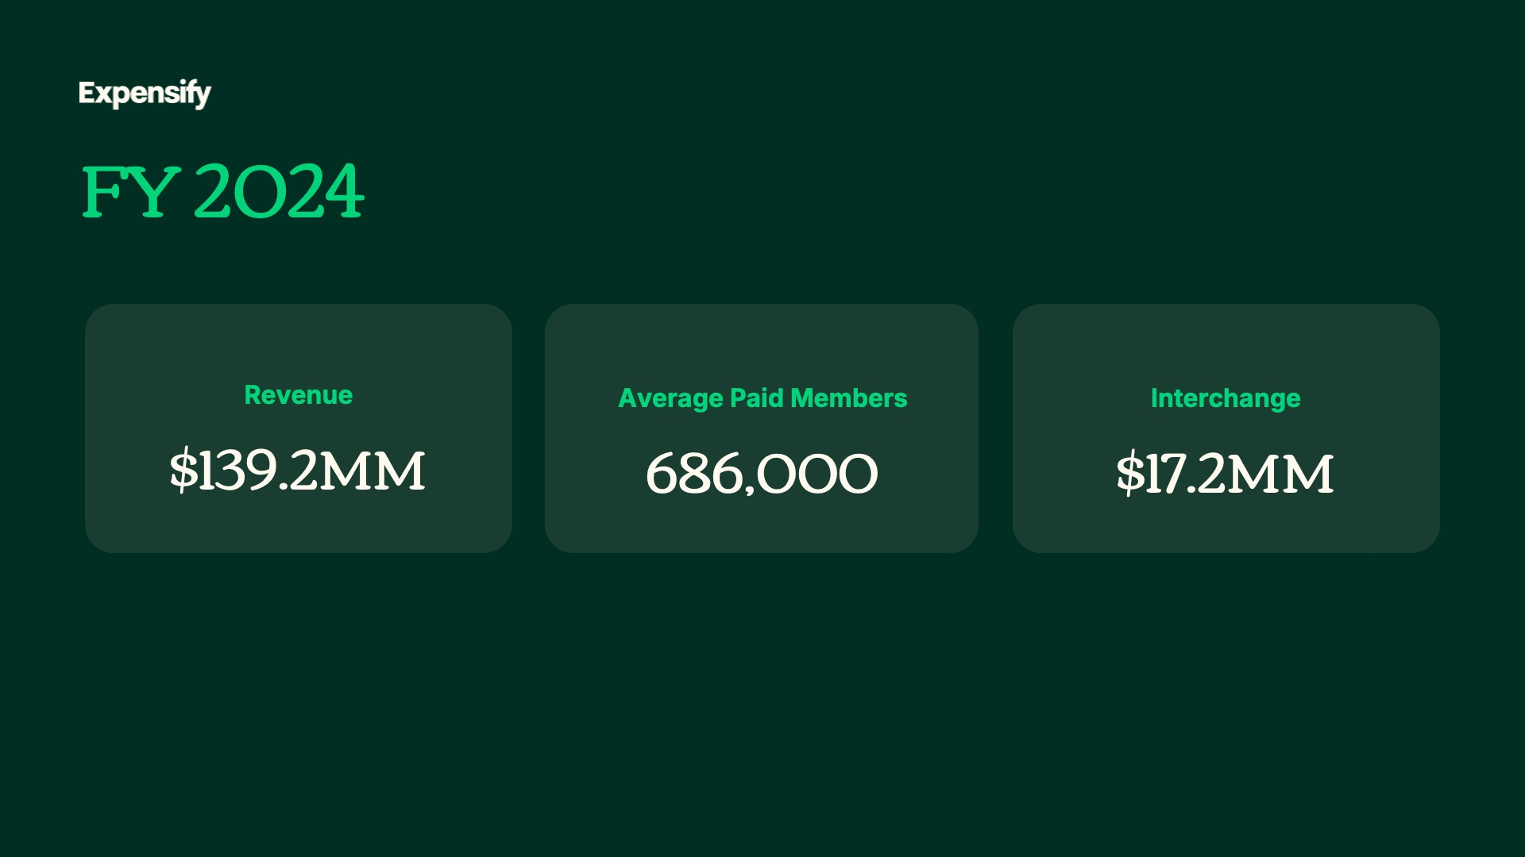

Exhibit 99.2
6
Expensify, Inc.
Investor Presentation

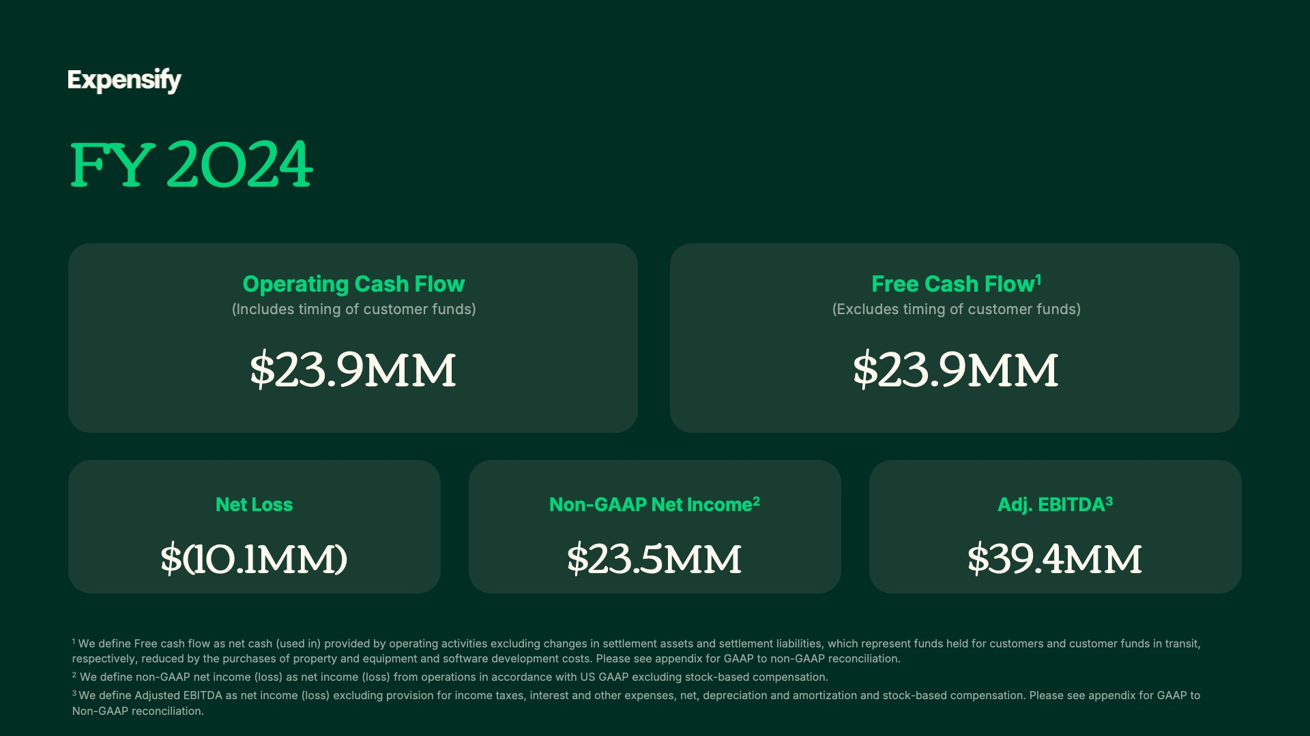

Exhibit 99.2
7
Expensify, Inc.
Investor Presentation

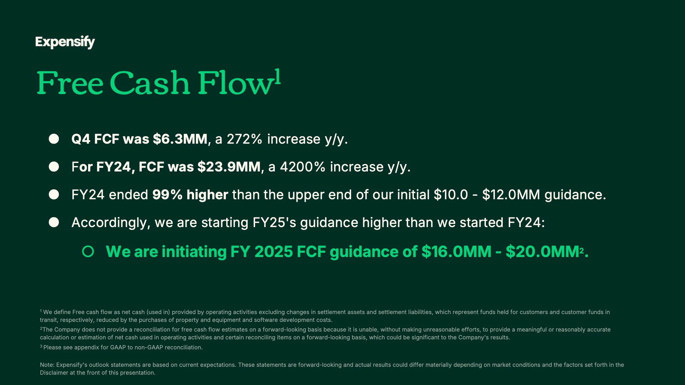

Exhibit 99.2
8
Expensify, Inc.
Investor Presentation

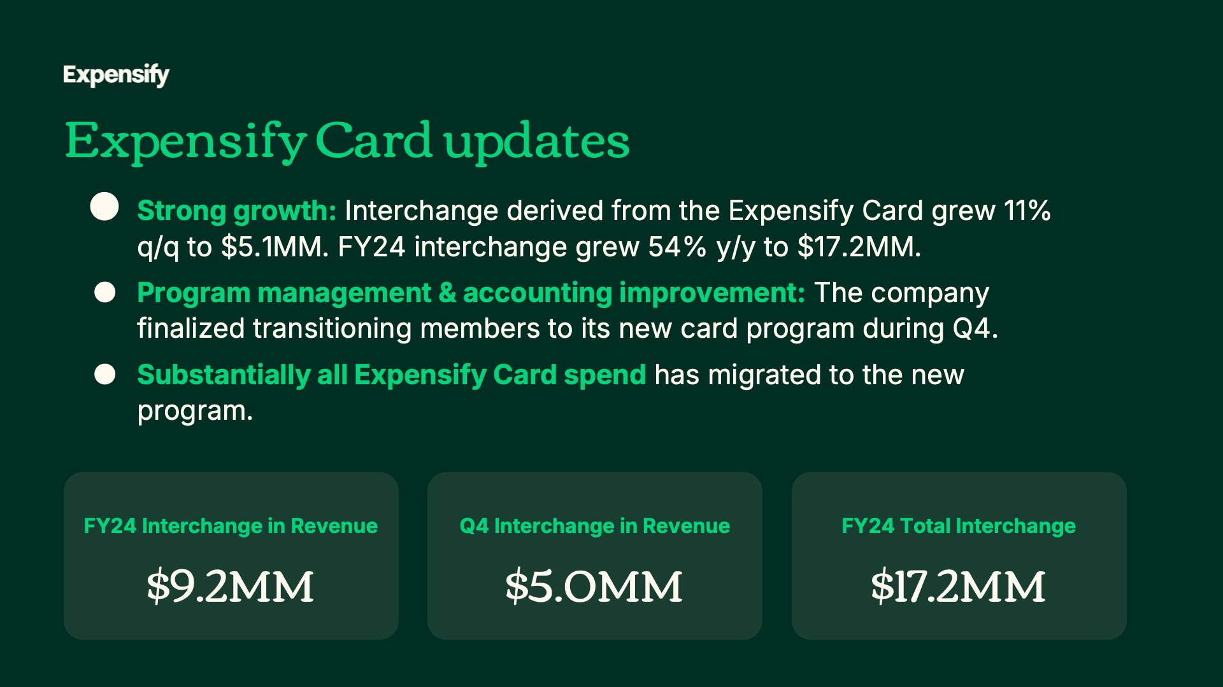

Exhibit 99.2
9
Expensify, Inc.
Investor Presentation

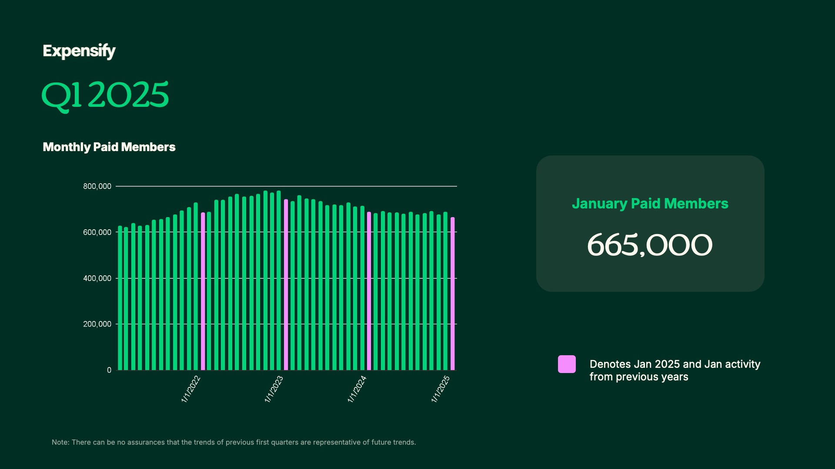
Exhibit 99.2
10
Expensify, Inc.
Investor Presentation


Exhibit 99.2
11
Expensify, Inc.
Investor Presentation

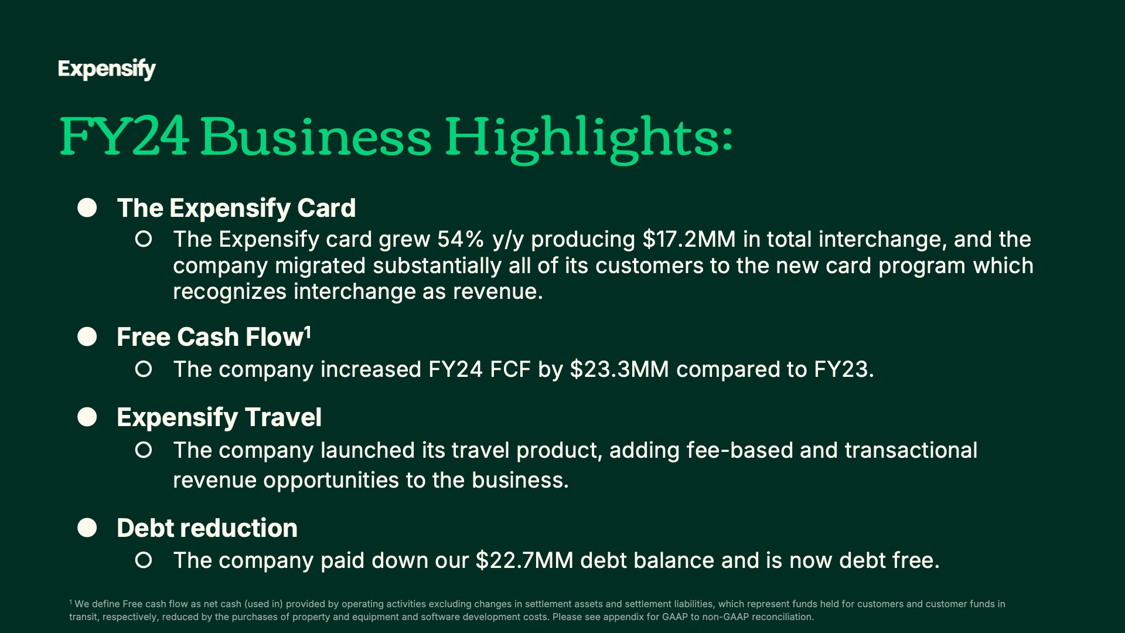
Exhibit 99.2
12
Expensify, Inc.
Investor Presentation


Exhibit 99.2
13
Expensify, Inc.
Investor Presentation


Exhibit 99.2
14
Expensify, Inc.
Investor Presentation

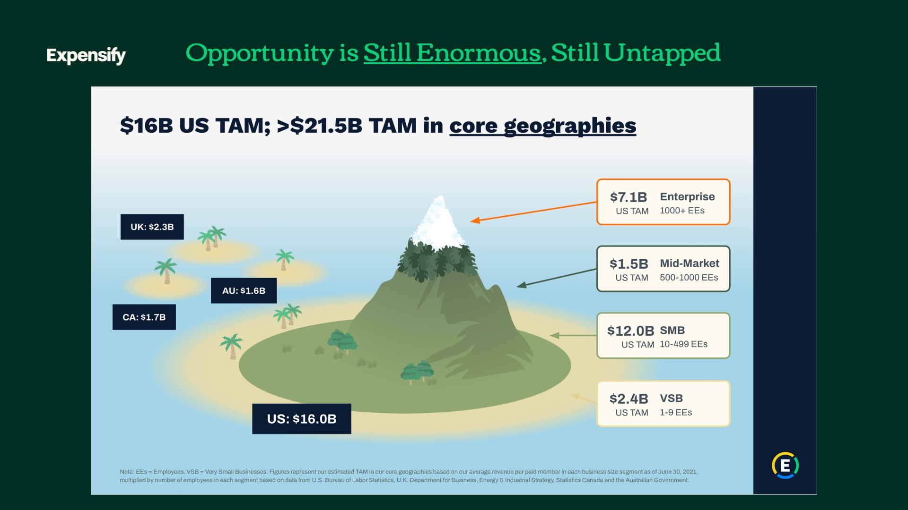
Exhibit 99.2
15
Expensify, Inc.
Investor Presentation

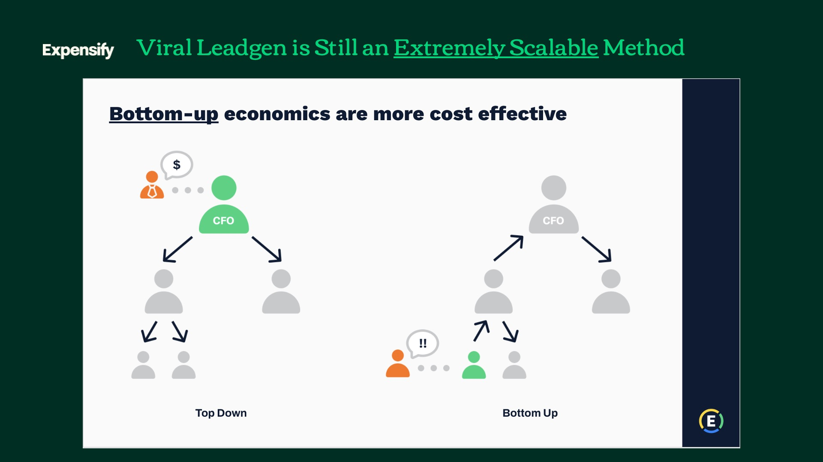
Exhibit 99.2
16
Expensify, Inc.
Investor Presentation

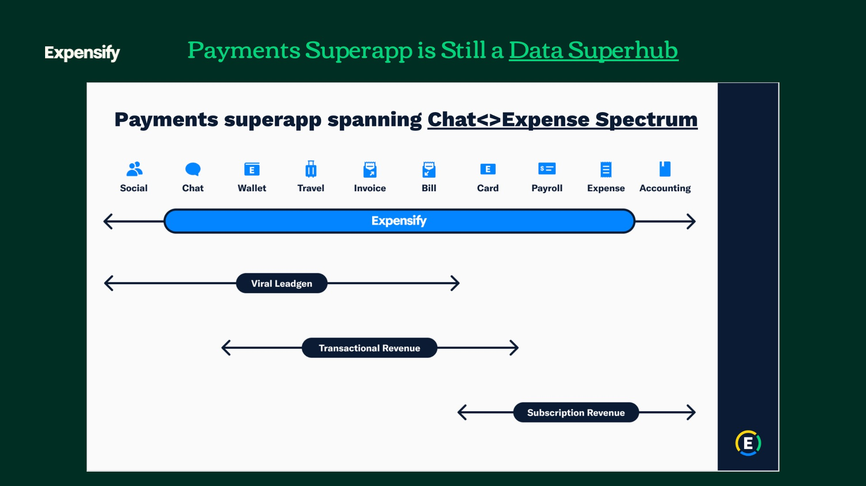
Exhibit 99.2
17
Expensify, Inc.
Investor Presentation


Exhibit 99.2
18
Expensify, Inc.
Investor Presentation

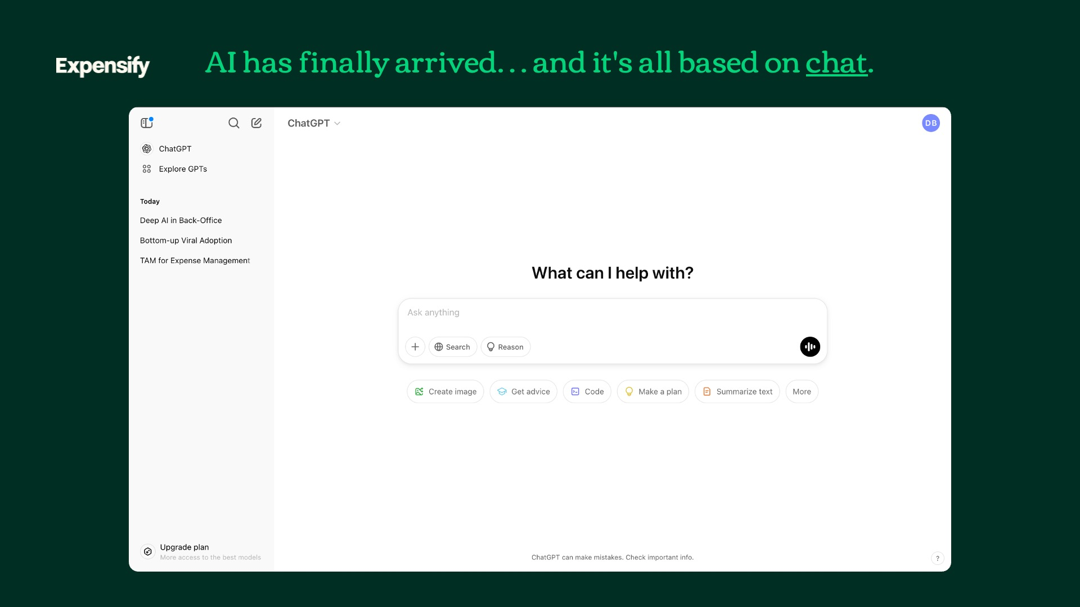
Exhibit 99.2
19
Expensify, Inc.
Investor Presentation


Exhibit 99.2
20
Expensify, Inc.
Investor Presentation

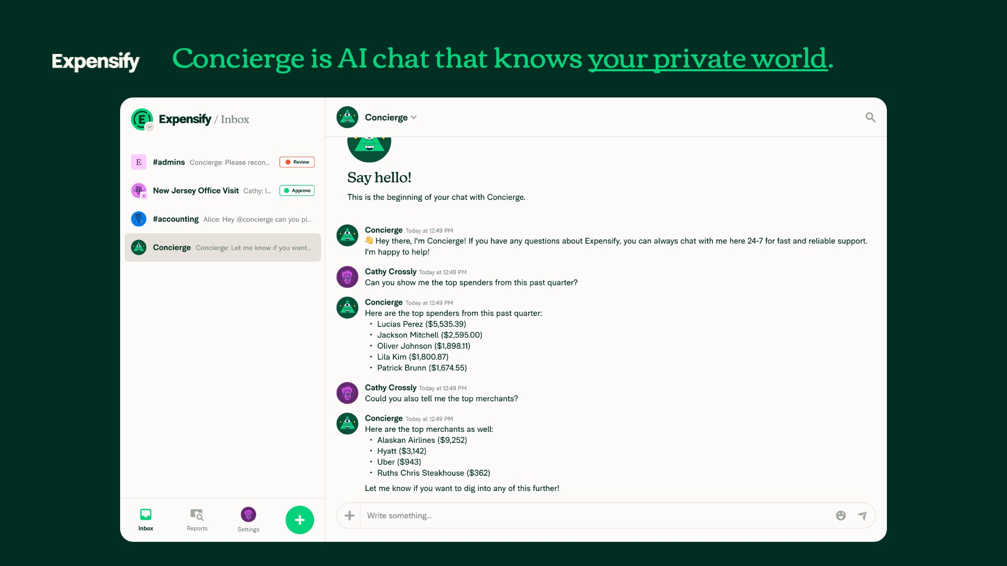
Exhibit 99.2
21
Expensify, Inc.
Investor Presentation

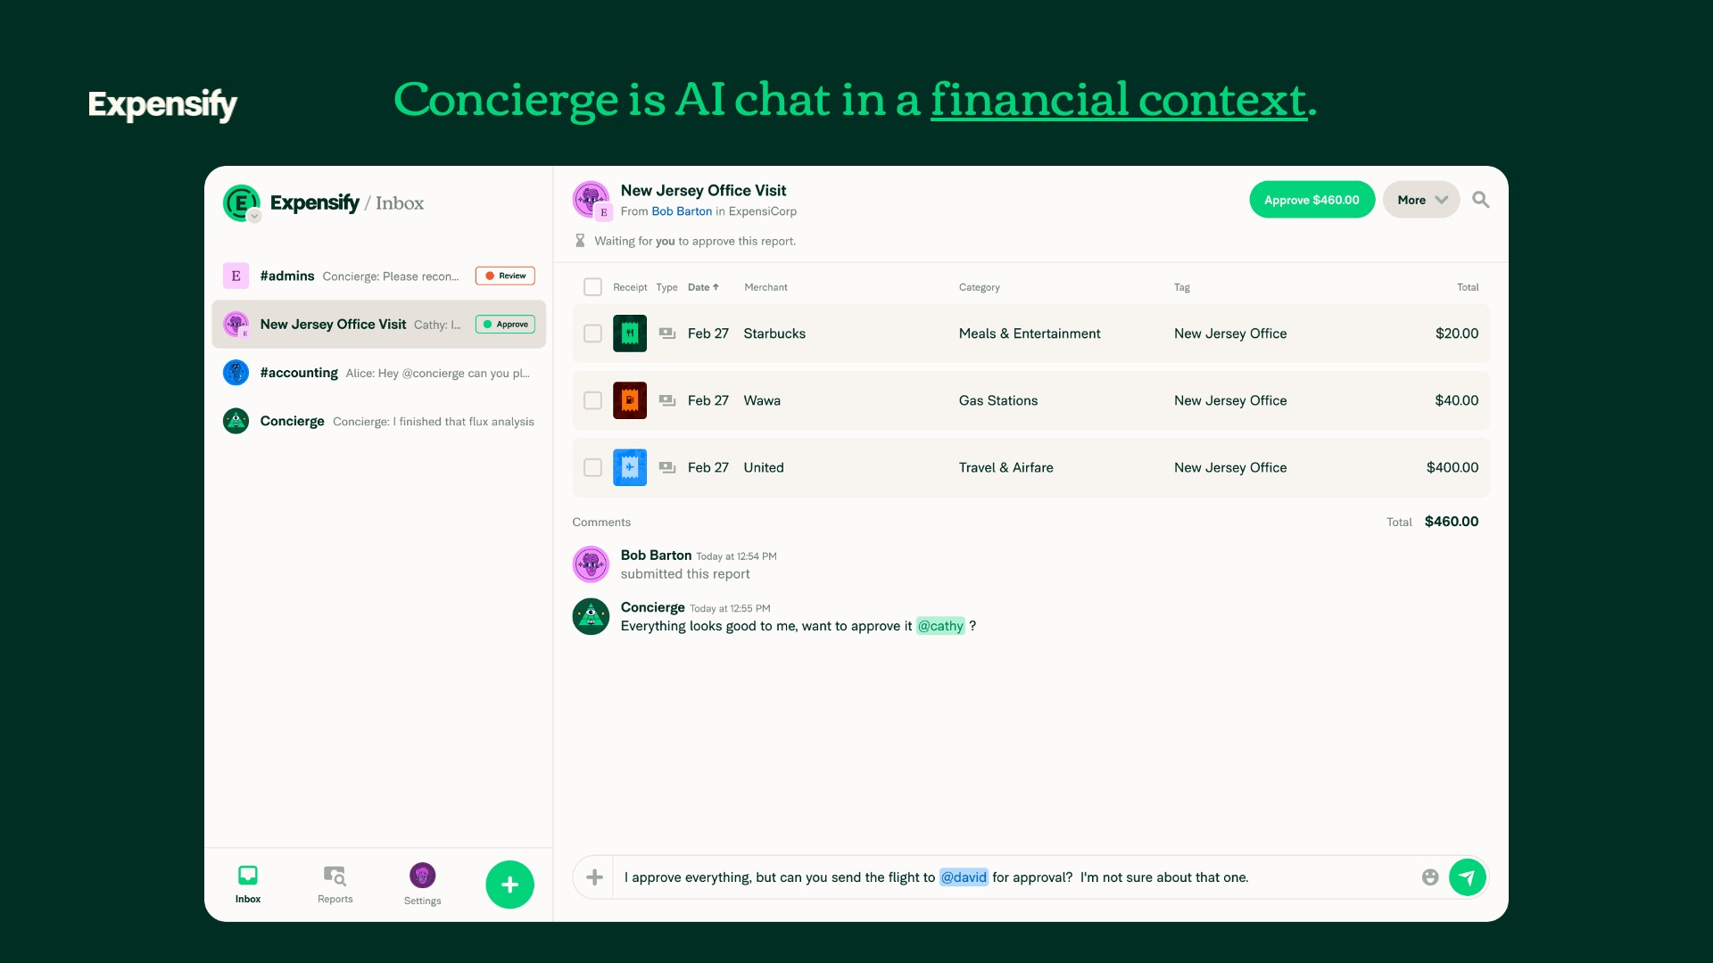
Exhibit 99.2
22
Expensify, Inc.
Investor Presentation

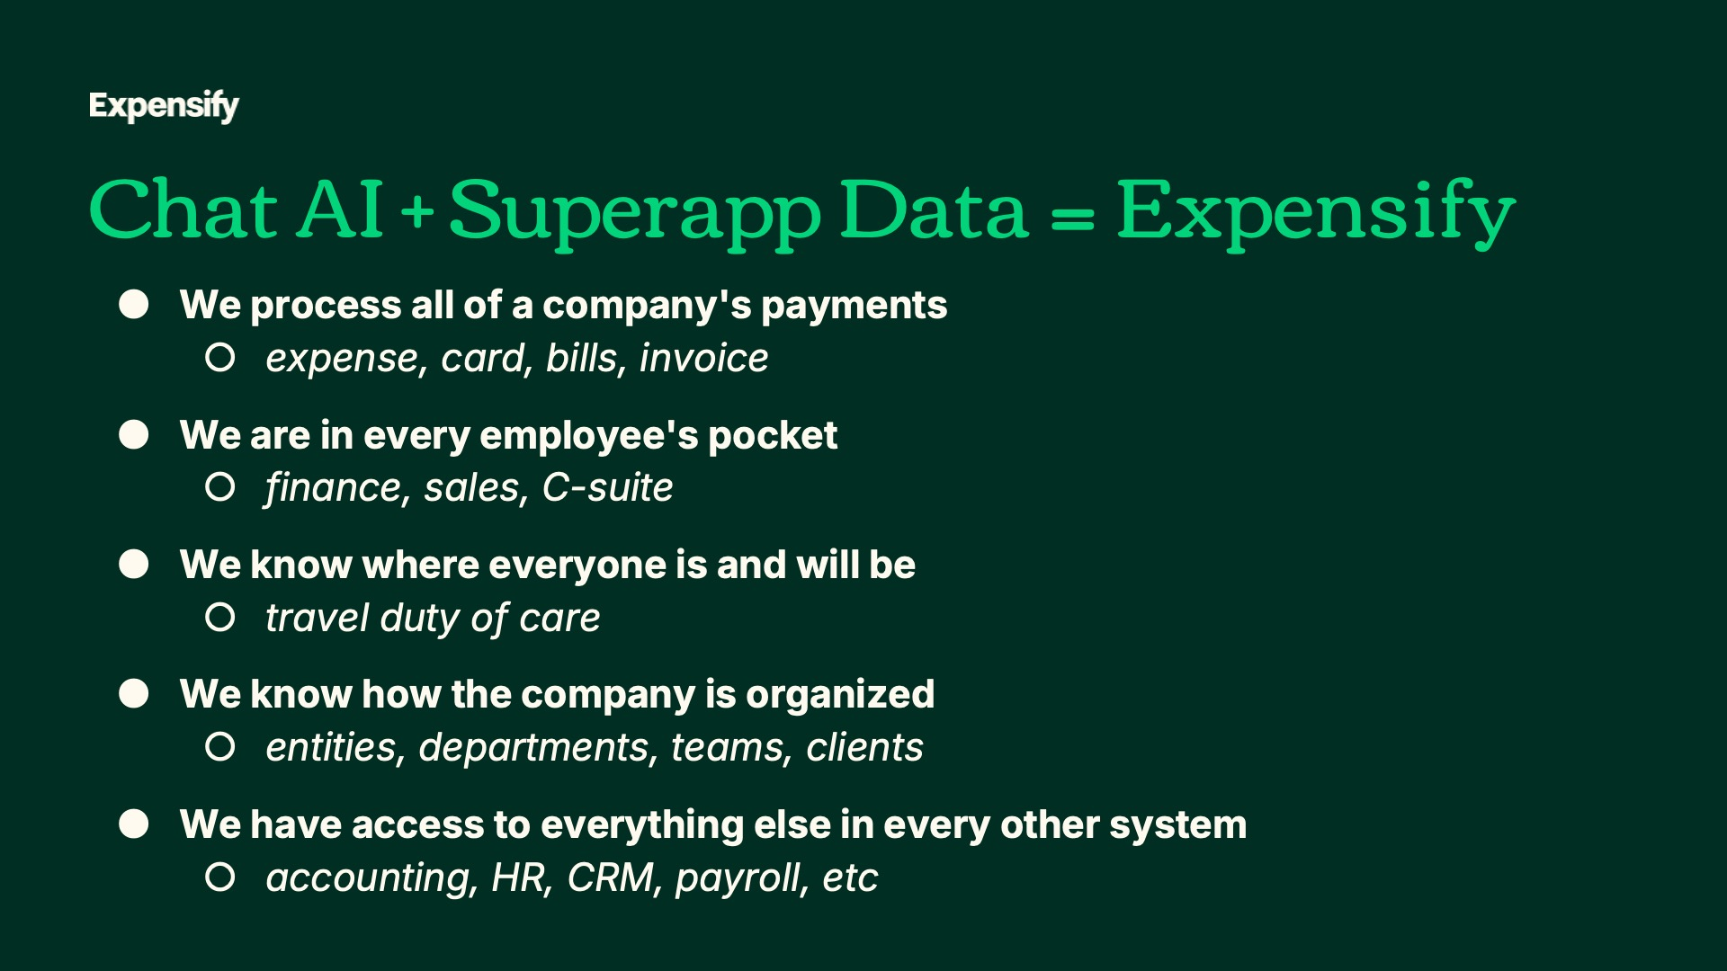
Exhibit 99.2
23
Expensify, Inc.
Investor Presentation


Exhibit 99.2
24
Expensify, Inc.
Investor Presentation

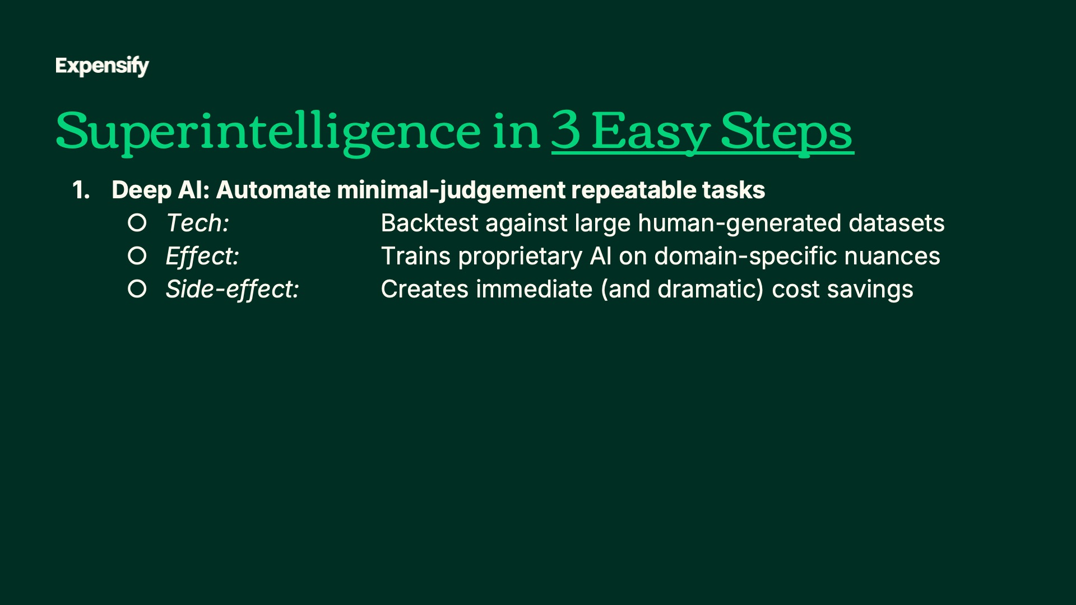
Exhibit 99.2
25
Expensify, Inc.
Investor Presentation

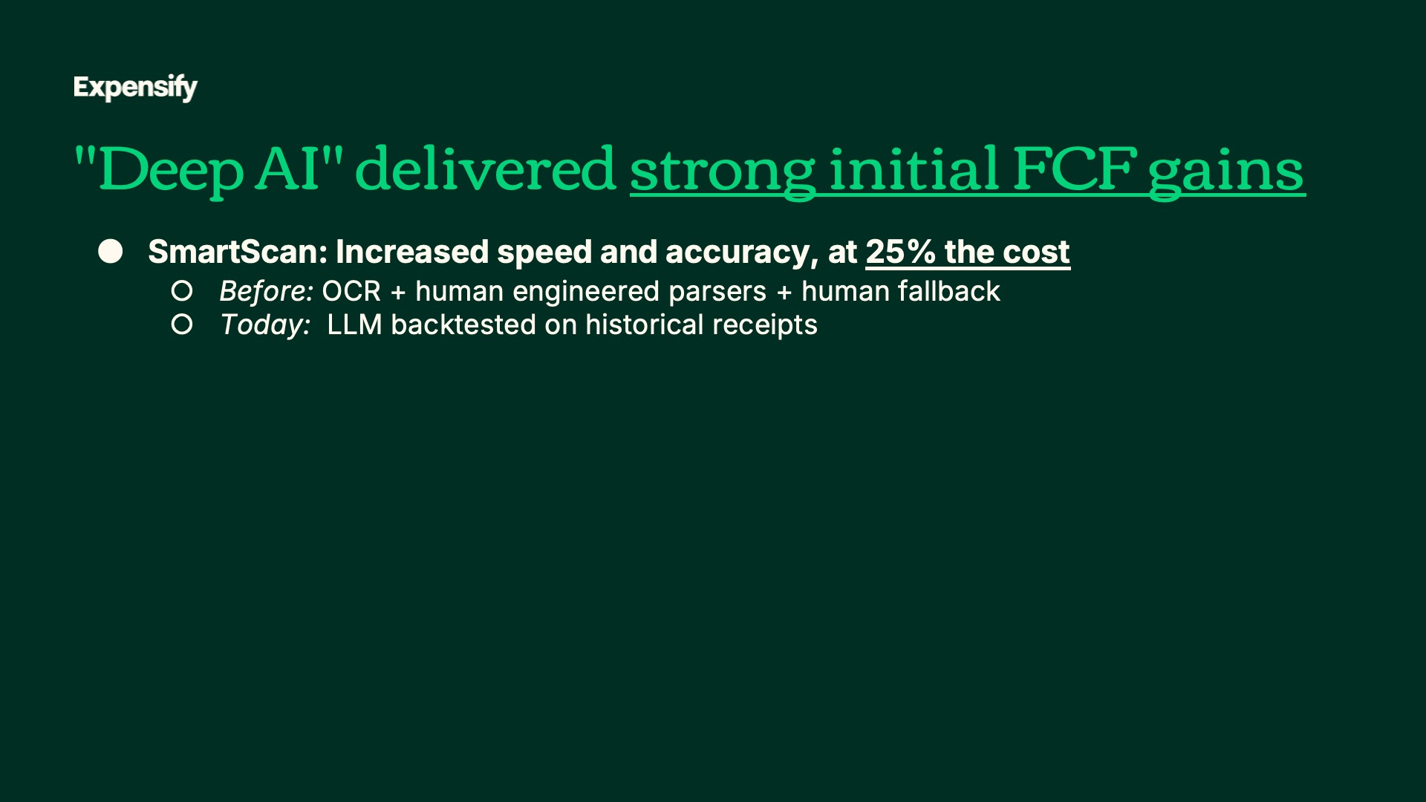
Exhibit 99.2
26
Expensify, Inc.
Investor Presentation

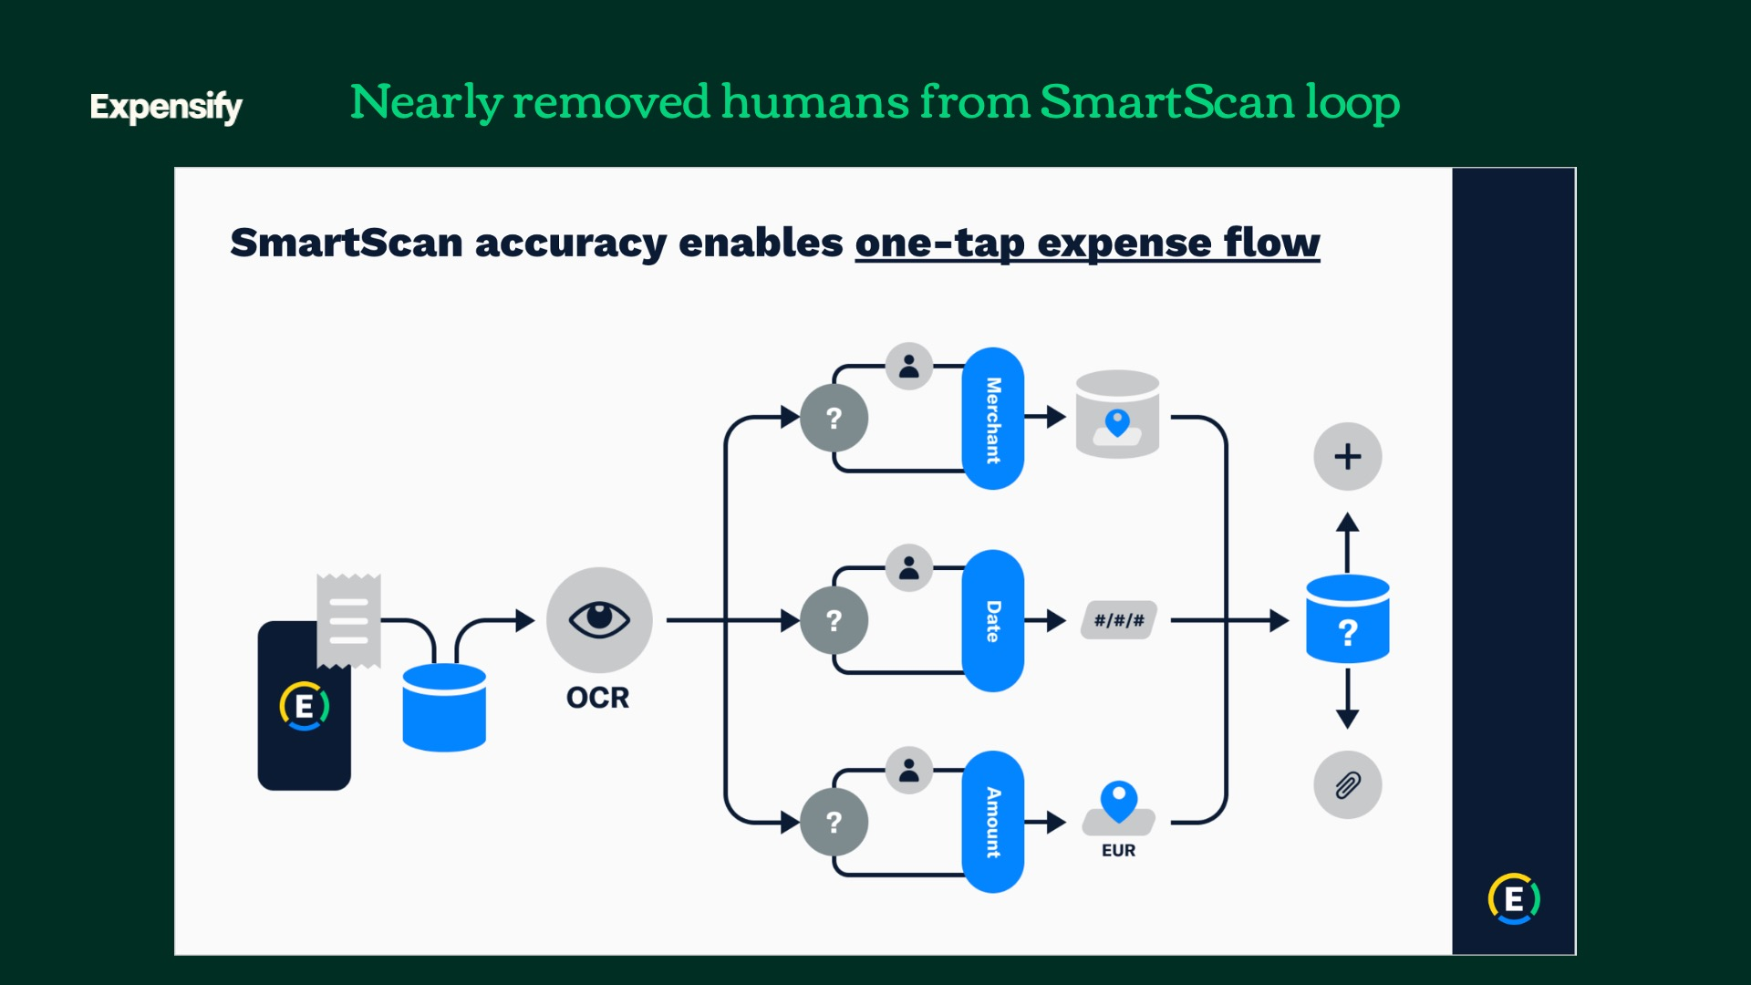
Exhibit 99.2
27
Expensify, Inc.
Investor Presentation

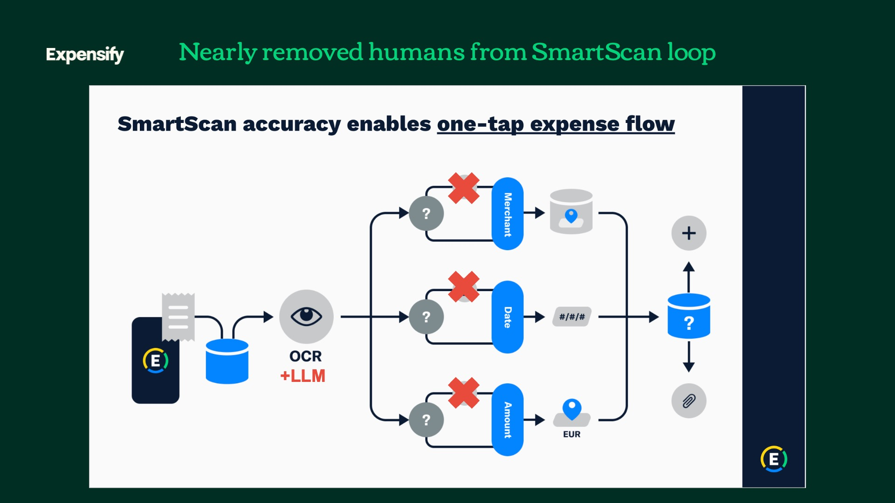
Exhibit 99.2
28
Expensify, Inc.
Investor Presentation

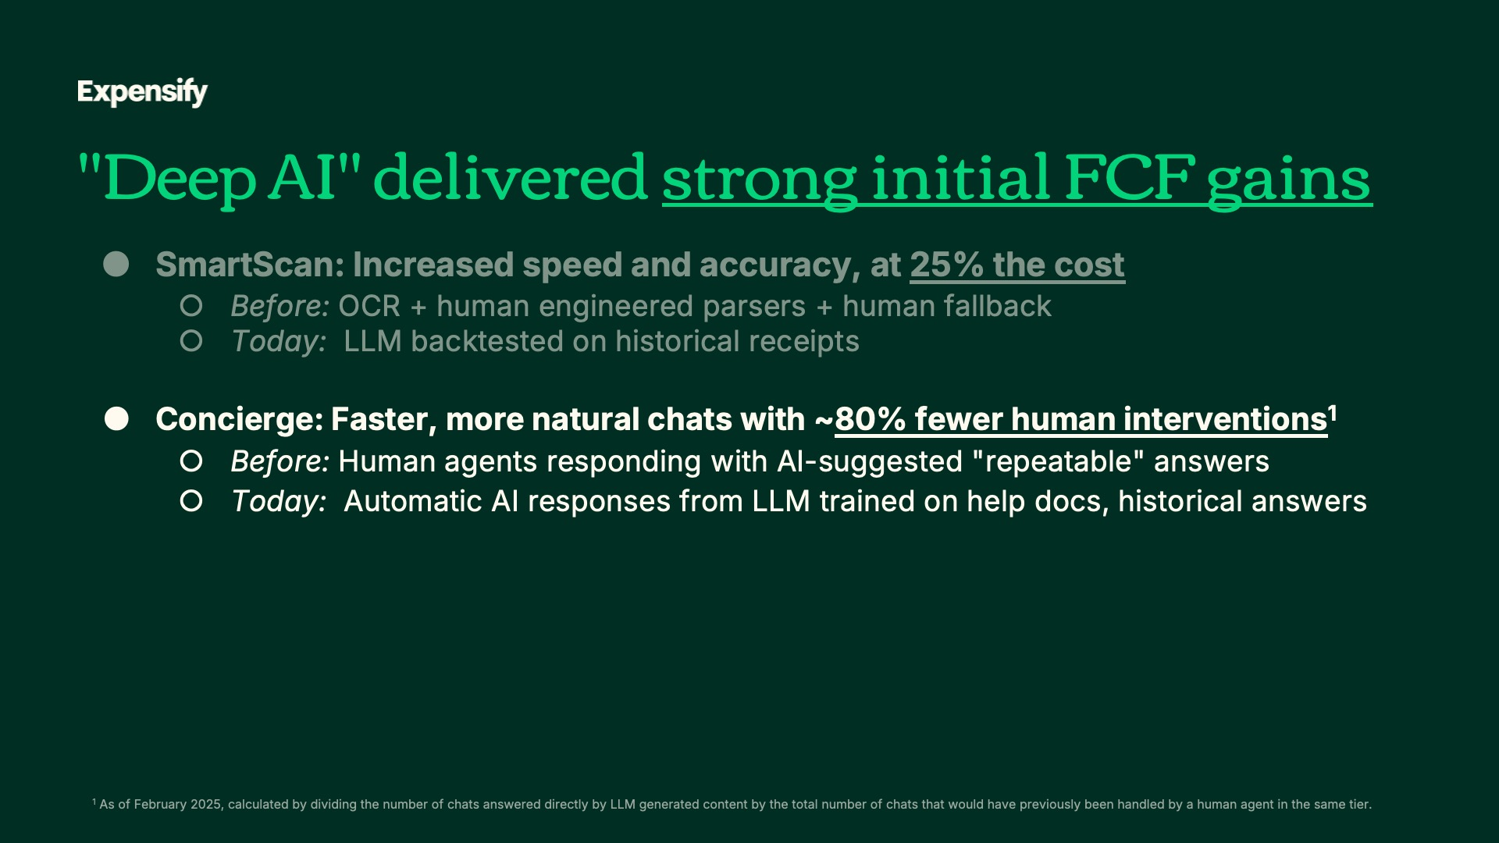

Exhibit 99.2
29
Expensify, Inc.
Investor Presentation

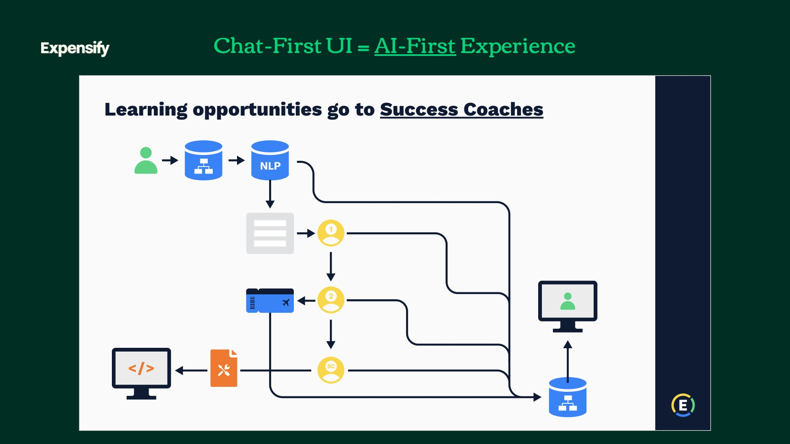
Exhibit 99.2
30
Expensify, Inc.
Investor Presentation

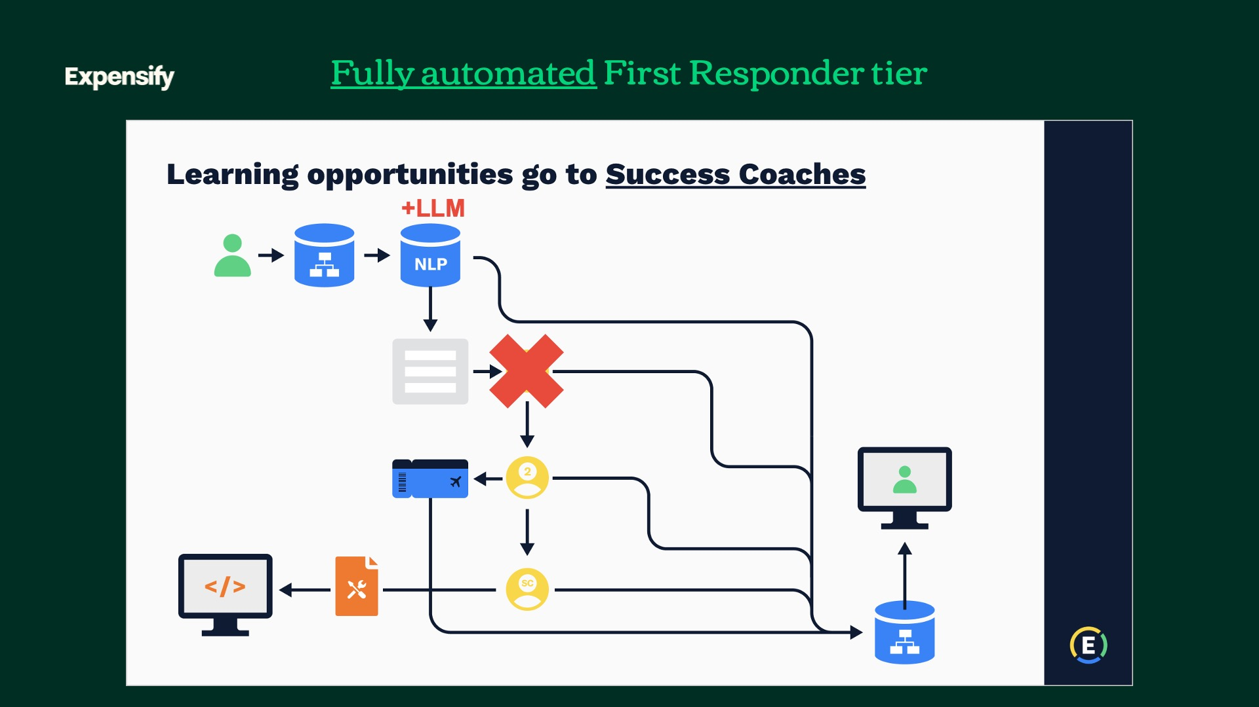
Exhibit 99.2
31
Expensify, Inc.
Investor Presentation

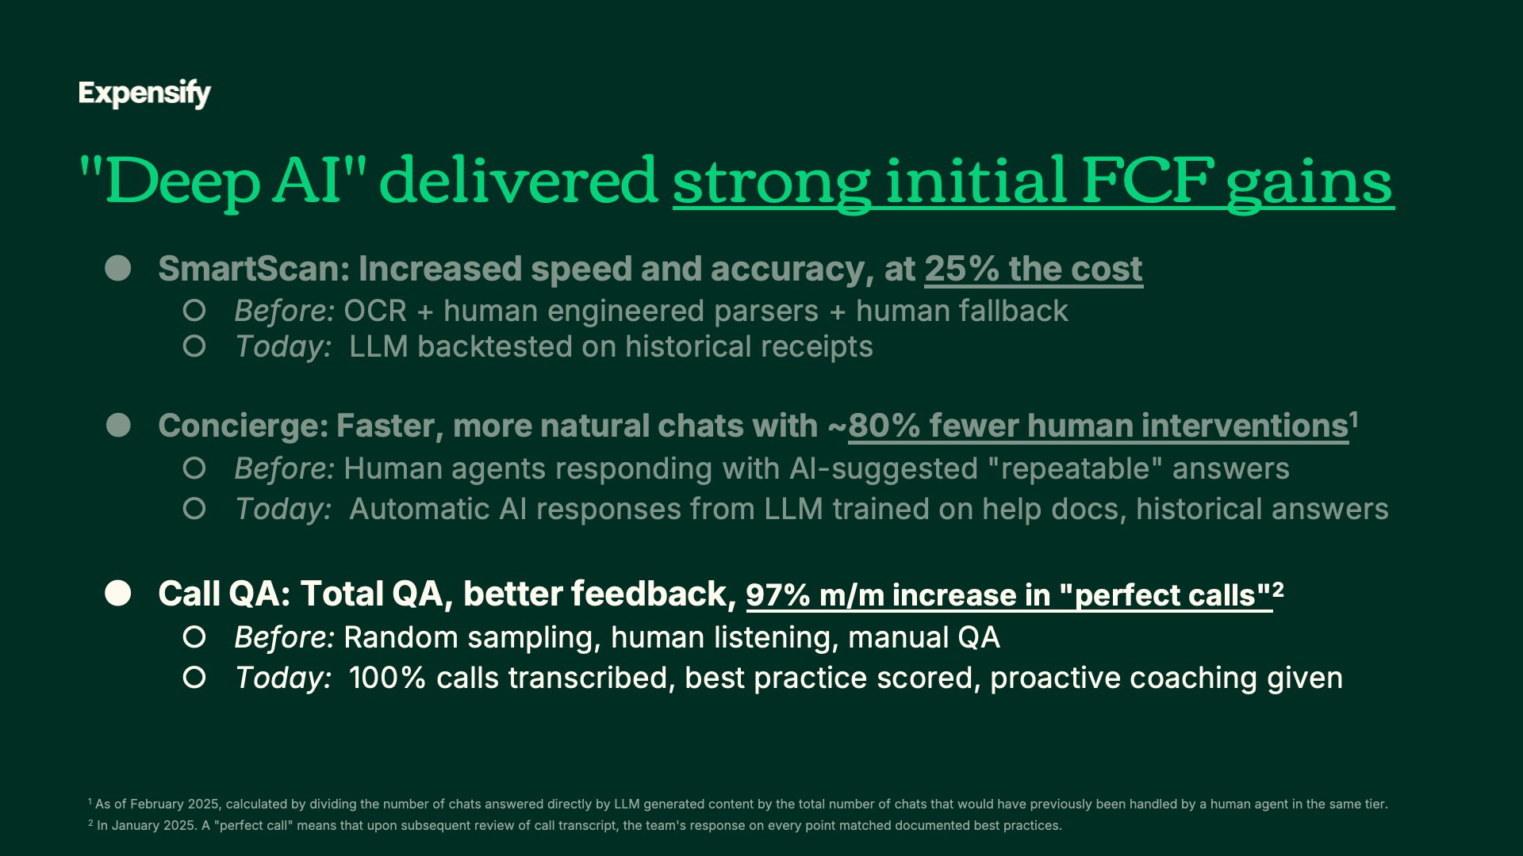
Exhibit 99.2
32
Expensify, Inc.
Investor Presentation

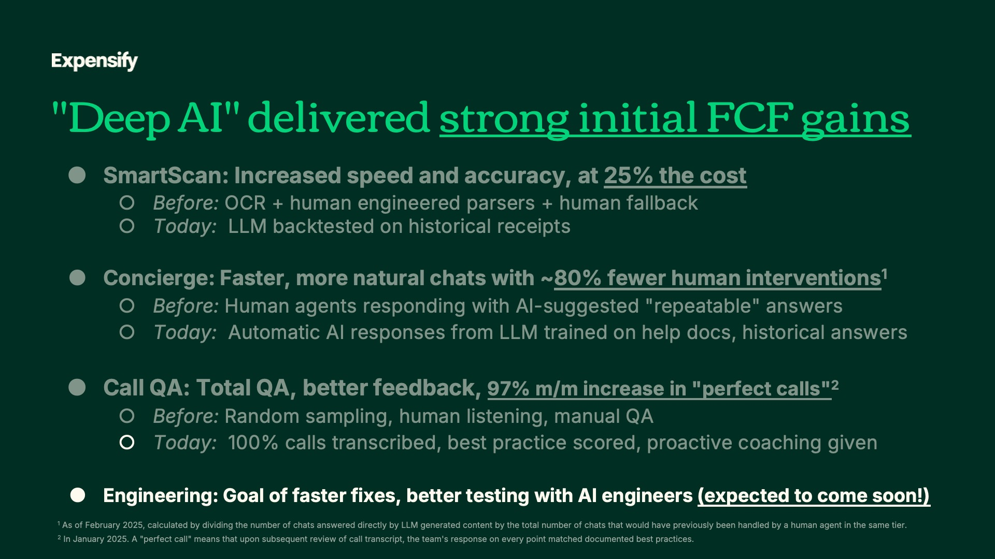

Exhibit 99.2
33
Expensify, Inc.
Investor Presentation

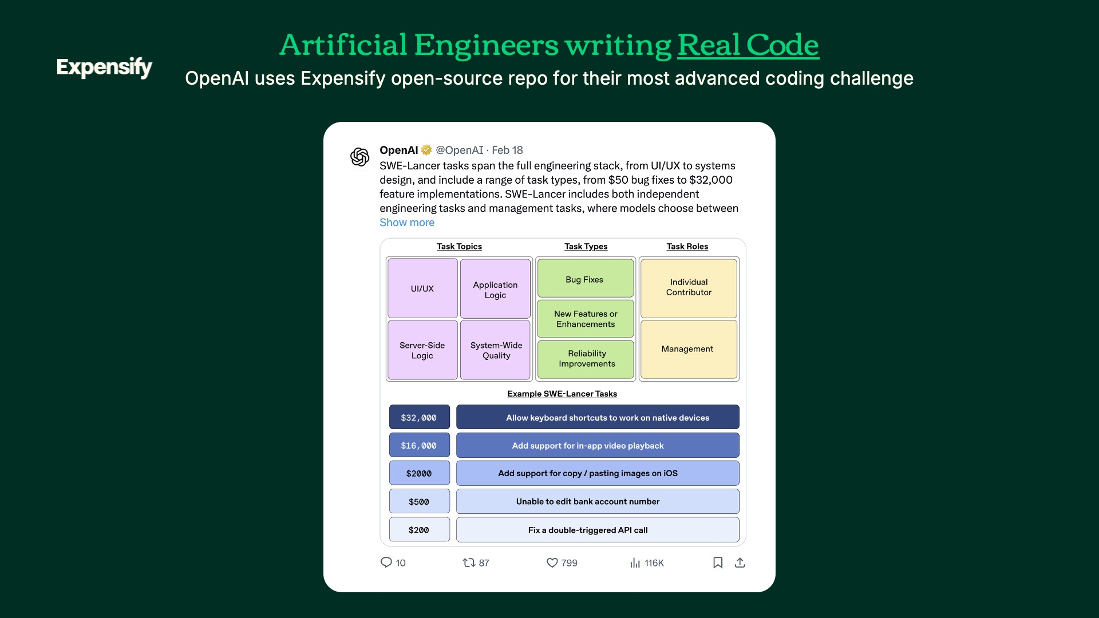

Exhibit 99.2
34
Expensify, Inc.
Investor Presentation

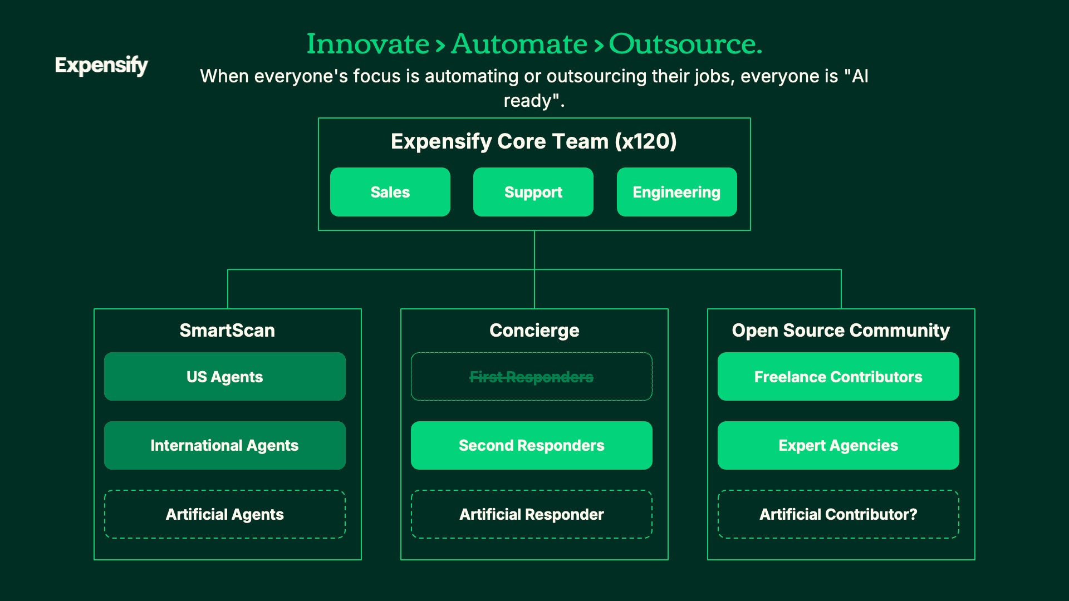

Exhibit 99.2
35
Expensify, Inc.
Investor Presentation

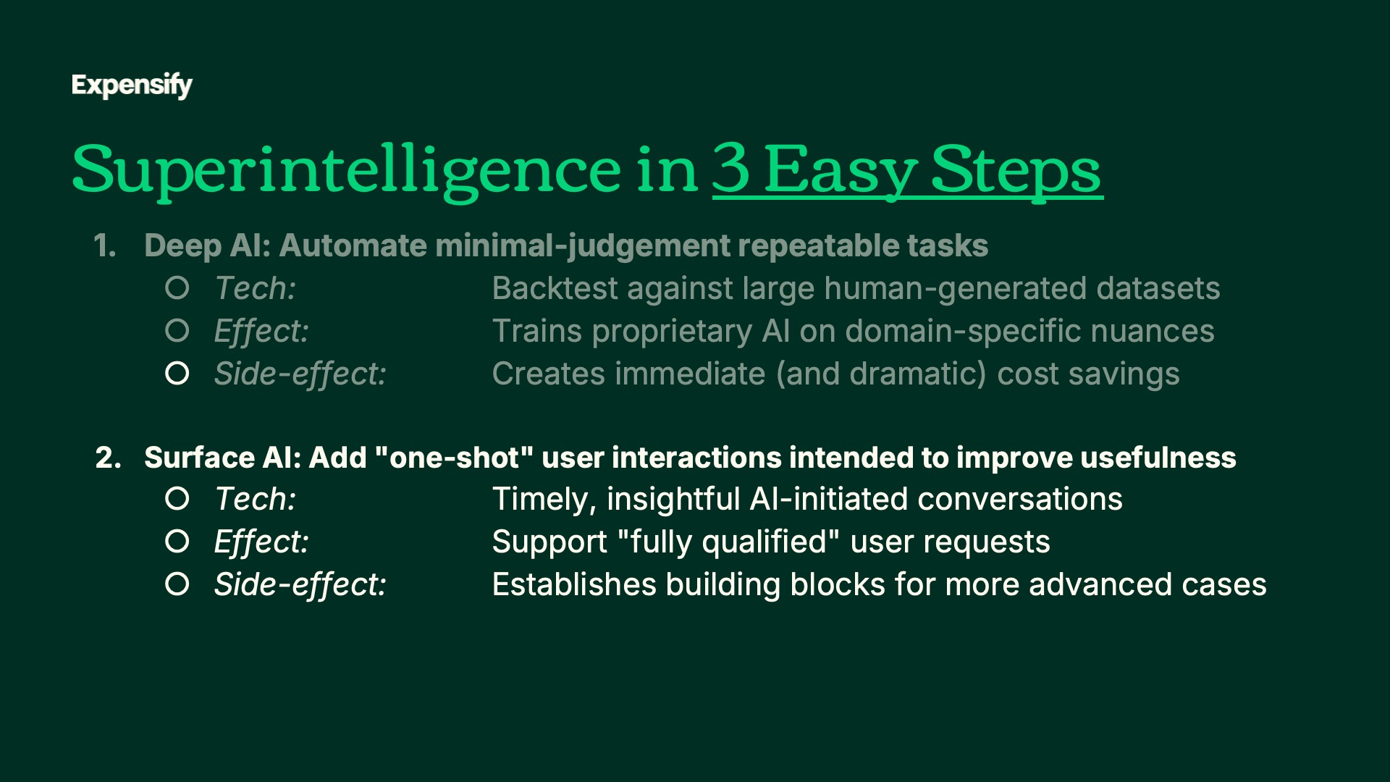

Exhibit 99.2
36
Expensify, Inc.
Investor Presentation



Exhibit 99.2
37
Expensify, Inc.
Investor Presentation

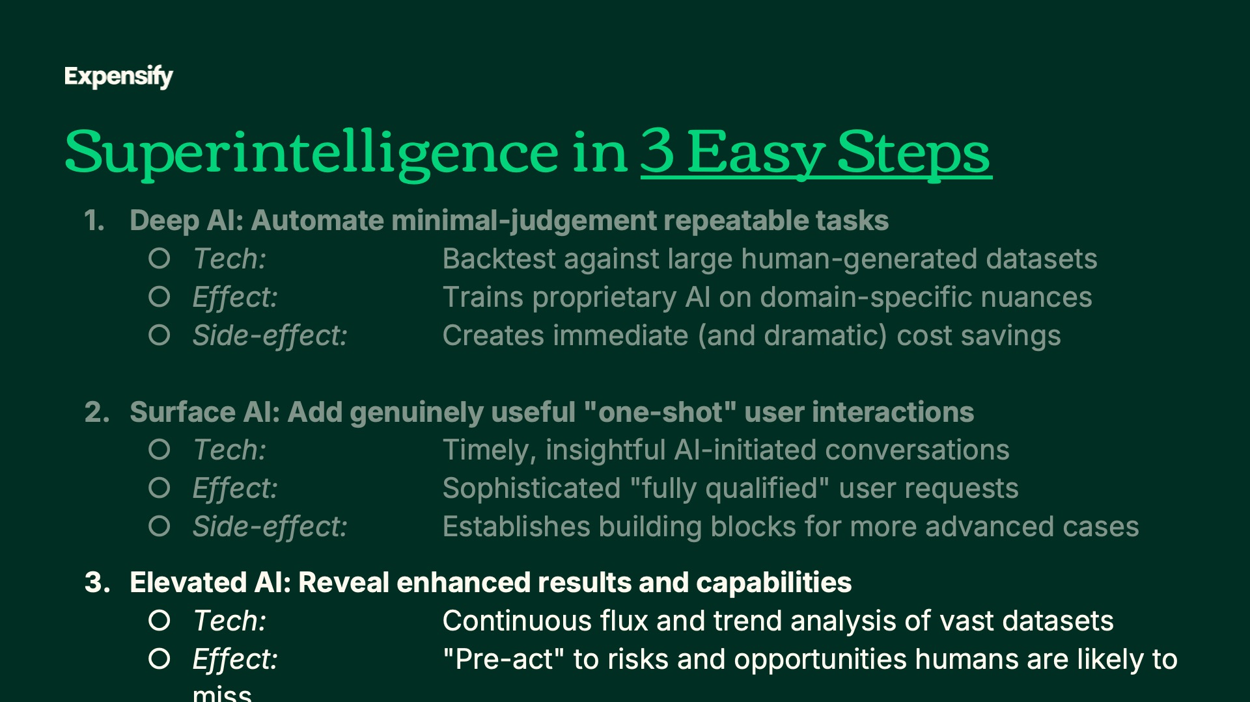

Exhibit 99.2
38
Expensify, Inc.
Investor Presentation



Exhibit 99.2
39
Expensify, Inc.
Investor Presentation

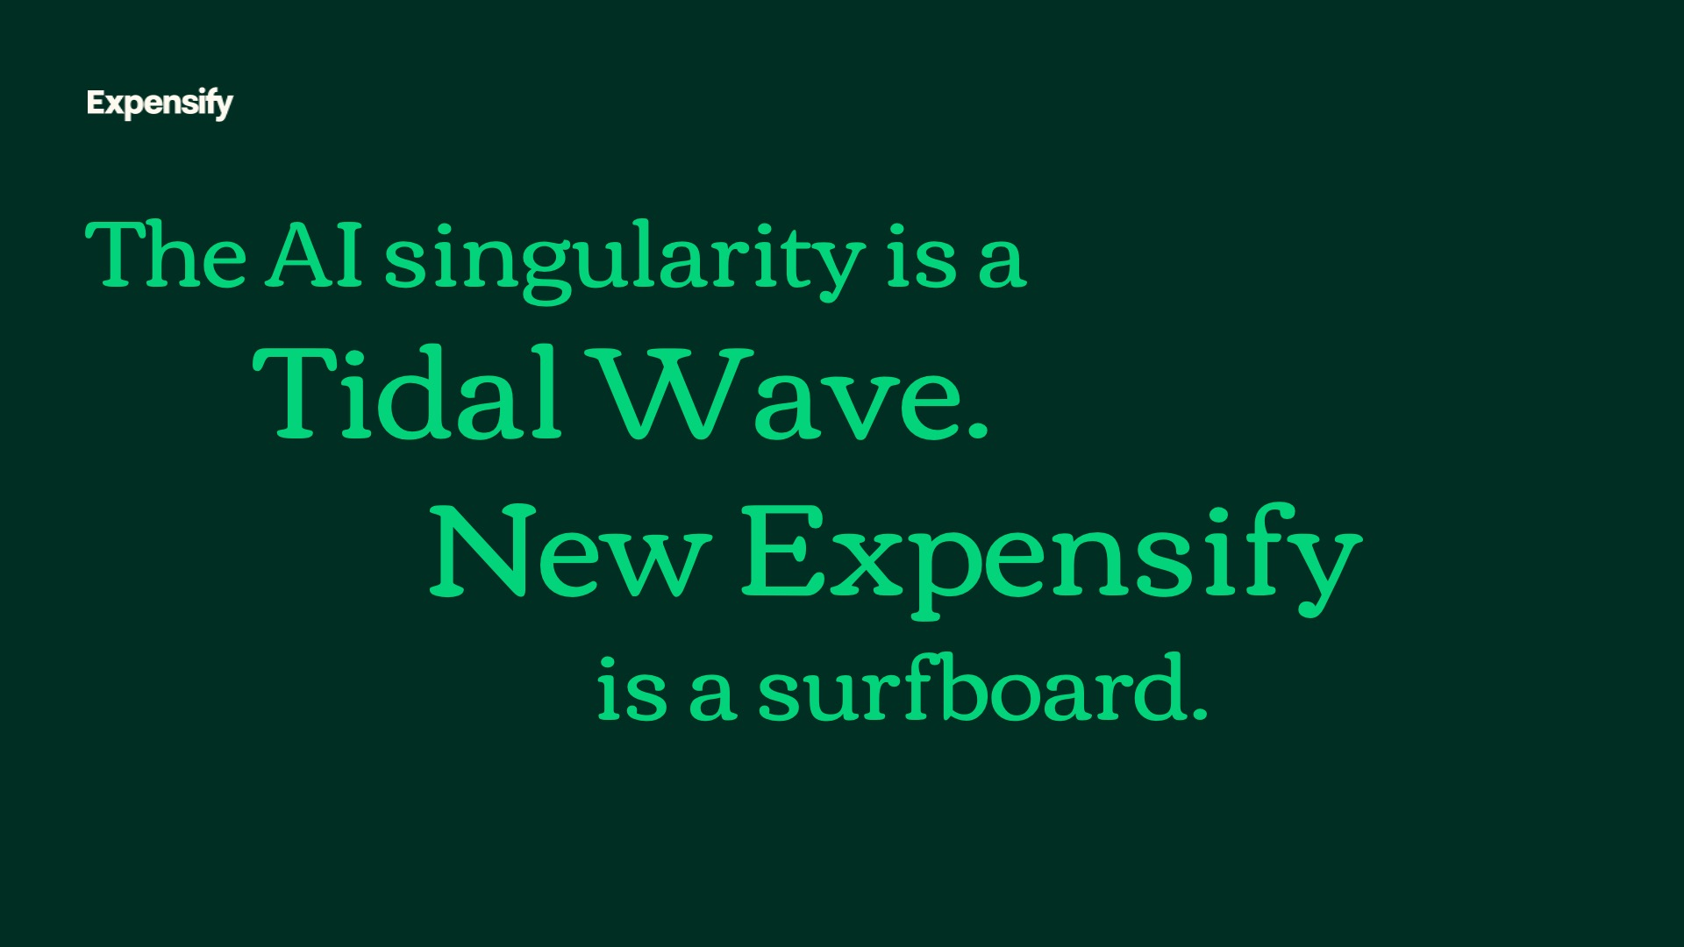

Exhibit 99.2
40
Expensify, Inc.
Investor Presentation

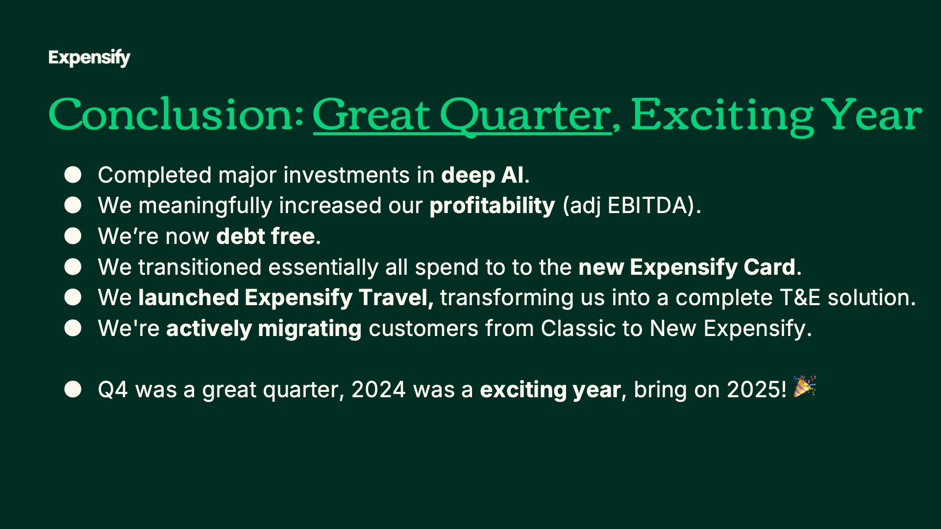

Exhibit 99.2
41
Expensify, Inc.
Investor Presentation


Exhibit 99.2
42
Expensify, Inc.
Investor Presentation


Exhibit 99.2
43
Expensify, Inc.
Investor Presentation


Exhibit 99.2
44
Expensify, Inc.
Investor Presentation

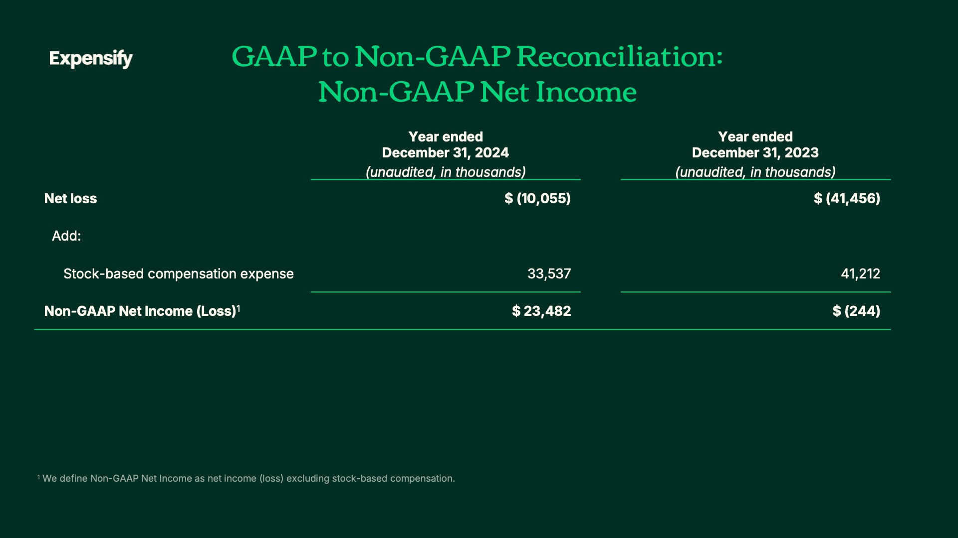

Exhibit 99.2
45
Expensify, Inc.
Investor Presentation

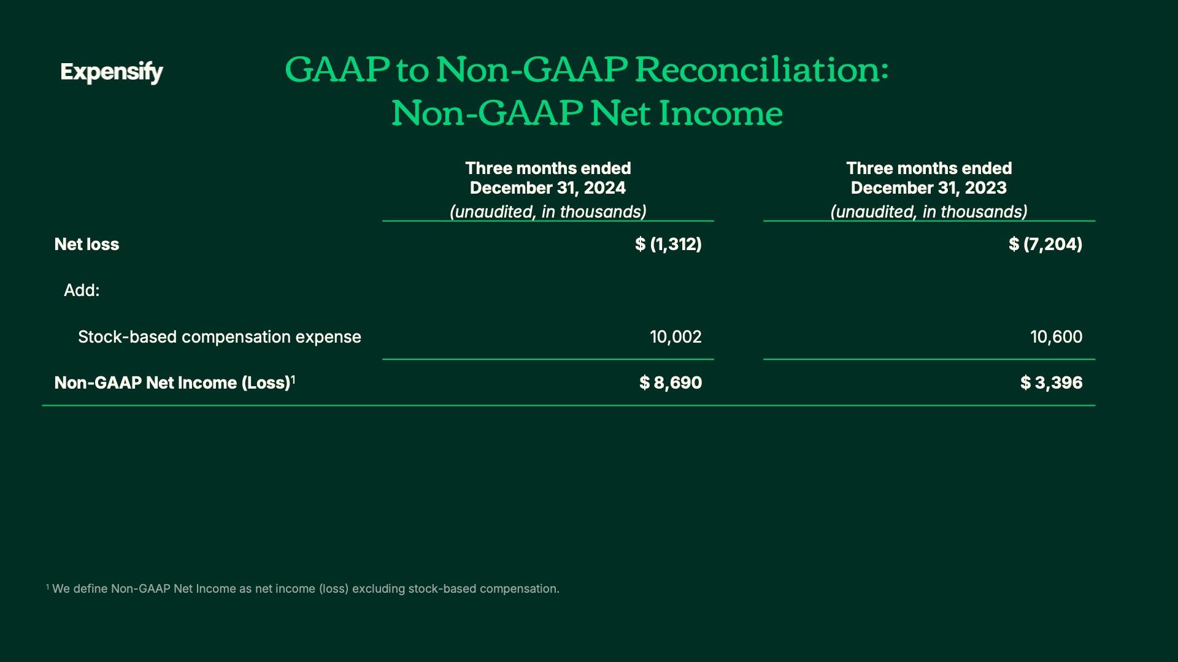

Exhibit 99.2
46
Expensify, Inc.
Investor Presentation

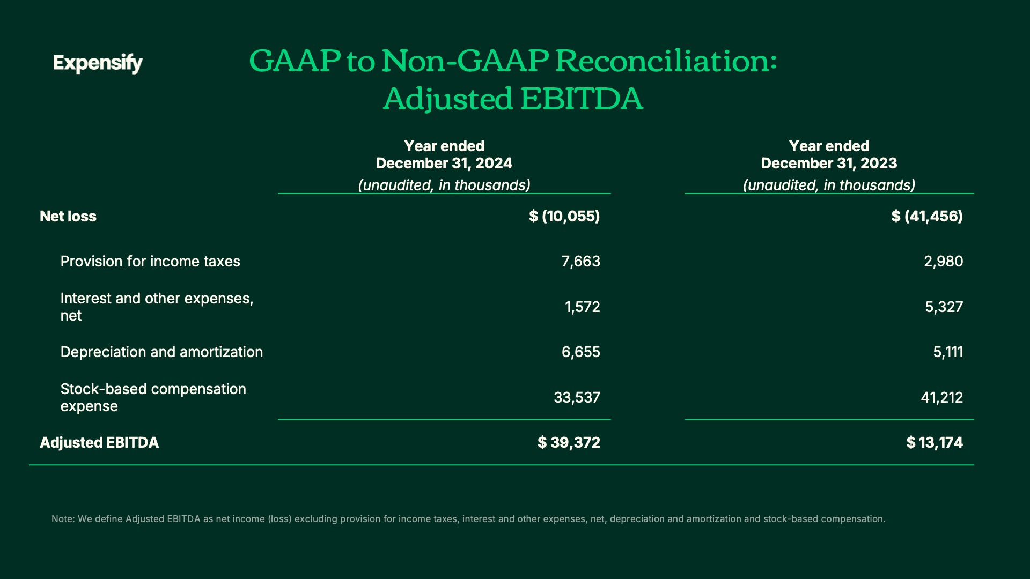

Exhibit 99.2
47
Expensify, Inc.
Investor Presentation

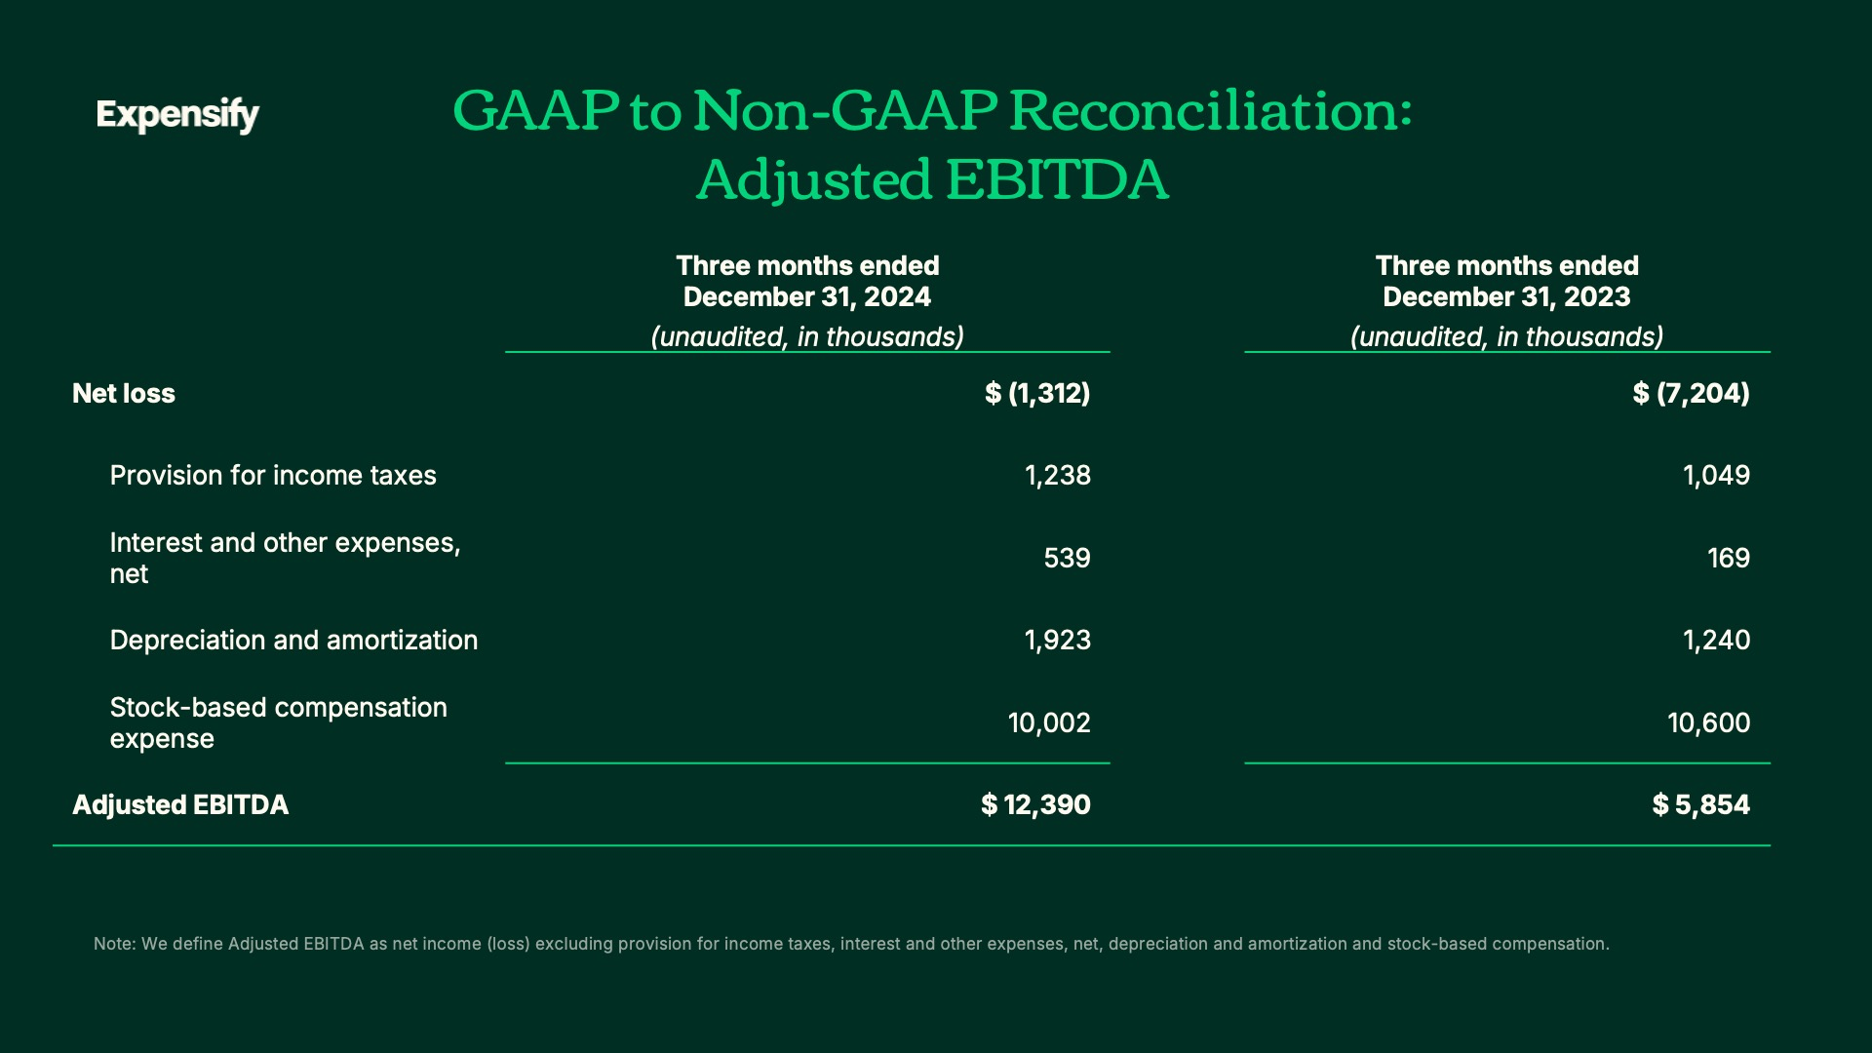

Exhibit 99.2
48
Expensify, Inc.
Investor Presentation

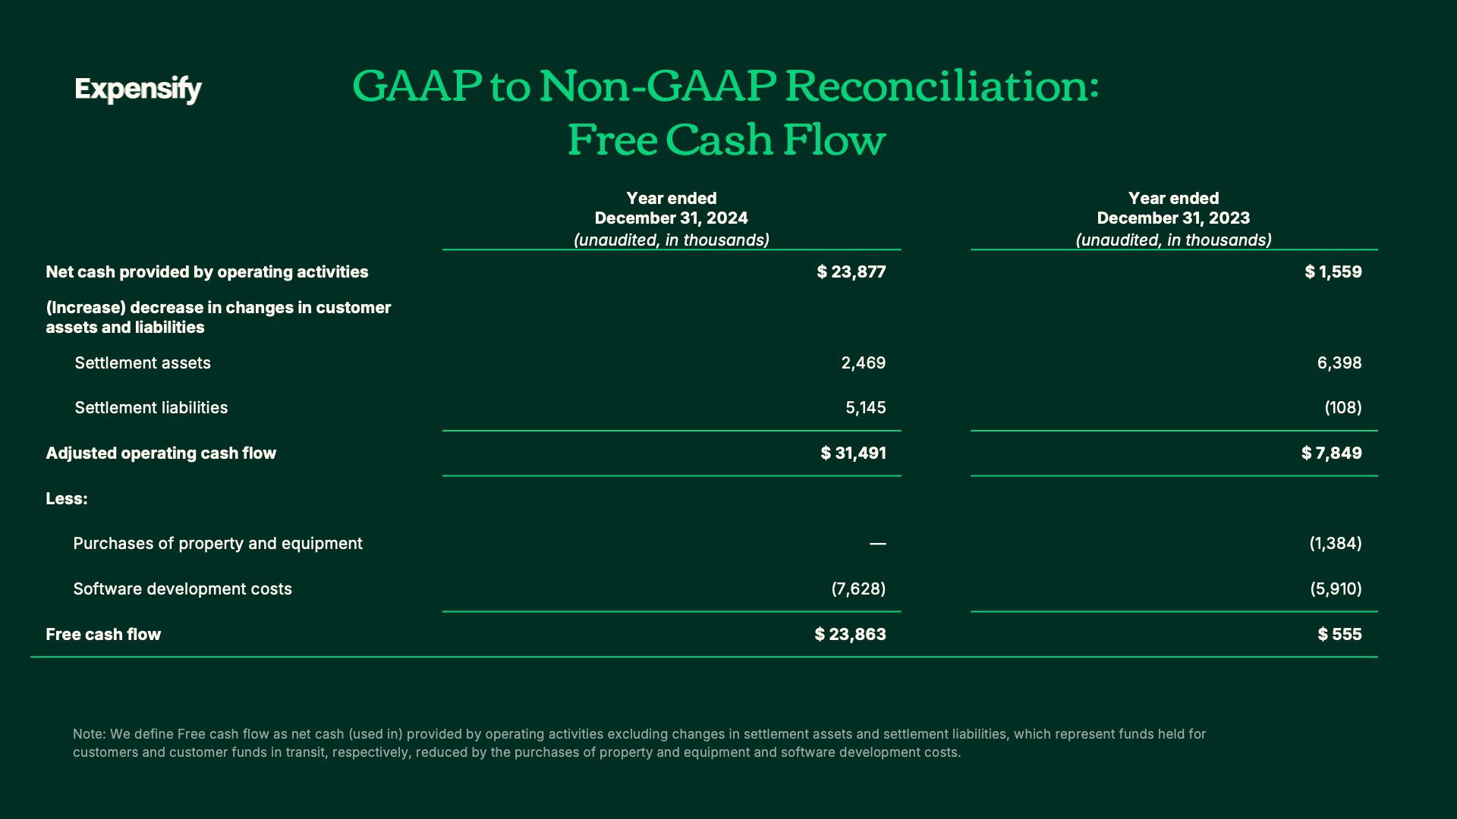

Exhibit 99.2
49
Expensify, Inc.
Investor Presentation

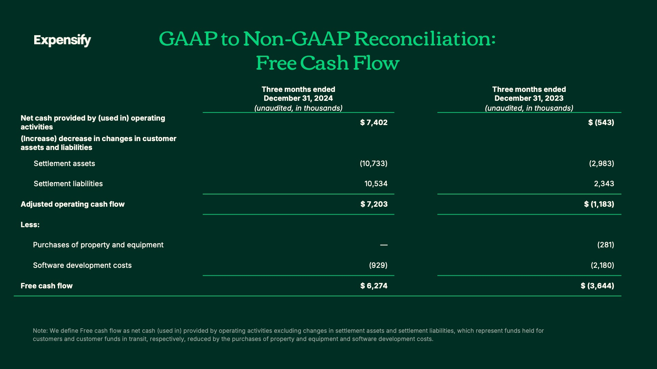
Exhibit 99.2
50
Expensify, Inc.
Investor Presentation

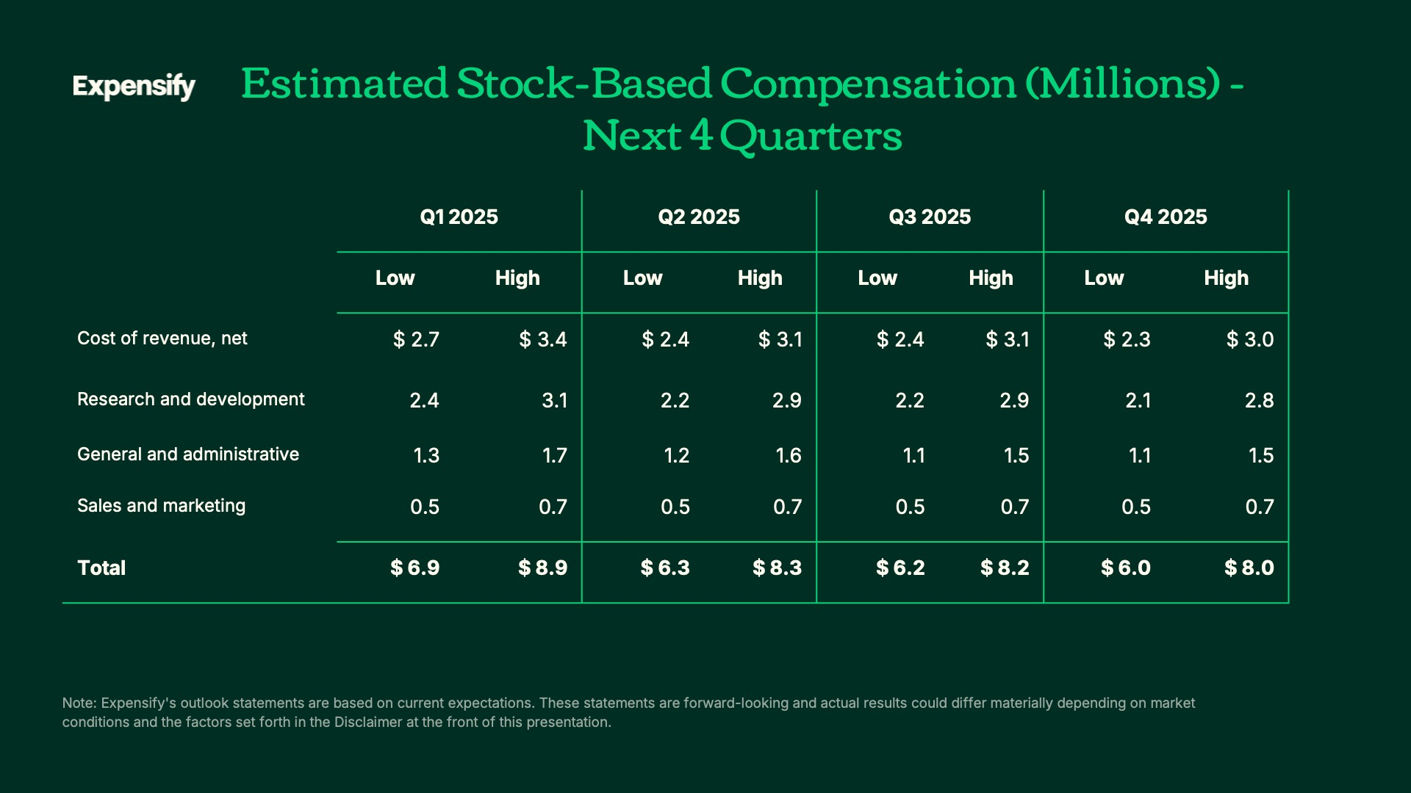

Exhibit 99.2
51
Expensify, Inc.
Investor Presentation

Exhibit 99.3
52
EXPENSIFY ANNOUNCES SHARE REPURCHASE PROGRAM

The program authorizes up to $50 million of Class A common stock to be repurchased.

PORTLAND, Ore.--(BUSINESS WIRE)--February 27, 2025-- Expensify, Inc. (Nasdaq: EXFY), a payments superapp that helps individuals and businesses around the world simplify the way they manage money across expenses, corporate cards and bills, today announced that its Board of Directors approved a new share repurchase program with authorization to purchase up to $50 million of shares of its Class A common stock. The program replaces the company’s share repurchase program that was approved in 2022, which was set to expire in March 2025.

“Given the success of this past year’s cost cutting measures and the resulting large increase in free cash flow, we believe there is an attractive potential buying opportunity for our stock. We became debt free last year, so buybacks are part of the next logical avenue to utilize our free cash flow to return value to our shareholders.” said Expensify CFO, Ryan Schaffer.

The new share repurchase program is designed to return value to shareholders by offsetting dilution from stock issuances and reducing share count over time. Expensify may repurchase shares from time to time through open market purchases, in privately negotiated transactions or by other means, including through the use of trading plans intended to qualify under Rule 10b5-1 under the Securities Exchange Act of 1934, as amended, in accordance with applicable securities laws and other restrictions. The timing and total amount of stock repurchases will depend upon business, economic and market conditions, corporate and regulatory requirements, prevailing stock prices, restrictions under the terms of our loan agreements and other considerations. This program terminates on March 31, 2028, may be suspended or discontinued at any time and does not obligate the company to acquire any amount of Class A common stock.

Forward-Looking Statements

Forward-looking statements in this press release, which are not historical facts, are forward-looking statements within the meaning of the Private Securities Litigation Reform Act of 1955. These statements include statements regarding our our intended share repurchases and expected shareholder benefits of the program. As a result, our actual results, performance or achievements may differ materially from those expressed or implied by these forward-looking statements. In some cases, you can identify forward-looking statements because they contain words such as “may,” “will,” “shall,” “should,” “expects,” “plans,” “anticipates,” “could,” “intends,” “target,” “projects,” “contemplates,” “believes,” “estimates,” “predicts,” “potential,” “goal,” “ambition,” “objective,” “seeks,” “outlook,” or “continue” or the negative of these words or other similar terms or expressions that concern our expectations, strategy, plans, or intentions. Such forward-looking statements are necessarily based upon estimates and assumptions that, while considered reasonable by us and our management, are inherently uncertain. Factors that may cause actual results to differ materially from current expectations include, but are not limited to: the impact on inflation on us and our members; our borrowing costs have and may continue to increase as a result of increases in interest rates; our expectations regarding our financial performance and future operating performance; our ability to attract and retain members, expand usage of our platform, sell subscriptions to our platform and convert individuals and organizations into paying customers; the timing and success of new features, integrations, capabilities and enhancements by us, or by competitors to their products, or any other changes in the competitive landscape of our market; the amount and timing of operating expenses and capital expenditures that we may incur to maintain and expand our business and operations to remain competitive; the sufficiency of our cash, cash equivalents and investments to meet our liquidity needs; our ability to make required payments under and to comply with the various requirements of our current and future indebtedness; our cash flows, the prevailing stock prices, general economic and market conditions and other considerations that could affect the specific timing, price and size of repurchases under our stock repurchase program or our ability to fund any stock repurchases; geopolitical tensions, including the war in Ukraine and the conflict in Israel, Gaza and surrounding areas; our ability to effectively manage our exposure to fluctuations in foreign currency exchange rates; the expenses associated with being a public company; the size of our addressable markets, market share and market trends; anticipated trends, developments and challenges in our industry, business and the highly competitive markets in which we operate; any adverse impact on our business operations as a result of using artificial intelligence or other machine learning technologies in our services; our expectations regarding our income tax liabilities and the adequacy of our reserves; our ability to effectively manage
Exhibit 99.3

our growth and expand our infrastructure and maintain our corporate culture; our ability to identify, recruit and retain skilled personnel, including key members of senior management; the safety, affordability and convenience of our platform and our offerings; our ability to successfully defend litigation brought against us; our ability to successfully identify, manage and integrate any existing and potential acquisitions of businesses, talent, technologies or intellectual property; general economic conditions in either domestic or international markets, and geopolitical uncertainty and instability, and their effects on software spending; our protections against security breaches, technical difficulties, or interruptions to our platform; our ability to maintain, protect and enhance our intellectual property; and other risks discussed in our filings with the Securities and Exchange Commission. All forward-looking statements attributable to us or persons acting on our behalf are expressly qualified in their entirety by the cautionary statements set forth above. We caution you not to place undue reliance on any forward-looking statements, which are made only as of the date of this press release. We do not undertake or assume any obligation to update publicly any of these forward-looking statements to reflect actual results, new information or future events, changes in assumptions or changes in other factors affecting forward-looking statements, except to the extent required by applicable law. If we update one or more forward-looking statements, no inference should be drawn that we will make additional updates with respect to those or other forward-looking statements.

About Expensify

Expensify helps 15 million people worldwide track expenses, book travel, reimburse employees, manage corporate cards, send invoices, and pay bills—all in one place. Whether you're self-employed, running a small business, managing a team, or overseeing global finances, let Expensify handle your travel and expense, at the speed of chat.

