UNITED STATES

SECURITIES AND EXCHANGE COMMISSION

Washington, D.C. 20549

FORM 8-K

CURRENT REPORT

PURSUANT TO SECTION 13 OR 15(d)

OF THE SECURITIES EXCHANGE ACT OF 1934

Date of report (Date of earliest event reported): March 30, 2022

Expensify, Inc.

(Exact Name of Registrant as Specified in its Charter)

Delaware | 001-41043 | 27-0239450
(State or Other Jurisdiction | (Commission | (IRS Employer
of Incorporation) | File Number) | Identification No.)
 | 401 SW 5th Ave
 | Portland, Oregon 97204
 | (Address of Principal Executive Offices) (Zip Code)
 | (971) 365-3939
 | (Registrant’s telephone number, including area code)
 | Not applicable
 | (Former Name or Former Address, if Changed Since Last Report)

Check the appropriate box below if the Form 8-K filing is intended to simultaneously satisfy the filing obligation of the registrant under any of the following provisions:

- Written communications pursuant to Rule 425 under the Securities Act (17 CFR 230.425).

- Soliciting material pursuant to Rule 14a-12 under the Exchange Act (17 CFR 240.14a-12).

- Pre-commencement communications pursuant to Rule 14d-2(b) under the Exchange Act (17 CFR 240.14d-2(b)).

- Pre-commencement communications pursuant to Rule 13e-4(c) under the Exchange Act (17 CFR 240.13e-4(c)).

Securities registered pursuant to Section 12(b) of the Act:

 |  | Trading |  | Name of each exchange
Title of each class |  | Symbols |  | on which registered
Class A Common Stock, par value $0.0001 per share |  | EXFY |  | The Nasdaq Stock Market LLC

Indicate by check mark whether the registrant is an emerging growth company as defined in Rule 405 of the Securities Act of 1933 (§230.405 of this chapter) or Rule 12b-2 of the Securities Exchange Act of 1934 (§240.12b-2 of this chapter).

Emerging growth company ☒

If an emerging growth company, indicate by check mark if the registrant has elected not to use the extended transition period for complying with any new or revised financial accounting standards provided pursuant to Section 13(a) of the Exchange Act. ☐

Item 2.02 Results of Operations and Financial Condition.

On March 30, 2022, Expensify, Inc. (“Expensify” or the “Company”) issued a press release announcing its financial results for the year and quarter ended December 31, 2022. A copy of this press release is furnished as Exhibit 99.1 to this current report on Form 8-K and is incorporated herein by reference.

Item 7.01 Regulation FD Disclosure.

On March 30, 2022, the Company posted an investor presentation to its website at https://ir.expensify.com (the “Investor Presentation”). A copy of the Investor Presentation is attached as Exhibit 99.2 to this current report on Form 8-K and is incorporated herein by reference. The Company expects to use the Investor Presentation, in whole or in part, and possibly with modifications, in connection with presentations to investors, analysts and others.

The information contained in the Investor Presentation is summary information that is intended to be considered in the context of the Company’s Securities and Exchange Commission (“SEC”) filings and other public announcements that the Company may make, by press release or otherwise, from time to time. The Investor Presentation speaks only as of the date of this current report on Form 8-K. The Company undertakes no duty or obligation to publicly update or revise the information included in the Investor Presentation, although it may do so from time to time. Any such updating may be made through the filing of other reports or documents with the SEC, through press releases or other public disclosure. In addition, the exhibit furnished herewith contains statements intended as “forward-looking statements” that are subject to the cautionary statements about forward-looking statements set forth in such exhibit. By furnishing the information contained in the Investor Presentation, the Company makes no admission as to the materiality of any information in the Investor Presentation that is required to be disclosed solely by reason of Regulation FD.

The information contained in Item 2.02 and this Item 7.01, including Exhibit 99.1 and 99.2, is being furnished and shall not be deemed “filed” for the purposed of Section 18 of the Securities and Exchange Act of 1934, as amended (the “Exchange Act”), or otherwise subject to the liabilities of that section, nor shall it be deemed incorporated by reference in any filing made by Expensify under the Securities Act of 1933, as amended, or the Exchange Act, except as expressly set forth by specific reference in such a filing.

Item 9.01 Financial Statements and Exhibits.

- Exhibits.

Exhibit No. Description

99.1 Press Release issued by Expensify, Inc., dated March 30, 2022.

99.2 Investor Presentation, dated March 30, 2022.

104 Cover Page Interactive Data File (embedded within the Inline XBRL document).

SIGNATURE

Pursuant to the requirements of the Securities Exchange Act of 1934, the registrant has duly caused this report to be signed on its behalf by the undersigned hereunto duly authorized.

Expensify, Inc.

By: /s/ Ryan Schaffer

Name: Ryan Schaffer

Title: Chief Financial Officer

Date: March 30, 2022

Exhibit 99.1

Expensify Announces Q4 and Full Year Fiscal 2021 Results

Ended the year with 63% revenue growth and the largest quarterly increase in paid members since the start of the pandemic.

PORTLAND, Ore.–(BUSINESS WIRE)–Expensify, Inc. (Nasdaq: EXFY), a payments superapp that helps individuals and businesses around the world simplify the way they manage money across expenses, corporate cards and bills, today announced results for its fourth quarter and full year ended December 31, 2021.

“The major highlight of 2021 was releasing our Free Plan in October and growing it to more than 3,100 customers by year end,” says David Barrett, founder and CEO of Expensify. “We opened the floodgates into our product wider than they’ve ever been before, to individuals and businesses of all types, and it’s been a huge success in such a short amount of time. Free expense management, corporate cards, invoicing, bill pay, and travel booking all in one place – it’s the perfect foundation on which to build the reimagined, chat-centric future for our product.”

“We’re proud to have ended 2021 with a bang,” says Ryan Schaffer, Chief Financial Officer of Expensify. “The pandemic has been a sobering stress test on the resiliency of our viral business model, but we’ve shown that our bottom-up approach to member acquisition has the power to weather any storm. The results speak for themselves: product-led growth and word-of-mouth adoption propelled us to a 62% revenue increase in 2021.”

Financial

Q4 2021:

- Revenue was $40.4 million, an increase of 56.0% from the same period last year.

- An IPO-related bonus expense of $14.2 million impacted net (loss) income.

- Net (loss) income was $(21.9) million, compared to $1.7 million for the same period last year. The loss was primarily due to the IPO-related bonus.

  - Non-GAAP net income was $4.4 million. Non-GAAP net income excludes stock based compensation which was not excluded in prior periods.

- Adjusted EBITDA was $(6.9) million, compared to $10.2 million for the same period last year.

- Adjusted EBITDA excluding the IPO bonus was $7.3 million, compared to $10.2 million for the same period last year.

Full Year Fiscal 2021:

- Revenue was $142.8 million, an increase of 61.8% from the same period last year.

- An IPO-related bonus expense of $48.4 million impacted net (loss) income and Adjusted EBITDA.

- Net loss was $(13.6) million, compared to $(1.7) million for the same period last year. The loss was primarily due to the IPO-related bonus.

  - Non-GAAP net income was $49.4 million.

- Adjusted EBITDA was $9.5 million, compared to $26.8 million for the same period last year.

- Adjusted EBITDA excluding the IPO bonus was $58.0 million, compared to $26.8 million for the same period last year.

Business

- Paid members - saw major growth, with 711 thousand in the fourth quarter of 2021.

Exhibit 99.1

- Free plan - launched in October and grew to over 3,100 customers by December 2021. Includes expense management, the Expensify Card, next-day reimbursement, invoicing, bill pay, and travel booking.

- Expensify Card - adoption continued at a rapid pace and interchange increased by 185% in 2021.

- Cash back - introduced unlimited cash back on the Expensify Card, with an introductory rate of 4% followed by an ongoing rate of 2% across all purchases and categories.

- Invoicing and bill pay - completed Expensify’s expansion into accounts payable and receivable, rounding out its offerings as a full-service preaccounting platform.

- New.expensify.com - launched a sneak peek of Expensify’s future product that mixes chat and payments for easy financial collaboration across work and personal life.

- Expensify.org - funded more than 50 grassroots organizations fighting injustice in their communities, reimbursed thousands of families on SNAP/EBT for groceries and COVID-19 vaccinations, and donated clothing to people experiencing homelessness.

- Podcast - aired first season of “Live Rich, Have Fun, Save the World,” which features individual trailblazers pursuing the lofty goals aligned with Expensify’s three-part company mission.

- ESG - reached carbon neutrality via offsets in 2021 and set a goal of Net Zero emissions by 2030.

- Customer support - won “Best Customer Support” from TrustRadius.

- Operational efficiency - annualized revenue per employee topped $1.1MM.

  - Calculated as three months ended December 31, 2021 revenue multiplied by four (quarters), divided by 144 full-time employees as of December 31, 2021.

Financial Outlook

Expensify's outlook statements are based on current expectations. The following statements are forward-looking and actual results could differ materially depending on market conditions and the factors set forth under “Forward-Looking Statements” below.

For the fiscal first quarter ending March 31, 2022, Expensify expects:

- Revenue between $38.6 million and $39.6 million.

- Average monthly paid members between 684 thousand and 702 thousand.

Availability of Information on Expensify’s Website

Investors and others should note that Expensify routinely announces material information to investors and the marketplace using SEC filings, press releases, public conference calls, webcasts and the Expensify Investor Relations website at https://ir.expensify.com. While not all of the information that the Company posts to its Investor Relations website is of a material nature, some information could be deemed to be material. Accordingly, the Company encourages investors, the media and others interested in Expensify to review the information that it shares on its Investor Relations website.

Conference Call

Expensify will host a video call to discuss the results at 2:00 p.m. Pacific Time today. The video call information is available on Expensify’s Investor Relations website at https://ir.expensify.com. A replay of the call will be available on the site for three months.

Non-GAAP Financial Measures

Exhibit 99.1

In addition to financial measures prepared in accordance with U.S. generally accepted accounting principles (“GAAP”), we provide certain non-GAAP financial measures, including Adjusted EBITDA, Adjusted EBITDA excluding the IPO-related bonus, and Non-GAAP net income.

We believe our non-GAAP financial measures are useful in evaluating our business, measuring our performance, identifying trends affecting our business, formulating business plans and making strategic decisions. Accordingly, we believe that these non-GAAP financial measures provide useful information to investors and others in understanding and evaluating our results of operations in the same manner as our management team. These non-GAAP financial measures are presented for supplemental informational purposes only, should not be considered a substitute for financial information presented in accordance with GAAP, and may be different from similarly titled metrics or measures presented by other companies. Non-GAAP financial measures have limitations as analytical tools and should not be considered in isolation or as substitutes for financial information presented under GAAP. There are a number of limitations related to the use of non-GAAP financial measures versus comparable financial measures determined under GAAP. For example, other companies in our industry may calculate these non-GAAP financial measures differently or may use other measures to evaluate their performance. All of these limitations could reduce the usefulness of these non-GAAP financial measures as analytical tools. Investors are encouraged to review the related GAAP financial measures and the reconciliations of these non-GAAP financial measures to their most directly comparable GAAP financial measures and to not rely on any single financial measure to evaluate our business. A reconciliation of each non-GAAP financial measure to the most directly comparable financial measure stated in accordance with GAAP is at the end of this press release.

We define Adjusted EBITDA as net income from operations excluding provision for income taxes, interest and other expenses, net, depreciation and amortization and stock based compensation.

We define Adjusted EBITDA excluding the IPO-related bonus as net income from operations excluding provision for income taxes, interest and other expenses, net, depreciation and amortization, stock based compensation, and IPO-related bonus costs.

We define non-GAAP net income as net income from operations in accordance with US GAAP excluding stock-based compensation and IPO-related bonus costs. In prior periods, this metric only excluded IPO-related bonus costs and did not exclude expenses related to stock-based compensation. However, management now believes that further excluding stock-based compensation from non-GAAP net income is useful to better understand the financial performance of our business and to facilitate a better comparison of our results to those of peer companies over multiple periods given that this item may vary between companies for reasons unrelated to overall operating performance.

The tables at the end of the Financial Statements provide reconciliations to the most directly comparable GAAP financial measure to each of these non-GAAP financial measures.

Forward-Looking Statements

Forward-looking statements in this press release, which are not historical facts, are forward-looking statements within the meaning of the Private Securities Litigation Reform Act of 1955. These statements include statements regarding our strategy, future financial condition, future operations, projected costs, prospects, plans, objectives of management and expected market growth and involve known and unknown risks that are difficult to predict. As a result, our actual results, performance or achievements may differ materially from those expressed or implied by these forward-looking statements. In some cases, you can identify forward-looking statements because they contain words such as “may,” “will,” “shall,” “should,” “expects,” “plans,” “anticipates,” “could,” “intends,” “target,” “projects,” “contemplates,” “believes,” “estimates,” “predicts,” “potential,” “goal,” “objective,” “seeks,” or “continue” or the negative of these words or other similar terms or expressions that concern our expectations, strategy, plans, or intentions. Such forward-looking statements are necessarily based upon estimates and

Exhibit 99.1

assumptions that, while considered reasonable by us and our management, are inherently uncertain. Factors that may cause actual results to differ materially from current expectations include, but are not limited to: the economic, political and social impact of, and uncertainty relating to, the COVID-19 pandemic; the war in Ukraine and escalating geopolitical tensions as a result of Russia's invasion of Ukraine; our expectations regarding our financial performance and future operating performance; our ability to attract and retain members, expand usage of our platform, sell subscriptions to our platform and convert individuals and organizations into paying customers; the timing and success of new features, integrations, capabilities and enhancements by us, or by competitors to their products, or any other changes in the competitive landscape of our market; the amount and timing of operating expenses and capital expenditures that we may incur to maintain and expand our business and operations to remain competitive; the sufficiency of our cash, cash equivalents and investments to meet our liquidity needs; our ability to make required payments under and to comply with the various requirements of our current and future indebtedness; our ability to effectively manage our exposure to fluctuations in foreign currency exchange rates; the increased expenses associated with being a public company; the size of our addressable markets, market share and market trends; anticipated trends, developments and challenges in our industry, business and the highly competitive markets in which we operate; our expectations regarding our income tax liabilities and the adequacy of our reserves; our ability to effectively manage our growth and expand our infrastructure and maintain our corporate culture; our ability to identify, recruit and retain skilled personnel, including key members of senior management; the safety, affordability and convenience of our platform and our offerings; our ability to successfully defend litigation brought against us; our ability to successfully identify, manage and integrate any existing and potential acquisitions of businesses, talent, technologies or intellectual property; general economic conditions in either domestic or international markets, including the societal and economic impact of the COVID-19 pandemic, and geopolitical uncertainty and instability; our protections against security breaches, technical difficulties, or interruptions to our platform; our ability to maintain, protect and enhance our intellectual property; and other risks discussed in our filings with the SEC. All forward-looking statements attributable to us or persons acting on our behalf are expressly qualified in their entirety by the cautionary statements set forth above. We caution you not to place undue reliance on any forward-looking statements, which are made only as of the date of this press release. We do not undertake or assume any obligation to update publicly any of these forward-looking statements to reflect actual results, new information or future events, changes in assumptions or changes in other factors affecting forward-looking statements, except to the extent required by applicable law. If we update one or more forward-looking statements, no inference should be drawn that we will make additional updates with respect to those or other forward-looking statements.

About Expensify

Expensify is a payments superapp that helps individuals and businesses around the world simplify the way they manage money. More than 10 million people use Expensify's free features, which include corporate cards, expense tracking, next-day reimbursement, invoicing, bill pay, and travel booking in one app. All free. Whether you own a small business, manage a team, or close the books for your clients, Expensify makes it easy so you have more time to focus on what really matters.

Investor Relations Contact

Nick Tooker

investors@expensify.com

Press Contact

James Dean

press@expensify.com

Expensify, Inc. |  |  |  | Exhibit 99.1
Consolidated Balance Sheets
(unaudited, in thousands, except share and per share data)
 |  | As of December 31,
 | 2021 |  |  | 2020
Assets
Cash and cash equivalents | $ | 98,398 |  | $
Accounts receivable, net |  | 15,713
Settlement assets |  | 21,880
Prepaid expenses |  | 7,436
Related party loan receivable, current |  | 14
Other current assets |  | 14,201
Total current assets |  | 157,642
Capitalized software, net |  | 6,359
Property and equipment, net |  | 15,930
Lease right-of-use assets |  | 2,202
Deferred tax assets, net |  | 370
Other assets |  | 710
Total assets | $ | 183,213 |  | $
Liabilities, convertible preferred stock and stockholders' equity (deficit)
Accounts payable | $ | 3,752 |  | $
Accrued expenses and other liabilities |  | 11,046
Borrowings under line of credit |  | 15,000
Current portion of long-term debt, net of issuance costs |  | 549
Lease liabilities, current |  | 1,549
Settlement liabilities |  | 21,680
Total current liabilities |  | 53,576
Lease liabilities, non-current |  | 802
Deferred tax liabilities, net |  | —
Other liabilities |  | 153
Long-term debt, net of issuance costs |  | 52,067
Total liabilities |  | 106,598
Commitments and contingencies (Note 12)
Convertible preferred stock, par value $0.0001; 0 and 4,203,139 shares authorized, issued and outstanding as of December
31, 2021 and 2020, respectively; (aggregate liquidation preference of $0 and $24,929,457 as of December 31, 2021 and
2020, respectively) |  | —
Stockholders' equity (deficit):
Common stock, par value $0.0001; 1,000,000,000 and 95,000,000 shares of Class A common stock authorized as of
December 31, 2021 and 2020, respectively; 67,844,060 and 29,366,940 shares of Class A common stock issued and
outstanding as of December 31, 2021 and 2020, respectively; 25,000,000 and 0 shares of LT10 common stock
authorized as of December 31, 2021 and 2020, respectively; 7,332,640 and 0 shares of LT10 common stock issued and
outstanding as of December 31, 2021 and 2020, respectively; 25,000,000 and 0 shares of LT50 common stock
authorized as of December 31, 2021 and 2020, respectively; 6,224,160 and 0 shares of LT50 common stock issued and
outstanding as of December 31, 2021 and 2020, respectively |  | 6
Additional paid-in capital |  | 142,515
Accumulated deficit |  | (65,906) |  | (
Total stockholders' equity (deficit) |  | 76,615 |  | (
Total liabilities, convertible preferred stock and stockholders' equity (deficit) | $ | 183,213 |  | $

 | Expensify, Inc. |  |  |  |  |  |  |  |  |  | Exhibit 99.1
 | Consolidated Statements of Income
(unaudited, in thousands, except share and per share data)
 |  |  | Three months ended December 31, |  |  |  |  | Year ended December 31,
 |  |  | 2021 |  |  | 2020 |  | 2021 |  |  | 2020
Revenue | $ |  | 40,364 |  | $ | 25,737 | $ | 142,835 | $ |  | 88,072
Cost of revenue, net |  |  | 19,925 |  |  | 8,533 |  | 53,693 |  |  | 32,414
Gross margin |  |  | 20,439 |  |  | 17,204 |  | 89,142 |  |  | 55,658
Operating expenses:
Research and development |  |  | 2,850 |  |  | 2,083 |  | 10,988 |  |  | 6,728
General and administrative |  |  | 24,915 |  |  | 8,655 |  | 60,742 |  |  | 33,372
Sales and marketing |  |  | 13,109 |  |  | 2,074 |  | 27,664 |  |  | 9,888
Total operating expenses |  |  | 40,874 |  |  | 12,812 |  | 99,394 |  |  | 49,988
(Loss) income from operations |  |  | (20,435) |  |  | 4,392 |  | (10,252) |  |  | 5,670
Interest and other expenses, net |  |  | (920) |  |  | (558) |  | (3,480) |  |  | (2,718)
(Loss) income before income taxes |  |  | (21,355) |  |  | 3,834 |  | (13,732) |  |  | 2,952
Benefit (provision) for income taxes |  |  | (532) |  |  | (2,092) |  | 174 |  |  | (4,662)
Net (loss) income | $ |  | (21,887) |  | $ | 1,742 | $ | (13,558) | $ |  | (1,710)
Less: income allocated to participating securities |  |  | — |  |  | (1,742) |  | — |  |  | —
Net loss attributable to Class A, LT10 and LT50 common stockholders |  | $ | (21,887) |  | $ | — | $ | (13,558) |  | $ | (1,710)
Net loss per share attributable to Class A, LT10 and LT50 common stockholders:
Basic and diluted |  | $ | (0.82) |  | $ | — | $ | (0.36) |  | $ | (0.06)
Weighted-average shares of common stock used to compute net loss per share attributable to
Class A, LT10 and LT50 common stockholders:
Basic and diluted |  |  | 26,776,561 |  |  | 28,402,996 |  | 38,039,222 |  |  | 27,424,480

Expensify, Inc. |  |  |  |  | Exhibit 99.1
Consolidated Statements of Cash Flows
(unaudited, in thousands)
 | Year Ended December 31,
 | 2021 |  |  |  | 2020
Cash flows from operating activities:
Net (loss) income | $ | (13,558) |  | $ | (1,710)
Adjustments to reconcile net loss to net cash provided by operating activities:
Depreciation and amortization |  | 5,197 |  |  | 3,248
Reduction of operating lease right-of-use assets |  | 741 |  |  | 1,311
Loss on impairment, receivables and sale or disposal of equipment |  | 319 |  |  | 162
Stock-based compensation |  | 14,574 |  |  | 17,837
Amortization of debt issuance costs |  | 32 |  |  | 32
Deferred tax assets |  | 48 |  |  | 2,437
Deferred tax liabilities |  | (916) |  |  | 916
Changes in assets and liabilities:
Accounts receivable |  | (6,006) |  |  | (2,170)
Settlement assets |  | 173 |  |  | 2,878
Prepaid expenses |  | (6,509) |  |  | 270
Other current assets |  | (4,100) |  |  | (1,393)
Related party loan receivable |  | 586 |  |  | —
Other assets |  | 124 |  |  | (248)
Accounts payable |  | 1,424 |  |  | (714)
Accrued expenses and other liabilities |  | 7,511 |  |  | 1,774
Operating lease liabilities |  | (801) |  |  | (1,374)
Settlement liabilities |  | 7,372 |  |  | (16,548)
Other liabilities |  | (725) |  |  | 877
Net cash provided by operating activities |  | 5,486 |  |  | 7,585
Cash flows from investing activities:
Purchase of property and equipment |  | (2,706) |  |  | (2,488)
Proceeds from sale or disposal of property and equipment |  | — |  |  | 2
Software development costs |  | (4,908) |  |  | (1,809)
Net cash used by investing activities |  | (7,614) |  |  | (4,295)
Cash flows from financing activities:
Principal payments of finance leases |  | (774) |  |  | (808)
Principal payments of term loan |  | (25,191) |  |  | (319)
Proceeds from term loan |  | 45,000 |  |  | —
Principal payments of line of credit |  | — |  |  | (1,000)
Proceeds from line of credit |  | — |  |  | 9,613
Repurchases of common stock |  | — |  |  | —
Vesting of restricted common stock |  | 567 |  |  | —
Proceeds from initial public offering, net of underwriters' discounts and commissions |  | 57,458 |  |  | —
Proceeds from issuance of common stock on exercise of stock options |  | 3,505 |  |  | 1,301
Net cash provided by financing activities |  | 80,565 |  |  | 8,787
Net increase in cash and cash equivalents |  | 78,437 |  |  | 12,077
Cash and cash equivalents and restricted cash, beginning of period |  | 46,878 |  |  | 34,801
Cash and cash equivalents and restricted cash, end of period | $ | 125,315 |  | $ | 46,878
Supplemental disclosure of cash flow information:
Cash paid for interest | $ | 3,082 |  | $ | 2,929
Cash paid for income taxes | $ | 6,922 |  | $ | 150
Noncash investing and financing items:
Commercial building and land acquired with long-term debt (net of issuance costs of $8,226) | $ | — |  | $ | —
Right-of-use assets acquired with lease liabilities | $ | — |  | $ | 1,260
Reconciliation of cash, cash equivalents and restricted cash to the consolidated balance sheets
Cash and cash equivalents | $ | 98,398 |  | $ | 34,401
Restricted cash included in other current assets |  | 8,651 |  |  | 1,955
Restricted cash included in other assets |  | 47 |  |  | 48
Restricted cash included in settlement assets |  | 18,219 |  |  | 10,474
Total cash, cash equivalents and restricted cash | $ | 125,315 |  | $ | 46,878

Exhibit 99.1

Expensify, Inc.

Reconciliation of GAAP to Non-GAAP Financial Measures

(unaudited, in thousands)

Adjusted EBITDA

 | Three months ended December 31, |  |  |  |  |  | Year ended December 31,
 | 2021 |  |  | 2020 |  |  | 2021 |  |  | 2020
 | (in thousands, except percentages) |  |  |  |  |  | (in thousands, except percentages)
Net (loss) income | $ | (21,887) |  | $ | 1,742 | $ | (13,558) |  | $ | (1,710)
Add:
(Benefit) provision for income taxes | $ | 532 |  | $ | 2,092 |  | (174) |  |  | 4,662
Interest and other expenses, net |  | 920 |  |  | 558 |  | 3,497 |  |  | 2,718
Depreciation and amortization |  | 1,465 |  |  | 895 |  | 5,197 |  |  | 3,248
Stock-based compensation |  | 12,079 |  |  | 4,886 |  | 14,574 |  |  | 17,837
Adjusted EBITDA | $ | (6,891) |  | $ | 10,173 | $ | 9,536 |  | $ | 26,755
Adjusted EBITDA Excluding the IPO-Related Bonus
 | Three months ended December 31, |  |  |  |  |  | Year ended December 31,
 | 2021 |  |  | 2020 |  |  | 2021 |  |  | 2020
 | (in thousands, except percentages) |  |  |  |  |  | (in thousands, except percentages)
Net (loss) income | $ | (21,887) |  | $ | 1,742 | $ | (13,558) |  | $ | (1,710)
Add:
(Benefit) provision for income taxes | $ | 532 |  | $ | 2,092 |  | (174) |  |  | 4,662
Interest and other expenses, net |  | 920 |  |  | 558 |  | 3,497 |  |  | 2,718
Depreciation and amortization |  | 1,465 |  |  | 895 |  | 5,197 |  |  | 3,248
Stock-based compensation |  | 12,079 |  |  | 4,886 |  | 14,574 |  |  | 17,837
IPO-related bonus expense |  | 14,190 |  |  | — |  | 48,416 |  |  | —
Adjusted EBITDA Excluding the IPO-Related Bonus | $ | 7,299 |  | $ | 10,173 | $ | 57,952 |  | $ | 26,755
Non-GAAP net income
 | Three months ended December 31, |  |  |  |  |  | Year ended December 31,
 | 2021 |  |  | 2020 |  |  | 2021 |  |  | 2020
 |  | (in thousands, except percentages) |  |  |  |  | (in thousands, except percentages)
Net (loss) income | $ | (21,887) |  | $ | 1,742 | $ | (13,558) |  | $ | (1,710)
Add:
Stock-based compensation |  | 12,079 |  |  | 4,886 |  | 14,574 |  |  | 17,837
IPO-related bonus expense |  | 14,190 |  |  | — |  | 48,416 |  |  | —
Non-GAAP net income | $ | 4,382 |  | $ | 6,628 | $ | 49,432 |  | $ | 16,127

Exhibit 99.2

Expensify, Inc.

Investor Presentation
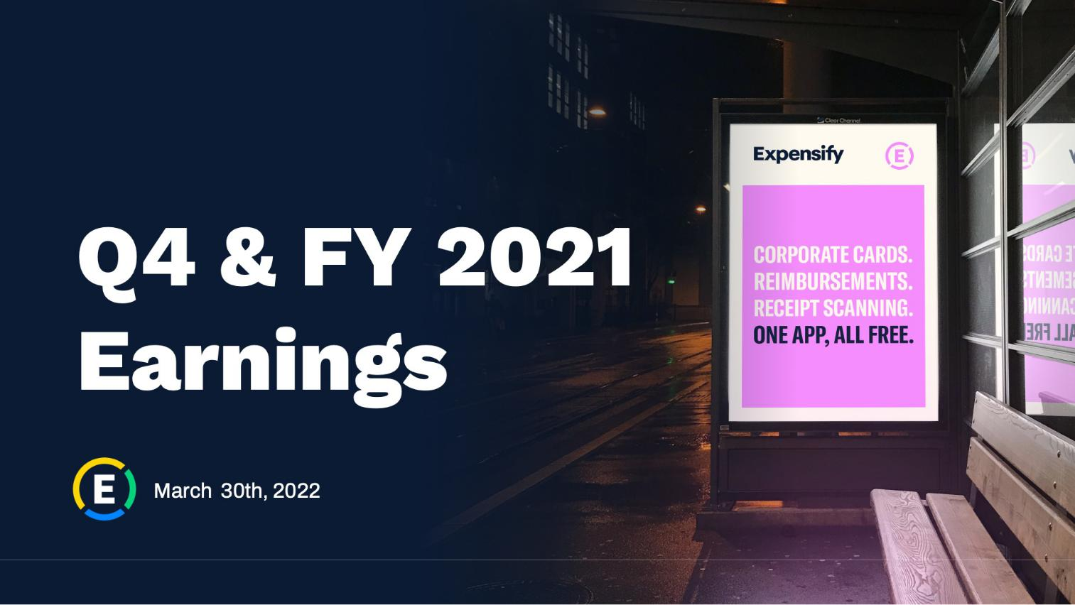

1

Exhibit 99.2

Expensify, Inc.

Investor Presentation
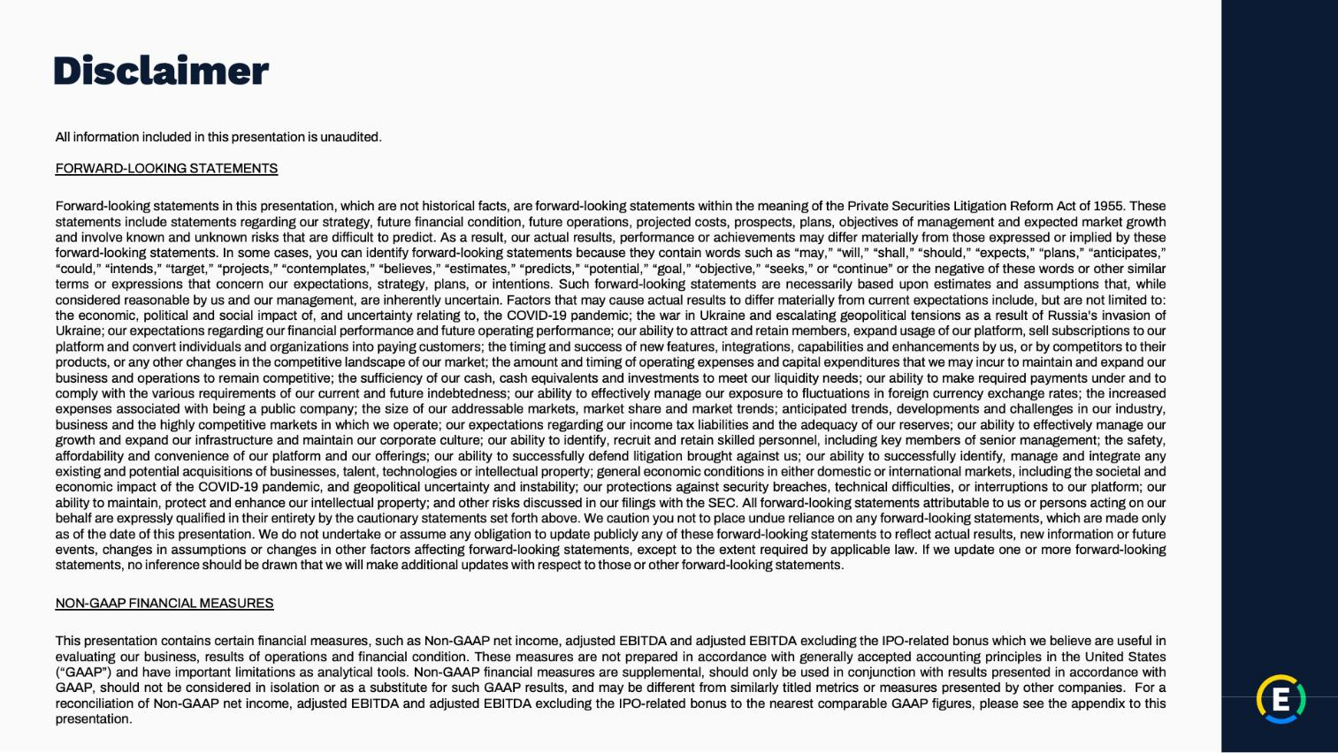

2

Exhibit 99.2

Expensify, Inc.

Investor Presentation
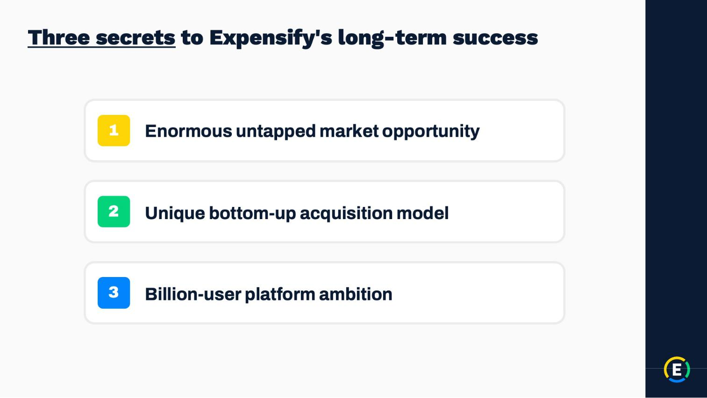

3

Exhibit 99.2

Expensify, Inc.

Investor Presentation
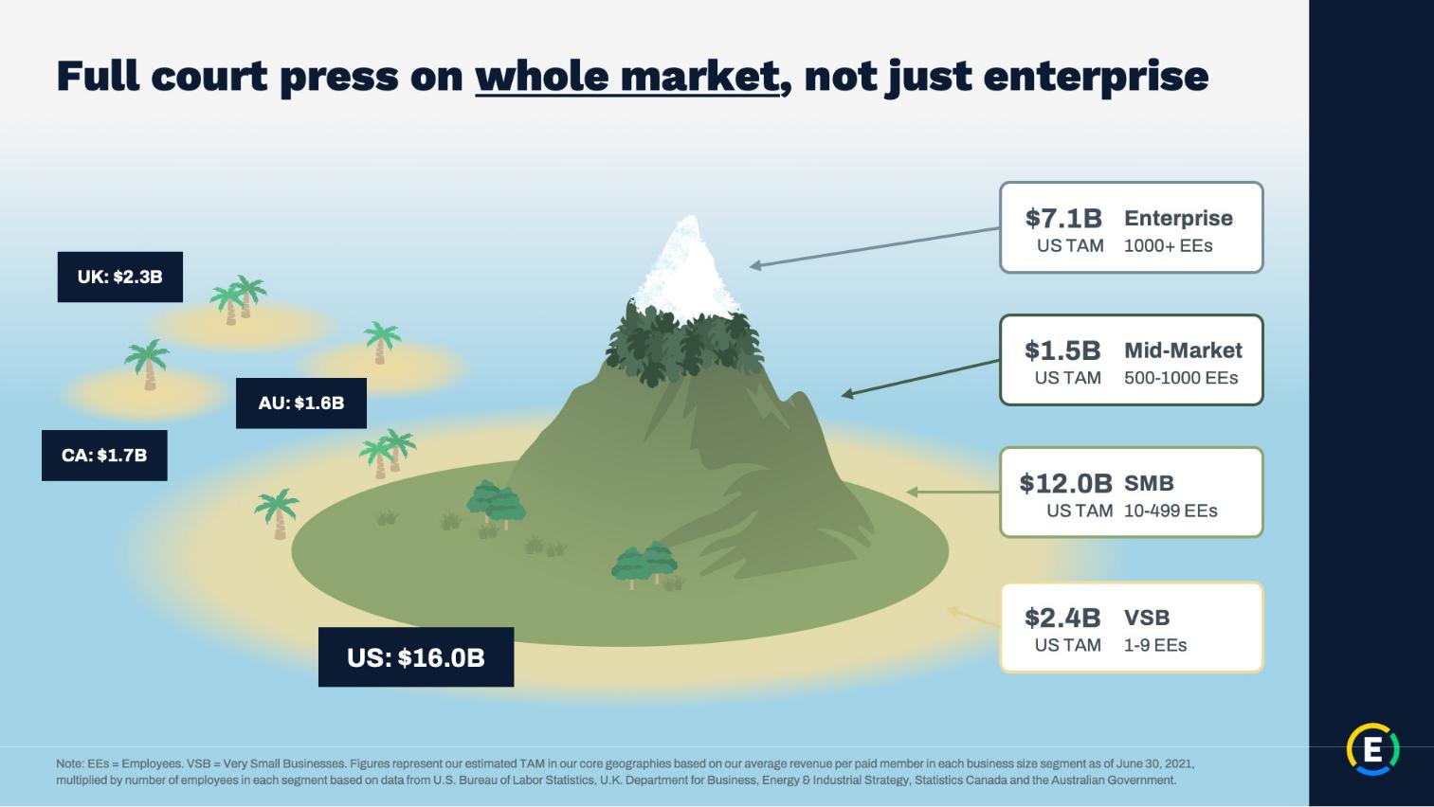

4

Exhibit 99.2

Expensify, Inc.

Investor Presentation
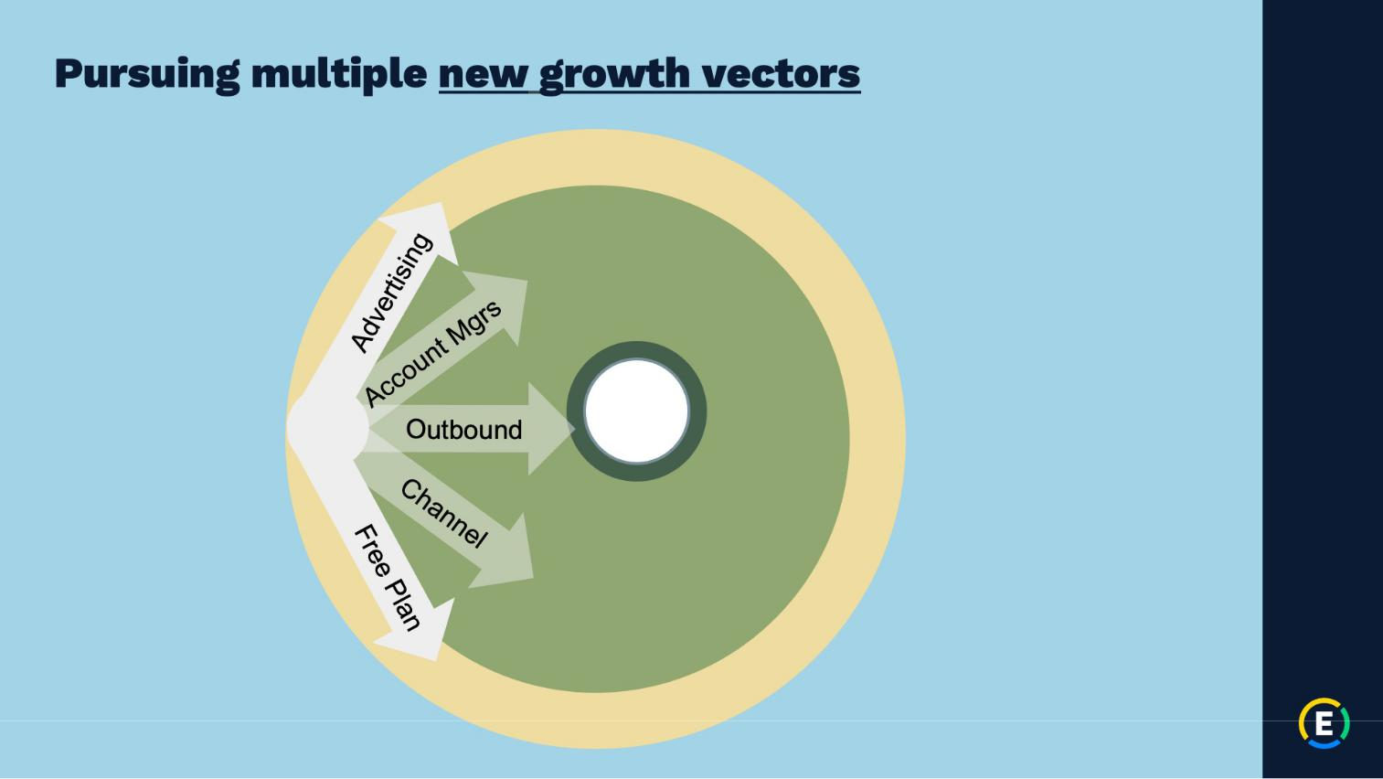

5

Exhibit 99.2

Expensify, Inc.

Investor Presentation
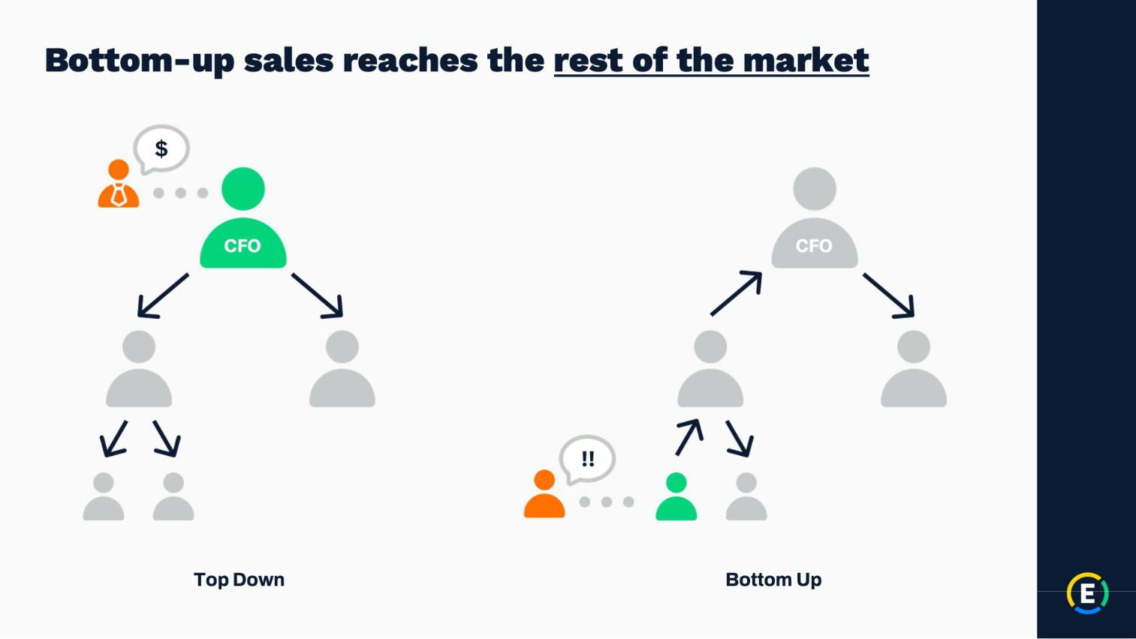

6

Exhibit 99.2

Expensify, Inc.

Investor Presentation
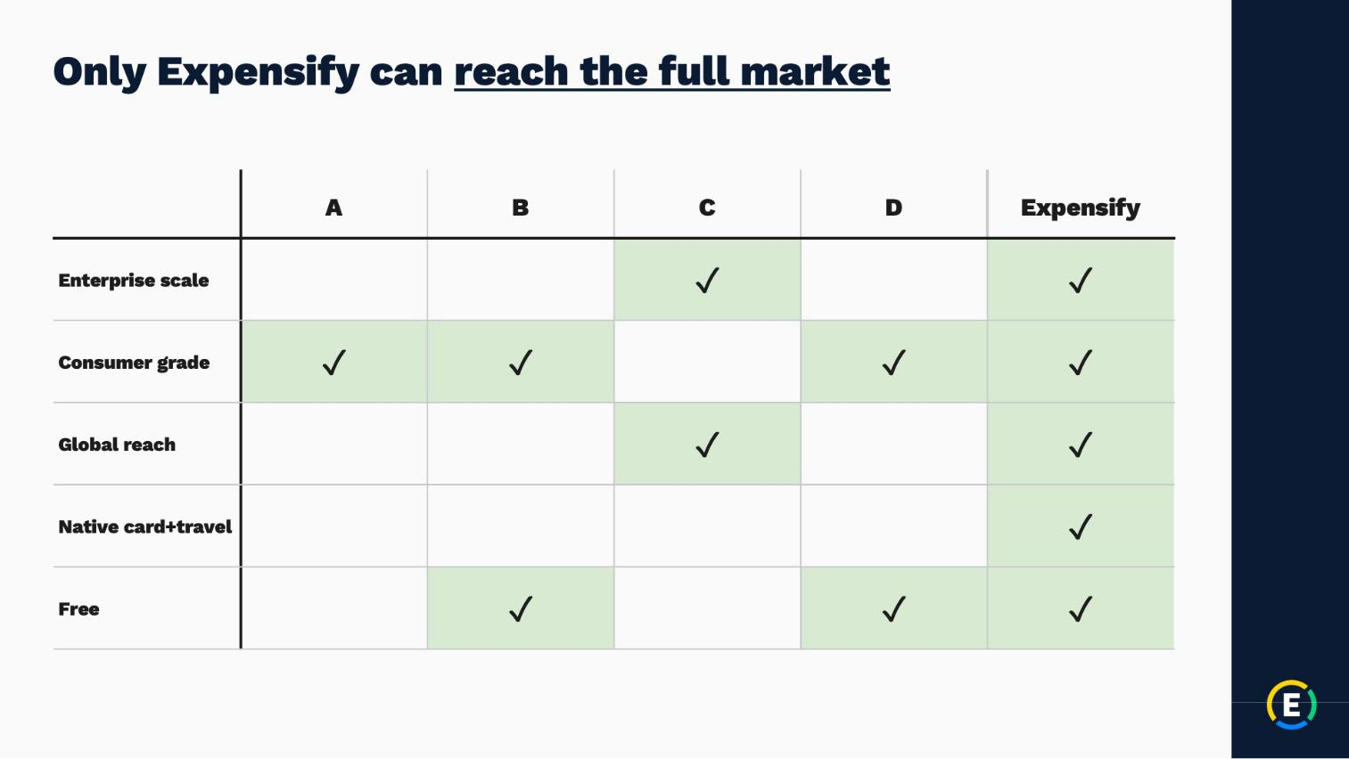

7

Exhibit 99.2

Expensify, Inc.

Investor Presentation
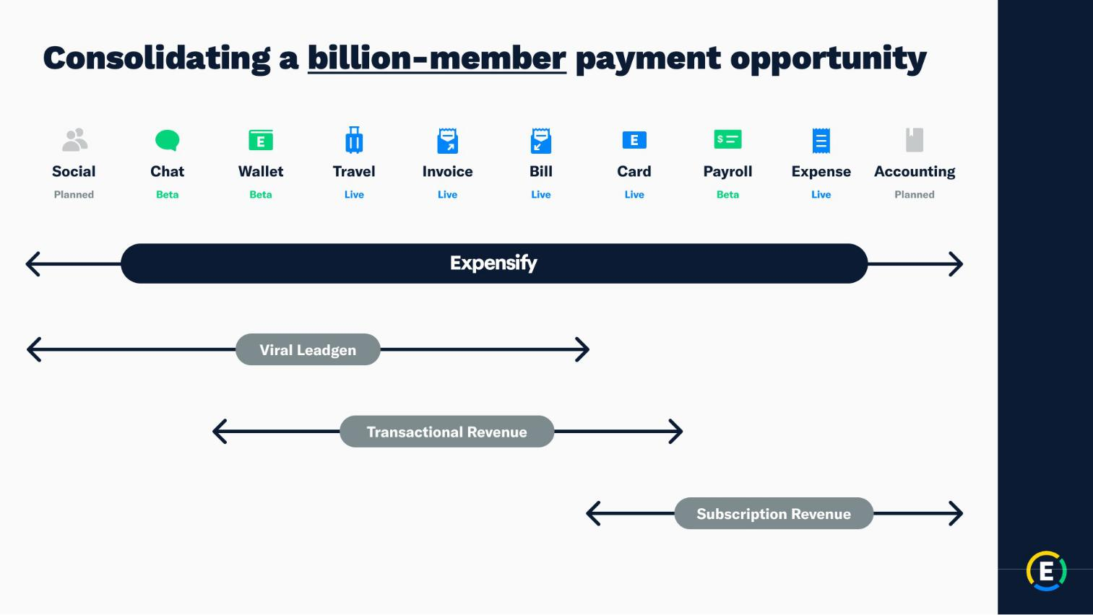

8

Exhibit 99.2

Expensify, Inc.

Investor Presentation
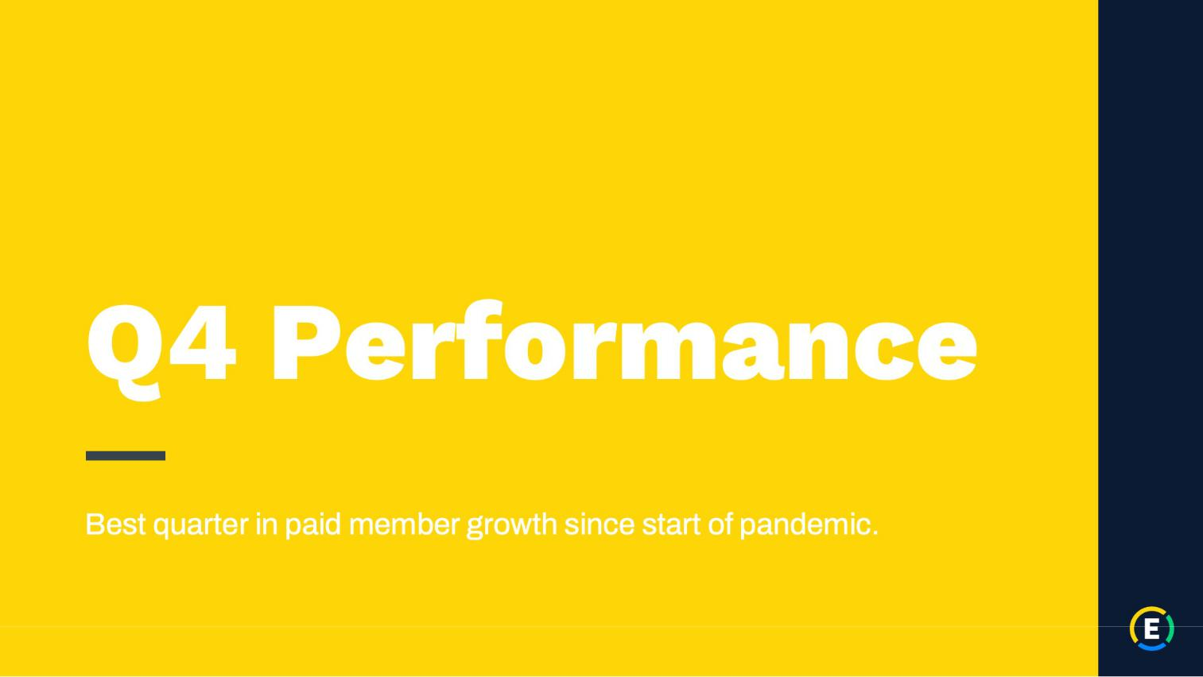

9

Exhibit 99.2

Expensify, Inc.

Investor Presentation
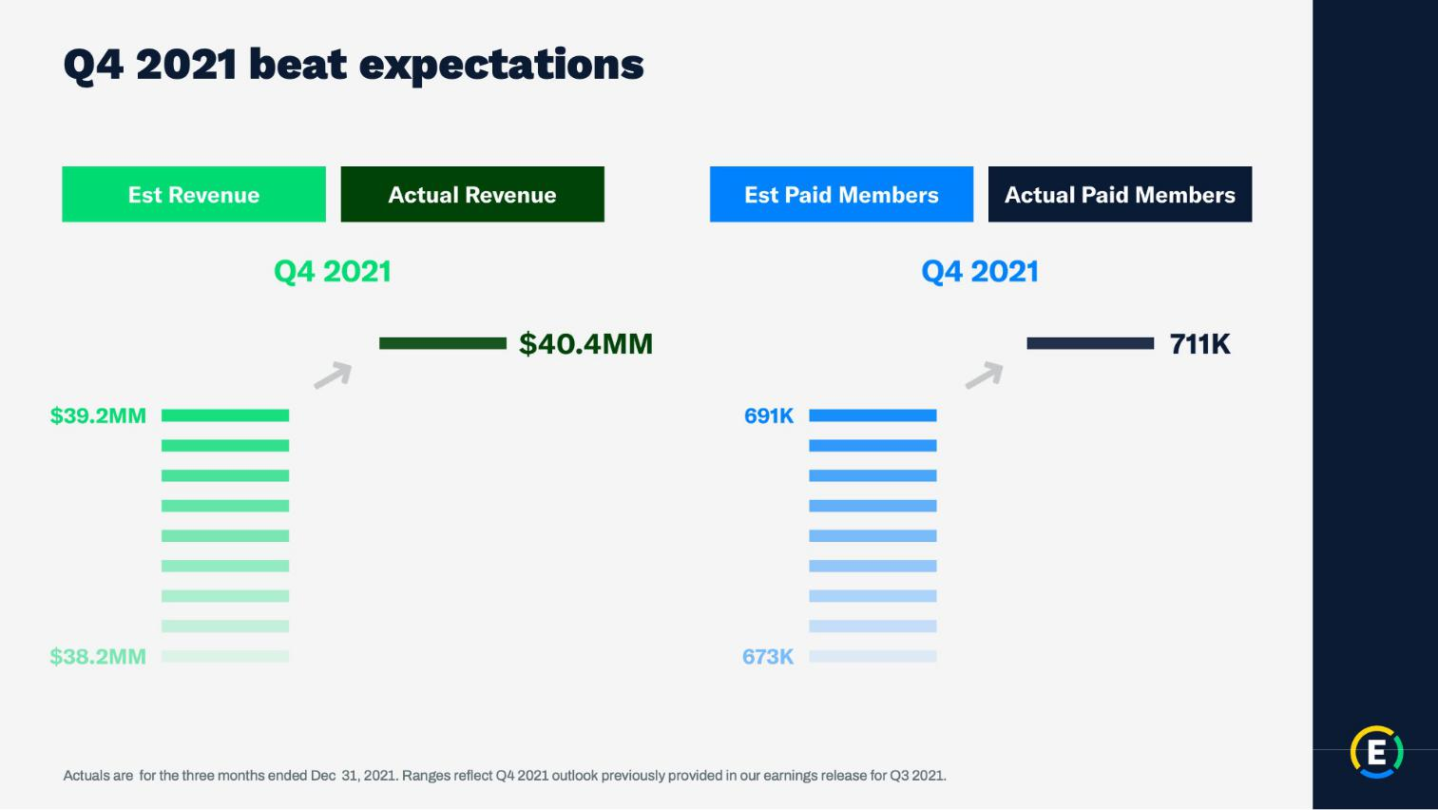

10

Exhibit 99.2

Expensify, Inc.

Investor Presentation
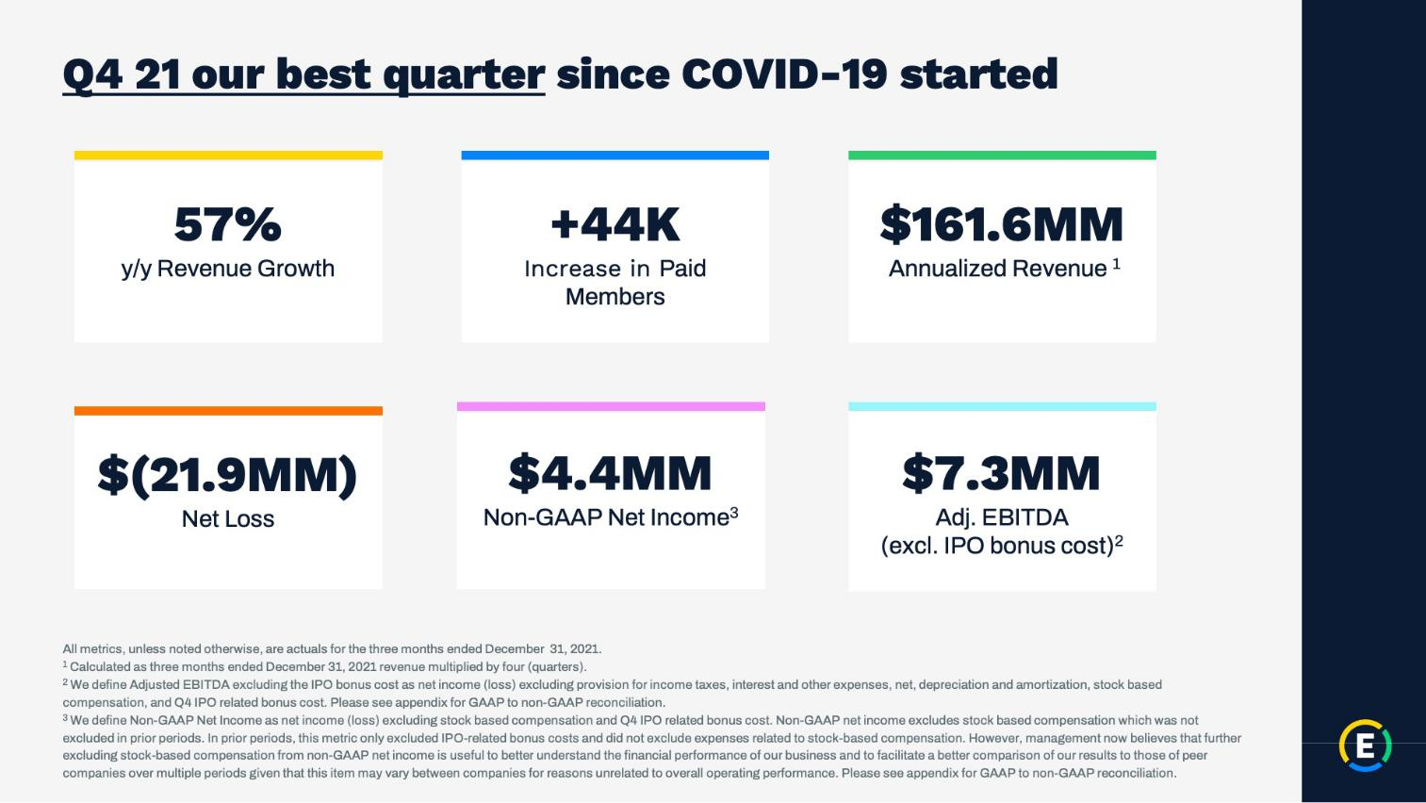

11

Exhibit 99.2

Expensify, Inc.

Investor Presentation
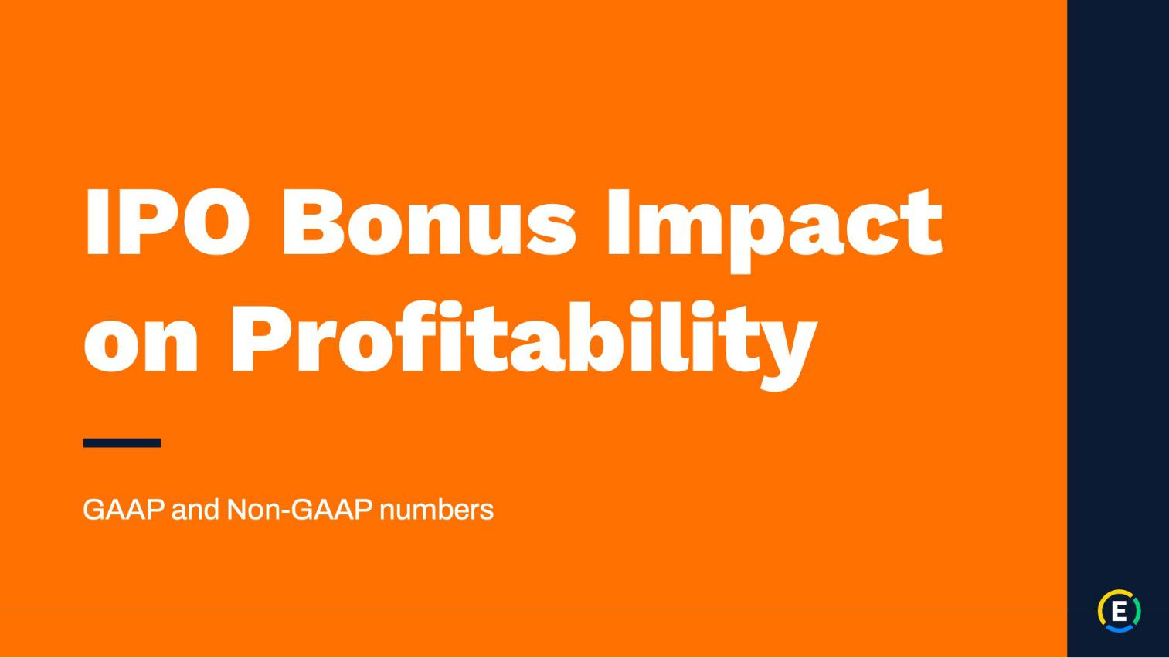

12

Exhibit 99.2

Expensify, Inc.

Investor Presentation
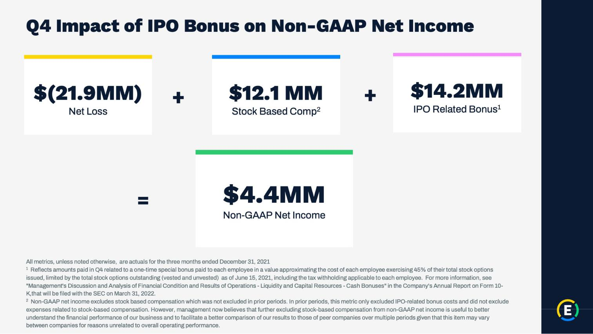

13

Exhibit 99.2

Expensify, Inc.

Investor Presentation
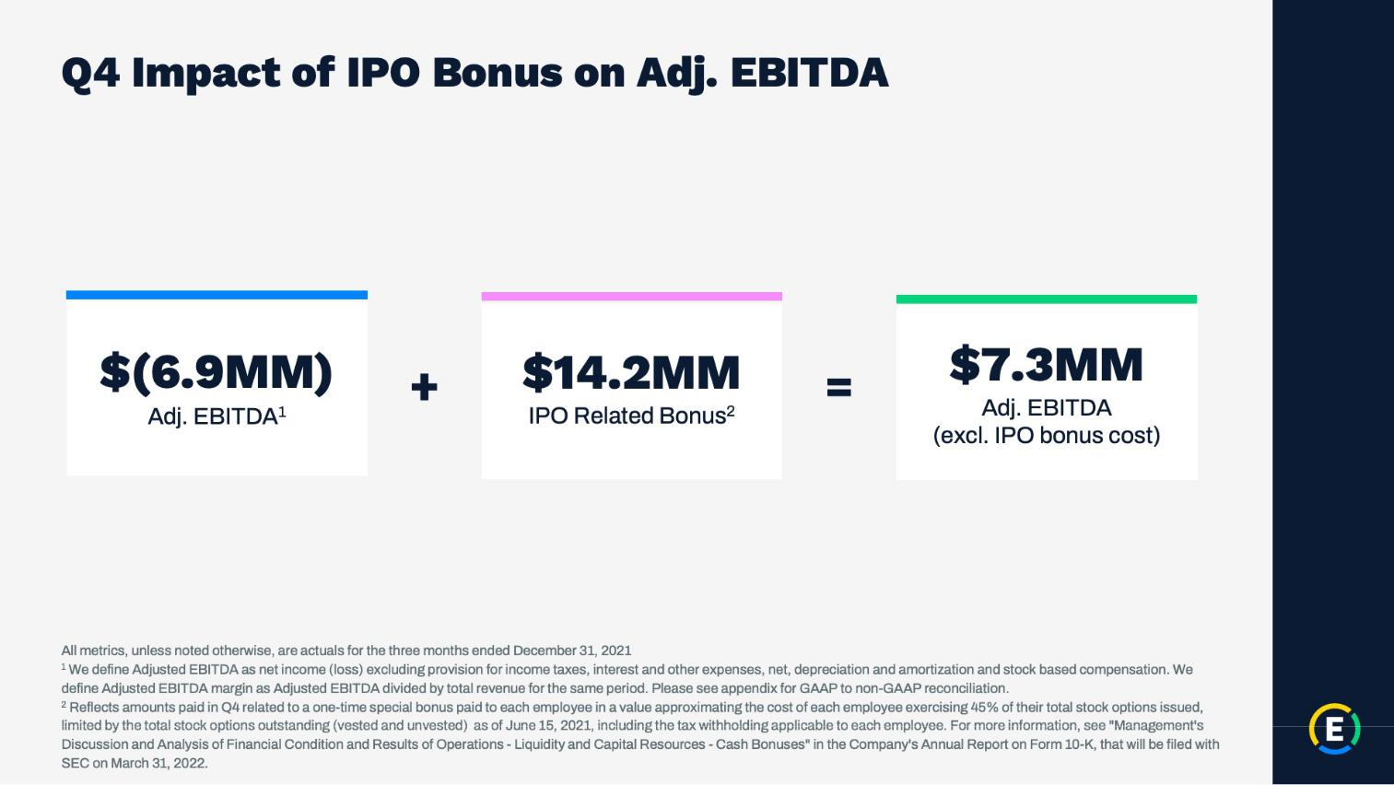

14

Exhibit 99.2

Expensify, Inc.

Investor Presentation


15

Exhibit 99.2

Expensify, Inc.

Investor Presentation
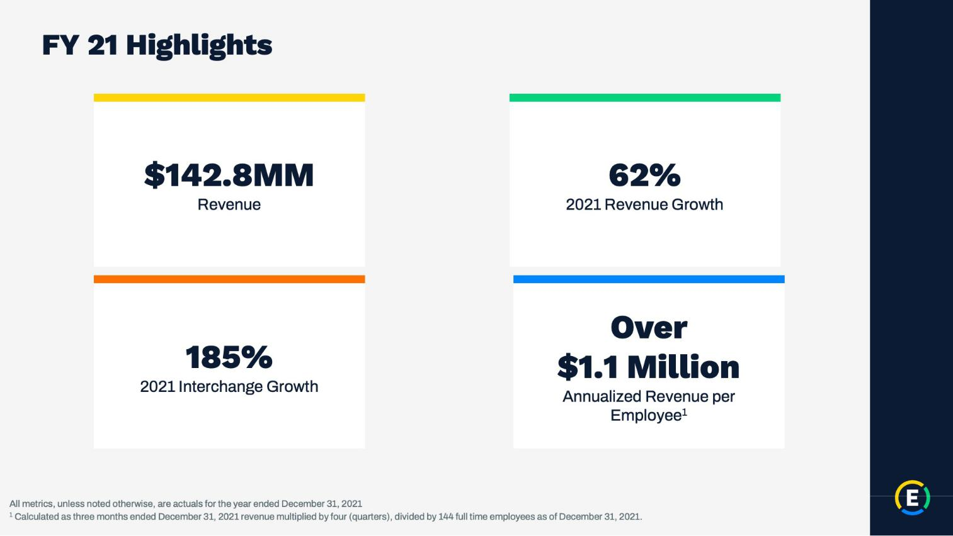

16

Exhibit 99.2

Expensify, Inc.

Investor Presentation
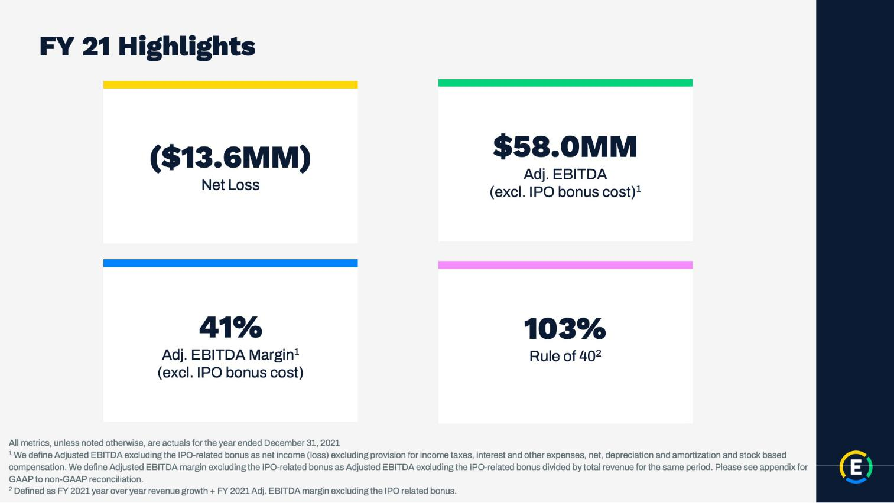

17

Exhibit 99.2

Expensify, Inc.

Investor Presentation


18

Exhibit 99.2

Expensify, Inc.

Investor Presentation
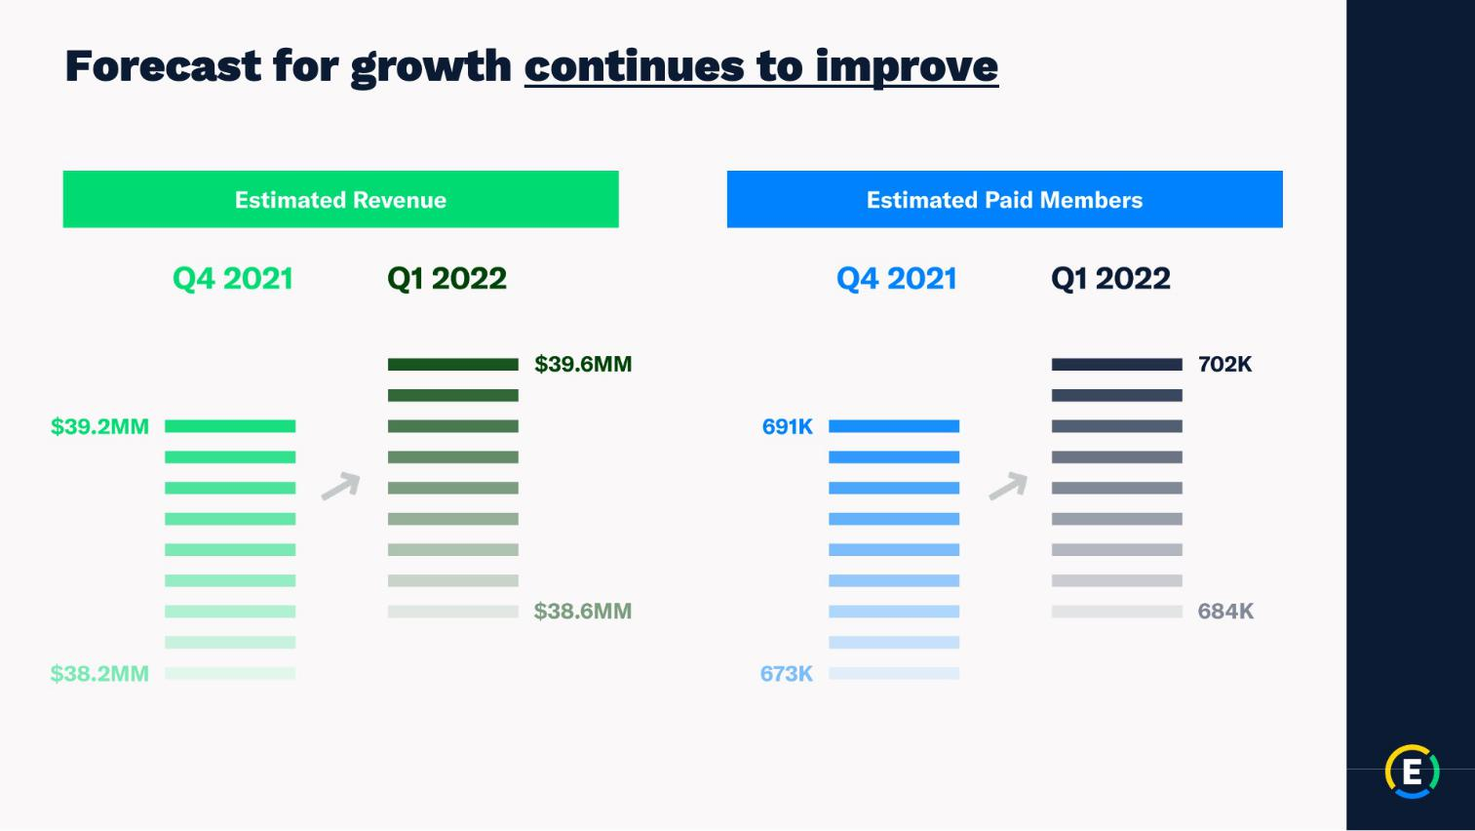

19

Exhibit 99.2

Expensify, Inc.

Investor Presentation


20

Exhibit 99.2

Expensify, Inc.

Investor Presentation
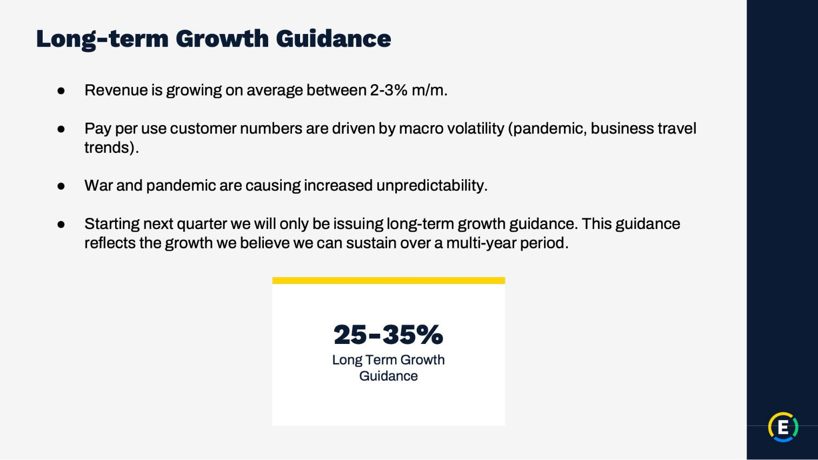

21

Exhibit 99.2

Expensify, Inc.

Investor Presentation


22

Exhibit 99.2

Expensify, Inc.

Investor Presentation


23

Exhibit 99.2

Expensify, Inc.

Investor Presentation


24

Exhibit 99.2

Expensify, Inc.

Investor Presentation
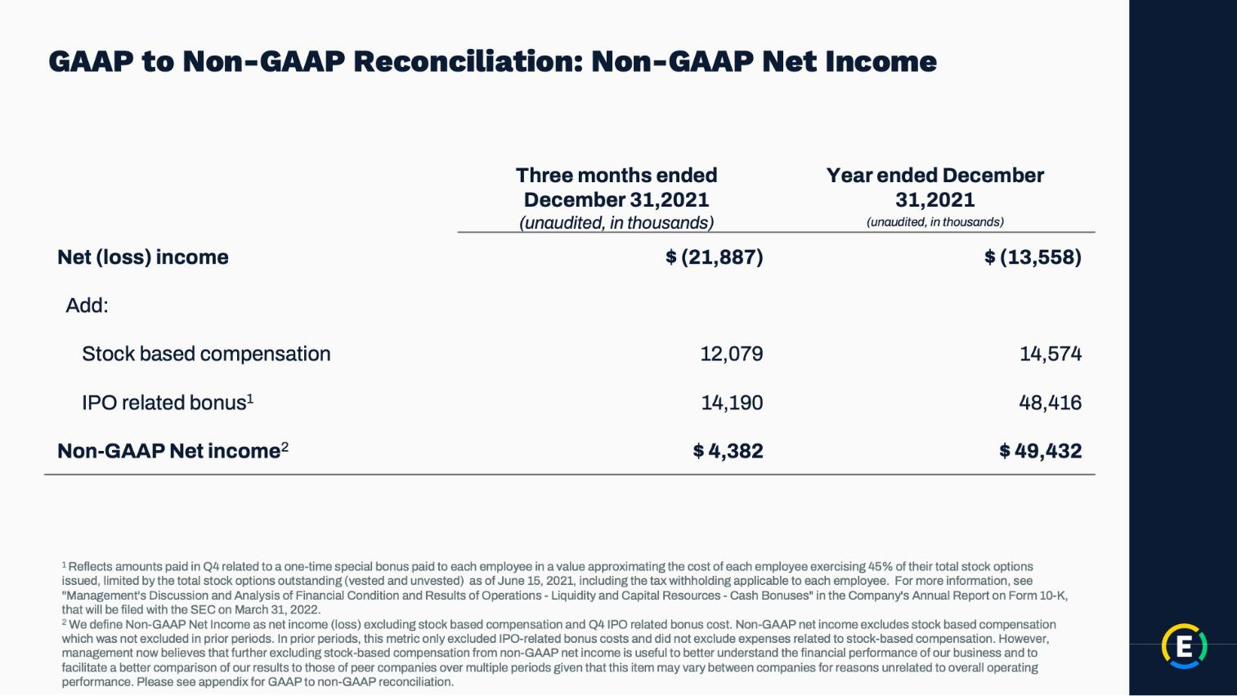

25

Exhibit 99.2

Expensify, Inc.

Investor Presentation
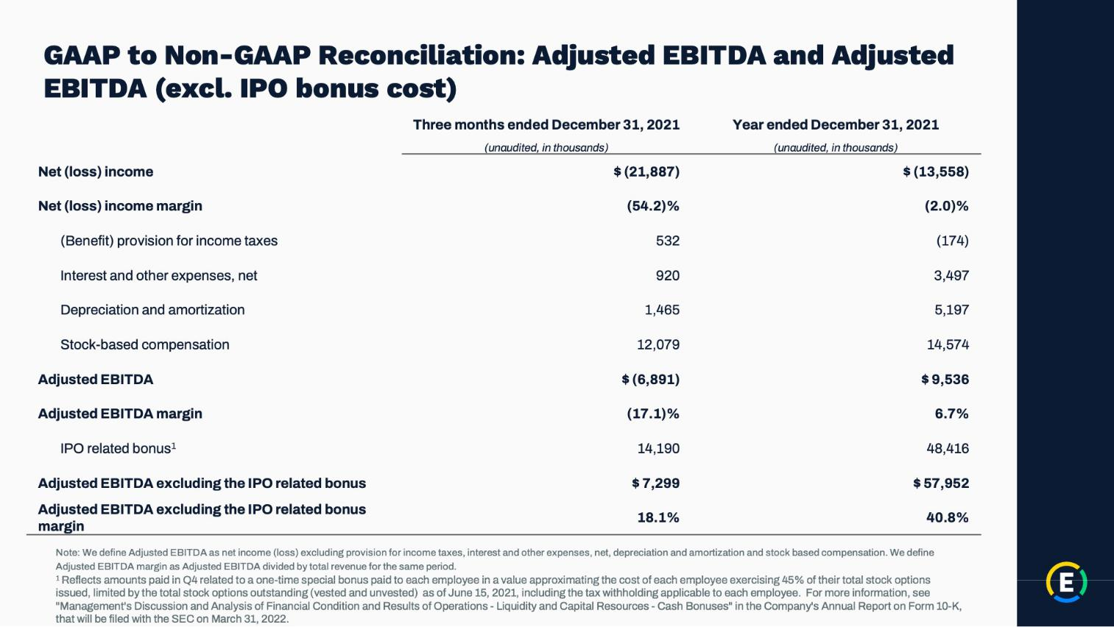

26

Exhibit 99.2

Expensify, Inc.

Investor Presentation

27

