UNITED STATES

SECURITIES AND EXCHANGE COMMISSION

Washington, D.C. 20549

FORM 8-K

CURRENT REPORT

PURSUANT TO SECTION 13 OR 15(d)

OF THE SECURITIES EXCHANGE ACT OF 1934

Date of report (Date of earliest event reported): December 16, 2021

Expensify, Inc.

(Exact Name of Registrant as Specified in its Charter)

Delaware | 001-41043 | 27-0239450
(State or Other Jurisdiction | (Commission | (IRS Employer
of Incorporation) | File Number) | Identification No.)
 | 401 SW 5th Ave
 | Portland, Oregon 97204
 | (Address of Principal Executive Offices) (Zip Code)
 | (971) 365-3939
 | (Registrant’s telephone number, including area code)
 | Not applicable
 | (Former Name or Former Address, if Changed Since Last Report)

Check the appropriate box below if the Form 8-K filing is intended to simultaneously satisfy the filing obligation of the registrant under any of the following provisions:

- Written communications pursuant to Rule 425 under the Securities Act (17 CFR 230.425).

- Soliciting material pursuant to Rule 14a-12 under the Exchange Act (17 CFR 240.14a-12).

- Pre-commencement communications pursuant to Rule 14d-2(b) under the Exchange Act (17 CFR 240.14d-2(b)).

- Pre-commencement communications pursuant to Rule 13e-4(c) under the Exchange Act (17 CFR 240.13e-4(c)).

Securities registered pursuant to Section 12(b) of the Act:

 |  | Trading |  | Name of each exchange
Title of each class |  | Symbols |  | on which registered
Class A Common Stock, par value $0.0001 per share |  | EXFY |  | The Nasdaq Stock Market LLC

Indicate by check mark whether the registrant is an emerging growth company as defined in Rule 405 of the Securities Act of 1933 (§230.405 of this chapter) or Rule 12b-2 of the Securities Exchange Act of 1934 (§240.12b-2 of this chapter).

Emerging growth company ☒

If an emerging growth company, indicate by check mark if the registrant has elected not to use the extended transition period for complying with any new or revised financial accounting standards provided pursuant to Section 13(a) of the Exchange Act. ☐

Item 2.02 Results of Operations and Financial Condition.

On December 16, 2021, Expensify, Inc. (“Expensify” or the “Company”) issued a press release announcing its financial results for the quarter ended September 30, 2021. A copy of this press release is furnished as Exhibit 99.1 to this current report on Form 8-K and is incorporated herein by reference.

Item 7.01 Regulation FD Disclosure.

On December 16, 2021, the Company posted an investor presentation to its website at https://ir.expensify.com (the “Investor Presentation”). A copy of the Investor Presentation is attached as Exhibit 99.2 to this current report on Form 8-K and is incorporated herein by reference. The Company expects to use the Investor Presentation, in whole or in part, and possibly with modifications, in connection with presentations to investors, analysts and others.

The information contained in the Investor Presentation is summary information that is intended to be considered in the context of the Company’s Securities and Exchange Commission (“SEC”) filings and other public announcements that the Company may make, by press release or otherwise, from time to time. The Investor Presentation speaks only as of the date of this current report on Form 8-K. The Company undertakes no duty or obligation to publicly update or revise the information included in the Investor Presentation, although it may do so from time to time. Any such updating may be made through the filing of other reports or documents with the SEC, through press releases or other public disclosure. In addition, the exhibit furnished herewith contains statements intended as “forward-looking statements” that are subject to the cautionary statements about forward-looking statements set forth in such exhibit. By furnishing the information contained in the Investor Presentation, the Company makes no admission as to the materiality of any information in the Investor Presentation that is required to be disclosed solely by reason of Regulation FD.

The information contained in Item 2.02 and this Item 7.01, including Exhibit 99.1 and 99.2, is being furnished and shall not be deemed “filed” for the purposed of Section 18 of the Securities and Exchange Act of 1934, as amended (the “Exchange Act”), or otherwise subject to the liabilities of that section, nor shall it be deemed incorporated by reference in any filing made by Expensify under the Securities Act of 1933, as amended, or the Exchange Act, except as expressly set forth by specific reference in such a filing.

Item 9.01 Financial Statements and Exhibits.

- Exhibits.

Exhibit No. Description

99.1 Press Release issued by Expensify, Inc., dated December 16, 2021.

99.2 Investor Presentation, dated December 16, 2021.

104 Cover Page Interactive Data File (embedded within the Inline XBRL document).

SIGNATURE

Pursuant to the requirements of the Securities Exchange Act of 1934, the registrant has duly caused this report to be signed on its behalf by the undersigned hereunto duly authorized.

Expensify, Inc.

By: | /s/ Ryan Schaffer
Name: | Ryan Schaffer
Title: | Chief Financial Officer

Date: December 16, 2021

Exhibit 99.1

Expensify Announces Third Quarter 2021 Results

Increased revenues 72.6% year-over-year, introduced Free Plan with unparalleled functionality, and announced up to 2% cash back on all Expensify Card spend

PORTLAND, Ore.–(BUSINESS WIRE)–Expensify, Inc. (Nasdaq: EXFY), a payments superapp that helps individuals and businesses around the world simplify the way they manage money across expenses, corporate cards and bills, today announced results for its quarter ended September 30, 2021.

“The biggest news coming out of Q3 was the launch of our Free Plan for SMBs. It offers all the basics of Expensify for free – including corporate cards with up to 2% cash back, reimbursements, bill pay, invoicing, and travel booking – so teams don't have to worry about their back office while they grow their business,” said David Barrett, founder and CEO of Expensify. “We're especially excited to watch our Free Plan spread naturally across organizations as a result of our viral, bottom-up business model and the immense greenfield opportunity that still remains in our target market.”

"We saw strong paid member growth in Q3 as SMBs continue to bounce back from the pandemic, business-wise," said Ryan Schaffer, CFO of Expensify. "Combine that with a 200% year-over-year increase in Expensify Card interchange and we're very confident in our ability to continue executing our long-term vision."

Third Quarter 2021 Highlights

Financial:

- Revenue was $37.4 million, an increase of 72.6% from the same period last year.

- An IPO-related bonus expense of $26.3 million impacted net (loss) income and Adjusted EBITDA.

- Net loss was $(6.3) million, compared to $(6.9) million for the same period last year. This was due to the IPO-related bonus.

  - However, Non-GAAP net income (excluding the IPO-related bonus) was $19.9 million.

- Adjusted EBITDA was $(6.5) million, compared to $7.4 million for the same period last year. The decrease was due to the IPO-related bonus.

  - Adjusted EBITDA excluding the IPO-related bonus was $19.8 million.

- Operating cash flows were $34.6 million.

Business:

- Paid members saw the biggest uptick in Q3 since the onset of the COVID-19 pandemic in March 2020. Average monthly paid members increased to 667 thousand, up from 639 thousand in the previous quarter. This is attributed to an increase in marketing spend and the strengthening of SMBs as lockdown restrictions were lifted.

- In September 2021, Expensify introduced the Free Plan, which allows members to roll out Expensify functionality across their businesses for free. The Expensify Card, expense management, next-day reimbursement, invoicing, bill pay, and travel booking are all included in the Free Plan.

- The Expensify Card continues to perform well. Interchange from the card increased by 207% from the same period last year.

- Cash back, a new Expensify Card benefit, launched in September 2021. Now, all Expensify members can get up to 2% cash back on all purchases using the Expensify Card.

Exhibit 99.1

- Expensify.org selected 62 grassroots organizations as winners of the Community Justice Grant Challenge. All 62 organizations will be reimbursed up to $5,000 each to help fight injustice in their communities. From those 62 organizations, 10 were selected by community vote to be reimbursed up to $25,000 each.

- In line with its continued commitment to ESG principles, Expensify reached carbon neutrality in 2021 and set a goal of Net Zero emissions by 2030.

Financial Outlook

Expensify's outlook statements are based on current expectations. The following statements are forward-looking and actual results could differ materially depending on market conditions and the factors set forth under “Forward-Looking Statements” below.

For the fiscal fourth quarter ending December 31, 2021, Expensify expects:

- Revenue between $38.2 million and $39.2 million.

- Average monthly paid members between 673 thousand and 691 thousand.

Availability of Information on Expensify’s Website

Investors and others should note that Expensify routinely announces material information to investors and the marketplace using SEC filings, press releases, public conference calls, webcasts and the Expensify Investor Relations website at https://ir.expensify.com. While not all of the information that the Company posts to its Investor Relations website is of a material nature, some information could be deemed to be material. Accordingly, the Company encourages investors, the media and others interested in Expensify to review the information that it shares on its Investor Relations website.

Conference Call

Expensify will host a video call to discuss the results at 2:00 p.m. Pacific Time today. The video call information is available on Expensify’s Investor Relations website at https://ir.expensify.com. A replay of the call will be available on the site for three months.

Non-GAAP Financial Measures

In addition to financial measures prepared in accordance with U.S. generally accepted accounting principles (“GAAP”), we provide certain non-GAAP financial measures, including Adjusted EBITDA, Adjusted EBITDA excluding the IPO-related bonus, and Non-GAAP net income.

We believe our non-GAAP financial measures are useful in evaluating our business, measuring our performance, identifying trends affecting our business, formulating business plans and making strategic decisions. Accordingly, we believe that these non-GAAP financial measures provide useful information to investors and others in understanding and evaluating our results of operations in the same manner as our management team. These non-GAAP financial measures are presented for supplemental informational purposes only, should not be considered a substitute for financial information presented in accordance with GAAP, and may be different from similarly titled metrics or measures presented by other companies. Non-GAAP financial measures have limitations as analytical tools and should not be considered in isolation or as substitutes for financial information presented under GAAP. There are a number of limitations related to the use of non-GAAP financial measures versus comparable financial measures determined under GAAP. For example, other companies in our industry may calculate these non-GAAP financial measures differently or may use other measures to evaluate their performance. All of these limitations could reduce the usefulness of these non-GAAP financial measures as analytical tools. Investors are encouraged to review the related GAAP financial measures and the reconciliations of these non-GAAP financial measures to their most directly comparable GAAP financial measures and to not rely on any single financial measure to evaluate our

Exhibit 99.1

business. A reconciliation of each non-GAAP financial measure to the most directly comparable financial measure stated in accordance with GAAP is at the end of this press release.

We define Adjusted EBITDA as net income from operations excluding provision for income taxes, interest and other expenses, net, depreciation and amortization and stock based compensation.

We define Adjusted EBITDA excluding the IPO-related bonus as net income from operations excluding provision for income taxes, interest and other expenses, net, depreciation and amortization, stock based compensation, and IPO-related bonus costs.

We define Non-GAAP net income as GAAP net income excluding the IPO-related bonus costs.

The tables at the end of the Financial Statements provide reconciliations to the most directly comparable GAAP financial measure to each of these non-GAAP financial measures.

Forward-Looking Statements

Forward-looking statements in this press release, which are not historical facts, are forward-looking statements within the meaning of the Private Securities Litigation Reform Act of 1955. These statements include statements regarding our strategy, future financial condition, future operations, projected costs, prospects, plans, objectives of management and expected market growth and involve known and unknown risks that are difficult to predict. As a result, our actual results, performance or achievements may differ materially from those expressed or implied by these forward-looking statements. In some cases, you can identify forward-looking statements because they contain words such as “may,” “will,” “shall,” “should,” “expects,” “plans,” “anticipates,” “could,” “intends,” “target,” “projects,” “contemplates,” “believes,” “estimates,” “predicts,” “potential,” “goal,” “objective,” “seeks,” or “continue” or the negative of these words or other similar terms or expressions that concern our expectations, strategy, plans, or intentions. Such forward-looking statements are necessarily based upon estimates and assumptions that, while considered reasonable by us and our management, are inherently uncertain. Factors that may cause actual results to differ materially from current expectations include, but are not limited to: the effects of the COVID-19 pandemic and the end of the COVID-19 pandemic on our business, results of operations and financial condition, and the global economy generally; our expectations regarding our financial performance and future operating performance; our ability to attract and retain members, expand usage of our platform, sell subscriptions to our platform and convert individuals and organizations into paying customers; the timing and success of new features, integrations, capabilities and enhancements by us, or by competitors to their products, or any other changes in the competitive landscape of our market; the amount and timing of operating expenses and capital expenditures that we may incur to maintain and expand our business and operations to remain competitive; the sufficiency of our cash, cash equivalents and investments to meet our liquidity needs; our ability to make required payments under and to comply with the various requirements of our current and future indebtedness; our ability to effectively manage our exposure to fluctuations in foreign currency exchange rates; the increased expenses associated with being a public company; the size of our addressable markets, market share and market trends; anticipated trends, developments and challenges in our industry, business and the highly competitive markets in which we operate; our expectations regarding our income tax liabilities and the adequacy of our reserves; our ability to effectively manage our growth and expand our infrastructure and maintain our corporate culture; our ability to identify, recruit and retain skilled personnel, including key members of senior management; the safety, affordability and convenience of our platform and our offerings; our ability to successfully defend litigation brought against us; our ability to successfully identify, manage and integrate any existing and potential acquisitions of businesses, talent, technologies or intellectual property; general economic conditions in either domestic or international markets, including the societal and economic impact of the COVID-19 pandemic, and geopolitical uncertainty and instability; our protections against security breaches, technical difficulties, or interruptions to our platform; our ability to maintain, protect and enhance our intellectual property; and other risks discussed in our filings with the SEC. All forward-looking statements attributable to us or persons acting on our behalf are expressly qualified in their entirety by the cautionary statements set forth above. We caution you not to place undue reliance on any forward-looking

Exhibit 99.1

statements, which are made only as of the date of this press release. We do not undertake or assume any obligation to update publicly any of these forward-looking statements to reflect actual results, new information or future events, changes in assumptions or changes in other factors affecting forward-looking statements, except to the extent required by applicable law. If we update one or more forward-looking statements, no inference should be drawn that we will make additional updates with respect to those or other forward-looking statements.

About Expensify

Expensify is a payments superapp that helps individuals and businesses around the world simplify the way they manage money. More than 10 million people use Expensify's free features, which include corporate cards, expense tracking, next-day reimbursement, invoicing, bill pay, and travel booking in one app. All free. Whether you own a small business, manage a team, or close the books for your clients, Expensify makes it easy so you have more time to focus on what really matters.

Investor Relations Contact

Nick Tooker

investors@expensify.com

Press Contact

James Dean

press@expensify.com

Exhibit 99.1

Expensify, Inc.

Consolidated Balance Sheets

(unaudited, in thousands, except share and per share data)

As of September 30,

2021

As of December 31,

2020

Assets
Cash and cash equivalents | $ | 68,058 |  | $ | 34,401
Accounts receivable, net |  | 13,608 |  |  | 10,024
Settlement assets |  | 25,107 |  |  | 14,308
Prepaid expenses |  | 3,813 |  |  | 927
Related party loan receivable, current |  | 824 |  |  | 600
Other current assets |  | 11,817 |  |  | 3,404
Total current assets |  | 123,227 |  |  | 63,664
Capitalized software, net |  | 6,607 |  |  | 3,722
Property and equipment, net |  | 16,335 |  |  | 15,363
Lease right-of-use assets |  | 2,588 |  |  | 3,733
Deferred tax assets, net |  | 418 |  |  | 418
Related party loan receivable, non-current |  | — |  |  | —
Other assets |  | 712 |  |  | 833
Total assets | $ | 149,887 |  | $ | 87,733
Liabilities, convertible preferred stock and stockholders' deficit
Accounts payable | $ | 1,998 |  | $ | 2,328
Accrued expenses and other liabilities |  | 23,200 |  |  | 3,535
Borrowings under line of credit |  | 15,000 |  |  | 15,000
Current portion of long-term debt, net of issuance costs |  | 547 |  |  | 2,454
Lease liabilities, current |  | 1,540 |  |  | 1,575
Settlement liabilities |  | 25,007 |  |  | 14,308
Total current liabilities |  | 67,292 |  |  | 39,200
Lease liabilities, non-current |  | 1,192 |  |  | 2,350
Deferred tax liabilities, net |  | 916 |  |  | 916
Other liabilities |  | 405 |  |  | 877
Long-term debt, net of issuance costs |  | 52,093 |  |  | 30,321
Total liabilities |  | 121,898 |  |  | 73,664
Commitments and contingencies (Note 12)
Convertible preferred stock, par value $0.0001; 4,203,139 shares authorized, issued and outstanding at September 30, 2021 and
December 31, 2020 (aggregate liquidation preference of $24,929,457 at September 30, 2021 and December 31, 2020 |  | 45,105 |  |  | 45,105
Stockholders' deficit:
Common stock, par value $0.0001; 95,000,000 shares authorized: 36,240,800 and 29,366,940 shares issued and outstanding at
September 30, 2021 and December 31, 2020 respectively |  | — |  |  | —
Additional paid-in capital |  | 27,416 |  |  | 21,312
Subscriptions receivable (including accrued interest of $0) |  | (513) |  |  | —
Accumulated deficit |  | (44,019) |  |  | (52,348)
Total stockholders' deficit |  | (17,116) |  |  | (31,036)
Total liabilities, convertible preferred stock and stockholders' deficit | $ | 149,887 |  | $ | 87,733

Exhibit 99.1

Expensify, Inc.

Consolidated Statements of Income

(unaudited, in thousands, except share and per share data)

Three months ended September 30,

2021 2020

Nine months ended September 30,

2021 2020

Revenue | $ | 37,447 |  | $ | 21,694 |  | $ | 102,471 |  | $ | 62,335
Cost of revenue, net |  | 18,197 |  |  | 8,443 |  |  | 33,768 |  |  | 23,881
Gross margin |  | 19,250 |  |  | 13,251 |  |  | 68,703 |  |  | 38,454
Operating expenses:
Research and development |  | 2,167 |  |  | 2,268 |  |  | 8,138 |  |  | 4,645
General and administrative |  | 18,333 |  |  | 14,579 |  |  | 35,827 |  |  | 24,717
Sales and marketing |  | 7,608 |  |  | 1,491 |  |  | 14,555 |  |  | 7,814
Total operating expenses |  | 28,108 |  |  | 18,338 |  |  | 58,520 |  |  | 37,176
(Loss) income from operations |  | (8,858) |  |  | (5,087) |  |  | 10,183 |  |  | 1,278
Interest and other expenses, net |  | (1,054) |  |  | (646) |  |  | (2,560) |  |  | (2,160)
(Loss) income before income taxes |  | (9,912) |  |  | (5,733) |  |  | 7,623 |  |  | (882)
Benefit (provision) for income taxes |  | 3,567 |  |  | (1,205) |  |  | 706 |  |  | (2,570)
Net (loss) income | $ | (6,345) |  | $ | (6,938) |  | $ | 8,329 |  | $ | (3,452)
Less: income allocated to participating securities |  | — |  |  | — |  |  | (5,625) |  |  | —
Net (loss) income attributable to common stockholders | $ | (6,345) |  | $ | (6,938) |  | $ | 2,704 |  | $ | (3,452)
Net (loss) income per share attributable to common stockholders:
Basic | $ | (0.18) |  | $ | (0.25) |  | $ | 0.09 |  | $ | (0.13)
Diluted | $ | (0.18) |  | $ | (0.25) |  | $ | 0.07 |  | $ | (0.13)
Weighted-average shares of common stock used to compute net (loss)
income per share attributable to common stockholders:
Basic |  | 34,490,860 |  |  | 27,951,536 |  |  | 31,301,387 |  |  | 27,095,925
Diluted |  | 34,490,860 |  |  | 27,951,536 |  |  | 41,452,880 |  |  | 27,095,925

Exhibit 99.1

Expensify, Inc.

Consolidated Statements of Cash Flows

(unaudited, in thousands)

 |  | Nine months ended September 30,
 | 2021 |  |  |  | 2020
Cash flows from operating activities:
Net income (loss) | $ | 8,329 |  | $ | (3,452)
Adjustments to reconcile net income (loss) to net cash provided (used) by operating activities:
Depreciation and amortization |  | 3,732 |  |  | 2,353
Reduction of operating lease right-of-use assets |  | 552 |  |  | 1,120
Loss on impairment, receivables and sale or disposal of equipment |  | 283 |  |  | 91
Stock-based compensation |  | 2,495 |  |  | 12,951
Amortization of debt issuance costs |  | 23 |  |  | 24
Deferred tax assets |  | — |  |  | 2,304
Changes in assets and liabilities:
Accounts receivable |  | (3,865) |  |  | (229)
Related party loan receivables |  | (224) |  |  | —
Settlement assets |  | (3,344) |  |  | 312
Prepaid expenses |  | (2,886) |  |  | (291)
Other current assets |  | 1,212 |  |  | (934)
Other assets |  | 120 |  |  | (287)
Accounts payable |  | (330) |  |  | (1,563)
Accrued expenses and other liabilities |  | 18,870 |  |  | 162
Operating lease liabilities |  | (614) |  |  | (1,179)
Settlement liabilities |  | 10,699 |  |  | (16,084)
Other liabilities |  | (472) |  |  | 310
Net cash provided (used) by operating activities |  | 34,580 |  |  | (4,392)
Cash flows from investing activities:
Purchase of property and equipment |  | (2,602) |  |  | (1,857)
Software development costs |  | (4,397) |  |  | (1,051)
Net cash used by investing activities |  | (6,999) |  |  | (2,908)
Cash flows from financing activities:
Principal payments of finance leases |  | (579) |  |  | (617)
Principal payments of term loan |  | (25,157) |  |  | (92)
Principal payments of line of credit |  | — |  |  | (1,000)
Proceeds from line of credit |  | — |  |  | 9,613
Proceeds from term loan |  | 45,000 |  |  | —
Payments of deferred offering costs |  | (4,796) |  |  | —
Vesting of restricted common stock |  | 234 |  |  | —
Proceeds from issuance of common stock on exercise of stock options |  | 2,862 |  |  | 559
Net cash provided by financing activities |  | 17,564 |  |  | 8,463
Net increase in cash and cash equivalents |  | 45,145 |  |  | 1,163
Cash and cash equivalents and restricted cash, beginning of period |  | 46,878 |  |  | 34,801
Cash and cash equivalents and restricted cash, end of period | $ | 92,023 |  | $ | 35,964
Supplemental disclosure of cash flow information:
Cash paid for interest | $ | 2,182 |  | $ | 2,186
Cash paid for income taxes | $ | 6,910 |  | $ | 101
Noncash investing and financing items:
Right-of-use assets acquired with lease liabilities | $ | — |  | $ | 1,260
Accrued deferred offering costs | $ | 795 |  | $ | —
Reconciliation of cash, cash equivalents and restricted cash to the consolidated balance sheets
Cash and cash equivalents | $ | 68,058 |  | $ | 25,881
Restricted cash included in other current assets |  | 5,989 |  |  | 1,666
Restricted cash included in other assets |  | 47 |  |  | 45
Restricted cash included in settlement assets |  | 17,929 |  |  | 8,372
Total cash, cash equivalents and restricted cash | $ | 92,023 |  | $ | 35,964

Exhibit 99.1

Expensify, Inc.

Reconciliation of GAAP to Non-GAAP Financial Measures

(unaudited, in thousands)

Adjusted EBITDA

 | Three months ended September 30,
 | 2021 |  |  | 2020
Net (loss) income | $ | (6,345) |  | $ | (6,938)
Add:
(Benefit) provision for income taxes |  | (3,567) |  |  | 1,205
Interest and other expenses, net |  | 1,054 |  |  | 646
Depreciation and amortization |  | 1,438 |  |  | 744
Stock-based compensation |  | 897 |  |  | 11,765
Adjusted EBITDA | $ | (6,523) |  | $ | 7,422
Adjusted EBITDA Excluding the IPO-Related Bonus
 | Three months ended September 30,
 | 2021 |  |  | 2020
Net (loss) income | $ | (6,345) |  | $ | (6,938)
Add:
(Benefit) provision for income taxes |  | (3,567) |  |  | 1,205
Interest and other expenses, net |  | 1,054 |  |  | 646
Depreciation and amortization |  | 1,438 |  |  | 744
Stock-based compensation |  | 897 |  |  | 11,765
IPO Related Bonuses |  | 26,287 |  |  | —
Adjusted EBITDA Excluding the IPO-Related Bonus | $ | 19,764 |  | $ | 7,422
Non-GAAP Net Income
 | Three months ended September 30,
 | 2021 |  |  | 2020
Net (loss) income | $ | (6,345) |  | $ | (6,938)
Add:
IPO Related Bonuses |  | 26,287 |  |  | —
Non-GAAP Net (loss) income | $ | 19,942 |  | $ | (6,938)

Exhibit 99.2

Expensify, Inc.

Investor Presentation


Exhibit 99.2

Expensify, Inc.

Investor Presentation
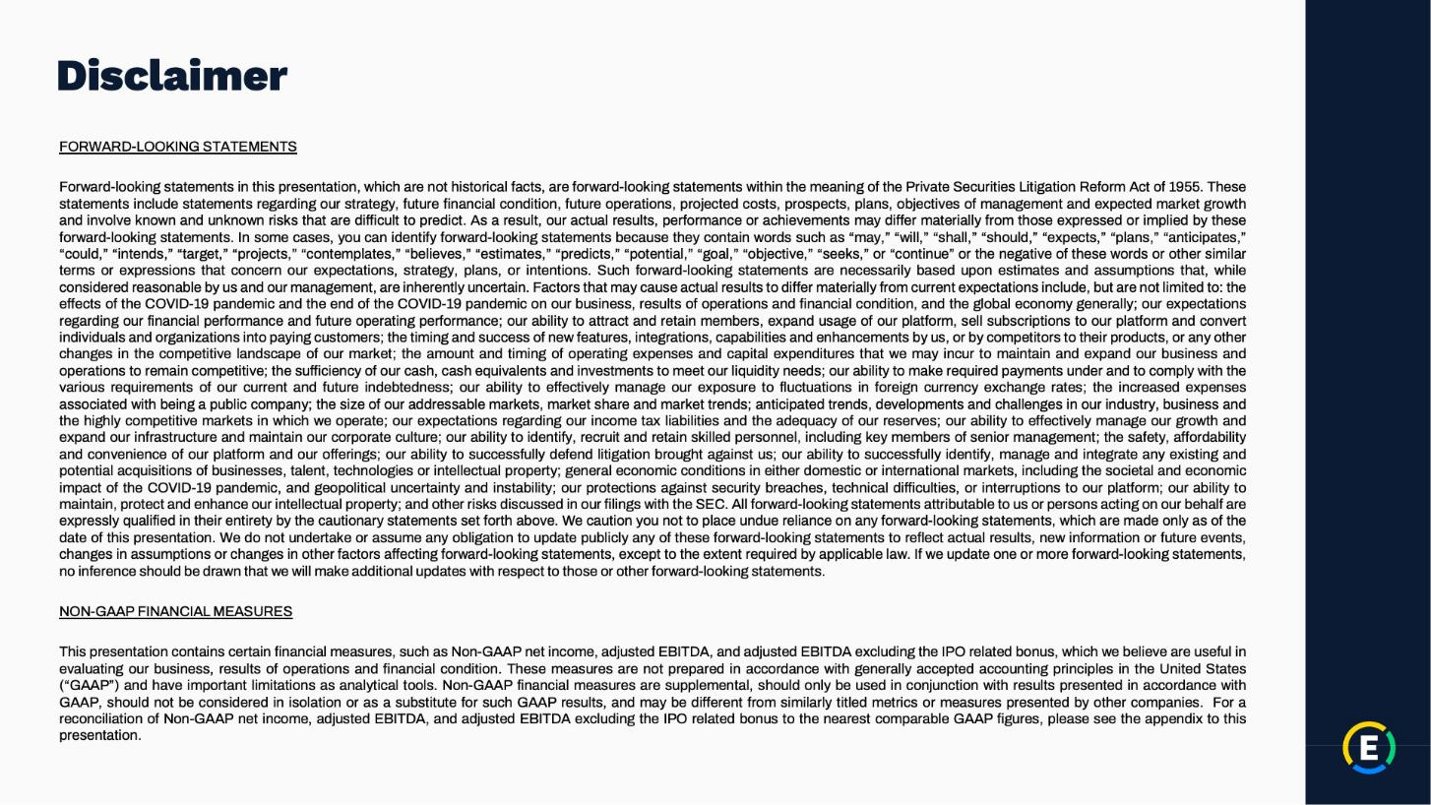

Exhibit 99.2

Expensify, Inc.

Investor Presentation
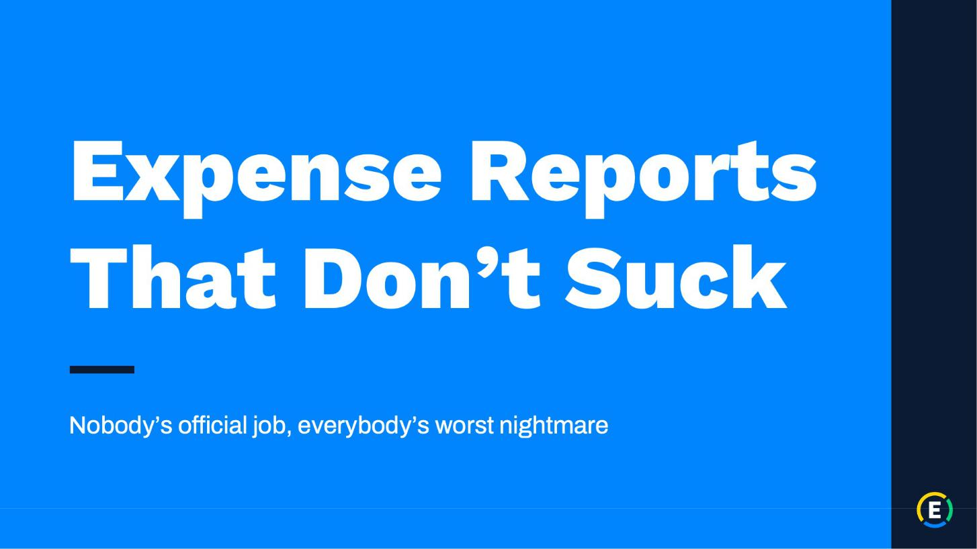

Exhibit 99.2

Expensify, Inc.

Investor Presentation
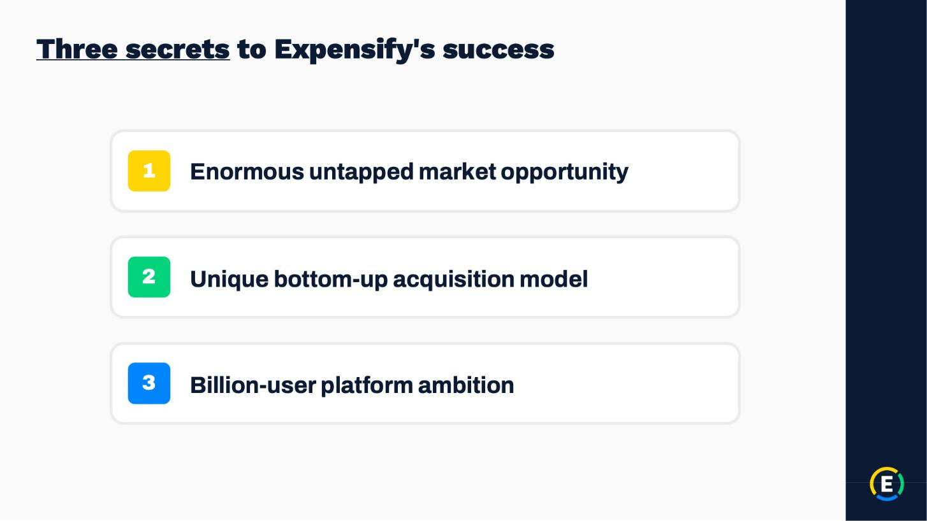

Exhibit 99.2

Expensify, Inc.

Investor Presentation
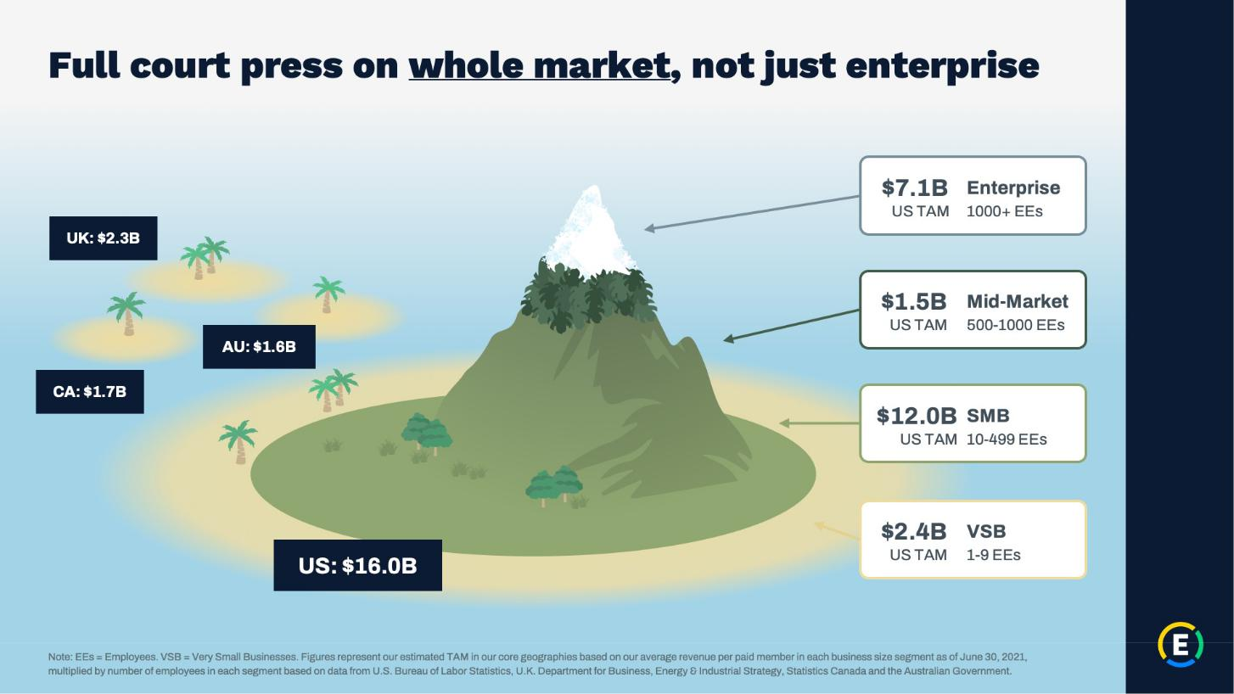

Exhibit 99.2

Expensify, Inc.

Investor Presentation
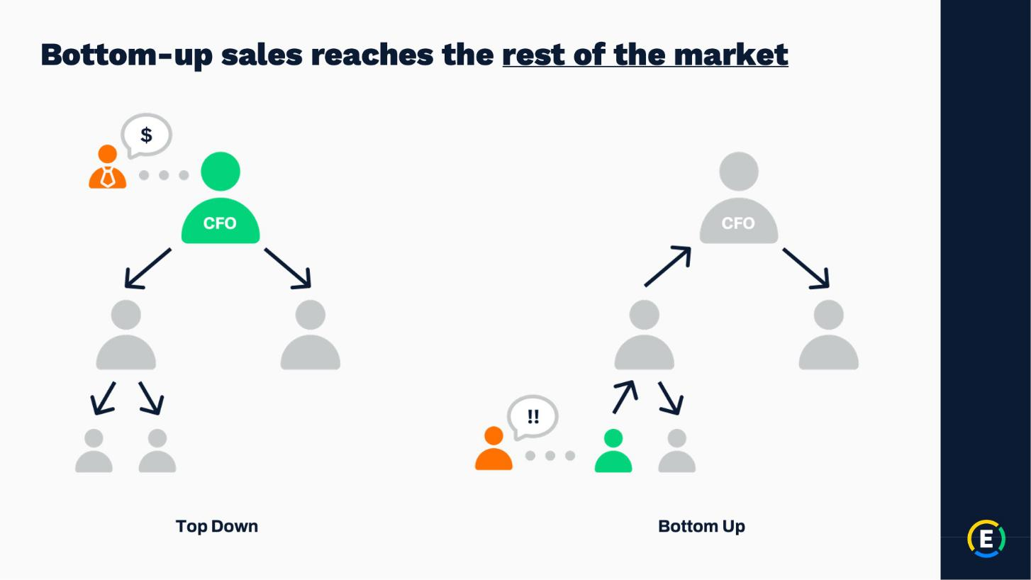

Exhibit 99.2

Expensify, Inc.

Investor Presentation
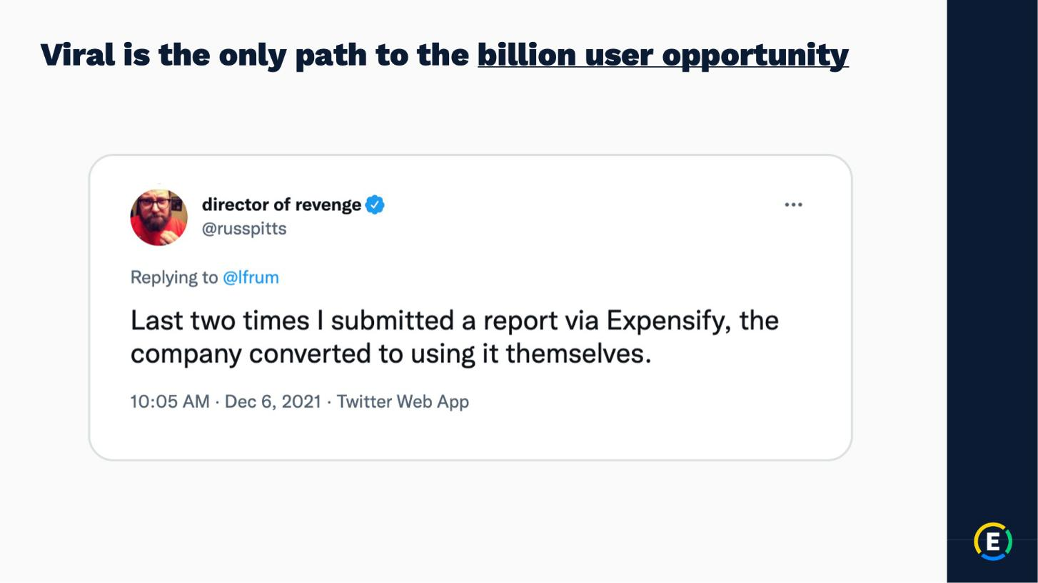

Exhibit 99.2

Expensify, Inc.

Investor Presentation
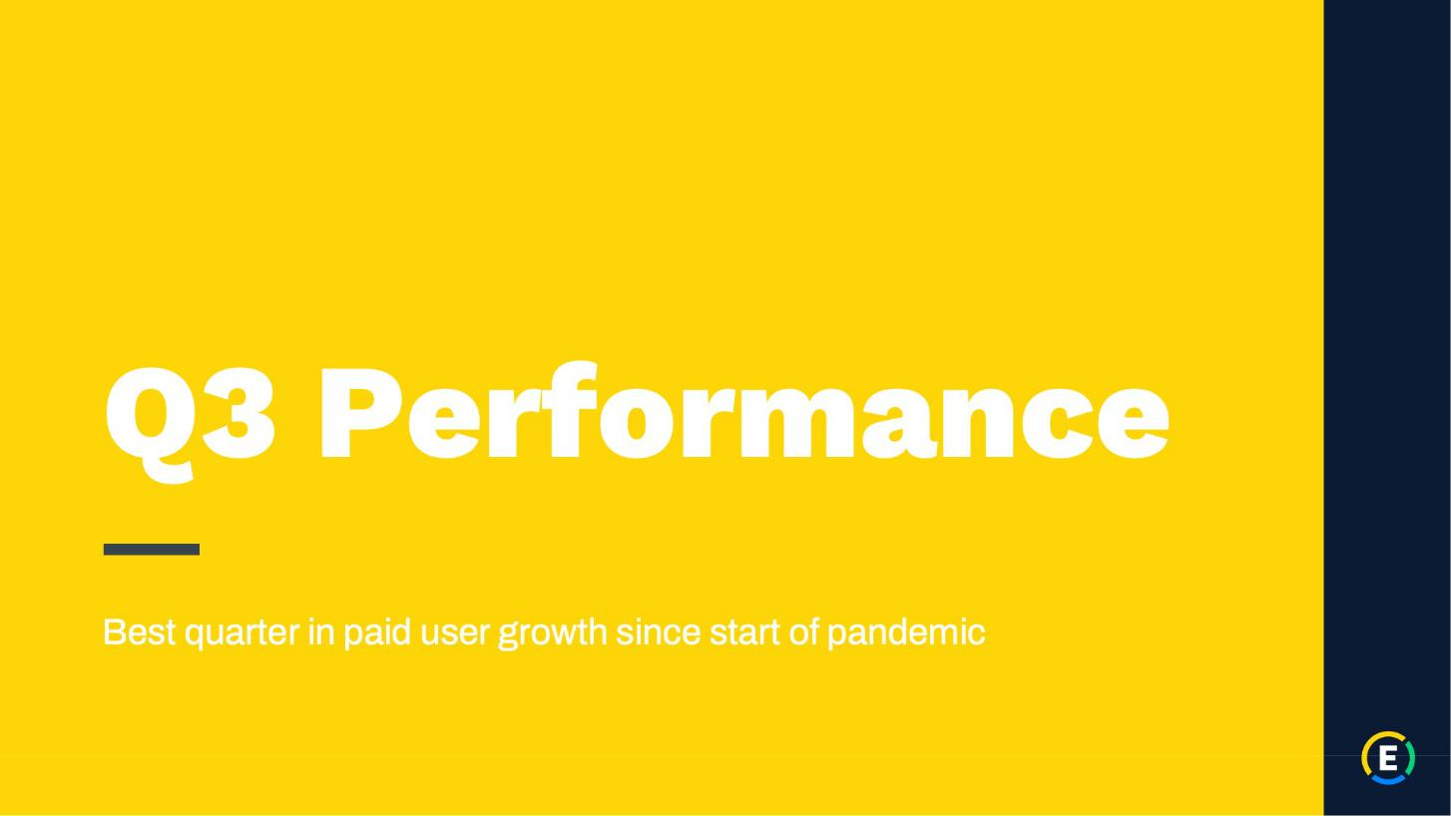

Exhibit 99.2

Expensify, Inc.

Investor Presentation
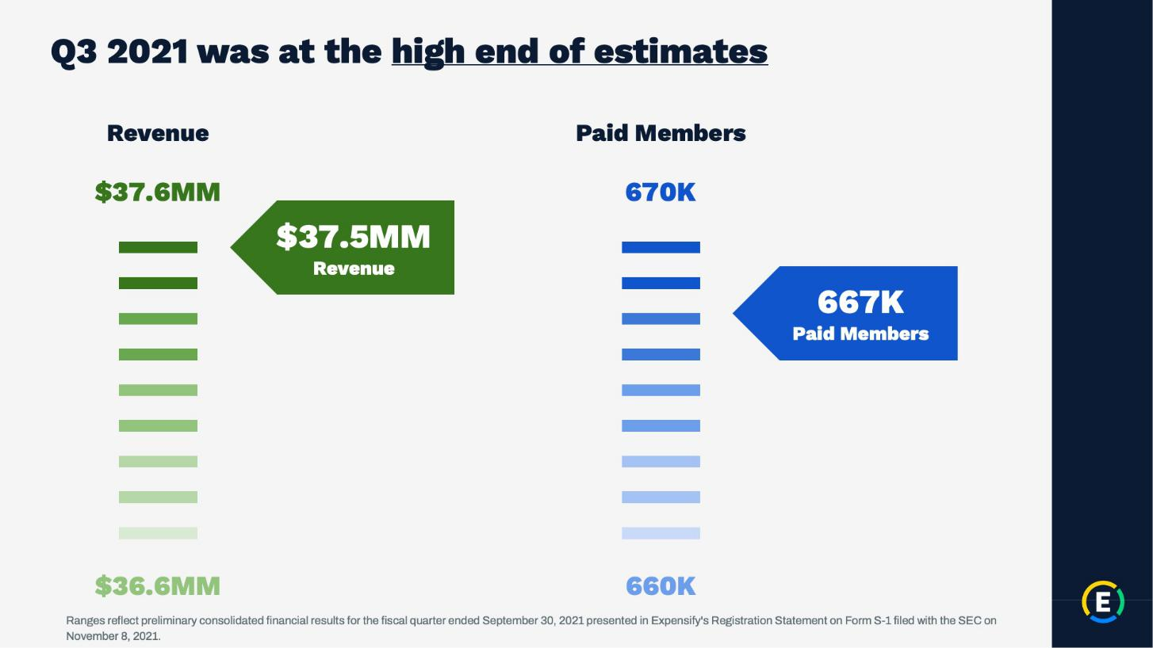

Exhibit 99.2

Expensify, Inc.

Investor Presentation
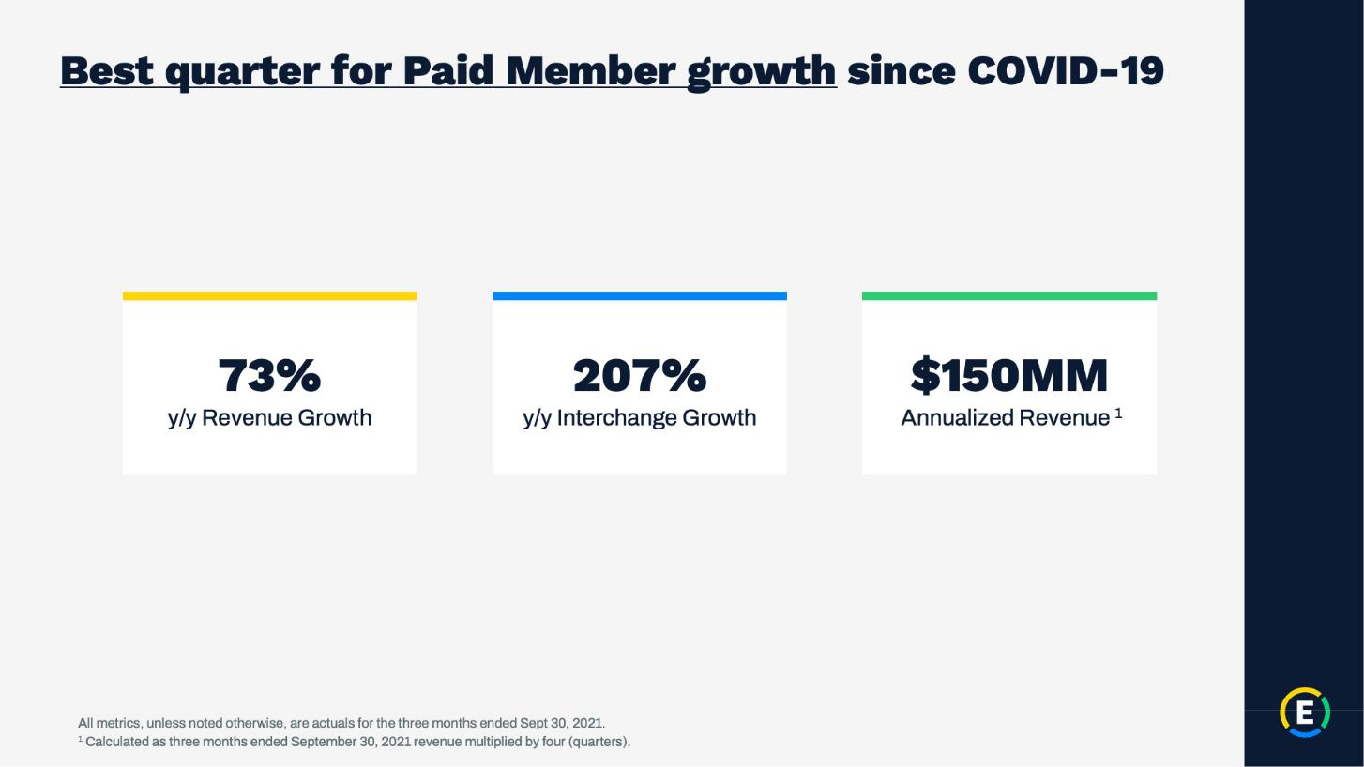

Exhibit 99.2

Expensify, Inc.

Investor Presentation
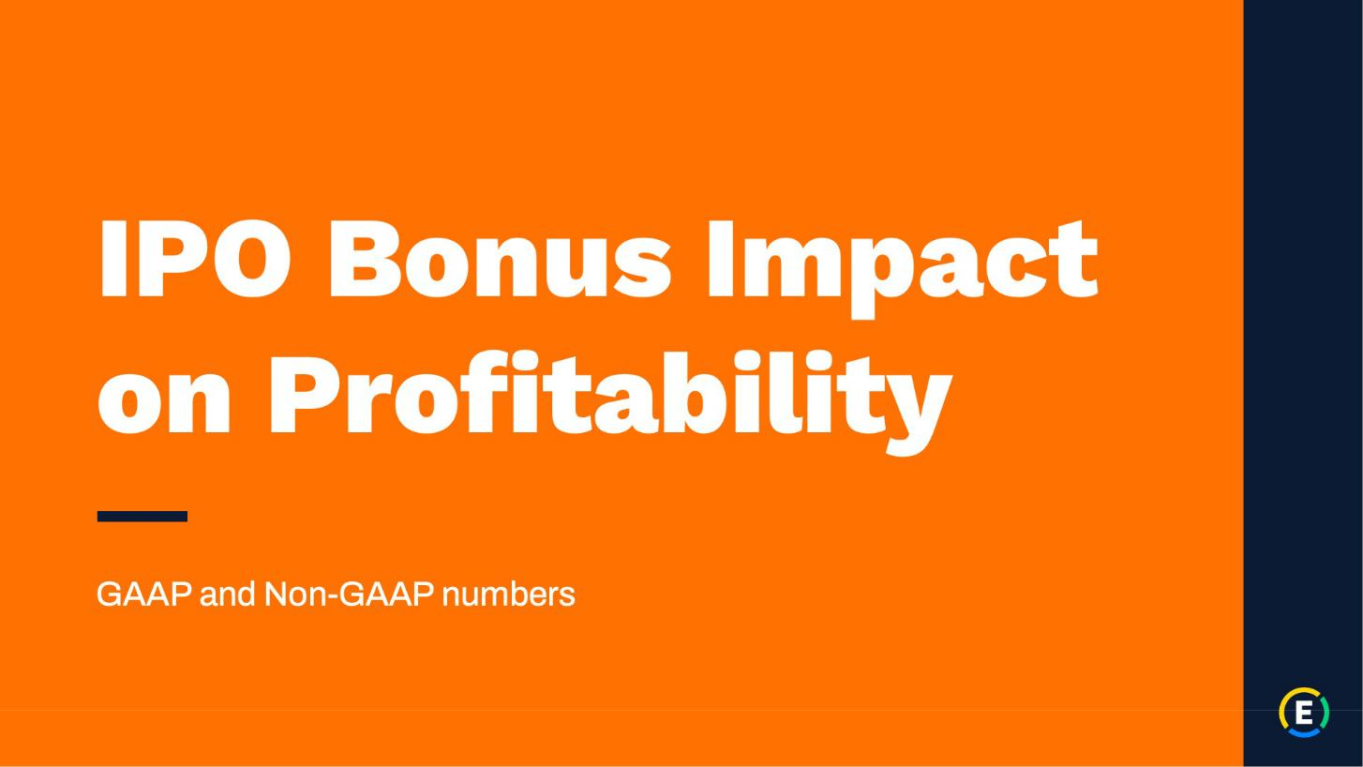

Exhibit 99.2

Expensify, Inc.

Investor Presentation
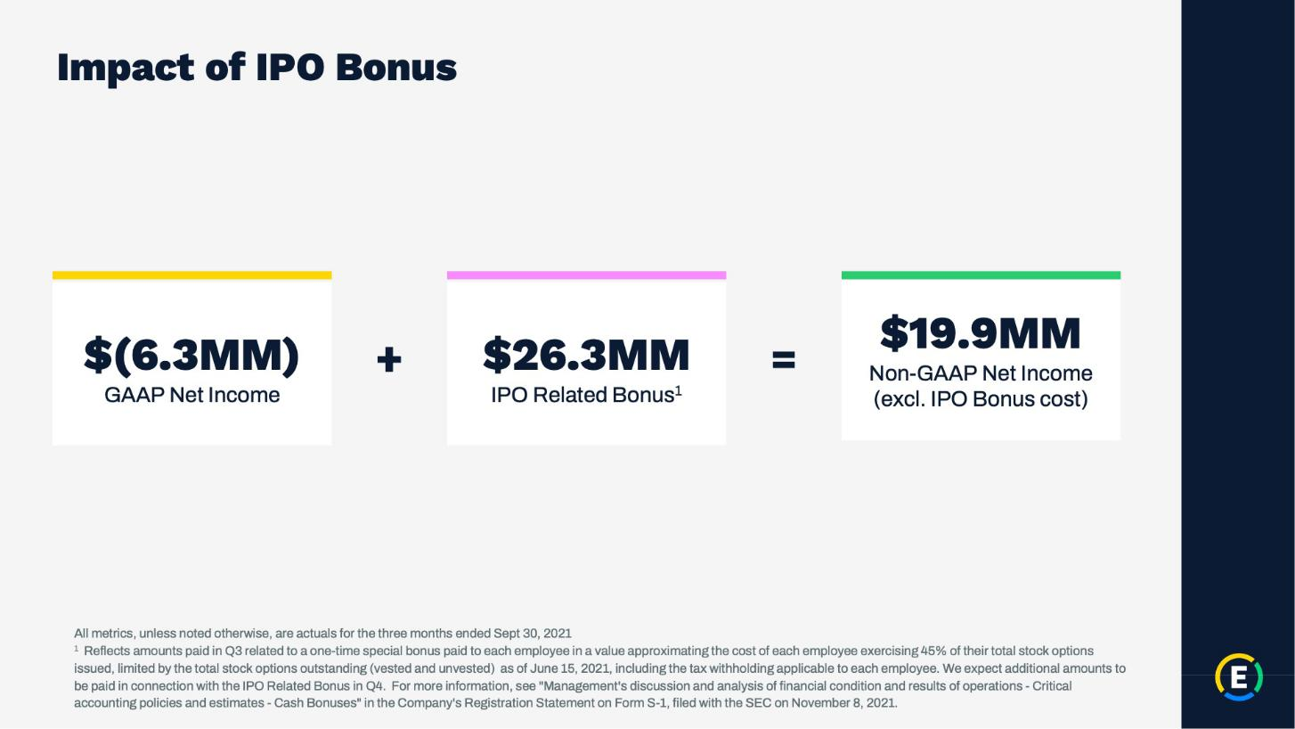

Exhibit 99.2

Expensify, Inc.

Investor Presentation
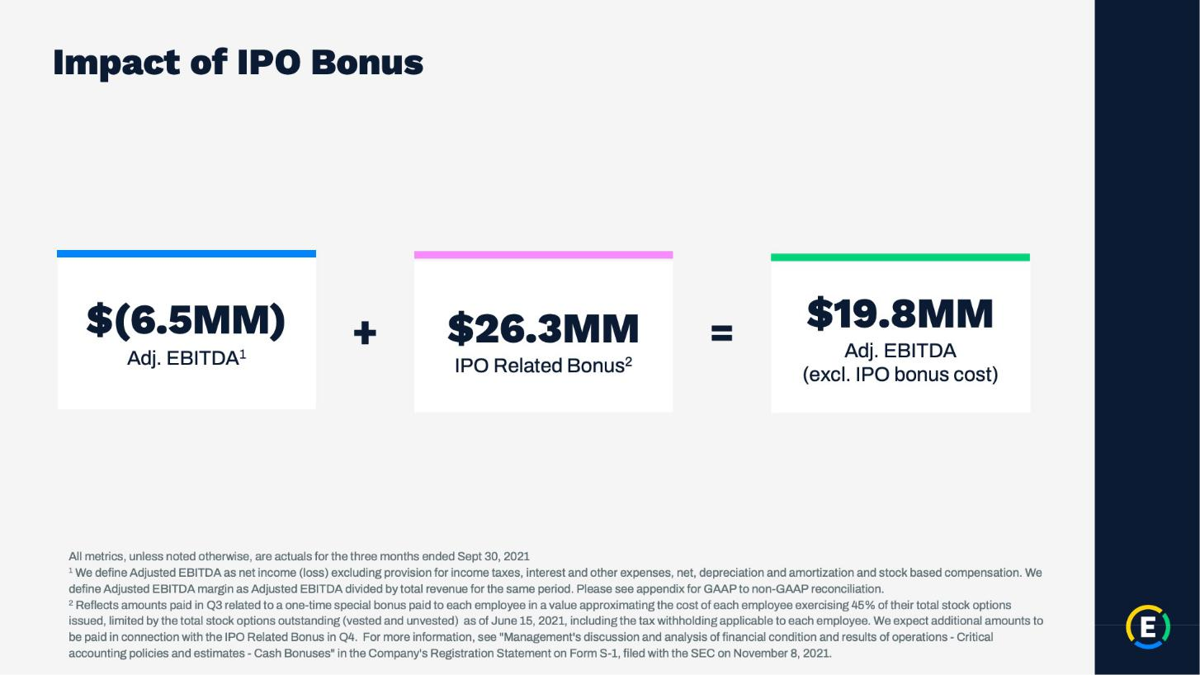

Exhibit 99.2

Expensify, Inc.

Investor Presentation
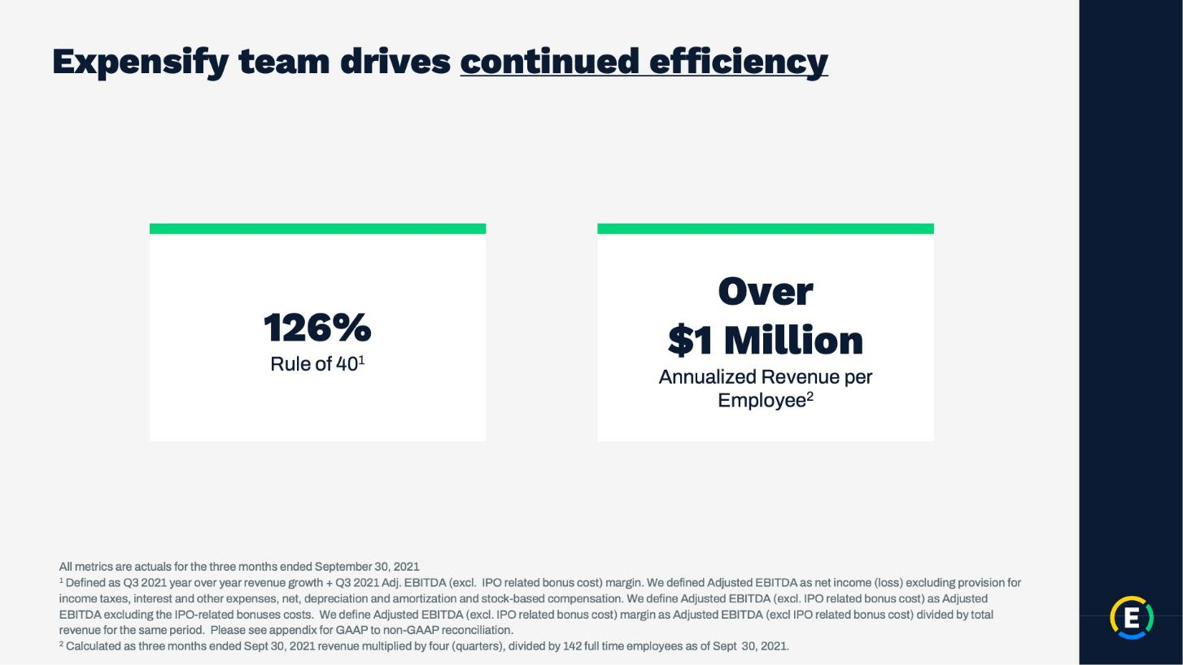

Exhibit 99.2

Expensify, Inc.

Investor Presentation

Exhibit 99.2

Expensify, Inc.

Investor Presentation
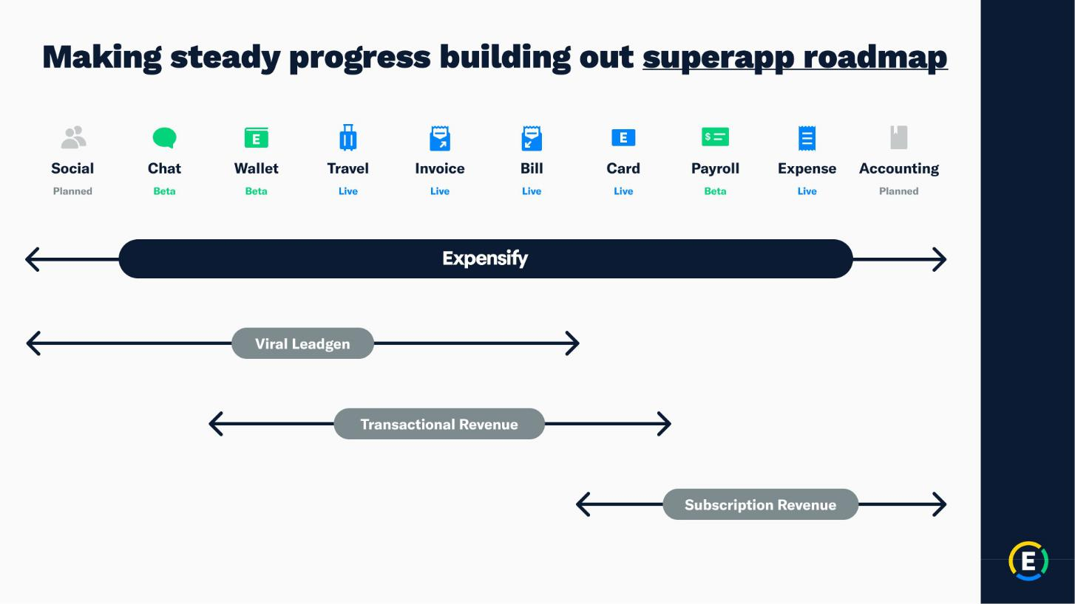

Exhibit 99.2

Expensify, Inc.

Investor Presentation
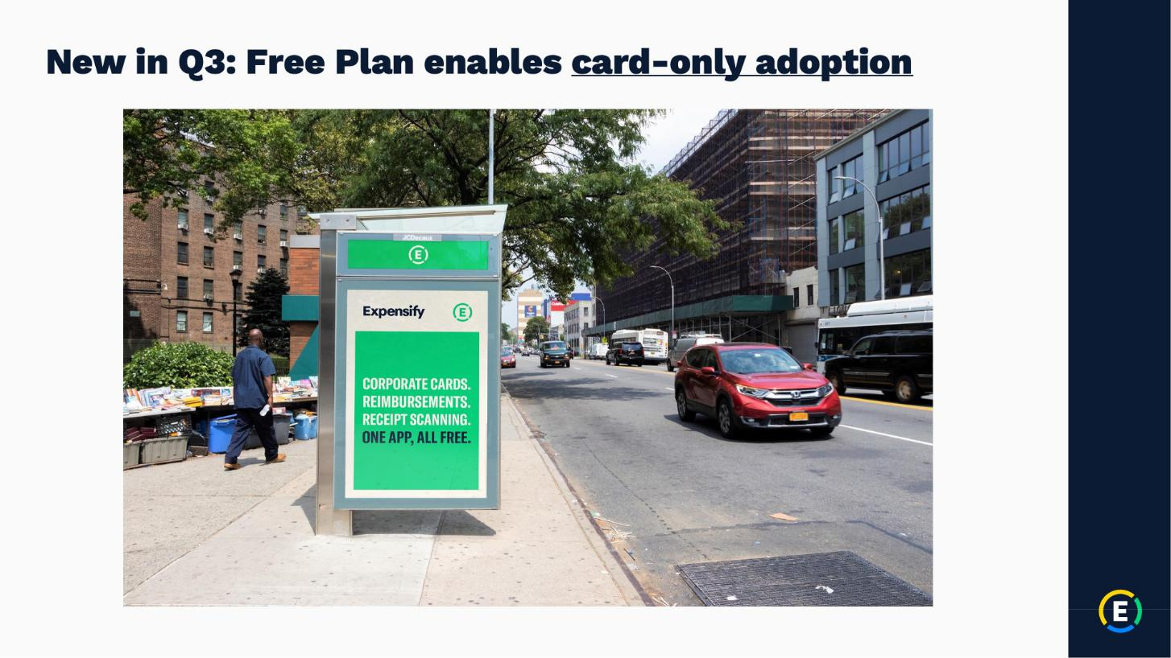

Exhibit 99.2

Expensify, Inc.

Investor Presentation
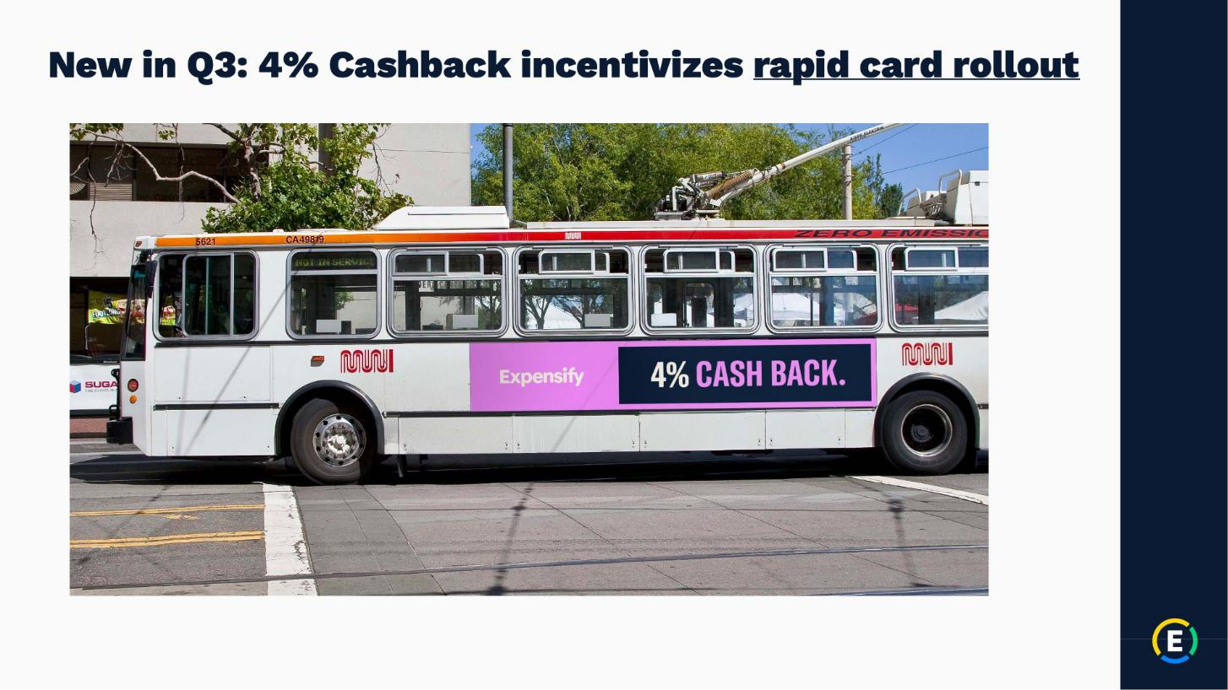

Exhibit 99.2

Expensify, Inc.

Investor Presentation


Exhibit 99.2

Expensify, Inc.

Investor Presentation
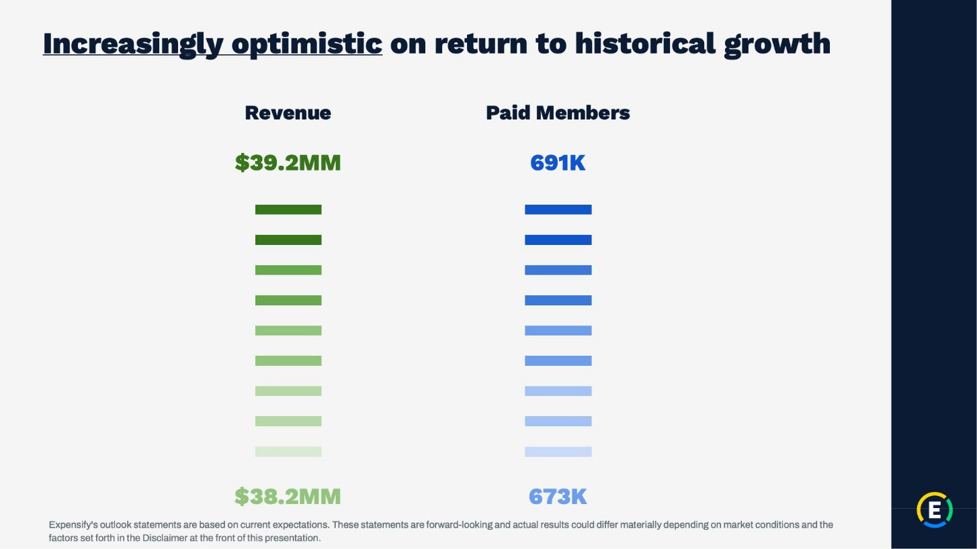

Exhibit 99.2

Expensify, Inc.

Investor Presentation
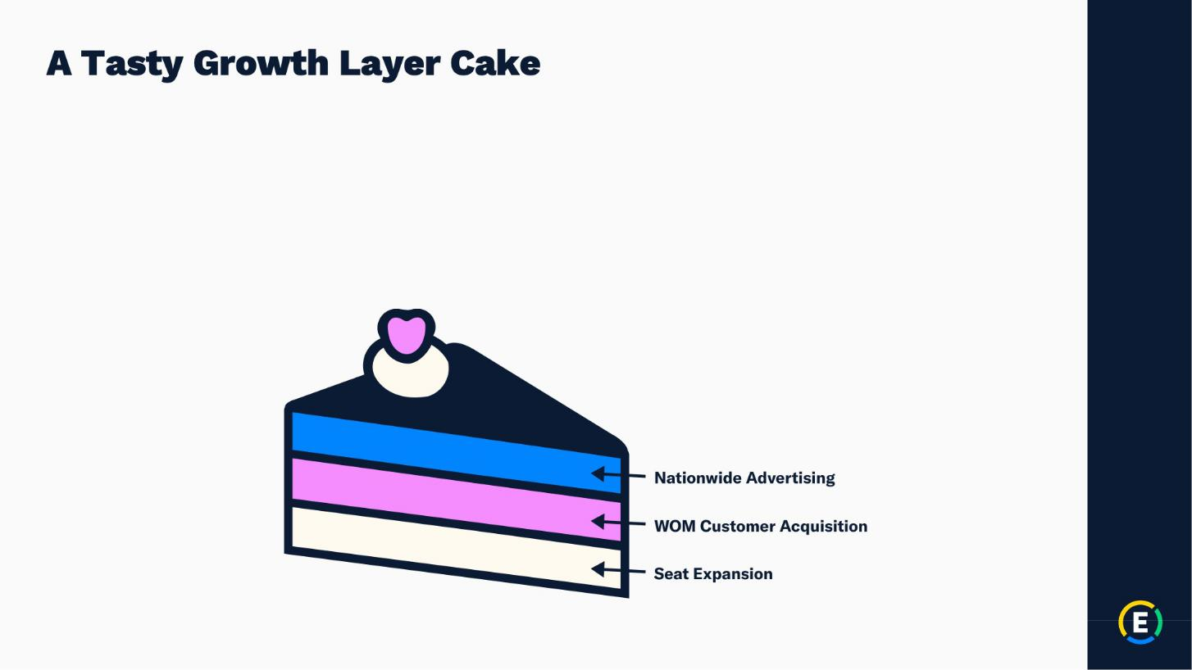

Exhibit 99.2

Expensify, Inc.

Investor Presentation
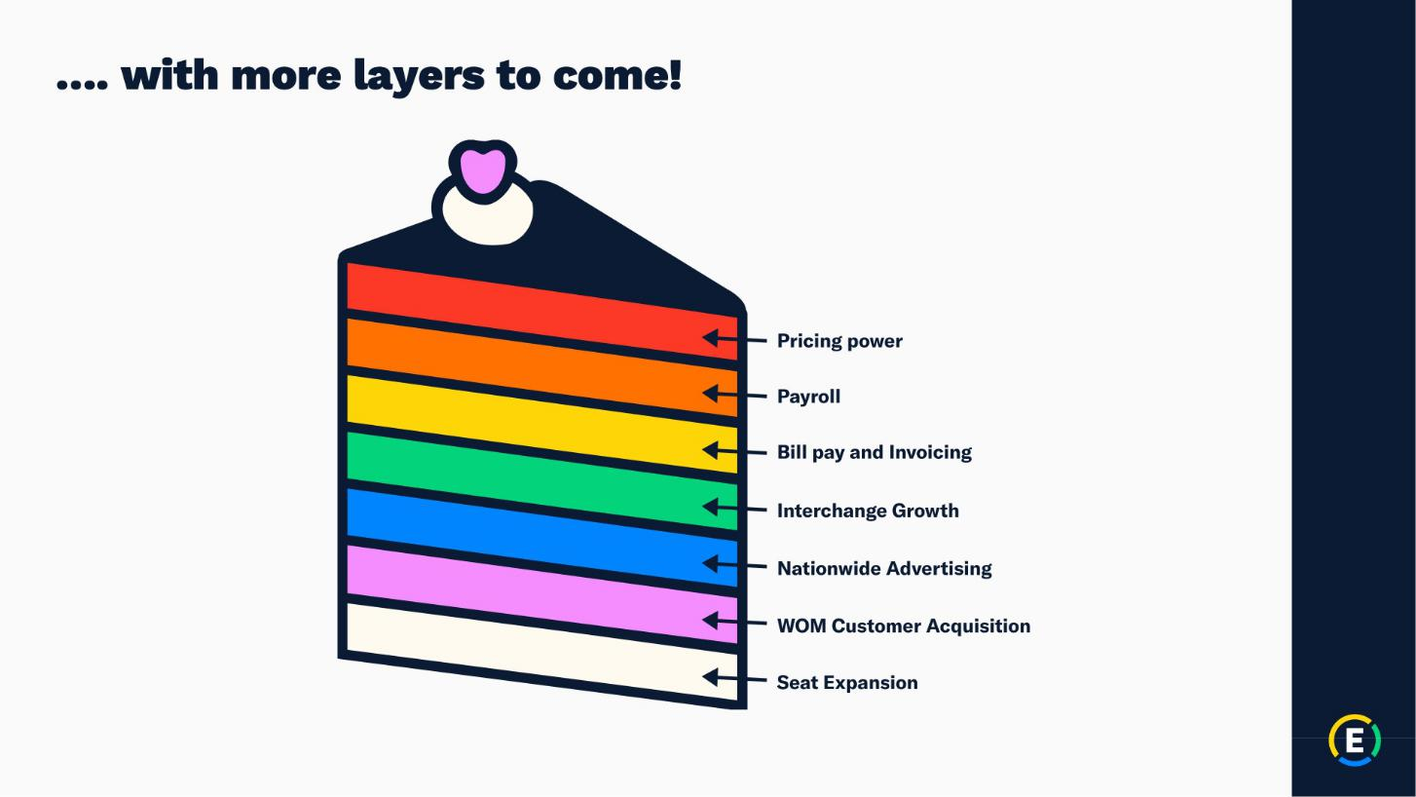

Exhibit 99.2

Expensify, Inc.

Investor Presentation

Exhibit 99.2

Expensify, Inc.

Investor Presentation

Exhibit 99.2

Expensify, Inc.

Investor Presentation


Exhibit 99.2

Expensify, Inc.

Investor Presentation
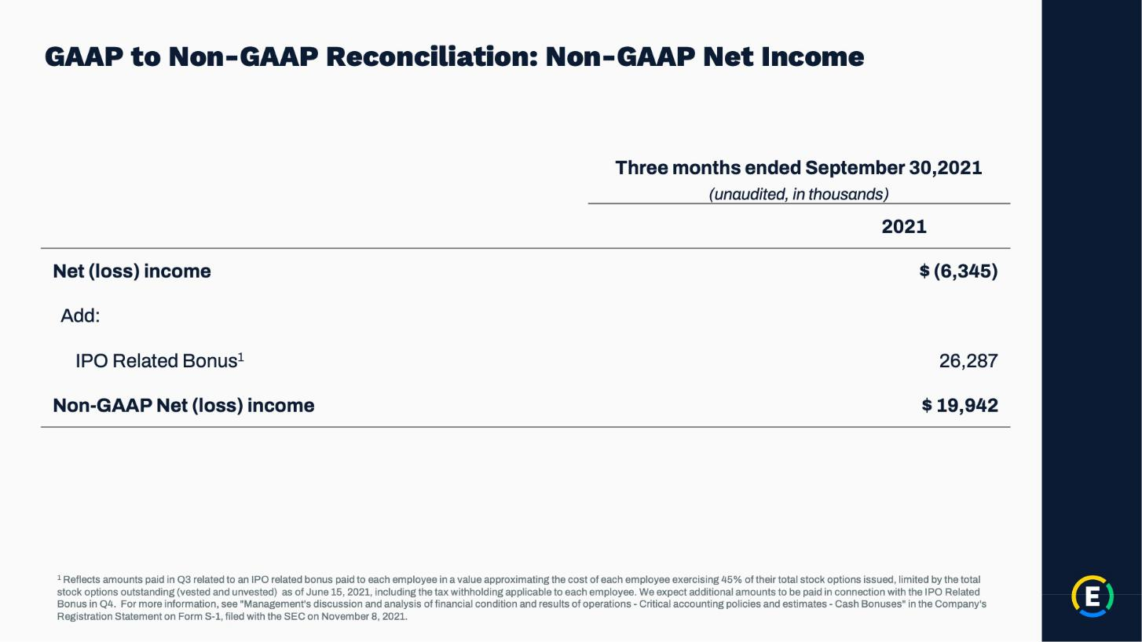

Exhibit 99.2

Expensify, Inc.

Investor Presentation
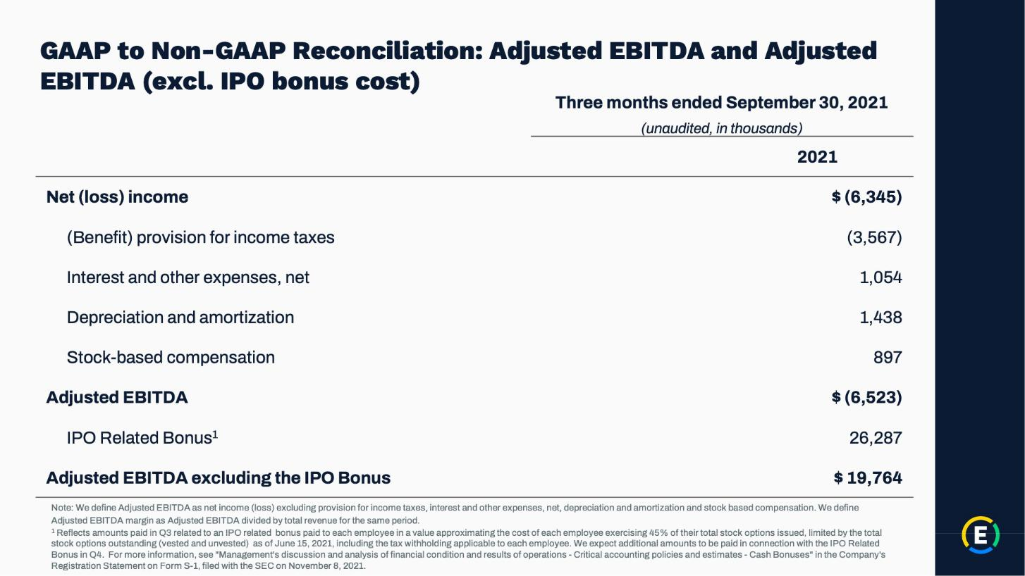

Exhibit 99.2

Expensify, Inc.

Investor Presentation

