UNITED STATES
SECURITIES AND EXCHANGE COMMISSION
Washington, D.C. 20549
FORM 8-K
CURRENT REPORT
PURSUANT TO SECTION 13 OR 15(d)
OF THE SECURITIES EXCHANGE ACT OF 1934
Date of report (Date of earliest event reported): May 12, 2022
Expensify, Inc.
(Exact Name of Registrant as Specified in its Charter)
Delaware |  |  |  |  |  | 001-41043 |  |  |  |  |  | 27-0239450
(State or Other Jurisdiction  of Incorporation) |  |  |  |  |  | (Commission  File Number) |  |  |  |  |  | (IRS Employer  Identification No.)
401 SW 5th Ave
Portland, Oregon 97204
(Address of Principal Executive Offices) (Zip Code)
(971) 365-3939
(Registrant’s telephone number, including area code)
Not applicable
(Former Name or Former Address, if Changed Since Last Report)
Check the appropriate box below if the Form 8-K filing is intended to simultaneously satisfy the filing obligation of the registrant under any of the following provisions:
☐ |  |  |  |  |  | Written communications pursuant to Rule 425 under the Securities Act (17 CFR 230.425).
☐ |  |  |  |  |  | Soliciting material pursuant to Rule 14a-12 under the Exchange Act (17 CFR 240.14a-12).
☐ |  |  |  |  |  | Pre-commencement communications pursuant to Rule 14d-2(b) under the Exchange Act (17 CFR 240.14d-2(b)).
☐ |  |  |  |  |  | Pre-commencement communications pursuant to Rule 13e-4(c) under the Exchange Act (17 CFR 240.13e-4(c)).
Securities registered pursuant to Section 12(b) of the Act:
Title of each class |  |  |  |  |  | Trading  Symbols |  |  |  |  |  | Name of each exchange  on which registered
Class A Common Stock, par value $0.0001 per share |  |  |  |  |  | EXFY |  |  |  |  |  | The Nasdaq Stock Market LLC
Indicate by check mark whether the registrant is an emerging growth company as defined in Rule 405 of the Securities Act of 1933 (§230.405 of this chapter) or Rule 12b-2 of the Securities Exchange Act of 1934 (§240.12b-2 of this chapter).
Emerging growth company ☒
If an emerging growth company, indicate by check mark if the registrant has elected not to use the extended transition period for complying with any new or revised financial accounting standards provided pursuant to Section 13(a) of the Exchange Act. ☐

Item 2.02 Results of Operations and Financial Condition.
On May 12, 2022, Expensify, Inc. (“Expensify” or the “Company”) issued a press release announcing its financial results for the quarter ended March 31, 2022. A copy of this press release is furnished as Exhibit 99.1 to this current report on Form 8-K and is incorporated herein by reference.

Item 7.01 Regulation FD Disclosure.
On May 12, 2022, the Company posted an investor presentation to its website at https://ir.expensify.com (the “Investor Presentation”). A copy of the Investor Presentation is attached as Exhibit 99.2 to this current report on Form 8-K and is incorporated herein by reference. The Company expects to use the Investor Presentation, in whole or in part, and possibly with modifications, in connection with presentations to investors, analysts and others.
The information contained in the Investor Presentation is summary information that is intended to be considered in the context of the Company’s Securities and Exchange Commission (“SEC”) filings and other public announcements that the Company may make, by press release or otherwise, from time to time. The Investor Presentation speaks only as of the date of this current report on Form 8-K. The Company undertakes no duty or obligation to publicly update or revise the information included in the Investor Presentation, although it may do so from time to time. Any such updating may be made through the filing of other reports or documents with the SEC, through press releases or other public disclosure. In addition, the exhibit furnished herewith contains statements intended as “forward-looking statements” that are subject to the cautionary statements about forward-looking statements set forth in such exhibit. By furnishing the information contained in the Investor Presentation, the Company makes no admission as to the materiality of any information in the Investor Presentation that is required to be disclosed solely by reason of Regulation FD.

The information contained in Item 2.02 and this Item 7.01, including Exhibit 99.1 and 99.2, is being furnished and shall not be deemed “filed” for the purposed of Section 18 of the Securities and Exchange Act of 1934, as amended (the “Exchange Act”), or otherwise subject to the liabilities of that section, nor shall it be deemed incorporated by reference in any filing made by Expensify under the Securities Act of 1933, as amended, or the Exchange Act, except as expressly set forth by specific reference in such a filing.

Item 8.01 Other Events.

On May 12, 2022, the Company issued a press release announcing that its board of directors approved a share repurchase program with authorization to purchase up to $50 million of shares of its Class A common stock. The Company may repurchase shares from time to time through open market purchases, in privately negotiated transactions or by other means, including through the use of trading plans intended to qualify under Rule 10b5-1 under the Exchange Act, in accordance with applicable securities laws and other restrictions. The actual timing and total amount of future repurchases are subject to business, economic and market conditions, corporate and regulatory requirements, prevailing stock prices, restrictions under the terms of our loan agreements and other considerations. The share repurchase program does not obligate the Company to acquire any particular amount of common stock, and the program may be suspended or terminated at any time by the Company at any time at its discretion without prior notice. A copy of the press release is attached hereto as Exhibit 99.3 and is incorporated by reference herein.

Item 9.01 Financial Statements and Exhibits.
(d) Exhibits.
Exhibit No. |  |  |  |  |  | Description
99.1 |  |  |  |  |  | Press Release issued by Expensify, Inc., dated May 12, 2022.
99.2 |  |  |  |  |  | Investor Presentation, dated May 12, 2022.
99.3 |  |  |  |  |  | Press Release issued by Expensify, Inc. dated May 12, 2022.
104 |  |  |  |  |  | Cover Page Interactive Data File (embedded within the Inline XBRL document).

SIGNATURE
Pursuant to the requirements of the Securities Exchange Act of 1934, the registrant has duly caused this report to be signed on its behalf by the undersigned hereunto duly authorized.
Expensify, Inc.
By: |  |  |  |  |  | /s/ Ryan Schaffer
Name: |  |  |  |  |  | Ryan Schaffer
Title: |  |  |  |  |  | Chief Financial Officer
Date: May 12, 2022

Exhibit 99.1

EXPENSIFY ANNOUNCES Q1 2022 RESULTS
Free Plan membership grew 183% Q/Q to over 9,000 customers. The company generated positive cash flow of $11.2M with a 28% cash flow margin.

PORTLAND, Ore.--(BUSINESS WIRE)--May 12, 2022-- Expensify, Inc. (Nasdaq: EXFY), a payments superapp that helps individuals and businesses around the world simplify the way they manage money across expenses, corporate cards and bills, today announced results for its quarter ended March 31, 2022.

“The biggest news coming out of Q1 was the growth of our Free Plan for SMBs. The plan grew to over 9,000 customers, which is an 183% increase from last quarter. The plan allows members to roll out Expensify functionality across their businesses for free, including the Expensify Card, expense management, next-day reimbursement, invoicing, bill pay, and travel booking,” says David Barrett, Expensify’s founder and CEO.

“In addition to the incredible growth we’re seeing from the Free Plan, March '22 was the second best month in company history from a paid member perspective,” says Ryan Schaffer, Expensify’s CFO. “So we’re doing a great job adding users on both the paid and free sides of the business, which is encouraging and shows the momentum we have in the business right now.”

First Quarter 2022 Highlights
Financial:
•Revenue was $40.4 million, an increase of 36% from the same period last year.
•Positive operating cash flows of $11.2 million.
•Net (loss) income was $(7.4) million, compared to $8.0 million for the same period last year. This loss is driven by stock-based compensation expenses of $14.7 million.
•Non-GAAP net income was $7.3 million.
•Adjusted EBITDA was $11.0 million, with an Adjusted EBITDA margin of 27%.
Business
•Free plan - swelled to over 9,000 businesses in Q1, a 183% increase from the previous quarter. The Free Plan includes the Expensify Card, expense management, next-day reimbursement, invoicing, bill pay, and travel booking.
•Paid members - despite the challenges presented by the COVID-19 Omicron spike early in the year, a strong second half of Q1 propelled average paid members for the quarter to 706,000, exceeding expectations.
•Expensify Card - continues to perform well, interchange increased by 150% from the same period last year.
•CPA Card - announced in January as the first smart card with exclusive perks, pricing, and upgrades for CPAs, accounting firms, and their clients.

Financial Outlook
Expensify's outlook statements are based on current expectations. The following statements are forward-looking and actual results could differ materially depending on market conditions and the factors set forth under “Forward-Looking Statements” below.

Exhibit 99.1

We reaffirm our long term guidance provided in connection with our fourth quarter 2021 results of 25-35% revenue growth over a multi-year period.

Expensify is also providing an estimate on what stock based compensation is expected to look like for the rest of the fiscal year. Driven primarily by the pre-IPO grant of RSUs issued to all employees (which vest over 8 years – 1/8 after one year and quarterly thereafter), stock based compensation is estimated as seen below:

Est. stock-based compensation (millions)
 |  |  | Q2 2022 |  |  |  |  |  |  |  |  |  |  |  | Q3 2022 |  |  |  |  |  |  |  |  |  |  |  | Q4 2022
 |  |  | Low |  |  |  |  |  | High |  |  |  |  |  | Low |  |  |  |  |  | High |  |  |  |  |  | Low |  |  |  |  |  | High
Cost of revenue, net |  |  | $ | 4.8 |  |  |  |  | $ | 5.4 |  |  |  |  | $ | 4.6 |  |  |  |  | $ | 5.3 |  |  |  |  | $ | 3.4 |  |  |  |  | $ | 4.1
Research and development |  |  | 2.7 |  |  |  |  |  | 3.0 |  |  |  |  |  | 2.6 |  |  |  |  |  | 2.9 |  |  |  |  |  | 1.9 |  |  |  |  |  | 2.3
General and administrative |  |  | 4.6 |  |  |  |  |  | 5.3 |  |  |  |  |  | 4.5 |  |  |  |  |  | 5.1 |  |  |  |  |  | 3.3 |  |  |  |  |  | 4.0
Sales and marketing |  |  | 2.0 |  |  |  |  |  | 2.2 |  |  |  |  |  | 1.9 |  |  |  |  |  | 2.2 |  |  |  |  |  | 1.4 |  |  |  |  |  | 1.7
Total |  |  | $ | 14.0 |  |  |  |  | $ | 16.0 |  |  |  |  | $ | 13.5 |  |  |  |  | $ | 15.5 |  |  |  |  | $ | 10.0 |  |  |  |  | $ | 12.0
Note: Amounts may not sum due to minor rounding differences.

Availability of Information on Expensify’s Website
Investors and others should note that Expensify routinely announces material information to investors and the marketplace using SEC filings, press releases, public conference calls, webcasts and the Expensify Investor Relations website at https://ir.expensify.com. While not all of the information that the Company posts to its Investor Relations website is of a material nature, some information could be deemed to be material. Accordingly, the Company encourages investors, the media and others interested in Expensify to review the information that it shares on its Investor Relations website.

Conference Call
Expensify will host a video call to discuss the results at 2:00 p.m. Pacific Time today. The video call information is available on Expensify’s Investor Relations website at https://ir.expensify.com. A replay of the call will be available on the site for three months.

Non-GAAP Financial Measures
In addition to financial measures prepared in accordance with U.S. generally accepted accounting principles (“GAAP”), we provide certain non-GAAP financial measures, including Adjusted EBITDA and Non-GAAP net income.

We believe our non-GAAP financial measures are useful in evaluating our business, measuring our performance, identifying trends affecting our business, formulating business plans and making strategic decisions. Accordingly, we believe that these non-GAAP financial measures provide useful information to investors and others in understanding and evaluating our results of operations in the same manner as our management team. These non-GAAP financial measures are presented for supplemental informational purposes only, should not be considered a substitute for financial information presented in accordance with GAAP, and may be different from similarly titled metrics or measures presented by other companies. Non-GAAP financial measures have limitations as analytical tools and should not be considered in isolation or as substitutes for financial information presented under GAAP. There are a number of limitations related to the use of non-GAAP financial measures versus comparable financial measures determined under GAAP. For example, other companies in our industry may calculate these non-GAAP financial measures differently or may use other measures to evaluate their performance. All of these limitations could reduce the usefulness of these non-GAAP financial measures as analytical tools. Investors are encouraged to review the related GAAP financial measures and the reconciliations of these non-GAAP financial measures to their
Exhibit 99.1

most directly comparable GAAP financial measures and to not rely on any single financial measure to evaluate our business. A reconciliation of each non-GAAP financial measure to the most directly comparable financial measure stated in accordance with GAAP is at the end of this press release.

We define Adjusted EBITDA as net income from operations excluding provision for income taxes, interest and other expenses, net, depreciation and amortization and stock based compensation.

We define non-GAAP net income as net income from operations in accordance with US GAAP excluding stock-based compensation and IPO-related bonus costs. In prior periods, this metric only excluded IPO-related bonus costs and did not exclude expenses related to stock-based compensation. However, management now believes that further excluding stock-based compensation from non-GAAP net income is useful to better understand the financial performance of our business and to facilitate a better comparison of our results to those of peer companies over multiple periods given that this item may vary between companies for reasons unrelated to overall operating performance. IPO-related bonus costs impacted the second, third and fourth fiscal quarters of 2021, but are not expected to impact future periods beginning with the first quarter of 2022.

The tables at the end of the Financial Statements provide reconciliations to the most directly comparable GAAP financial measure to each of these non-GAAP financial measures.

Forward-Looking Statements
Forward-looking statements in this press release, which are not historical facts, are forward-looking statements within the meaning of the Private Securities Litigation Reform Act of 1955. These statements include statements regarding our strategy, future financial condition, future operations, projected costs, prospects, plans, objectives of management and expected market growth and involve known and unknown risks that are difficult to predict. As a result, our actual results, performance or achievements may differ materially from those expressed or implied by these forward-looking statements. In some cases, you can identify forward-looking statements because they contain words such as “may,” “will,” “shall,” “should,” “expects,” “plans,” “anticipates,” “could,” “intends,” “target,” “projects,” “contemplates,” “believes,” “estimates,” “predicts,” “potential,” “goal,” “objective,” “seeks,” or “continue” or the negative of these words or other similar terms or expressions that concern our expectations, strategy, plans, or intentions. Such forward-looking statements are necessarily based upon estimates and assumptions that, while considered reasonable by us and our management, are inherently uncertain. Factors that may cause actual results to differ materially from current expectations include, but are not limited to: the economic, political and social impact of, and uncertainty relating to, the COVID-19 pandemic; the war in Ukraine and escalating geopolitical tensions as a result of Russia's invasion of Ukraine; our expectations regarding our financial performance and future operating performance; our ability to attract and retain members, expand usage of our platform, sell subscriptions to our platform and convert individuals and organizations into paying customers; the timing and success of new features, integrations, capabilities and enhancements by us, or by competitors to their products, or any other changes in the competitive landscape of our market; the amount and timing of operating expenses and capital expenditures that we may incur to maintain and expand our business and operations to remain competitive; the sufficiency of our cash, cash equivalents and investments to meet our liquidity needs; our ability to make required payments under and to comply with the various requirements of our current and future indebtedness; our ability to effectively manage our exposure to fluctuations in foreign currency exchange rates; the increased expenses associated with being a public company; the size of our addressable markets, market share and market trends; anticipated trends, developments and challenges in our industry, business and the highly competitive markets in which we operate; our expectations regarding our income tax liabilities and the adequacy of our reserves; our ability to effectively manage our growth and expand our infrastructure and maintain our corporate culture; our ability to identify, recruit and retain skilled personnel, including key members of senior management; the safety, affordability and convenience of our platform and our offerings; our ability to successfully defend litigation brought against us; our ability to successfully identify, manage and integrate any existing and potential acquisitions of businesses, talent, technologies or intellectual property; general economic conditions in either domestic or international markets, including the societal and economic impact of the COVID-19 pandemic, and geopolitical
Exhibit 99.1

uncertainty and instability; our protections against security breaches, technical difficulties, or interruptions to our platform; our ability to maintain, protect and enhance our intellectual property; and other risks discussed in our filings with the SEC. All forward-looking statements attributable to us or persons acting on our behalf are expressly qualified in their entirety by the cautionary statements set forth above. We caution you not to place undue reliance on any forward-looking statements, which are made only as of the date of this press release. We do not undertake or assume any obligation to update publicly any of these forward-looking statements to reflect actual results, new information or future events, changes in assumptions or changes in other factors affecting forward-looking statements, except to the extent required by applicable law. If we update one or more forward-looking statements, no inference should be drawn that we will make additional updates with respect to those or other forward-looking statements.

About Expensify
Expensify is a payments superapp that helps individuals and businesses around the world simplify the way they manage money. More than 10 million people use Expensify's free features, which include corporate cards, expense tracking, next-day reimbursement, invoicing, bill pay, and travel booking in one app. All free. Whether you own a small business, manage a team, or close the books for your clients, Expensify makes it easy so you have more time to focus on what really matters.

Investor Relations Contact
Nick Tooker
investors@expensify.com
Press Contact
James Dean
press@expensify.com

Exhibit 99.1

Expensify, Inc.
Condensed Consolidated Balance Sheets
(unaudited, in thousands, except share and per share data)
 |  |  | As of March 31, |  |  |  |  |  | As of December 31,
 |  |  | 2022 |  |  |  |  |  | 2021
Assets
Cash and cash equivalents |  |  | $ | 101,101 |  |  |  |  | $ | 98,398
Accounts receivable, net |  |  | 16,022 |  |  |  |  |  | 15,713
Settlement assets |  |  | 34,313 |  |  |  |  |  | 21,880
Prepaid expenses |  |  | 7,060 |  |  |  |  |  | 7,436
Related party loan receivable, current |  |  | — |  |  |  |  |  | 14
Other current assets |  |  | 15,746 |  |  |  |  |  | 14,201
Total current assets |  |  | 174,242 |  |  |  |  |  | 157,642
Capitalized software, net |  |  | 6,158 |  |  |  |  |  | 6,359
Property and equipment, net |  |  | 15,584 |  |  |  |  |  | 15,930
Lease right-of-use assets |  |  | 1,832 |  |  |  |  |  | 2,202
Deferred tax assets, net |  |  | 370 |  |  |  |  |  | 370
Other assets |  |  | 628 |  |  |  |  |  | 710
Total assets |  |  | $ | 198,814 |  |  |  |  | $ | 183,213
Liabilities and stockholders' equity
Accounts payable |  |  | $ | 1,437 |  |  |  |  | $ | 3,752
Accrued expenses and other liabilities |  |  | 8,411 |  |  |  |  |  | 11,046
Borrowings under line of credit |  |  | 15,000 |  |  |  |  |  | 15,000
Current portion of long-term debt, net of issuance costs |  |  | 547 |  |  |  |  |  | 549
Lease liabilities, current |  |  | 1,559 |  |  |  |  |  | 1,549
Settlement liabilities |  |  | 34,113 |  |  |  |  |  | 21,680
Total current liabilities |  |  | 61,067 |  |  |  |  |  | 53,576
Lease liabilities, non-current |  |  | 405 |  |  |  |  |  | 802
Other liabilities |  |  | 1,028 |  |  |  |  |  | 153
Long-term debt, net of issuance costs |  |  | 51,847 |  |  |  |  |  | 52,067
Total liabilities |  |  | 114,347 |  |  |  |  |  | 106,598
Commitments and contingencies (Note 4)
Stockholders' equity:
Common stock, par value $0.0001; 1,000,000,000 shares of Class A common stock authorized as of March 31, 2022 and December 31, 2021; 68,050,193 and 67,844,060 shares of Class A common stock issued and outstanding as of March 31, 2022 and December 31, 2021, respectively; 25,000,000 shares of LT10 common stock authorized as of March 31, 2022 and December 31, 2021; 7,332,640 shares of LT10 common stock issued and outstanding as of March 31, 2022 and December 31, 2021; 25,000,000 shares of LT50 common stock authorized as of March 31, 2022 and December 31, 2021; 6,224,160 shares of LT50 common stock issued and outstanding as of March 31, 2022 and December 31, 2021 |  |  | 6 |  |  |  |  |  | 6
Additional paid-in capital |  |  | 157,743 |  |  |  |  |  | 142,515
Accumulated deficit |  |  | (73,282) |  |  |  |  |  | (65,906)
Total stockholders' equity |  |  | 84,467 |  |  |  |  |  | 76,615
Total liabilities and stockholders' equity |  |  | $ | 198,814 |  |  |  |  | $ | 183,213

Exhibit 99.1

Expensify, Inc.
Condensed Consolidated Statements of Income
(unaudited, in thousands, except share and per share data)
 |  |  | Three months ended March 31,
 |  |  | 2022 |  |  |  |  |  | 2021
Revenue |  |  | $ | 40,370 |  |  |  |  | $ | 29,720
Cost of revenue, net(1) |  |  | 14,133 |  |  |  |  |  | 7,637
Gross margin |  |  | 26,237 |  |  |  |  |  | 22,083
Operating expenses:
Research and development(1) |  |  | 3,701 |  |  |  |  |  | 1,097
General and administrative(1) |  |  | 14,006 |  |  |  |  |  | 6,367
Sales and marketing(1) |  |  | 13,372 |  |  |  |  |  | 3,077
Total operating expenses |  |  | 31,079 |  |  |  |  |  | 10,541
(Loss) income from operations |  |  | (4,842) |  |  |  |  |  | 11,542
Interest and other expenses, net |  |  | (902) |  |  |  |  |  | (737)
(Loss) income before income taxes |  |  | (5,744) |  |  |  |  |  | 10,805
Provision for income taxes |  |  | (1,632) |  |  |  |  |  | (2,762)
Net (loss) income |  |  | $ | (7,376) |  |  |  |  | $ | 8,043
Less: income allocated to participating securities |  |  | — |  |  |  |  |  | (5,547)
Net (loss) income attributable to Class A, LT10 and LT50 common stockholders |  |  | $ | (7,376) |  |  |  |  | $ | 2,496
Net (loss) income per share attributable to Class A, LT10 and LT50 common stockholders:
Basic |  |  | $ | (0.09) |  |  |  |  | $ | 0.08
Diluted |  |  | $ | (0.09) |  |  |  |  | $ | 0.06
Weighted-average shares of common stock used to compute net (loss) income per share attributable to Class A, LT10 and LT50 common stockholders:
Basic |  |  | 80,147,208 |  |  |  |  |  | 29,522,409
Diluted |  |  | 80,147,208 |  |  |  |  |  | 40,576,339
(1)Includes stock-based compensation expense as follows:

 |  |  | Three months ended March 31,
 |  |  | 2022 |  |  |  |  |  | 2021
 |  |  | (in thousands)
Cost of revenue, net |  |  | $ | 4,908 |  |  |  |  | $ | 188
Research and development |  |  | 2,708 |  |  |  |  |  | 154
General and administrative |  |  | 4,975 |  |  |  |  |  | 304
Sales and marketing |  |  | 2,076 |  |  |  |  |  | 64
Total stock-based compensation expense |  |  | $ | 14,667 |  |  |  |  | $ | 710

Exhibit 99.1

Expensify, Inc.
Condensed Consolidated Statements of Cash Flows
(unaudited, in thousands)
 |  |  | Three months ended March 31,
 |  |  | 2022 |  |  |  |  |  | 2021
Cash flows from operating activities:
Net (loss) income |  |  | $ | (7,376) |  |  |  |  | $ | 8,043
Adjustments to reconcile net (loss) income to net cash provided (used) by operating activities:
Depreciation and amortization |  |  | 1,167 |  |  |  |  |  | 1,170
Reduction of operating lease right-of-use assets |  |  | 185 |  |  |  |  |  | 181
Loss on impairment, receivables and sale or disposal of equipment |  |  | 231 |  |  |  |  |  | 56
Stock-based compensation |  |  | 14,667 |  |  |  |  |  | 710
Amortization of debt issuance costs |  |  | 10 |  |  |  |  |  | 8
Changes in assets and liabilities:
Accounts receivable |  |  | (482) |  |  |  |  |  | (1,601)
Related party loan receivables |  |  | 14 |  |  |  |  |  | —
Settlement assets |  |  | (5,689) |  |  |  |  |  | 464
Prepaid expenses |  |  | 377 |  |  |  |  |  | (1,642)
Other current assets |  |  | (224) |  |  |  |  |  | 318
Other assets |  |  | 80 |  |  |  |  |  | 9
Accounts payable |  |  | (2,316) |  |  |  |  |  | 236
Accrued expenses and other liabilities |  |  | (2,635) |  |  |  |  |  | 2,821
Operating lease liabilities |  |  | (6) |  |  |  |  |  | (200)
Settlement liabilities |  |  | 12,433 |  |  |  |  |  | (980)
Other liabilities |  |  | 787 |  |  |  |  |  | 316
Net cash provided by operating activities |  |  | 11,223 |  |  |  |  |  | 9,909
Cash flows from investing activities:
Purchase of property and equipment |  |  | (179) |  |  |  |  |  | (284)
Software development costs |  |  | (494) |  |  |  |  |  | (669)
Net cash used by investing activities |  |  | (673) |  |  |  |  |  | (953)
Cash flows from financing activities:
Principal payments of finance leases |  |  | (197) |  |  |  |  |  | (192)
Principal payments of term loan |  |  | (146) |  |  |  |  |  | (616)
Payments of deferred offering costs |  |  | — |  |  |  |  |  | (400)
Vesting of restricted common stock |  |  | 295 |  |  |  |  |  | —
Issuance of restricted stock units |  |  | 18 |  |  |  |  |  | —
Repurchases of early exercised stock options |  |  | (4) |  |  |  |  |  | —
Proceeds from issuance of common stock on exercise of stock options |  |  | 252 |  |  |  |  |  | 125
Net cash provided by financing activities |  |  | 218 |  |  |  |  |  | (1,083)
Net increase in cash and cash equivalents |  |  | 10,768 |  |  |  |  |  | 7,873
Cash and cash equivalents and restricted cash, beginning of period |  |  | 125,315 |  |  |  |  |  | 46,878
Cash and cash equivalents and restricted cash, end of period |  |  | $ | 136,083 |  |  |  |  | $ | 54,751
Supplemental disclosure of cash flow information:
Cash paid for interest |  |  | $ | 267 |  |  |  |  | $ | 723
Cash paid for income taxes |  |  | $ | 284 |  |  |  |  | $ | 263
Noncash investing and financing items:
Accrued deferred offering costs |  |  | $ | — |  |  |  |  | $ | 531
Reconciliation of cash, cash equivalents and restricted cash to the consolidated balance sheets
Cash and cash equivalents |  |  | $ | 101,101 |  |  |  |  | $ | 41,926
Restricted cash included in other current assets |  |  | 9,973 |  |  |  |  |  | 2,818
Restricted cash included in other assets |  |  | 46 |  |  |  |  |  | 48
Restricted cash included in settlement assets |  |  | 24,963 |  |  |  |  |  | 9,959
Total cash, cash equivalents and restricted cash |  |  | $ | 136,083 |  |  |  |  | $ | 54,751

Exhibit 99.1

Expensify, Inc.
Reconciliation of GAAP to Non-GAAP Financial Measures
(unaudited, in thousands)
Adjusted EBITDA
 |  |  | Three months ended March 31,
 |  |  | 2022
 |  |  | (in thousands, except percentages)
Net (loss) income |  |  | $ | (7,376)
Net (loss) income margin |  |  | (18) |  | %
Add:
Provision for income taxes |  |  | 1,632
Interest and other expenses, net |  |  | 902
Depreciation and amortization |  |  | 1,167
Stock-based compensation |  |  | 14,667
Adjusted EBITDA |  |  | $ | 10,992
Adjusted EBITDA margin |  |  | 27 |  | %

Non-GAAP net income
 |  |  | Three months ended March 31,
 |  |  | 2022
 |  |  | (in thousands, except percentages)
Net (loss) income |  |  | $ | (7,376)
Net (loss) income margin |  |  | (18) |  | %
Add:
Stock-based compensation |  |  | 14,667
IPO-related bonus expense |  |  | —
Non-GAAP net income |  |  | $ | 7,291
Non-GAAP net income margin |  |  | 18 |  | %

Exhibit 99.2

Expensify, Inc.
Investor Presentation

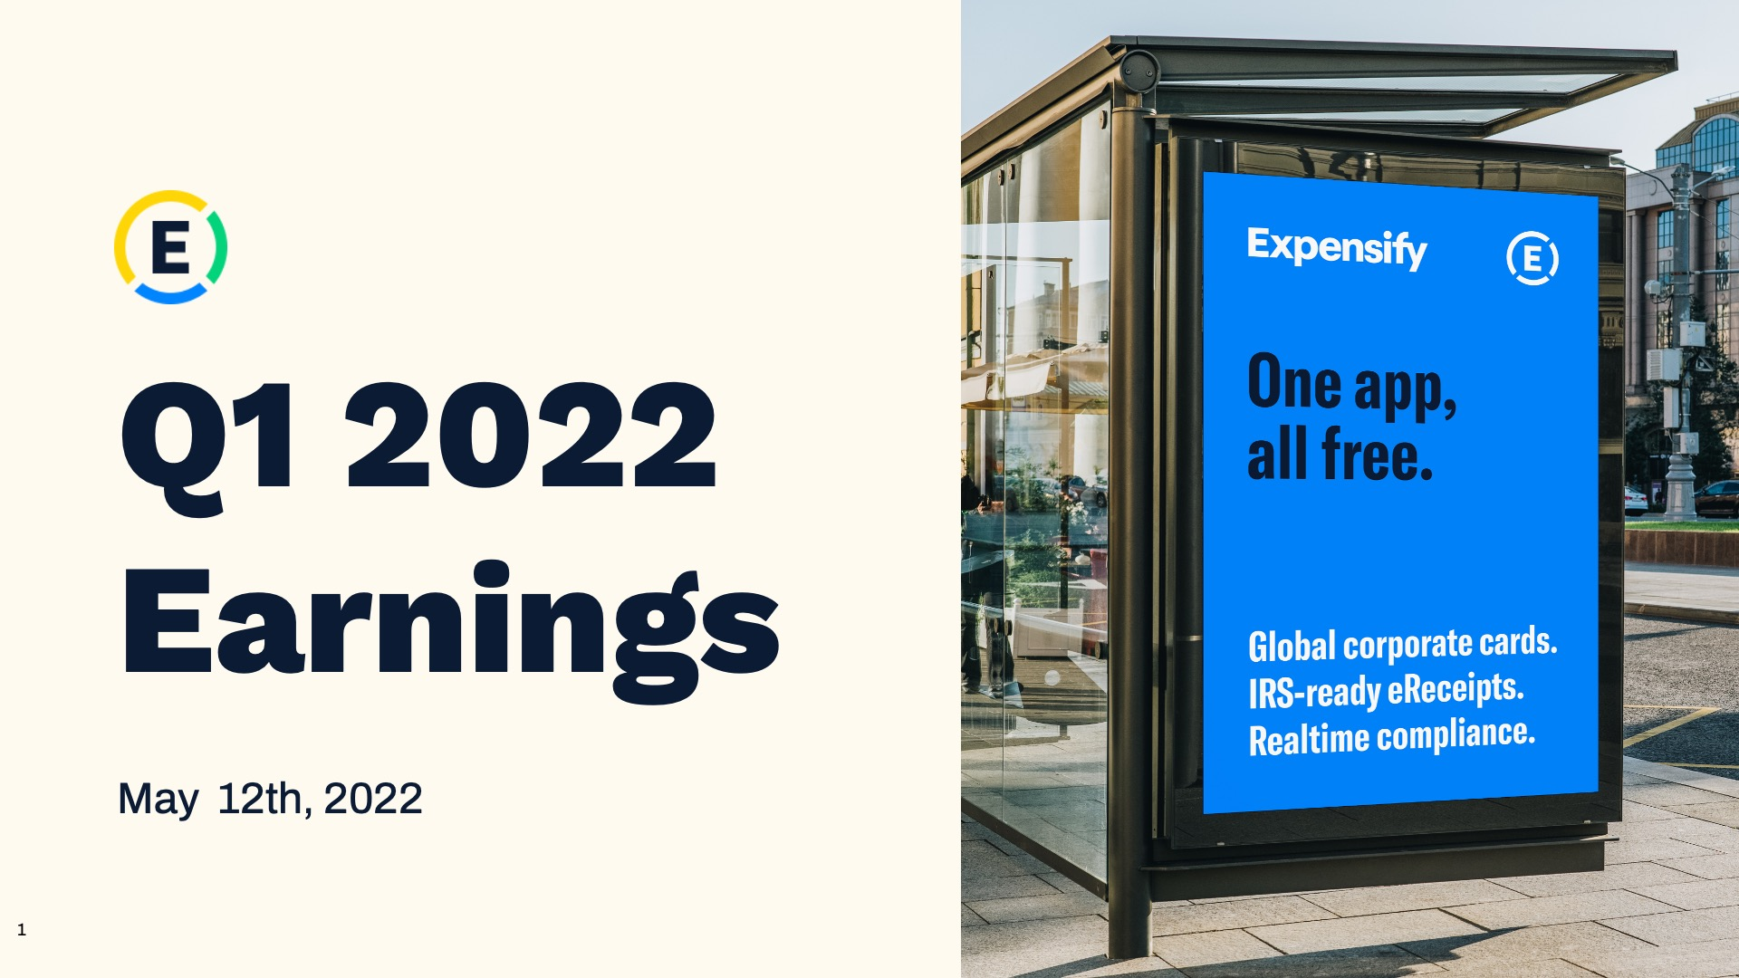

Exhibit 99.2
1
Expensify, Inc.
Investor Presentation

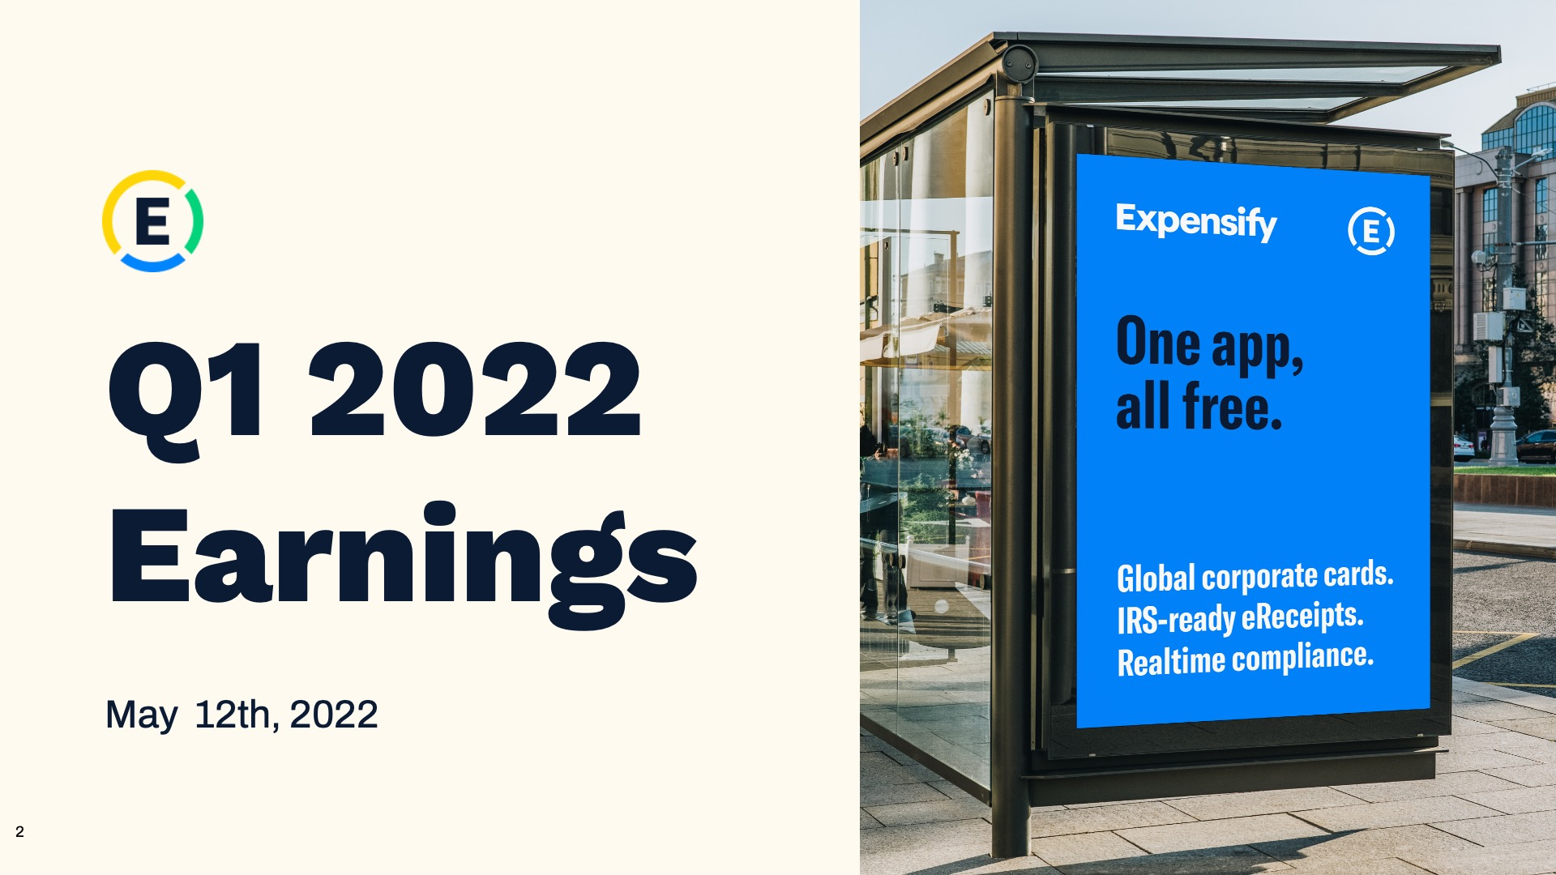

Exhibit 99.2
2
Expensify, Inc.
Investor Presentation

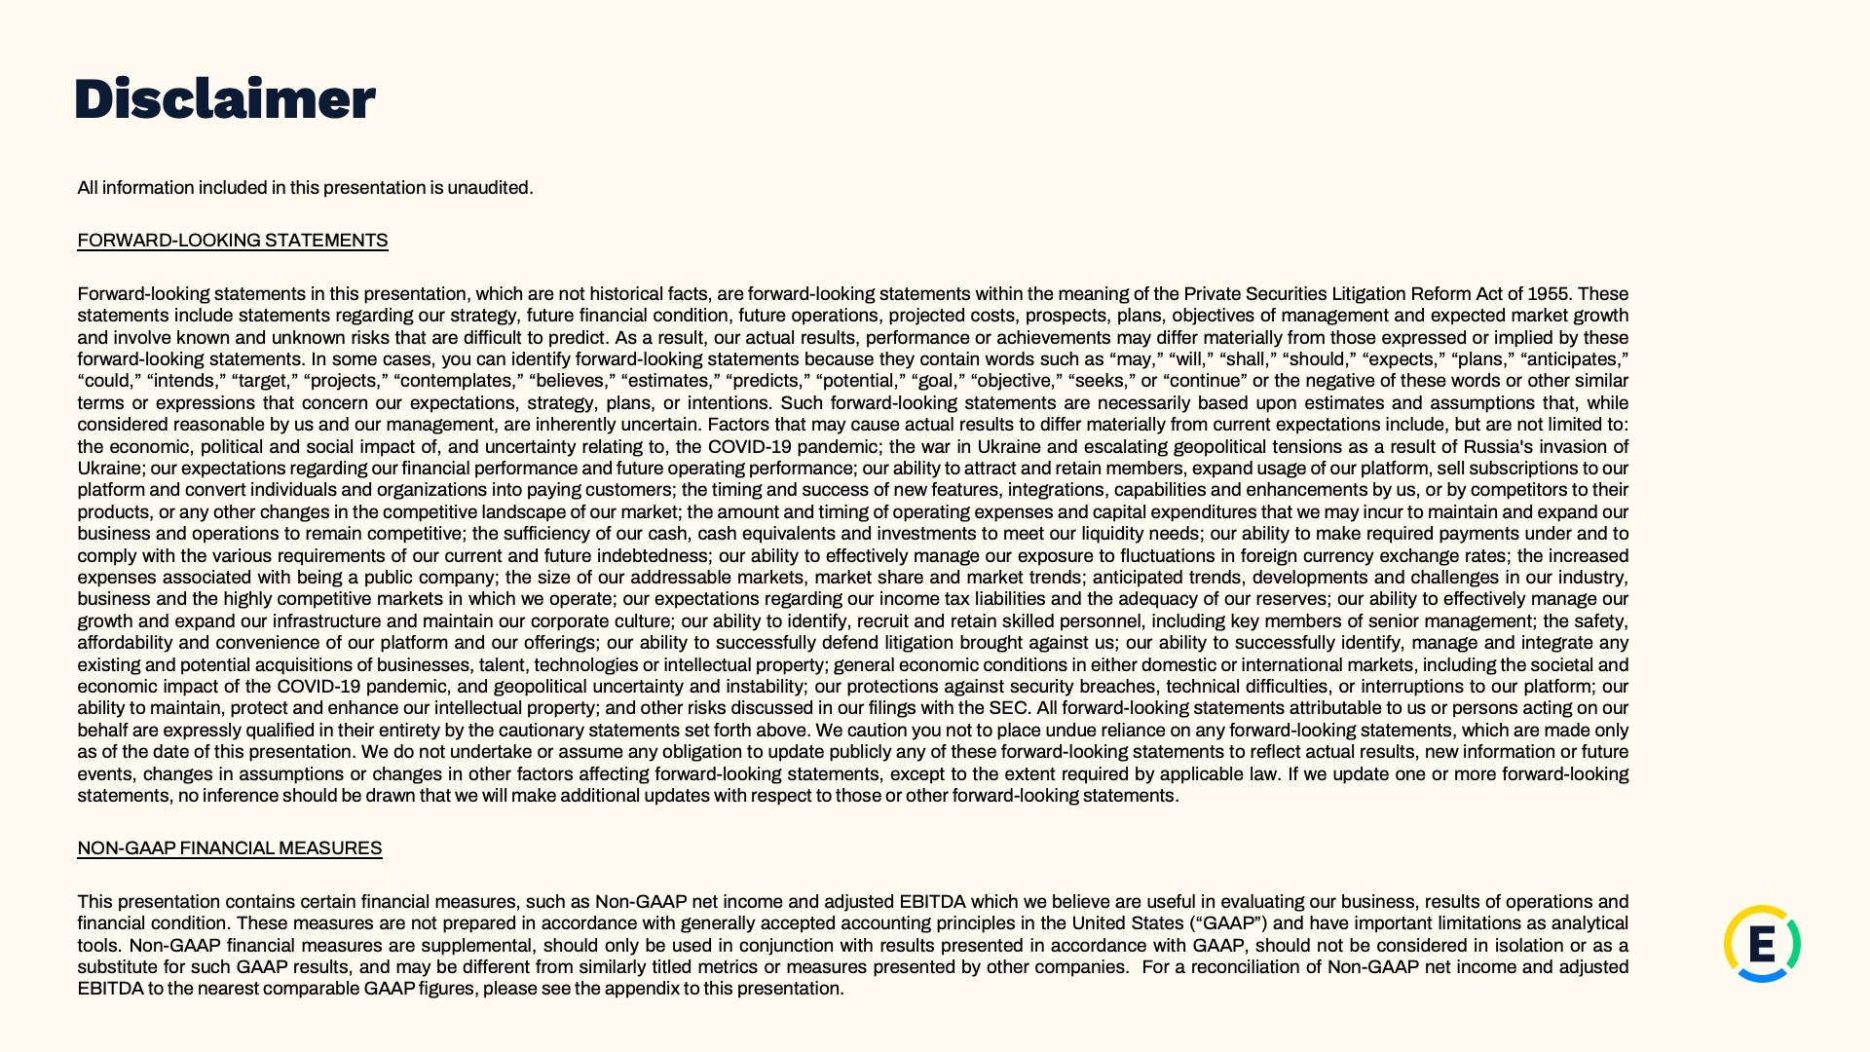

Exhibit 99.2
3
Expensify, Inc.
Investor Presentation

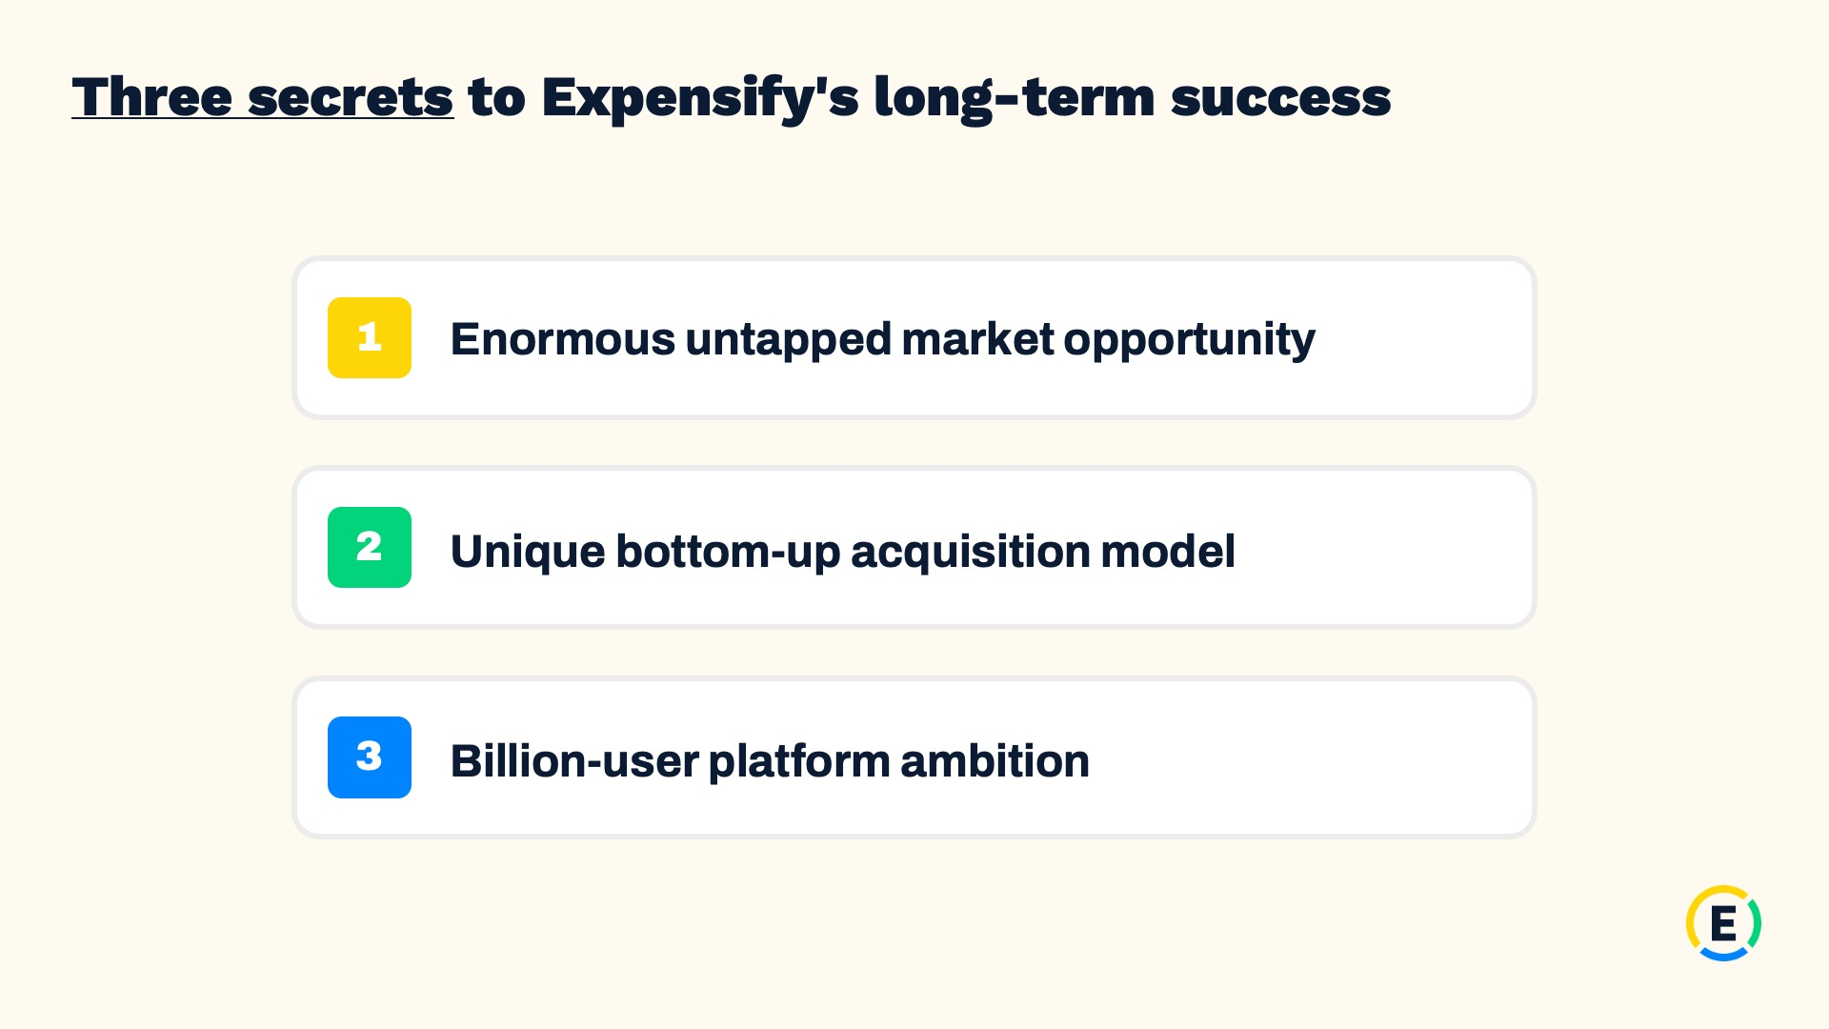

Exhibit 99.2
4
Expensify, Inc.
Investor Presentation

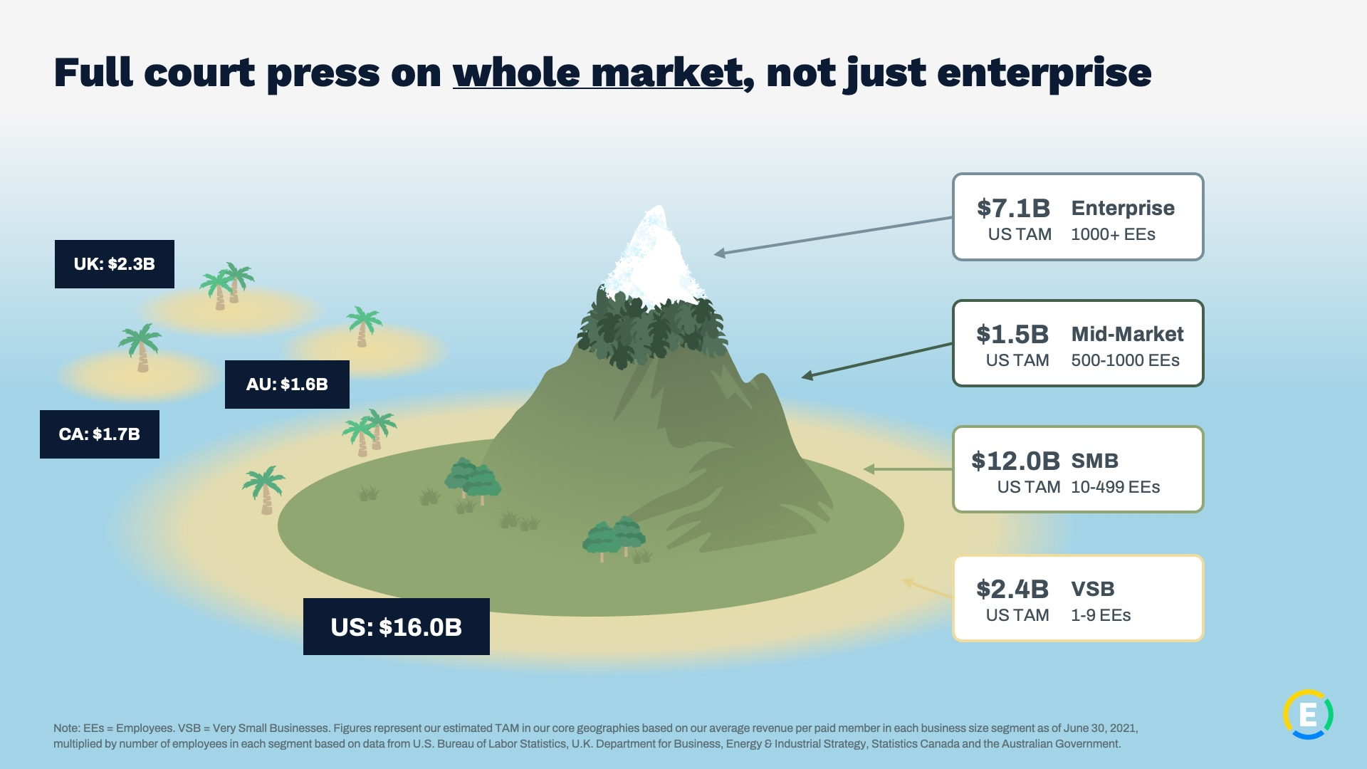

Exhibit 99.2
5
Expensify, Inc.
Investor Presentation

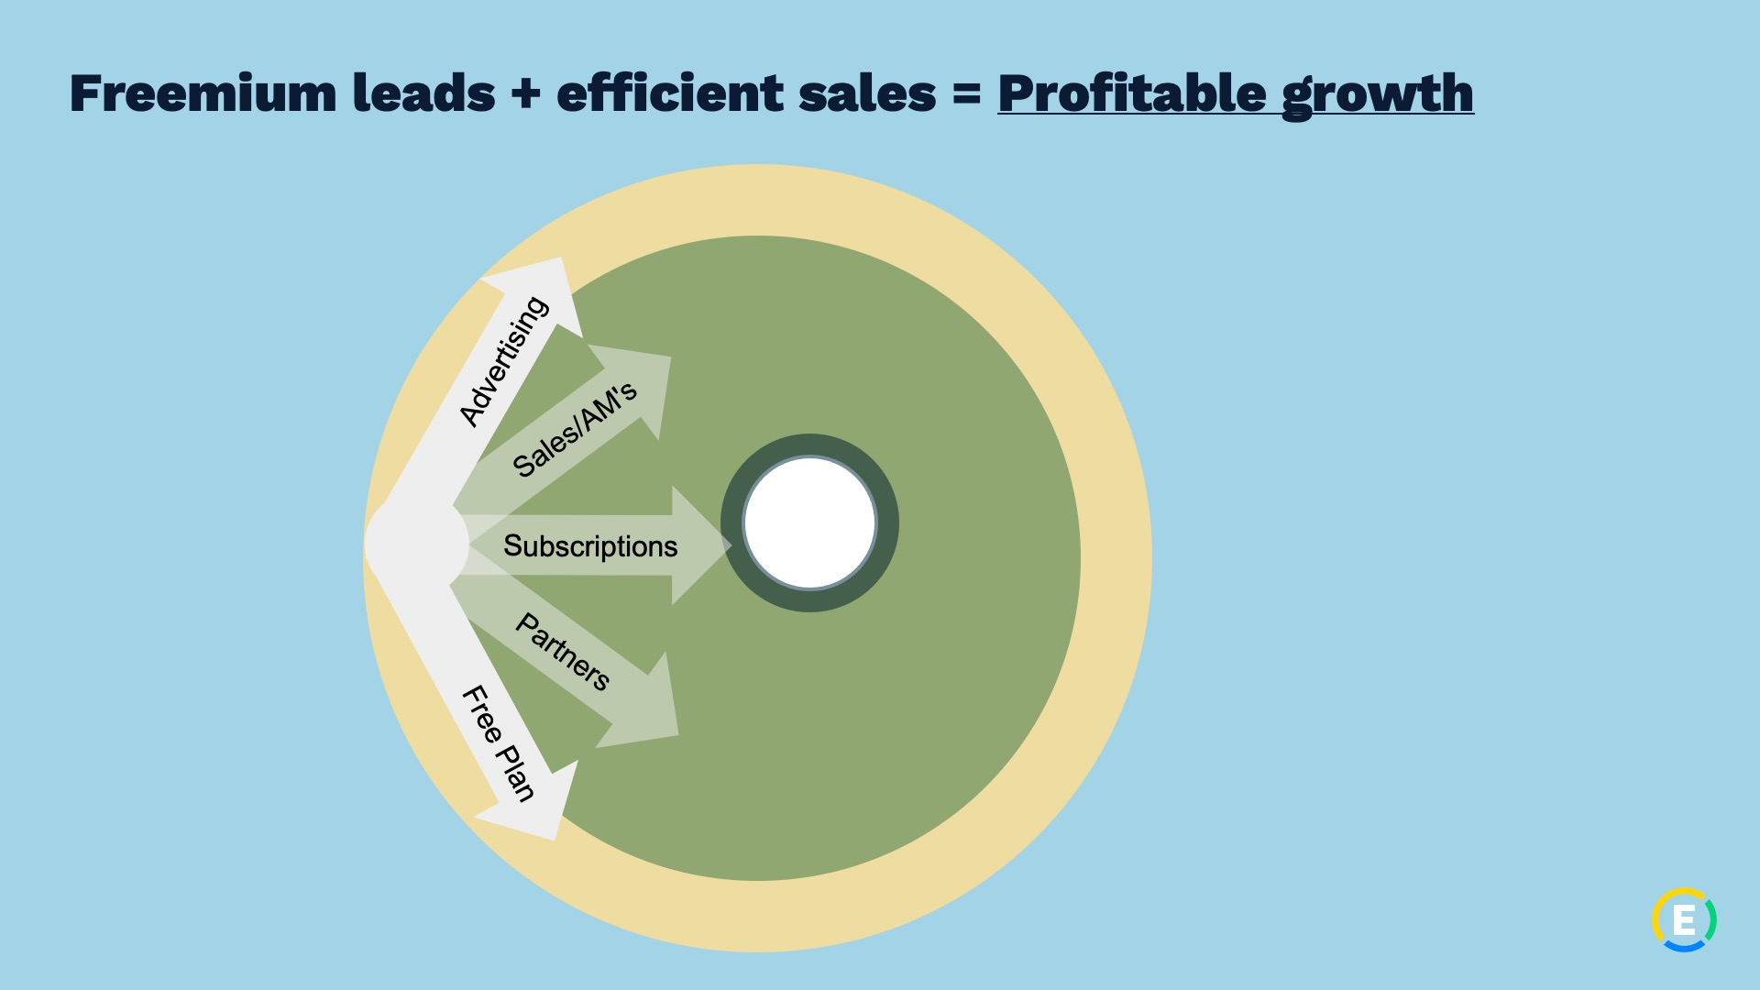

Exhibit 99.2
6
Expensify, Inc.
Investor Presentation

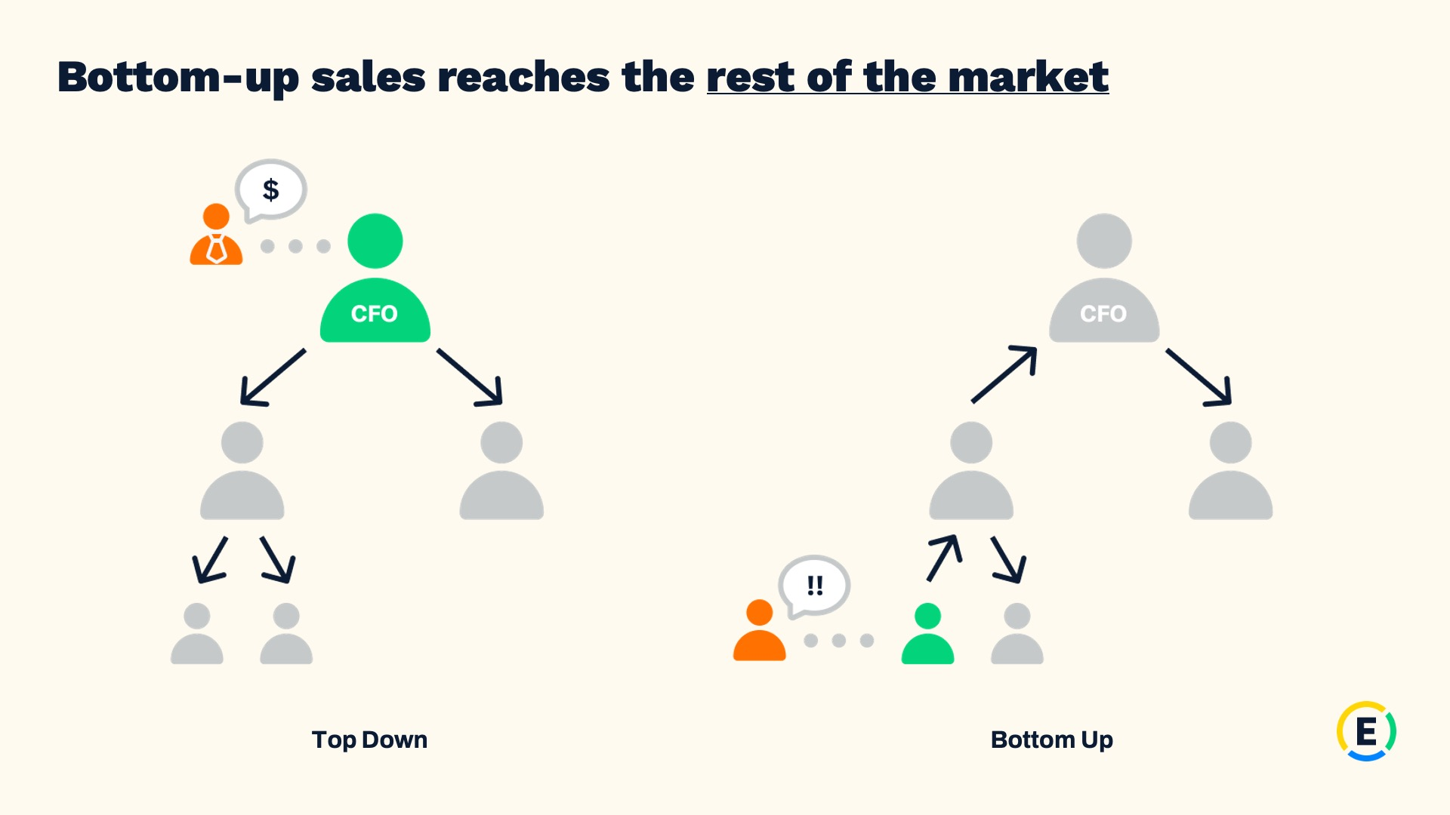

Exhibit 99.2
7
Expensify, Inc.
Investor Presentation

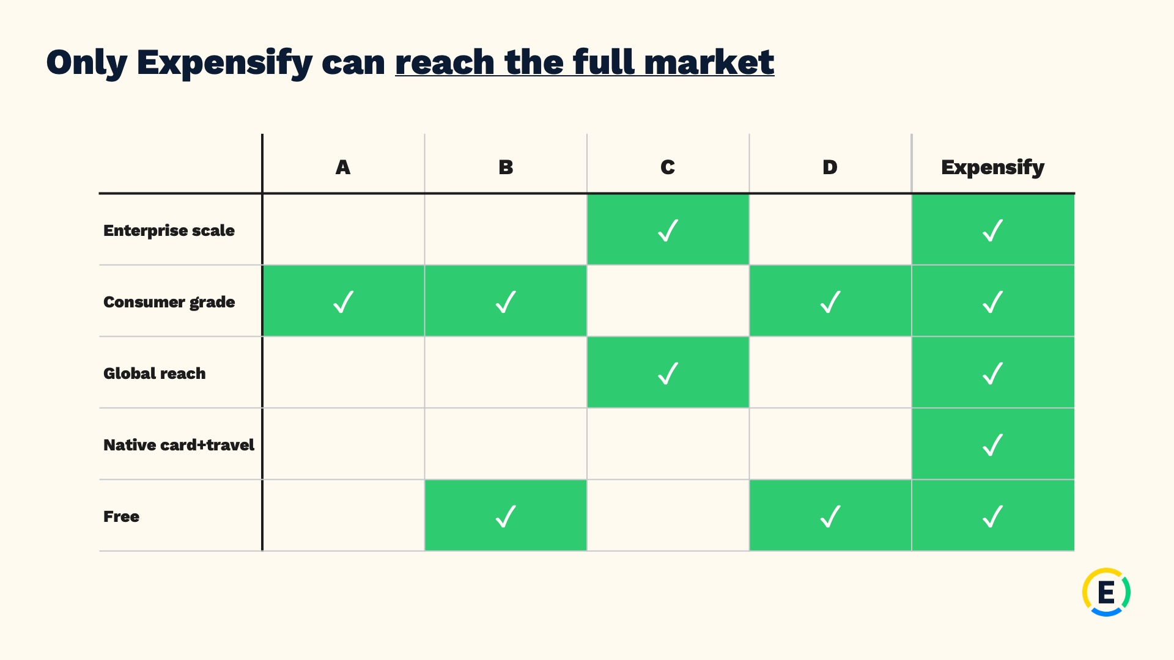

Exhibit 99.2
8
Expensify, Inc.
Investor Presentation

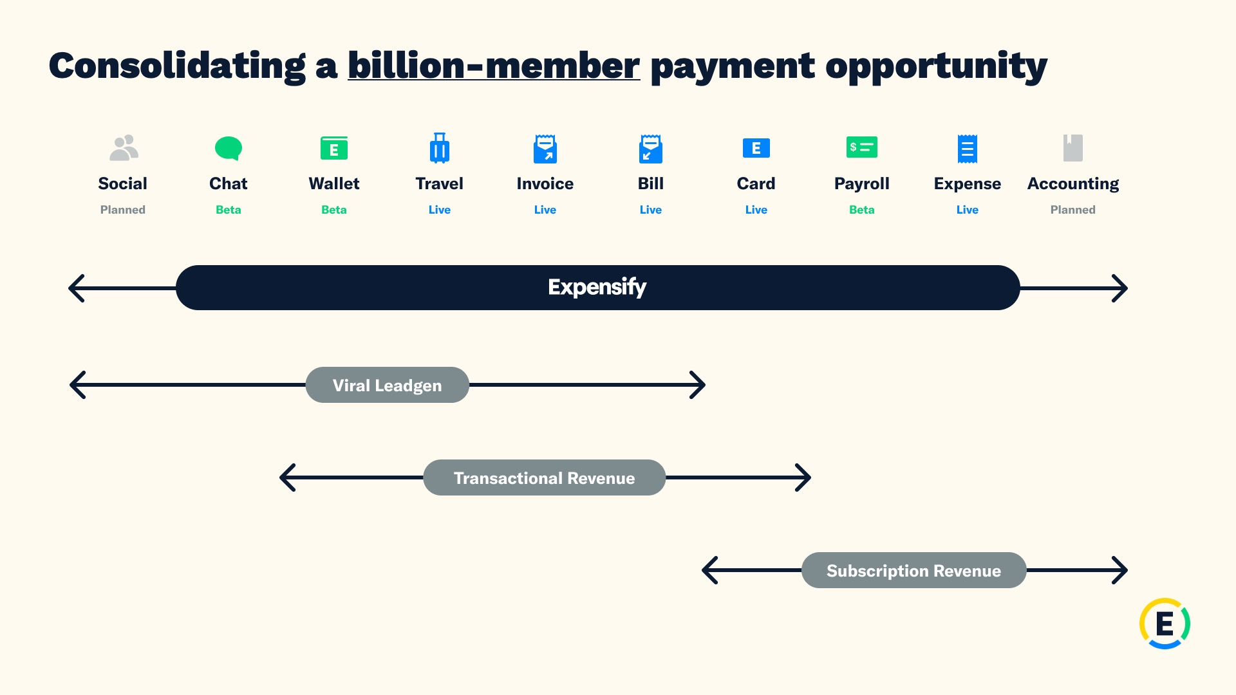

Exhibit 99.2
9
Expensify, Inc.
Investor Presentation



Exhibit 99.2
10
Expensify, Inc.
Investor Presentation



Exhibit 99.2
11
Expensify, Inc.
Investor Presentation


Exhibit 99.2
12
Expensify, Inc.
Investor Presentation


Exhibit 99.2
13
Expensify, Inc.
Investor Presentation

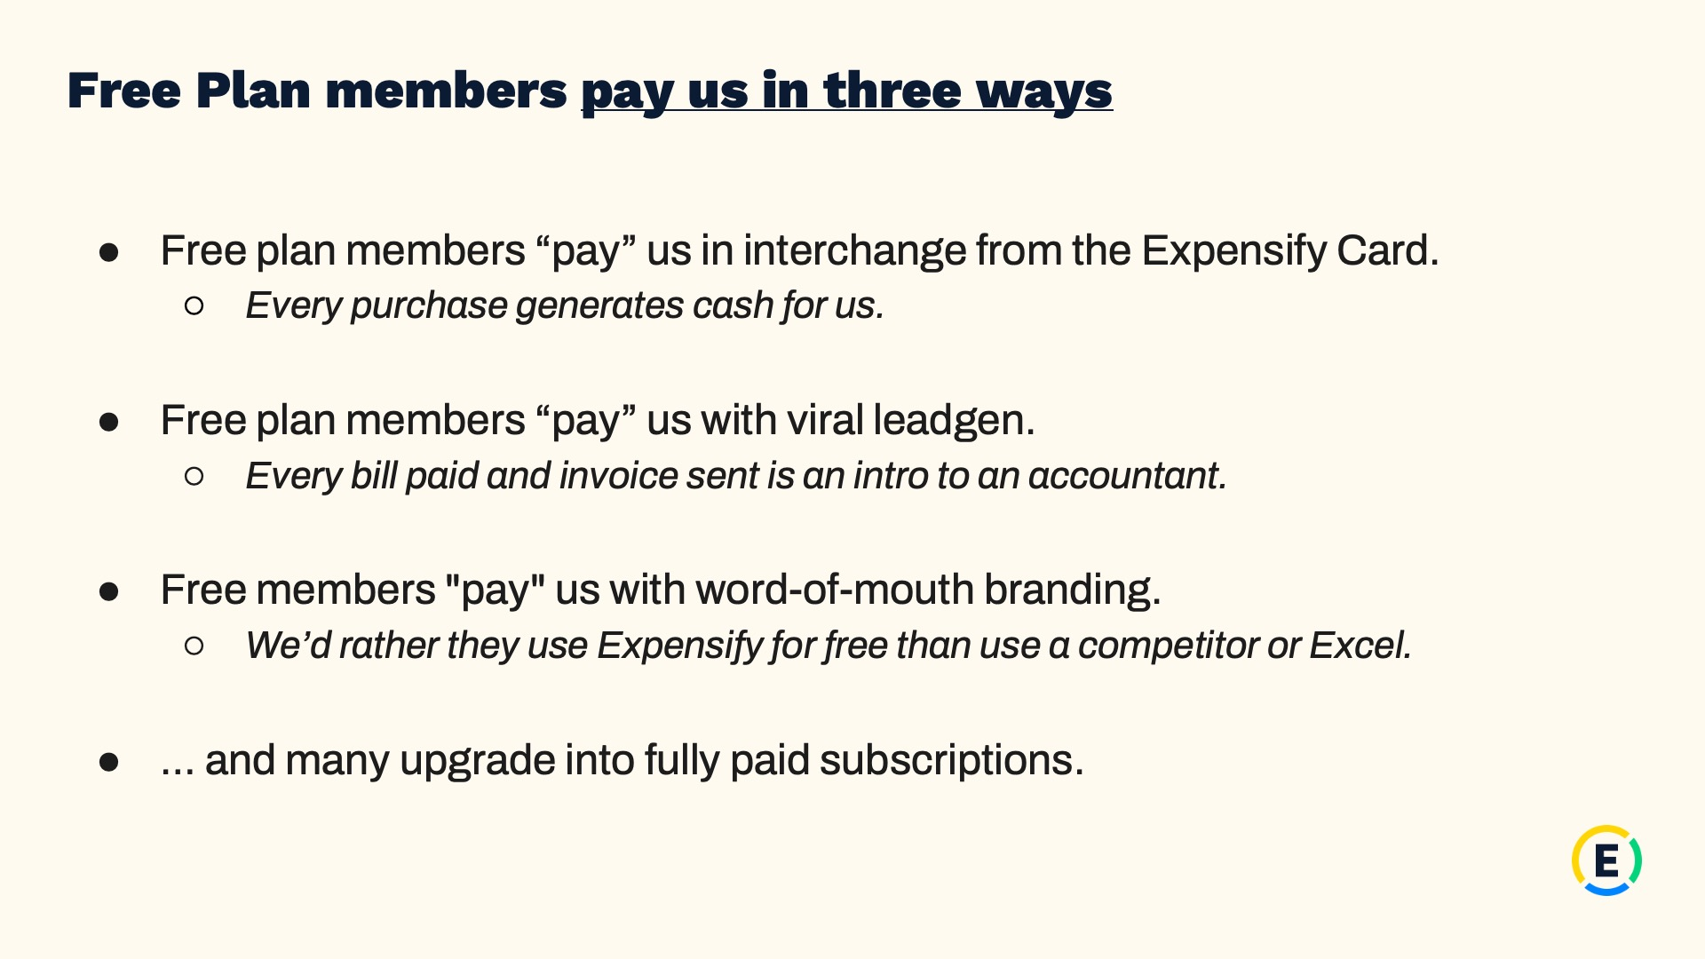
Exhibit 99.2
14
Expensify, Inc.
Investor Presentation


Exhibit 99.2
15
Expensify, Inc.
Investor Presentation

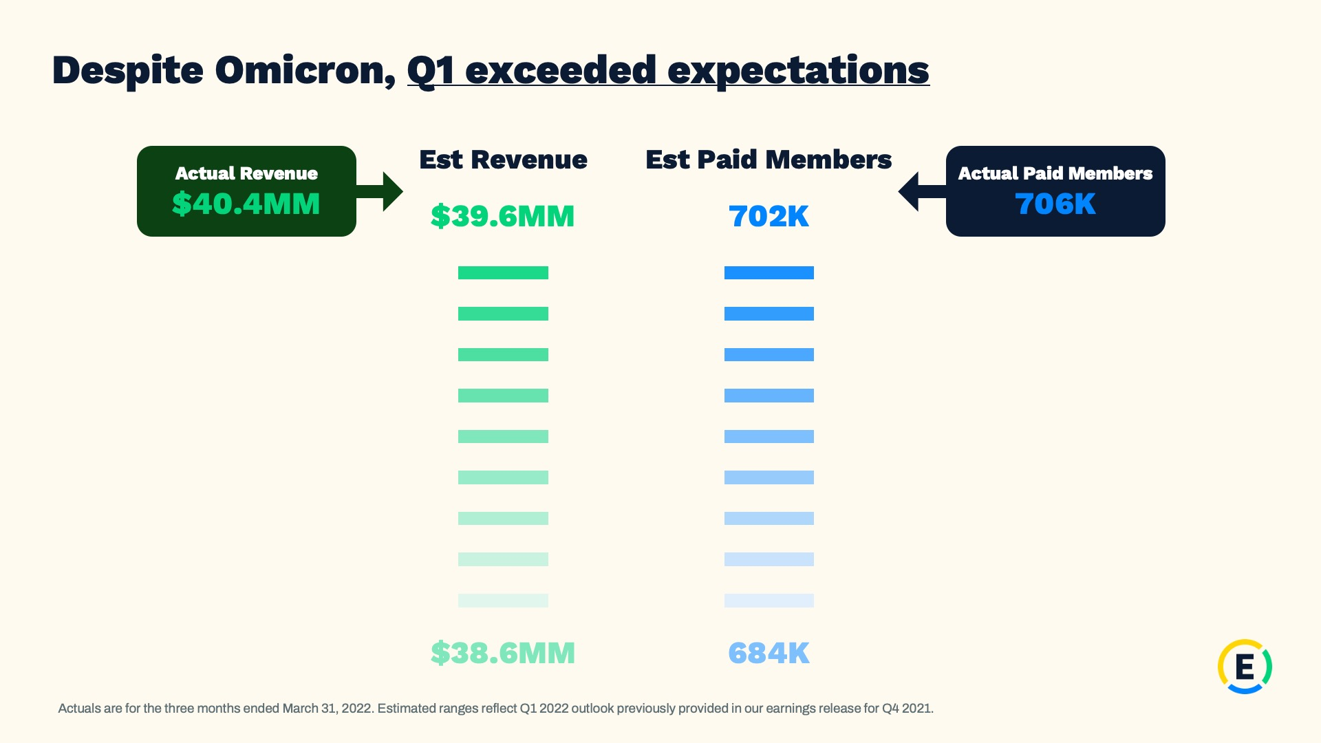
Exhibit 99.2
16
Expensify, Inc.
Investor Presentation

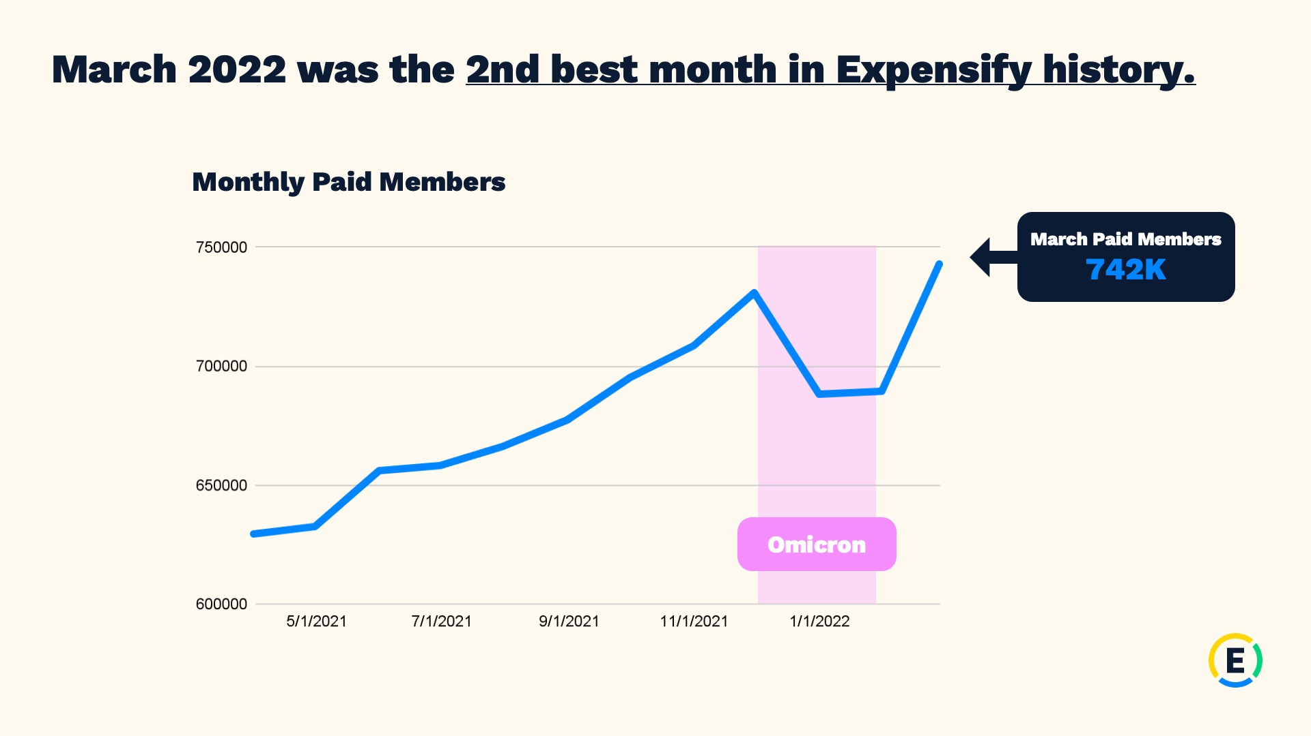
Exhibit 99.2
17
Expensify, Inc.
Investor Presentation

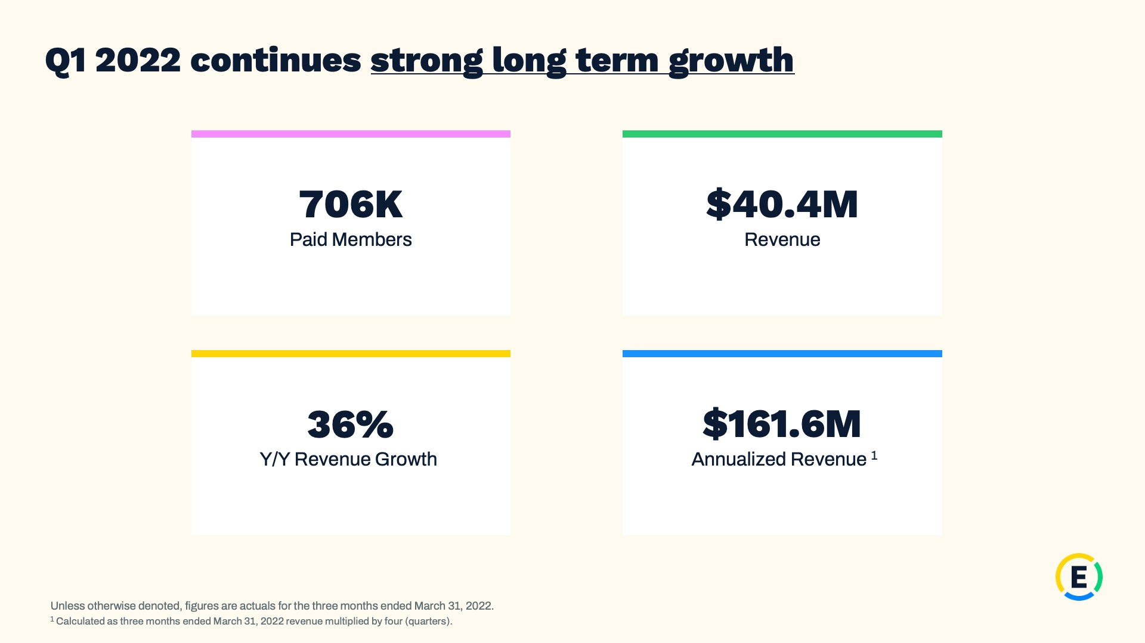
Exhibit 99.2
18
Expensify, Inc.
Investor Presentation

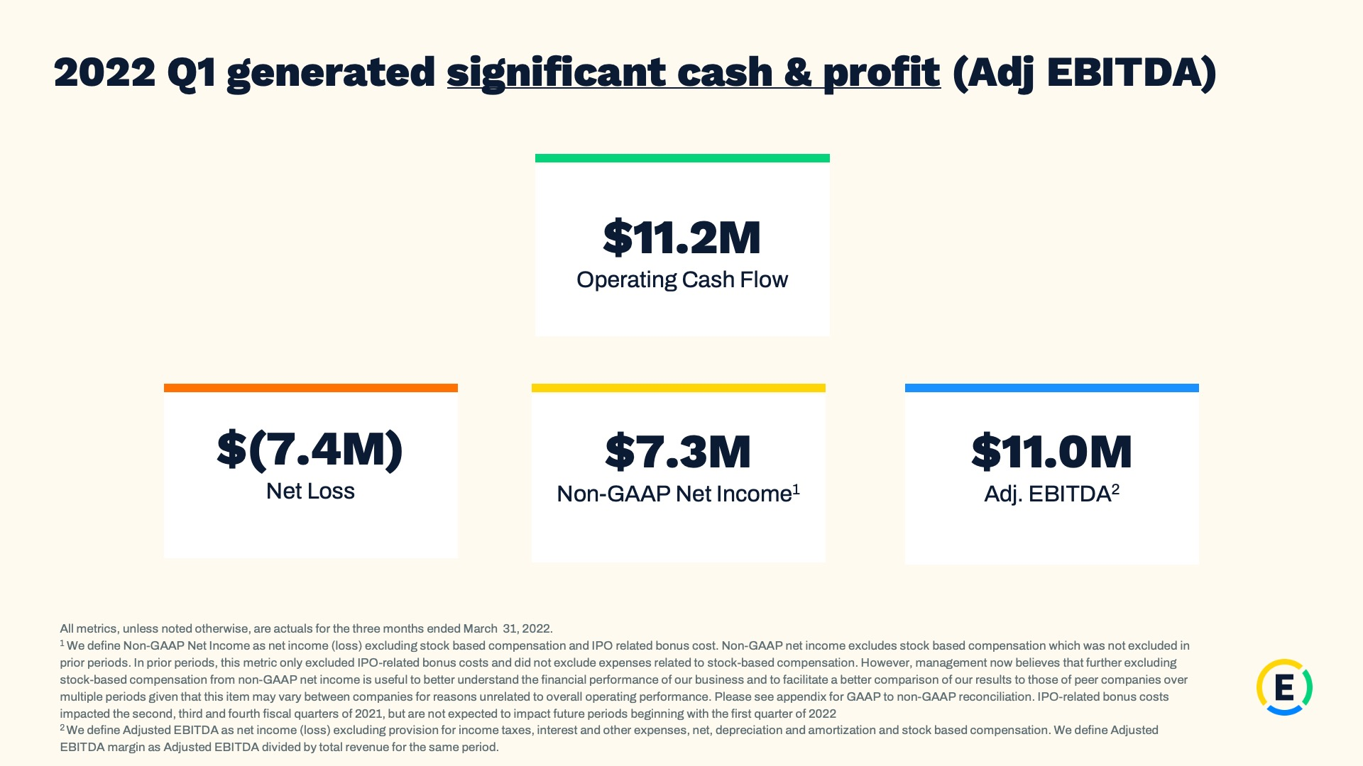
Exhibit 99.2
19
Expensify, Inc.
Investor Presentation

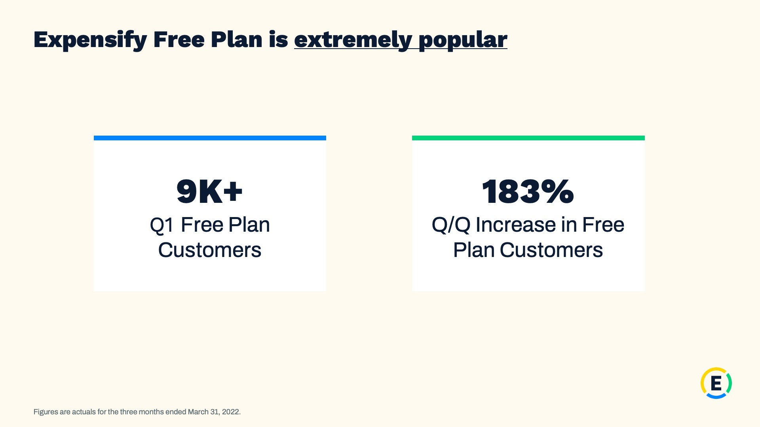
Exhibit 99.2
20
Expensify, Inc.
Investor Presentation

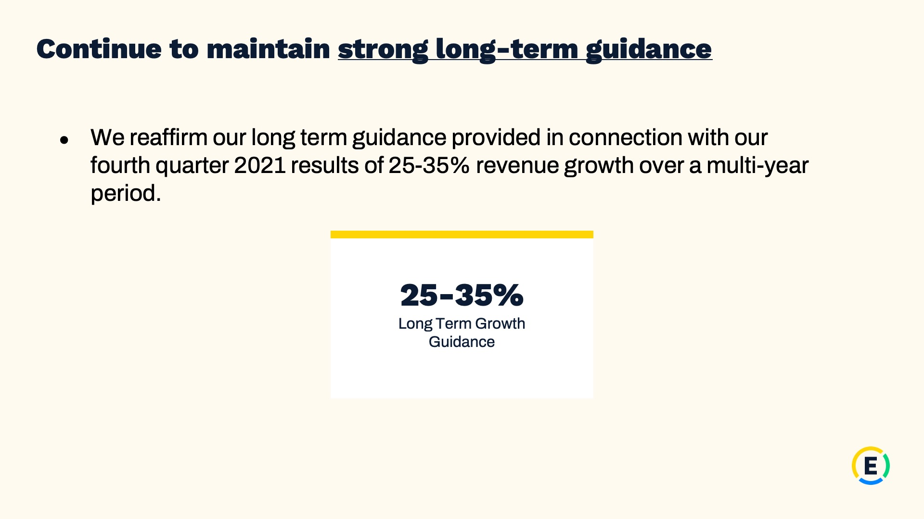
Exhibit 99.2
21
Expensify, Inc.
Investor Presentation


Exhibit 99.2
22
Expensify, Inc.
Investor Presentation

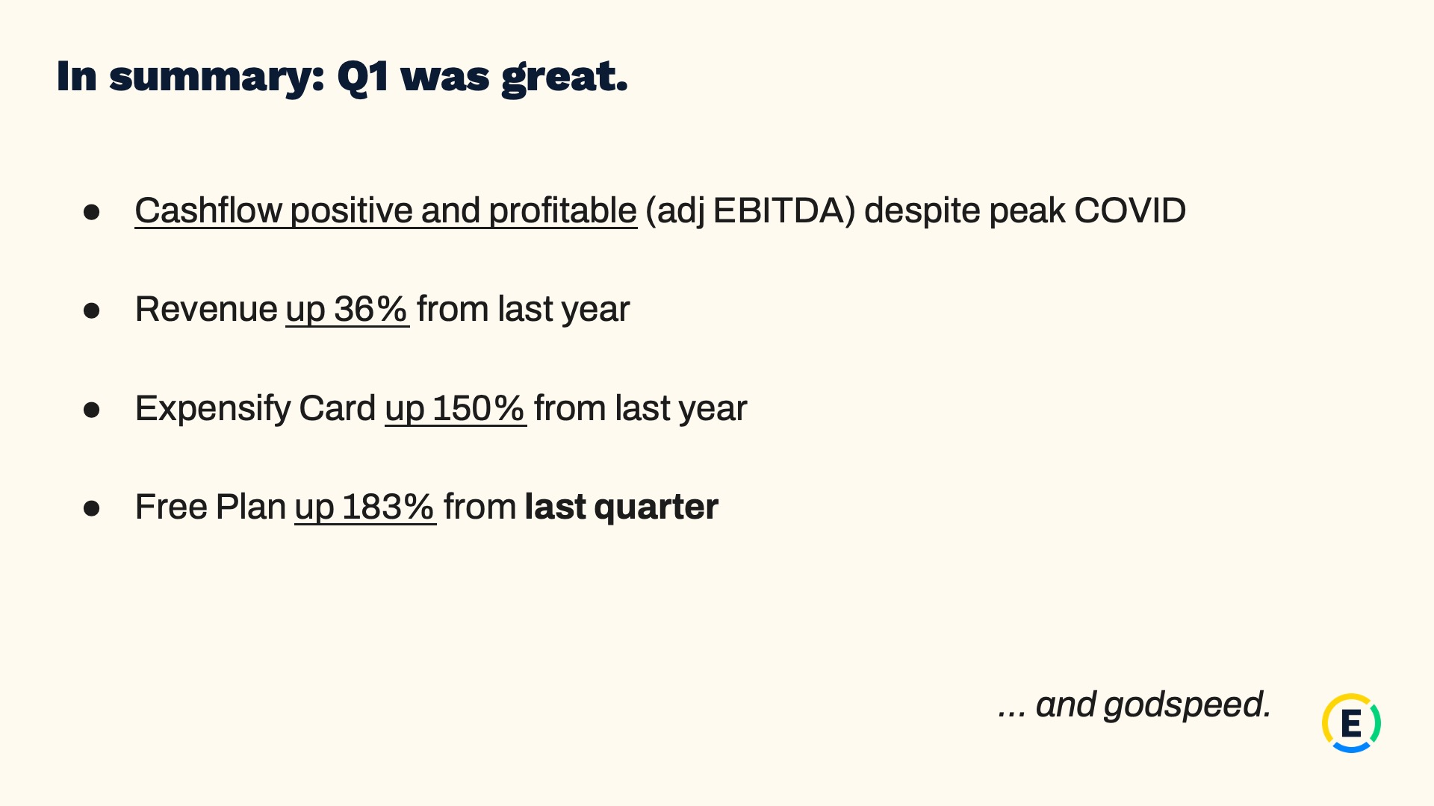
Exhibit 99.2
23
Expensify, Inc.
Investor Presentation


Exhibit 99.2
24
Expensify, Inc.
Investor Presentation


Exhibit 99.2
25
Expensify, Inc.
Investor Presentation

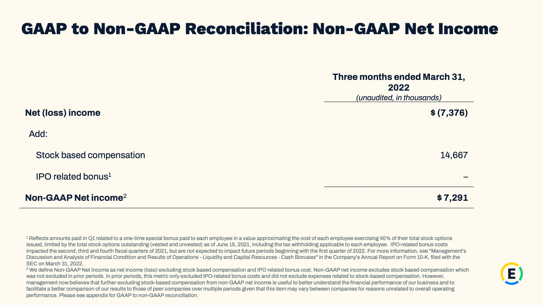
Exhibit 99.2
26
Expensify, Inc.
Investor Presentation

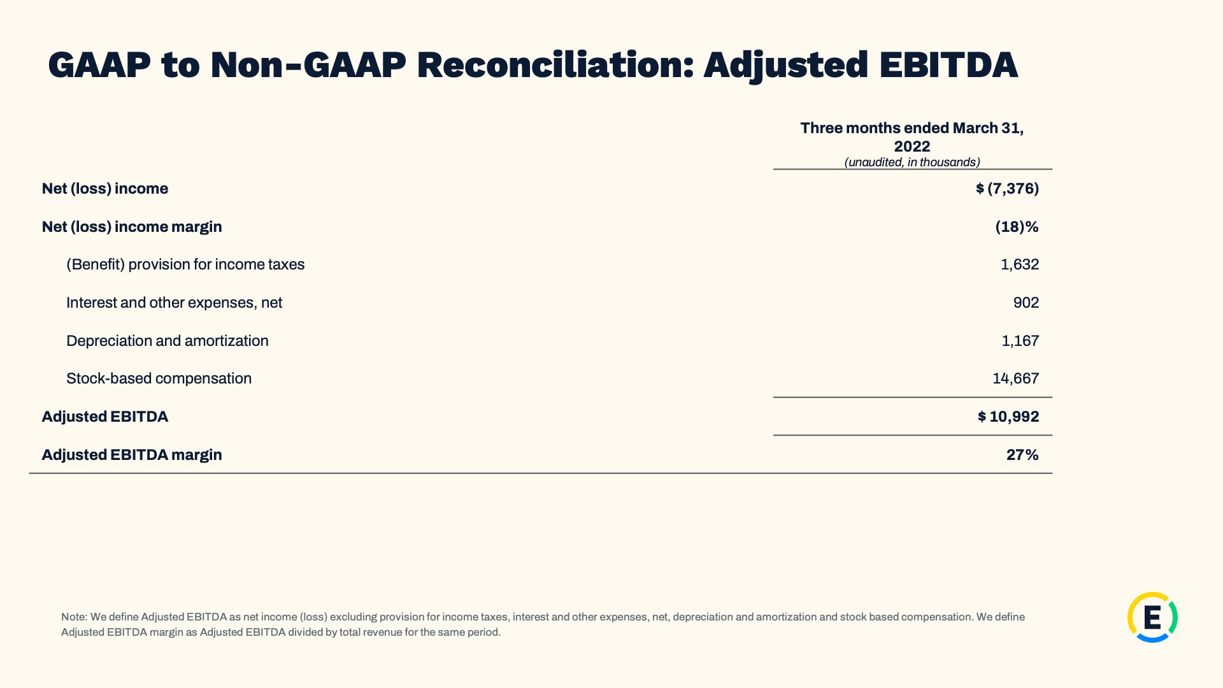
Exhibit 99.2
27
Expensify, Inc.
Investor Presentation

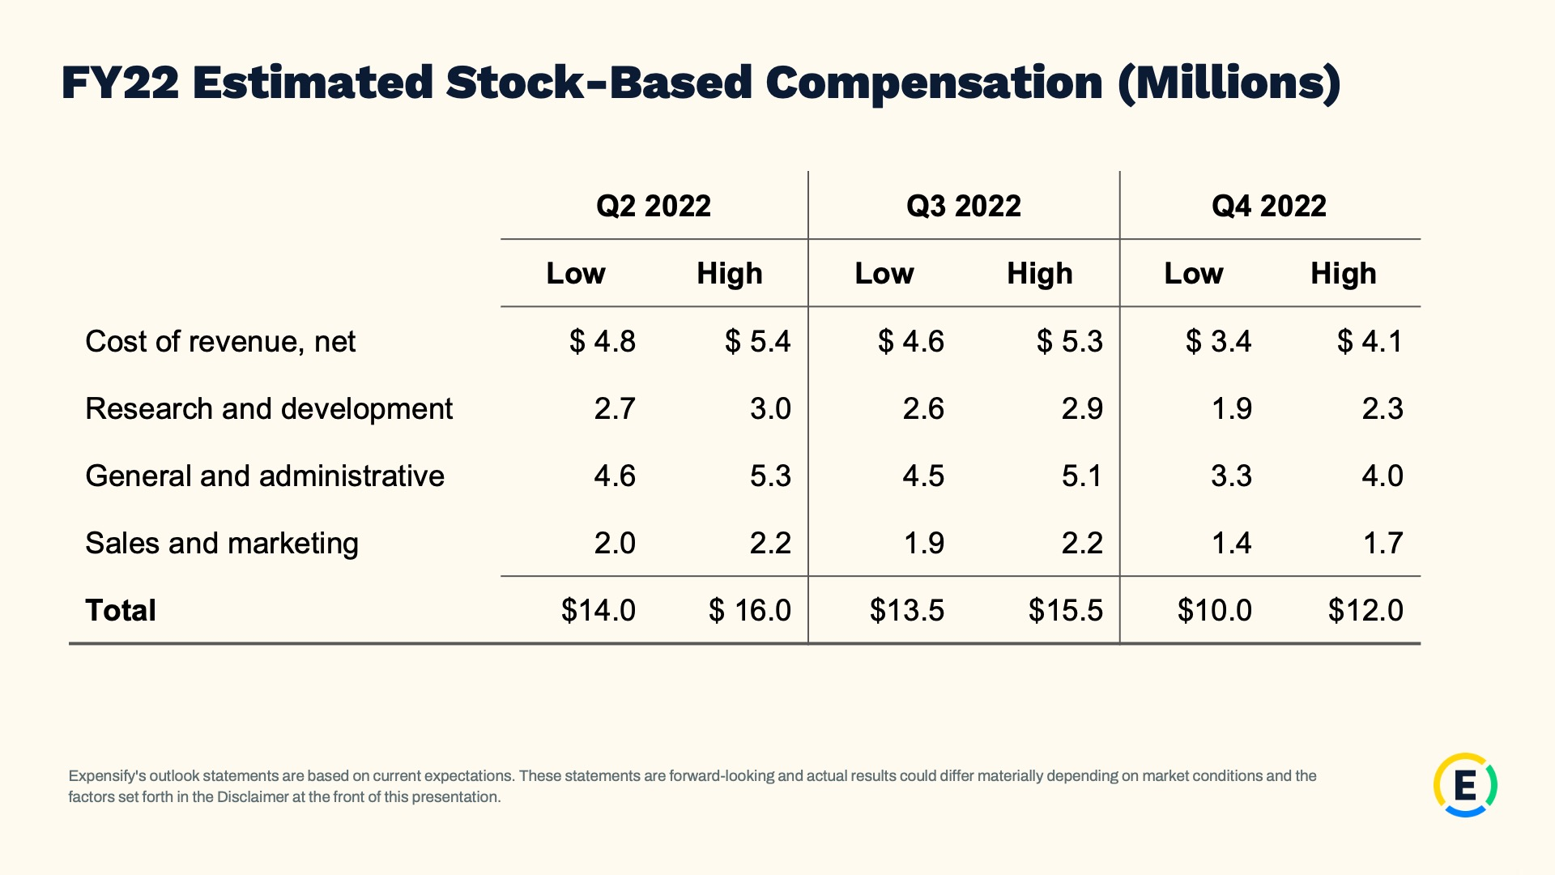
Exhibit 99.2
28
Expensify, Inc.
Investor Presentation

Exhibit 99.3
29
EXPENSIFY ANNOUNCES SHARE REPURCHASE PROGRAM

The program authorizes up to $50 million of Class A common stock to be repurchased.

PORTLAND, Ore.--(BUSINESS WIRE)--May 12, 2022-- Expensify, Inc. (Nasdaq: EXFY), a payments superapp that helps individuals and businesses around the world simplify the way they manage money across expenses, corporate cards and bills, today announced that its Board of Directors approved a new share repurchase program with authorization to purchase up to $50 million of shares of its Class A common stock.

“With the current market volatility due to macroeconomic conditions, we believe there is, and could continue to be, an attractive buying opportunity for our stock. Our positive free cash flow puts us in a good position to be able to initiate a buyback program and return value to our shareholders,” said Expensify CFO, Ryan Schaffer.

The new share repurchase program is designed to return value to shareholders by offsetting dilution from stock issuances and reducing share count over time. Expensify may repurchase shares from time to time through open market purchases, in privately negotiated transactions or by other means, including through the use of trading plans intended to qualify under Rule 10b5-1 under the Securities Exchange Act of 1934, as amended, in accordance with applicable securities laws and other restrictions. The timing and total amount of stock repurchases will depend upon business, economic and market conditions, corporate and regulatory requirements, prevailing stock prices, restrictions under the terms of our loan agreements and other considerations. This program has no termination date, may be suspended or discontinued at any time and does not obligate the company to acquire any amount of common stock.

Forward-Looking Statements

Forward-looking statements in this press release, which are not historical facts, are forward-looking statements within the meaning of the Private Securities Litigation Reform Act of 1955. These statements include statements regarding our intended share repurchases and expected shareholder benefits; expected funding through cash generated from operations; and our expected future free cash flow generation. As a result, our actual results, performance or achievements may differ materially from those expressed or implied by these forward-looking statements. In some cases, you can identify forward-looking statements because they contain words such as “may,” “will,” “shall,” “should,” “expects,” “plans,” “anticipates,” “could,” “intends,” “target,” “projects,” “contemplates,” “believes,” “estimates,” “predicts,” “potential,” “goal,” “objective,” “seeks,” or “continue” or the negative of these words or other similar terms or expressions that concern our expectations, strategy, plans, or intentions. Such forward-looking statements are necessarily based upon estimates and assumptions that, while considered reasonable by us and our management, are inherently uncertain. Factors that may cause actual results to differ materially from current expectations include, but are not limited to: the economic, political and social impact of, and uncertainty relating to, the COVID-19 pandemic; the war in Ukraine and escalating geopolitical tensions as a result of Russia's invasion of Ukraine; our expectations regarding our financial performance and future operating performance; our ability to attract and retain members, expand usage of our platform, sell subscriptions to our platform and convert individuals and organizations into paying customers; the timing and success of new features, integrations, capabilities and enhancements by us, or by competitors to their products, or any other changes in the competitive landscape of our market; the amount and timing of operating expenses and capital expenditures that we may incur to maintain and expand our business and operations to remain competitive; the sufficiency of our cash, cash equivalents and investments to meet our liquidity needs; our ability to make required payments under and to comply with the various requirements of our current and future indebtedness; our ability to effectively manage our exposure to fluctuations in foreign currency exchange rates; the increased expenses associated with being a public company; the size of our addressable markets, market share and market trends; anticipated trends, developments and challenges in our industry, business and the highly competitive markets in which we operate; our expectations regarding our income tax liabilities and the adequacy of our reserves; our ability to effectively manage our growth and expand our infrastructure and maintain our corporate culture; our ability to identify, recruit and retain skilled personnel, including key members of senior management; the safety, affordability and convenience of our platform and our offerings; our ability to successfully defend litigation brought against us; our ability to successfully identify, manage and integrate any existing and potential acquisitions of businesses, talent, technologies or intellectual
Exhibit 99.3

property; general economic conditions in either domestic or international markets, including the societal and economic impact of the COVID-19 pandemic, and geopolitical uncertainty and instability; our protections against security breaches, technical difficulties, or interruptions to our platform; our ability to maintain, protect and enhance our intellectual property; and other risks discussed in our filings with the SEC. All forward-looking statements attributable to us or persons acting on our behalf are expressly qualified in their entirety by the cautionary statements set forth above. We caution you not to place undue reliance on any forward-looking statements, which are made only as of the date of this press release. We do not undertake or assume any obligation to update publicly any of these forward-looking statements to reflect actual results, new information or future events, changes in assumptions or changes in other factors affecting forward-looking statements, except to the extent required by applicable law. If we update one or more forward-looking statements, no inference should be drawn that we will make additional updates with respect to those or other forward-looking statements.

About Expensify

Expensify is a payments superapp that helps individuals and businesses around the world simplify the way they manage money. More than 10 million people use Expensify's free features, which include corporate cards, expense tracking, next-day reimbursement, invoicing, bill pay, and travel booking in one app. All free. Whether you own a small business, manage a team, or close the books for your clients, Expensify makes it easy so you have more time to focus on what really matters.

