UNITED STATES
SECURITIES AND EXCHANGE COMMISSION
Washington, D.C. 20549
FORM 8-K
CURRENT REPORT
PURSUANT TO SECTION 13 OR 15(d)
OF THE SECURITIES EXCHANGE ACT OF 1934
Date of report (Date of earliest event reported): August 8, 2023
Expensify, Inc.
(Exact Name of Registrant as Specified in its Charter)
Delaware |  |  |  |  |  | 001-41043 |  |  |  |  |  | 27-0239450
(State or Other Jurisdiction  of Incorporation) |  |  |  |  |  | (Commission  File Number) |  |  |  |  |  | (IRS Employer  Identification No.)
401 SW 5th Ave
Portland, Oregon 97204
(Address of Principal Executive Offices) (Zip Code)
(971) 365-3939
(Registrant’s telephone number, including area code)
Not applicable
(Former Name or Former Address, if Changed Since Last Report)
Check the appropriate box below if the Form 8-K filing is intended to simultaneously satisfy the filing obligation of the registrant under any of the following provisions:
☐ |  |  |  |  |  | Written communications pursuant to Rule 425 under the Securities Act (17 CFR 230.425).
☐ |  |  |  |  |  | Soliciting material pursuant to Rule 14a-12 under the Exchange Act (17 CFR 240.14a-12).
☐ |  |  |  |  |  | Pre-commencement communications pursuant to Rule 14d-2(b) under the Exchange Act (17 CFR 240.14d-2(b)).
☐ |  |  |  |  |  | Pre-commencement communications pursuant to Rule 13e-4(c) under the Exchange Act (17 CFR 240.13e-4(c)).
Securities registered pursuant to Section 12(b) of the Act:
Title of each class |  |  |  |  |  | Trading  Symbol(s) |  |  |  |  |  | Name of each exchange  on which registered
Class A Common Stock, par value $0.0001 per share |  |  |  |  |  | EXFY |  |  |  |  |  | The Nasdaq Stock Market LLC
Indicate by check mark whether the registrant is an emerging growth company as defined in Rule 405 of the Securities Act of 1933 (§230.405 of this chapter) or Rule 12b-2 of the Securities Exchange Act of 1934 (§240.12b-2 of this chapter).
Emerging growth company ☐
If an emerging growth company, indicate by check mark if the registrant has elected not to use the extended transition period for complying with any new or revised financial accounting standards provided pursuant to Section 13(a) of the Exchange Act. ☐

Item 2.02 Results of Operations and Financial Condition.
On August 8, 2023, Expensify, Inc. (“Expensify” or the “Company”) issued a press release announcing its financial results for the quarter ended June 30, 2023. A copy of this press release is furnished as Exhibit 99.1 to this current report on Form 8-K and is incorporated herein by reference.

Item 7.01 Regulation FD Disclosure.
On August 8, 2023, the Company posted an investor presentation to its website at https://ir.expensify.com (the “Investor Presentation”). A copy of the Investor Presentation is furnished as Exhibit 99.2 to this current report on Form 8-K and is incorporated herein by reference. The Company expects to use the Investor Presentation, in whole or in part, and possibly with modifications, in connection with presentations to investors, analysts and others.
The information contained in the Investor Presentation is summary information that is intended to be considered in the context of the Company’s Securities and Exchange Commission (“SEC”) filings and other public announcements that the Company may make, by press release or otherwise, from time to time. The Investor Presentation speaks only as of the date of this current report on Form 8-K. The Company undertakes no duty or obligation to publicly update or revise the information included in the Investor Presentation, although it may do so from time to time. Any such updating may be made through the filing of other reports or documents with the SEC, through press releases or other public disclosure. In addition, the exhibit furnished herewith contains statements intended as “forward-looking statements” that are subject to the cautionary statements about forward-looking statements set forth in such exhibit. By furnishing the information contained in the Investor Presentation, the Company makes no admission as to the materiality of any information in the Investor Presentation that is required to be disclosed solely by reason of Regulation FD.

The information contained in Item 2.02 and this Item 7.01, including Exhibits 99.1 and 99.2, is being furnished and shall not be deemed “filed” for purposes of Section 18 of the Securities and Exchange Act of 1934, as amended (the “Exchange Act”), or otherwise subject to the liabilities of that section, nor shall it be deemed incorporated by reference in any filing made by Expensify under the Securities Act of 1933, as amended, or the Exchange Act, except as expressly set forth by specific reference in such a filing.

Item 9.01 Financial Statements and Exhibits.
(d) Exhibits.
Exhibit No. |  |  |  |  |  | Description
99.1 |  |  |  |  |  | Press Release issued by Expensify, Inc., dated August 8, 2023.
99.2 |  |  |  |  |  | Investor Presentation, dated August 8, 2023.
104 |  |  |  |  |  | Cover Page Interactive Data File (embedded within the Inline XBRL document).

SIGNATURE
Pursuant to the requirements of the Securities Exchange Act of 1934, the registrant has duly caused this report to be signed on its behalf by the undersigned hereunto duly authorized.
Expensify, Inc.
By: |  |  |  |  |  | /s/ Ryan Schaffer
Name: |  |  |  |  |  | Ryan Schaffer
Title: |  |  |  |  |  | Chief Financial Officer
Date: August 8, 2023

Exhibit 99.1

EXPENSIFY ANNOUNCES Q2 2023 RESULTS
Expensify Card interchange increased by 56% as compared to the previous period last year. Company repurchased $3.9 million in common shares (including $0.9 million of net share settlement on equity awards), decreased outstanding debt by $8.2 million.

PORTLAND, Ore.--(BUSINESS WIRE)--August 8, 2023-- Expensify, Inc. (Nasdaq: EXFY), a payments superapp that helps individuals and businesses around the world simplify the way they manage money across expenses, corporate cards and bills, today released a letter to shareholders from Founder and CEO David Barrett alongside results for its quarter ended June 30, 2023.

A Message From Our Founder

This is an exciting time for the expense management industry. As long predicted, our major competitors have abandoned their interchange-only business models and announced a transition to Expensify-style subscription pricing plans. This welcome change signals the beginning of the end of this strange, distorted period where free options were being dumped into the industry at a perpetual loss. We knew it couldn't last forever, and we're thankful that reality is starting to sink in, because Expensify's ultimate strength is its amazing unit economics.

With twelve consecutive quarters of profitability (on an Adjusted EBITDA basis), we have spent our entire history gearing up for a long and grueling battle in the trenches, and we relish the fight. While weathering the combined fire of our competition in the current, tiny, heavily contested corner of the market, we believe we are the only ones genuinely preparing for the next order of magnitude, targeting the 100MM+ businesses in the world that have never heard of any of us. And those preparations are going great:

•We deployed our cross-platform, open-source, universal chat foundation at multiple real world conferences, acquiring 3x the leads that our booth traditionally has -- while enabling a presence at 10x the conferences at 1/10th the cost of attending physically. After all, it doesn't matter what the conference is about: if it's for business, every single attendee is likely to file an expense report after.

•We began our first real world expense reimbursements on the New Expensify platform, proving out the "universal" nature of our chat-first payment design -- and are aggressively porting over more advanced cases to begin testing with live customers.

•We activated ChatGPT for high quality, high scale, real time content moderation, and are beginning to incorporate it throughout our chat-first sales, support, and product design.

On top of these major investments in revolutionary product design, we plan to continue making a full court press with evolutionary enhancements to our SDRs, SEO, SEM, dedicated sales, account management, and other more traditional growth tools, all of which are showing strong improvement. But the real opportunity is still in cracking open a market 10-100x larger than what we've ever seen before. Building this vision has admittedly taken longer than we estimated, giving more oxygen to our competition than we would have liked. But we remain convinced we are the only ones on the right path towards the biggest opportunity in the shortest time frame, even despite the stiffer than expected headwinds in the near term.

-david
Founder and CEO of Expensify

Exhibit 99.1

Second Quarter 2023 Highlights

Financial:
•Revenue was $38.9 million, a decrease of 10% compared to the same period last year.
•Utilized $0.4 million cash in operating activities and generated $1.1 million of free cash flow.
•Net loss was $11.3 million, compared to $8.0 million for the same period last year.
•Non-GAAP net loss was $1.0 million.
•Adjusted EBITDA was $2.2 million.
•Interchange derived from the Expensify Card grew to $2.7 million, an increase of 56% compared to the same period last year.
Business
•Paid members - Paid members were 742,000, a decrease of 2% from the same period last year.
•Hosted ExpensiCon 3 - An invite-only conference featuring successful accountants and thought leaders from top global accounting firms.
•Preferred agreements - Signed preferred partnership agreements with the California Society of Certified Public Accountants and the Texas Society of Certified Public Accountants.
•Share repurchase - The Company repurchased 625,345 shares during the quarter, representing 0.8% of total outstanding common shares, at a total cost of $3.9 million (including $0.9 million of net share settlement on equity awards). Since the approval of the Company’s share repurchase program in May 2022, the Company has repurchased shares at a total cost of $15.9 million (including $6.9 million of net share settlement on equity awards).
•Debt reduction - The Company reduced its outstanding debt balance by $8.2 million during the quarter.
•Global reimbursement - The Company expanded its employee reimbursement functionality; businesses can now reimburse employees in over 154 different currencies in more than 200 countries.

Exhibit 99.1

Financial Outlook
Expensify's outlook statements are based on current estimates, expectations and assumptions and are not a guarantee of future performance. The following statements are forward-looking and actual results could differ materially depending on market conditions and the factors set forth under “Forward-Looking Statements” below. There can be no assurance that the Company will achieve the results expressed by this guidance.

An estimate of expected stock-based compensation for the next four fiscal quarters is as follows, which is driven primarily by the pre-IPO grant of RSUs issued to all employees (which vest quarterly over eight years with approximately six years remaining).

Est. stock-based compensation (millions)
 |  |  | Q3 2023 |  |  |  |  |  |  |  |  |  |  |  | Q4 2023 |  |  |  |  |  |  |  |  |  |  |  | Q1 2024 |  |  |  |  |  |  |  |  |  |  |  | Q2 2024
 |  |  | Low |  |  |  |  |  | High |  |  |  |  |  | Low |  |  |  |  |  | High |  |  |  |  |  | Low |  |  |  |  |  | High |  |  |  |  |  | Low |  |  |  |  |  | High
Cost of revenue, net |  |  | $ | 3.4 |  |  |  |  | $ | 4.1 |  |  |  |  | $ | 3.3 |  |  |  |  | $ | 4.0 |  |  |  |  | $ | 3.2 |  |  |  |  | $ | 3.9 |  |  |  |  | $ | 3.1 |  |  |  |  | $ | 3.7
Research and development |  |  | 3.1 |  |  |  |  |  | 3.6 |  |  |  |  |  | 3.0 |  |  |  |  |  | 3.6 |  |  |  |  |  | 2.9 |  |  |  |  |  | 3.5 |  |  |  |  |  | 2.7 |  |  |  |  |  | 3.3
General and administrative |  |  | 2.1 |  |  |  |  |  | 2.5 |  |  |  |  |  | 2.0 |  |  |  |  |  | 2.4 |  |  |  |  |  | 1.9 |  |  |  |  |  | 2.3 |  |  |  |  |  | 1.8 |  |  |  |  |  | 2.2
Sales and marketing |  |  | 1.8 |  |  |  |  |  | 2.2 |  |  |  |  |  | 1.8 |  |  |  |  |  | 2.1 |  |  |  |  |  | 1.7 |  |  |  |  |  | 2.0 |  |  |  |  |  | 1.6 |  |  |  |  |  | 2.0
Total |  |  | $ | 10.4 |  |  |  |  | $ | 12.4 |  |  |  |  | $ | 10.1 |  |  |  |  | $ | 12.1 |  |  |  |  | $ | 9.7 |  |  |  |  | $ | 11.7 |  |  |  |  | $ | 9.2 |  |  |  |  | $ | 11.2

Availability of Information on Expensify’s Website
Investors and others should note that Expensify routinely announces material information to investors and the marketplace using SEC filings, press releases, public conference calls, webcasts and the Expensify Investor Relations website at https://ir.expensify.com. While not all of the information that the Company posts to its Investor Relations website is of a material nature, some information could be deemed to be material. Accordingly, the Company encourages investors, the media and others interested in Expensify to review the information that it shares on its Investor Relations website.

Conference Call
Expensify will host a video call to discuss the financial results and business highlights at 2:00 p.m. Pacific Time today. An investor presentation and the video call information is available on Expensify’s Investor Relations website at https://ir.expensify.com. A replay of the call will be available on the site for three months.

Non-GAAP Financial Measures
In addition to financial measures prepared in accordance with U.S. generally accepted accounting principles (“GAAP”), we provide certain non-GAAP financial measures, including adjusted EBITDA, adjusted EBITDA margin, non-GAAP net loss, and free cash flow.

We believe our non-GAAP financial measures are useful in evaluating our business, measuring our performance, identifying trends affecting our business, formulating business plans and making strategic decisions. Accordingly, we believe that these non-GAAP financial measures provide useful information to investors and others in understanding and evaluating our results of operations in the same manner as our management team. These non-GAAP financial measures are presented for supplemental informational purposes only, should not be considered a substitute for financial information presented in accordance with GAAP, and may be different from similarly titled metrics or measures presented by other companies. Non-GAAP financial measures have limitations as analytical tools and should not be considered in isolation or as substitutes for financial information presented under GAAP. There are a number of limitations related to the use of non-GAAP financial measures versus comparable financial measures determined under GAAP. For example, other companies in our industry may calculate these non-GAAP financial measures differently or may use other measures to evaluate their performance. All of these limitations
Exhibit 99.1

could reduce the usefulness of these non-GAAP financial measures as analytical tools. Investors are encouraged to review the related GAAP financial measures and the reconciliations of these non-GAAP financial measures to their most directly comparable GAAP financial measures and to not rely on any single financial measure to evaluate our business. A reconciliation of each non-GAAP financial measure to the most directly comparable financial measure stated in accordance with GAAP is at the end of this press release.

Adjusted EBITDA. We define adjusted EBITDA as net income from operations excluding provision for income taxes, interest and other expenses, net, depreciation and amortization and stock-based compensation.

Non-GAAP net loss. We define non-GAAP net loss as net income (loss) from operations in accordance with US GAAP excluding stock-based compensation.

Free cash flow. We define Free cash flow as net cash (used in) provided by operating activities excluding changes in settlement assets and settlement liabilities, which represent funds held for customers and customer funds in transit, respectively, reduced by the purchases of property and equipment and software development costs.

The tables at the end of the Condensed Consolidated Financial Statements provide reconciliations to the most directly comparable GAAP financial measure to each of these non-GAAP financial measures.

Forward-Looking Statements
Forward-looking statements in this press release, or made during the earnings call, which are not historical facts, are forward-looking statements within the meaning of the Private Securities Litigation Reform Act of 1955. These statements include statements regarding our strategy, future financial condition, future operations, projected costs, prospects, plans, objectives of management and expected market growth, product developments and their potential impact, our ability to meet our long-term guidance, the amount and timing of any share repurchases and our stock-based compensation estimates and involve known and unknown risks that are difficult to predict. As a result, our actual results, performance or achievements may differ materially from those expressed or implied by these forward-looking statements. In some cases, you can identify forward-looking statements because they contain words such as “may,” “will,” “shall,” “should,” “expects,” “plans,” “anticipates,” “could,” “intends,” “target,” “projects,” “contemplates,” “believes,” “estimates,” “predicts,” “potential,” “goal,” “ambition,” “objective,” “seeks,” “outlook,” or “continue” or the negative of these words or other similar terms or expressions that concern our expectations, strategy, plans, or intentions. Such forward-looking statements are necessarily based upon estimates and assumptions that, while considered reasonable by us and our management, are inherently uncertain. Factors that may cause actual results to differ materially from current expectations include, but are not limited to: the impact on inflation on us and our members; our borrowing costs have and may continue to increase as a result of increases in interest rates; our expectations regarding our financial performance and future operating performance; our ability to attract and retain members, expand usage of our platform, sell subscriptions to our platform and convert individuals and organizations into paying customers; the timing and success of new features, integrations, capabilities and enhancements by us, or by competitors to their products, or any other changes in the competitive landscape of our market; the amount and timing of operating expenses and capital expenditures that we may incur to maintain and expand our business and operations to remain competitive; the sufficiency of our cash, cash equivalents and investments to meet our liquidity needs; our ability to make required payments under and to comply with the various requirements of our current and future indebtedness; our cash flows, the prevailing stock prices, general economic and market conditions and other considerations that could affect the specific timing, price and size of repurchases under our stock repurchase program or our ability to fund any stock repurchases; the war in Ukraine and escalating geopolitical tensions as a result of Russia's invasion of Ukraine; our ability to effectively manage our exposure to fluctuations in foreign currency exchange rates; the increased expenses associated with being a public company; the size of our addressable markets, market share and market trends; anticipated trends, developments and challenges in our industry, business and the highly competitive markets in which we operate; our expectations regarding our income tax liabilities and the adequacy of our reserves; our ability to effectively manage our growth and expand our infrastructure and maintain our corporate culture; our ability to identify, recruit and retain skilled personnel, including key members of senior management; the safety, affordability and convenience of our platform and our offerings; our ability to successfully defend litigation brought against us; our ability to successfully identify, manage and integrate any existing and potential acquisitions of businesses, talent, technologies or intellectual property;
Exhibit 99.1

general economic conditions in either domestic or international markets; our protections against security breaches, technical difficulties, or interruptions to our platform; our ability to maintain, protect and enhance our intellectual property; and other risks discussed in our filings with the SEC. All forward-looking statements attributable to us or persons acting on our behalf are expressly qualified in their entirety by the cautionary statements set forth above. We caution you not to place undue reliance on any forward-looking statements, which are made only as of the date of this press release. We do not undertake or assume any obligation to update publicly any of these forward-looking statements to reflect actual results, new information or future events, changes in assumptions or changes in other factors affecting forward-looking statements, except to the extent required by applicable law. If we update one or more forward-looking statements, no inference should be drawn that we will make additional updates with respect to those or other forward-looking statements.

About Expensify
Expensify is a payments superapp that helps individuals and businesses around the world simplify the way they manage money. More than 12 million people use Expensify's free features, which include corporate cards, expense tracking, next-day reimbursement, invoicing, bill pay, and travel booking in one app. All free. Whether you own a small business, manage a team, or close the books for your clients, Expensify makes it easy so you have more time to focus on what really matters.

Investor Relations Contact
Nick Tooker
investors@expensify.com
Press Contact
James Dean
press@expensify.com

Expensify, Inc.
Condensed Consolidated Balance Sheets
(unaudited, in thousands, except share data)
 |  |  | As of June 30, |  |  |  |  |  | As of December 31,
 |  |  | 2023 |  |  |  |  |  | 2022
Assets
Cash and cash equivalents |  |  | $ | 97,795 |  |  |  |  | $ | 103,787
Accounts receivable, net |  |  | 14,922 |  |  |  |  |  | 16,448
Settlement assets, net |  |  | 39,276 |  |  |  |  |  | 35,838
Prepaid expenses |  |  | 5,050 |  |  |  |  |  | 8,825
Other current assets |  |  | 24,606 |  |  |  |  |  | 22,217
Total current assets |  |  | 181,649 |  |  |  |  |  | 187,115
Capitalized software, net |  |  | 8,617 |  |  |  |  |  | 6,881
Property and equipment, net |  |  | 14,545 |  |  |  |  |  | 14,492
Lease right-of-use assets |  |  | 6,417 |  |  |  |  |  | 745
Deferred tax assets, net |  |  | 409 |  |  |  |  |  | 344
Other assets |  |  | 749 |  |  |  |  |  | 664
Total assets |  |  | $ | 212,386 |  |  |  |  | $ | 210,241
Liabilities and stockholders' equity
Accounts payable |  |  | $ | 1,691 |  |  |  |  | $ | 1,059
Accrued expenses and other liabilities |  |  | 11,650 |  |  |  |  |  | 9,070
Borrowings under line of credit |  |  | 15,000 |  |  |  |  |  | 15,000
Current portion of long-term debt, net of original issue discount and debt issuance costs |  |  | 557 |  |  |  |  |  | 551
Lease liabilities, current |  |  | 278 |  |  |  |  |  | 800
Settlement liabilities |  |  | 32,500 |  |  |  |  |  | 33,882
Total current liabilities |  |  | 61,676 |  |  |  |  |  | 60,362
Lease liabilities, non-current |  |  | 6,226 |  |  |  |  |  | —
Other liabilities |  |  | 1,441 |  |  |  |  |  | 1,204
Long-term debt, net of original issue discount and debt issuance costs |  |  | 43,180 |  |  |  |  |  | 51,434
Total liabilities |  |  | 112,523 |  |  |  |  |  | 113,000
Commitments and contingencies
Stockholders' equity:
Preferred stock, par value $0.0001; 10,000,000 shares of preferred stock authorized as of June 30, 2023 and December 31, 2022; no shares of preferred stock issued and outstanding as of June 30, 2023 and December 31, 2022 |  |  | — |  |  |  |  |  | —
Common stock, par value $0.0001; 1,000,000,000 shares of Class A common stock authorized as of June 30, 2023 and December 31, 2022; 68,347,794 and 68,238,245 shares of Class A common stock issued and outstanding as of June 30, 2023 and December 31, 2022, respectively; 24,996,238 and 24,997,561 shares of LT10 common stock authorized as of June 30, 2023 and December 31, 2022, respectively; 7,334,868 and 7,336,191 shares of LT10 common stock issued and outstanding as of June 30, 2023 and December 31, 2022, respectively; 24,999,020 shares of LT50 common stock authorized as of June 30, 2023 and December 31, 2022; 7,093,829 and 6,854,931 shares of LT50 common stock issued and outstanding as of June 30, 2023 and December 31, 2022, respectively |  |  | 7 |  |  |  |  |  | 7
Additional paid-in capital |  |  | 216,422 |  |  |  |  |  | 194,807
Accumulated deficit |  |  | (116,566) |  |  |  |  |  | (97,573)
Total stockholders' equity |  |  | 99,863 |  |  |  |  |  | 97,241
Total liabilities and stockholders' equity |  |  | $ | 212,386 |  |  |  |  | $ | 210,241

Expensify, Inc.
Condensed Consolidated Statements of Operations
(unaudited, in thousands, except share and per share data)
 |  |  | Three Months Ended June 30, |  |  |  |  |  |  |  |  |  |  |  | Six Months Ended June 30,
 |  |  | 2023 |  |  |  |  |  | 2022 |  |  |  |  |  | 2023 |  |  |  |  |  | 2022
Revenue |  |  | $ | 38,884 |  |  |  |  | $ | 43,162 |  |  |  |  | $ | 78,985 |  |  |  |  | $ | 83,532
Cost of revenue, net (1) |  |  | 16,925 |  |  |  |  |  | 15,876 |  |  |  |  |  | 32,700 |  |  |  |  |  | 30,010
Gross margin |  |  | 21,959 |  |  |  |  |  | 27,286 |  |  |  |  |  | 46,285 |  |  |  |  |  | 53,522
Operating expenses:
Research and development (1) |  |  | 5,094 |  |  |  |  |  | 3,584 |  |  |  |  |  | 10,512 |  |  |  |  |  | 7,285
General and administrative (1) |  |  | 11,712 |  |  |  |  |  | 15,432 |  |  |  |  |  | 24,141 |  |  |  |  |  | 29,438
Sales and marketing (1) |  |  | 14,714 |  |  |  |  |  | 12,244 |  |  |  |  |  | 23,897 |  |  |  |  |  | 25,616
Total operating expenses |  |  | 31,520 |  |  |  |  |  | 31,260 |  |  |  |  |  | 58,550 |  |  |  |  |  | 62,339
Loss from operations |  |  | (9,561) |  |  |  |  |  | (3,974) |  |  |  |  |  | (12,265) |  |  |  |  |  | (8,817)
Interest and other expenses, net |  |  | (1,367) |  |  |  |  |  | (1,955) |  |  |  |  |  | (2,783) |  |  |  |  |  | (2,856)
Loss before income taxes |  |  | (10,928) |  |  |  |  |  | (5,929) |  |  |  |  |  | (15,048) |  |  |  |  |  | (11,673)
Provision for income taxes |  |  | (376) |  |  |  |  |  | (2,065) |  |  |  |  |  | (2,201) |  |  |  |  |  | (3,697)
Net loss |  |  | $ | (11,304) |  |  |  |  | $ | (7,994) |  |  |  |  | $ | (17,249) |  |  |  |  | $ | (15,370)
Net loss per share:
Basic and diluted |  |  | $ | (0.14) |  |  |  |  | $ | (0.10) |  |  |  |  | $ | (0.21) |  |  |  |  | $ | (0.19)
Weighted average shares of common stock used to compute net loss per share:
Basic and diluted |  |  | 82,011,477 |  |  |  |  |  | 80,473,097 |  |  |  |  |  | 81,890,624 |  |  |  |  |  | 80,311,053
(1)Includes stock-based compensation expense as follows:
 |  |  | Three Months Ended June 30, |  |  |  |  |  |  |  |  |  |  |  | Six months ended June 30,
 |  |  | 2023 |  |  |  |  |  | 2022 |  |  |  |  |  | 2023 |  |  |  |  |  | 2022
Cost of revenue, net |  |  | $ | 3,600 |  |  |  |  | $ | 4,704 |  |  |  |  | $ | 6,906 |  |  |  |  | $ | 9,611
Research and development |  |  | 2,455 |  |  |  |  |  | 1,877 |  |  |  |  |  | 4,661 |  |  |  |  |  | 4,298
General and administrative |  |  | 2,376 |  |  |  |  |  | 5,463 |  |  |  |  |  | 5,020 |  |  |  |  |  | 10,439
Sales and marketing |  |  | 1,910 |  |  |  |  |  | 2,004 |  |  |  |  |  | 3,758 |  |  |  |  |  | 4,080
Total stock-based compensation expense |  |  | $ | 10,341 |  |  |  |  | $ | 14,048 |  |  |  |  | $ | 20,345 |  |  |  |  | $ | 28,428

Expensify, Inc.
Condensed Consolidated Statements of Cash Flows
(unaudited, in thousands)
 |  |  | Six Months Ended June 30,
 |  |  | 2023 |  |  |  |  |  | 2022
Cash flows from operating activities:
Net loss |  |  | $ | (17,249) |  |  |  |  | $ | (15,370)
Adjustments to reconcile net loss to net cash provided by operating activities:
Depreciation and amortization |  |  | 2,789 |  |  |  |  |  | 2,735
Reduction of operating lease right-of-use assets |  |  | 334 |  |  |  |  |  | 358
Loss on impairment, receivables and sale or disposal of equipment |  |  | 402 |  |  |  |  |  | 475
Stock-based compensation expense |  |  | 20,345 |  |  |  |  |  | 28,428
Amortization of original issue discount and debt issuance costs |  |  | 49 |  |  |  |  |  | 21
Deferred tax assets |  |  | (65) |  |  |  |  |  | (319)
Changes in assets and liabilities:
Accounts receivable, net |  |  | 1,358 |  |  |  |  |  | (906)
Settlement assets, net |  |  | (5,244) |  |  |  |  |  | (8,999)
Prepaid expenses |  |  | 3,775 |  |  |  |  |  | 2,006
Related party loan receivable |  |  | — |  |  |  |  |  | 14
Other current assets |  |  | (952) |  |  |  |  |  | 1,193
Other assets |  |  | (88) |  |  |  |  |  | 2
Accounts payable |  |  | 632 |  |  |  |  |  | (1,583)
Accrued expenses and other liabilities |  |  | 2,670 |  |  |  |  |  | (1,366)
Operating lease liabilities |  |  | (294) |  |  |  |  |  | (404)
Settlement liabilities |  |  | (1,382) |  |  |  |  |  | 19,910
Other liabilities |  |  | 128 |  |  |  |  |  | 963
Net cash provided by operating activities |  |  | 7,208 |  |  |  |  |  | 27,158
Cash flows from investing activities:
Purchases of property and equipment |  |  | (479) |  |  |  |  |  | (267)
Software development costs |  |  | (2,043) |  |  |  |  |  | (468)
Net cash used in investing activities |  |  | (2,522) |  |  |  |  |  | (735)
Cash flows from financing activities:
Principal payments of finance leases |  |  | (404) |  |  |  |  |  | (394)
Principal payments of term loan |  |  | (8,300) |  |  |  |  |  | (297)
Repurchases of early exercised stock options |  |  | (13) |  |  |  |  |  | (20)
Proceeds from common stock purchased under Matching Plan |  |  | 2,076 |  |  |  |  |  | 1,188
Proceeds from issuance of common stock on exercise of stock options |  |  | 125 |  |  |  |  |  | 519
Payments for employee taxes withheld from stock-based awards |  |  | (1,524) |  |  |  |  |  | —
Repurchase and retirement of common stock |  |  | (3,000) |  |  |  |  |  | —
Net cash (used in) provided by financing activities |  |  | (11,040) |  |  |  |  |  | 996
Net (decrease) increase in cash and cash equivalents and restricted cash |  |  | (6,354) |  |  |  |  |  | 27,419
Cash and cash equivalents and restricted cash, beginning of period |  |  | 147,710 |  |  |  |  |  | 125,315
Cash and cash equivalents and restricted cash, end of period |  |  | $ | 141,356 |  |  |  |  | $ | 152,734
Supplemental disclosure of cash flow information:
Cash paid for interest |  |  | $ | 2,912 |  |  |  |  | $ | 1,750
Cash paid for income taxes |  |  | $ | 2,251 |  |  |  |  | $ | 606
Noncash investing and financing items:
Stock-based compensation capitalized as software development costs |  |  | $ | 1,399 |  |  |  |  | $ | —
Right-of-use assets acquired through operating leases |  |  | $ | 6,402 |  |  |  |  | $ | —
Accrued property and equipment |  |  | $ | 373 |  |  |  |  | $ | —
Reconciliation of cash and cash equivalents and restricted cash to the Condensed Consolidated Balance Sheets
Cash and cash equivalents |  |  | $ | 97,795 |  |  |  |  | $ | 105,537
Restricted cash included in other current assets |  |  | 20,986 |  |  |  |  |  | 16,077
Restricted cash included in settlement assets, net |  |  | 22,575 |  |  |  |  |  | 31,120
Total cash, cash equivalents and restricted cash |  |  | $ | 141,356 |  |  |  |  | $ | 152,734

Expensify, Inc.
Reconciliation of GAAP to Non-GAAP Financial Measures
(unaudited, in thousands, except percentages)
Adjusted EBITDA and Adjusted EBITDA Margin
 |  |  | Three Months Ended June 30,
 |  |  | 2023 |  |  |  |  |  | 2022
Net loss |  |  | $ | (11,304) |  |  |  |  | $ | (7,994)
Net loss margin |  |  | (29) |  | % |  |  |  | (19) |  | %
Add:
Provision for income taxes |  |  | 376 |  |  |  |  |  | 2,065
Interest and other expenses, net |  |  | 1,367 |  |  |  |  |  | 1,955
Depreciation and amortization |  |  | 1,376 |  |  |  |  |  | 1,582
Stock-based compensation |  |  | 10,341 |  |  |  |  |  | 14,048
Adjusted EBITDA |  |  | $ | 2,156 |  |  |  |  | $ | 11,656
Adjusted EBITDA margin |  |  | 6 |  | % |  |  |  | 27 |  | %

Non-GAAP Net Loss and Non-GAAP Net Loss Margin
 |  |  | Three Months Ended June 30,
 |  |  | 2023 |  |  |  |  |  | 2022
Net loss |  |  | $ | (11,304) |  |  |  |  | $ | (7,994)
Net loss margin |  |  | (29) |  | % |  |  |  | (19) |  | %
Add:
Stock-based compensation |  |  | 10,341 |  |  |  |  |  | 14,048
Non-GAAP net loss |  |  | $ | (963) |  |  |  |  | $ | 6,054
Non-GAAP net loss margin |  |  | (2) |  | % |  |  |  | 14 |  | %

Adjusted Operating Cash Flow and Free Cash Flow
 |  |  | Three Months Ended June 30,
 |  |  | 2023 |  |  |  |  |  | 2022
Net cash (used in) provided by operating activities |  |  | $ | (434) |  |  |  |  | $ | 15,935
(Increase) decrease in changes in assets and liabilities:
Settlement assets |  |  | (2,561) |  |  |  |  |  | (3,310)
Settlement liabilities |  |  | (644) |  |  |  |  |  | 7,477
Adjusted operating cash flow |  |  | 2,771 |  |  |  |  |  | 11,768
Less:
Purchases of property and equipment |  |  | (451) |  |  |  |  |  | (88)
Software development costs |  |  | (1,173) |  |  |  |  |  | 26
Free cash flow |  |  | $ | 1,147 |  |  |  |  | $ | 11,706

Exhibit 99.2

Expensify, Inc.
Investor Presentation



Exhibit 99.2
1
Expensify, Inc.
Investor Presentation



Exhibit 99.2
2
Expensify, Inc.
Investor Presentation

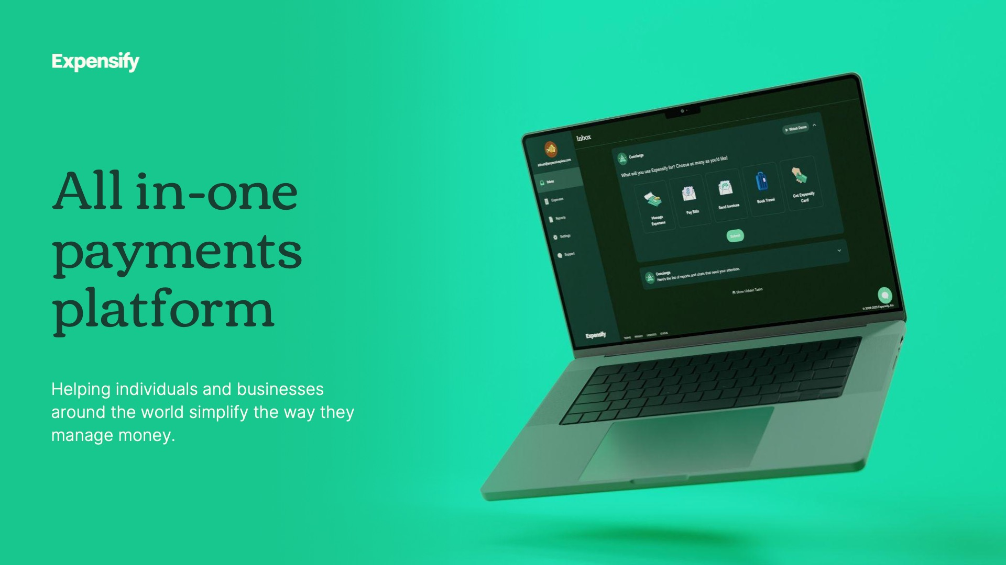

Exhibit 99.2
3
Expensify, Inc.
Investor Presentation



Exhibit 99.2
4
Expensify, Inc.
Investor Presentation

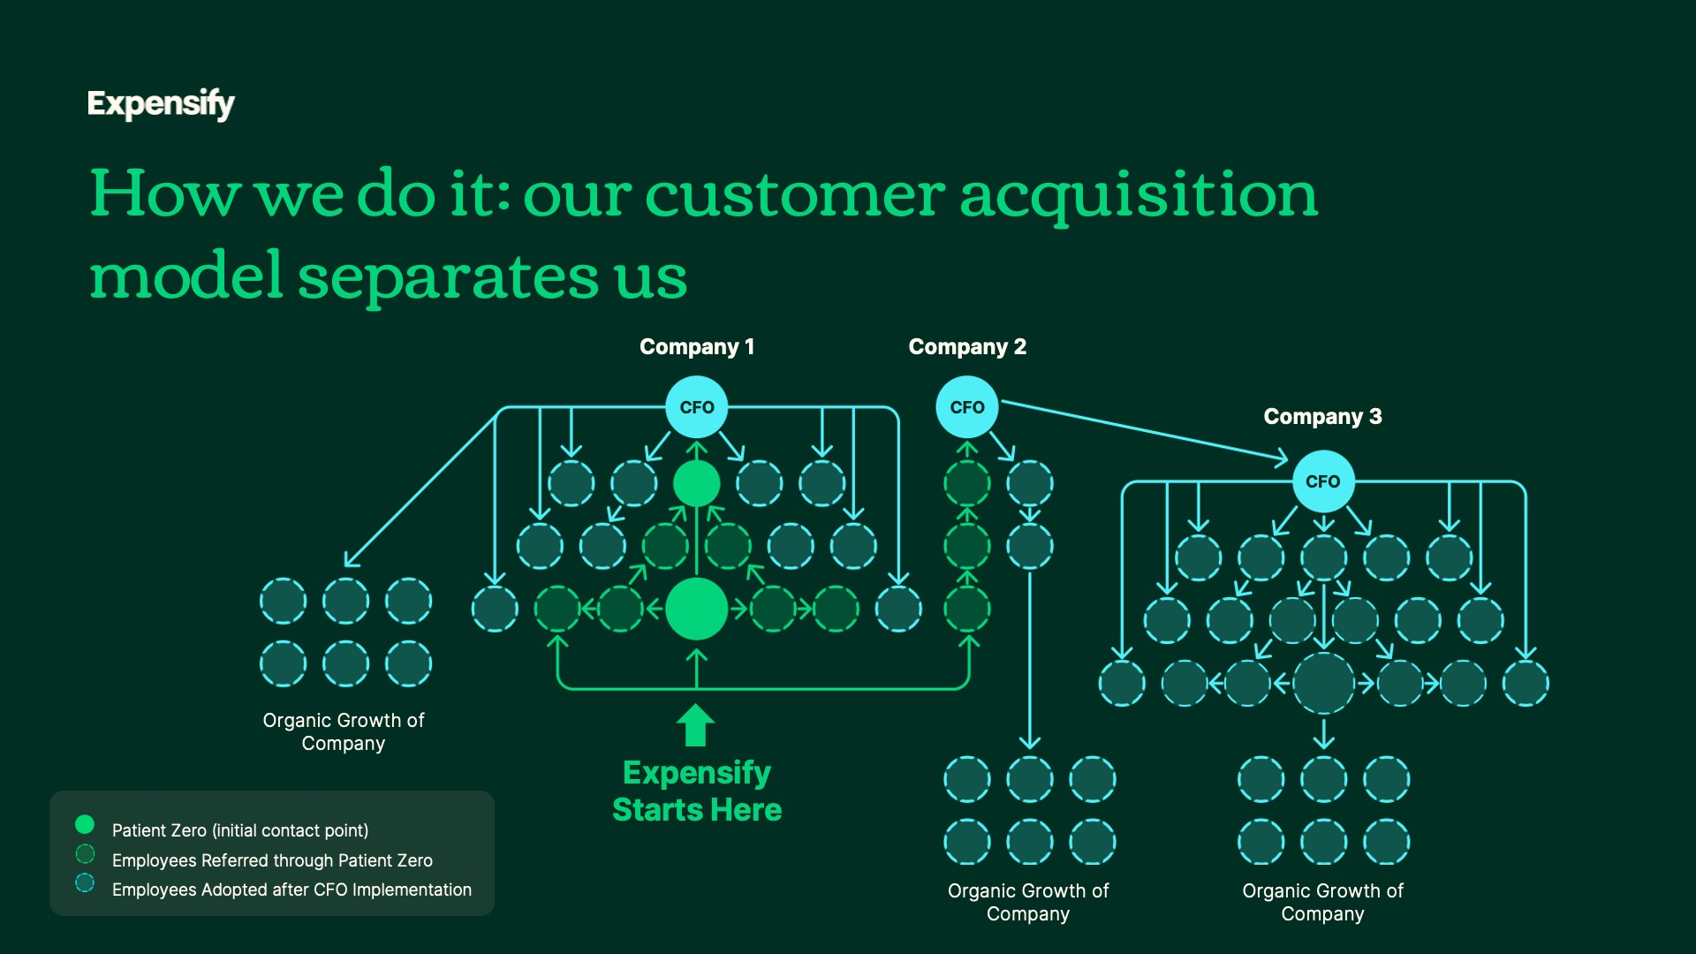

Exhibit 99.2
5
Expensify, Inc.
Investor Presentation

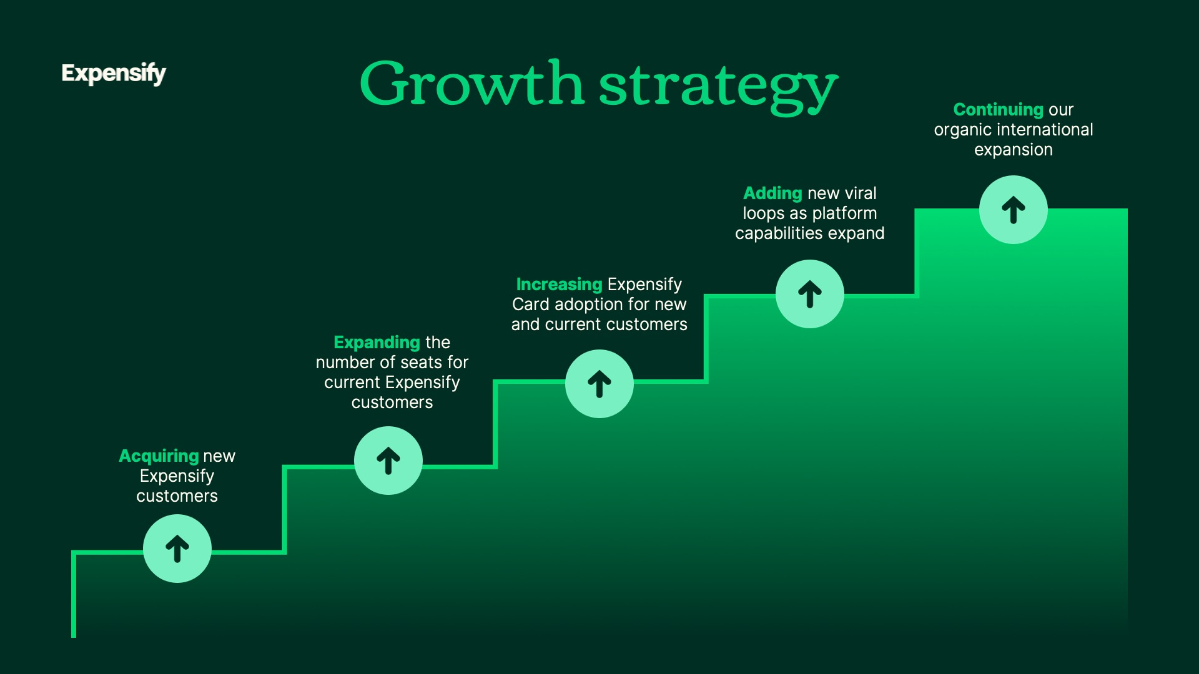

Exhibit 99.2
6
Expensify, Inc.
Investor Presentation



Exhibit 99.2
7
Expensify, Inc.
Investor Presentation

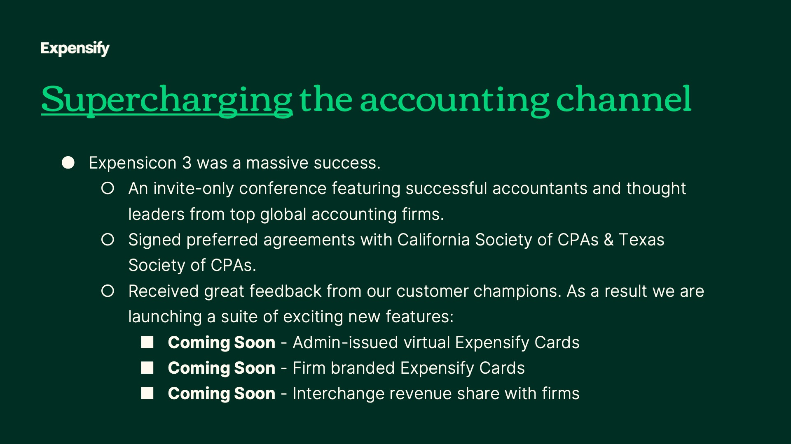

Exhibit 99.2
8
Expensify, Inc.
Investor Presentation



Exhibit 99.2
9
Expensify, Inc.
Investor Presentation

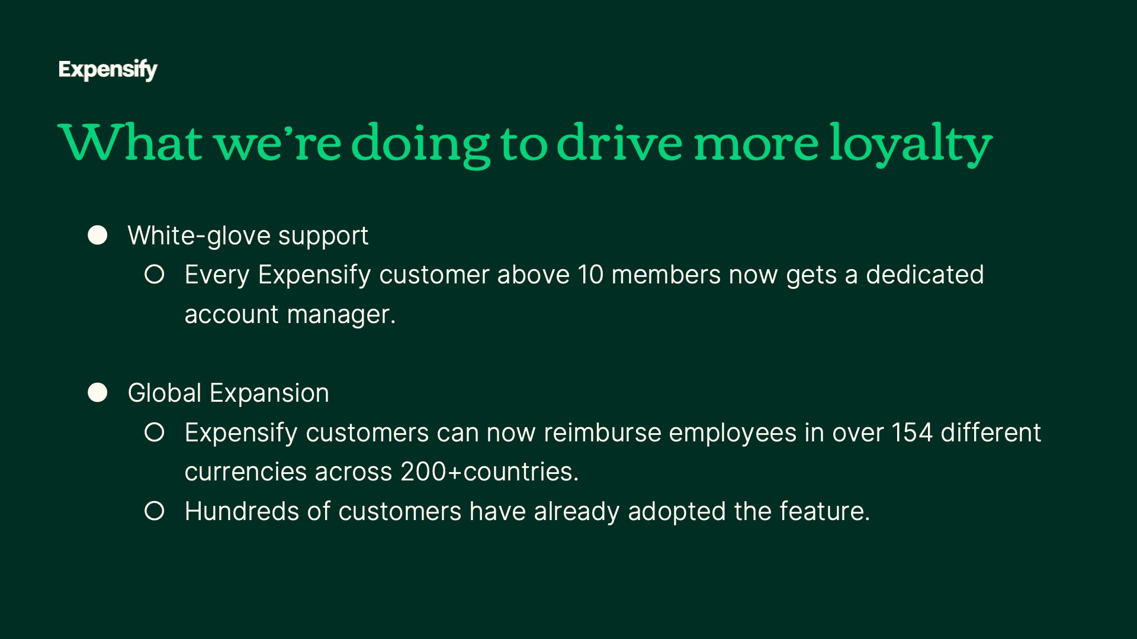

Exhibit 99.2
10
Expensify, Inc.
Investor Presentation



Exhibit 99.2
11
Expensify, Inc.
Investor Presentation

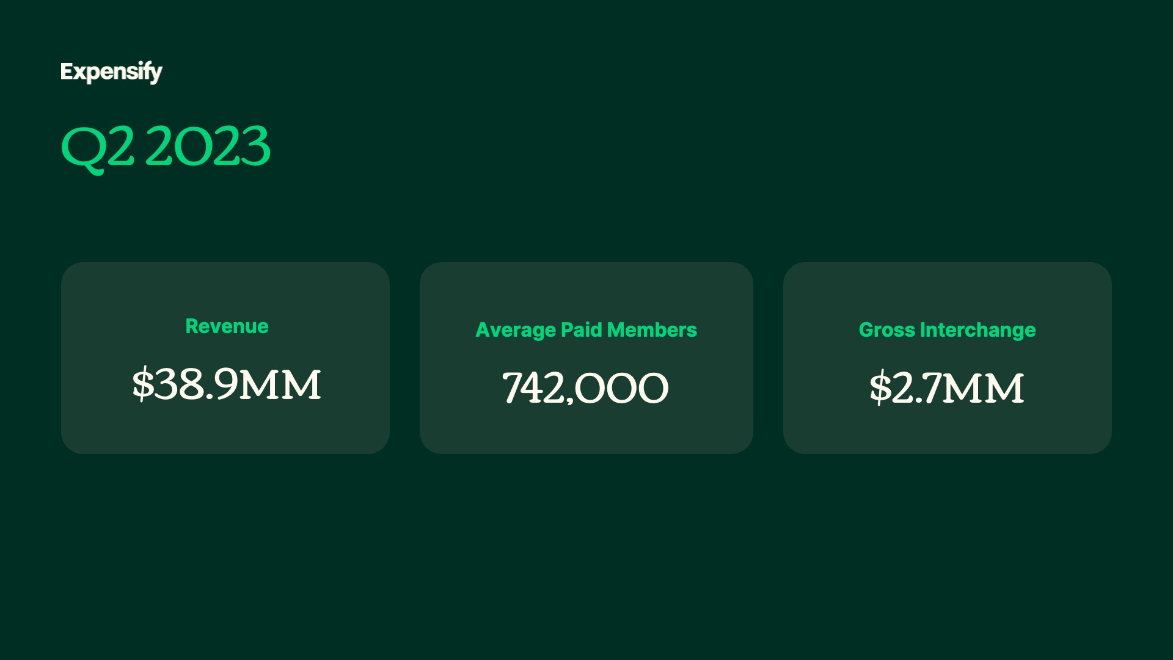
Exhibit 99.2
12
Expensify, Inc.
Investor Presentation

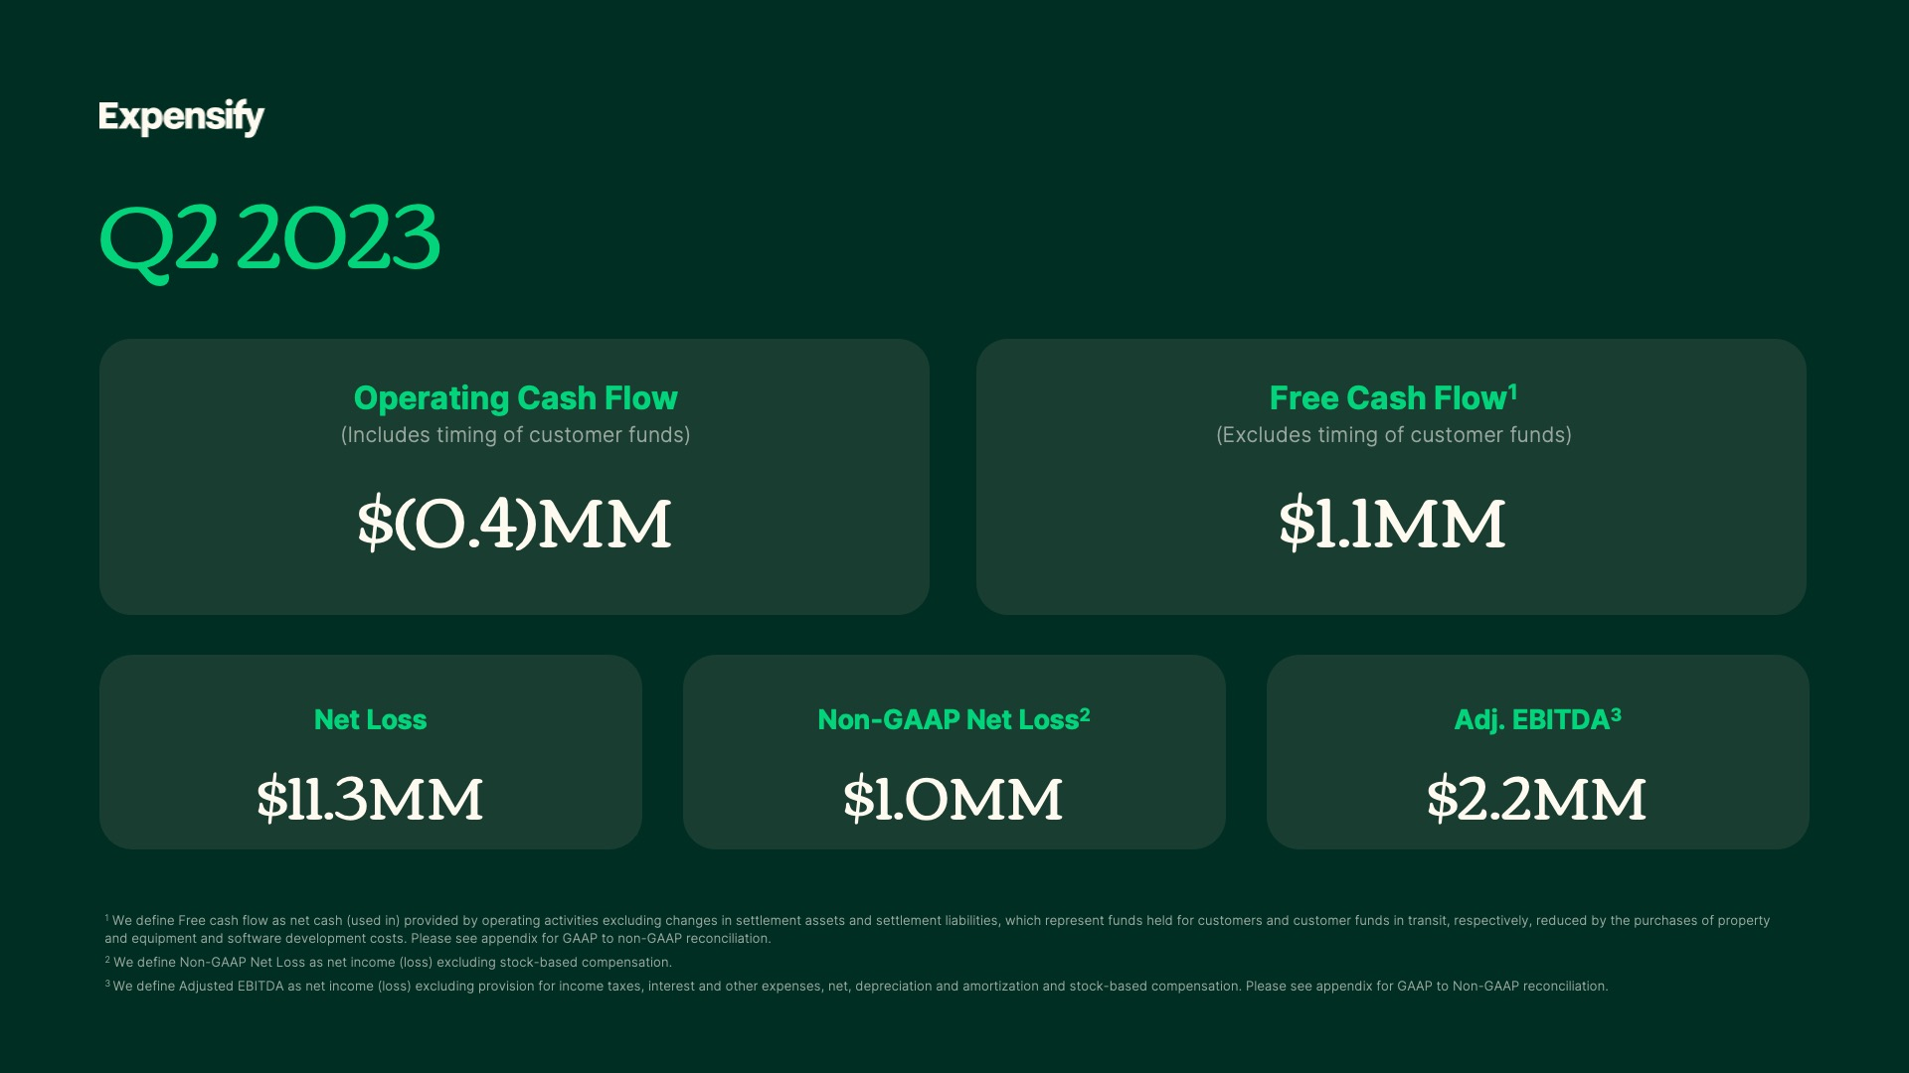
Exhibit 99.2
13
Expensify, Inc.
Investor Presentation

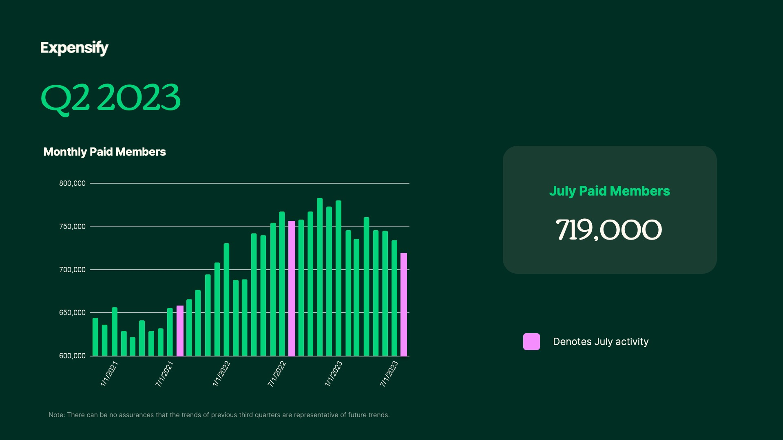
Exhibit 99.2
14
Expensify, Inc.
Investor Presentation

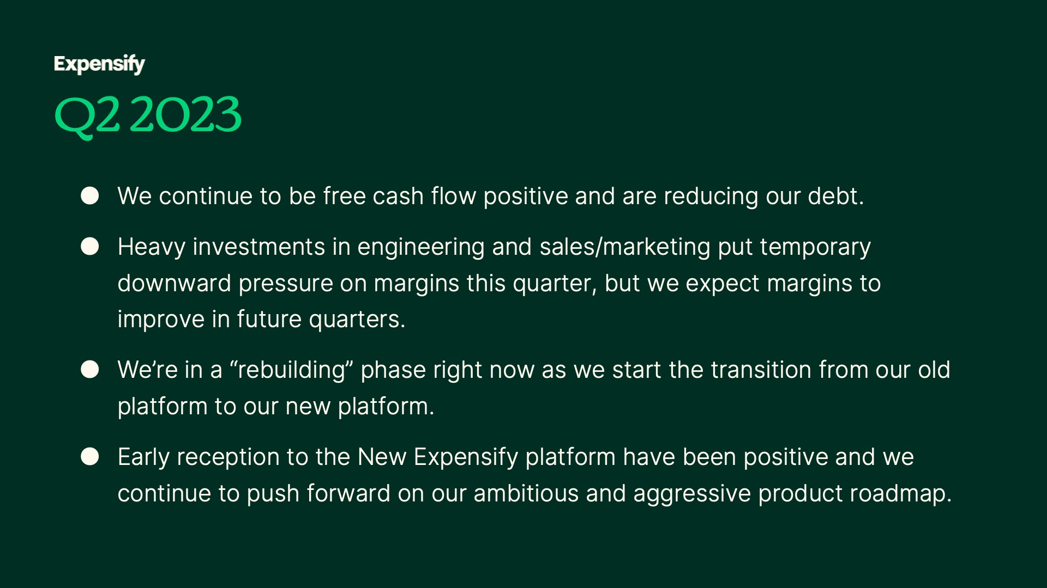
Exhibit 99.2
15
Expensify, Inc.
Investor Presentation


Exhibit 99.2
16
Expensify, Inc.
Investor Presentation


Exhibit 99.2
17
Expensify, Inc.
Investor Presentation


Exhibit 99.2
18
Expensify, Inc.
Investor Presentation

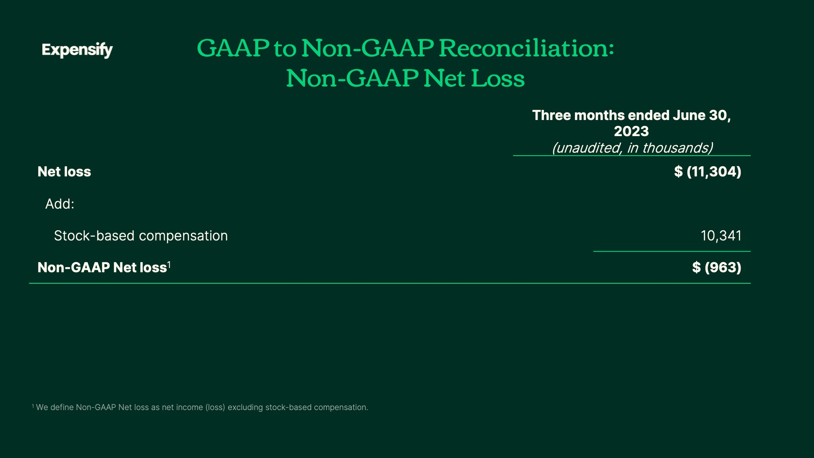
Exhibit 99.2
19
Expensify, Inc.
Investor Presentation

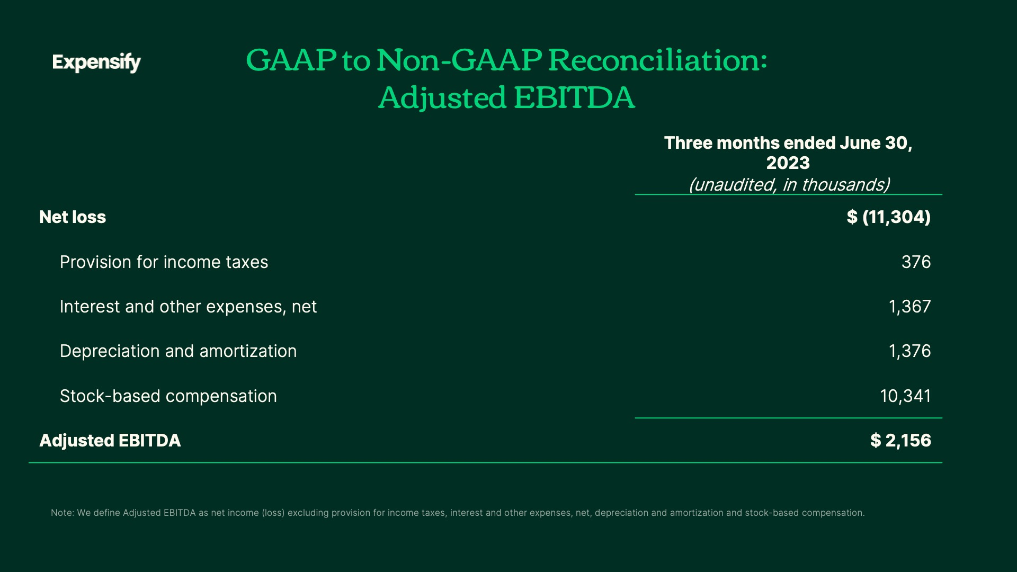
Exhibit 99.2
20
Expensify, Inc.
Investor Presentation

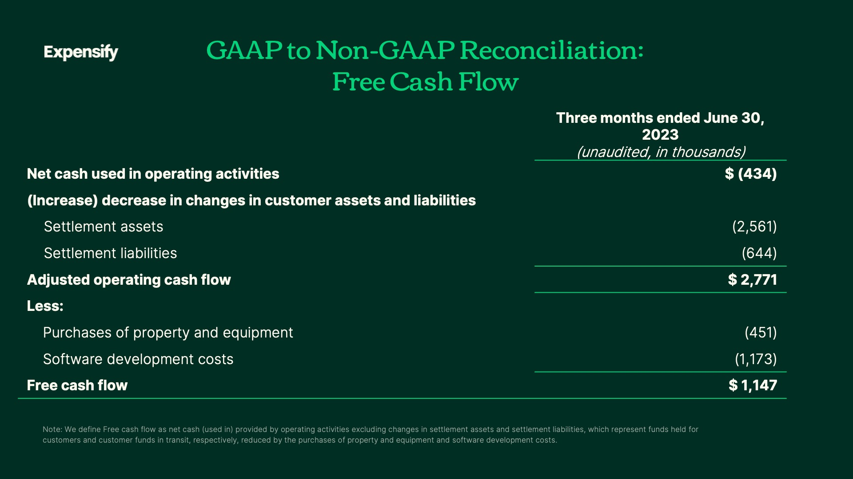
Exhibit 99.2
21
Expensify, Inc.
Investor Presentation

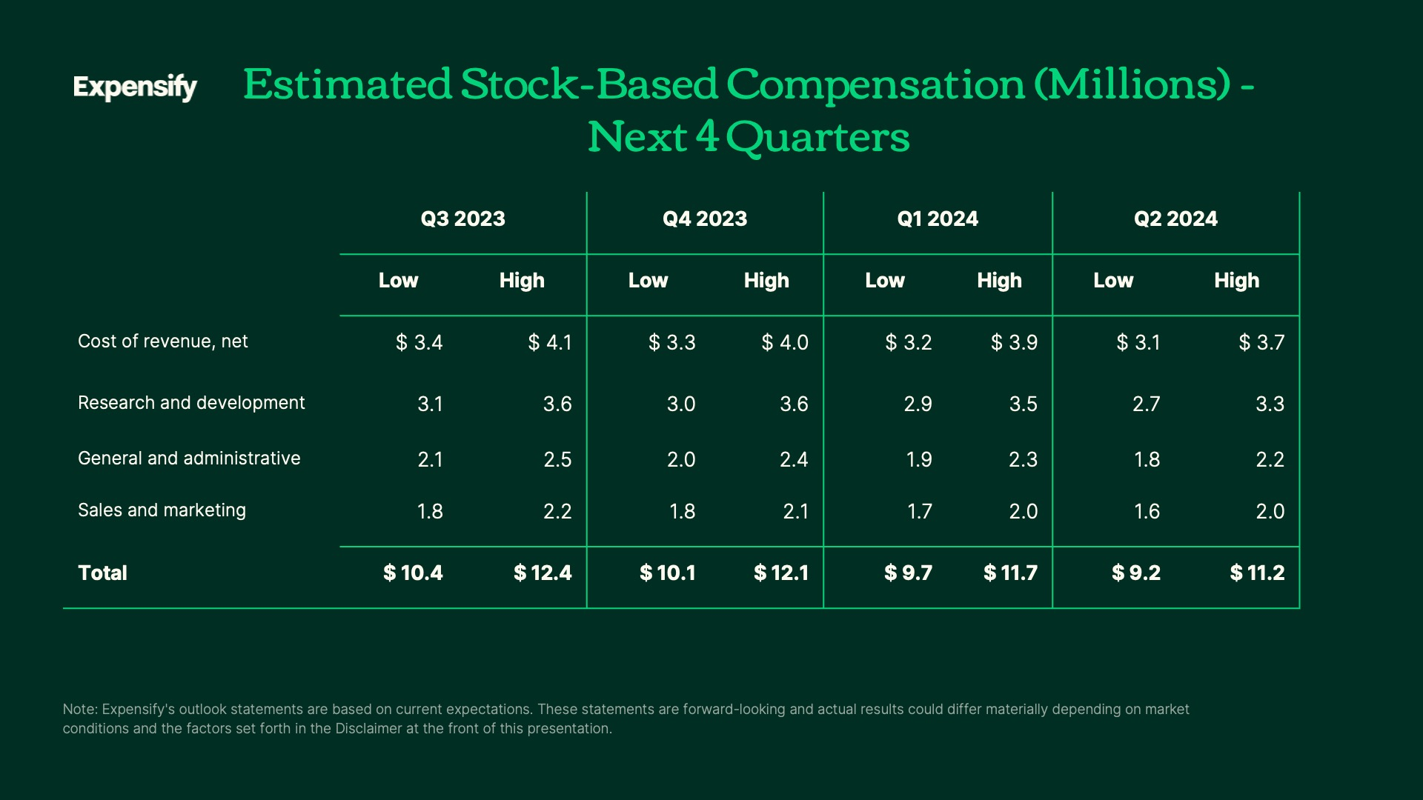
Exhibit 99.2
22
Expensify, Inc.
Investor Presentation

23

