UNITED STATES
SECURITIES AND EXCHANGE COMMISSION
Washington, D.C. 20549
FORM 8-K
CURRENT REPORT
PURSUANT TO SECTION 13 OR 15(d)
OF THE SECURITIES EXCHANGE ACT OF 1934
Date of report (Date of earliest event reported): February 26, 2026
Expensify, Inc.
(Exact Name of Registrant as Specified in its Charter)
Delaware |  |  |  |  |  | 001-41043 |  |  |  |  |  | 27-0239450
(State or Other Jurisdiction  of Incorporation) |  |  |  |  |  | (Commission  File Number) |  |  |  |  |  | (IRS Employer  Identification No.)
88 Kearny St, Ste 1600
San Francisco, California 94108
(Address of Principal Executive Offices) (Zip Code)
(971) 365-3939
(Registrant’s telephone number, including area code)
Not applicable
(Former Name or Former Address, if Changed Since Last Report)
Check the appropriate box below if the Form 8-K filing is intended to simultaneously satisfy the filing obligation of the registrant under any of the following provisions:
☐ |  |  |  |  |  | Written communications pursuant to Rule 425 under the Securities Act (17 CFR 230.425).
☐ |  |  |  |  |  | Soliciting material pursuant to Rule 14a-12 under the Exchange Act (17 CFR 240.14a-12).
☐ |  |  |  |  |  | Pre-commencement communications pursuant to Rule 14d-2(b) under the Exchange Act (17 CFR 240.14d-2(b)).
☐ |  |  |  |  |  | Pre-commencement communications pursuant to Rule 13e-4(c) under the Exchange Act (17 CFR 240.13e-4(c)).
Securities registered pursuant to Section 12(b) of the Act:
Title of each class |  |  |  |  |  | Trading  Symbols |  |  |  |  |  | Name of each exchange  on which registered
Class A Common Stock, par value $0.0001 per share |  |  |  |  |  | EXFY |  |  |  |  |  | The Nasdaq Stock Market LLC
Indicate by check mark whether the registrant is an emerging growth company as defined in Rule 405 of the Securities Act of 1933 (§230.405 of this chapter) or Rule 12b-2 of the Securities Exchange Act of 1934 (§240.12b-2 of this chapter).
Emerging growth company ☐
If an emerging growth company, indicate by check mark if the registrant has elected not to use the extended transition period for complying with any new or revised financial accounting standards provided pursuant to Section 13(a) of the Exchange Act. ☐

Item 2.02 Results of Operations and Financial Condition.
On February 26, 2026, the Expensify, Inc. (“Expensify” or “the Company”) issued a press release announcing its financial results for the year and quarter ended December 31, 2025. A copy of this press release is furnished as Exhibit 99.1 to this current report on Form 8-K and is incorporated herein by reference.

Item 7.01 Regulation FD Disclosure.
On February 26, 2026, the Company posted an investor presentation to its website at https://ir.expensify.com (the “Investor Presentation”). A copy of the Investor Presentation is attached as Exhibit 99.2 to this current report on Form 8-K and is incorporated herein by reference. The Company expects to use the Investor Presentation, in whole or in part, and possibly with modifications, in connection with presentations to investors, analysts and others.
The information contained in the Investor Presentation is summary information that is intended to be considered in the context of the Company’s Securities and Exchange Commission (“SEC”) filings and other public announcements that the Company may make, by press release or otherwise, from time to time. The Investor Presentation speaks only as of the date of this current report on Form 8-K. The Company undertakes no duty or obligation to publicly update or revise the information included in the Investor Presentation, although it may do so from time to time. Any such updating may be made through the filing of other reports or documents with the SEC, through press releases or other public disclosure. In addition, the exhibit furnished herewith contains statements intended as “forward-looking statements” that are subject to the cautionary statements about forward-looking statements set forth in such exhibit. By furnishing the information contained in the Investor Presentation, the Company makes no admission as to the materiality of any information in the Investor Presentation that is required to be disclosed solely by reason of Regulation FD.
The information contained in Item 2.02 and this Item 7.01, including Exhibit 99.1 and 99.2, is being furnished and shall not be deemed “filed” for the purposed of Section 18 of the Securities and Exchange Act of 1934, as amended (the “Exchange Act”), or otherwise subject to the liabilities of that section, nor shall it be deemed incorporated by reference in any filing made by Expensify under the Securities Act of 1933, as amended, or the Exchange Act, except as expressly set forth by specific reference in such a filing.

Item 9.01 Financial Statements and Exhibits.
(d) Exhibits.
Exhibit No. |  |  |  |  |  | Description
99.1 |  |  |  |  |  | Press Release issued by Expensify, Inc., dated February 26, 2026.
99.2 |  |  |  |  |  | Investor Presentation, dated February 26, 2026.
104 |  |  |  |  |  | Cover Page Interactive Data File (embedded within the Inline XBRL document).

SIGNATURE
Pursuant to the requirements of the Securities Exchange Act of 1934, the registrant has duly caused this report to be signed on its behalf by the undersigned hereunto duly authorized.
Expensify, Inc.
By: |  |  |  |  |  | /s/ Ryan Schaffer
Name: |  |  |  |  |  | Ryan Schaffer
Title: |  |  |  |  |  | Chief Financial Officer
Date: February 26, 2026

Exhibit 99.1

EXPENSIFY ANNOUNCES Q4 AND FULL YEAR FISCAL 2025 RESULTS
The company generated $20.1 million in operating cash flow and
$19.9 million in free cash flow in fiscal year 2025
SAN FRANCISCO, Cal.--(BUSINESS WIRE)--February 26, 2026-- Expensify, Inc. (Nasdaq: EXFY), a payments superapp that helps individuals and businesses around the world simplify the way they manage money across expenses, corporate cards and bills, today released a letter to shareholders from Founder and CEO David Barrett alongside results for its quarter and year ended December 31, 2025.

A Message From Our Founder
2025 was an extremely productive year. We continue to add cash to our debt-free balance sheet, with revenue, interchange, and card spend all up over 2024. But most exciting: New Expensify is now feature-complete for nearly all customers, rolled out to 63% of paying customers, and is the default for all new customers. While we are methodically "nudging" all of our Classic customers over to New Expensify, we are increasingly shifting our engineering focus toward new feature development, in three main areas:
•Bring your own card. We spent years building a modern spend management platform that offers a corporate card deeply integrated into all things Expensify. But many of our customers, and most of the market, still wants to use their existing corporate card. We’ve been investing heavily in bringing modern spend management functionality, like merchant-based rules, real time transaction import, and smart reconciliation, to customers who want to keep their card.
•Product-led growth. New Expensify's radical design enables a wide range of "bottom up" features that enable individual employees to "crowdsource" their company's configuration and collectively pressure their company to adopt. This was our primary lead source for growing Classic into a dominant position in the industry, and we are excited to reactivate this in a supercharged fashion atop New Expensify's real-time platform.
•Accountable Intelligence. New Expensify's chat-first design not only infuses AI into every expense, but is built to be truly "accountable". In a market where every if/then statement is promoted as AI, our Concierge achieves what we feel is a higher level of intelligence by embodying three core principles:
◦Contextual: You don't need to copy/paste, upload, or screenshot your data into a Concierge AI chat: just open a conversational thread directly on the card swipe, expense report, audit log, or error message you want to investigate. Concierge isn't some "Clippy 2.0" on the outside looking in – Concierge is infused throughout every part of the UI, and you can talk to it anywhere, in any context, right on the thing you want to talk about.
◦Correctable: Concierge doesn't just automate, it self-diagnoses and self-corrects when things go wrong. No more guesswork as to which combination of rules and configurations produced an unexpected result: Concierge can tell you directly, explain how you can fix it, and even just reconfigure itself to do it right the next time.
◦Continuous: Concierge won't just react when you ask – it'll be always working in the background to review your books, analyze trends, and monitor system health. From detecting unusual expense patterns to catching bank or accounting sync errors the moment they occur, Concierge can proactively flag issues and tell you exactly how to fix them before they become real problems.

Exhibit 99.1

We believe this AI-native design is unique in the marketplace and built to be viral, and its early form is already resonating with customers. Excitement has truly never been higher – especially in our sales and product teams – because this is the year we've been preparing for. To support this, we are pulling out all the stops (including setting a modest FCF target to free up resources for expected increased spend in sales, marketing, and AI) with the goal of moving from a "building" mindset back to the "growth" posture that established the leading brand we enjoy today. It has been a long and difficult road to get to this point, and we are eager to prove to everyone it was worth it.

-david
Founder and CEO of Expensify

Financial
Fourth Quarter 2025 Highlights
•Revenue was $35.2 million, a decrease of 5% compared to the same period last year.
•Generated $2.2 million of cash from operating activities.
•Free cash flow was $3.2 million.
•Net loss was $7.1 million, compared to $1.3 million for the same period last year.
•Non-GAAP net loss was $2.1 million.
•Adjusted EBITDA was $3.3 million.
•Interchange derived from the Expensify Card grew to $5.5 million, an increase of 9% compared to the same period last year.
•See Financial Outlook section for Free Cash Flow guidance for fiscal year ending December 31, 2026.
Full Year Fiscal 2025 Highlights
•Revenue was $142.1 million, an increase of 2% compared to the prior year.
•Generated $20.1 million of cash from operating activities.
•Free cash flow was $19.9 million.
•Net loss was $21.4 million, compared to $10.1 million for the prior year.
•Non-GAAP net income was $5.2 million.
•Adjusted EBITDA was $16.9 million.
•Interchange derived from the Expensify Card grew to $21.3 million, an increase of 24% compared to the prior year.
Exhibit 99.1

Business
Fourth Quarter 2025 Highlights
•Paid members - Paid members were 650,000, a decrease of 5% compared to the same period last year, but an increase of 1% compared to Q3 2025's paid members of 642,000.
•Expensify and Uber for Business - The company entered a multi-year integration partnership with Uber for Business to automate travel and meal receipts, improving policy controls across corporate travel and expense workflows.
•TrustRadius 2026 Buyer’s Choice Award - Expensify was recognized by customer reviews for excellence in capabilities, value for price, and customer relationships in the expense management category.
2025 Highlights
•Expensify Travel - Expensify Travel quarterly travel bookings grew by 434% in Q4 2025 as compared to the same period last year.
•Expensify Card - Total interchange increased by 24% in FY 2025 as compared to the prior year.
•Share repurchases - The company repurchased 4,823,118 shares of its Class A common stock throughout 2025, totaling approximately $9.1 million.

Exhibit 99.1

Financial Outlook
Expensify's outlook statements are based on current estimates, expectations and assumptions and are not a guarantee of future performance. The following statements are forward-looking and actual results could differ materially depending on market conditions and the factors set forth under “Forward-Looking Statements” below. There can be no assurance that the Company will achieve the results expressed by this guidance.
Free Cash Flow
Expensify estimates free cash flow of $6.0 million - $9.0 million for the fiscal year ending December 31, 2026.
The Company does not provide a reconciliation for free cash flow estimates on a forward-looking basis because it is unable, without making unreasonable efforts, to provide a meaningful or reasonably accurate calculation or estimation of net cash provided by operating activities and certain reconciling items on a forward-looking basis, which could be significant to the Company's results.
Stock Based Compensation
An estimate of expected stock-based compensation expense for the next four fiscal quarters is as follows, which is driven primarily by the pre-IPO grant of RSUs issued to all employees (which vest quarterly over eight years with approximately four years remaining).
Est. stock-based compensation (millions)
 |  |  | Q1 2026 |  |  |  |  |  |  |  |  |  |  |  | Q2 2026 |  |  |  |  |  |  |  |  |  |  |  | Q3 2026 |  |  |  |  |  |  |  |  |  |  |  | Q4 2026
 |  |  | Low |  |  |  |  |  | High |  |  |  |  |  | Low |  |  |  |  |  | High |  |  |  |  |  | Low |  |  |  |  |  | High |  |  |  |  |  | Low |  |  |  |  |  | High
Cost of revenue, net |  |  | $ | 2.3 |  |  |  |  | $ | 3.1 |  |  |  |  | $ | 2.2 |  |  |  |  | $ | 3.0 |  |  |  |  | $ | 2.1 |  |  |  |  | $ | 2.9 |  |  |  |  | $ | 2.1 |  |  |  |  | $ | 2.9
Research and development |  |  | 1.4 |  |  |  |  |  | 2.0 |  |  |  |  |  | 1.4 |  |  |  |  |  | 2.0 |  |  |  |  |  | 1.3 |  |  |  |  |  | 1.9 |  |  |  |  |  | 1.3 |  |  |  |  |  | 1.9
General and administrative |  |  | 0.8 |  |  |  |  |  | 1.2 |  |  |  |  |  | 0.8 |  |  |  |  |  | 1.2 |  |  |  |  |  | 0.8 |  |  |  |  |  | 1.2 |  |  |  |  |  | 0.8 |  |  |  |  |  | 1.2
Sales and marketing |  |  | 0.5 |  |  |  |  |  | 0.7 |  |  |  |  |  | 0.5 |  |  |  |  |  | 0.7 |  |  |  |  |  | 0.5 |  |  |  |  |  | 0.7 |  |  |  |  |  | 0.5 |  |  |  |  |  | 0.7
Total |  |  | $ | 5.0 |  |  |  |  | $ | 7.0 |  |  |  |  | $ | 4.9 |  |  |  |  | $ | 6.9 |  |  |  |  | $ | 4.7 |  |  |  |  | $ | 6.7 |  |  |  |  | $ | 4.7 |  |  |  |  | $ | 6.7
Availability of Information on Expensify’s Website
Investors and others should note that Expensify routinely announces material information to investors and the marketplace using SEC filings, press releases, public conference calls, webcasts and the Expensify Investor Relations website at https://ir.expensify.com. While not all of the information that the Company posts to its Investor Relations website is of a material nature, some information could be deemed to be material. Accordingly, the Company encourages investors, the media and others interested in Expensify to review the information that it shares on its Investor Relations website.
Conference Call
Expensify will host a video call to discuss the financial results and business highlights at 2:00 p.m. Pacific Time today. An investor presentation and the video call information is available on Expensify’s Investor Relations website at https://ir.expensify.com. A replay of the call will be available on the site for three months.
Non-GAAP Financial Measures
In addition to financial measures prepared in accordance with U.S. generally accepted accounting principles (“GAAP”), we provide certain non-GAAP financial measures, including adjusted EBITDA, non-GAAP net (loss) income, and free cash flow.
We believe our non-GAAP financial measures are useful in evaluating our business, measuring our performance, identifying trends affecting our business, formulating business plans and making strategic decisions. Accordingly, we believe that these non-GAAP financial measures provide useful information to investors and others in understanding and evaluating our results of operations in the same manner as our management team. These non-
Exhibit 99.1

GAAP financial measures are presented for supplemental informational purposes only, should not be considered a substitute for financial information presented in accordance with GAAP, and may be different from similarly titled metrics or measures presented by other companies. Non-GAAP financial measures have limitations as analytical tools and should not be considered in isolation or as substitutes for financial information presented under GAAP. There are a number of limitations related to the use of non-GAAP financial measures versus comparable financial measures determined under GAAP. For example, other companies in our industry may calculate these non-GAAP financial measures differently or may use other measures to evaluate their performance. All of these limitations could reduce the usefulness of these non-GAAP financial measures as analytical tools. Investors are encouraged to review the related GAAP financial measures and the reconciliations of these non-GAAP financial measures to their most directly comparable GAAP financial measures and to not rely on any single financial measure to evaluate our business. A reconciliation of each non-GAAP financial measure to the most directly comparable financial measure stated in accordance with GAAP is at the end of this press release.
Adjusted EBITDA. We define adjusted EBITDA as net loss excluding provision for income taxes, other income (expense), net, depreciation and amortization, and stock-based compensation expense.
Non-GAAP net (loss) income. We define non-GAAP net (loss) income as net loss excluding stock-based compensation expense.
Free cash flow. We define free cash flow as net cash provided by operating activities excluding changes in settlement assets and settlement liabilities, which represent funds held for customers and customer funds in transit, respectively, reduced by the purchases of property and equipment and software development costs.
The tables at the end of the Consolidated Financial Statements provide reconciliations to the most directly comparable GAAP financial measure to each of these non-GAAP financial measures.
Forward-Looking Statements
Forward-looking statements in this press release, or made during the earnings call, which are not historical facts, are forward-looking statements within the meaning of the Private Securities Litigation Reform Act of 1955. These statements include statements regarding our strategy, future financial condition, future operations, future cash flow, projected costs, prospects, plans, objectives of management and expected market growth, product developments and their potential impact and our stock-based compensation estimates and involve known and unknown risks that are difficult to predict. As a result, our actual results, performance or achievements may differ materially from those expressed or implied by these forward-looking statements. In some cases, you can identify forward-looking statements because they contain words such as “may,” “will,” “shall,” “should,” “expects,” “plans,” “anticipates,” “could,” “intends,” “target,” “projects,” “contemplates,” “believes,” “estimates,” “predicts,” “potential,” “goal,” “ambition,” “objective,” “seeks,” “outlook,” or “continue” or the negative of these words or other similar terms or expressions that concern our expectations, strategy, plans, or intentions. Such forward-looking statements are necessarily based upon estimates and assumptions that, while considered reasonable by us and our management, are inherently uncertain. Factors that may cause actual results to differ materially from current expectations include, but are not limited to: the impact on inflation on us and our members; our borrowing costs, which have and may continue to increase as a result of increases in interest rates; our expectations regarding our financial performance and future operating performance; our ability to attract and retain members, expand usage of our platform, sell subscriptions to our platform and convert individuals and organizations into paying customers; the timing and success of new features, integrations, capabilities and enhancements by us, or by competitors to their products, or any other changes in the competitive landscape of our market; the amount and timing of operating expenses and capital expenditures that we may incur to maintain and expand our business and operations to remain competitive; the sufficiency of our cash, cash equivalents and investments to meet our liquidity needs; our ability to make required payments under and to comply with the various requirements of our current and future indebtedness; our cash flows, the prevailing stock prices, general economic and market conditions and other considerations that could affect the specific timing, price and size of repurchases under our stock repurchase program or our ability to fund any stock repurchases; geopolitical tensions, including the war in Ukraine and the conflict in Israel, Gaza and surrounding areas; our ability to effectively manage our exposure to fluctuations in foreign currency exchange rates; the size of our addressable markets, market share and market trends; anticipated trends, developments and challenges in our industry, business and the highly competitive markets in which we operate; any adverse impact on our business operations as a result of using artificial intelligence or other machine learning technologies in our
Exhibit 99.1

services; our expectations regarding our income tax liabilities and the adequacy of our reserves; our ability to effectively manage our growth and expand our infrastructure and maintain our corporate culture; our ability to identify, recruit and retain skilled personnel, including key members of senior management; the safety, affordability and convenience of our platform and our offerings; our ability to successfully defend litigation brought against us; our ability to successfully identify, manage and integrate any existing and potential acquisitions of businesses, talent, technologies or intellectual property; general economic conditions in either domestic or international markets, including geopolitical uncertainty and instability, and their effects on software spending; our ability to protect against security incidents, technical difficulties, or interruptions to our platform; our ability to maintain, protect and enhance our intellectual property; the impact of tariffs and global trade disruptions on us, our customers and our vendors, including the impact on inflation, supply chains and consumer sentiment; and other risks discussed in our filings with the SEC. All forward-looking statements attributable to us or persons acting on our behalf are expressly qualified in their entirety by the cautionary statements set forth above. We caution you not to place undue reliance on any forward-looking statements, which are made only as of the date of this press release. We do not undertake or assume any obligation to update publicly any of these forward-looking statements to reflect actual results, new information or future events, changes in assumptions or changes in other factors affecting forward-looking statements, except to the extent required by applicable law. If we update one or more forward-looking statements, no inference should be drawn that we will make additional updates with respect to those or other forward-looking statements.
About Expensify
Expensify is the easiest way to do your expenses, travel, and corporate cards. Built for businesses of all sizes and trusted by 15 million members worldwide, Expensify is a top-rated app across G2, TrustRadius, Capterra, and more. Learn more at use.expensify.com.
Investor Relations Contact
Nick Tooker
investors@expensify.com
Press Contact
James Dean
press@expensify.com

Expensify, Inc.
Consolidated Balance Sheets
(unaudited, in thousands, except share and per share data)
 |  |  | As of December 31,
 |  |  | 2025 |  |  |  |  |  | 2024
Assets
Cash and cash equivalents |  |  | $ | 63,080 |  |  |  |  | $ | 48,772
Accounts receivable, net |  |  | 12,617 |  |  |  |  |  | 12,701
Settlement assets, net |  |  | 45,378 |  |  |  |  |  | 42,406
Prepaid expenses |  |  | 5,588 |  |  |  |  |  | 12,089
Other current assets |  |  | 26,344 |  |  |  |  |  | 20,908
Total current assets |  |  | 153,007 |  |  |  |  |  | 136,876
Capitalized software, net |  |  | 13,596 |  |  |  |  |  | 16,232
Property and equipment, net |  |  | 13,016 |  |  |  |  |  | 13,621
Lease right-of-use assets |  |  | 4,730 |  |  |  |  |  | 5,441
Deferred tax assets, net |  |  | 494 |  |  |  |  |  | 499
Other assets |  |  | 1,146 |  |  |  |  |  | 1,011
Total assets |  |  | $ | 185,989 |  |  |  |  | $ | 173,680
Liabilities and stockholders' equity
Accounts payable |  |  | $ | 289 |  |  |  |  | $ | 196
Accrued expenses and other liabilities |  |  | 17,893 |  |  |  |  |  | 8,240
Lease liabilities, current |  |  | 678 |  |  |  |  |  | 729
Settlement liabilities |  |  | 27,545 |  |  |  |  |  | 28,845
Total current liabilities |  |  | 46,405 |  |  |  |  |  | 38,010
Lease liabilities, non-current |  |  | 5,061 |  |  |  |  |  | 5,738
Other liabilities |  |  | 1,778 |  |  |  |  |  | 1,689
Total liabilities |  |  | 53,244 |  |  |  |  |  | 45,437
Commitments and contingencies (Note 12)
Stockholders' equity:
Preferred stock, par value $0.0001; 10,000,000 shares of preferred stock authorized; no shares of preferred stock issued and outstanding as of December 31, 2025 and 2024 |  |  | — |  |  |  |  |  | —
Common stock, par value $0.0001;  Class A common stock; 1,000,000,000 shares authorized; 80,767,385 and 79,471,414 shares issued and outstanding as of December 31, 2025 and 2024, respectively  LT10 common stock; 21,871,197 shares authorized; 4,209,827 shares issued and outstanding as of December 31, 2025 and 2024  LT50 common stock; 24,967,114 shares authorized; 8,083,690 and 7,695,524 shares issued and outstanding as of December 31, 2025 and 2024, respectively |  |  | 9 |  |  |  |  |  | 9
Additional paid-in capital |  |  | 304,953 |  |  |  |  |  | 279,062
Accumulated deficit |  |  | (172,217) |  |  |  |  |  | (150,828)
Total stockholders' equity |  |  | 132,745 |  |  |  |  |  | 128,243
Total liabilities and stockholders' equity |  |  | $ | 185,989 |  |  |  |  | $ | 173,680

Expensify, Inc.
Consolidated Statements of Operations
(unaudited, in thousands, except share and per share data)
 |  |  | Three Months Ended December 31, |  |  |  |  |  |  |  |  |  |  |  | Year ended December 31,
 |  |  | 2025 |  |  |  |  |  | 2024 |  |  |  |  |  | 2025 |  |  |  |  |  | 2024
Revenue |  |  | $ | 35,198 |  |  |  |  | $ | 37,004 |  |  |  |  | $ | 142,101 |  |  |  |  | $ | 139,236
Cost of revenue, net(1) |  |  | 17,888 |  |  |  |  |  | 18,148 |  |  |  |  |  | 70,574 |  |  |  |  |  | 64,239
Gross margin |  |  | 17,310 |  |  |  |  |  | 18,856 |  |  |  |  |  | 71,527 |  |  |  |  |  | 74,997
Operating expenses:
Research and development(1) |  |  | 5,262 |  |  |  |  |  | 6,702 |  |  |  |  |  | 20,683 |  |  |  |  |  | 24,638
General and administrative(1) |  |  | 12,067 |  |  |  |  |  | 8,622 |  |  |  |  |  | 42,121 |  |  |  |  |  | 38,382
Sales and marketing(1) |  |  | 3,918 |  |  |  |  |  | 3,067 |  |  |  |  |  | 26,742 |  |  |  |  |  | 12,797
Total operating expenses |  |  | 21,247 |  |  |  |  |  | 18,391 |  |  |  |  |  | 89,546 |  |  |  |  |  | 75,817
(Loss) income from operations |  |  | (3,937) |  |  |  |  |  | 465 |  |  |  |  |  | (18,019) |  |  |  |  |  | (820)
Other income (expense), net |  |  | 417 |  |  |  |  |  | (539) |  |  |  |  |  | 1,726 |  |  |  |  |  | (1,572)
Loss before income taxes |  |  | (3,520) |  |  |  |  |  | (74) |  |  |  |  |  | (16,293) |  |  |  |  |  | (2,392)
Provision for income taxes |  |  | (3,597) |  |  |  |  |  | (1,238) |  |  |  |  |  | (5,096) |  |  |  |  |  | (7,663)
Net loss |  |  | $ | (7,117) |  |  |  |  | $ | (1,312) |  |  |  |  | $ | (21,389) |  |  |  |  | $ | (10,055)
Net loss per share:
Basic and diluted |  |  | $ | (0.08) |  |  |  |  | $ | (0.01) |  |  |  |  | $ | (0.23) |  |  |  |  | $ | (0.12)
Weighted average shares of common stock used to compute net loss per share:
Basic and diluted |  |  | 92,786,358 |  |  |  |  |  | 89,577,172 |  |  |  |  |  | 92,283,974 |  |  |  |  |  | 87,380,708

(1)Includes stock-based compensation expense as follows:
 |  |  | Three Months Ended December 31, |  |  |  |  |  |  |  |  |  |  |  | Year ended December 31,
 |  |  | 2025 |  |  |  |  |  | 2024 |  |  |  |  |  | 2025 |  |  |  |  |  | 2024
Cost of revenue, net |  |  | $ | 2,198 |  |  |  |  | $ | 3,845 |  |  |  |  | $ | 10,637 |  |  |  |  | $ | 12,506
Research and development |  |  | 1,399 |  |  |  |  |  | 3,476 |  |  |  |  |  | 7,701 |  |  |  |  |  | 11,900
General and administrative |  |  | 871 |  |  |  |  |  | 1,850 |  |  |  |  |  | 4,768 |  |  |  |  |  | 6,815
Sales and marketing |  |  | 529 |  |  |  |  |  | 831 |  |  |  |  |  | 3,472 |  |  |  |  |  | 2,316
Total stock-based compensation expense |  |  | $ | 4,997 |  |  |  |  | $ | 10,002 |  |  |  |  | $ | 26,578 |  |  |  |  | $ | 33,537

Expensify, Inc.
Consolidated Statements of Cash Flows
(unaudited, in thousands)
 |  |  | Year Ended December 31,
 |  |  | 2025 |  |  |  |  |  | 2024
Cash flows from operating activities:
Net loss |  |  | $ | (21,389) |  |  |  |  | $ | (10,055)
Adjustments to reconcile net loss to cash provided by operating activities:
Depreciation and amortization |  |  | 8,460 |  |  |  |  |  | 6,814
Reduction of operating lease right-of-use assets |  |  | 575 |  |  |  |  |  | 547
Loss on impairment, receivables and sale or disposal of equipment |  |  | 603 |  |  |  |  |  | 727
Stock-based compensation |  |  | 26,578 |  |  |  |  |  | 33,537
Amortization of debt issuance costs |  |  | 133 |  |  |  |  |  | 54
Deferred tax assets |  |  | 5 |  |  |  |  |  | (42)
Changes in assets and liabilities:
Accounts receivable, net |  |  | (355) |  |  |  |  |  | 704
Settlement assets, net |  |  | (2,054) |  |  |  |  |  | (2,469)
Prepaid expenses |  |  | 6,501 |  |  |  |  |  | (1,490)
Other current assets |  |  | (6,852) |  |  |  |  |  | 2,341
Other assets |  |  | (135) |  |  |  |  |  | (167)
Accounts payable |  |  | 91 |  |  |  |  |  | (1,091)
Accrued expenses and other liabilities |  |  | 9,727 |  |  |  |  |  | (404)
Operating lease liabilities |  |  | (588) |  |  |  |  |  | 8
Settlement liabilities |  |  | (1,300) |  |  |  |  |  | (5,145)
Other liabilities |  |  | 89 |  |  |  |  |  | 8
Net cash provided by operating activities |  |  | 20,089 |  |  |  |  |  | 23,877
Cash flows from investing activities:
Purchase of property and equipment |  |  | (17) |  |  |  |  |  | —
Software development costs |  |  | (3,538) |  |  |  |  |  | (7,628)
Net cash used in investing activities |  |  | (3,555) |  |  |  |  |  | (7,628)
Cash flows from financing activities:
Principal payments of finance leases |  |  | (140) |  |  |  |  |  | (129)
Principal payments of outstanding debt |  |  | — |  |  |  |  |  | (22,671)
Payments for debt issuance costs |  |  | (153) |  |  |  |  |  | (71)
Repurchases of early exercised stock options |  |  | — |  |  |  |  |  | (35)
Proceeds from common stock purchased under Matching Plan |  |  | 6,321 |  |  |  |  |  | 4,091
Proceeds from issuance of common stock on exercise of stock options |  |  | 323 |  |  |  |  |  | 431
Payments for employee taxes withheld from stock-based awards |  |  | — |  |  |  |  |  | (2,179)
Repurchase and retirement of common stock |  |  | (9,095) |  |  |  |  |  | (1,510)
Net cash used in financing activities |  |  | (2,744) |  |  |  |  |  | (22,073)
Net increase (decrease) in cash and cash equivalents and restricted cash |  |  | 13,790 |  |  |  |  |  | (5,824)
Cash and cash equivalents and restricted cash, beginning of period |  |  | 90,834 |  |  |  |  |  | 96,658
Cash and cash equivalents and restricted cash, end of period |  |  | $ | 104,624 |  |  |  |  | $ | 90,834
Supplemental disclosure of cash flow information:
Cash paid for interest |  |  | $ | — |  |  |  |  | $ | 1,362
Noncash investing and financing items:
Stock-based compensation capitalized as software development costs |  |  | $ | 1,618 |  |  |  |  | $ | 2,688
Purchases of property and equipment and capitalized software in accounts payable and accrued expenses |  |  | $ | 111 |  |  |  |  | $ | 37
Fair value of common stock issued to settle liability-classified restricted stock units |  |  | $ | 1,198 |  |  |  |  | $ | —
Cashless exercise of stock options |  |  | $ | — |  |  |  |  | $ | 335
Reconciliation of cash and cash equivalents and restricted cash to the Consolidated Balance Sheets:
Cash and cash equivalents |  |  | $ | 63,080 |  |  |  |  | $ | 48,772
Restricted cash included in other current assets |  |  | 18,544 |  |  |  |  |  | 19,980

Expensify, Inc.
Consolidated Statements of Cash Flows
(unaudited, in thousands)
Restricted cash included in settlement assets, net |  |  | 23,000 |  |  |  |  |  | 22,082
Total cash and cash equivalents and restricted cash |  |  | $ | 104,624 |  |  |  |  | $ | 90,834

Expensify, Inc.
Reconciliation of GAAP to Non-GAAP Financial Measures
(unaudited, in thousands, except percentages)
Adjusted EBITDA and Adjusted EBITDA Margin
 |  |  | Three Months Ended December 31, |  |  |  |  |  |  |  |  |  |  |  | Year ended December 31,
 |  |  | 2025 |  |  |  |  |  | 2024 |  |  |  |  |  | 2025 |  |  |  |  |  | 2024
Net loss |  |  | $ | (7,117) |  |  |  |  | $ | (1,312) |  |  |  |  | $ | (21,389) |  |  |  |  | $ | (10,055)
Net loss margin |  |  | (20) |  | % |  |  |  | (4) |  | % |  |  |  | (15) |  | % |  |  |  | (7) |  | %
Add:
Provision for income taxes |  |  | 3,597 |  |  |  |  |  | 1,238 |  |  |  |  |  | 5,096 |  |  |  |  |  | 7,663
Other (income) expense, net |  |  | (417) |  |  |  |  |  | 539 |  |  |  |  |  | (1,726) |  |  |  |  |  | 1,572
Depreciation and amortization |  |  | 2,240 |  |  |  |  |  | 1,923 |  |  |  |  |  | 8,299 |  |  |  |  |  | 6,655
Stock-based compensation expense |  |  | 4,997 |  |  |  |  |  | 10,002 |  |  |  |  |  | 26,578 |  |  |  |  |  | 33,537
Adjusted EBITDA |  |  | $ | 3,300 |  |  |  |  | $ | 12,390 |  |  |  |  | $ | 16,858 |  |  |  |  | $ | 39,372
Adjusted EBITDA margin |  |  | 9 |  | % |  |  |  | 33 |  | % |  |  |  | 12 |  | % |  |  |  | 28 |  | %

Non-GAAP Net (Loss) Income and Non-GAAP Net (Loss) Income Margin
 |  |  | Three Months Ended December 31, |  |  |  |  |  |  |  |  |  |  |  | Year ended December 31,
 |  |  | 2025 |  |  |  |  |  | 2024 |  |  |  |  |  | 2025 |  |  |  |  |  | 2024
Net loss |  |  | $ | (7,117) |  |  |  |  | $ | (1,312) |  |  |  |  | $ | (21,389) |  |  |  |  | $ | (10,055)
Net loss margin |  |  | (20) |  | % |  |  |  | (4) |  | % |  |  |  | (15) |  | % |  |  |  | (7) |  | %
Add:
Stock-based compensation expense |  |  | 4,997 |  |  |  |  |  | 10,002 |  |  |  |  |  | 26,578 |  |  |  |  |  | 33,537
Non-GAAP net (loss) income |  |  | $ | (2,120) |  |  |  |  | $ | 8,690 |  |  |  |  | $ | 5,189 |  |  |  |  | $ | 23,482
Non-GAAP net (loss) income margin |  |  | (6) |  | % |  |  |  | 23 |  | % |  |  |  | 4 |  | % |  |  |  | 17 |  | %

Free Cash Flow and Free Cash Flow Margin
 |  |  | Three Months Ended December 31, |  |  |  |  |  |  |  |  |  |  |  | Year ended December 31,
 |  |  | 2025 |  |  |  |  |  | 2024 |  |  |  |  |  | 2025 |  |  |  |  |  | 2024
Net cash provided by operating activities |  |  | $ | 2,202 |  |  |  |  | $ | 7,402 |  |  |  |  | $ | 20,089 |  |  |  |  | $ | 23,877
Operating cash flow margin |  |  | 6 |  | % |  |  |  | 20 |  | % |  |  |  | 14 |  | % |  |  |  | 17 |  | %
Changes in settlement assets and liabilities:
Settlement assets |  |  | (5,852) |  |  |  |  |  | (10,733) |  |  |  |  |  | 2,054 |  |  |  |  |  | 2,469
Settlement liabilities |  |  | 7,693 |  |  |  |  |  | 10,534 |  |  |  |  |  | 1,300 |  |  |  |  |  | 5,145
Less:
Purchases of property and equipment |  |  | — |  |  |  |  |  | — |  |  |  |  |  | (17) |  |  |  |  |  | —
Software development costs |  |  | (798) |  |  |  |  |  | (929) |  |  |  |  |  | (3,538) |  |  |  |  |  | (7,628)
Free cash flow |  |  | $ | 3,245 |  |  |  |  | $ | 6,274 |  |  |  |  | $ | 19,888 |  |  |  |  | $ | 23,863
Free cash flow margin |  |  | 9 |  | % |  |  |  | 17 |  | % |  |  |  | 14 |  | % |  |  |  | 17 |  | %

Exhibit 99.2

Expensify, Inc.
Investor Presentation



Exhibit 99.2
1
Expensify, Inc.
Investor Presentation



Exhibit 99.2
2
Expensify, Inc.
Investor Presentation



Exhibit 99.2
3
Expensify, Inc.
Investor Presentation

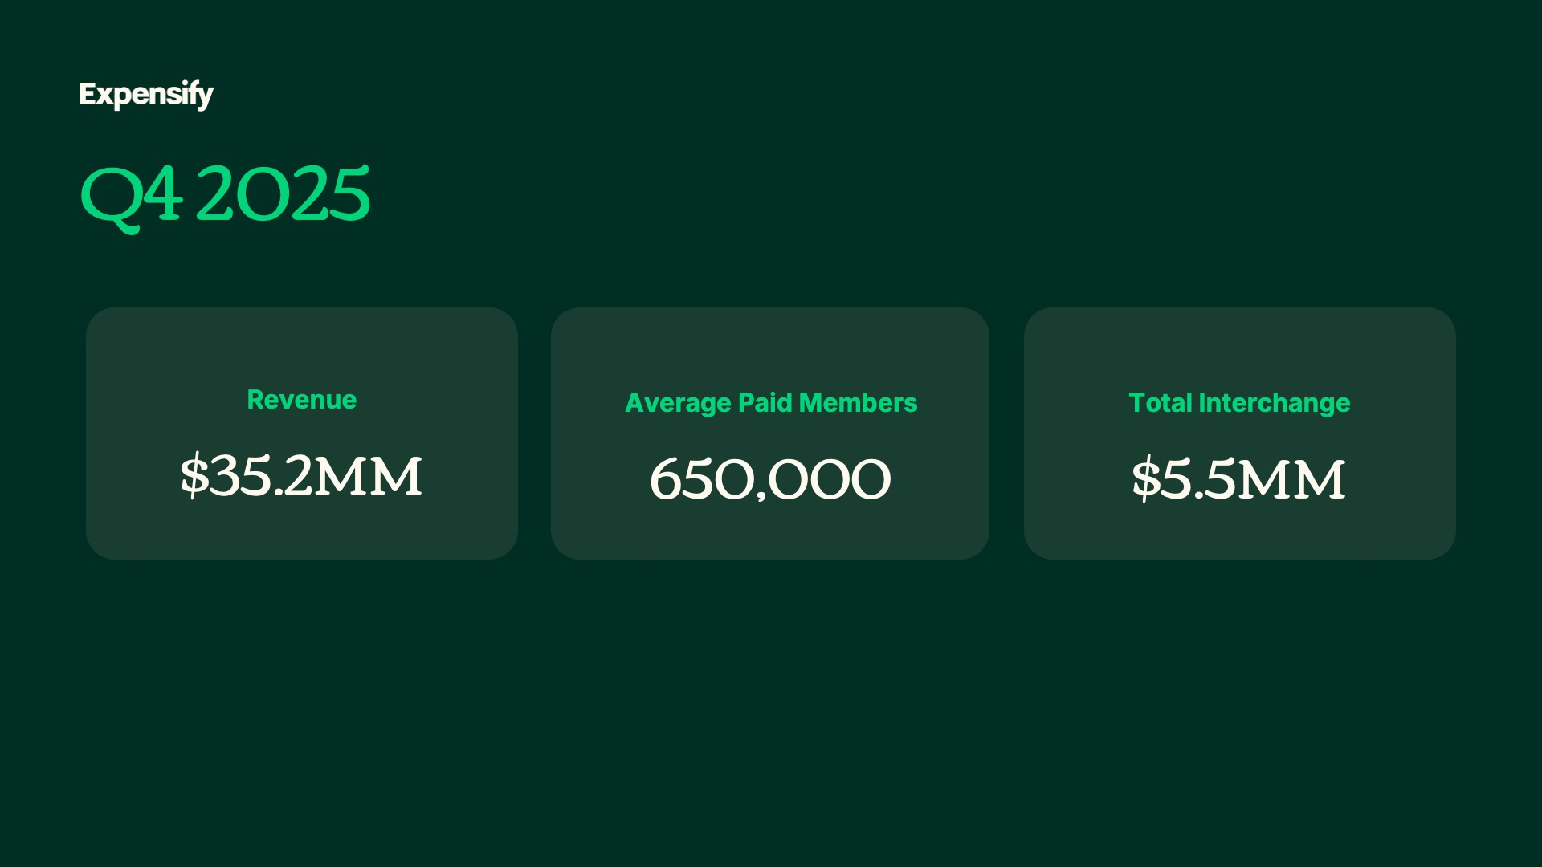

Exhibit 99.2
4
Expensify, Inc.
Investor Presentation

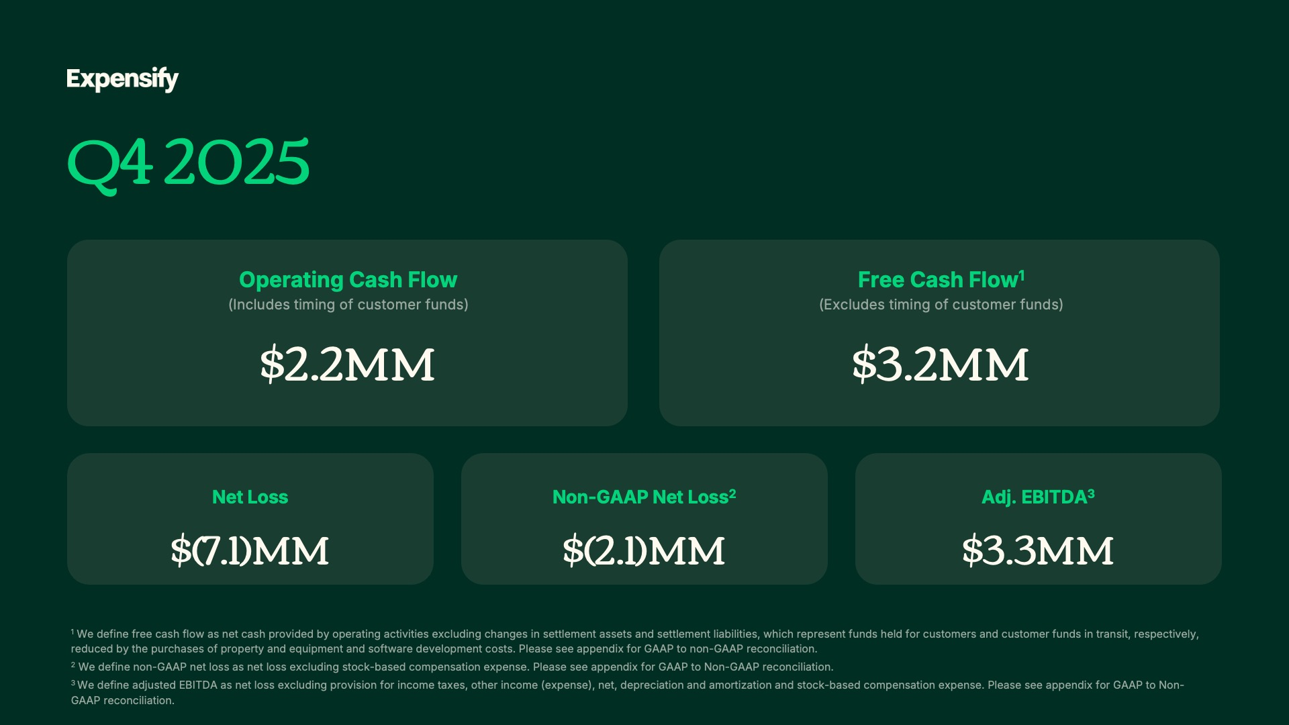

Exhibit 99.2
5
Expensify, Inc.
Investor Presentation



Exhibit 99.2
6
Expensify, Inc.
Investor Presentation

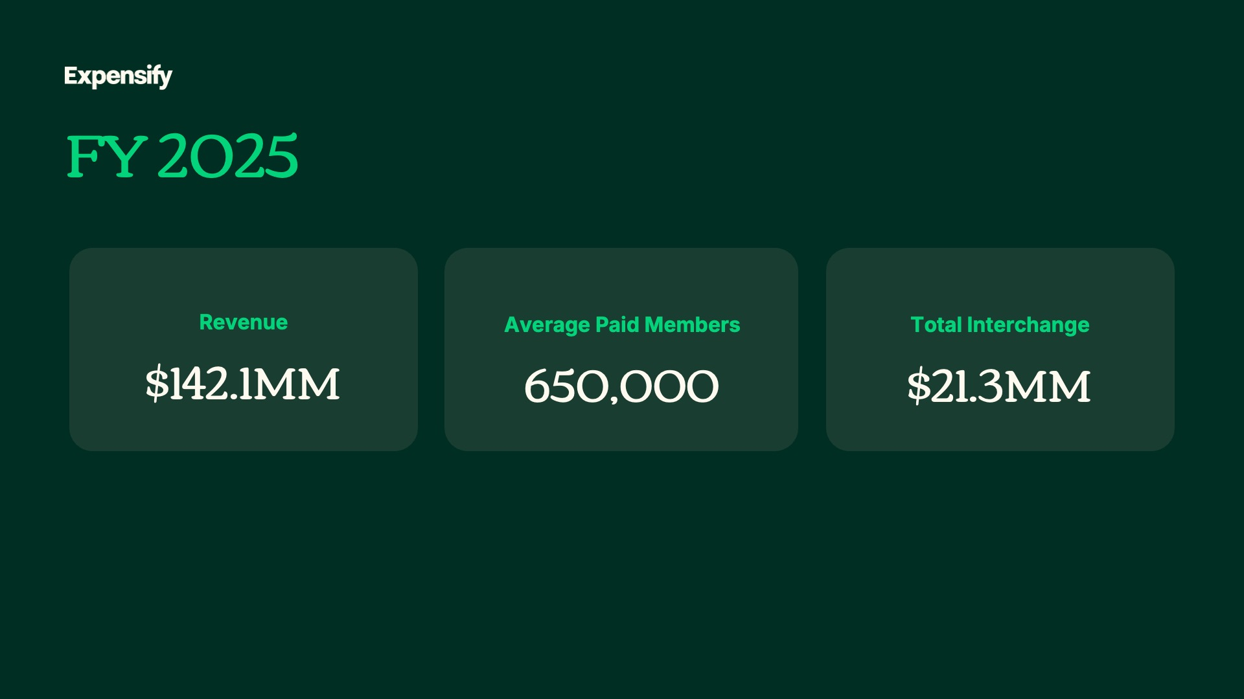

Exhibit 99.2
7
Expensify, Inc.
Investor Presentation

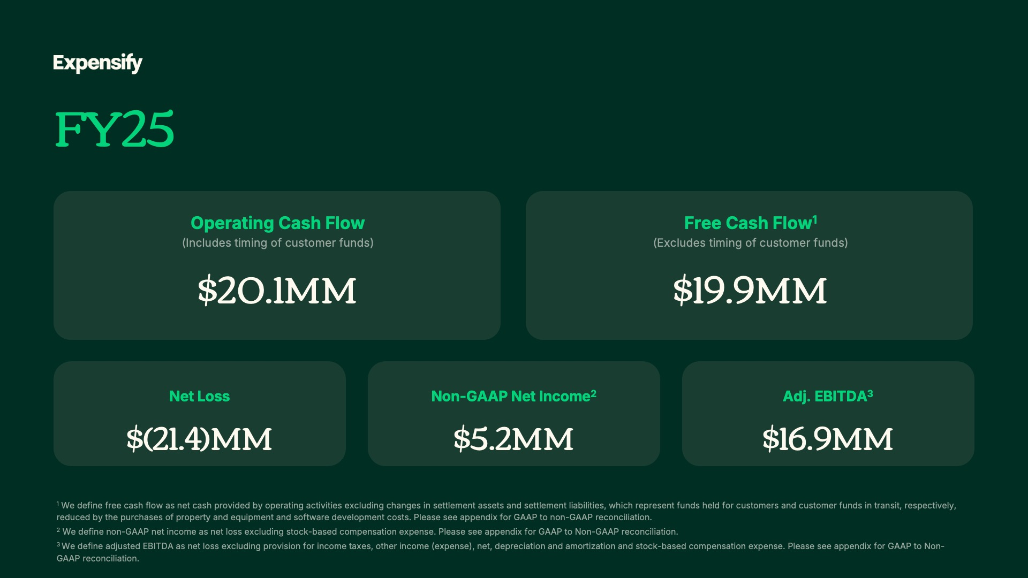

Exhibit 99.2
8
Expensify, Inc.
Investor Presentation

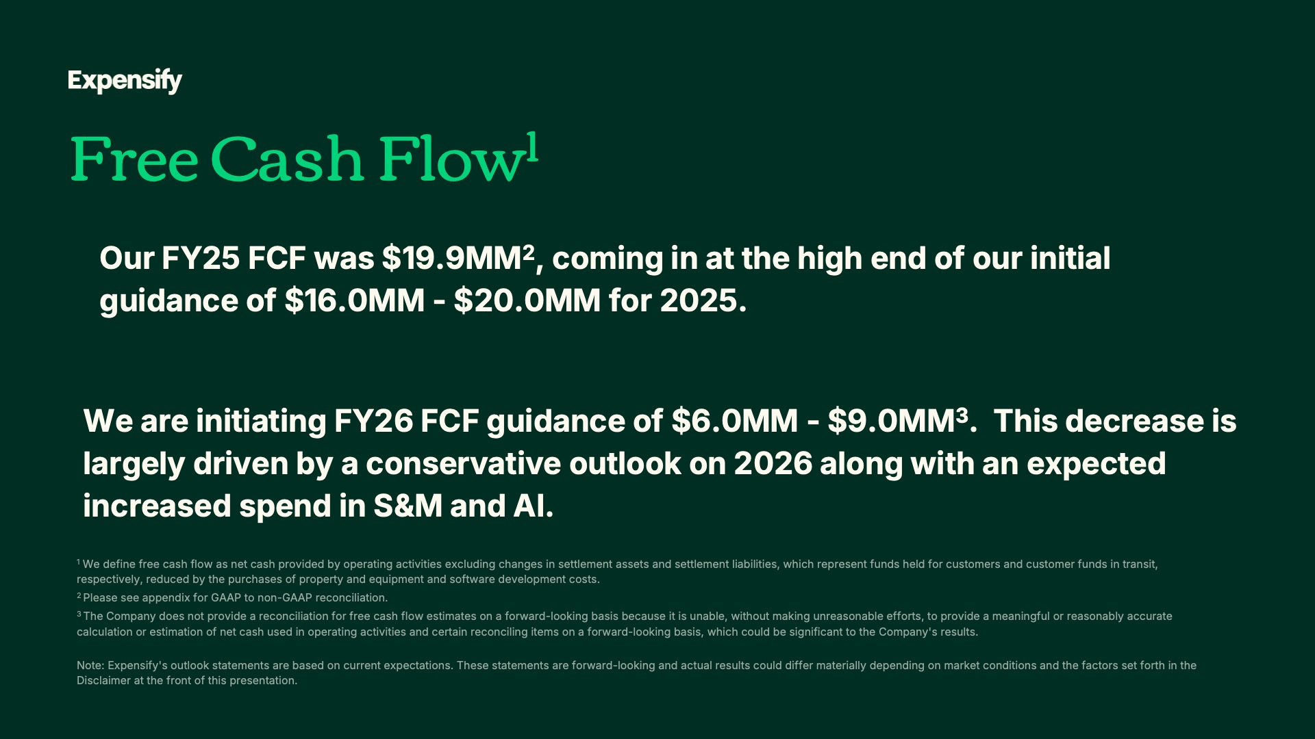

Exhibit 99.2
9
Expensify, Inc.
Investor Presentation

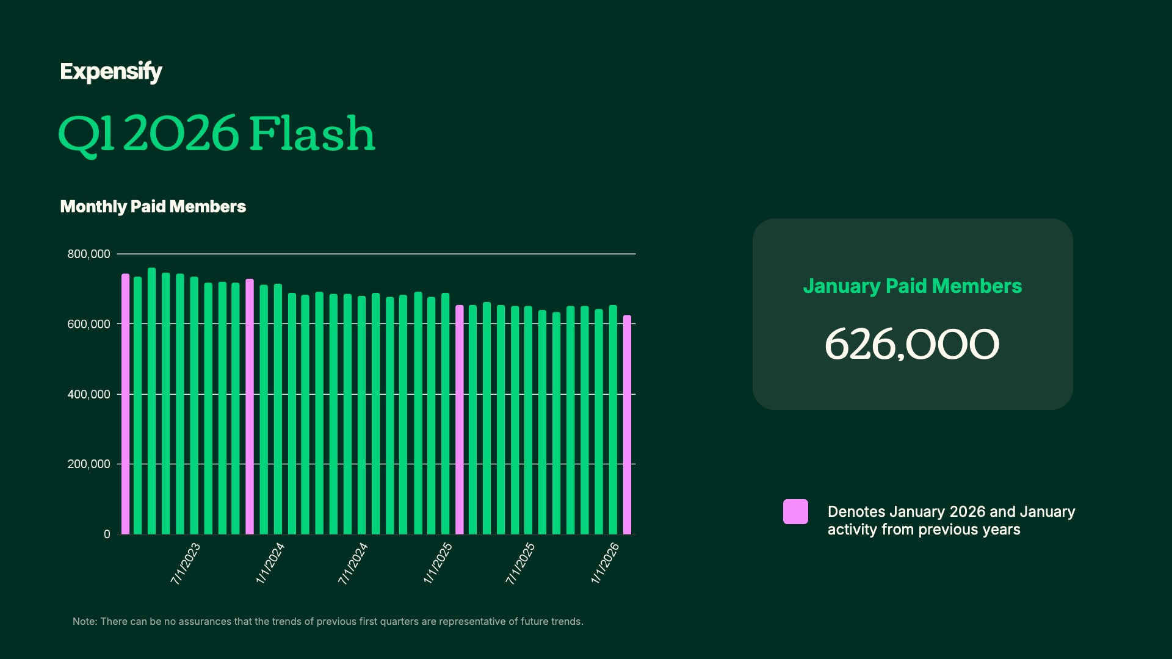
Exhibit 99.2
10
Expensify, Inc.
Investor Presentation

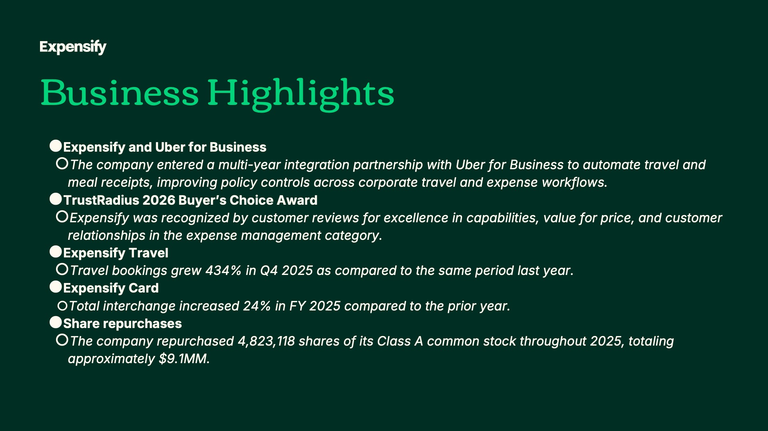
Exhibit 99.2
11
Expensify, Inc.
Investor Presentation


Exhibit 99.2
12
Expensify, Inc.
Investor Presentation

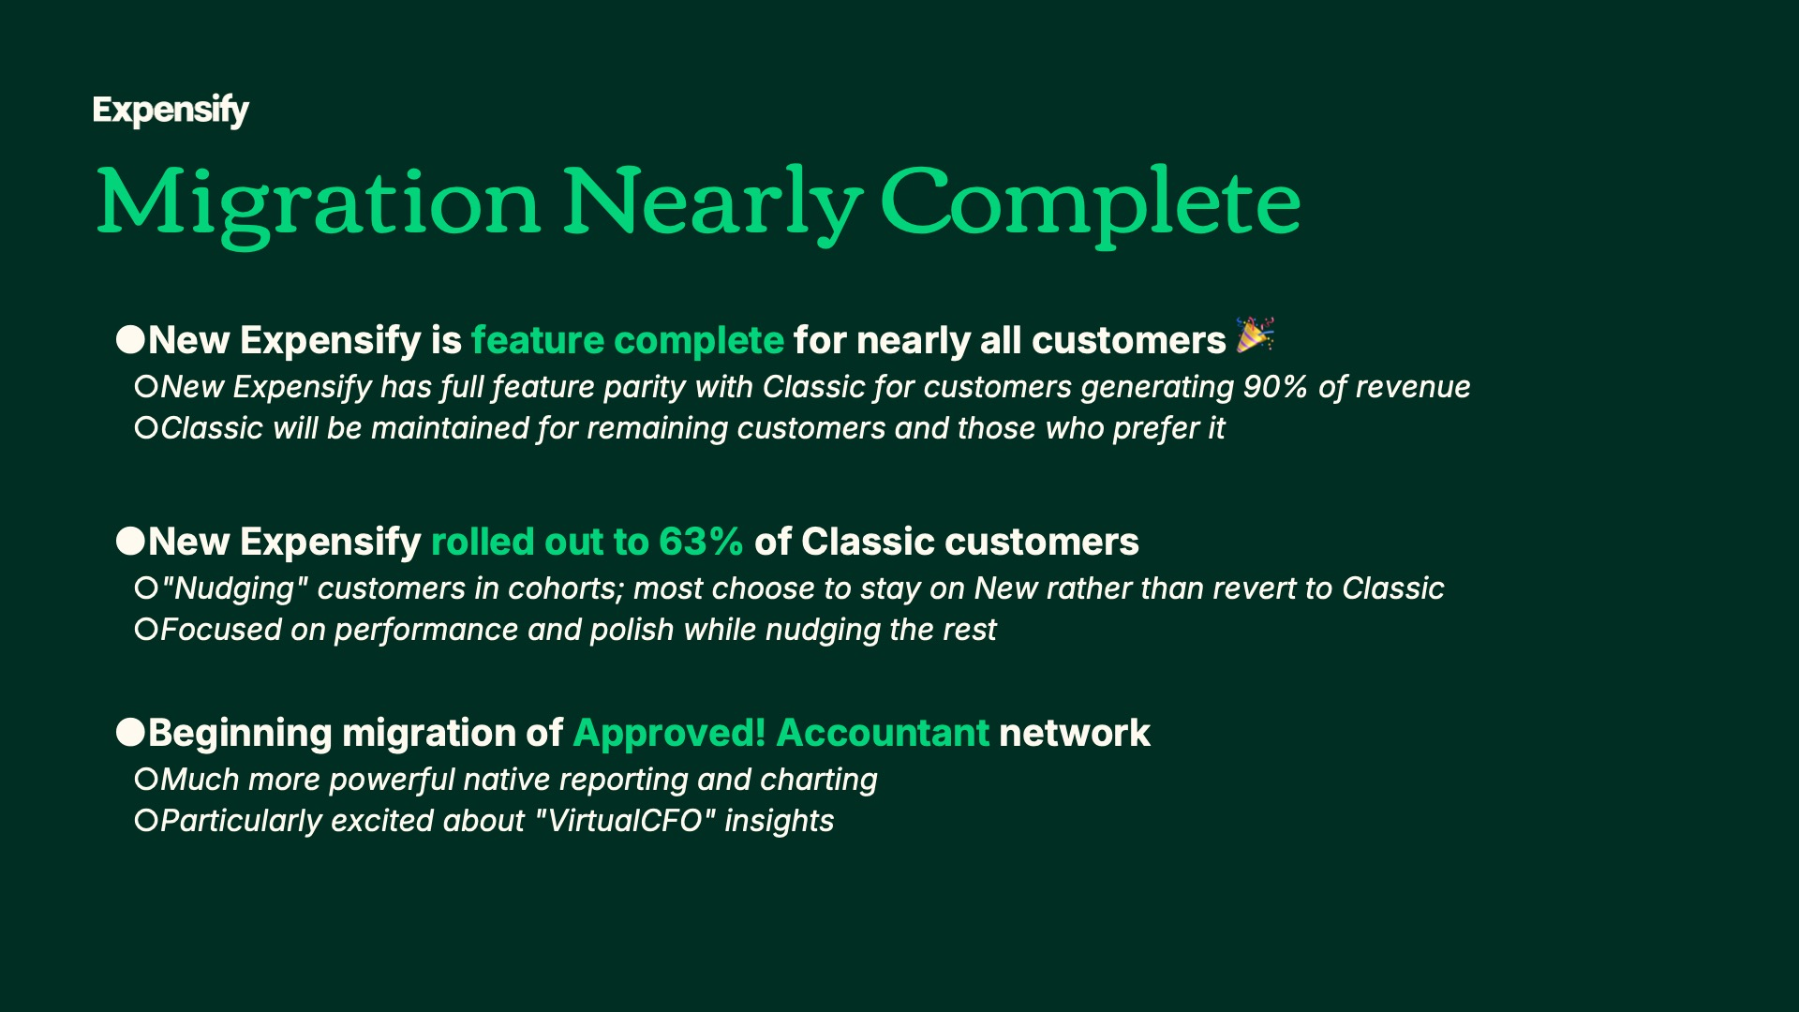
Exhibit 99.2
13
Expensify, Inc.
Investor Presentation

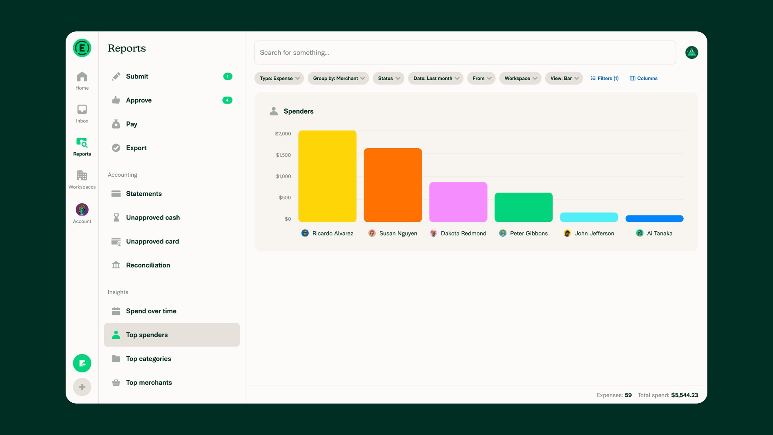
Exhibit 99.2
14
Expensify, Inc.
Investor Presentation

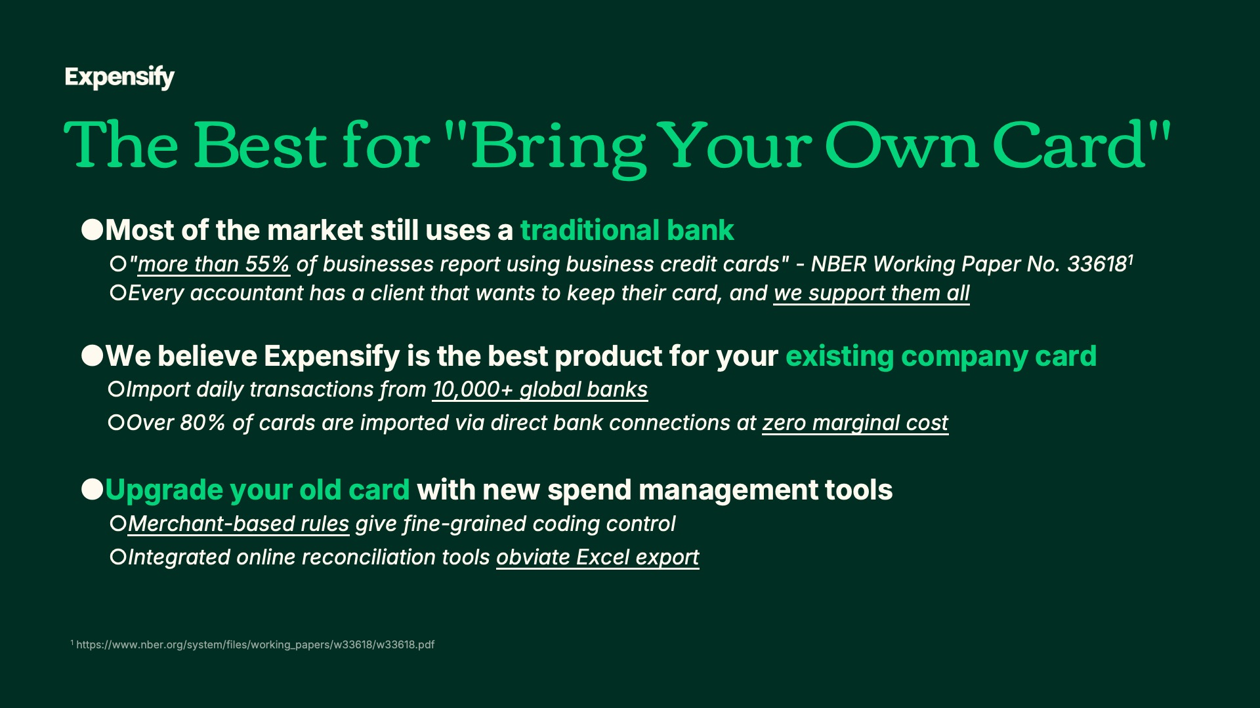
Exhibit 99.2
15
Expensify, Inc.
Investor Presentation

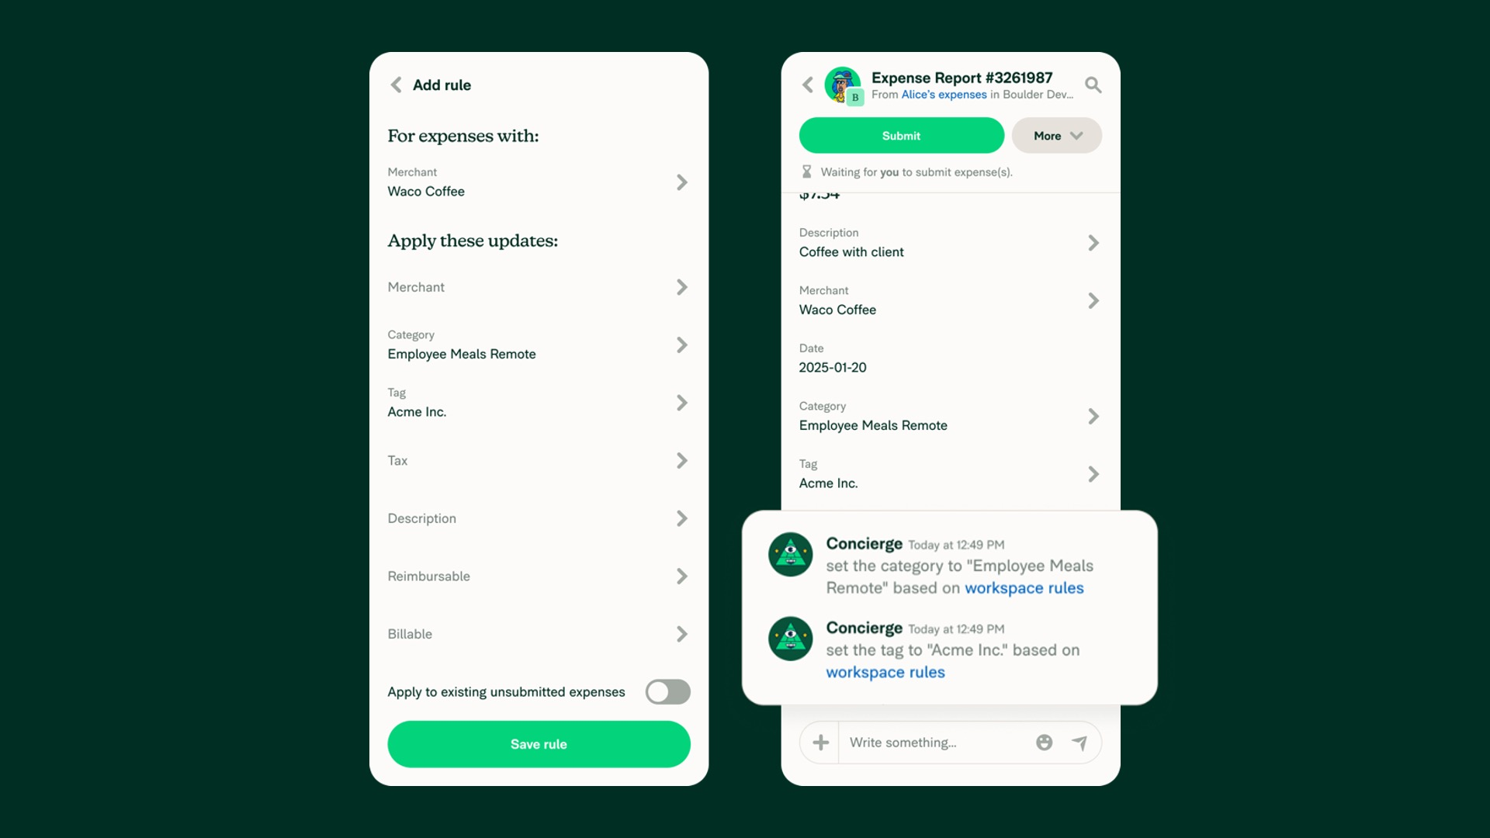
Exhibit 99.2
16
Expensify, Inc.
Investor Presentation

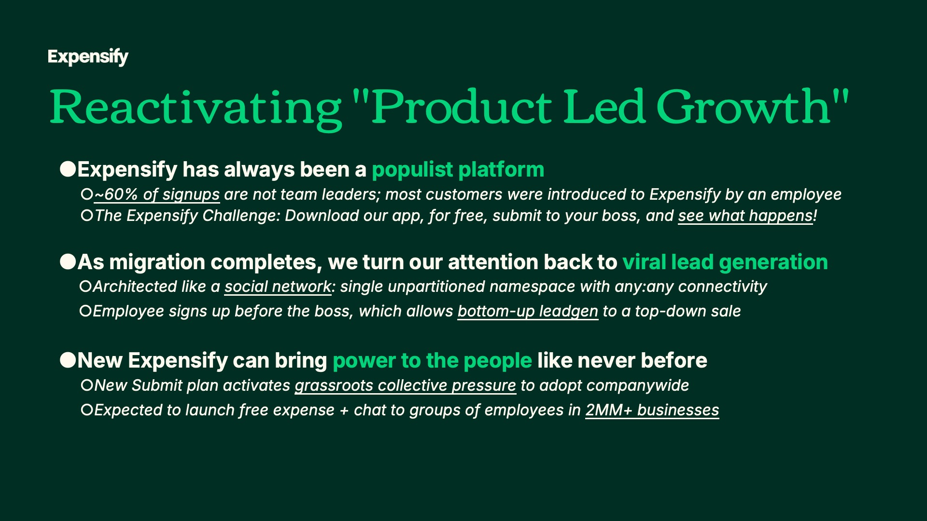
Exhibit 99.2
17
Expensify, Inc.
Investor Presentation


Exhibit 99.2
18
Expensify, Inc.
Investor Presentation

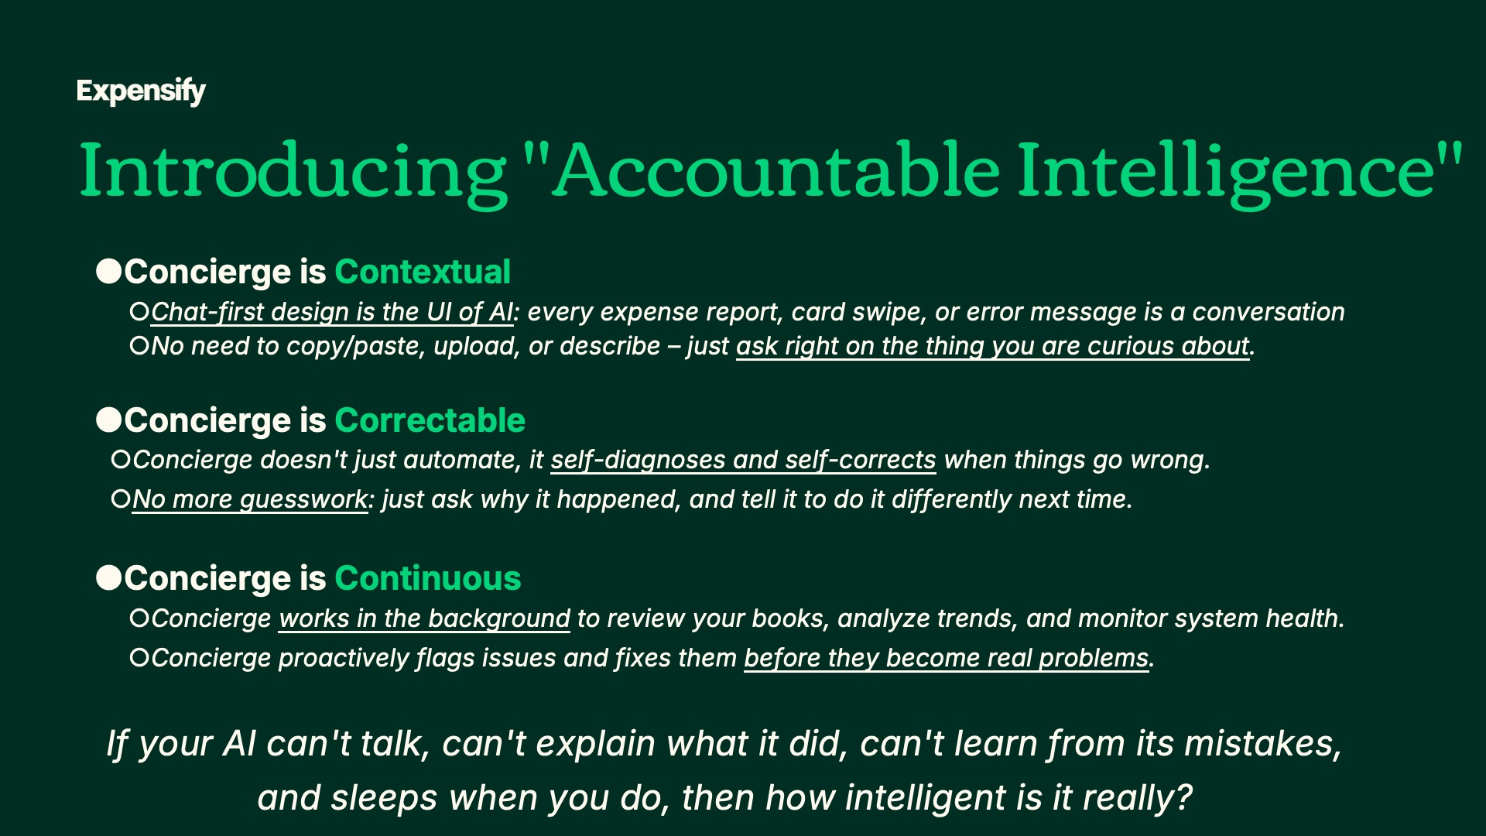
Exhibit 99.2
19
Expensify, Inc.
Investor Presentation

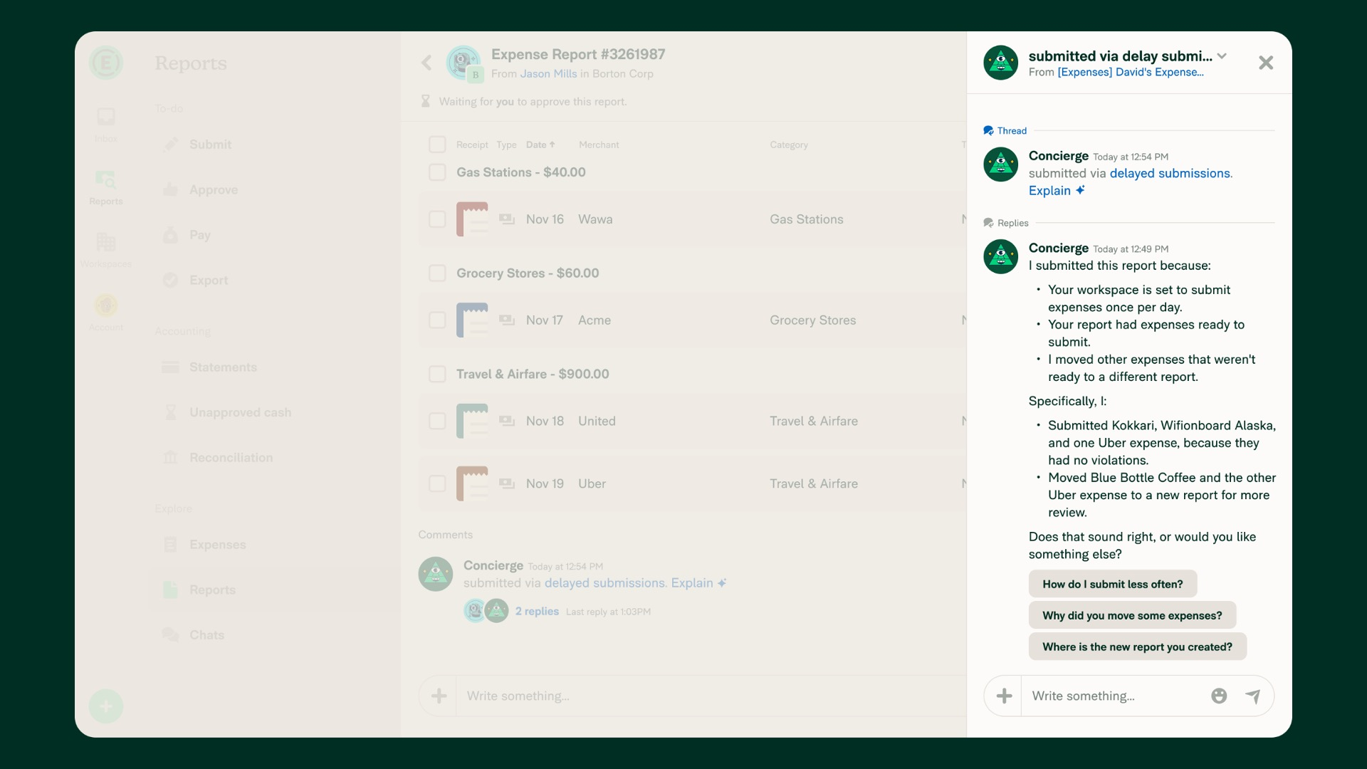
Exhibit 99.2
20
Expensify, Inc.
Investor Presentation

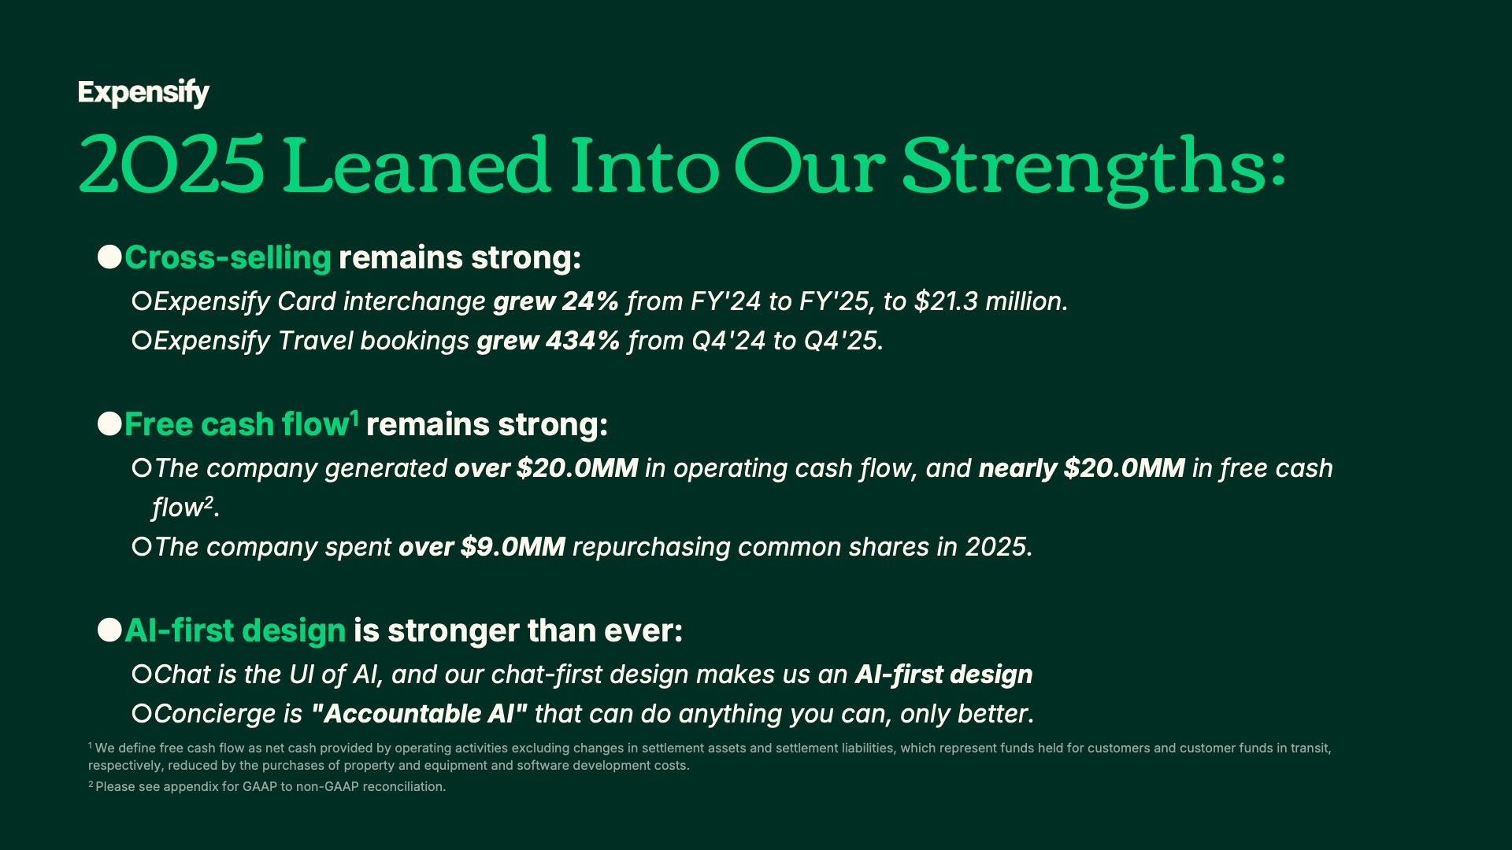
Exhibit 99.2
21
Expensify, Inc.
Investor Presentation


Exhibit 99.2
22
Expensify, Inc.
Investor Presentation


Exhibit 99.2
23
Expensify, Inc.
Investor Presentation


Exhibit 99.2
24
Expensify, Inc.
Investor Presentation

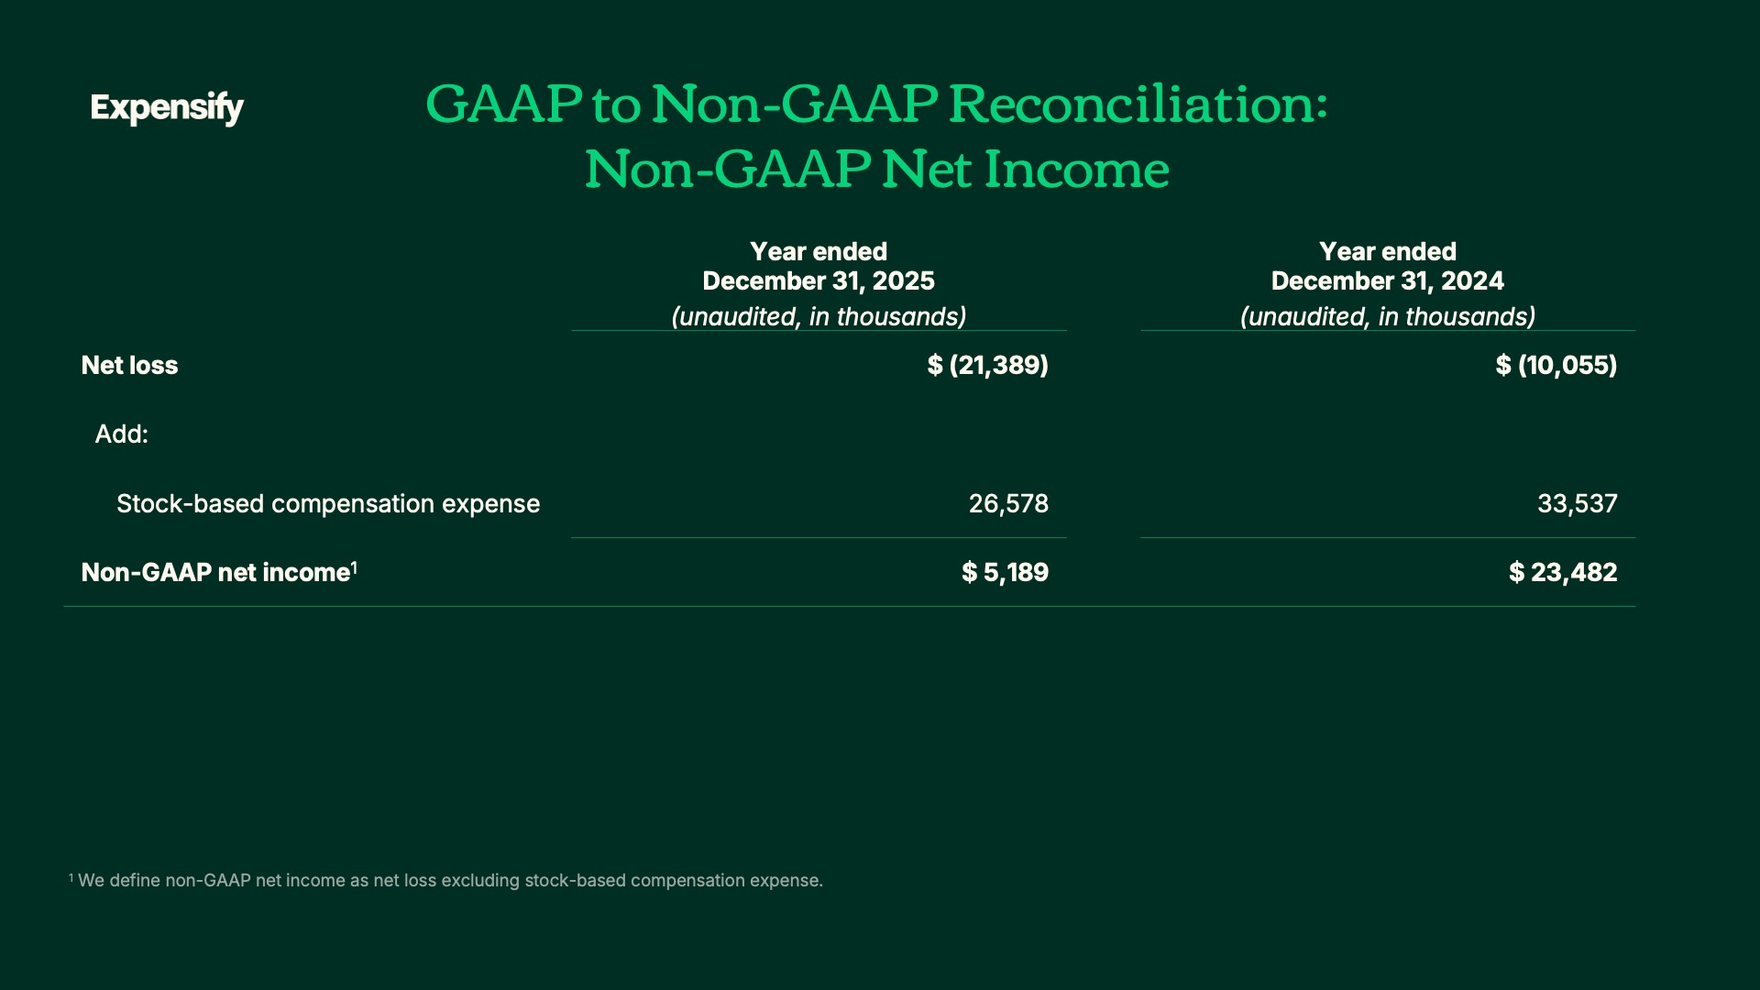
Exhibit 99.2
25
Expensify, Inc.
Investor Presentation

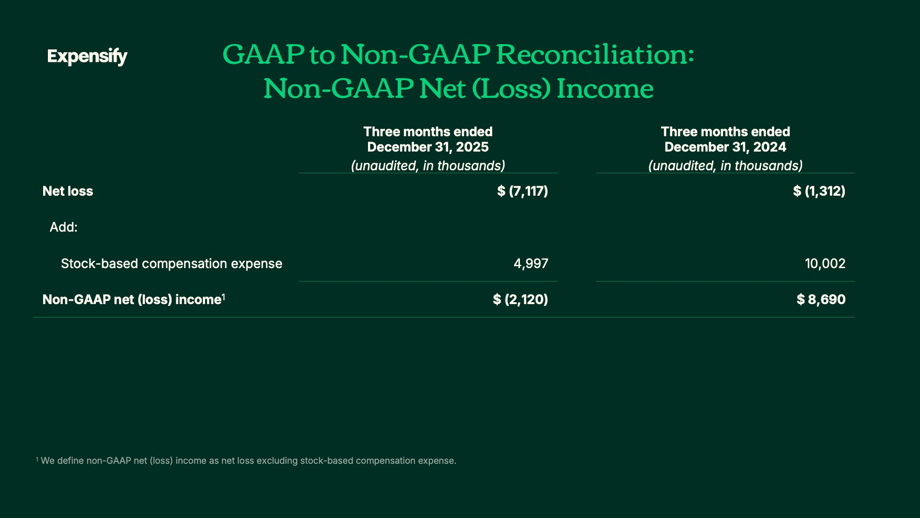
Exhibit 99.2
26
Expensify, Inc.
Investor Presentation

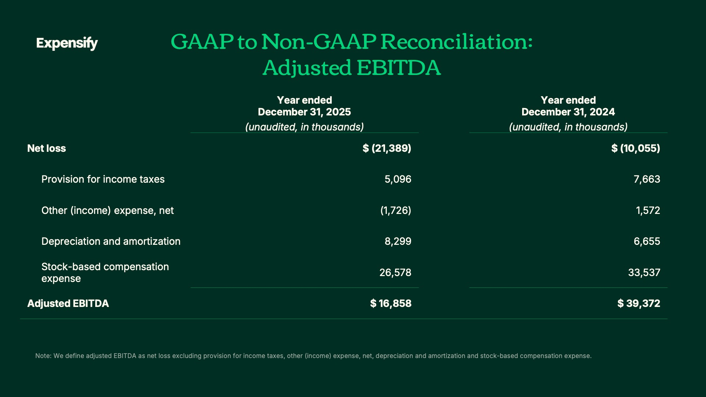
Exhibit 99.2
27
Expensify, Inc.
Investor Presentation

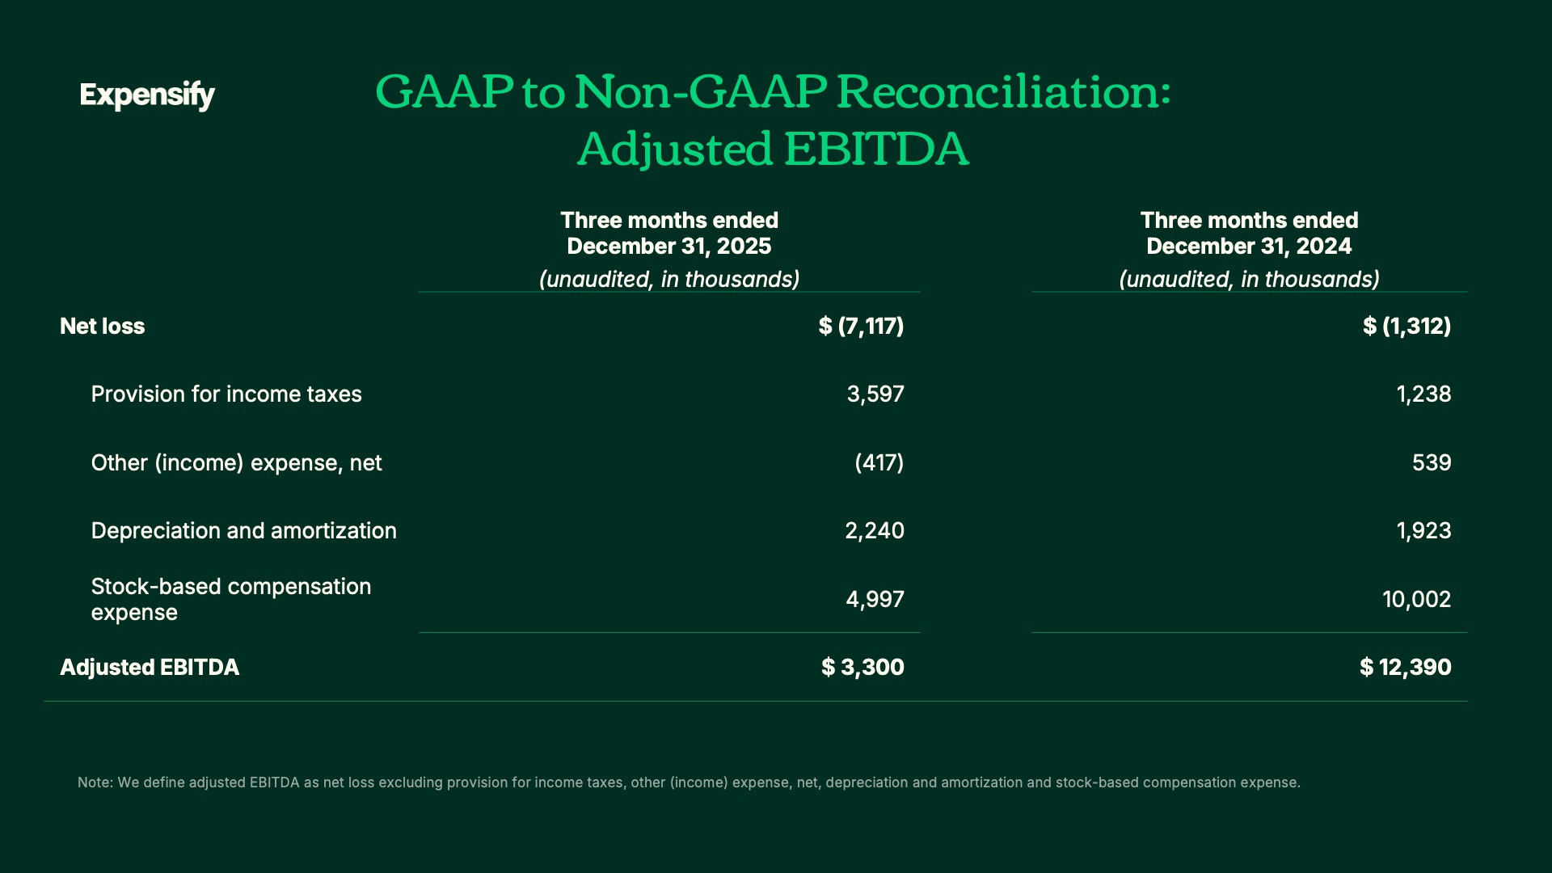
Exhibit 99.2
28
Expensify, Inc.
Investor Presentation

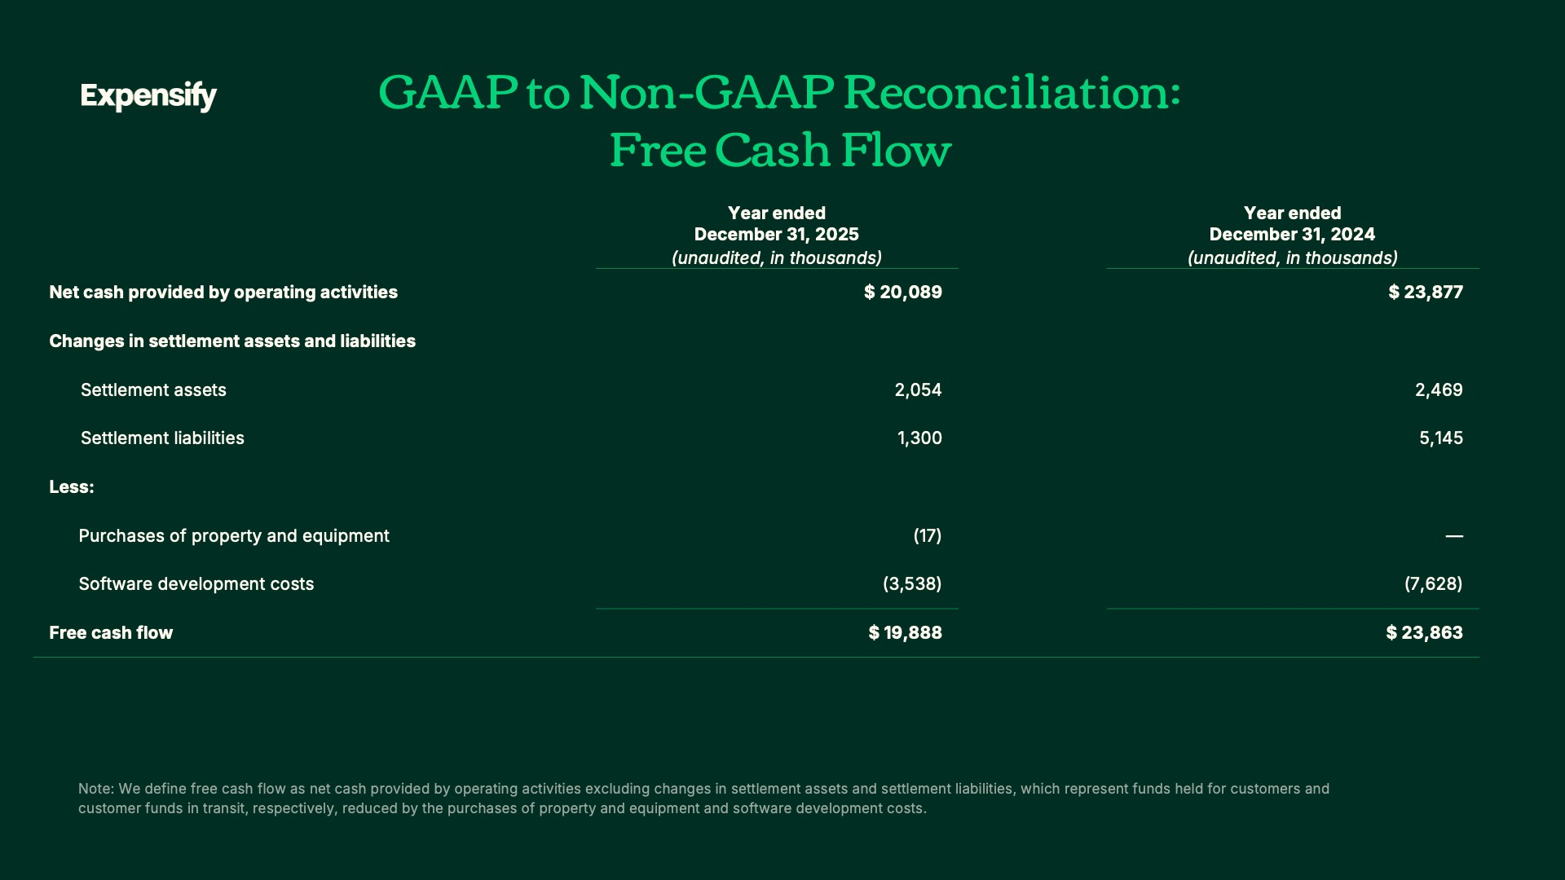

Exhibit 99.2
29
Expensify, Inc.
Investor Presentation

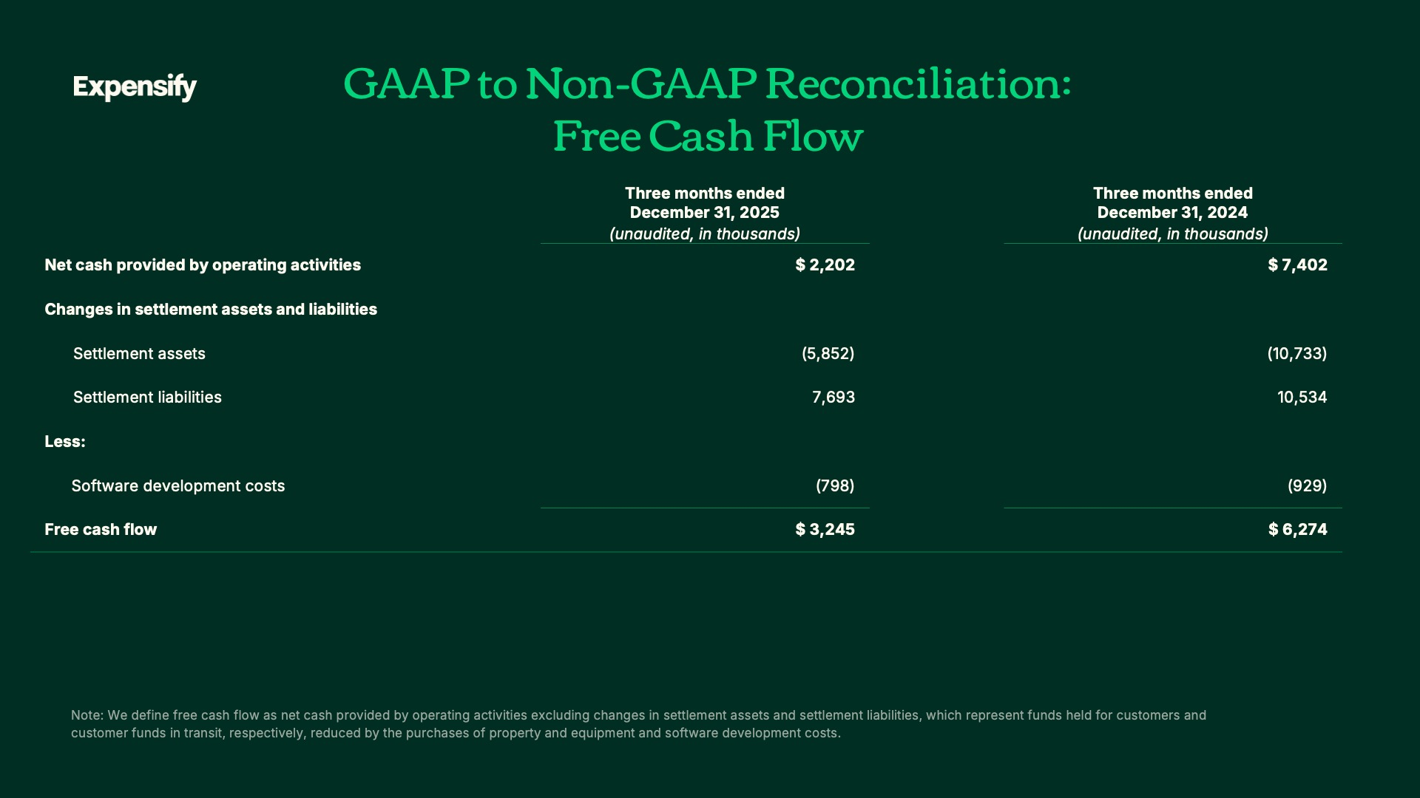
Exhibit 99.2
30
Expensify, Inc.
Investor Presentation

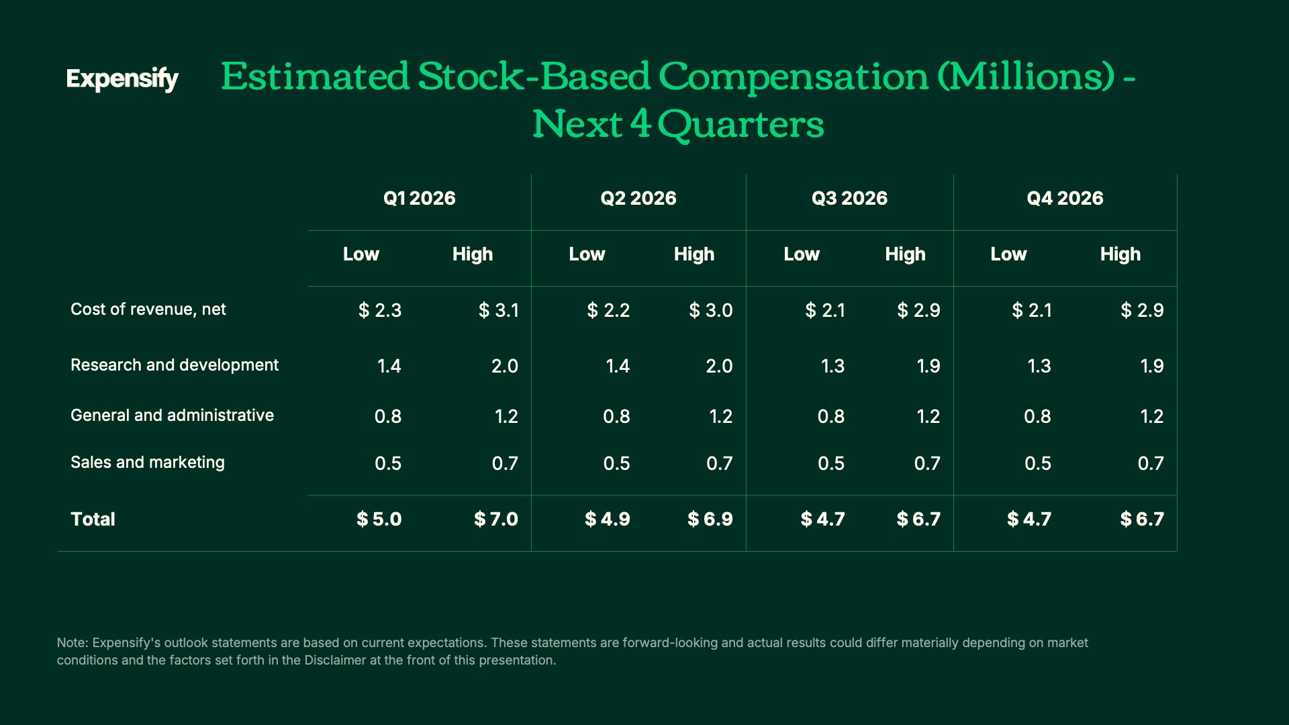
Exhibit 99.2
31
Expensify, Inc.
Investor Presentation

32

