UNITED STATES

SECURITIES AND EXCHANGE COMMISSION

Washington, D.C. 20549

FORM 8-K

CURRENT REPORT

PURSUANT TO SECTION 13 OR 15(d)

OF THE SECURITIES EXCHANGE ACT OF 1934

Date of report (Date of earliest event reported): August 11, 2022

Expensify, Inc.

 | (Exact Name of Registrant as Specified in its Charter)
Delaware | 001-41043 | 27-0239450
(State or Other Jurisdiction | (Commission | (IRS Employer
of Incorporation) | File Number) | Identification No.)
 | 401 SW 5th Ave
 | Portland, Oregon 97204
 | (Address of Principal Executive Offices) (Zip Code)
 | (971) 365-3939
 | (Registrant’s telephone number, including area code)
 | Not applicable
 | (Former Name or Former Address, if Changed Since Last Report)

Check the appropriate box below if the Form 8-K filing is intended to simultaneously satisfy the filing obligation of the registrant under any of the following provisions:

- Written communications pursuant to Rule 425 under the Securities Act (17 CFR 230.425).

- Soliciting material pursuant to Rule 14a-12 under the Exchange Act (17 CFR 240.14a-12).

- Pre-commencement communications pursuant to Rule 14d-2(b) under the Exchange Act (17 CFR 240.14d-2(b)).

- Pre-commencement communications pursuant to Rule 13e-4(c) under the Exchange Act (17 CFR 240.13e-4(c)).

Securities registered pursuant to Section 12(b) of the Act:

 |  | Trading |  | Name of each exchange
Title of each class |  | Symbol(s) |  | on which registered
Class A Common Stock, par value $0.0001 per share |  | EXFY |  | The Nasdaq Stock Market LLC

Indicate by check mark whether the registrant is an emerging growth company as defined in Rule 405 of the Securities Act of 1933 (§230.405 of this chapter) or Rule 12b-2 of the Securities Exchange Act of 1934 (§240.12b-2 of this chapter).

Emerging growth company ☒

If an emerging growth company, indicate by check mark if the registrant has elected not to use the extended transition period for complying with any new or revised financial accounting standards provided pursuant to Section 13(a) of the Exchange Act. ☐

Item 2.02 Results of Operations and Financial Condition.

On August 11, 2022, Expensify, Inc. (“Expensify” or the “Company”) issued a press release announcing its financial results for the quarter ended June 30, 2022. A copy of this press release is furnished as Exhibit 99.1 to this current report on Form 8-K and is incorporated herein by reference.

Item 7.01 Regulation FD Disclosure.

On August 11, 2022, the Company posted an investor presentation to its website at https://ir.expensify.com (the “Investor Presentation”). A copy of the Investor Presentation is attached as Exhibit 99.2 to this current report on Form 8-K and is incorporated herein by reference. The Company expects to use the Investor Presentation, in whole or in part, and possibly with modifications, in connection with presentations to investors, analysts and others.

The information contained in the Investor Presentation is summary information that is intended to be considered in the context of the Company’s Securities and Exchange Commission (“SEC”) filings and other public announcements that the Company may make, by press release or otherwise, from time to time. The Investor Presentation speaks only as of the date of this current report on Form 8-K. The Company undertakes no duty or obligation to publicly update or revise the information included in the Investor Presentation, although it may do so from time to time. Any such updating may be made through the filing of other reports or documents with the SEC, through press releases or other public disclosure. In addition, the exhibit furnished herewith contains statements intended as “forward-looking statements” that are subject to the cautionary statements about forward-looking statements set forth in such exhibit. By furnishing the information contained in the Investor Presentation, the Company makes no admission as to the materiality of any information in the Investor Presentation that is required to be disclosed solely by reason of Regulation FD.

The information contained in Item 2.02 and this Item 7.01, including Exhibits 99.1 and 99.2, is being furnished and shall not be deemed “filed” for purposes of Section 18 of the Securities and Exchange Act of 1934, as amended (the “Exchange Act”), or otherwise subject to the liabilities of that section, nor shall it be deemed incorporated by reference in any filing made by Expensify under the Securities Act of 1933, as amended, or the Exchange Act, except as expressly set forth by specific reference in such a filing.

Item 9.01 Financial Statements and Exhibits.

- Exhibits.

Exhibit No. Description

99.1 Press Release issued by Expensify, Inc., dated August 11, 2022.

99.2 Investor Presentation, dated August, 11, 2022.

104 Cover Page Interactive Data File (embedded within the Inline XBRL document).

SIGNATURE

Pursuant to the requirements of the Securities Exchange Act of 1934, the registrant has duly caused this report to be signed on its behalf by the undersigned hereunto duly authorized.

Expensify, Inc.

By: /s/ Ryan Schaffer

Name: Ryan Schaffer

Title: Chief Financial Officer

Date: August 11, 2022

Exhibit 99.1

EXPENSIFY ANNOUNCES Q2 2022 RESULTS

The company experienced its strongest quarter for paid member growth to date, generated year-over-year interchange growth from the Expensify Card of 142% and saw positive

operating cash flow of $27.2 million for the quarter.

PORTLAND, Ore.--(BUSINESS WIRE)--August 11, 2022-- Expensify, Inc. (Nasdaq: EXFY), a payments superapp that helps individuals and businesses around the world simplify the way they manage money across expenses, corporate cards and bills, today announced results for its quarter ended June 30, 2022.

“Our paid member count has fully rebounded and currently exceeds pre-pandemic levels, so there’s a lot to be excited about,” said David Barrett, Expensify’s founder and CEO. “We’re also doubling down on accounting partnerships – one of our most successful sales channels – by introducing dedicated partner managers and bringing back our invite-only accounting retreat, ExpensiCon, next May 2023. Not only has every ExpensiCon paid for itself many times over from the resulting subscription increases, it’s also a big cultural moment for the accounting industry and supercharges the activity we see in that channel.”

“We delivered great results this quarter anchored by an increase in subscription revenue and Expensify Card interchange.” says Ryan Schaffer, Expensify’s CFO. “The strength the business is experiencing right now can also be seen in our positive operating cash flow of $27.2 million. We’re excited by the momentum we’re seeing in the business despite the challenging climate as we continue to offer and improve upon the most effective solution to serve all small businesses.”

Second Quarter 2022 Highlights

Financial:

- Revenue was $43.2 million, an increase of 22% compared to the same period last year.

- Interchange derived from the Expensify Card saw sequential quarterly growth of 40%, resulting in a 142% increase compared to the same period last year.

- Positive operating cash flows of $27.2 million.

- Net (loss) income was $(8.0) million, compared to $6.6 million for the same period last year. This loss was primarily driven by stock-based compensation expenses of $14.0 million.

  - Non-GAAP net income was $6.1 million.

- Adjusted EBITDA was $11.7 million, with an Adjusted EBITDA margin of 27%.

Business

- Paid members - a strong Q2 propelled quarterly paid members for the quarter to 754,000 compared to 706,000 in Q1.

- ExpensiCon - the third-ever, invite-only accounting retreat is returning May 2023, this time bringing industry thought-leaders to the legendary Borgo Egnazia in Puglia, Italy.

- Awards

  - Expensify’s employee-controlled compensation program earned two finalist spots as part of Fast Company’s World Changing Ideas Awards.

  - Expensify also won multiple workplace awards for 2022, with Fortune designating the company one of the best small workplaces and the San Francisco Chronicle ranking it one of the top workplaces in the Bay Area.

Exhibit 99.1

Financial Outlook

Expensify's outlook statements are based on current estimates, expectations and assumptions and are not a guarantee of future performance. The following statements are forward-looking and actual results could differ materially depending on market conditions and the factors set forth under “Forward-Looking Statements” below. There can be no assurance that the Company will achieve the results expressed by this guidance.

We reaffirm our long term guidance provided in connection with our fourth quarter 2021 results of 25-35% revenue growth over a multi-year period.

Expensify is also providing an estimate on what stock based compensation is expected to look like for the rest of the fiscal year. Driven primarily by the pre-IPO grant of RSUs issued to all employees (which vest over 8 years – 1/8 after one year and quarterly thereafter), stock based compensation is estimated as seen below:

Est. stock-based compensation (millions)

 |  | Q3 2022 |  |  |  |  |  | Q4 2022 |  |  |  |  |  | Q1 2023
 |  | Low |  |  | High |  |  | Low |  |  | High |  |  | Low |  |  | High
Cost of revenue, net | $ | 4.4 |  | $ | 5.1 |  | $ | 3.6 |  | $ | 4.3 |  | $ | 3.4 |  | $ | 4.1
Research and development |  | 1.8 |  |  | 2.0 |  |  | 1.4 |  |  | 1.7 |  |  | 1.4 |  |  | 1.6
General and administrative |  | 5.1 |  |  | 5.9 |  |  | 4.2 |  |  | 4.9 |  |  | 4.0 |  |  | 4.7
Sales and marketing |  | 1.9 |  |  | 2.2 |  |  | 1.5 |  |  | 1.8 |  |  | 1.5 |  |  | 1.7
Total | $ | 13.2 |  | $ | 15.2 |  | $ | 10.7 |  | $ | 12.7 |  | $ | 10.3 |  | $ | 12.1

Availability of Information on Expensify’s Website

Investors and others should note that Expensify routinely announces material information to investors and the marketplace using SEC filings, press releases, public conference calls, webcasts and the Expensify Investor Relations website at https://ir.expensify.com. While not all of the information that the Company posts to its Investor Relations website is of a material nature, some information could be deemed to be material. Accordingly, the Company encourages investors, the media and others interested in Expensify to review the information that it shares on its Investor Relations website.

Conference Call

Expensify will host a video call to discuss the financial results and business highlights at 2:00 p.m. Pacific Time today. An investor presentation and the video call information is available on Expensify’s Investor Relations website at https://ir.expensify.com. A replay of the call will be available on the site for three months.

Non-GAAP Financial Measures

In addition to financial measures prepared in accordance with U.S. generally accepted accounting principles (“GAAP”), we provide certain non-GAAP financial measures, including adjusted EBITDA and non-GAAP net income.

We believe our non-GAAP financial measures are useful in evaluating our business, measuring our performance, identifying trends affecting our business, formulating business plans and making strategic decisions. Accordingly, we believe that these non-GAAP financial measures provide useful information to investors and others in understanding and evaluating our results of operations in the same manner as our management team. These non-GAAP financial measures are presented for supplemental informational purposes only, should not be considered a substitute for financial information presented in accordance with GAAP, and may be different from similarly titled metrics or measures presented by other companies. Non-GAAP financial measures have limitations as analytical tools and should not be considered in isolation or as substitutes for financial information presented under GAAP.

Exhibit 99.1

There are a number of limitations related to the use of non-GAAP financial measures versus comparable financial measures determined under GAAP. For example, other companies in our industry may calculate these non-GAAP financial measures differently or may use other measures to evaluate their performance. All of these limitations could reduce the usefulness of these non-GAAP financial measures as analytical tools. Investors are encouraged to review the related GAAP financial measures and the reconciliations of these non-GAAP financial measures to their most directly comparable GAAP financial measures and to not rely on any single financial measure to evaluate our business. A reconciliation of each non-GAAP financial measure to the most directly comparable financial measure stated in accordance with GAAP is at the end of this press release.

Adjusted EBITDA. We define adjusted EBITDA as net income from operations excluding provision for income taxes, interest and other expenses, net, depreciation and amortization and stock based compensation.

Adjusted EBITDA margin. We define adjusted EBITDA margin as adjusted EBITDA divided by total revenue for the same period.

Non-GAAP net income. We define non-GAAP net income as net income from operations in accordance with US GAAP excluding stock-based compensation and IPO-related bonus costs. Prior to the four quarter of 2021, this metric only excluded IPO-related bonus costs and did not exclude expenses related to stock-based compensation. However, management now believes that further excluding stock-based compensation from non-GAAP net income is useful to better understand the financial performance of our business and to facilitate a better comparison of our results to those of peer companies over multiple periods given that this item may vary between companies for reasons unrelated to overall operating performance. IPO-related bonus costs impacted the second, third and fourth fiscal quarters of 2021 but did not impact the first or second quarters of 2022 and are not expected to impact future periods.

Non-GAAP net income margin. We define non-GAAP net income as non-GAAP net income divided by total revenue for the same period.

The tables at the end of the Condensed Consolidated Financial Statements provide reconciliations to the most directly comparable GAAP financial measure to each of these non-GAAP financial measures.

Forward-Looking Statements

Forward-looking statements in this press release, or made during the earnings call, which are not historical facts, are forward-looking statements within the meaning of the Private Securities Litigation Reform Act of 1955. These statements include statements regarding our strategy, future financial condition, future operations, projected costs, prospects, plans, objectives of management and expected market growth and involve known and unknown risks that are difficult to predict. As a result, our actual results, performance or achievements may differ materially from those expressed or implied by these forward-looking statements. In some cases, you can identify forward-looking statements because they contain words such as “may,” “will,” “shall,” “should,” “expects,” “plans,” “anticipates,” “could,” “intends,” “target,” “projects,” “contemplates,” “believes,” “estimates,” “predicts,” “potential,” “goal,” “objective,” “seeks,” or “continue” or the negative of these words or other similar terms or expressions that concern our expectations, strategy, plans, or intentions. Such forward-looking statements are necessarily based upon estimates and assumptions that, while considered reasonable by us and our management, are inherently uncertain. Factors that may cause actual results to differ materially from current expectations include, but are not limited to: the economic, political and social impact of, and uncertainty relating to, the COVID-19 pandemic; the war in Ukraine and escalating geopolitical tensions as a result of Russia's invasion of Ukraine; our expectations regarding our financial performance and future operating performance; our ability to attract and retain members, expand usage of our platform, sell subscriptions to our platform and convert individuals and organizations into paying customers; the timing and success of new features, integrations, capabilities and enhancements by us, or by competitors to their products, or any other changes in the competitive landscape of our market; the amount and timing of operating expenses and capital expenditures that we may incur to maintain and expand our business and operations to remain

Exhibit 99.1

competitive; the sufficiency of our cash, cash equivalents and investments to meet our liquidity needs; our ability to make required payments under and to comply with the various requirements of our current and future indebtedness; our ability to effectively manage our exposure to fluctuations in foreign currency exchange rates; the increased expenses associated with being a public company; the size of our addressable markets, market share and market trends; anticipated trends, developments and challenges in our industry, business and the highly competitive markets in which we operate; our expectations regarding our income tax liabilities and the adequacy of our reserves; our ability to effectively manage our growth and expand our infrastructure and maintain our corporate culture; our ability to identify, recruit and retain skilled personnel, including key members of senior management; the safety, affordability and convenience of our platform and our offerings; our ability to successfully defend litigation brought against us; our ability to successfully identify, manage and integrate any existing and potential acquisitions of businesses, talent, technologies or intellectual property; general economic conditions in either domestic or international markets, including the societal and economic impact of the COVID-19 pandemic, and geopolitical uncertainty and instability; our protections against security breaches, technical difficulties, or interruptions to our platform; our ability to maintain, protect and enhance our intellectual property; and other risks discussed in our filings with the SEC. All forward-looking statements attributable to us or persons acting on our behalf are expressly qualified in their entirety by the cautionary statements set forth above. We caution you not to place undue reliance on any forward-looking statements, which are made only as of the date of this press release. We do not undertake or assume any obligation to update publicly any of these forward-looking statements to reflect actual results, new information or future events, changes in assumptions or changes in other factors affecting forward-looking statements, except to the extent required by applicable law. If we update one or more forward-looking statements, no inference should be drawn that we will make additional updates with respect to those or other forward-looking statements.

About Expensify

Expensify is a payments superapp that helps individuals and businesses around the world simplify the way they manage money. More than 12 million people use Expensify's free features, which include corporate cards, expense tracking, next-day reimbursement, invoicing, bill pay, and travel booking in one app. All free. Whether you own a small business, manage a team, or close the books for your clients, Expensify makes it easy so you have more time to focus on what really matters.

Investor Relations Contact

Nick Tooker

investors@expensify.com

Press Contact

James Dean

press@expensify.com

Expensify, Inc.

Condensed Consolidated Balance Sheets

(unaudited, in thousands, except share and per share data)

As of June 30,

2022

As of December

2021

Assets
Cash and cash equivalents | $ | 105,537 |  | $
Accounts receivable, net |  | 16,270
Settlement assets |  | 43,780
Prepaid expenses |  | 5,430
Related party loan receivable |  | —
Other current assets |  | 20,434
Total current assets |  | 191,451
Capitalized software, net |  | 6,006
Property and equipment, net |  | 15,174
Lease right-of-use assets |  | 1,472
Deferred tax assets, net |  | 689
Other assets |  | 580
Total assets | $ | 215,372 |  | $
Liabilities and stockholders' equity
Accounts payable | $ | 2,169 |  | $
Accrued expenses and other liabilities |  | 8,967
Borrowings under line of credit |  | 15,000
Current portion of long-term debt, net of original issuance discount and debt issuance costs |  | 548
Lease liabilities, current |  | 1,508
Settlement liabilities |  | 41,590
Total current liabilities |  | 69,782
Lease liabilities, non-current |  | 68
Other liabilities |  | 1,121
Long-term debt, net of original issuance discount and debt issuance costs |  | 51,710
Total liabilities |  | 122,681
Commitments and contingencies (Note 4)
Stockholders' equity:
Common stock, par value $0.0001; 1,000,000,000 shares of Class A common stock authorized as of June 30, 2022 and December 31, 2021; 68,209,726 and
67,844,060 shares of Class A common stock issued and outstanding as of June 30, 2022 and December 31, 2021, respectively; 24,999,330 and 25,000,000
shares of LT10 common stock authorized as of June 30, 2022 and December 31, 2021, respectively; 7,337,960 and 7,332,640 shares of LT10 common stock
issued and outstanding as of June 30, 2022 and December 31, 2021, respectively; 24,999,170 and 25,000,000 shares of LT50 common stock authorized as of
June 30, 2022 and December 31, 2021, respectively; 6,225,330 and 6,224,160 shares of LT50 common stock issued and outstanding as of June 30, 2022 and
December 31, 2021, respectively; preferred stock, par value $0.0001; 10,000,000 shares of preferred stock authorized as of June 30, 2022 and December 31,
2021; no shares of preferred stock outstanding as of June 30, 2022 and December 31, 2021 |  | 6
Additional paid-in capital |  | 173,961
Accumulated deficit |  | (81,276)
Total stockholders' equity |  | 92,691
Total liabilities and stockholders' equity | $ | 215,372 |  | $

Expensify, Inc.

Condensed Consolidated Statements of Operations

(unaudited, in thousands, except share and per share data)

 |  | Three months ended June 30, |  |  |  |  |  | Six months ended June 30,
 |  | 2022 |  |  | 2021 |  |  | 2022 |  |  | 2021
 |  |  |  |  | (in thousands, except per share data)
Revenue | $ | 43,162 |  | $ | 35,304 |  | $ | 83,532 |  | $ | 65,024
Cost of revenue, net⁽¹⁾ |  | 15,876 |  |  | 7,934 |  |  | 30,010 |  |  | 15,571
Gross margin |  | 27,286 |  |  | 27,370 |  |  | 53,522 |  |  | 49,453
Operating expenses:
Research and development⁽¹⁾ |  | 3,584 |  |  | 4,874 |  |  | 7,285 |  |  | 5,971
General and administrative⁽¹⁾ |  | 15,432 |  |  | 11,127 |  |  | 29,438 |  |  | 17,494
Sales and marketing⁽¹⁾ |  | 12,244 |  |  | 3,870 |  |  | 25,616 |  |  | 6,947
Total operating expenses |  | 31,260 |  |  | 19,871 |  |  | 62,339 |  |  | 30,412
(Loss) income from operations |  | (3,974) |  |  | 7,499 |  |  | (8,817) |  |  | 19,041
Interest and other expenses, net |  | (1,955) |  |  | (769) |  |  | (2,856) |  |  | (1,506)
(Loss) income before income taxes |  | (5,929) |  |  | 6,730 |  |  | (11,673) |  |  | 17,535
Provision for income taxes |  | (2,065) |  |  | (99) |  |  | (3,697) |  |  | (2,861)
Net (loss) income | $ | (7,994) |  | $ | 6,631 |  | $ | (15,370) |  | $ | 14,674
Less: income allocated to participating securities |  | — |  |  | (4,706) |  |  | — |  |  | (9,426)
Net (loss) income attributable to Class A, LT10 and LT50 | $ | (7,994) |  | $ | 1,925 |  | $ | (15,370) |  | $ | 5,248
common stockholders | $ | (7,994) |  | $ | 1,925 |  | $ | (15,370) |  | $ | 5,248
Net (loss) income per share attributable to Class A, LT10 and
LT50 common stockholders:
Basic | $ | (0.10) |  | $ | 0.06 |  | $ | (0.19) |  | $ | 0.18
Diluted | $ | (0.10) |  | $ | 0.05 |  | $ | (0.19) |  | $ | 0.13
Weighted-average shares of common stock used to compute net
(loss) income per share attributable to Class A, LT10 and
LT50 common stockholders:
Basic |  | 80,473,097 |  |  | 29,836,295 |  |  | 80,311,053 |  |  | 29,680,220
Diluted |  | 80,473,097 |  |  | 41,341,330 |  |  | 80,311,053 |  |  | 41,216,420

- Includes stock-based compensation expense as follows:

 | Three months ended June 30, |  |  |  |  |  |  | Six months ended June 30,
 | 2022 |  |  | 2021 |  |  |  | 2022 |  |  | 2021
Cost of revenue, net | $ | 4,704 |  | $ | 237 |  | $ | 9,611 |  | $ | 425
Research and development |  | 1,877 |  |  | 174 |  |  | 4,298 |  |  | 328
General and administrative |  | 5,463 |  |  | 404 |  |  | 10,439 |  |  | 708
Sales and marketing |  | 2,004 |  |  | 73 |  |  | 4,080 |  |  | 137
Total stock-based compensation expense | $ | 14,048 |  | $ | 888 |  | $ | 28,428 |  | $ | 1,598

Expensify, Inc.

Condensed Consolidated Statements of Cash Flows

(unaudited, in thousands)

 |  | Six months ended June 30,
 | 2022 |  |  |  | 2021
Cash flows from operating activities:
Net (loss) income | $ | (15,370) |  | $ | 14,674
Adjustments to reconcile net (loss) income to net cash provided by operating activities:
Depreciation and amortization |  | 2,735 |  |  | 2,294
Reduction of operating lease right-of-use assets |  | 358 |  |  | 365
Loss on impairment, receivables and sale or disposal of equipment |  | 475 |  |  | 133
Stock-based compensation |  | 28,428 |  |  | 1,598
Amortization of original issuance discount and debt issuance costs |  | 21 |  |  | 16
Deferred tax assets |  | (319) |  |  | —
Changes in assets and liabilities:
Accounts receivable, net |  | (906) |  |  | (3,513)
Settlement assets |  | (8,999) |  |  | (2,996)
Prepaid expenses |  | 2,006 |  |  | (1,542)
Related party loan receivable |  | 14 |  |  | (291)
Other current assets |  | 1,193 |  |  | 855
Other assets |  | 2 |  |  | 20
Accounts payable |  | (1,583) |  |  | (1,335)
Accrued expenses and other liabilities |  | (1,366) |  |  | 6,768
Operating lease liabilities |  | (404) |  |  | (406)
Settlement liabilities |  | 19,910 |  |  | 7,101
Other liabilities |  | 963 |  |  | 472
Net cash provided by operating activities |  | 27,158 |  |  | 24,213
Cash flows from investing activities:
Purchases of property and equipment |  | (267) |  |  | (1,940)
Software development costs |  | (468) |  |  | (1,353)
Net cash used by investing activities |  | (735) |  |  | (3,293)
Cash flows from financing activities:
Principal payments of finance leases |  | (394) |  |  | (385)
Principal payments of term loan |  | (297) |  |  | (1,231)
Repurchases of early exercised stock options |  | (20) |  |  | —
Proceeds from common stock purchased under Matching Plan |  | 1,188 |  |  | —
Payments of deferred offering costs |  | — |  |  | (3,343)
Proceeds from issuance of common stock on exercise of stock options |  | 519 |  |  | 971
Net cash provided (used) by financing activities |  | 996 |  |  | (3,988)
Net increase in cash and cash equivalents and restricted cash |  | 27,419 |  |  | 16,932
Cash and cash equivalents and restricted cash, beginning of period |  | 125,315 |  |  | 46,878
Cash and cash equivalents and restricted cash, end of period | $ | 152,734 |  | $ | 63,810
Supplemental disclosure of cash flow information:
Cash paid for interest | $ | 1,750 |  | $ | 1,445
Cash paid for income taxes | $ | 606 |  | $ | 5,122
Noncash investing and financing items:
Accrued deferred offering costs | $ | — |  | $ | 821
Reconciliation of cash, cash equivalents and restricted cash to the condensed consolidated balance sheets
Cash and cash equivalents | $ | 105,537 |  | $ | 45,429
Restricted cash included in other current assets |  | 16,077 |  |  | 3,652
Restricted cash included in other assets |  | — |  |  | 49
Restricted cash included in settlement assets |  | 31,120 |  |  | 14,680
Total cash, cash equivalents and restricted cash | $ | 152,734 |  | $ | 63,810

Expensify, Inc.
Reconciliation of GAAP to Non-GAAP Financial Measures
(unaudited, in thousands, except percentages)
Adjusted EBITDA and Adjusted EBITDA Margin
 |  | Three months ended June 30,
 |  | 2022
Net (loss) income | $ | (7,994)
Net (loss) income margin |  | (19)%
Add:
Provision for income taxes |  | 2,065
Interest and other expenses, net |  | 1,955
Depreciation and amortization |  | 1,582
Stock-based compensation |  | 14,048
Adjusted EBITDA | $ | 11,656
Adjusted EBITDA margin |  | 27 %
Non-GAAP Net Income and Non-GAAP Net Income Margin
 |  | Three months ended June 30,
 |  | 2022
Net (loss) income | $ | (7,994)
Net (loss) income margin |  | (19)%
Add:
Stock-based compensation |  | 14,048
IPO-related bonus expense |  | —
Non-GAAP net income | $ | 6,054
Non-GAAP net income margin |  | 14 %

Exhibit 99.2

Expensify, Inc.

Investor Presentation


1

Exhibit 99.2

Expensify, Inc.

Investor Presentation


2

Exhibit 99.2

Expensify, Inc.

Investor Presentation
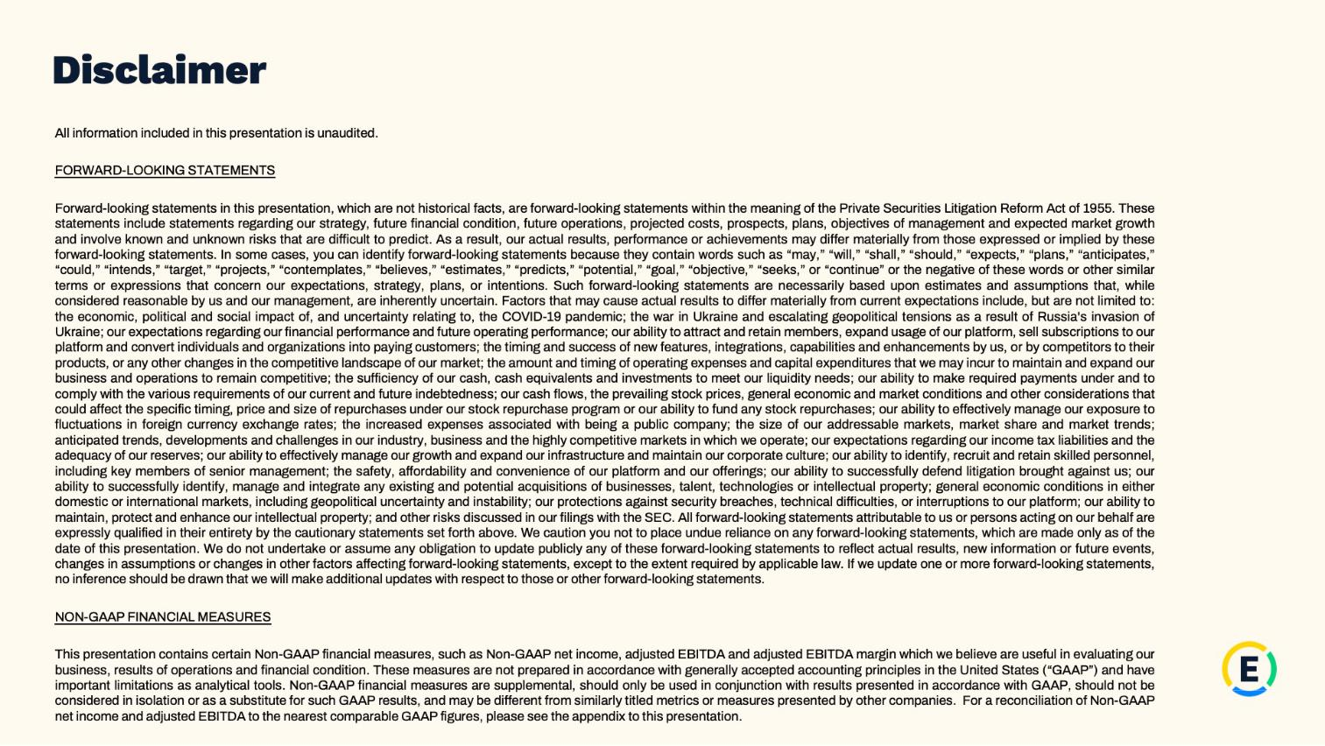

3

Exhibit 99.2

Expensify, Inc.

Investor Presentation
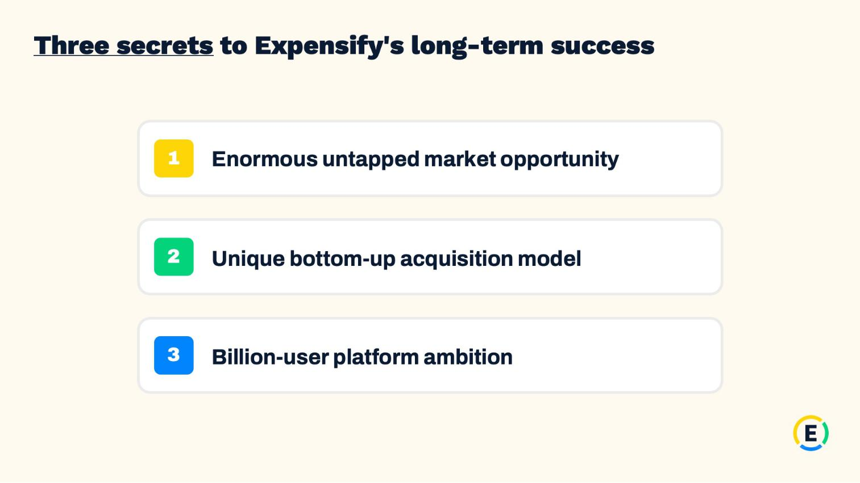

4

Exhibit 99.2

Expensify, Inc.

Investor Presentation
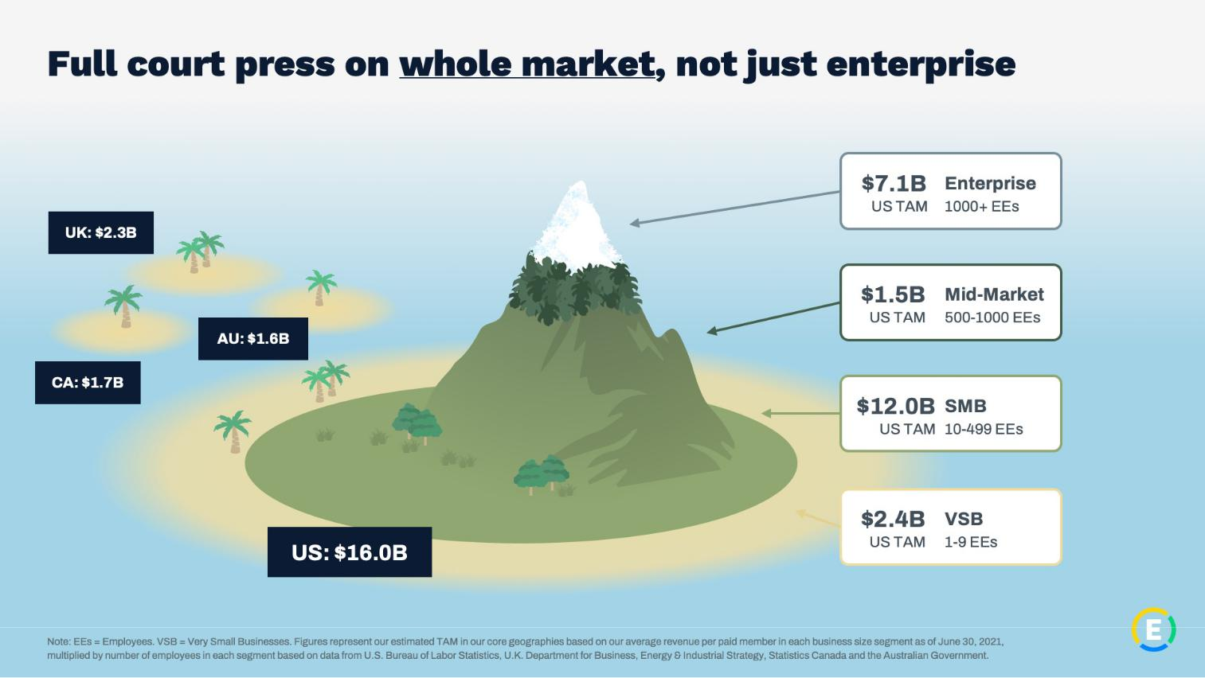

5

Exhibit 99.2

Expensify, Inc.

Investor Presentation
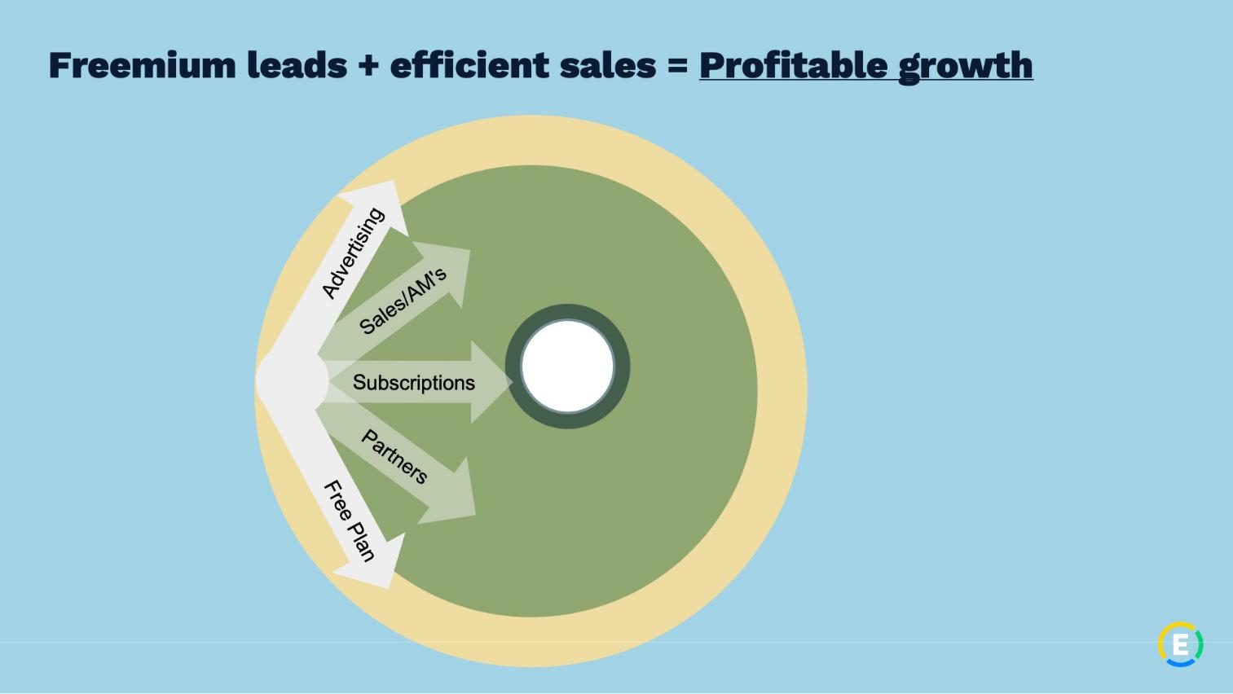

6

Exhibit 99.2

Expensify, Inc.

Investor Presentation
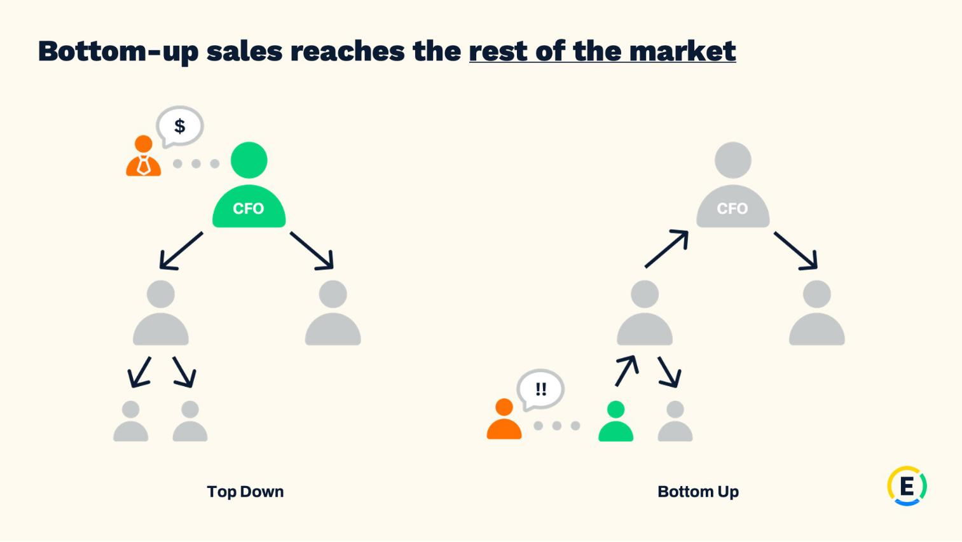

7

Exhibit 99.2

Expensify, Inc.

Investor Presentation
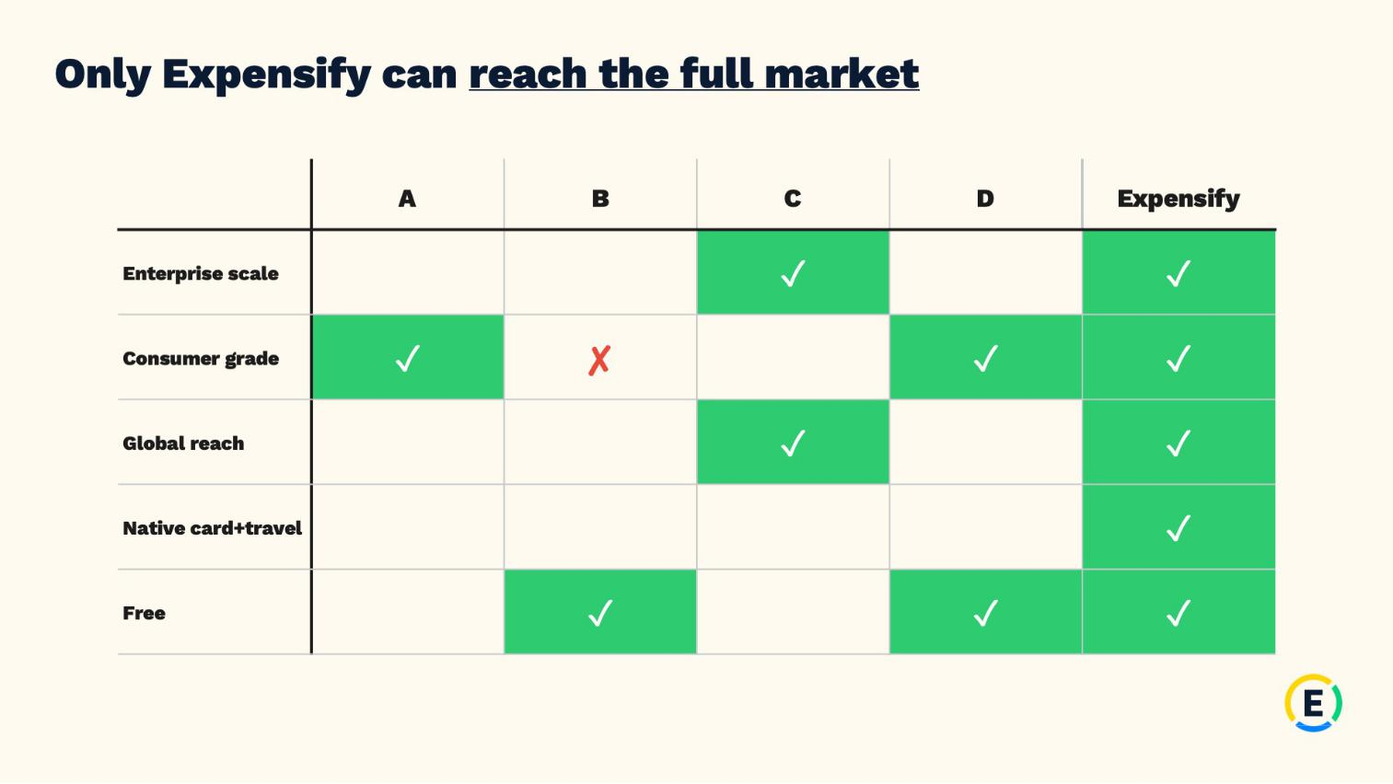

8

Exhibit 99.2

Expensify, Inc.

Investor Presentation
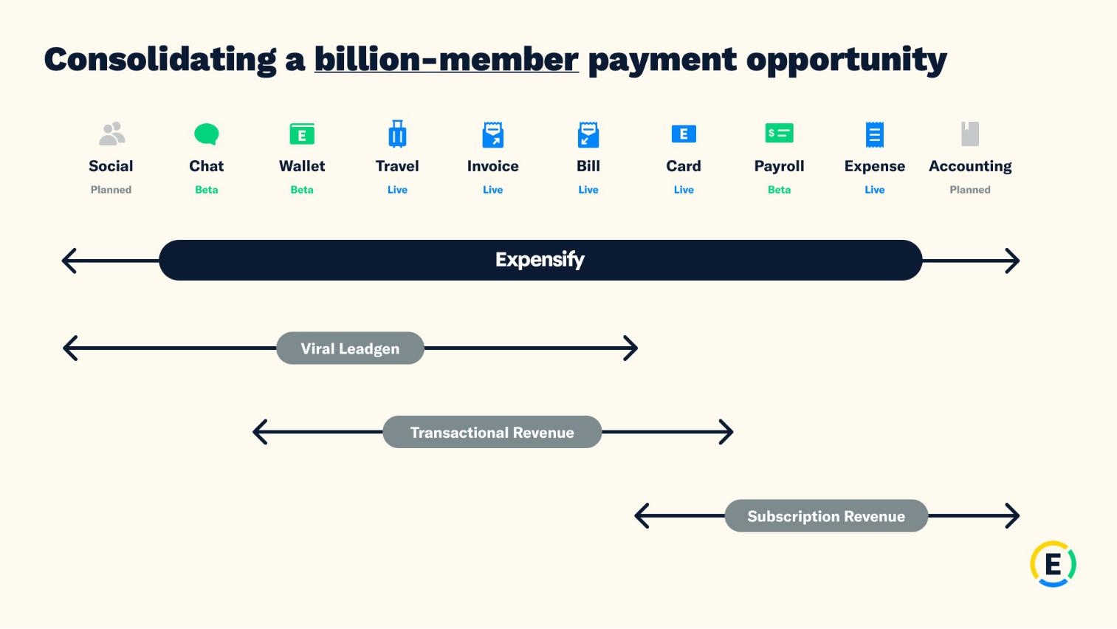

9

Exhibit 99.2

Expensify, Inc.

Investor Presentation


10

Exhibit 99.2

Expensify, Inc.

Investor Presentation
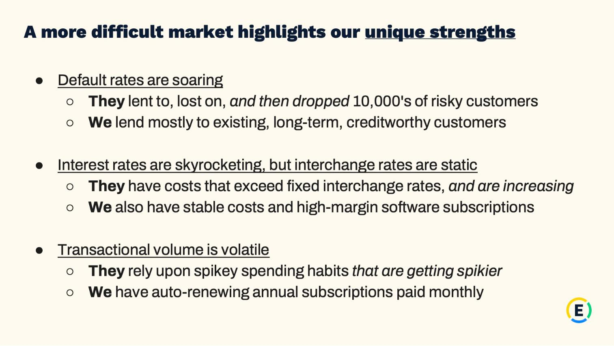

11

Exhibit 99.2

Expensify, Inc.

Investor Presentation
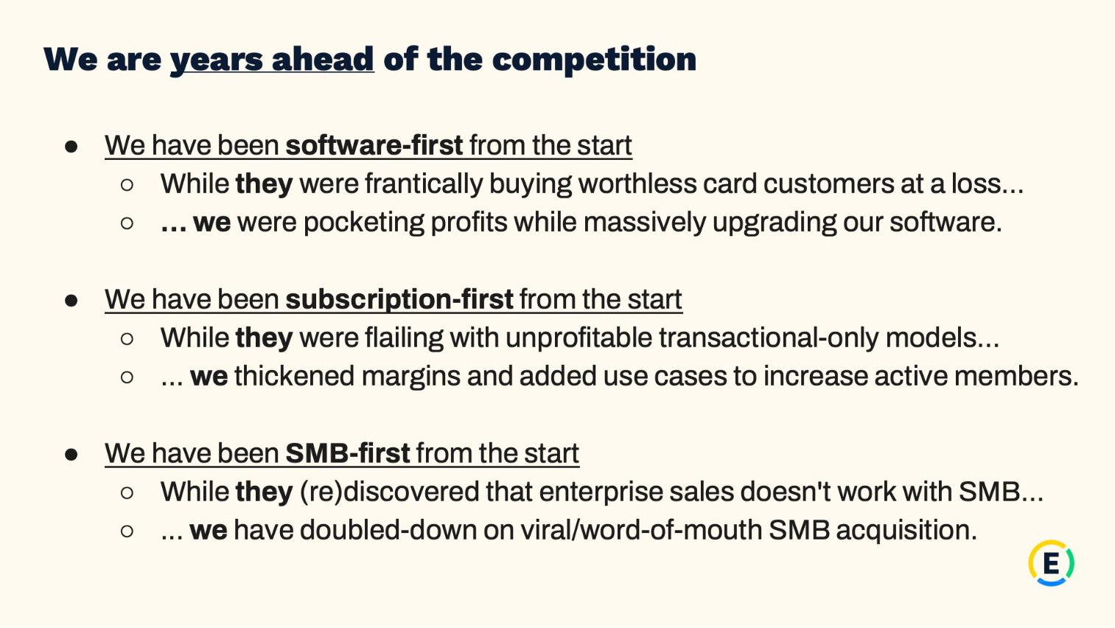

12

Exhibit 99.2

Expensify, Inc.

Investor Presentation


13

Exhibit 99.2

Expensify, Inc.

Investor Presentation
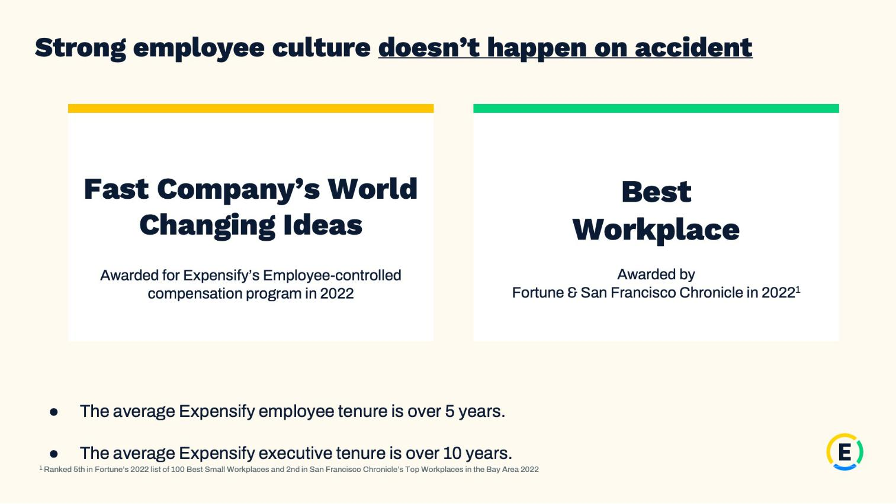

14

Exhibit 99.2

Expensify, Inc.

Investor Presentation


15

Exhibit 99.2

Expensify, Inc.

Investor Presentation
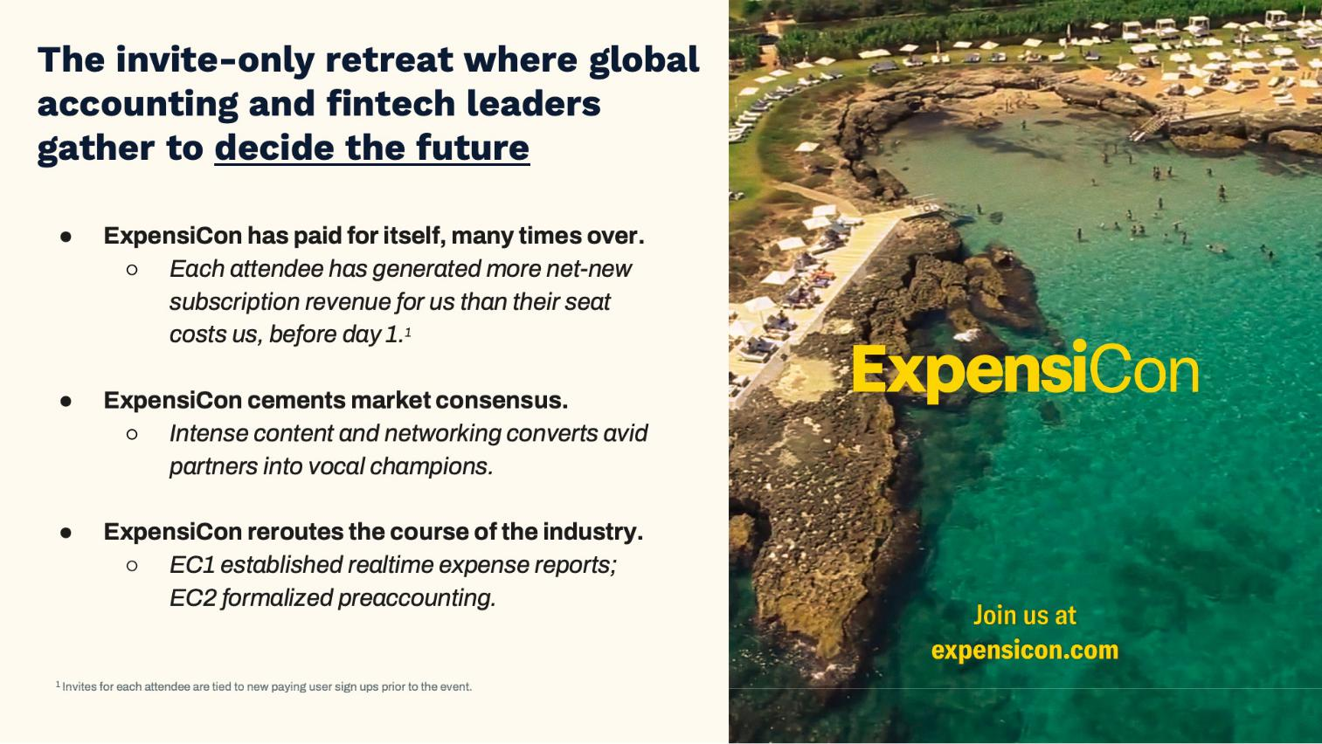

16

Exhibit 99.2

Expensify, Inc.

Investor Presentation
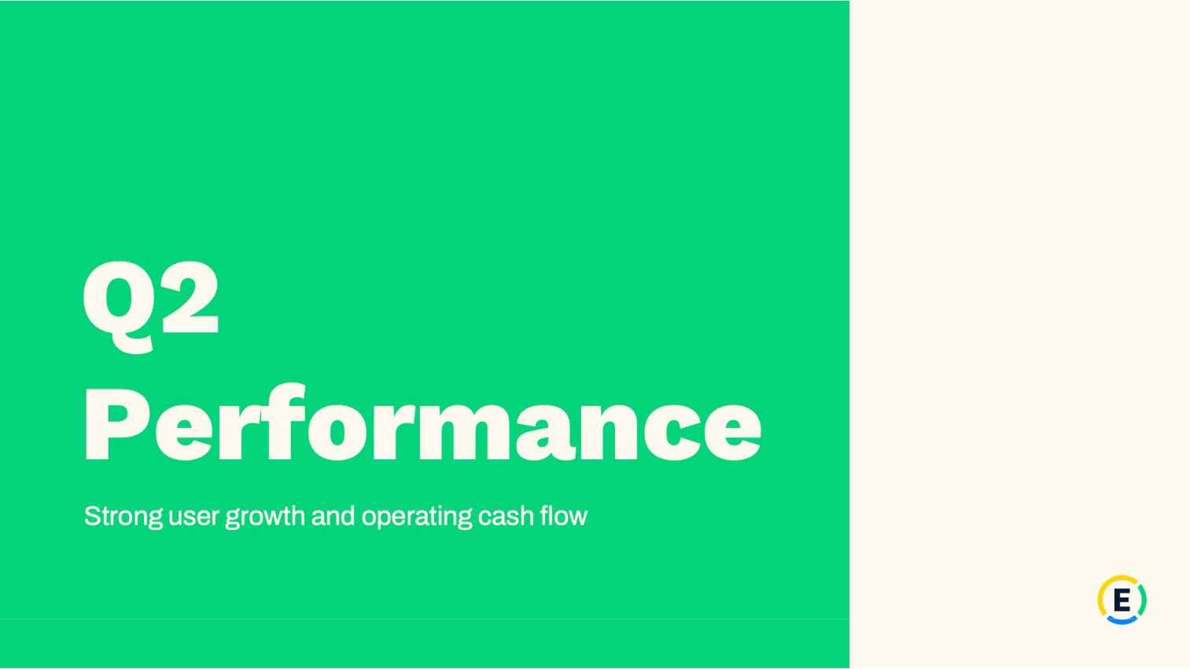

17

Exhibit 99.2

Expensify, Inc.

Investor Presentation
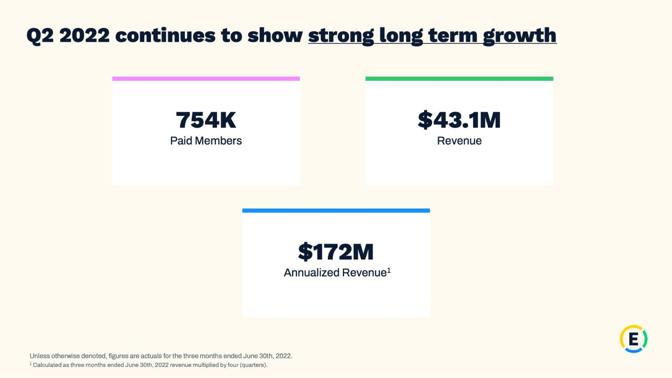

18

Exhibit 99.2

Expensify, Inc.

Investor Presentation
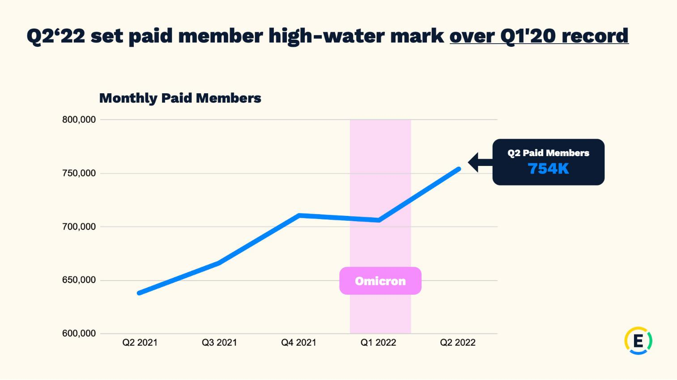

19

Exhibit 99.2

Expensify, Inc.

Investor Presentation
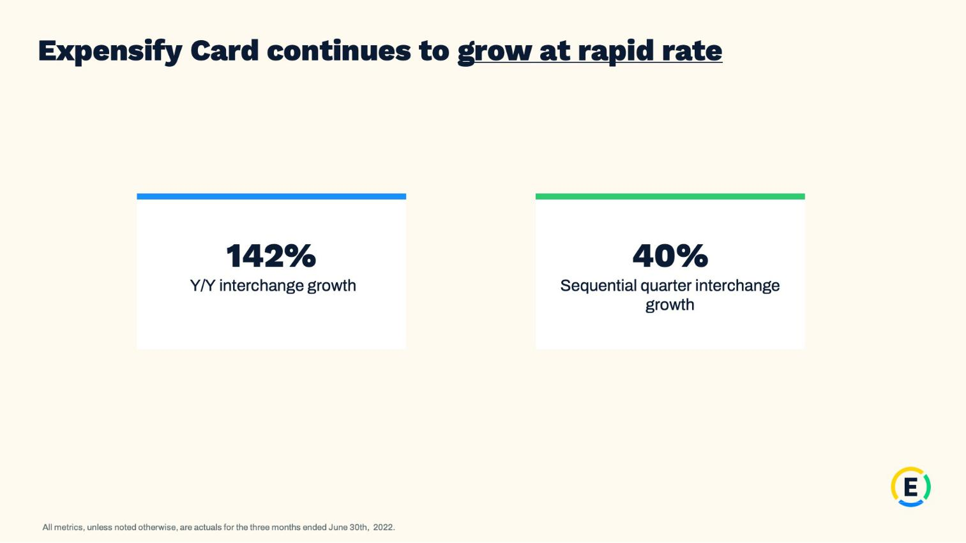

20

Exhibit 99.2

Expensify, Inc.

Investor Presentation
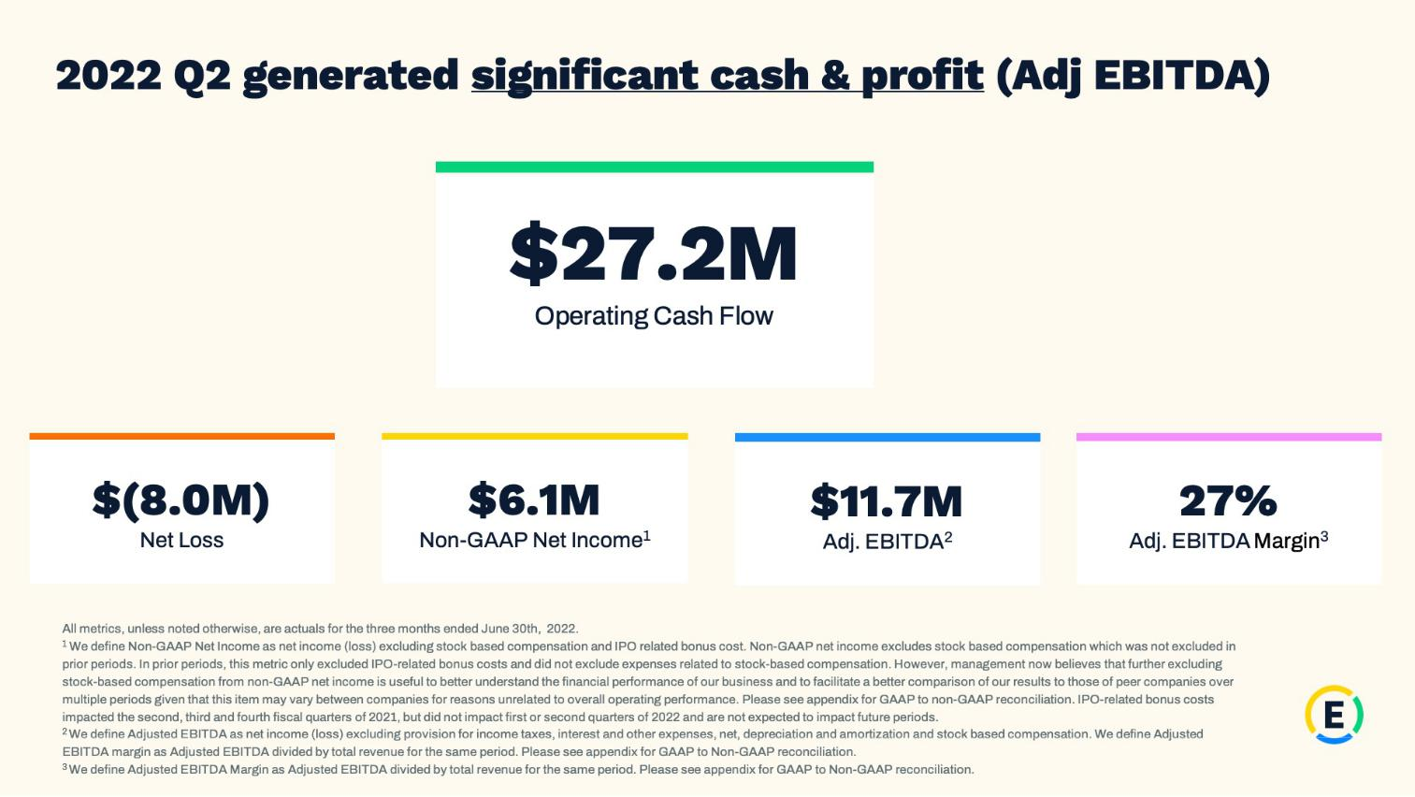

21

Exhibit 99.2

Expensify, Inc.

Investor Presentation
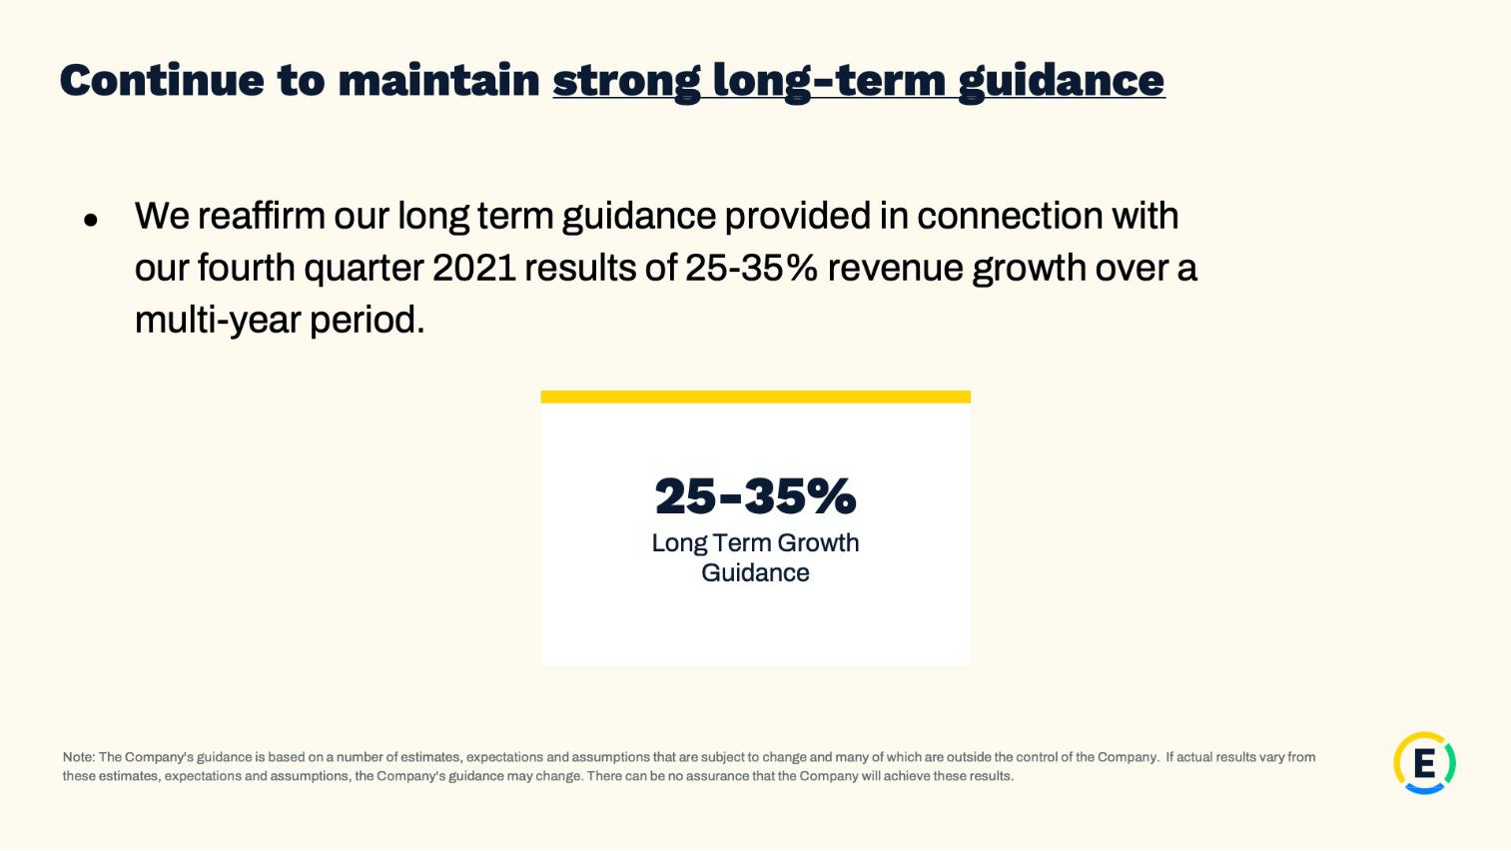

22

Exhibit 99.2

Expensify, Inc.

Investor Presentation
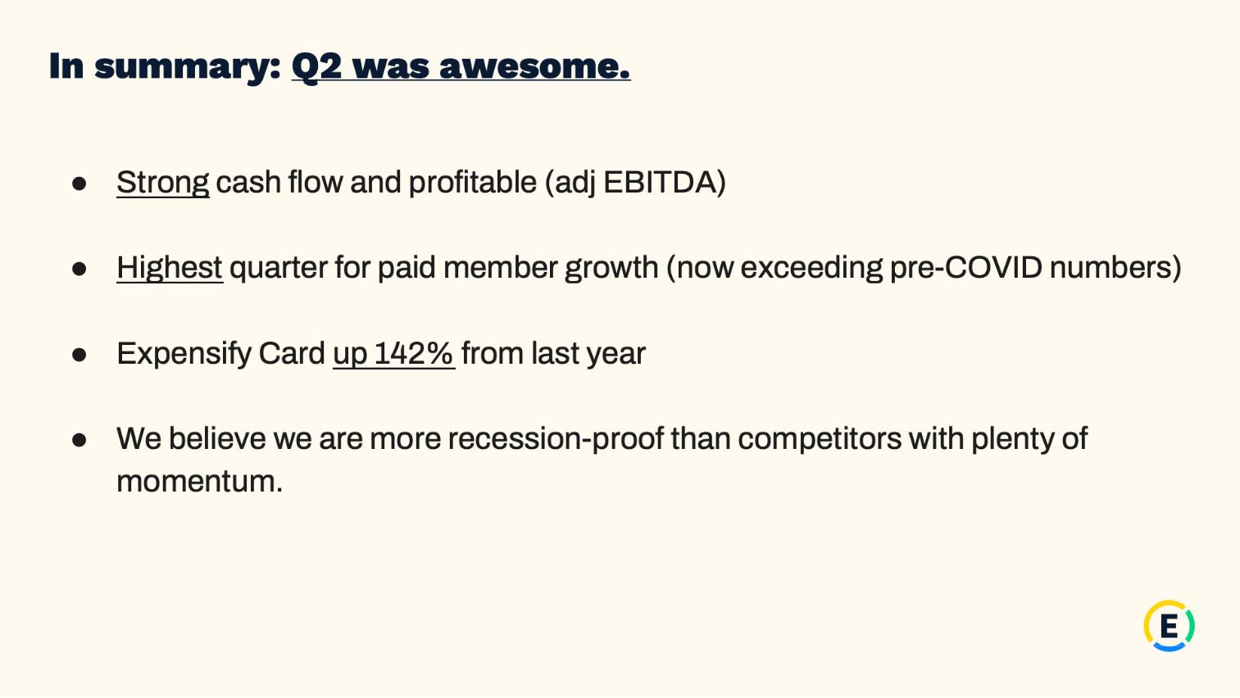

23

Exhibit 99.2

Expensify, Inc.

Investor Presentation


24

Exhibit 99.2

Expensify, Inc.

Investor Presentation


25

Exhibit 99.2

Expensify, Inc.

Investor Presentation


26

Exhibit 99.2

Expensify, Inc.

Investor Presentation
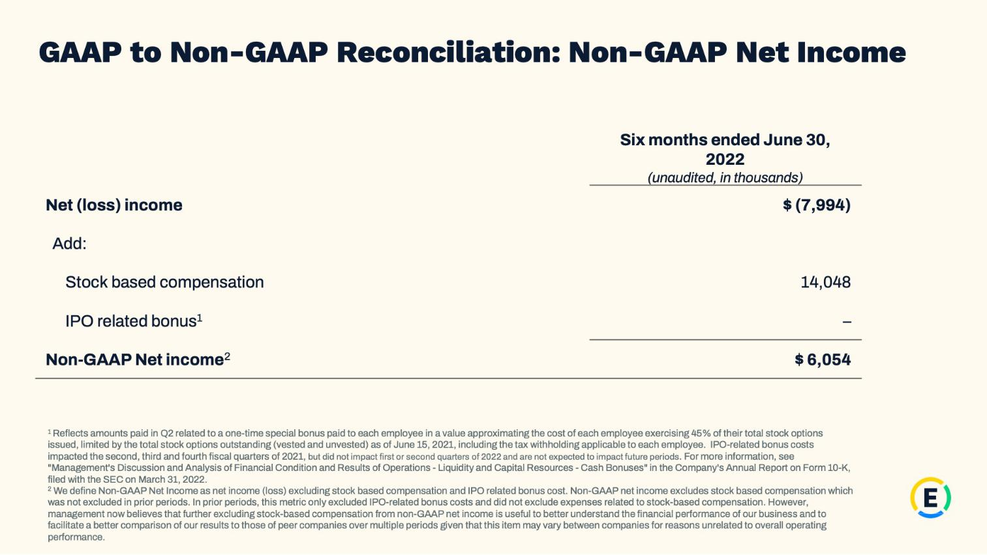

27

Exhibit 99.2

Expensify, Inc.

Investor Presentation
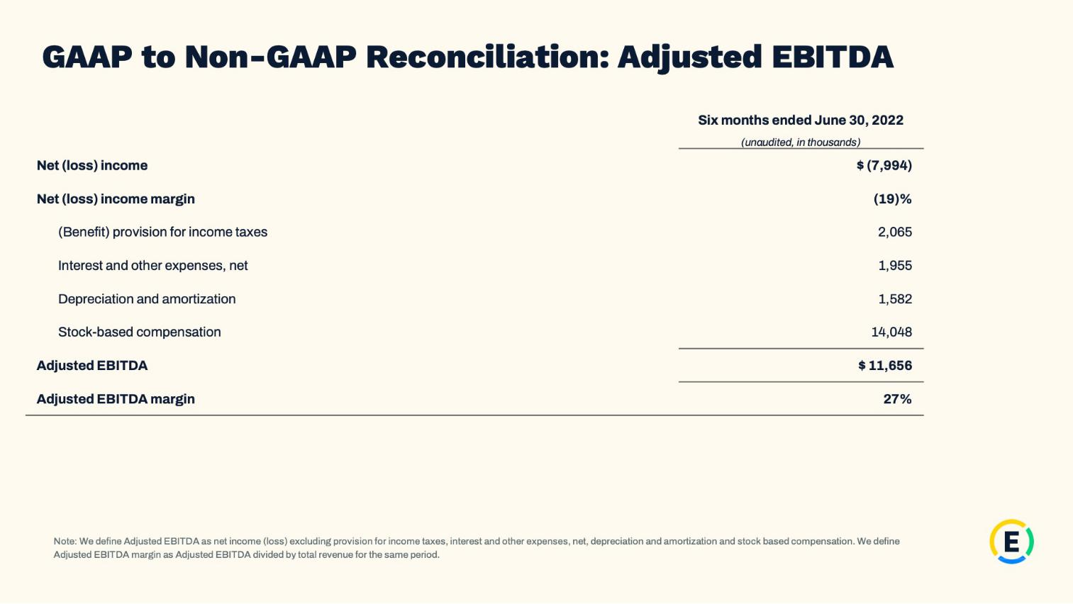

28

Exhibit 99.2

Expensify, Inc.

Investor Presentation
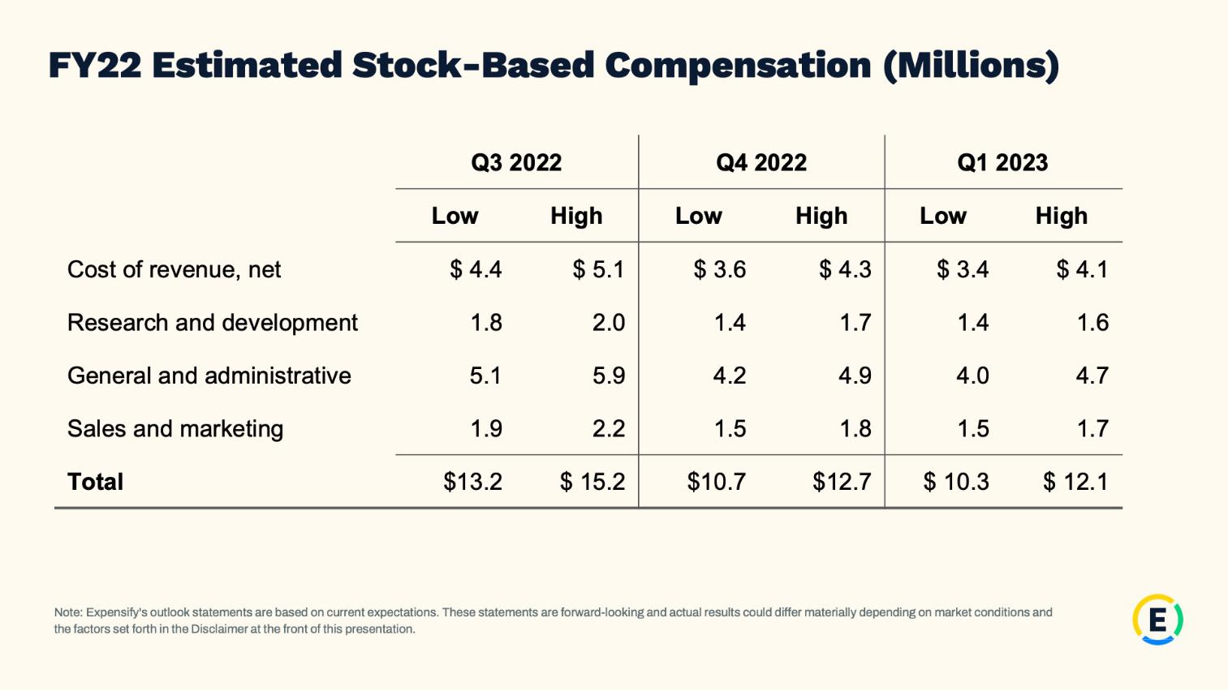

29

Exhibit 99.2

Expensify, Inc.

Investor Presentation

30

